Study on management and milk production of indigenous cows at Trishal in Mymensingh

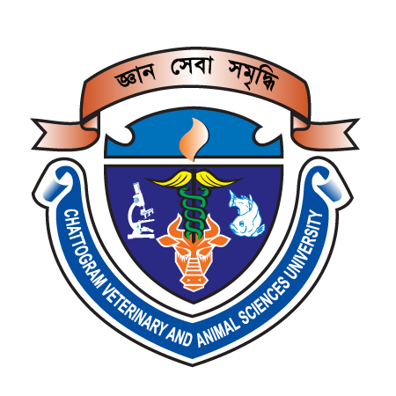

A production report submitted in partial satisfaction of the requirement for the Degree of Doctor of Veterinary Medicine (DVM)

By-
Maria Yeasmin Mili
Intern ID: 12
Roll no: 17/15
Reg. no: 01834
Session: 2016-‘17

Faculty of Veterinary Medicine
Chattogram Veterinary and Animal Sciences University
Khulshi, Chattogram – 4225, Bangladesh
Study on management and milk production of indigenous cows at Trishal in Mymensingh

Approved by-
Professor Dr. Gous Miah
Department of Genetics and Animal Breeding
Faculty of Veterinary Medicine

Faculty of Veterinary Medicine
Chattogram Veterinary and Animal Sciences University
Khulshi, Chattogram – 4225, Bangladesh
Table of contents
Contents Page no.
Abstract V
Introduction 01-02
Methodology
Study area 03
Preparation of survey questionnaire 03
Data collection 03
Data entry, sorting and statistical analysis 03
Result and Discussion
Purpose of cattle rearing 04
Feeding 04-05
Housing 06
Deworming 07
BCS 07
Milk production 09
Dry period o9
Calving interval 09
Suggestions 10
Limitations 10
Conclusion 11
Acknowledgement 12
Reference 13-14
Biography 15

List of Table
Contents Page no.
Table 1 06
Table 2 06
Table 3 07
Table 4 07
Table 5 08
Table 6 08
Table 7 09

List of Figure
Contents Page no.
Figure 1 04
Abstract
The purpose of this study was to determine the current state of small dairy farms, including general information, feeding, housing, milking as well as the productive performance of indigenous cows. With this in mind, empirical data was gathered via a structured questionnaire. The study was conducted in Trishal area. Data were collected from 46 respondents in a 2.5 month survey to explore the knowledge about the management and milk production of indigenous cows. Most of the farmers reared their cows in semi-intensive system housed on the mud floor, graze on pastureland, feed straw, rice polish, wheat bran, and broken rice. Few farmers provide manufactured cattle feed. Only 15.22% of cattle were administered anthelmintics within the last 6 months. The average body condition score was found 2.40 where the highest score was 3 (17.39%) and the lowest was 2 (21.74%). The rest (60.87%) scored 2.5. The cows produce 1.46 liter milk per day averagely. To improve the scenario more research is required and demands to raise awareness of the farmers about cattle management.
Keywords: Indigenous, management, milk production.

