Chapter 1

Introduction

Ice cream is a frozen milk product made by suitable blending and processing of cream and other milk products, together with sugar and flavor, with or without stabilizer or color, and with the incorporation of air during the freezing process(1). A typical compositional range for the components used in ice cream mix is milk fat 10 -16%,milk solids not fat 9-12%, sucrose 9-12%, corn syrup solids4-6%, stabilizers/emulsifiers 0 -0.5%, total solids 36 -45%and water 55 -64% (1).
Fig: Chemical Content of Ice Cream
In Bangladesh, ice cream is without a doubt one of the most popular and preferred foods, especially during the summer. Here, a number of ice cream brands in a wide range of flavors have been promoted. Both extrinsic factors, such as the manufacturing process, and intrinsic factors, such as the ingredient proportions utilized, affect the quality of ice cream.
The development of the ice cream industry has helped all industrialized nations build significant improvements to their economies and public health. Unfortunately, Bangladesh’s development of the ice cream industries, such as Savoy, Polar, Kwality, Igloo, Milk vita, etc., has been highly limited in light of the country’s consistent consumer protection legislation. It is quite challenging to determine whether the ice cream manufactured and distributed in our nation is hygienically safe and free of any public health risks because Bangladesh lacks any formalized food control service to ensure the safety of food supplies.(3)
To minimize these adulterations and ensuring nutritionally balanced ice cream to the consumers, more analytical study is necessary. The information is very limited on the nutritional content quality of different brand ice cream in Chattogram area. However, very limited number of research works has been carried out in Bangladesh regarding ice cream quality. Therefore, the present study will undertake with the aim to make a comparative study regarding Organoleptic and chemical quality (fat ,SNF, TS)of brand ice cream available at different points in Chattogram area.

Chapter 2

Materials and methods

Place of Study and Collection of samples
2.1 Sources, Collection and Transportation of Samples
This experiment was conducted at Dairy and Poultry Science Laboratory of Chattogram Veterinary And Animal Sciences University, Chattogram, Bangladesh .The samples were collected from various retail shoos at Khulshi, Chattogram from 1 January to 1 March. Three manufacturers' ice creams (Lovello, Polar, Igloo,) were gathered for this investigation. To identify chemical content and organoleptic properties of ice cream, a total of nine ice cream samples from each brand were acquired from the retail outlets. Ice cream containers or cups were held in a deep freezer cabinet by the store owners before being sold. Ice cream sample collection was done using aseptic techniques. The samples consist of unopened containers or tubes that were sent to the lab in perfect condition. For collection and subsequent research, all samples were transferred to the lab within 30 minutes in an insulated container packed with ice.

2.2 Preparation of Sample
According to the recommendations of Harrigan and McCance(4) and Rahman(5), the ice cream was kept in a water bath at 45°C before sampling. A sterile pipette can be introduced for the collection of samples following defrosting and when the top has fully liquefied. About 10 cc of liquid ice cream were extracted by pipetting from various depths and put in a clear glass bottle with a screw-on cork. Each brand of ice cream received six cups, and samples were gathered in labeled bottles as mentioned above. Each brand's ice cream samples totaled 60 cc after being collected in this way. One typical sample of ice cream was considered to have been collected.
A precise amount of 1 ml of ice cream was pipetted out of this completely mixed sample, transferred aseptically, and sealed with cotton into a sterile empty test tube. This ice cream was given a 1:10 v/v dilution by adding 9 ml of diluent. Sterile water diluted with 0.1% peptone at a pH range of 6.8–7.0 was used to prepare the samples. According to the APHA's recommended standard procedure (6), additional decimal dilutions were generated when needed.
2.3 Judging/ Organoleptic evaluation of Samples
Using a standard scorecard for evaluating ice cream, a panel of experienced judges scored each sample separately to assess appearance, color, odor, and overall features. Hedonic measures were employed to score sensory attributes, with scores of 90–100 denoting excellent, 80–89 good, 70–79 fair, 60–69 marginally acceptable, 30-59 unacceptable, and 0–29 bad. Highest 100 points were earned overall for the five distinctive parameters.(2)

Table 1: Judging Score of different ice cream sample.
Scores | Criterion
90-100 | Excellent
80-89 | Good
70-79 | Fair
60-69 | Marginally acceptable
30-59 | Unacceptable
0-29 | Bad

2.4 Chemical Analysis
Fat percentage, Solids-Not-Fat (SNF), total Solids (TS) were estimated under chemical Analysis. Fat percentage was measured by Gerber method.the percentage of fat by Gerber method; Solids-not-Fat (SNF) and total solids (TS) according to Ecles et al (1993)
Table 2: Selected Brandsof different ice cream sample.
Brand list | Brand Name
Sample A | Lovello
Sample B | Polar
Sample C | Iglo
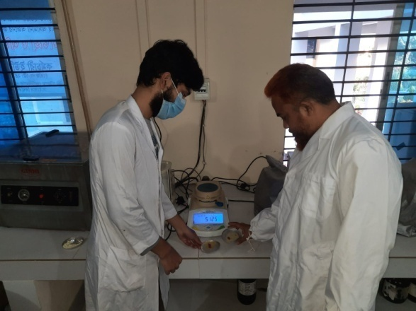
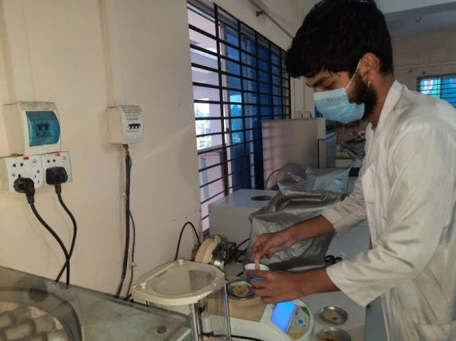
Fig: Lab work for qualitative tests.
Statistical Analysis: The Mean, Standard Deviation of the data were calculated to explain data scientifically.

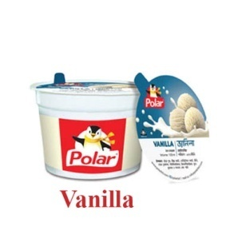
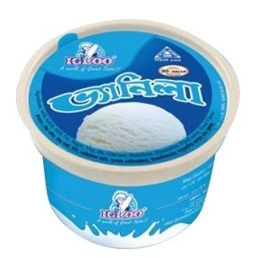
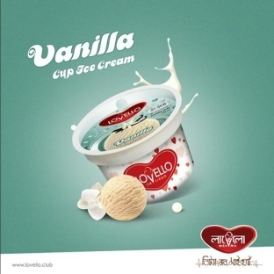
Fig: Ice cream of different companies which quality is tested

Chapter 3

Result and Discussion
1.1 Sensory evaluation
The ice cream sample was served to panelists for sensory evaluation. The sensory scores for flavor, body and texture, melting quality, color and appearance were shown in Table 1. In flavor all three sample were good enough but sample A was better than others. In all other parameter sample A stands to be better. There is defect in packaging for sample B, sample C; melting quality is also not up to the mark for sample B and sample C (2).
Table-1: Sensory evaluation scores of different ice cream sample.
Attributes | Sample A | Sample B | Sample C
Flavor  (40) | No defect  (38) | Slightly less flavor  (35) | Lack of sweetness  (30)
Body and texture  (30) | Slightly coarse  (25) | Slightly Crumbly  (20) | Slightly Crumbly  (20)
Melting quality  (20) | Slow melting  (12) | Fast melting  (9) | Foamy melting  (8)
Color and appearance  (10) | No visible defect  (8) | Defective packing  (7) | Defective packing  (6)
Total Scores | 83 | 71 | 64

Comparison between theses sensory evaluation:

1.2 Chemical analysis
The fat percentage of these samples range from 9.3% to 8.1% and total solids range from 46.85 to 41.75 while moisture content ranging from 53.15% to 58.25% (Table 2). The ice cream’s fat level and sensory quality were likely improved by the milk’s high fat content (Li et al, 1997). Highest fat content was found in Sample A(9.3%) and lowest was found in Sample C (8.1%)
Ice cream’s total solids content ranges from 40 to 45%. The viscosity and total solids content of ice cream are increased when sweets are added (Marshal et al, 1996). Highest content of total solids found in Sample B and lowest was Sample C (Table 2)

Table-2: Chemical composition (Moisture, Total Solids and Solids Not Fat) of different ice cream sample.

Sample Name | Fat Percentage | Moisture percentage | Total Solids | Solids Not Fat
Sample A | 9.3% | 54.25% | 45.75% | 36.45%
Sample B | 8.7% | 53.15% | 46.85% | 38.15%
Sample C | 8.1% | 58.25% | 41.75% | 33.65%

Comparison between the Chemical content of these samples:

Chapter 4
Conclusion
Being an delicious dairy products ice cream is consumed in large amount, where renowned brands get preference. The quality of this ice cream depends on chemical standard as well as melting quality, color and appearance, body and texture etc. The study findings show that majority of the renowned products lacks of the standard chemical content and failed to provide the amount written on the pack. However further study could be done to find out the other elements like microbial content, foreign content, trace elements.
Limitations
Our sample size was limited.

Recommendations
1) The regulatory authorities like BSTI should increase regulatory activities.
2) The Govt. should help to investigate on the major consumed brand.
3) Strict laws and regulation should be implemented ..
4) More funded study would make the investigation easier.

References:
Hossain, MT and Kober, AKMH, Microbiological quality of ice cream available in Chattogram. Bangladesh Journal of Microbiology, 2008, 25:135-136,
K.M.M Hossain, S.M.L Kabir, Organoleptic and Microbial Quality of Ice Cream Sold at Retail Stores in Mymensingh, Bangladesh, Journal of Microbiology Research 2012, 2(4): 89-94
Joshi, D.R., Shah, P.K., Manandhar, S., Sharma, S., and Banmali, P., 2004, Microbial quality of ice cream sold in Kathmandu. Journal of Nepal Health Research Council, Vol. 2 No. 2 pp. 37-40
Harrigan, M. F., and McCance, M. E., 1976, Laboratory methods in food and dairy microbiology. Academic Press, London, England. Pp. 193
Rahman, M. M., 1997, Practical food microbiology, Bangla Academy, Dhaka Bangladesh, pp. 70
American Public Health Association, ,1987, Standard Methods for Examination of Dairy Products. 10thed APHA. Inc., New Yord, pp. 144 and 147-148 .

Biography

The author Mohammad Robiul Hossen, son of Mohammed Samir Hossen and Kamrun Nahar, passed his Secondary School Certificate (SSC) examination from NoaparaMuslim High School, Noapara, Raozan,Chattogram, in 2013 and Higher School Certificate (HSC) examination from CUET College, Chattogram in 2015. Thereafter, he enrolled for Doctor of Veterinary Medicine (DVM) degree in Chattrogram Veterinary and Animal Sciences University (CVASU), Bangladesh and now is an intern student in this university.

