Authorization
I, DR. Kona Adhikary, confirm of authenticity of all the works in this report. All the information collected from books, national and international journals, websites and other references have been acknowledged accordingly.
I hereby declare that I am the sole author of the thesis. I also authorize the Chattogram Veterinary and Animal Sciences University (CVASU) to lend this thesis to other institutions or individuals for the purpose of scholarly research. I further authorize the CVASU to reproduce the thesis by photocopying or by other means, in total or in part, at the request of other institutions or individuals for the purpose of scholarly research.

Hence, I hold entire responsibility of for collection, compilation, preservation and publication of all data accumulated here in this report. I, the undersigned, and author of this work, declare that the electronic copy of this thesis provided to the CVASU Library, is an accurate copy of the print thesis submitted, within the limits of the technology available.

The Author
June 2019

Effects of dry and probiotic-fermented Carica papaya leaves on Growth Performance, Carcass Characteristics, Serum Parameters and Meat Quality in Broiler

Kona Adhikary
Roll No.: 0117/01
Registration No.: 00379
Session: 2017-2018

This is to certify that we have examined the above Master’s thesis and have found that is complete and satisfactory in all respects, and that all revisions required by the thesis examination committee have been made.

-----------------------------------------------------(Prof. Dr. Md. Manirul Islam)  Supervisor  Department of Animal Science and Nutrition, CVASU | -----------------------------------------------------(Prof. Dr. Goutam Buddha Das)  Co-supervisor  Department of Animal Science and Nutrition, CVASU

-----------------------------------------------
(Prof. Md. Emran Hossain)
Chairman of the Examination Committee and Head
Department of Animal Science and Nutrition

Faculty of Veterinary Medicine
Chattogram Veterinary and Animal Sciences University
Khulshi, Chittagong-4225, Bangladesh
JUNE 2019

Acknowledgements
I sincerely appreciate the almighty God for His graces, strength, sustenance and above all, His faithfulness and love all along the completion of my thesis. His benevolence has made me excel and successful in making my thesis possible.
My unalloyed appreciation goes to my amiable, ever supportive and humble supervisor, Professor Dr. Md. Manirul Islam for his voluminous and invaluable contributions and instructions throughout my research. His encouragement and high degree of freedom to me in the course of this study is highly appreciated.
I am extremely privileged to convey my profound gratitude to the Vice-Chancellor and co-supervisor Dr. Goutam Buddha Das, Professor, Department of Animal Science and Nutrition, Chittagong Veterinary and Animal Sciences University (CVASU) for his valuable advice, scholastic guidance, suggestions and inspiration.
Furthermore I would also like to acknowledge with much appreciation the crucial role of all the staff of the Department of Animal Science and Nutrition in every step throughout the research period.
I must not fail to sincerely appreciate and acknowledge the financial support from National Science and Technology, Ministry of Science and Technology, Bangladesh without which the research may not go smoothly.
I sincerely thank to all the members of the Department of Physiology, Biochemistry and Pharmacology, for their help in using their laboratory. Also thanks to DR. Inkeyas Uddin, Scientific Officer, Poultry Research and Training Center (PRTC) for letting me work in the laboratory.
I would like to thank DR. Kalishangkar Paul, DR. Priunka Bhowmik and Md. Showkat Ullah their support during the whole experimental period.
Finally, an honorable mention goes to my families and friends for their understandings and supports in completing this thesis. Without their help, it would have been impossible to overcome the difficulties faced during the research period.

The Author
June 2019
Table of Contents
Authorization I
Acknowledgements III
Abstract XI
CHAPTER-I: INTRODUCTION 1
1.1 Objectives 3
1.2 Research Hypothesis 3
CHAPTER-II: REVIEW OF LITERATURE 4
2.1 Carica papaya 4
2.1.1 Compositions: 4
2.2 Medicinal use of papaya leaf 7
2.2.1 Digestive health and celiac disease elimination 7
2.2.2 Antimicrobial property 7
2.2.3 Antioxidant potential 8
2.2.4 Antidiabetic activity: 8
2.2.5 Anti-inflammatory and immunemodulatory effects 8
2.2.6 Dengue and malaria treatment 8
2.3 Probiotics 9
2.3.1 Lactobacillus 9
2.3.2 Saccharomyces 9
2.4 Effects of probiotics in broiler nutrition 10
2.4.1 Evaluating probiotic effects on growth performance 10
2.4.2 Evaluating probiotic effects on meat quality 11
2.4.3 Evaluating probiotic effects on immune response 11
2.5 Effects of papaya on broiler 12
2.6 Summary 12
CHAPTER-III: MATERIALS AND METHODS 13
3.1 Study area 13
3.2 Study period and climatic condition 13
3.3 Preparation of leaf meal 13
3.3.1 Collection of leaves 13
3.3.2 Grinding and storage of leaves 13
3.4 Preparation of probiotic 14
3.4.1 Collection of yoghurt sample 14
3.4.2 Isolation of Lactobacillus 14
3.4.3 Isolation of Saccharomyces 14
3.4.4 Determination of Lactobacillus and Saccharomyces concentration in yoghurt 15
3.4.5 Culture of Lactobacillus and Saccharomyces for probiotic 15
3.4.6 Determining concentration of microorganisms in probiotic culture 16
3.4.7 Stocking of probiotic culture 16
3.5 Probiotic incorporated with papaya leaf 16
3.6 Layout of the experiment 16
3.7 Preparation of the shed 17
3.8 Collection of birds 18
3.9 Management 18
3.9.1 Brooding 18
3.9.2 Housing 18
3.9.3 Feeding and watering 19
Estimated chemical composition of the treatments 19
3.9.4 Vaccination and medication 20
3.10 Determination of growth parameters 20
3.10.1 Live weight gain 21
3.10.2 Feed intake 21
3.10.3 Feed conversion ratio (FCR) 21
3.11 Evaluation of carcass characteristics 21
3.12 Biochemical analysis 22
3.12 Proximate Analysis of meat 23
3.13 Oxidative rancidity of meat 24
3.14 Cost benefit analysis 25
3.15 Data collection 25
3.15 Statistical analysis 25
CHAPTER-IV: RESULTS 27
4.1 Concentration of organisms in probiotics: 27
4.3 Effects on growth performance 27
4.3.1 Live weight 28
4.3.2 Average daily gain 29
4.3.3 Average daily feed intake 29
4.3.4 Feed conversion ratio (FCR) 29
4.4 Carcass characteristics 29
4.5 Serum parameters 30
4.5.1 Serum cholesterol level 31
4.5.2 Serum HDL level 31
4.5.3 Serum LDL level 31
4.5.4 Triglyceride level in serum 31
4.6 Chemical composition of meat 32
4.7 Oxidative stability of meat 33
4.8 Cost benefit analysis 34
CHAPTER V: DISCUSSION 35
5.1 Weight gain 35
5.2 Feed intake 36
5.3 Feed conversion ratio (FCR) 36
5.4 Serum biochemical parameters 37
5.5 Carcass characteristics 37
5.6 Proximate analysis of thigh and breast meat 38
5.7 Oxidative stability of meat 38
5.8 Cost benefit analysis 39
CHAPTER VI: CONCLUSION 40
CHAPTER VII: RECOMMENDATIONS 41
CHAPTER VIII: REFERENCES 42
Biography 54

List of Tables
Table 1. | Chemical composition of Carica papaya leaves…………………. | 5
Table 2. | Quantitative assessment of phytochemicals in papaya leaves……. | 5
Table 3. | Layout of the experiment…………………………………………. | 17
Table 4. | The nutritional value of basal diet (CP feed)……………………... | 19
Table 5. | Chemical composition of given supplements…………………...... | 20
Table 6. | Vaccination schedule……………………………………………... | 20
Table 7. | Concentration of microorganisms in probiotics…………………... | 27
Table 8. | Dietary effects of dry and probiotic fermented papaya leaf on growth performance in broiler……………………………………. | 28
Table 9. | Effects of dry and probiotic fermented papaya leaves on carcass characteristics and organ weight………………………………….. | 30
Table 10. | Dietary effects of dry and probiotic fermented papaya leaf on serum parameters…………………………………………………. | 31
Table 11. | Variation in chemical composition in dietary groups…………...... | 32
Table 12. | Cost benefit analysis of the bird fed supplemented diets with dry and probiotic fermented papaya leaves…………………………… | 34

List of Figures
Figure 1 | Collection of papaya leaves………………………………….. | 13
Figure 2 | Lactobacillus isolation………………………………………. | 14
Figure 3 | Serial dilution of yoghurt sample……………………………. | 15
Figure 4 | Bacterial colony count……………………………………….. | 16
Figure 5 | Initial weight recording……………………………………… | 18
Figure 6 | Brooding of the chicks………………………………………. | 18
Figure 7 | Housing of the birds…………………………………………. | 18
Figure 8 | Dressing of carcass…………………………………………... | 22
Figure 9 | Weighing of dressed carcass………………………………… | 22
Figure 10 | Separating different parts and organs………………………... | 22
Figure 11 | Weighing leg………………………………………………… | 22
Figure 12 | Weighing liver……………………………………………….. | 22
Figure 13 | Weighing intestine…………………………………………… | 22
Figure 14 | Blood collection……………………………………………... | 23
Figure 15 | Biochemical analysis of serum………………………………. | 23
Figure 16 | Weighing of sample…………………………………………. | 24
Figure 17 | Digestion for CP estimation…………………………………. | 24
Figure 18 | Titration of CP estimation…………………………………… | 24
Figure 19 | Estimation of CF…………………………………………….. | 24
Figure 20 | Estimation of EE…………………………………………….. | 24
Figure 21 | Estimation of Ash……………………………………………. | 24
Figure 22 | Determination of TBARS value from meat sample…………. | 25
Figure 23 | Weekly Thiobarbituric acid reactive substance (TBARS) value of meat in all dietary groups…………………………... | 33

List of abbreviations
Abbreviation | Elaboration
AGP…………………… | Antibiotic growth promoter
ANOVA………………. | Analysis of variance
CF…………………….. | Crude fibre
CFU…………………... | Colony forming unit
CP…………………….. | Crude protein
DDGS…………………. | Distiller's dried grains with soluble
DFRB ………………… | De-fatted rice barn
DM……………………. | Dry matter
DOC………………….. | Day Old Chick
EE…………………….. | Ether extract
FCR…………………… | Feed conversion ratio
ft | Feet
g/b/d..…………………. | Gram per bird per day
GLM………………….. | General linear model
HDL…………………... | High density lipoprotein
IU……………………... | International unit
Kcal/kg……………….. | Kilocalorie per kilogram
LDL…………………... | Low density lipoprotein
LW……………………. | Live weight
MDA………………….. | Malondialdehyde
ME …………………… | Metabolizable energy
mg……………………… | Milligram
NGP…………………… | Natural growth promoter
PFA……………………. | Phytogenic feed additives
SEM…………………… | Standard error of mean
TA……………………... | Total Ash
TBARS………………… | Thiobarbituric acid reactive substance
TC……………………... | Total cholesterol
TG……………………... | Triglyceride
Wt……………………... | Weight
˂……………………….. | Less than
˃……………………….. | Greater than
e.g……………………… | Example
et al……………………. | And his associates
% ……………………… | Percentage
i.e. ………………...…… | That is
Sig. …………………….. | Significance
Ref. ……………………. | Reference

Abstract
A 28 day feeding trial was conducted to evaluate the effects of Carica papaya leaf meal with or without (dry) fermentation on growth performance, carcass characteristics, serum parameters, meat composition and oxidative stability of meat in broiler. A total of 135 day-old, ROSS-308 chicks was assigned to five treatment groups: Control (Basal diet), D₁ (Basal diet + 0.5% Dry leaf on DM basis), D₂ (Basal diet + 1.0% Dry leaf on DM basis), F₁ (Basal diet + 0.5% Fermented leaf on DM basis) and F₂ (Basal diet + 1.0% Fermented leaf on DM basis) having 3 replications consisting of 9 birds each in a completely randomized design. The results revealed that overall average daily gain (ADG) differed significantly (P<0.001) in all treatment groups compared to control. The average daily feed intake (ADFI) remained unchanged (P>0.05) among all dietary groups. A significantly (P<0.001) better final FCR was observed in all treatment groups in contrast to control. The weekly FCR remained unaffected except 4th week in which significant (P<0.001) change was observed. The proximate composition of breast meat showed significant (P<0.01) increase in crude protein (CP) content. Again, in thigh meat, crude protein and ether extract (EE) content differed significantly (P<0.01) among all dietary treatment groups than control. A significant (P<0.01) increase in serum HDL level and decrease in serum LDL and triglyceride level was observed in all treatment groups when compared with control. All visceral and total lymphatic organs weight remained unchanged (P>0.05) in all treatment groups in comparison to control. The oxidative stability of meat measuring thiobarbituric acid reactive substances (TBARS) had significantly (P<0.05) reduced in all additive treatment groups compared to control up to 3rd weeks. The net profit from papaya supplemented group differed significantly (P<0.001) than control. Finally, dry and fermented Carica papaya leaf increased ADG, serum HDL level, net profit and decreased FCR, serum LDL, triglyceride level and TBARS of meat. Hence, Papaya leaf meal showed beneficial effects on broiler and can be a potential source to be used as feed additive in broiler.
Keywords: Broiler, carcass characteristics, Carica papaya leaves, growth performance, probiotics

CHAPTER-I: INTRODUCTION
Poultry is one of the remarkably dynamic sub-sector, contributing in fostering agricultural growth, providing food security and nutrition and a source of income. In Bangladesh, commercial poultry farming has started from 1980 and it has been growing rapidly since early 1990 due to improved genetics, manufactured feeds and management (Raha, 2000). Chicken contributes 5l % of total meat production of the country (Raha, 2007). Among poultry, broiler farming seems to be a considerable part of meat production and consumption in the country. But the major challenges for poultry farmers are to get maximum performance from minimizing main cost of production which is feed cost. For this purpose, they use different strategies including use of antibiotic growth promoter (AGP) in sub-therapeutic doses in broiler (Oleforuh-Okoleh et al., 2015). AGP use improves meat production by increasing feed conversion ratio (FCR), promoting growth rate and disease prophylaxis which can successfully be obtained at sub-therapeutic dose (Chattopadhyay, 2014; Engberg et al., 2000; Gunal et al., 2006; Castanon, 2007). The use of AGP causes accumulation of residues in meat resulting in resistance of bacteria to those antibiotics, difficulty in treatment and ultimate environmental hazard as well as multidrug resistance (Puvača et al., 2013; Marshall and Levy, 2011; Sarker et al., 2018). Considering the possible health hazards, the use of AGPs was banned in many countries including European Union, The Netherlands, Germany, Sweden, US, Australia (Hayes et al., 2001; Casewell et al., 2003; Cogliani et al., 2011; Laxminarayan et al., 2015). In October 2010, use of all AGPs were banned by the Government of Bangladesh through the Fish and Animal Feed Act-2010 and later framed by Animal Feeds Rules-2013 (MoFL, 2013).

Due to restriction of AGPs by several international jurisdiction, the animal producers are need to rely on feed additives alternative to antibiotics which drives the use of natural sources (Wenk, 2003). This made the researchers to think about feed additives alternative to antibiotics aiming for good animal yield, low mortality, no adverse effect on human health as well as preservation of environment. The most common substitute can be phytogenic feed additives, probiotics, prebiotics, essential oils, amino acids, organic acids, enzymes, nanoparticles etc. (Mehdi et al., 2018). They are known as natural growth promoters (NGPs) (Panda et al., 2006).

Phytogenic feed additives (PFA) or phytobiotics are plant, herb powder or extract which contains many bio-active compounds that improve animal performance. The bio-active compounds mostly contain secondary metabolites such as terpenoids (mono-and sesquiterpenes, steroids, etc.), phenolics (tannins), glycosides and alkaloids such as alcohols, aldehydes, ketones, esters, ethers, lactones, etc. (Huyghebaert et al., 2011). PFAs are proven in poultry for growth promotion by improving weight gain and feed conversion ratio, gut function, gut microflora, nutrient digestibility (Ghasemi et al., 2014; Vidanarachchi et al., 2006; Jamroz et al., 2003). PFAs also increase feed palatability and reduce mortality. They also have positive effect on immune function and carcass meat safety and quality (Mountzouris et al., 2010). Some leaf meal/extracts that are successfully used as growth promoters in broiler chickens are Moringa olerifera, lemon grass leaf, banana leaf, bitter leaf and also papaya leaf (Oleforuh-Okoleh et al., 2015).
Papaya or pawpaw (Carica papaya) which belongs to the family Caricaceae, is a plant in tropics and subtropics. Parts of this plant include leaves, fruit, seed and root are known to be digestive stimulant, analgesic, antipyretic, antibacterial, stomachic, cardiotonic, hypotensive, laxative and vermifugic (Boshra and Tajul, 2013). Papaya leaf is a rich source of the proteolytic enzymes papain and chymopapain A and B, and papaya peptidase which have protein digesting properties (Oloruntola et al., 2018). The leaf also contains alkalois, glycosides, provitamin A, vitamin C, vitamin E, calcium, phosphorous and iron (Pawar et al., 2010). Use of papaya leaf meal in broiler diet as a source of protein has significant effect of treatments on final body weight, weight gain, daily weight gain, feed conversion ratio and feed cost/kg gain (Onyimonyi and Ernest, 2009). Papaya leaf has also been observed to improve carcass quality, digestibility and health of broiler chicken (Oloruntola et al., 2018). So papaya leaf meal can be a promising source of feed additive in broiler production.

Again, probiotics which are different strains nonpathogenic living microorganisms, currently has gained attention as a substitute of antibiotics for poultry production as growth promoters with feed additives (Ahmad, 2006). Probiotics stimulate digestive enzyme activity, reduce of metabolic reactions that produce toxic substances (Hassanein and Soliman, 2010). They also produce vitamins, balance gut microbes by competitive exclusion, maintain gut integrity, enhance immunity, improve feed intake and digestion and act as growth stimulator (Jin et al., 1997; Simon et al., 2001). Probiotics are observed to increase the meat quality by reducing fat and cholesterol, improving pH, color, fatty acid profile, chemical composition, water retention capacity and oxidation stability (Popova, 2017; Abdurrahman et al., 2016). The most common probiotics are lactic acid producing bacteria especially Lactobacillus acidophilus, Lactobacillus casei, and also other species like Bacillus, Bifidobacterium, Saccharomyces sp. etc. which can be found in yoghurt. (Lourens-Hattingh and Viljoen, 2001; Karaolis et al., 2013). So these probiotics can be used in poultry farming as alternative to AGPs.

Therefore, this study was conducted to investigate the effects of Carica papaya leaf meal with or without probiotics on growth performance, serum biochemical parameters, meat quality and oxidative stability of meat in broiler chicken.

1.1 Objectives
- To investigate the effects of dry and probiotic-fermented papaya leaves on growth performance, carcass characteristics and meat quality in broiler.
- To assess the effects of dry and probiotic-fermented papaya leaves on serum biochemical parameters of broiler.
- To determine the concentration of dry and probiotic fermented leaves resulting better performance in broiler.
- To calculate the economic viability of the ration in broiler.

Research Hypothesis
Supplementation of papaya leaves in broiler diet may improve the growth performance, serum parameters, oxidative stability and meat quality. Papaya leaves when incorporated with probiotics may have synergistic effects and exert better performance on broiler.

CHAPTER-II: REVIEW OF LITERATURE
The aim of this chapter is to represent arguments why the effects of dry and probiotic treated Carica papaya leaf on growth performance, carcass characteristics, biochemical parameters, meat quality and oxidative stability in broiler was studied. The chapter includes the basic antecedents of the phytogenic feed additive Carica papaya, its composition and function, probiotics: Lactobacillus and Saccharomyces. The justification of the experiment are assimilated in the effects of Carica papaya and probiotics in broiler.

2.1 Carica papaya
Papaya (Carica papaya L.) of the family Caricaceae belonging to Laticiferous plant group is a large perennial herb with a rapid growth rate (Vyas et al., 2014). The origin of this plant probably was to Southern Mexico and Costa Rica, but is distributed in Australia, Hawaii, Philippines, Sri Lanka, South Africa, India, Bangladesh, Malaysia and all tropical and subtropical regions (Krishna, 2008). The useful parts of the plant include leaves, fruit, seed, latex, and root. Every part of the plant has been used for both nutritional and medicinal purpose and so they are of economic value (Nwofia et al., 2012).

2.1.1 Compositions:
Carica papaya leaves contains about 15 to 19% dry matter which consists of crude protein, crude fibre, carbohydrates, minerals such as calcium, phosphorus, magnesium iron etc. and vitamins. The chemical composition of papaya leaves are presented in Table 1.

Table 1. Chemical composition of Carica papaya leaves
Constituents/Unit | Nutritive value of leaves
Gross energy (kcal/kg) |  | 2912
Moisture (%) |  | 81.27-85.17
Crude fibre (%) |  | 11.41-13.15
Protein (%) |  | 5.84-10.8
Fat (%) |  | 1.27-3.15
Ash (%) |  | 1.43-2.25
Carbohydrate (%) |  | 72.02-78.22
Calcium (mg/100g) |  | 267.2-366.07
Magnesium (mg/100g) |  | 29.6-37.6
Phosphorus (mg/100g) |  | 199.47-221.08
Iron (mg/100g) |  | 5.9-6.34
Vitamin C (mg/100g) |  | 25.23-38.13
Niacin (mg/100g) |  | 0.35-0.43
Thiamine (mg/100g) |  | 0.43-0.46
Riboflavin (mg/100g) |  | 0.12-0.15
Β-carotene (IU/100g) |  | 644.1-666.67
Source: (Nwofia et al., 2012; Mahejabin et al., 2015)
Carica papaya leaves contains many different phytochemical including of alkaloid, flavonoids, saponin, tannin, glycosides carpaine and pseudocarpine, deoxycarpaine I and II, choline, caroposide, Vitamin C, Vitamin A, Vitamin E, Vitamin B (Ikeyi et al., 2013; Krishna, 2008; Nwofia et al., 2012). The quantitative assessment of phytochemicals in papaya leaves are given in Table 2.
Table 2. Quantitative assessment of phytochemicals in papaya leaves
Phytochemicals/ Unit | Concentration
Tannin (%) | 2.66
Saponin (%) | 3.57
Total Phenol (%) | 2.87
Non tannin phenol (%) | 0.21
Source: (Nath and Dutta, 2016)
Tannins bind to produce rich protein and interfere with protein synthesis. They exert anti-microbial activities by iron deprivation, inhibition of extracellular microbial enzymes, specific interactions with vital proteins or by inhibiting oxidative phosphorylation in microbial cells (Scalbert, 1991). Tannin have remarkable activity on anticancer prevention (Li et al., 2003). Papaya leaf has cytotoxic effects due to the presene of saponin as saponin are cytotoxic (Nath and Dutta, 2016). Since tannin and saponin are found to have antimethanogenic activity, papaya leaves can reduce methanogenesis in rumen liquor (Gangwar et al., 2018).
The leaves of papaya have shown to contain many active components, such as papain, chymopapain, cystatin, tocopherol, ascorbic acid, cyanogenic glucosides and glucosinolates (Seigler et al., 2002). These components can increase the total antioxidant power in blood and reduce lipid peroxidation level (Otsuki et al., 2010).
Papain is a vegetable pepsin which aids in the digestion of proteinous materials in food in acidic, alkaline or neutral medium (Gunde and Amnerkar, 2016). By bonding to the water insoluble fraction of the crude papain, papaya lipase serves as a “naturally immobilized biocatalyst” (de María et al., 2006).
The fruits contain protein, fibre, fat, carbohydrates, minerals as calcium, phosphorus, iron, many vitamins including vitamin C, thiamine, riboflavin, niacin and caroxene, amino acid, citric acids and molic acid, volatile compounds such as linalol, benzylisothiocynate, 2, 6-dimethyl-3, 6 expoxy-7 octen-2-ol. Alkaloids and glucosides (Bruneton, 1999). The energy value of papaya is 200 kJ/100 g. The main sugars include glucose (29.8 g/100 g), fructose (21.9 g/100 g), and sucrose (48.3 g/100 g). About 100 g of fresh fruit endows with 108 mg of ascorbic acid; which is higher than oranges (67 mg/100 g of fresh fruit) (Lim et al., 2007).
Pectin, extracted mainly from papaya fruits for as in gelling agent, increases viscosity in intestinal tracts, reducing cholesterol absorption from bile or food thus reducing overall blood cholesterol levels. Pectin is further degraded by microorganisms releasing short chain fatty acids that also have prebiotic effect in the large intestines and colon (Srivastava and Malviya, 2011).
In seeds many nutrients and phytochemicals such as fatty acids, crude proteins, crude fibre, papaya oil, carpaine, benzylisothiocynate, benzylglucosinolate, glucotropacolin, benzylthiourea, hentriacontane, β-sistosterol,caricin and enzyme nyrosin are found to be present (Yogiraj et al., 2014).
Roots of the plant possess Carposide and enzyme myrosin and the presence of β-sitosterol, glucose, fructose, sucrose and xylitol in barks was also confirmed in a study by Boshra and Tajul (2013).

2.2 Medicinal use of papaya leaf
Different parts of papaya tree (latex, seed, leaf, root, stem, bark and fruit) retain various biologically active compounds which may result in many pharmacological actions and medicinal uses papaya extracts. They have been used as traditional medicine for the treatment of various diseases.

2.2.1 Digestive health and celiac disease elimination
Four types of proteases are present in papaya, papain, chymopapain A and B, glycyl endopeptidase, and caricain. These form 69–89% of its total protein content These proteases find wide application in medicine and the food industry (Barrett et al., 1998).
Papain from papaya, is a complex of various enzymes that have proteolytic, amylolytic, and weak lipolytic activity. It serves as an effective digestive aid by breaking down of proteins. Besides, it has an action similar to that of pepsin in gastric juice. Celiac disease is an immune-mediated enteropathy of the small bowel where the absorption of nutrients are affected by an immune response against cereal-derived proteins in the small intestine that leads to metabolic complications (Strauch and Cotter, 2011). It is observed that celiac activity of gluten was eliminated by glutamine cyclotransferase that is present in crude papain (Cornell and Stelmasiak, 2007).

2.2.2 Antimicrobial property
Antimicrobial activity against a wide range of bacteria has been documented from the fruit and the seed of papaya (Krishna, 2008). Aqueous extract of papaya was reported to exhibit not only antimicrobial activity but also encouraged therapeutic effect in healing wounds in diabetic rats (Nayak et al., 2007). Both the seed and pulp were reported to show bacteriostatic properties against several enteropathogen such as Bacillus subtilis, Salmonella typhi, Staphylococous aureus, Proteus vulgaris, Pseudomonas aeruginosa and Klebsiella pneumoniae (Osato et al., 1993). The seeds of papaya shows antimicrobial activity against Trichomonas vaginalis tropozoites but a careful use is suggested because of its possible toxicity (Calzada et al., 2007).

2.2.3 Antioxidant potential
Papaya leaves and fruits are rich source of ascorbic acid, carotene and vitamin E (Boshra and Tajul, 2013). Vitamin C is an electron donor, and as an electron donor, vitamin C is a potent water-soluble antioxidant (Padayatty et al., 2003). Carotene, vitamin C and vitamin E act as protective antioxidant that give protection against cancer (Byers and Perry, 1992). Reports revealed that fermented papaya preparation has natural antioxidant activity which is able to prevent lipid oxidation (Rimbach et al., 2000).

2.2.4 Antidiabetic activity:
In a recent epidemiological studies it was envisaged that supplementation of fermented papaya preparation administered orally has the ability to produce a considerable decline in plasma sugar level of both healthy persons as well as in patients with type-II diabetes with the improvement in lipid profile (Danese, 2006).

2.2.5 Anti-inflammatory and immunemodulatory effects
Papaya seed extract had been found to have immunemodulatory and anti-inflammatory activities in a study by Mojica‐Henshaw et al. (2003). Fermented papaya preparation exerts both immunomodulatory and antioxidant action since it regulates the interferon induced nitrous oxide which takes part in the immune defense system of a host against bacteria and viruses (Rimbach et al., 2000). The anti-inflammatory effects of papaya had been established in a study where the ethanolic extract of papaya leaves significantly reduced paw edema and granuloma (Owoyele et al., 2008).

2.2.6 Dengue and malaria treatment
Malaria is one of the most prevalent disease which has been reported to be cured effectively by papaya leaves as papaya leaves contains alkaloids and quinine in alkaloids are antimalarial agent (Pierre et al., 2011). Dengue fever which is the most up-and-coming viral disease has reported to be effectively treated using papaya leaves (Ahmad et al., 2011).

2.3 Probiotics
Probiotics are mono or mixed culture of live microorganisms administered through the digestive tract that beneficially affect the host's health (Kabir, 2009a). Probiotics act by maintaining normal intestinal microflora by competitive exclusion and antagonism, altering metabolism by increasing digestive enzyme activity and decreasing bacterial enzyme activity and ammonia production, improving feed intake and digestion (Apata, 2008; Kabir, 2009b). The mode of action of probiotics in poultry also includes lowering gut pH, producing bacteriocins, lysozyme and peroxides, and stimulate the immune system (Panda et al., 2006). Microorganisms used in animal feed are mainly bacterial strains belonging to different genera and the most common of which are Lactobacilli, Bacilli, Streptococci, Bifidobacterii and Sacharomcyces varieties. Some probiotic microorganisms are normally resides in the digestive tract, while others are not (Guillot, 2001).

2.3.1 Lactobacillus
The most well-known group of probiotics are lactic acid bacteria. These are mostly Lactobacillus bulgaricus, Lactobacillus acidophilus, Lactobacillus casei, Lactobacillus helveticus, Lactobacillus lactis, Lactobacillus salivarius, Lactobacillus plantarum (Kabir, 2009). It has been shown that lactic acid bacteria produced lactic acid in vitro which is used by the strictly anaerobic butyrate producing bacteria such as Clostridium and produced large concentrations of butyric acid (Duncan et al., 2004). This mechanism is called cross-feeding and that’s why lactic acid bacteria administration can beneficially affect the performance facilitating butyric acid production (Huyghebaert et al., 2011). Lactobacillus is also found in competitive exclusion of organisms such as the Salmonella, Campylobacter, Listeria, Enterococci and E. coli from the intestine of the domestic fowl (Edens, 2003). A study revealed that Lactobacillus bulgaricus when added in broiler diets significantly improved growth performance, increased nutrient digestibility and stimulated humoral immune response (Apata, 2008).

2.3.2 Saccharomyces
Saccharomyces are single-celled yeast that have a potential due to its improvement effect on performance as probiotic feed additive for poultry (KATOCH et al., 2003) . Kabir (2009) reported that, adding a live yeast into laying hens diet improved feed intake and feed conversion ratio. They also have characteristics effect on modulation of intestinal microflora and pathogen inhibition (Hassanein and Soliman, 2010).
An experiment by Yoon and Stern (1996) on in vitro effects of strains of Saccharomyces cerevisiae on the activity of anaerobic rumen microorganisms revealed that they stimulate the growth of some anaerobic bacteria, including the cellulolytic and the lactic acid utilizing bacteria.
It has been reported that Saccharomyces cervisiae supplementation of broilers had significantly increased the body weight gain, feed consumption and feed conversion efficiency (Shareef and Al-Dabbagh, 2009). The beneficial effect of Saccharomyces cerevisiae is because it is a naturally rich source of proteins, minerals and B-complex vitamins (Hassanein and Soliman, 2010).

2.4 Effects of probiotics in broiler nutrition
In broiler nutrition, probiotic species belonging to Lactobacillus, Streptococcus, Bacillus, Bifidobacterium, Enterococcus, Aspergillus, Candida, and Saccharomyces have a beneficial effect on broiler performance. The addition of probiotics to the diet has been found to improve growth performance, feed conversion in broilers and reduction in mortality in several studies (Jin et al., 1997; Yeo and Kim, 1997; Kumprecht, 1998).

2.4.1 Evaluating probiotic effects on growth performance
Studies on the beneficial impact on poultry performance have indicated that probiotic supplementation can have positive effects. A study by Kabir et al. (2004) that the live weight gains were significantly (P<0.01) higher in experimental birds as compared to control. Many other investigation supported this result who demonstrated increased live weight gain in probiotic fed birds such as Lactobacillus (Jin et al., 1998; Kamruzzaman et al., 2005; Timmerman et al., 2006; Mountzouris et al., 2007). Huang et al. (2004) demonstrated that probiotics inactivated by a high-pressure homogenizer, have positive effects on the production performance of broiler chickens when used at certain concentrations. Nevertheless, Saccharomyces cerevisiae as a dietary probiotic had shown no overall weight gain difference. Although in a study, it was recorded that mean values of giblets, hot dress weight, cold dress weight and dressing percentage were significantly (P<0.05) higher for probiotic (Lactotobacillus-Saccharomyces) fed broilers (Mahajan et al., 1999).

2.4.2 Evaluating probiotic effects on meat quality
While evaluating the effects of probiotics on the sensory characteristics and microbiological quality of dressed broiler meat, Kabir et al. (2005) reported that supplementation of probiotics in broiler ration improved the meat quality both at prefreezing and postfreezing storage. Mahajan et al. (1999) stated that the scores for the sensory attributes of the meat balls appearance, texture, juiciness and overall acceptability were significantly (P<0.001) higher and those for flavour were lower in the probiotic (Lactobacillus-Saccharomyces) fed group and their meat had lower total viable count as compared to the meat obtained from control birds. An investigation on the effects of Saccharomyces cerevisiae cell components on the meat quality showed that meat tenderness could be improved by the whole yeast or Saccharomyces cerevisiae extract (Zhang et al., 2005). On the other hand, Loddi et al. (2000) reported that neither probiotic nor antibiotic affected sensory characteristics (intensity of aroma, strange aroma, flavor, strange flavor, tenderness, juiciness, acceptability, characteristic color and overall aspects) of breast and leg meats.

2.4.3 Evaluating probiotic effects on immune response
The dynamics of probiotics on immune response of broilers were reported significantly higher antibody production (P<0.01) in experimental birds as compared to control ones (Kabir et al., 2004). They also demonstrated that the differences in the weight of spleen and bursa of probiotics and conventional fed broilers could be attributed to different level of antibody production in response to sheep red blood cell. Haghighi et al. (2005) demonstrated that administration of probiotics enhances serum and intestinal natural antibodies to several foreign antigens in chickens. On the other hand, Dalloul et al. (2005) examined the effects of feeding a Lactobacillus-based probiotic on the intestinal immune responses of broiler chickens over the course of an Eimeria acervulina infection and they demonstrated that the probiotic continued to afford some measure of protection through immune modulation despite a fairly overwhelming dose of E. acervulina. Simultaneously, several investigators demonstrated the potential effect of probiotic on immunomodulation (Mathivanan and Kalaiarasi, 2007; Zulkifli et al., 2000; Matsuzaki and Chin, 2000). On the other hand, Midilli et al. (2008) showed the ineffectiveness of additive supplementation of probiotics on systemic immunoglobin G.

2.5 Effects of papaya on broiler
A study by Adeyemo and Akanmu (2012) to determine the effects of papaya leaf meal on broiler performance and carcass characteristics showed that papaya leaf meal improves body weight gain, feed intake and feed conversion ratio. The effects of neem and pawpaw leaf meal on blood profile of broiler were investigated by Akaninu and Adeyemo (2012) where it was found that there was an increase in total serum protein and globulin compared to control although albumin, cholesterol, aspartate transaminase and alanine transaminase showed no significant difference. A study by Bolu et al. (2009) showed that dried papaya seeds in broiler resulted in higher body weight gain, feed intake and feed conversion compared to control. A study showed that feeding sun dried pawpaw leaves increased weight gain and FCR numerically and increased feed intake significantly (Unigwe and Okorafor, 2014). A study by Nwangwa and Ekhoye (2013) on anti-hyperlipidemic activity of aqueous extract of papaya seeds showed significant reduction in serum cholesterol, LDL and triglycerides whereas it increased HDL significantly.

2.6 Summary
It was observant from this above discussion that both papaya leaves and probiotics have beneficial effects on broiler production. But in none of these researches, papaya leaves were fermented with probiotics and used in broiler. So in this research both of this two beneficial natural growth promoters are combined together to observe its effect on growth performance carcass characteristics, serum parameters and meat quality in broiler and also a comparison with the dry papaya leaves and control using different concentration is conducted to observe which preparation and concentration give better result.

CHAPTER-III: MATERIALS AND METHODS

3.1 Study area
The study was conducted at Chattogram Veterinary and Animal Sciences University (CVASU), Khulshi, Chattogram, Bangladesh. The experimental poultry shed under the Department of Animal Science and Nutrition was used for animal trial and different analysis were conducted in Department of Physiology Biochemistry and Pharmacology and PRTC laboratories of CVASU.

3.2 Study period and climatic condition
The overall research was conducted from August, 2018 to March, 2019. The weather of Chattogram is characterized by tropical monsoon where the dry winter season from December to February, the pre-monsoon hot summer season from March to May, monsoon season from mid-May to September, the post-monsoon autumn season from October to November (Climate Report, 2016). The animal trial was conducted avoiding extreme weather condition.

3.3 Preparation of leaf meal

3.3.1 Collection of leaves
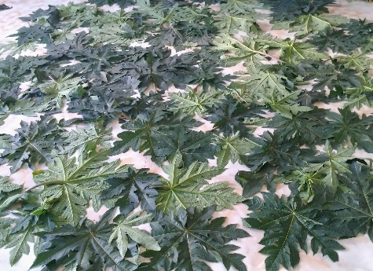
Fresh, mature and healthy Carica papaya leaves were collected from different locality of Chattogram from 2nd August to 17th August. The leaves were then checked and left for shed drying at 27-28°C temperature for until the moisture dried out within 4-5 days.
Figure 1. Collected papaya leaves

3.3.2 Grinding and storage of leaves
The air-dried leaves were ground using electrical grinder using 20,000 rotation per minute. The particle size of the ground leaf was fine enough to be mixed easily and uniformly with the basal feed. The ground leaf meal was then stored in airtight container at a temperature of 4°C until use.

3.4 Preparation of probiotic

3.4.1 Collection of yoghurt sample
For isolation of microorganisms, 5 commercial yoghurt samples were collected from local market. The samples were examined for the presence of Lactobacillus spp. and Saccharomyces Spp.

3.4.2 Isolation of Lactobacillus
For the purpose of isolating bacteria, deMan, Rogosa and Sharpe agar (Lactobacillus MRS Agar, Ref: M641-500G, HiMedia® Laboratories Pvt. Ltd., India) was used which supports the luxuriant growth of all Lactobacilli from dairy products (Black, 2018). The agar was prepared using the given direction from the company (67.15 grams in 1000 ml of distilled water) which was then heated till dissolve and then autoclaved (Autoclave Digital, Model: LAT-105, Labnics® Equipment, USA) at a temperature of 121°C for 15 minutes with a pressure of 15lbs. Then the media was poured in sterile petridishes within laminar air flow (Laminar Flow Cabinet, Model: JSCB-900SL, Labnics® Equipment, USA). From each yoghurt sample, sticking were done on the plates and incubated (General Incubator, Model: LGI-150T, Labnics® Equipment, USA) at a temperature of 37°C for 24-48 hours. Lactobacillus were found to grow in the media plates.
Figure 2. Lactobacillus isolation

3.4.3 Isolation of Saccharomyces
Potato Dextrose agar (Potato Dextrose Agar, Ref: M096-500G, HiMedia® Laboratories Pvt. Ltd., India) was used to facilitate the growth of Saccharomyces. Sharply 39 g of agar powder was suspended in 1000 ml of distilled water, heated up to boiling and then sterilized in the autoclave at 121°C temperature for 15 minutes with 15lbs pressure. The media were poured in sterile petridishes under laminar air flow. Yoghurt samples were spread on agar plates and incubated for 48 hours. After incubation, yeast colony were observed on the potato dextrose agar (PDA) plates.

3.4.4 Determination of Lactobacillus and Saccharomyces concentration in yoghurt
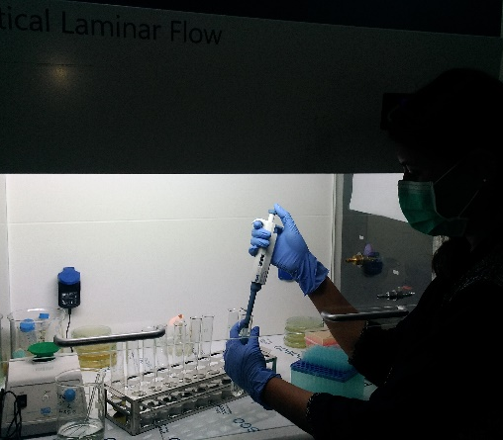
To determine the concentration of bacteria in yoghurt, ten-fold serial dilution and plate count technique were performed. For serial dilution, 10 sterile test tubes were taken and numbered sequentially. 10 ml of Phosphate Buffer Solution (PBS) was taken in each test tube. Then 1 ml of yoghurt was taken in 1st test tube, mixed well and from that mixture, 1 ml of diluent was taken and mixed with 2nd test tube. The same procedure was followed for the rest of the test tubes. And finally, from 10th test tube, 1 ml diluent was discarded. 100 µl of mixture solution from each test tube was poured in MRS agar plates for Lactobacillus and PDA agar plates for Saccharomyces and incubated for 24 and 48 hours, respectively. The growth in agar plates were counted in colony counter (Model: SC6+, Stuart® Equipment, UK) and the concentration was expressed by colony forming unit (CFU) per ml of yoghurt.
Figure 3. Serial dilution of yoghurt sample

3.4.5 Culture of Lactobacillus and Saccharomyces for probiotic
Lactobacillus sp. was cultured in MRS broth (Lactobacillus MRS Broth Ref: M369-500G, HiMedia® Laboratories Pvt. Ltd., India). The media was prepared dissolving 55.15 grams of media in 1000 ml of distilled water and then heated till boiling. After that, the broth was autoclaved at 15 lbs pressure using 121°C temperature for a period of 15 minutes. After cooling, 2-3 colonies of bacteria were taken and inoculated in the broth. The broth was then incubated at 37°C for 24 hours in the shaking incubator (Model: LBSI-100A, Labnics® Equipment, USA) to nourish the growth of the bacteria.
The culture of Saccharomyces spp. was performed using yeast malt extract broth (Yeast Malt Broth, Ref: M425-500G, HiMedia® Laboratories Pvt. Ltd., India). Around 10.5 grams of broth powder were suspended in 490 ml of distilled water which was then autoclaved at 121°C for 15 minutes. Followed by cooling, 2-3 colonies were inoculated in the broth and then it was incubated in the shaking incubator at 37°C for 48 hours to facilitate the growth of yeast.

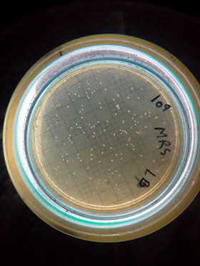
3.4.6 Determining concentration of microorganisms in probiotic culture
The concentration of Lactobacillus sp. and Saccharomyces sp. in probiotic was determined using ten-fold serial dilution method as described earlier. It was detected whether there is desirable amount of microorganisms in the cultures probiotics or not.
Figure 4. Bacterial colony count

3.4.7 Stocking of probiotic culture
Lactobacillus sp. was stocked for further use by taking 700 µl of cultured broth and mixing it with 300 µl of 50% glycerol in a cryovial. To stock Saccharomyces spp., again, 50% glycerol was used in cultured YM broth at a ratio of 3:7. Glycerol was used as a cryo-protector (Brialy et al., 1995). After a gentle mixing, the vials were preserved at -80°C in the freezer (Esco®, Model: UUs-4398-1, USA).

3.5 Probiotic incorporated with papaya leaf
A mixture of 30% papaya leaf, 35% DDGS (Distiller’s dried grains with solubles, Prodigy Foods Ltd., India) and 35% DFRB (Defatted Rice Bran, Yess Agro Products, India) were prepared and homogenized in a sterile jar. A 100 ml culture of Lactobacillus and 100 ml culture of Saccharomyces with sufficient amount of distilled water were added with the mixture and the preparation was incubated in the shaking incubator for 72 hours. After incubation, the concentration of microorganisms in fermented leaf was determined using ten-fold serial dilution and plate count.

3.6 Layout of the experiment
The layout of the experiment is presented in Table 3. For the experiment, a total of 135 birds was collected and randomly distributed in completely randomized design with following treatments: C as control, D₁ (basal diet with 0.5% dry leaf supplement), D₂ (basal diet with 1.0% dry leaf supplement), F₁ (basal diet with 0.5% probiotic fermented leaf supplement) and F₂ (basal diet with 1.0% probiotic fermented leaf supplement). Each treatment consisted of 3 replications.

Table 3. Layout of the experiment
Dietary treatment groups | Replications | No. of birds per replication | No. of birds per treatment
C=Control (Basal diet) | R₁  R₂  R₃ | 9  9  9 | 27
D₁ = 0.5% dry leaf (Basal diet +0.5% dry leaf supplement on DM basis) | R₁  R₂  R₃ | 9  9  9 | 27
D₂ + 1.0% dry leaf (Basal diet +1.0% dry leaf supplement on DM basis) | R₁  R₂  R₃ | 9  9  9 | 27
F₁ =0.5% fermented leaf (basal diet + 0.5% fermented leaf supplement on DM basis) | R₁  R₂  R₃ | 9  9  9 | 27
F₂ + 1.0% fermented leaf (basal diet + 1.0% fermented leaf supplement on DM basis) | R₁  R₂  R₃ | 9  9  9 | 27
Total |  |  | 135

3.7 Preparation of the shed
While preparing the poultry shed, first it was cleaned and washed thoroughly with tap water and caustic soda using brushes and scrapers. All the cages, brooding boxes, corners, ceiling, feed storing racks and fans were given extra attention to. Then the shed was disinfected spraying 0.5% (v/v) phenyl solution. The house was left for a week to completely dry out. The house was then fumigated using formalin (40% formaldehyde) and potassium permanganate and left for 24 hours. During fumigation, it was make sure that the room was completely sealed. At the entrance of the shed a footbath containing 1% potassium permanganate solution was placed and the solution was changed daily. Lime was spread around the shed to maintain strict biosecurity of the shed. Feeder and drinkers were cleaned using water, detergent followed by 0.3% potassium permanganate solution.

3.8 Collection of birds
Figure 5. Initial weight recording
A total of 135, unsexed day old chicks Ross-308®) was collected from Nahar Agro Group Limited. Soon after arrival, the birds were checked for abnormalities. After that they were weighed to maintain the uniformity among each replications of the treatment groups. The average initial weight of chick was recorded 41.71±0.05g. Dextrose water was supplied to the chicks after weighing to recover the stress from transportation.

3.9 Management

3.9.1 Brooding
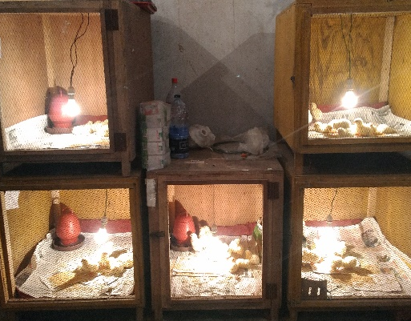
The chicks were brooded in individual brooding pen. During brooding, the provided temperature was at 95°F, 90°F, 85°Fand 80°F at 1st, 2nd, 3rd and 4th week respectively. The temperature was maintained using 100W and 60W electrical bulbs and ceiling fans. The temperature was recorded placing a thermometer within the brooding cage. While brooding, the given floor space per bird was about 0.15 square feet and newspapers were used as litter, which was changed routinely. Separate feeder and drinker were used for every brooding cage.
Figure 6. Brooding of the chicks

3.9.2 Housing
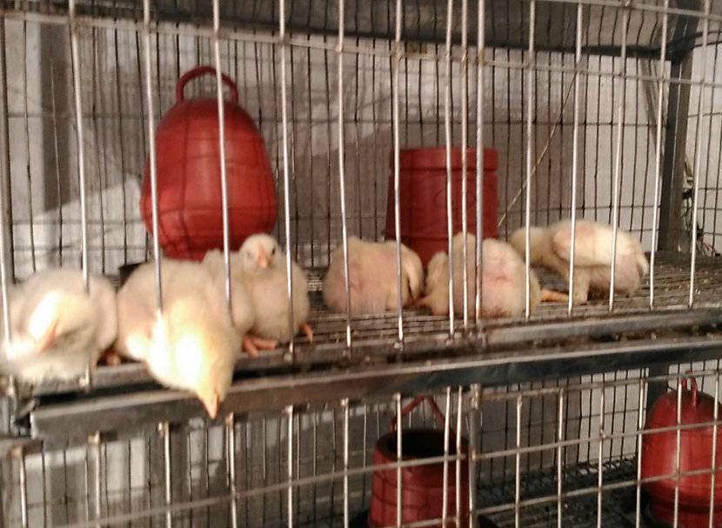
The birds were housed in well-ventilated, wire-floored, closed cages. Each cage was checked for any loose wire which could cause injury to the birds. The floor space per cage was 3.5 ft ×1.63 ft where 9 birds were housed allowing 0.63 square ft floor space per bird. Each cage was provided with drinker and drinker to ensure ad-libitum supply of feed and free access to water.
Figure 7. Housing of the birds

3.9.3 Feeding and watering
The birds were supplied with ready-made feed from a renowned feed company (C.P. Bangladesh Co. Ltd., Bangladesh). While purchasing, the freshness of the product and its expiry date were checked. Two different diets for two different growth stages to meet the body requirement of the birds. Starter ration was offered from day 0 to day 14 and grower ration was offered from day 15 to day 28. The nutritive value of the diets is presented in Table 4. The supplements were mixed uniformly with the feed before feeding to the birds. In Control, only basal diet was offered. In treatment groups, 0.5% dry leaf supplement (D₁), 1.0% dry leaf supplement (D₂), 0.5% probiotic fermented leaf supplement (F₁) and 1.0% probiotic fermented leaf supplement (F₂) on dry matter basis were mixed with basal diet. Feed and water were supplied ad-libitum to all groups of birds in three different times in a day (7.00, 14.00 and 21.00 o’clock) throughout the experimental period. For first two weeks feed was offered in round feeder which was replaced by line feeder in next two weeks. Fresh drinking water was supplied to the birds in round drinker with a capacity of 1.5 liters. The nutritional value of the feed are given in Table 4.
Table 4. The nutritional value of basal diet (CP feed)
Chemical Composition | Type of a diet/Age of chicken (days)
 | Starter (1 – 14) | Grower (15 – 28)
DM (%) | 90.00 |  | 90.00
ME (Kcal/kg) | 3050.00 |  | 3100.00
Crude protein (%) | 21.50 |  | 20.00
Crude fiber (%) | 5.00 |  | 5.00
Fat (%) | 3.00 |  | 3.50
Calcium (%) | 0.80 |  | 0.70
Phosphorus (%) | 0.50 |  | 0.40
Lysine (%) | 1.25 |  | 1.20
Methionine (%) | 0.50 |  | 0.45
Source: CP Feed Limited

Estimated chemical composition of the treatments
The chemical composition of the treatments are presented in Table 5. Results showed that dry papaya leaf contains slightly higher protein, more ether extract and ash content. The probiotic fermented supplement have higher amount of fibre because it contains DDGS and DFRB.
Table 5. Chemical composition of given supplements
Components on dry basis | Dry papaya leaf supplement | Probiotic fermented supplement
Moisture (%) | 11.20 | 13.10
Crude protein (%) | 25.55 | 25.38
Crude fibre (%) | 10.74 | 17.26
Ether extract (%) | 6.42 | 5.60
Total ash (%) | 13.14 | 12.20

3.9.4 Vaccination and medication
All the birds were routinely vaccinated against Newcastle Disease (ND) and Infectious Bursal Disease. The vaccines were purchased from Division Livestock Office and transported in icebox to maintain the quality and function. Vaccination was performed early in the morning to reduce the stress. No medication or antibiotic was provided with the feed.
Table 6. Vaccination schedule
Age of birds | Name of diseases | Name of the vaccine | Route of administration
4th day | New Castle Disease | BCRDV (Live) | One drop in one eye
12th +18th day | Infectious Bursal Disease | IBD | One drop in one eye
21th day | New castle Disease | BCRDV (Booster) | One drop in one eye

3.10 Determination of growth parameters
While measuring growth parameters, the body weight was recorded per replication on weekly basis. The final body weight was recorded at the last day of the experiment. In addition, feed consumption for each replication was determined by deducting the feed residue from supplied feed. Feed conversion was calculated as the weight of feed consumed divided by body weight gain.

3.10.1 Live weight gain
The live weight was measured by weighing in digital weight balance. The live weight gain is calculated from the difference between live weight and initial weight. The weight gain per day was calculated using following formula:
$$Average daily gain (g) =\frac{Final weight-Initial weight}{Number of days}$$

3.10.2 Feed intake
Feed intake is determined by subtracting the refusal feed collected every morning before supplying of feed from the weighed feed provided to the birds for ad-libitum feeding. The average daily feed intake was calculated using the formula:
$$Average daily feed intake =\frac{Weight of supplied feed-weight of refused feed}{Number of birds}$$

3.10.3 Feed conversion ratio (FCR)
The feed conversion ratio was determined as average daily feed intake divided by average daily gain.

3.11 Evaluation of carcass characteristics
At the end of 28 days trial, 3 birds from each replication were randomly selected and the weight of the birds were recorded. Then the birds were sacrificed severing jugular vein and carotid artery and left for bleeding. After completion of sufficient bleeding, the skin with feather was removed by using scissors, knives and hand force. The birds were eviscerated, heads and feet were removed. While dressing the carcass, the technique was performed following the standard described by Jones (1984). After dressing, dressed carcass was measured to determine the dressed weight. Different cuts of meat such as breast, thigh, and drumstick were also weighed. All visceral as well as lymphatic organs weight such as liver, spleen, bursa and intestine were recorded. Abdominal fat weight, total yield of thigh and breast meat were also measured.
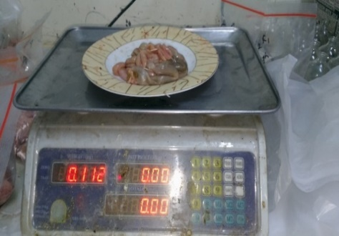
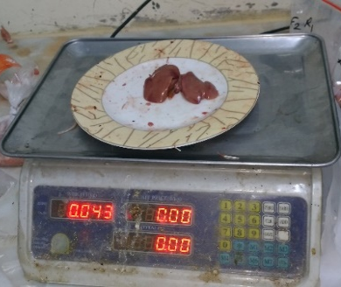
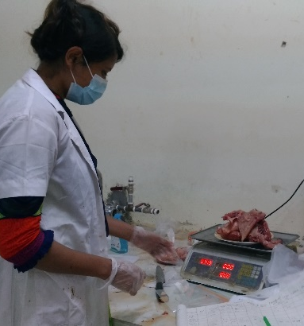
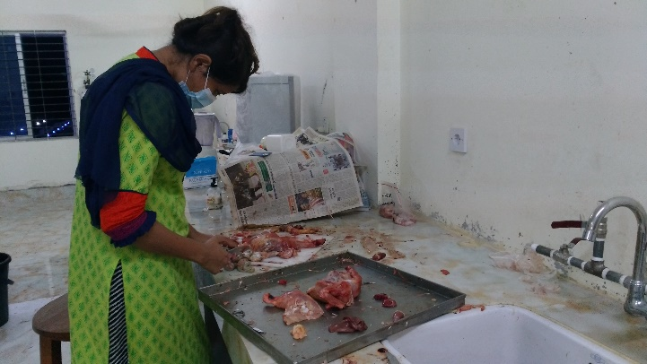
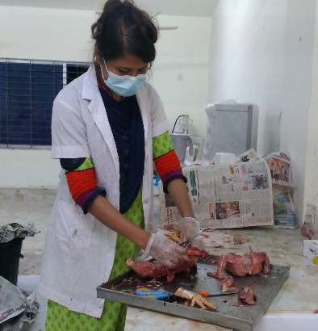
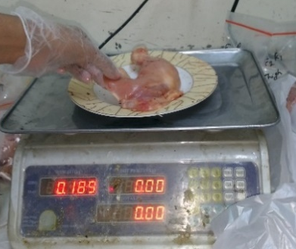
Figure 10. Separating different parts
Figure 9. Weighing of dressed carcass
Figure 8. Dressing of carcass
Figure 13. Weighing intestine
Figure 12. Weighing liver
Figure 11. Weighing leg

3.12 Biochemical analysis
The blood of two birds from each replication was collected in 5 ml syringe using 23 Gauge needle. The blood was immediately transferred to vacutainers containing clot activator. The vacutainers were centrifuged at 3000 rpm for about 20 minutes to separate the serum from blood. The separated serums were then separated using micropipette and collected in eppendorf tube. The serums were then stored in freezer at ‒20°C. From these serums different biochemical tests such as total cholesterol (TC), triglyceride (TG), high density lipoprotein (HDL) and low density lipoprotein (LDL) were determined using biochemical analyzer (Humalyzer 3000, Human ® Diagnostics, Germany) in the Post Graduate laboratory of Department of Animal Science and Nutrition by following the directions supplied with the kits (Randox® Laboratories limited, UK).

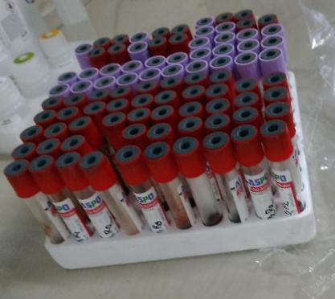
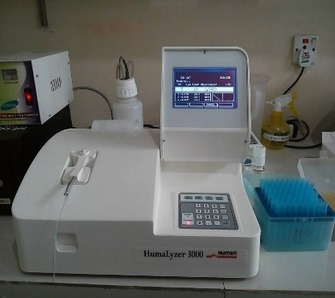
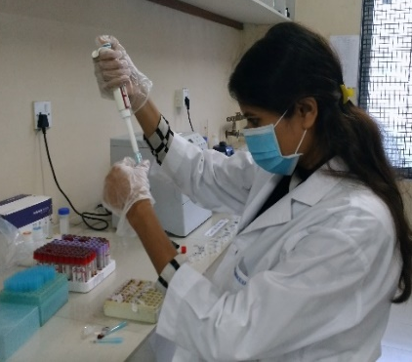
Figure 15. Biochemical analysis of serum
Figure 14. Blood collection

3.12 Proximate Analysis of meat
Samples from both breast and thigh meat were collected in plastic zipper bag and stored in freezer at -20°C. From these samples, chemical analysis was performed according to the standardized formula by AOAC International (2006). The analysis of proximate components was carried out in the Nutrition Laboratory under the Department of Animal Science and Nutrition, CVASU, to determine the dry matter (DM), Crude protein (CP), crude fiber (CF) ether extract (EE) and total ash (TA) of meat sample.
Briefly, the moisture and ash were determined using weight difference method. Fibre content was estimated from the loss in weight of the crucible and its content on ignition. The nitrogen value, which is the precursor for protein of a substance, was determined by micro Kjeldahl method, involving digestions (Model: FoodALYT SBS-800, Omnilab®, Germany), distillation (Model: FoodALYT D-1000, Omnilab®, Germany) and finally titration of the sample. The nitrogen value was converted to protein by multiplying a factor of 6.25. Ether extract (crude fat) was determined by the Soxhlet apparatus (Solvent extractor, Model: SER-148, Velp® Scientifica, Italy). All the proximate values are presented in percentage. The sum of total crude protein, ether extract, crude fibre and total ash was subtracted from 100. Total ash content was determined by heating the ground material in a dry crucible on a low flame and then it was heated in muffle furnace at 600C for 3- 4 hours.

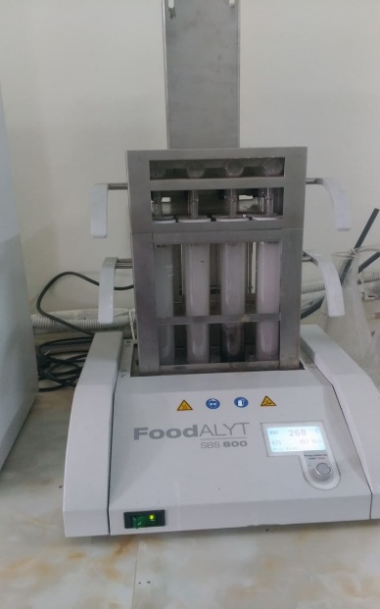
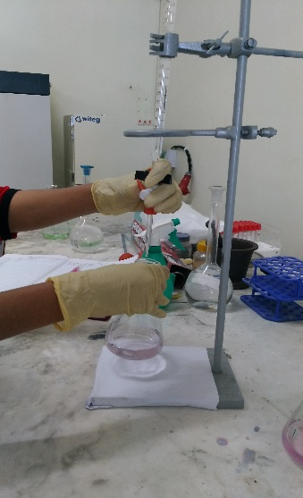
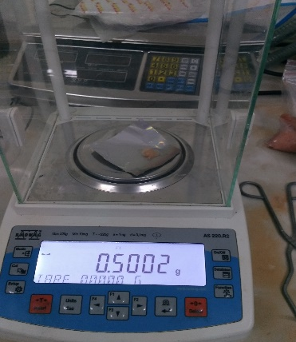
Figure 18. Titration of
CP estimation
Figure 16. Weighing of
sample
Figure 17. Digestion for
CP estimation
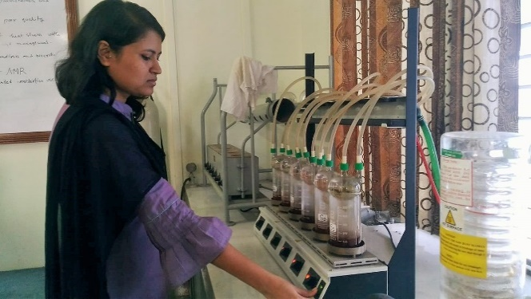
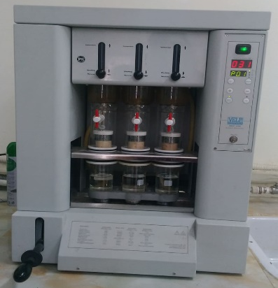
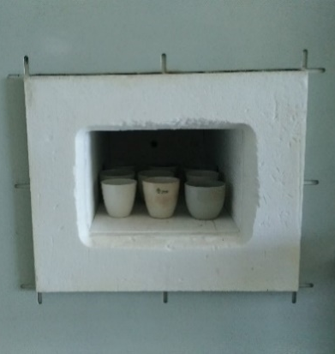
Figure 21. Estimation of Ash
Figure 20. Estimation of EE
Figure 19. Estimation of
CF

3.13 Oxidative rancidity of meat
The oxidative rancidity of meat was determined by measuring the thiobarbituric acid reactive substances (TBARS) through spectrophotometer according to the method of Ke et al. (1984). TBARS were determined from fresh breast meat samples as well as from the same samples stored at 4°C for 1st, 2nd, and 3rd weeks. Therefore, oxidative rancidity of meat was assayed by detecting the increase in TBARS value per week at 4°C. To determine TBARS, 4 g of meat sample was taken in a open mouthed test tube with which 10 ml of solution 1 consisting of 20% trichloroacetic acid in 2M phosphoric acid were added. Then 10 ml distiller water was added to dilute it. After that the sample was blended with a homoginizer (Model: SR-30, Medline Scientific Ltd., UK) the slurry was filtered using Double Rings-102 filter paper with medium speed. 2ml of filtrate was taken and mixed with 2 ml of solution-2 consisting of 0.005 M of 4,6 dihydroxi-2-mercaptopyridine in distiller water. The test tubes are then put in the water bath (Digital Pricise Water bath®, Model: WB-22, Witeg, Germany) of 80°C for 30 minutes. After 30 minutes, the test tubes are removed and kept at room temperature until cooling. The absorbance of the solution was then measured by spectrophotometer (Model: U-2900, Hitachi® Ltd, Japan) with a wavelength of 530 nm. The value of TBARS was expressed as micromoles of malondialdehyde (MDA) per 100 g of meat.
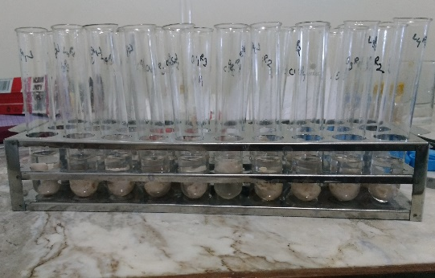
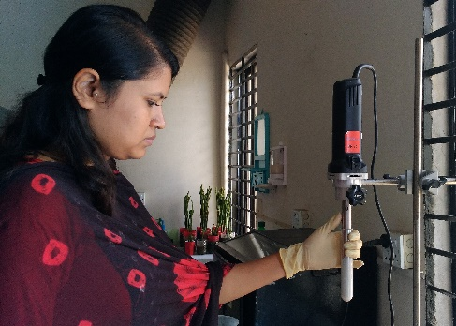

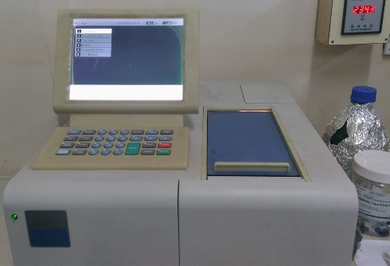
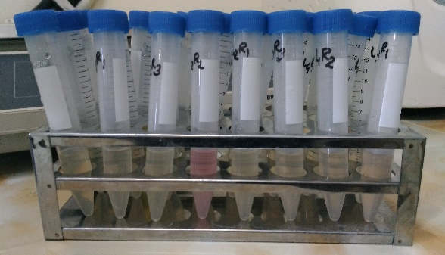

Figure 22. Determination of TBARS value from meat sample

3.14 Cost benefit analysis
While measuring cost benefit analysis, the total cost of production per bird and the selling price of bird were measured. The total profit was calculated by deducting the total cost from selling price.

3.15 Data collection
The initial body weight of the chicks was recorded soon after arrival. A record of the data of weight gain, feed intake, FCR was kept at weekly interval. Different parameters of carcass characteristics and biochemical analysis were recorded at 4th week. The results of proximate analysis were recorded. The oxidative stability of meat were calculated in 4 consecutive weeks and the results were recorded.

3.15 Statistical analysis
After collection, all the data were entered into MS Excel (Microsoft Office Excel-2013, USA) and analyzed by using the General Linear Model (GLM) procedure of SAS Institute Inc. (2003). Means showing significant differences were compared by Duncan’s New Multiple Range Test. The level of statistical significance was accepted at P<0.05.

CHAPTER-IV: RESULTS
The aim of this chapter is to present the findings of the assessment of dietary effects of dry and probiotic treated Carica papaya leaf on growth performance, carcass characteristics, biochemical parameters, meat quality and oxidative stability in Ross-308 broiler. The recorded findings with statistical analysis are represented under different sections of this chapter.

4.1 Concentration of organisms in probiotics:
The concentration of Lactobacillus and Saccharomyces in probiotic culture after grown for 48 hours presented in Table 7 showed that the concentrations had increased compared to the concentration in yoghurt.
Table 7. Concentration of microorganisms in probiotics
Microbes | Concentration in yoghurt (CFU/ml) | Concentration in Probiotics (CFU/ml)
Lactobacillus Spp.  Saccharomyces Spp. | 1.6×10⁶  4.4×10⁷ | 5.3×10⁸  2.7×10⁹

4.3 Effects on growth performance
The growth performance of different treatment groups supplied with dried and probiotic treated papaya leaf are shown in Table 8.

Table 5. Dietary effects of dry and probiotic fermented papaya leaf on growth performance in broiler
Variables | Age of birds | Treatments |  |  |  |  | SEM | P value
 |  | C | D₁ | D₂ | F₁ | F₂
Live weight (g) | Initial wt | 41.56 | 41.89 | 41.89 | 41.63 | 41.56 | 0.08 | 0.66
 | 1st week | 172.74 | 178.81 | 180.92 | 181.74 | 176.78 | 2.76 | 0.31
 | 2nd week | 389.89 | 414.26 | 409.78 | 430.11 | 408.81 | 8.36 | 0.13
 | 3rd week | 996.96^{c} | 1034.07^{ab} | 1032.63^{ab} | 1050.93ª | 1006.52^{bc} | 8.54 | 0.011
 | 4th week | 1588.51^{c} | 1679.24ª | 1600.52^{bc} | 1660.11ª | 1624.67^{b} | 7.89 | <0.001
ADG (g/b/d) | 1st week | 18.74 | 19.56 | 19.86 | 20.01 | 19.32 | 0.39 | 0.33
 | 2nd week | 31.02 | 33.64 | 32.69 | 35.48 | 33.15 | 1.21 | 0.29
 | 3rd week | 86.71 | 88.54 | 88.98 | 88.69 | 85.39 | 2.67 | 0.49
 | 4th week | 84.52^{bc} | 92.17ª | 81.13^{c} | 87.03^{b} | 88.31^{ab} | 1.22 | 0.002
 | 0-4th wk | 55.25^{c} | 58.48ª | 55.66^{bc} | 57.80ª | 56.54^{b} | 0.28 | <0.001
ADFI (g/b/d) | 1st week | 22.16 | 22.25 | 22.14 | 22.32 | 22.18 | 0.11 | 0.80
 | 2nd week | 50.86 | 50.31 | 50.75 | 52.22 | 52.52 | 1.04 | 0.58
 | 3rd week | 112.10 | 106.66 | 108.18 | 107.00 | 104.04 | 2.49 | 0.48
 | 4th week | 132.63 | 127.32 | 125.08 | 128.67 | 130.43 | 1.77 | 0.14
 | 0-4th wk | 79.44 | 76.64 | 76.54 | 77.56 | 77.29 | 0.69 | 0.09
FCR | 1st week | 1.18 | 1.14 | 1.12 | 1.11 | 1.15 | 0.02 | 0.27
 | 2nd week | 1.64 | 1.50 | 1.57 | 1.47 | 1.59 | 0.06 | 0.44
 | 3rd week | 1.29 | 1.20 | 1.22 | 1.21 | 1.22 | 0.02 | 0.103
 | 4th week | 1.57ª | 1.38^{c} | 1.54ª | 1.48^{b} | 1.48^{b} | 0.01 | <0.001
 | 0-4th wk | 1.44ª | 1.31^{c} | 1.37^{b} | 1.34^{b} | 1.37^{b} | 0.01 | <0.001
^{abc} means with different superscipts in the same row differ significantly.
Data indicated the mean value of 3 replications with 9 birds per treatment (n=27).
C=Control (Basal diet); D₁=0.5% dry leaves+basal diet; D₂=1.0% dry leaves+basal diet; F₁=0.5% probiotic fermented leaves+basal diet; F₂=1.0% probiotic fermented leaves+basal diet; g=Gram, FCR= Feed Conversion Ratio, SEM=Standard error of means.

4.3.1 Live weight
Results on live weight presented in Table 8 indicated a significant (P<0.001) increase in the final live weight in all treatment groups compared to control where the highest (1679.24) weight was observed in D₁ group. The weekly average live weight increased in treatment groups while comparing to the control in every week, among which a significant increase was observed in 3rd (P<0.01) and 4th weeks (P<0.001).

4.3.2 Average daily gain
The data presented in Table 8 shows a significant (P<0.001) increase in overall average daily gain (ADG) in all treatment groups compared to that of control. The highest ADG was observed in Group D₁ (58.48 g/bird/day) and the lowest was obtained in control group (55.25 g/bird/day). The weekly ADG first three weeks showed numerical increase in all dietary groups in contrast to control whereas in 4th week the ADG differed significantly (P<0.01) in all treatment groups in comparison to control.

4.3.3 Average daily feed intake
The overall average daily feed intake (ADFI) presented in Table 8 showed no significant (P>0.05) variation among all dietary groups throughout the study period. The highest weekly ADFI in 1st and 2nd week was observed in F₁ and F₂ group respectively though in 3rd and 4th week, it was higher in control group which was not statistically significant (P>0.05)

4.3.4 Feed conversion ratio (FCR)
The feed conversion ratio tabulated in Table 8 shows that there was a significant (P<0.0001) reduction in the overall FCR in all treatment groups in comparison to control. The lowest value was observed in D₁ group (1.31±0.01) followed by F₁ (1.34±0.01). The weekly FCR result shows that, at 1st and 2nd week, the lowest FCR was recorded in F₁ group and at 3rd and 4th week, the lowest value was found in D₁. The FCR value at 4th week differed significantly (P<0.001).

4.4 Carcass characteristics
Dietary effects of dry and probiotic fermented papaya leaves on different carcass characteristics have been presented in Table 9. Relative weights of different components of carcass and organs calculated as a percentage of body weight, have been sequentially described according to different treatment groups. Live weights showed a significant increase (P<0.001) in all dietary groups compared to control. The relative weight of thigh and thigh meat increased numerically in all treatment groups while comparing with control. Although other collected parts of carcass had no significant difference compared to control. The total lymphatic organs (liver, spleen and bursa) weight also showed an increase in weight in contrast to control, though the results were not significant statistically (P>0.05).
Table 6. Effects of dry and probiotic fermented papaya leaves on carcass characteristics and organ weight
Parameters | Treatments |  |  |  |  | SEM | P value
 | C | D₁ | D₂ | F₁ | F₂
Live weight | 1588.51^{c} | 1679.24ª | 1600.52^{bc} | 1660.11ª | 1624.67^{b} | 7.89 | <0.001
Dressing (% ) | 64.39 | 65.27 | 64.62 | 63.14 | 63.67 | 1.52 | 0.13
Thigh weight (%) | 17.76 | 20.02 | 21.51 | 18.96 | 19.61 | 0.85 | 0.17
Thigh meat wt (%) | 13.65 | 16.09 | 17.26 | 14.94 | 14.81 | 0.89 | 0.57
Breast meat wt (%) | 22.78 | 22.51 | 20.91 | 21.89 | 21.94 | 1.09 | 0.88
Intestinal wt (%) | 5.19 | 5.01 | 4.92 | 5.92 | 5.49 | 0.62 | 0.81
Abdominal fat (%) | 0.78 | 0.75 | 0.85 | 0.66 | 0.66 | 0.22 | 0.98
Bursa wt (%) | 0.18 | 0.14 | 0.19 | 0.24 | 0.17 | 0.03 | 0.58
Liver wt (%) | 2.31 | 2.76 | 2.42 | 2.41 | 2.50 | 0.12 | 0.25
Spleen wt (%) | 0.07 | 0.11 | 0.08 | 0.13 | 0.12 | 0.02 | 0.34
Total LO wt (%) | 2.56 | 3.00 | 2.68 | 2.78 | 2.79 | 0.13 | 0.36
^{abc} means with different superscipts in the same row differ significantly.
Data indicated the mean value of 3 replications with 1 bird per treatment (n=9).
C=Control (Basal diet); D₁=0.5% dry leaves+basal diet; D₂=1.0% dry leaves+basal diet; F₁=0.5% probiotic fermented leaves+basal diet; F₂=1.0% probiotic fermented leaves+basal diet; LO= lymphatic organs, SEM=Standard error of means.

4.5 Serum parameters
The changes in serum lipid profiles due to dry and probiotic treated papaya leaf meal on are presented in Table 10. The total cholesterol, HDL, LDL and TG contents were tested and compared between treatment groups with control.

Table 7. Dietary effect of dry and probiotic fermented papaya leaf on serum parameters
Parameter | Treatments |  |  |  |  | SEM | P value
 | C | D₁ | D₂ | F₁ | F₂
Cholesterol (mg/dl) | 110.06 | 100.07 | 112.99 | 108.49 | 96.64 | 6.92 | 0.56
HDL (mg/dl) | 16.61^{c} | 18.77^{c} | 23.43^{b} | 28.28ª | 17.53^{c} | 1.10 | 0.0027
LDL (mg/dl) | 103.17ª | 46.26^{b} | 111.02ª | 67.00^{b} | 62.27^{b} | 9.24 | 0.001
TG (mg/dl) | 69.81ª | 22.2^{ab} | 24.84^{ab} | 13.08^{c} | 35.01^{b} | 4.05 | <.001
^{abc} means with different superscipts in the same row differ significantly.
Data indicated the mean value of 3 replications with 2 birds per treatment (n=18).
C=Control (Basal diet); D₁=0.5% dry leaves+basal diet; D₂=1.0% dry leaves+basal diet; F₁=0.5% probiotic fermented leaves+basal diet; F₂=1.0% probiotic fermented leaves+basal diet; HDL= High density lipoprotein, LDL= Low density lipoprotein, TG= Triglyceride, SEM=Standard error of means.

4.5.1 Serum cholesterol level
The result reveals a figurative reduction in total cholesterol level in serum from almost all treatment groups except D₁. The lowest cholesterol level was found in F₂ group.

4.5.2 Serum HDL level
The serum HDL level in different dietary levels in comparison with control shows statistically significant differences between treatment groups with control group (P<0.001). The HDL level increased in all treatment groups compared to control with highest value in F₁.

4.5.3 Serum LDL level
The comparison of concentration of LDL in serum of treatment group with control are shows that treatment D₁ had the lowest level of LDL in serum. It is revealed that the LDL level reduced significantly in all treatment groups except D₂ when compared to control (P<0.01).

4.5.4 Triglyceride level in serum
The level of triglyceride in serum had dramatically declined in all treatment groups in contrast to control group which has statistical significance (P<0.001). The lowest value was obtained in F₁ while the highest value was in control group.

4.6 Chemical composition of meat
Dietary effects of dry and probiotic fermented papaya leaf supplements on chemical composition of meat are represented in Table 11.
The result shows that the moisture percentage differs non-significantly among all dietary groups in both thigh and breast meat. In thing meat, there was a significant increase in crude protein was observed in all dietary group compared to control (P<0.01). The highest value was observed in D₂ group (21.18±0.15). The ether extract increased in D₁ group (6.22±0.19) compared to control although in other groups the value decreased. The total ash content possessed no significant change among all dietary groups with control
While assessing proximate composition of breast meat, it was observed that the crude protein increased in all treatment groups compared to control except D₁. The highest percentage of crude protein was obtained in F₂ (23.45±0.23) (P<0.01). The changes in ether extract value did not show any significant variation still the highest value was observed in D₂ group (3.7±0.17). The total ash content varied non-significantly.
Table 8. Variation in chemical composition in dietary groups
Meat | Parameters | Treatments |  |  |  |  | SEM | P value
 |  | C | D₁ | D₂ | F₁ | F₂
Thigh Meat | Moisture (%) | 73.61 | 72.81 | 72.99 | 71.77 | 72.38 | 0.96 | 0.78
 | CP (%) | 19.31^{c} | 20.24^{b} | 21.18ª | 20.01^{bc} | 19.78^{bc} | 0.22 | 0.003
 | EE (%) | 5.59^{ab} | 6.22ª | 4.38^{c} | 5.30^{b} | 4.87^{bc} | 0.22 | 0.0027
 | Total ash (%) | 1.18 | 1.07 | 1.10 | 1.14 | 1.14 | 0.04 | 0.53
Breast meat | Moisture (%) | 74.62 | 74.05 | 75.31 | 74.01 | 73.69 | 0.47 | 0.2341
 | CP (%) | 22.05^{c} | 21.64^{c} | 22.34^{bc} | 23.04^{ab} | 23.45ª | 0.26 | 0.0042
 | EE (%) | 3.08 | 2.33 | 3.70 | 2.35 | 2.32 | 0.27 | 0.1063
 | Total ash (%) | 1.14 | 1.13 | 1.14 | 1.17 | 1.17 | 0.06 | 0.9808
^{abc} means with different superscipts in the same row differ significantly.
Data indicated the mean value of 3 replications with 1 bird per treatment (n=9).
C=Control (Basal diet); D₁=0.5% dry leaves+basal diet; D₂=1.0% dry leaves+basal diet; F₁=0.5% probiotic fermented leaves+basal diet; F₂=1.0% probiotic fermented leaves+basal diet; CP= Crude protein, EE= Ether extract; SEM=Standard error of means.

4.7 Oxidative stability of meat
The total effects of dry and probiotic treated papaya leaves on TBARS value of breast meat of broiler kept at 4°C for 3 consecutive weeks are demonstrated in Figure 23. A significant decrease was observed on fresh meat sample as well as at rest of the weeks (P<0.05). The lowest average TBARS value was observed in D₂ (74.42±7.15) treatment followed by F₂ group (82.91±4.84) whereas the highest value was observed in control group (118.4±6.67).
The weekly TBARS value also exhibited significant reduction in all treatment groups from control (P<0.05). At fresh meat as well as in 2nd and 3rd week, the lowest value of TBARS was observed in D₂ treatment group. However at 1st week, the lowest TBARS value was observed in F₂ (18.85±7.09). The highest value of TBARS was constantly found in control group from fresh meat up to 3 consecutive weeks of refrigeration at 4°C.
Figure 23. Weekly Thiobarbituric acid reactive substance (TBARS) value of meat in all dietary groups
^{abcd} means with different superscipts in the same bar differ significantly.
Data indicated the mean value of 3 replications with 1 bird per treatment (n=9).
C=Control (Basal diet); D₁=0.5% dry leaves+basal diet; D₂=1.0% dry leaves+basal diet; F₁=0.5% probiotic fermented leaves+basal diet; F₂=1.0% probiotic fermented leaves+basal diet; TBARS= Thiobarbituric acid reactive substances; MDA= Malondialdehyde; SEM=Standard error of means.

4.8 Cost benefit analysis
The cost benefit analysis of the bird fed supplemented diets with dry and probiotic fermented papaya leaves in comparison with control are given in Table 12. The net profit varied significantly (P<0.001) among all dietary groups compared to control. The net profit per kg was highest in D₁ group which was followed by F₁. The lowest net profit per kg was found in control group.
Table 9. Cost benefit analysis of the bird fed supplemented diets with dry and probiotic fermented papaya leaves.
Parameters | Treatments |  |  |  |  | SEM | P value
 | C | D1 | D2 | F1 | F2
Live weight (Kg) | 1.59^{c} | 1.68ª | 1.60^{bc} | 1.66ª | 1.62^{b} | 0.01 | <.001
Feed intake/bird (Kg) | 2.22 | 2.15 | 2.15 | 2.17 | 2.16 | 0.02 | 0.10
Feed cost/bird (Tk) | 104.54 | 101.92 | 102.87 | 105.32 | 106.05 | 0.92 | 0.06
Chick price (TK/bird) | 40.00 | 40.00 | 40.00 | 40.00 | 40.00 | - | -
Other costs (TK) | 30.00 | 30.00 | 30.00 | 30.00 | 30.00 | - | -
Total cost (TK) | 174.54 | 171.92 | 172.87 | 175.32 | 176.05 | 0.92 | 0.06
Selling price/Kg (TK) | 130.00 | 130.00 | 130.00 | 130.00 | 130.00 | - | -
Selling price (Tk) | 206.51^{c} | 218.30ª | 208.07^{bc} | 215.81ª | 211.21^{b} | 0.02 | <.001
Net profit (Tk) | 31.96^{d} | 46.38ª | 35.20^{c} | 40.50^{b} | 35.16^{c} | 0.96 | <.001
Net profit/kg (Tk) | 20.12^{d} | 27.62ª | 21.99^{c} | 24.39^{b} | 21.64^{cd} | 0.52 | <.001
^{abcd} means with different superscipts in the same row differ significantly.
Data indicated the mean value of 3 replications with 9 bird per treatment (n=27).
C=Control (Basal diet); D₁=0.5% dry leaves+basal diet; D₂=1.0% dry leaves+basal diet; F₁=0.5% probiotic fermented leaves+basal diet; F₂=1.0% probiotic fermented leaves+basal diet; SEM=Standard error of means.

CHAPTER V: DISCUSSION
The results of the present study, conducted for investigating the dietary effects of papaya leaf both in dry and fermented form on growth performance, serum biochemistry, carcass characteristics, meat quality and oxidative stability, are discussed under this chapter.

5.1 Weight gain
While measuring productive performance it was evident that dietary supplement of dry and probiotic treated papaya leaf showed positive impact on weight gain. The highest weight gain was observant in the group supplied with 0.5% of dry papaya leaf. Similar result was obtained in a study by Onyimonyi and Ernest (2009), where it was reported that in broiler, supplying papaya leaf meal at the level of 0.5%, 1.5% and 2% showed better growth compared to control. The result was also in accordance with Mahejabin et al. (2015) where it was established that higher body weight and weekly gain in weight were found using papaya, turmeric and neem extract supplement in broiler. Higher weight gain was also observed in broiler supplied with papaya leaf meal in an experiment by Oloruntola et al. (2018). The better weight gain using papaya leaf can be due to the presence of papain, chymopapain and papaya proteinase III that helps in protein digestion and thus increase the availability of free amino acids necessary for growth (Zucker et al., 1985). A study showed positive effect of papaya leaf meal on digestibility of dry matter and crude protein (Oloruntola et al., 2018).
The average daily gain (ADG) had also significantly increased in probiotic treated papaya leaf supplemented group than control where better result was observed in the group supplied with 0.5% of fermented leaf supplementation. The experiment by Jin et al. (1998) showed improved weight gain in broiler fed Lactobacillus sp. Again, Lactobacillus aids the growth of butyric acid producing bacteria that produces butyric acid and this acids can promote growth performance in the host (Duncan et al., 2004; Huyghebaert et al., 2011). Similar result was also observed by Kalavathy et al. (2003). A study by Shareef and Al-Dabbagh (2009) showed that addition of Saccharomyces cerevisiae at a rate of 1.5, 2 and 2.5% resulted significant increase in weight gain of broiler chicks. The reason for promoting weight gain could be due to its direct nutritional effects on host body (Patterson and Burkholder, 2003). Another possible reason is that Saccharomyces cerevisiae could act as bioregulator for the intestinal micro flora and improve host defense and immune response (Line et al., 1998). The naturally derived extract from the cell wall of Saccharomyces cerevisiae, mannan oligosaccharide are responsible for these effects.
The ADG of D₂ group supplied with higher amount of papaya leaf showed less growth rate compared to D₁ which could be because of the presence of tannin that can be an anti-nutritional factor by binding with protein and enzymes and thus interfering with digestion (Fahey Jr and Jung, 1989).

5.2 Feed intake
The average daily feed intake in this study showed no significant difference between the treatment groups with control. It was found that there was a numerical decrease in feed intake among treatment groups compared to control which was in agreement with the work of Oloruntola et al. (2018) where only numerical reduction in feed intake was observed. Different scenario was observed regarding the effects of papaya leaf meal on feed intake in other experiments where feeding papaya leaf increased feed intake (Mahejabin et al., 2015; Onyimonyi and Ernest, 2009). An experiment by Salarmoini and Fooladi (2011) found that the group fed Lactobacillus acidophilus from fermented milk significantly reduced feed intake compared to that from commercial probiotic, although it had no effect on feed conversion ratio.

5.3 Feed conversion ratio (FCR)
The present study showed significant reduction in feed conversion ratio in all treatment groups compared to control. The lowest value was observed in D₁ treatment group given 0.5% dry leaves which was followed by F1 given 0.5% probiotic fermented leaves. Similar results were also recorded in many studies on broiler fed with papaya leaf meal where the FCR significantly reduced in treatment groups compared to control (Onyimonyi and Ernest, 2009; Adeyemo and Akanmu, 2012; Mahejabin et al., 2015; Sorwar et al., 2016). The possible reason for improving FCR can be because of the enzyme papain which was proved to have a positive impact in reducing FCR (Rumokoy et al., 2016).
A significant improvement on FCR in probiotic treated groups were observed in comparison to control. Similar results were obtained in a study where it was established that providing Lactobacillus based probiotic reduced FCR by 3.5% (Vicente et al., 2007). In another study, it was evident that supplementation of Saccharomyces in broiler significantly reduced FCR (Gil de los Santos et al., 2005).

5.4 Serum biochemical parameters
In this study while measuring the lipid profile, a numerical decrease in serum cholesterol was found in treatment groups compared to control. Serum LDL and triglyceride level reduced significantly with which, serum HDL level increased in all treatment groups when compared to control. In an experiment on rat, Carica papaya significantly decreased the mean level of the total cholesterol, triglyceride and LDL with significant increase in HDL in serum at the same time (Nwangwa and Ekhoye, 2013). The reason behind this can be flavonoids, saponins and tannins in papaya that influence lipid metabolism (Abolaji et al., 2007).
Oloruntola et al. (2018) reported that papaya leaf meal reduced serum cholesterol and LDL which is in accordance with the present study. Papaya contains a carotenoid lycopene which can significantly reduce serum LDL (Ried and Fakler, 2011).
In probiotic treated group, the cholesterol also reduced. Lactobacillus was found to reduce blood cholesterol in broiler in a study (Salarmoini M and Fooladi MH, 2011) which justifies the current research. It could be due to assimilation of cholesterol by Lactobacillus and reducing serum cholesterol which was proved in vitro in pig in a study by Gilliland et al. (1985). Addition of Saccharomyces cerevisiae in layer diet resulted a significant reduction in blood cholesterol in an experiment (Hassanein and Soliman, 2010).

5.5 Carcass characteristics
The dressing percentage showed no significant difference among the dietary groups of the experiment. Although there was found to increase dressing percentage in dietary groups supplied with papaya leaf meal while comparing with the control that disagree with the result found in this experiment, but the liver weight differed non-significantly between control and treatment groups that agrees with this study (Onyimonyi and Ernest, 2009). The weight of different parts and visceral organs such as thigh weight, breast and thigh meat weight, abdominal fat, intestine, liver, spleen, bursa showed no significant variation between dietary groups with control. Similarities with these results was observed in a study by Adeyemo and Akanmu (2012). According to (Salarmoini M and Fooladi MH, 2011), there was no significant difference in organ weights except bursa among dietary treatments containing Lactobacillus and control.

5.6 Proximate analysis of thigh and breast meat
The proximate analysis showed that there was a significant increase in crude protein and ether extract percentage of meat in all dietary supplemented group compared to control. The highest CP% was found in D₂ in case of thigh meat and F₂ in breast meat. The enzyme papain helps in digestion of protein which may have effect on muscle protein (Krishna, KL, 2008). Also there could be a synergism between plant phytochemicals with probiotics. No significant variation was observed in moisture and total ash percentage in thigh meat and in breast meat, ether extract, total ash and moisture percentage remained unchanged.
The experiment by Pietras (2001) reported that when given probiotic (Lactobacillus acidophilus and streptococcus faecium bacteria) on the whole rearing period, the meat had significantly higher protein content, while crude fat and total cholesterol contents tended to decrease. In an investigation by Khaksefidi and Ghoorchi (2006) showed that probiotic fed chickens the leg and breast meat were higher in moisture, protein and ash content as compared to control. This can explain the increase in CP and EE percentage of thigh and breast meat in probiotic fermented papaya supplement.

5.7 Oxidative stability of meat
The oxidative stability of meat determined by measuring TBARS value of meat showed that the TBARS value reduced in all treatment groups compared to control. The lowest value was observed in D₂ group followed by F₂. Both dry and probiotic treated group with higher papaya concentration increased the oxidative stability of meat. The phenolic compounds in plant extract was proved to inhibit the development and propagation of free radical reactions by cheleting metal ions in pork (Shan et al., 2009). A study by showed that papaya seed extract can produce antioxidant activity by DPPH (2,2-diphenyl-1-picrylhydrazyl) radical scavenging, ABTS⁺ (2, 2'-Azino-Bis-3-Ethylbenzothiazoline-6-Sulfonic Acid) radical scavenging, reducing ferric ions, metal chelating activity and lipid peroxidation inhibition even though these activities were lower than that of grape seed extract due to less amount of flavonoids content (Sofi et al., 2016). As papaya leaf contains flavonoid, this may support the result found in the current study. Another study showed significant reduction in TBARS value with feeding citrus peels when compared to control because of the phenolic compounds in the peal (Tumbas et al., 2010). Antioxidant properties of phenolic compounds were also evident in a study by Rice-Evans et al. (1997). Again, papaya leaf contains vitamin C and E that have antioxidant properties that also prevent oxidation of lipids (Sies and Stahl, 1995). It has been evident that probiotics act as antioxidant which will explain the reduction of TBARS value of meat (Wang et al., 2017). These explain the causes of reduction of TBARS value of meat in dietary groups compared to control

5.8 Cost benefit analysis
The total cost varied non-significantly among all treatment groups with control. A significantly high net profit was obtained from all dietary group in comparison with control (P<0.001). Again, the highest net profit was gained from D₁ group fed with 0.5% dry papaya leaf which was followed by F₁ group supplied with 0.5% probiotic fermented papaya leaf meal. The result is in accordance with another study by Sorwar et al. (2016) where supplementation of papaya leaves and kalo jeera seeds were more profitable compared to control.

CHAPTER VI: CONCLUSION
This research investigated the effects of Carica papaya leaf both in dry and probiotic fermented form on growth performance, carcass characteristics, serum lipid profile, meat quality and oxidative stability of broiler meat for a period of 28 days. The final result revealed that live weight, average daily gain and feed conversion ratio was significantly higher in all dietary groups compared to control. The higher value was observed in dry leaf supplemented group containing 0.5% of the additive which was followed by 0.5% probiotic fermented additive group. However, dressing percentage and organ weights remained unchanged. Furthermore, lipid profile of serum showed a significantly better result where reduced serum cholesterol, LDL and TG with an increase in HDL concentration was observed compared to control. The proximate composition of thigh meat shows significantly higher CP and EE percentage in contrast to control, however, in breast meat, only CP percentage varied significantly. An excellent result on oxidative stability of meat was obtained in all treatment group compared to control. Also, feeding papaya in both dry and probiotic fermented form gave more profit in comparison with control. Therefore, papaya leaves can be a potential source of growth promoter replacing antibiotics in broiler chickens. Further investigation is required particularly to investigate the effects on layer diet.

CHAPTER VII: RECOMMENDATIONS
The use of phytobiotics as well as probiotics as growth promoter are being popular all over the world. Papaya leaf is a cheap and commonly available products that can be a source of feed in poultry. The leaves as well as its combination with probiotics both can be successful alternatives in producing antibiotic free meat. Again, organic meat is being popular worldwide and these additives can find their way in organic meat production industry. All dietary groups showed better results compared to control, however, 0.5% of dry and probiotic fermented leaves are recommended for better growth performance in broiler. As 1% inclusion of dry and fermented leaves had excellent effect on lipid profile of serum, further studies using a large range of inclusion doses and trials in different species can prove the potential of papaya leaves on blood profile of human to be used in controlling cardiovascular diseases.
Because of some constraints, the measurement of a few blood parameters and identification of fatty acids and trace minerals in meat did not happen to be possible. In future study, investigating these parameters with larger sample size and variable temporal pattern can open new horizon in both livestock industry and human health.

CHAPTER VIII: REFERENCES
Abdurrahman Z, Pramono YB, Suthama N. 2016. Meat Characteristic of Crossbred Local Chicken Fed Inulin of Dahlia Tuber and Lactobacillus sp. Media Peternakan. 39 (2).
Abolaji AO, Adebayo HA, Odesanmi OS. 2007. Effects of ethanolic fruit extract of Parinari polyandra (Rosaceae) on serum lipid profile and some electrolytes in pregnant rabbits. Research Journal of Medicinal Plant. 1 (4): 121–127.
Adeyemo G, Akanmu AM. 2012. Effects of neem (Azadirachta indica) and pawpaw [carica papaya) leaves supplementation on performance and carcass characteristics of broilers. International Journal of Current Research. 4 (12): 268–271.
Ahmad I. 2006. Effect of probiotics on broilers performance. International Journal of Poultry Science. 5 (6): 593–597.
Ahmad N, Fazal H, Ayaz M, Abbasi BH, Mohammad I, Fazal L. 2011. Dengue fever treatment with Carica papaya leaves extracts. Asian Pacific Journal of Tropical Biomedicine. 1 (4): 330–333.
Akaninu MA, Adeyemo GO. 2012. The effect of neem and pawpaw leaves supplementation on blood profile of broilers. International Journal of Current Research. 4 (12): 268–271.
AOAC. 2006. AOAC International Guidelines for Laboratories Performing Microbiological and Chemical Analyses of Food and Pharmaceuticals: An Aid to Interpretation of ISO/IEC 17025: 2005. AOAC international.
Apata DF. 2008. Growth performance, nutrient digestibility and immune response of broiler chicks fed diets supplemented with a culture of Lactobacillus bulgaricus. Journal of the Science of Food and Agriculture. 88 (7): 1253–1258.
Barrett AJ, Rawlings ND, Woessner JF. 1998. Introduction: cysteine peptidases and their clans. Handbook of Proteolytic Enzymes.: 545–566.
Black LA. 2018. Standard Methods for the Examination of Dairy Products. Journal of Milk and Food Technology. 23 (8): 246–248.
Bolu SAO, Sola-Ojo FE, Olorunsanya OA, Idris K. 2009. Effect of graded levels of dried pawpaw (Carica papaya) seed on the performance, haematology, serum biochemistry and carcass evaluation of chicken Broilers. International Journal of Poultry Science. 8 (9): 905–909.
Boshra V, Tajul AY. 2013. Papaya-an innovative raw material for food and pharmaceutical processing industry. Health and the Environment Journal. 4 (1): 68–75.
Brialy C, Rivalland P, Coiffard L, Holtzhauer YDR. 1995. Microbiological study of lyophilized dairy kefir. Folia Microbiologica. 40 (2): 198–200.
Bruneton J. 1999. Carica papaya, in pharmacognosy, phytochemistry of medical plants. Technique & Documentation, France. 221–223 p.
Byers T, Perry G. 1992. Dietary carotenes, vitamin C, and vitamin E as protective antioxidants in human cancers. Annual Review of Nutrition. 12 (1): 139–159.
Calzada F, Yépez-Mulia L, Tapia-Contreras A. 2007. Effect of Mexican medicinal plant used to treat trichomoniasis on Trichomonas vaginalis trophozoites. Journal of Ethnopharmacology. 113 (2): 248–251.
Casewell M, Friis C, Marco E, McMullin P, Phillips I. 2003. The European ban on growth-promoting antibiotics and emerging consequences for human and animal health. Journal of antimicrobial chemotherapy. 52 (2): 159–161.
Castanon JIR. 2007. History of the use of antibiotic as growth promoters in European poultry feeds. Poultry Science. 86 (11): 2466–2471.
Chattopadhyay MK. 2014. Use of antibiotics as feed additives: a burning question. Frontiers in microbiology. 5: 334.
Climate Report. 2016. Bangladesh Meteorological Department.
Cogliani C, Goossens H, Greko C. 2011. Restricting Antimicrobial Use in Food Animals: Lessons from Europe. Microbe Magazine. 6 (6): 274–279.
Cornell HJ, Stelmasiak T. 2007. A unified hypothesis of coeliac disease with implications for management of patients. Amino Acids. 33 (1): 43–49.
Dalloul RA, Lillehoj HS, Tamim NM, Shellem TA, Doerr JA. 2005. Induction of local protective immunity to Eimeria acervulina by a Lactobacillus-based probiotic. Comparative Immunology, Microbiology and Infectious Diseases. 28 (5–6): 351–361.
Danese C. 2006. Plasma glucose level decreases as collateral effect of fermented papaya preparation use. Clinica Terapeutica. 157 (3): 195–198.
Duncan SH, Louis P, Flint HJ. 2004. Lactate-utilizing bacteria, isolated from human feces, that produce butyrate as a major fermentation product. Applied and Environmental Microbiology. 70 (10): 5810–5817.
Edens FW. 2003. An alternative for antibiotic se in poultry: probiotics. Brazilian Journal of Poultry Science. 5 (2): 75–97.
Engberg RM, Hedemann MS, Leser TD, Jensen BB. 2000. Effect of zinc bacitracin and salinomycin on intestinal microflora and performance of broilers. Poultry Science. 79 (9): 1311–1319.
Fahey Jr GC, Jung HJG. 1989. Phenolic compounds in forages and fibrous feedstuffs. Toxicants of Plant Origin. 4: 123–190.
Gangwar SS, Chaudhary LC, Agarwal N, Nath R, Kamra DN. 2018. Effect of Leaves Containing Bioactive Compounds from North Eastern Region of India on In Vitro Fermentation and Methane Production. Animal Nutrition and Feed Technology. 18 (3): 451–458.
Ghasemi HA, Kasani N, Taherpour K. 2014. Effects of black cumin seed (Nigella sativa L.), a probiotic, a prebiotic and a synbiotic on growth performance, immune response and blood characteristics of male broilers. Livestock Science. 164: 128–134.
Gil de los Santos JR, Storch OB, Gil-Turnes C. 2005. Bacillus cereus var. toyoii and Saccharomyces boulardii increased feed efficiency in broilers infected with Salmonella enteritidis. British Poultry Science. 46 (4): 494–497.
Gilliland SE, Nelson CR, Maxwell C. 1985. Assimilation of cholesterol by Lactobacillus acidophilus. Applied and Environmental Microbiology Environ. Microbiol. 49 (2): 377–381.
Guillot JF. 2001. Consequences of probiotics release in the intestine of animals. Feed manufacturing in the Mediterranean region. Improving safety: From feed to food. Zaragoza: CIHEAM.: 17–21.
Gunal M, Yayli G, Kaya O, Karahan N, Sulak O. 2006. The effects of antibiotic growth promoter, probiotic or organic acid supplementation on performance, intestinal microflora and tissue of broilers. International Journal of Poultry Science. 5 (2): 149–155.
Gunde MC, Amnerkar ND. 2016. Nutritional, medicinal and pharmacological properties of papaya (Carica papaya Linn.): a review. Journal of Innovations in Pharmaceuticals and Biological Sciences. 3 (1): 162–169.
Haghighi HR, Gong J, Gyles CL, Hayes MA, Sanei B, Parvizi P, Gisavi H, Chambers JR, Sharif S. 2005. Modulation of antibody-mediated immune response by probiotics in chickens. Clinical and Vaccine Immunology. 12 (12): 1387–1392.
Hassanein SM, Soliman NK. 2010. Effect of probiotic (Saccharomyces cerevisiae) adding to diets on intestinal microflora and performance of Hy-Line layers hens. Journal of American Science. 6 (11): 159–169.
Hayes DJ, Jensen HH, Backstrom L, Fabiosa J. 2001. Economic impact of a ban on the use of over the counter antibiotics in US swine rations. The International Food and Agribusiness Management Review. 4 (1): 81–97.
Huang MK, Choi YJ, Houde R, Lee J-W, Lee B, Zhao X. 2004. Effects of Lactobacilli and an acidophilic fungus on the production performance and immune responses in broiler chickens. Poultry Science. 83 (5): 788–795.
Huyghebaert G, Ducatelle R, Van Immerseel F. 2011. An update on alternatives to antimicrobial growth promoters for broilers. The Veterinary Journal. 187 (2): 182–188.
Ikeyi AP, Ogbonna AO, Eze FU. 2013. Phytochemical analysis of paw-paw (Carica papaya) leaves. International Journal of Life Sciences Biotechnology and Pharma Research. 2 (3): 347–351.
Jamroz D, Orda J, Kamel C, Wiliczkiewicz A, Wertelecki T, Skorupinska J. 2003. The influence of phytogenic extracts on performance, nutrient digestibility, carcass characteristics, and gut microbial status in broiler chickens. Journal of Animal and Feed Sciences. 12 (3): 583–596.
Jin LZ, Ho YW, Abdullah N, Jalaludin S. 1998. Growth performance, intestinal microbial populations, and serum cholesterol of broilers fed diets containing Lactobacillus cultures. Poultry Science. 77 (9): 1259–1265.
Jin LZ, Ho YW, Abdullah N, Jalaludin S. 1997. Probiotics in poultry: modes of action. World’s Poultry Science Journal. 53 (4): 351–368.
Jones R. 1984. A standard method of dissection for carcass analysis of poultry. West of Scotland Agricultural Research. Technical Note. 222: 16–20.
Kabir S. 2009a. Effect of probiotics on broiler meat quality. African Journal of Biotechnology. 8 (15): 3623–3627.
Kabir SM. 2009b. The role of probiotics in the poultry industry. International Journal of Molecular Sciences. 10 (8): 3531–3546.
Kabir SML, Rahman MM, Rahman MB. 2005. Potentiation of probiotics in promoting microbiological meat quality of broilers. Journal of Bangladesh Social and Agricultural Science and Technology. 2: 93–96.
Kabir SML, Rahman MM, Rahman MB, Rahman MM, Ahmed SU. 2004. The dynamics of probiotics on growth performance and immune response in broilers. International Journal of Poultry Science. 3 (5): 361–364.
Kalavathy R, Abdullah N, Jalaludin S, Ho YW. 2003. Effects of Lactobacillus cultures on growth performance, abdominal fat deposition, serum lipids and weight of organs of broiler chickens. British Poultry Science. 44 (1): 139–144.
Kamruzzaman SM, Kabir SML, Rahman MM, Islam MW, Reza MA. 2005. Effect of probiotics and antibiotic supplementation on body weight and haemato-biochemical parameters in broilers. Bangladesh Journal of Veterinary Medicine. 3 (2): 100–104.
Karaolis C, Botsaris G, Pantelides I, Tsaltas D. 2013. Potential application of S accharomyces boulardii as a probiotic in goat’s yoghurt: survival and organoleptic effects. International Journal of Food Science & Technology. 48 (7): 1445–1452.
KATOCH S, KAISTHA M, Sharma KS, KUMARI M, Katoch BS. 2003. Biological performance of chicken fed newly isolated probiotics. Indian Journal of Animal Sciences. 73 (11): 1271–1273.
Ke PJ, Cervantes E, Robles‐Martinez C. 1984. Determination of thiobarbituric acid reactive substances (TBARS) in fish tissue by an improved distillation–spectrophotometric method. Journal of the Science of Food and Agriculture. 35 (11): 1248–1254.
Khaksefidi A, Ghoorchi T. 2006. Effect of probiotic on performance and immunocompetence in broiler chicks. The Journal of Poultry Science. 43 (3): 296–300.
Krishna, KL PM& PJ. 2008. Review on nutritional, medicinal and pharmacological properties of CP.. Natural Product Radiance. 7 (4): 364–373.
Kumprecht I. 1998. The effect of probiotic preparations containing Saccharomyces Cerevisae and Enterococcus Faecium in diets with different levels of B-vitamins on chicken broiler performance. Czech Journal of Animal Science. 43 (2): 63–70.
Laxminarayan R, Van Boeckel T, Teillant A. 2015. The economic costs of withdrawing antimicrobial growth promoters from the livestock sector. DOI:10.1787/5js64kst5wvl-en.
Li H, Wang Z, Liu Y. 2003. Review in the studies on tannins activity of cancer prevention and anticancer. Journal of Chinese Medicinal Materials. 26 (6): 444–448.
Lim YY, Lim TT, Tee JJ. 2007. Antioxidant properties of several tropical fruits: A comparative study. Food Chemistry. 103 (3): 1003–1008.
Line JE, Bailey JS, Cox NA, Stern NJ, Tompkins T. 1998. Effect of yeast-supplemented feed on Salmonella and Campylobacter populations in broilers. Poultry Science. 77 (3): 405–410.
Loddi MM, Gonzales E, Takita TS, Mendes AA, Roça R de O. 2000. Effect of the use of probiotic and antibiotic on the performance, yield and carcass quality of broilers. Revista Brasileira de Zootecnia. 29 (4): 1124–1131.
Lourens-Hattingh A, Viljoen BC. 2001. Yogurt as probiotic carrier food. International Dairy Journal. 11 (1–2): 1–17.
Mahajan P, Sahoo J, Panda PC. 1999. Effects of probiotic feeding and seasons on the growth performance and carcass quality of broilers. Indian Journal of Poultry Science. 34 (2): 167–173.
Mahejabin N, Mostofa M, Akter F, Das S, Alam M. 2015. Effects of Neem, turmeric and papaya leaf extract mixture on growth performance of broilers. International Journal of Natural and Social Sciences. 2 (2): 17–21.
de María PD, Sinisterra J V, Tsai S-W, Alcántara AR. 2006. Carica papaya lipase (CPL): an emerging and versatile biocatalyst. Biotechnology Advances. 24 (5): 493–499.
Marshall BM, Levy SB. 2011. Food animals and antimicrobials: impacts on human health. Clinical Microbiology Reviews. 24 (4): 718–733.
Mathivanan R, Kalaiarasi K. 2007. Panchagavya and Andrographis paniculata as alternatives to antibiotic growth promoters on haematological, serum biochemical parameters and immune status of broilers. The Journal of Poultry Science. 44 (2): 198–204.
Matsuzaki T, Chin J. 2000. Modulating immune responses with probiotic bacteria. Immunology and Cell Biology. 78 (1): 67–73.
Mehdi Y, Létourneau-Montminy M-P, Gaucher M-L, Chorfi Y, Suresh G, Rouissi T, Brar SK, Côté C, Ramirez AA, Godbout S. 2018. Use of antibiotics in broiler production: Global impacts and alternatives. Animal Nutrition. 4 (2): 170–178.
Midilli M, Alp M, Kocabach N, Muglah OH, Turan N, Yilmaz H, Cakir S. 2008. Effects of dietary probiotic and prebiotic supplementation on growth performance and serum IgG concentration of broilers. South African Journal of Animal Science. 38 (1): 21–27.
MoFL. 2013. Animal Feed Rules, Ministry of Fisheries and Livestock. https://mofl.gov.bd/site/law/ce09acc9-adcc-4d05-b81d-45701052b10e/Animal-Feed-Rules-2013.
Mojica‐Henshaw MP, Francisco AD, de Guzman F, Tigno XT. 2003. Possible immunomodulatory actions of Carica papaya seed extract. Clinical Hemorheology and Microcirculation. 29 (3, 4): 219–229.
Mountzouris KC, Paraskevas V, Fegeros K. 2010. Phytogenic compounds in broiler nutrition. Phytogenics in Animal Nutrition: Natural Concepts to Optimize Gut Health and Performance. Nottingham University Press. Nottingham, UK.: 97–110.
Mountzouris KC, Tsirtsikos P, Kalamara E, Nitsch S, Schatzmayr G, Fegeros K. 2007. Evaluation of the efficacy of a probiotic containing Lactobacillus, Bifidobacterium, Enterococcus, and Pediococcus strains in promoting broiler performance and modulating cecal microflora composition and metabolic activities. Poultry Science. 86 (2): 309–317.
Nath R, Dutta M. 2016. Phytochemical and Proximate Analysis of Papaya (Carica papaya) Leaves. Scholars Journal of Agriculture and Veterinary Sciences. 3 (32): 85–8785.
Nayak BS, Pereira LP, Maharaj D. 2007. Wound healing activity of Carica papaya L. In experimentally induced diabetic rats. Indian Journal of Experimental Biology. 45 (8): 739–743.
Nwangwa EK, Ekhoye EI. 2013. Anti-hyperlipidemic activity of aqueous extract of Carica papaya seed in albino rats fed with high fat diet. Current Trends in Technology and Science. 3 (2): 1–6.
Nwofia GE, Ojimelukwe P, Eji C. 2012. Chemical composition of leaves, fruit pulp and seeds in some Carica papaya (L) morphotypes. International Journal of Medicinal and Aromatic Plants. 2 (1): 200–206.
Oleforuh-Okoleh VU, Ogunnupebi JT, Iroka JC. 2015. Assessment of growth performance and certain blood constituents of broiler chicks given banana leaf as a phytoadditive. Asian Journal of Poultry Science. 9 (4): 242–249.
Oloruntola OD, Ayodele SO, Oloruntola DA. 2018. Effect of pawpaw (Carica papaya) leaf meal and dietary enzymes on broiler performance, digestibility, carcass and blood composition. Journal of Tropical Livestock Science. 71 (3).
Onyimonyi AE, Ernest O. 2009. An assessment of pawpaw leaf meal as protein ingredient for finishing broiler. International Journal of Poultry Science. 8 (10): 995–998.
Osato JA, Santiago LA, Remo GM, Cuadra MS, Mori A. 1993. Antimicrobial and antioxidant activities of unripe papaya. Life Sciences. 53 (17): 1383–1389.
Otsuki N, Dang NH, Kumagai E, Kondo A, Iwata S, Morimoto C. 2010. Aqueous extract of Carica papaya leaves exhibits anti-tumor activity and immunomodulatory effects. Journal of Ethnopharmacology. 127 (3): 760–767.
Owoyele B V, Adebukola OM, Funmilayo AA, Soladoye AO. 2008. Anti-inflammatory activities of ethanolic extract of Carica papaya leaves. Inflammopharmacology. 16 (4): 168–173.
Padayatty SJ, Katz A, Wang Y, Eck P, Kwon O, Lee J-H, Chen S, Corpe C, Dutta A, Dutta SK. 2003. Vitamin C as an antioxidant: evaluation of its role in disease prevention. Journal of the American College of Nutrition. 22 (1): 18–35.
Panda K, Rao SR, Raju M. 2006. Natural growth promoters have potential in poultry feeding systems. Feed Technology. 10 (8): 23–25.
Patterson JA, Burkholder KM. 2003. Application of prebiotics and probiotics in poultry production. Poultry Science. 82 (4): 627–631.
Pawar R, Patil U, Gadekar R, Singour P, Chaurasiya P. 2010. A potential of some medicinal plants as an antiulcer agents. Pharmacognosy Reviews. 4 (8): 136.
Pierre S, Alex NN, Jean M. 2011. Medicinal plants used in traditional treatment of malaria in Cameroon. Journal of Ecology and the Natural Environment. 3 (3): 104–117.
Pietras M. 2001. The effect of probiotics on selected blood and meat parameters of broiler chickens. Journal of Animal and Feed Sciences. 10: 297–302.
Popova T. 2017. Effect of probiotics in poultry for improving meat quality. Current Opinion in Food Science. 14: 72–77.
Puvača N, Stanaćev V, Glamočić D, Lević J, Perić L, Milić D. 2013. Beneficial effects of phytoadditives in broiler nutrition. World’s Poultry Science Journal. 69 (1): 27–34.
Raha S. 2000. Poultry industry in Bangladesh: present status and future potential. Mymensingh: Agricultural University of Mymensingh.
Raha SK. 2007. Poultry Industry In Bangladesh: Is It Growing? Bangladesh Journal of Agricultural Economics. 30 (454-2016–36423): 93–101.
Rice-Evans C, Miller N, Paganga G. 1997. Antioxidant properties of phenolic compounds. Trends in Plant Science. 2 (4): 152–159.
Ried K, Fakler P. 2011. Protective effect of lycopene on serum cholesterol and blood pressure: Meta-analyses of intervention trials. Maturitas. 68 (4): 299–310.
Rimbach G, Guo Q, Akiyama T, Matsugo S, Moini H, Virgili F, Packer L. 2000a. Ferric nitrilotriacetate induced DNA and protein damage: Inhibitory effect of a fermented papaya preparation. Anticancer Research. 20 (5): 2907–2914.
Rimbach G, Park YC, Guo Q, Moini H, Qureshi N, Saliou C, Takayama K, Virgili F, Packer L. 2000b. Nitric oxide synthesis and TNF-α secretion in RAW 264.7 macrophages. Life Sciences. 67 (6): 679–694.
Rumokoy L, Pudjihastuti E, Untu IM, Toar WL. 2016. The effects of Papain Crude Extract Addition in Diets on Broilers Production Performances. Animal Production. 18 (1): 30–35.
Salarmoini M and Fooladi MH. 2011. Efficacy of Lactobacillus acidophilus as probiotic to improve broiler chicks performance. Journal of Agricultural Science and Technology. 13 (2): 165–172.
Sarker YA, Hasan MM, Paul TK, Rashid SZ, Alam MN, Sikder MH. 2018. Screening of antibiotic residues in chicken meat in Bangladesh by thin layer chromatography. Journal of Advanced Veterinary and Animal Research. 5 (2): 140–145.
Scalbert A. 1991. Antimicrobial properties of tannins. Phytochemistry. 30 (12): 3875–3883.
Seigler DS, Pauli GF, Nahrstedt A, Leen R. 2002. Cyanogenic allosides and glucosides from Passiflora edulis and Carica papaya. Phytochemistry. 60 (8): 873–882.
Shan B, Cai Y, Brooks JD, Corke H. 2009. Antibacterial and antioxidant effects of five spice and herb extracts as natural preservatives of raw pork. Journal of the Science of Food and Agriculture. 89 (11): 1879–1885.
Shareef AM, Al-Dabbagh ASA. 2009. Effect of probiotic (Saccharomyces cerevisiae) on performance of broiler chicks. Iraqi Journal of Veterinary Sciences. 23 (Suppl I): 23–29.
Sies H, Stahl W. 1995. Vitamins E and C, beta-carotene, and other carotenoids as antioxidants. The American Journal of Clinical Nutrition. 62 (6): 1315S-1321S.
Simon O, Jadamus A, Vahjen W. 2001. Probiotic feed additives-effectiveness and expected modes of action. Journal of Animal and Feed Sciences. 10: 51–68.
Sofi FR, Raju C V, Lakshmisha IP, Singh RR. 2016. Antioxidant and antimicrobial properties of grape and papaya seed extracts and their application on the preservation of Indian mackerel (Rastrelliger kanagurta) during ice storage. Journal of Food Science and Technology. 53 (1): 104–117.
Sorwar MG, Mostofa M, Hasan MN, Billah M, Rahman MT. 2016. Effect of kalo jeera seeds and papaya leaf supplementation on the performance of broiler. Bangladesh Journal of Veterinary Medicine. 14 (1): 37–42.
Srivastava P, Malviya R. 2011. Sources of pectin, extraction and its applications in pharmaceutical industry - an overview. Indian Journal of Natural Products and Resources. 2 (1): 10–18.
Strauch KA, Cotter VT. 2011. Celiac disease: An overview and management for primary care nurse practitioners. The Journal for Nurse Practitioners. 7 (7): 588–599.
Timmerman HM, Veldman A, Van den Elsen E, Rombouts FM, Beynen AC. 2006. Mortality and growth performance of broilers given drinking water supplemented with chicken-specific probiotics. Poultry Science. 85 (8): 1383–1388.
Tumbas VT, Ćetković GS, Djilas SM, Čanadanović-Brunet JM, Vulić JJ, Knez Ž, Škerget M. 2010. Antioxidant activity of mandarin (Citrus reticulata) peel. Acta Periodica Technologica. 41: 195–203.
Unigwe CR, Okorafor UP OU and NO. 2014. The nutritive profile of sun-dried paw-paw (carica papaya) leaf meal and its effect on the growth performance of broiler chickens. International Journal of Pure and Applied Sciences and Technology. 20 (2): 72.
Vicente JL, Avina L, Torres-Rodriguez A, Hargis B, Tellez G. 2007. Effect of a Lactobacillus spp-based probiotic culture product on broiler chicks performance under commercial conditions. International Journal of Poultry Science. 6 (3): 154–156.
Vidanarachchi, J.K., L.L. Mikkelsen, I.M. Sims, P.A. Iji MC. 2006. Selected Plant Extracts Modulate the Gut Microflora in Broilers. Proceedings of the 18th Australian Poultry Science Symposium, New South Wales, Australia, 20-22 February 2006. (4): 145–148.
Vyas SJ, Khatri TT, Ram VR, Dave PN, Joshi HS. 2014. Biochemical Constituents in Leaf of (Carica papaya) - Ethnomedicinal Plant of Kachchh Region. International Letters of Natural Sciences. 12: 16–20.
Wang Y, Wu Y, Wang Y, Xu H, Mei X, Yu D, Wang Y, Li W. 2017. Antioxidant properties of probiotic bacteria. Nutrients. 9 (5): 521.
Wenk C. 2003. Herbs and botanicals as feed additives in monogastric animals. Asian-Australasian Journal of Animal Sciences. 16 (2): 282–289.
Yeo J, Kim K Il. 1997. Effect of feeding diets containing an antibiotic, a probiotic, or yucca extract on growth and intestinal urease activity in broiler chicks. Poultry Science. 76 (2): 381–385.
Yogiraj V, Goyal PK, Chauhan CS, Goyal A, Vyas B. 2014. Carica papaya Linn: an overview. International Journal of Herbal Medicine. 2 (5): 1–8.
Yoon IK, Stern MD. 1996. Effects of Saccharomyces cerevisiae and Aspergillus oryzae cultures on ruminal fermentation in dairy cows. Journal of Dairy Science. 79 (3): 411–417.
Zhang AW, Lee BD, Lee SK, Lee KW, An GH, Song KB, Lee CH. 2005. Effects of yeast (Saccharomyces cerevisiae) cell components on growth performance, meat quality, and ileal mucosa development of broiler chicks. Poultry Science. 84 (7): 1015–1021.
Zucker S, Buttle DJ, Nicklin MJH, Barrett AJ. 1985. The proteolytic activities of chymopapain, papain, and papaya proteinase III. Biochimica et Biophysica Acta (BBA)/Protein Structure and Molecular Enzymology. 828 (2): 196–204.
Zulkifli I, Abdullah N, Azrin NM, Ho YW. 2000. Growth performance and immune response of two commercial broiler strains fed diets containing Lactobacillus cultures and oxytetracycline under heat stress conditions. British Poultry Science. 41 (5): 593–597.

Biography
The author, DR. Kona Adhikary, was born in Barishal. She received her DVM degree from Chattogram Veterinary and Animal Sciences University. Before that, she completed her HSC from Holy Cross College, Dhaka and SSC from Agailjhara Shreemati Matri Mangal Secondary Girls’ School, Barisal. During her completion of graduation, she received clinical training from Tamil Nadu Veterinary and Animal Sciences University and was a short term scholar in Tufts Cummings School of Veterinary Medicine, USA.
Currently, she is serving as a faculty under the Department of Animal Science and Nutrition in the same university. She has a keen interest to research on sustainable farming, Wildlife Science, Animal welfare and emerging zoonotic diseases.

