Chapter I: Introduction

Egg plays pivotal role to fulfill the daily nutrient requirements of human being. Poultry eggs especially chicken and ducks are one of the most versatile foods. Egg is a rich source of protein that is of high biological value. The protein quality of the egg is often the standard for measuring the quality of all other food proteins. Egg also contains an important source of essential unsaturated fatty acids (Linoleic, oleic acid), iron, phosphate, trace minerals and the fat-soluble vitamins. Egg comprises 11% of fat, 12% of protein and other important components of minerals and vitamins (Panda, 1995). For growing children and teenager egg contributes significantly to the body’s nutrient demands. Egg provides a well-balanced source of nutrients for all ages of person (Stadelman and Cotterill, 1995). Also egg offers a rich source of lipids, include triacylglycerols, phospholipids and cholesterol (Watkins, B.N. 1995).

The main functional properties of egg are stabilization of emulsion, foamability and build up firm gels. It is also used as colorants (Stademan and Cotterill, 1995). These natural qualities of eggs are very effective in bakery industry, bakery mixer, mayonnaise dressing, confections, ice cream, pasta and many food items (Stadelman and Cotterill, 1995).Moreover, apart from their uses in food industries the eggs are also used as sources of raw materials for the pharmaceutical and cosmetic industries all over the world (Ternes & Leitsch, 1997).

Due to their bulkiness, fragility and highly vulnerability to the surrounding environment as their perishable nature, thus fresh raw eggs are difficult to transport (Jay, 2000). During transportation of fresh raw egg considerable loss of 2.5% occurs due to breakage (Jayaraman et al., 1976).

Day by day the commercial egg production has been increasing in Bangladesh, however, the price of eggs fluctuate very often, which is an obstacle in the growth of poultry industry. The producers face problems in preserving the raw eggs. As a result, the wastage of eggs causes huge economic loss. Therefore, eggs have to be utilized to greater extent possible to reduce wastages and to protect price structure. Because of the increased production and the disadvantages in the storage of whole egg, there is a need to preserve the egg for domestic consumption and to promote export (Rao et al., 1995).

The peoples are becoming aware regarding the health and they are more interested to consume different parts of eggs separately. For example, some peoples need only albumen and other needs yolk. To fulfill their requirements it’s essential to produce powder formed of eggs. However, So far we know the processing of egg powder production and their nutritional assessment were not done in the contexts of Bangladesh. Another important point is that, the people consume different types of poultry eggs. But, there are limited information regarding the nutrient levels among different types of poultry eggs.

Dehydrated egg products offer many advantages: longer shelf life, lower storage and transport costs, and specific functional properties. Egg powder is mostly available in bakery industry due to its ability of air trapping while its incorporation with other material, which gives the characteristic spongy texture to the product and to produce stable foam. Considering the above back grounds, the present study was undertaken with the following objectives:

Overall objectives: Production of egg powder and evaluate their nutrient composition in different types of poultry eggs.

Aims and objectives
- To produce egg albumen and egg yolk powder of different types of poultry eggs.
- To determine and compare the proximate components of albumen and yolk powder.
- To assess the weight of different parts of eggs at raw and dried condition.
- To determine and compare the minerals and vitamin E of albumen and yolk powder.

Chapter II: Review of Literature

The egg is that the organic vessel containing the zygote in which an embryo develops until it can survive on its own, at which point the animal hatches. An egg results from fertilization of an ovum. Most arthropods, vertebrates (except for mammals), and mollusks lay eggs, despite the fact that some, including scorpions, do not.
The most normally used poultry eggs are those from the chicken, duck, and goose eggs. Smaller eggs, which includes quail eggs, are used every now and then as a gourmet aspect in Western countries. Eggs are a commonplace normal food in many components of Asia, such as China and Thailand with Asian productionpresenting 59 percentage of the world general in 2013 (Anonymous 2014).
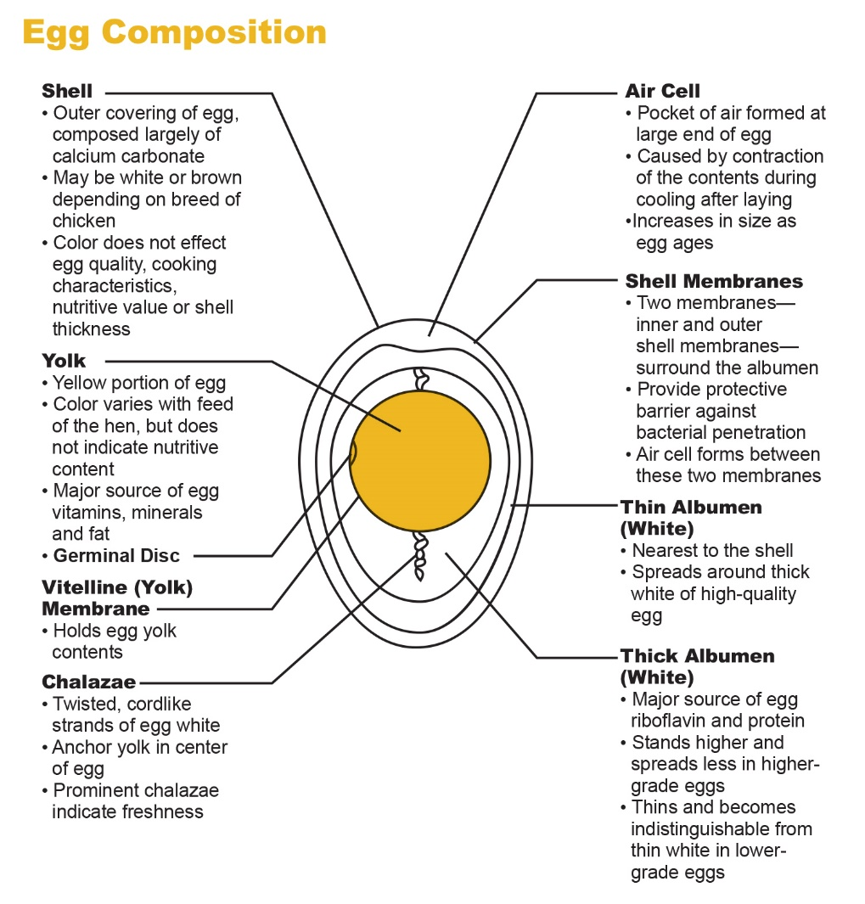
Source: American Egg Board, www.aeg.org
Figure 2.1: Composition of egg
Egg includes three foremost parts, the egg albumen, the egg yolk and the shell. The shell includes calcite crystals embedded in a matrix of proteins and polysaccharide complex. Inside the shell the viscous color less liquid known as the egg albumen accounts for about 58 percent of the entire egg weight. (Anonymous, 2015). The composition of egg white (albumen) and yolk is given in the following table.
Percentage composition of egg white and yolk
Table 2.1: Nutritional composition of egg white and yolk
Nutrients | Egg white | Egg yolk
Water | 88.0 | 48.0
Protein | 11.0 | 17.5
Fat | 0.2 | 32.5
Minerals | 0.8 | 2.0
(Yadunandan and Jhpyso, 2014)

2.1 Different types of egg products composition

Eggs are nature’s perfect food. Consumers’ growing interest in dietary health allows eggs, with excellent nutritional properties, to play a key role in the development of healthy and good-for-you food products. Eggs have been appeared as a beneficial ingredient for health and nutrition. In fact, eggs perform different functions in making processed food products. And they simplify the ingredient statement.

Table 2.2: Egg composition
Nutrients (per 100g) | Liquid/ Frozen |  |  |  |  |  | Dried
 | Whole egg | Yolk | Sugared yolk | Salted yolk | Salted whole egg | White | Whole egg | Yolk | Stabilized white
Protein | 12.0 | 15.3 | 13.9 | 14.1 | 11.0 | 9.3 | 48.4 | 33.7 | 84.6
Moisture | 75.2 | 56.8 | 51.2 | 50.9 | 67.8 | 89.0 | 3.7 | 2.7 | 6.5
Fat | 9.7 | 23.0 | 20.8 | 20.9 | 9.2 | 0.076 | 39.2 | 52.9 | 0.4
Ash | 0.8 | 1.4 | 1.1 | 10.4 | 10.3 | 0.4 | 3.4 | 3.3 | 3.6
Carbohydrate | 2.2 | 3.6 | 13.0 | 3.8 | 1.7 | 1.3 | 5.4 | 7.3 | 4.8
Calories | 144.0 | 282.0 | 294.0 | 259.3 | 133.0 | 43.0 | 568.0 | 640.0 | 361.0
cholesterol | 400.0 | 991.0 | 917.0 | 912.0 | 387 | 3.3 | 1630 | 2307 | 20.0
Trans fat | 0.11 | 0.24 | 0.18 | 0.16 | 0.09 | 0.02 | 0.35 | 0.63 | <.004
USDA Nutrient Database for Standard Reference, Release 13 (November 1999). *Nutrient values for liquid eggs may indicate a small variation from frozen eggs.

2.2 Vitamins of egg
Eggs are a good source of vitamins. The contribution to the recommended intake amount of the different vitamins varies considerably. One egg provides more than 15% of the recommended intake value of vitamins A (retinol-equivalents), D, K, B12, folic acid (folate equivalent) and biotin. Calculated for 100 g (~ two eggs) vitamin E (tocopherol-equivalents), B2 (riboflavin), niacin (-equivalent) and pantothenic acid exceed this percent and eggs can therefore (according to EC, 2008) be said to comprise a ‘significant amount’ of those vitamins. Egg is poor in vitamin C, because there is no need for this vitamin during the development of the embryo. Fat-soluble vitamins are found almost exclusively in the egg yolk, as are maximum water-soluble vitamins (Seuss-Baum, 2007; Nys and Sauveur, 2004).

Table 2.3: Egg vitamins
Vitamins | Liquid/ Frozen |  |  |  |  |  | Dried
 | Whole egg | Yolk | Sugared yolk | Salted yolk | Salted whole egg | White | Whole egg | Yolk | Stabilized white
Niacin (mg) | 0.10 | 0.03 | 0.04 | 0.03 | 0.08 | 0.09 | 0.34 | 0.08 | 0.77
Riboflavin (mg) | 0.52 | 0.56 | 0.52 | 0.43 | 0.44 | 0.42 | 1.98 | 1.26 | 3.71
B12 (mcg) | 1.16 | 1.64 | 1.64 | 1.61 | 1.21 | <0.12 | 3.39 | 6.02 | 0.18
Pantothenic acid (mg) | 1.57 | 3.29 | 3.29 | 3.17 | 1.26 | 0.15 | 5.55 | 9.06 | 0.67
Vitamin A (IU) | 488 | 1433 | 1433 | 1043 | 497 | <100 | 500 | 973 | <100
Thiamin (mg) | 0.07 | 0.14 | 0.14 | 0.14 | 0.06 | <0.01 | 0.18 | 0.93 | <0.05
Pyridoxine (mg) | 0.197 | 0.398 | 0.398 | 0.402 | 0.226 | <0.007 | 0.494 | 0.842 | 0.04
Folic acid | 0.087 | 0.174 | 0.174 | 0.112 | 0.0691 | 0.0091 | 0.119 | 0.209 | 0.022
Vitamin E (IU) | 1.07 | 3.35 | 3.35 | 3.40 | 1.20 | <0.50 | 3.24 | 7.17 | <0.500
Vitamin D (IU) | <60 | 123.0 | 123.0 | 126.0 | 56.5 | <60 | 125 | 75.1 | <90
USDA Nutrient Database for Standard Reference, Release 13 (November 1999).
*Nutrient values for liquid eggs may indicate a small variation from frozen eggs.

2.3 Minerals of egg
Eggs are also a good source of minerals. According to the EC 2008, only the phosphorus (16.4%) and selenium (23.6%) content meets the definition of ‘significant amount’ for one egg; for 100 g, iron (15%) is sufficient and zinc (14%) just misses the mark. Besides these vital elements, eggs contain almost all minerals and trace factors in small amounts.
Table 2.4: Egg minerals
Minerals | Liquid/ Frozen |  |  |  |  |  | Dried
 | Whole egg | Yolk | Sugared yolk | Salted yolk | Salted whole egg | White | Whole egg | Yolk | Stabilized white
Calcium (mg) | 62.6 | 133 | 124 | 113 | 113 | 10.1 | 236 | 307 | 104
Iron (mg) | 1.69 | 3.67 | 3.70 | 3.40 | 3.40 | 0.167 | 4.33 | 9.50 | 0.23
Magnesium (mg) | 8.70 | 10.9 | 10.5 | 6.70 | 6.70 | 11.1 | 6.74 | 25.5 | 82
Phosphorus (mg) | 193 | 420 | 404 | 414 | 414 | 13.1 | 629 | 1040 | 104
Potassium (mg) | 135 | 121 | 105 | 111 | 111 | 169 | 540 | 264 | 884
Sodium (mg) | 130 | 70.9 | 70.0 | 3487 | 3487 | 169 | 480 | 163 | 1014
Zinc (mg) | 1.32 | 3.17 | 3.06 | 2.87 | 2.87 | 0.070 | 3.15 | 7.73 | 0.135
Copper (mg) | <0.02 | <0.02 | <0.02 | 0.121 | 0.121 | 0.032 | 0.023 | <0.05 | 0.128
Manganese (mg) | 0.032 | 0.078 | 0.080 | 0.065 | 0.065 | <0.012 | 0.058 | 0.185 | <0.03
Selenium (mg) | 0.037 | 0.0564 | 0.0535 | 0.0569 | 0.0569 | 0.0095 | 0.165 | 0.139 | 0.226
USDA Nutrient Database for Standard Reference, Release 13 (November 1999).
*Nutrient values for liquid eggs may indicate a small variation from frozen eggs.

2.4 Egg White
Egg white consists of thick and thin portions. 20-25% of the whole egg white of fresh eggs (1-5 days old) is thin white. The most important ingredients of egg white except water are proteins. Many different-different forms of proteins are present in egg white (Bellairs and Osmond 2005, Bellairs, 1963).

Table 2.5: Composition and physicochemical properties of the major egg white proteins (Tilgner, 2009)
Protein fraction | Rel. amount  [%] | SH/SS  [–] | MG  [kDa] | IEP  [–] | Glycosylated  [–]
Ovalbumen | 54 | 4/2 | 45 | 4.6–4.8 | ✓
Ovotransferrin | 12–13 | 0/15 | 76–77.7 | 6.1–6.6 | ✓
Ovomucoid | 11 | 0/9 | 28 | 4.1 | ✓
G2 Globulin | 4.0 | – | 40–49 | 5.5 | ✓
G3 Globulin | 4.0 | – | 49–58 | 4.8–5.8 | ✓
Lysozym | 3.4–3.5 | 0/4 | 14.3 | 10.7 | –
Ovomucin | 1.5–3.5 | – | 230–8300 | 4.5–5.0 | ✓

2.4.1 Ovalbumen
Ovalbumen constitutes 55% of the proteins of egg white (albumen). It is a phosphor glycoprotein. It is composed of three additives A1, A2, and A3, which differ simplest in phosphorus content. It is a monomeric phosphoglycoprotein with a molecular weight of 44.5 kDa and an isoelectric point (IEP) of 4.5. Ovalbumin is the common egg white protein to include free-sulfhydryl groups (Mine, 1995).

2.4.2 Conalbumin
The egg white (albumin) protein contain 13% Conalbumin. It consists of two types neither of which contains phosphorus nor Sulphur. It is a glycoprotein and chargeable for the transfer of ferric ions from the hen’s oviduct to the developing embryo (Huopalahti et al., 2007). The IEP of ovotransferrin predicted upon on the amount of constant Fe3+ ions and varies among pH 7.2, pH 6.6 and pH 6.1 for no, one and two certain ferric ions, respectively. The denaturation temperature of ovotranferrin can be increased from 63 °C to 83.5 °C due to the complexation of Fe3⁺ at pH of 7.5(Ternes, 2008).

2.4.3 Ovamucoid
Ovamucoid is a glycoprotein. This constitutes approximately 10% of the egg white proteins. Ovomucoid has an IEP among pH 3.8 and 4.4 depending at the attached glycosyl residues (Ternes, 2008).

2.4.4 Ovomucin
Ovomucin protein is main reason for the thickness of the thick albumen and the jelly like nature of egg white. It includes 2% of the egg albumin. Ovomucin is content in the thick layers of albumin is about four instances greater than in thin layers. Ovomucin also insoluble in water but soluble in dilute salt solution.The molecular weight of the α-ovomucin subunit has been anticipated by means of SDS-PAGE or ultracentrifugation to be among 180 and 220 kDa and for β-ovomucin between four hundred and 720 kDa (Huopalahti et al., 2007).

2.4.5 Lysozyme
Egg white contains 3.5% of this content. Lysozyme is an enzyme capable of lysing or dissolving the cell wall of bacteria. It is mainly composed of three components A, B and C. It makes the diet unavailable and binds biotin. Hen egg white is the most commercial supply of lysozyme with a concentration of 3500 μg/ml. Lysozyme is especially small secretory enzyme with a molecular mass of 14.3 kDa and no carbohydrate compounds. It is a very primary protein with an IEP at pH 10.5. (Huopalahti et al., 2007).

2.4.6 Avidin
Avidin is 0.05% of the egg white protein. It is denatured by cooked eggs and heat and do not affect the availability of biotin.

2.4.7 Ovoglobulin
Ovoglobulin is a protein which includes two components G1 and G2 and both are outstanding foaming agents. They have an IEP at pH 4.8 to 5.8 depending on the amount of connected carbohydrates (Weijer et al., 2006). Furthermore, the molecular weights of G2 and G3 globulins had been roughly estimated to be 49.0 kDa (Weijer et al., 2006).
2.4.8 Ovoinhibitor
Another protein ovoinhibitor which is capable of inhibiting chymotrypsin and trypsin (Anonymous, 2017)

Table 2.6: Amount of proteins in hen and duck egg white (%)
Protein | Hen | Duck
Ovalbumin | 54 | 40
Panalbumin | 0 | 0.1
Conalbumin | 12 | 2
Ovomucoid | 11 | 10
Ovomucin | 3.5 | 3
Lysozyme | 3.4 | 1.2
Ovoinhibitor | 1.5 | –
Ovomacroglobulin | 0.5 | 1.0
Ovoflavoprotein | 0.8 | 0.3
Avidin | 0.05 | 0.03
Others | 15 | 42
Source: Modified from Lin (2000a).

2.5 Egg Yolk
In the egg, the color of yolk typically is yellow in color. It is spherical in form and is suspended in the egg white (known instead as albumen or glair/glaire) by way of one or spiral bands of tissue called the chalazae. The yolk mass, collectively with the eggcell or ovum properly (after fertilization, the embryo) is enclosed by way of the vitelline membrane, whose structure isn't the same as a mobile membrane (Takehiko et al. 1996, Landecker, 2007). The yolk is more often than not extracellular to the oolemma, being now not accumulated in the cytoplasm of the egg cell (as happens in frogs) (Patten, 1951) opposite to the claim that the avian egg cell (in strict sense) and its yolk are a single massive cell (Callebaut, 2008). After the fertilization, the embryo cleavage leads to the formation of the germinal disc. About 50% is solid content in the yolk.
The yolk corresponds to 36% of whole chicken egg weight. Its dry matter is ready 50–52% in step with the age of the laying hen and the duration of preservation (Kiosseoglou, 1989; Thapon and Bourgeois, 1994; Li-Chan et al., 1995). The nutrient compositions of fresh and dry yolks are presented in Table 2.7: the main components are lipids (about 65% of the dry matter) and the lipid to protein ratio is about 2:1.

Table 2.7:Composition of hen egg yolk
Nutrients | % of fresh yolk | % of dry yolk
Water | 51.1 | -
Lipids | 3.6 | 62.5
Protein | 16.0 | 33.0
Carbohydrate | 0.6 | 1.2
Minerals | 1.7 | 3.5
Source: Powrie and Nakai (1986).

To meet the dietary need of functional food, eicosapentaenoic acid (EPA) and docosahexaenoic acid (DHA)-enriched duck eggs had been studied (Chen et al., 2000a, 2000b; Hwang, 2002). Recently, functional components in duck eggs had been attracting attention (Chen, 2009; Wang et al., 2009). The anti-oxidative activities of hydrolysates from duck egg white using enzymatic hydrolysis had been investigated (Chen et al., 2009)

Table 2.8: Approximate egg yolk composition of duck egg
Approximate composition
Moisture | 44.7
Protein | 15.8
Fat | 36.8
Ash | 1.70

In general, egg yolk proteins are considered as more vital egg proteins within the food industry due to the incredible functional properties of its lipoproteins, and hence it is far broadly used in many applications ranging from a bakery to the manufacturing of cold sauces and salad dressings (Lechevalier et al., 2011; Strixner, Kulozik, 2011)

2.6 Production status of egg
The Bangladesh poultry industry normally produces chicken although a few other species like duck, pigeon, quail, goose, turkey, and guinea fowl are to be had for the duration of the year. Chicken meat and eggs are, so far, the most cost effective supply of animal protein in Bangladesh and it is well accepted via all religious, economic, social, and demographic groups (Simon, 2009). Poultry meat and eggs common in Bangladesh are mostly found from locally grown backyard poultry and also from small and large scale poultry industry. Meeting the household demand for meat and eggs through importation is very rare and sporadic (Anas, 2015). Before industrialization, backyard hen was the maximum source of local, low-productive, and non-descript chickens in Bangladesh and it widely met the demand of the producer’s own family consumption (Ahmed and Islam, 1985). Government efforts the involvement of some NGOs and scholastic entrepreneurs and changes within the socioeconomic status of the country over the latest two to three decades has favored this extra shift in the Bangladeshi poultry sector (Raha, 2013). The shares of commercial and backyard poultry sectors in Bangladesh are approximately 50:50 for egg production and 60:40 for meat production. The backyard chicken farming region is transitioning from circle of relative chicken manufacturing in the direction of turning into a mini industry regarding greater capital, greater job opportunities and extra productivity and profitability (Huque et al., 2011).
Table 2.9: Demand, production, availability and deficiency of milk, meat and eggs (2017-18)
Products | Demand | Production | Deficiency | Availability
Milk | 150.29lakh metric ton (250ml/day/head) | 94.06 lakh metric ton | 56.23 lakh metric ton | 158.19(ml/day/head)
Meat | 72.14lakh metric ton (120gm/day/head) | 72.60 lakh metric ton | Surplus 0.46 lakh metric ton | 122.10(gm/day/head)
Egg | 1712.88 crore number (104 numbers/year/head) | 1552.00 crore numbers | 160.88 crore numbers | 95.27(number/year/head)
Estimated population of the country: 16 crores 47 lakhs on 1 July, 2018 (P) Source: BBS

2.7 Powdered egg
Eggs generally encompass three important parts: the yolk, the albumen or white, and the eggshell with the eggshell membrane. The yolk is encompassed through the albumen and each are similarly wrapped by way of the eggshell membrane within the outer covering of a hard eggshell (Hincke et al. 2012). Egg powders were first evolved just before the Second World War, as their nutritional quality and ease of storage have been practical advantages in supplying troops. Dehydration is a successful technique of preserving eggs and effects in an extended shelf life. Nowadays, egg powders are mainly functional ingredients which provide enhanced technological properties compared to those of liquid egg products.

2.7.1 Production of egg powders: types and process
Egg powders are used extensively in bakery foods, mayonnaise, salad dressings, confectionaries, pasta and many convenience foods. Dehydration is indeed a successful way of preserving eggs and egg drying industry has developed over several years. First inspired from milk drying industry, research has then played a major role in adapting processes to the specificities of egg products.

2.7.2 Type of egg powders
There are many different types of dried egg products are available on the market, some of them being dedicated to specific applications. The most common products are presented in this section.

2.7.2.1 Dried egg white
Most albumen powders are spray dried after which pasteurized and/or functionalized via dry-heating to get both foaming or gelling albumen counting on the targeted use. Depending on the regulatory status of the country, a few commercially to be had whipping egg white may incorporate a whipping aid, inclusive of sodium lauryl sulphate, triethyl citrate, xanthan gum or sodium oleate used at about 0.1% based totally on the egg white solids (Strixner and Kulozik, 2011). The main downside of spray-dried egg white is its poor solubility, due to the fact the debris generally tend to agglomerate and form crumbs when blended with water. To overcome this problem, immediately albumen has been developed; this might be obtained through coating spray-dried albumen debris with a solution of sucrose (Bergquist et al., 1978). Egg white also can be dried using a conventional technology called ‘pandrying’. Pan-dried albumen is out there as flakes, granules or powder. It is specifically used for making aerated confectionaries.

2.7.2.2 Dried whole egg and egg yolk
Whole egg and yolk powders are obtained by spray drying. Several categories of products are to be had as trendy powders, stabilized powders, free-flowing powdersand blends with carbohydrates. Stabilized powders are whole egg or ingredient powders from which the glucose has been removed or bio converted to an acid form before drying. Free-flowing powders include a flowing agent, like sodium silico aluminate or silica up to twenty and 1%, respectively. To functionalize whole egg and yolk powders, some carbohydrates along with sucrose or syrup could also be added (Bergquist, 1995).

2.7.3 Special dried egg products

2.7.3.1 Lysozyme-free egg white
Lysozyme is an albumen protein widely utilized in the food and pharmaceutical industries for its antimicrobial properties. It represents up to 3.5 g L –1 in albumen. It is industrially extracted from albumen by cation exchange chromatography. This system dilutes dry content albumen, changes the inorganic composition and increases the bacterial load of the ensuring lysozyme free albumen. However, this lysozyme free albumen are frequently wont to supply albumen powder when we consider that these processes are frequently easily corrected during production.
2.7.3.2 Low cholesterol egg products
Low cholesterol egg products are frequently found via different strategies. These include: substituting yolk by means of adding non-fat milk and oil to the egg white; extracting cholesterol from the whole egg employing a solvent; or using supercritical CO₂ or a starch derivative (β-cyclodextrin) that adsorbs cholesterol from the egg yolk (Bergquist, 1995).

2.8 Drying methods for egg powder production
The methods employed in the production of dried egg such as pan drying, foam-drying, freeze drying, and spray-drying, the latter being frequently used (GUARDIOLA, F. et al.1995).The properties of eggs are very delicate, and the final characteristics of the dried product may be significantly affected by drying conditions (Bergquist 1980). Different types of drying methods are followed:

2.8.1 Spray drying
Spray drying process was used to dehydrate the whole egg liquid into powder form. Small drops of liquid sample turned into produced with the aid of atomization, high surface of small drops involve in excessive mass transfer rate which lead to less drying time (Fernandez et al., 2004). During the drying of the egg product droplets, a thermal equilibrium settles at a temperature on the brink of that of the moist temperature of the air, that is, from 45°C to 50°C in standard drying conditions (Bergquist, 1995). For egg powder production, most of the researches within the literature were related with the tactic of spray drying and process conditions (Caboni et al. 2005; Franke and Kießling 2002; Guardiola et al. 1995; Hammershøj et al. 2004; Lechevalier et al. 2007). Outlet air temperature is related to inlet air temperature: when the inlet air temperature is increased to enhance productivity while product flow rate is constant, the outlet air temperature increases as well. Typically, inlet air temperatures rarely exceed 180°C, 165°C and 145°C for albumen, whole egg and egg yolk, respectively (Galet et al. , 2010).

2.8.2 Pan drying
A traditional technology called pan drying is still used to produce flake-type egg white products. Glucose-free and concentrated egg white is placed on plates in a hot room (54°C maximum temperature) in which slow concentration and drying occurs without coagulation. A vitreous product is obtained, containing between 12% and 16% moisture; this can be ground to different sizes in order to meet customer requirements (Bergquist, 1995). This product needs minimum 24 h to rehydrate and is usually used for aerated food products.

2.8.3 Freeze drying
Freeze drying may be a gentler technology particularly appropriate for aromatic and/ or heat-sensitive products. With this technology, water is eliminated from the product while it is frozen via subjecting it to a really high vacuum: this is based on a direct phase transition from ice to vapor. Because of the value of freeze drying due to high latent heat requirements, commercial applications are rather limited. However, a freeze-drying process for egg yolk has currently been developed, producing a powder with technological and organoleptic properties identical to those of refrigerated liquid egg yolk (Jaekel et al., 2008).

2.8.4 Foam-mat drying
Foam-mat drying is an old technology used to process hard-to-dry materials, obtain products of desired properties (i.e., favorable rehydration, controlled density), and to retain volatiles that otherwise would be lost during the drying of non-foamed materials. The principle is to dehydrate a liquid concentrate along with or without foam stabilizer in foam-mat form (Thirupathi et al., 2008). Foaming is achieved by injecting a gas (which include carbon dioxide, nitrogen or air) into the liquid before the drying takes place within the spray dryers, plate dryers, or band dryers, or alternatively before conventional freeze drying, or the microwave drying of frozen foams (Kudra and Ratti, 2006). Compared to spray drying, foam-mat drying requires much less time, less energy, lesser production charges and with no need for concentration (Thirupathi et al., 2008). Foam-mat drying produces egg powders with better rehydration properties, decrease bulk density and different particle traits than normal spray-dried material (Rao et al., 1987).

2.9 Applications in the food and beverage industries
Egg powders are the most convenient, secure and economic varieties of egg products. They are used in maximum of the food industries for their nutritional cost and their aromatic power. However, a few applications need specific technological properties of egg powders (Lechvalier et al.,2013).

2.9.1 Confectionary
In confectionary food industry egg white powders are used for their foaming and anti-crystallizing properties. Confectionary manufacturers are also the only consumers of pan dried egg white powders, which are used in specific aerated confectioneries such as nougat (Lechvalier et al., 2013).

2.9.2 Meat and fish products
Egg white powders are used in surimi manufacture for their gelling properties. The synergy between fish and egg white proteins makes the egg white powder an indispensable ingredient of the recipe. They also are utilized in foamed meat and fish products industry. Whole egg is also applied in meat and fish products for its emulsifying and binding properties (Lechvalier et al., 2013).

2.9.3 Bakery
Whole egg is widely applied in bakery industry for its foaming, gelling, binding and coloring characteristics. In batter (genoeses), whole egg with sugar is a foaming ingredient, while in dough (e.g. in brioches and cakes), emulsifying and film-forming properties make a contribution to the alveolar structure. Whole egg also has a binding properties in short crust pastries, and is also used to glaze Viennese pastries after cooking. Egg yolk is used as an emulsifying and coloring agent, while egg white is used for its foaming and gelling properties (Lechvalier et al., 2013).

2.9.4 Desserts
Egg white foams are usually used in different types of desserts, including chocolate mousse, meringues, and macaroons. Egg white powders, functionality obtained through dry-heating, do not have any equivalent on the protein market for sugared foam applications. Foamed egg white is likewise integrated into many other desserts, such as angel food cake and sponge cake. In cakes, egg white additionally contributes to product firmness after cooking, because of its gelling properties.
Egg yolk is also a traditional component for desserts inclusive of cakes and ice creams. Proportions from 2% to 10% of the component mix give color and creaminess, or limit sugar crystallization in products includes custard and pastry cream. It is sometimes used in higher concentrations in some special food products (Lechvalier et al., 2013).

2.9.5 Mayonnaise, salad dressing and sauces
Egg yolk is a primary component of cold (mayonnaise, salad dressings, etc.) and warm (béarnaise sauce, etc.) emulsions. It contributes to the formation and the steadiness of emulsions by lowering the interfacial tension between the water and oil, and the encompassing oil droplets (Lechvalier et al., 2013).
2.9.6 Pasta
In dried pasta, whole egg is nowadays limited to regional specialties to add color and texture. However, egg is still a major ingredient in fresh pasta, since it gives excellent heat stability during pasteurization. The egg white and yolk ratio may be modified: egg white increases pasta firmness, while egg yolk aids pasta blowing at some point of cooking (Alemprese et al., 2009).

2.9.7 Dietary food
With a ratio of protein on dry content of at least 90%, egg white is a special natural ingredient. When concentrated via ultrafiltration, partial demineralization of 30–50% may be obtained, in according to the quantity reduction factor. The resulting powders have a very high protein to mineral ratio, which are appropriate for diets who needed a high protein however low sodium content (Lechvalier et al., 2013).

2.9.8 Beverages
Egg powders are usually used as cocktail substances in beverages such as ‘advocaat’ in Belgium and The Netherlands. However, the usage of egg powders in beverages may be very confidential and often reserved to unique products designed for protein supplementation or clinical use (Rao et al., 2012).

2.10 Conclusion
Egg quality is influenced by a wide range of factors in addition to bird strain and nutritional status. It is of importance for keeping a high quality of eggs to understand how the hens’ physiology influences egg quality in favor of positive traits whilst limiting the more negative traits. Bird age is obviously the major factor and a tremendous effort has already gone into selection to limit age-related effects on the likes of egg weight, albumen quality and shell quality.

Chapter III: Materials and Methods

The experiment was conducted in the laboratory of Applied Food Science and Nutrition Department; Food Processing and Engineering Department; Physiology, Pharmacology and Biochemistry Department and Poultry Research and Training Centre of Chattogram Veterinary and Animal Sciences University (CVASU), Chattogram, Bangladesh during April to December, 2019in order to manufacture quality egg powder and also to determine nutrient contents of it.. Egg was collected from local markets of Chattogram.

3.1 Egg collection and sample preparation

3.1.1 Collection of eggs
A total of 75 eggs of three types of poultry were collected from Zaotola kitchen market, Chattogram City in April, 2019. Equal number of egg samples of native chicken (deshi) (25), commercial layer chicken (25) and duck (25) were purchased and transferred to laboratory.

3.1.2 Samples preparation for nutritional composition analysis
The collected eggs were cleaned for further processing. The eggs were cleaned by the water spray and dried at room temperature to remove surface moisture. The eggs were carefully broken and separated egg yolk and egg albumin and egg liquid was inspected visually for any spoilage. The egg liquid was pasteurized at 64˚C for 3 min in a water bath and immediately cooled to 4˚C. For optimizing the drying time the egg liquid foam was dried by using cabinet drier at 60˚C. After drying the samples were blend and sieved to get fine egg yolk and egg albumin powder. The process of egg powder preparation is summarized in flow chart as follow:

Egg

Washed and cleaned

Broke the egg and separated egg yolk and albumen

Egg albumen
Egg yolk

Weighed
Weighed

Pasteurized at 64˚C
Pasteurized at 64˚C

Immediately cooled at 4˚C
Immediately cooled at 4˚C

Dried at 60˚C
Dried at 60˚C

Blended
Blended

Sieved
Sieved

Storage
Storage

Figure 3.1: Flow sheet for egg powder production

3.2 Chemical analysis of egg powder
Egg samples were analyzed for Moisture content (MC), Ash content (AC), Proteins, Fats, Crude fiber and total Carbohydrates. All determinations were done in triplicate and the result was expressed as the average value.

3.2.1 Determination of moisture content
Apparatus: Crucible, hot air oven, desiccator, weighing balance
Procedure: Moisture is always present in food staffs. Estimation of moisture is done simply by heating at 104-105°C for 3-4 hours in the oven and is cooled in a desiccator to absorb moisture. The process is repeated for several times until the constant weight shows by the sample.
Calculation: The percent of moisture was calculated as follows:

Moisture % = $\frac{Initial weight - Final weight}{sample weight}$ × 100

3.2.2 Determination of ash content
Apparatus: Porcelain, gas burner, muffle furnace
Procedure: The ash fraction contains all the mineral elements jumbled together. This method performs oxidization of all organic matter by incineration and determines the weight of remaining ash.
At first weighed the empty crucible. About 5 gm of dried samples was ignited in the crucible with the help of a suitable burner for about an hour. Completed the ignition by keeping in a muffle furnace at 550-600⁰C for about 3 hours until grey color ash was obtained. Then the crucible was taken from muffle furnace and cooled in desiccators. Later on the crucible was weighted.
Calculation: The ash content was calculated by the following expression:

Ash % of Sample =$\frac{Amount of ash of supplied sample}{Sample wt}$ × 100

3.2.3 Protein determination
Apparatus: Kjeldahl flask, Condenser, Kjeldahl digestion unit
Reagent required
1. Concentrated Sulphuric acid (0.2%)
2. Digestion mixture (K₂SO₄& CuSO₄)
3. Boric acid solution
4. Alkali solution.
5. Mixed indicator solution
6. Standard HCl (0.2 N)
Procedure: The estimation of nitrogen is done by Kjeldhal method. The protein content of food stuff was obtained by estimating the nitrogen content of the material and multiplying the nitrogen factor by 6.25.
Digestion
The digestion step was done to break down the intricate structure and chemical bonds of feed substance to simple ionic structure. In digestion procedure, proteins and other forms of nitrogen were broken down and converted to ammonia.
0.3g sample was weighed accurately. Then 4g digestion mixture was added. Further 5ml of conc. H₂SO₄ was added to the mixture. After that the digestion flask was placed on Kjeldahl digestion set. After digestion removed the flask from the chamber and cooled at room temperature.
Distillation
In Distillation steps, ammonia-nitrogen was separated from the digested end product. It involved the conversion of ammonium (NH₄⁺) ion to ammonia (NH₃). Distilling the ammonia, nitrogen was separated, and collected the distillate in a suitable trapping medium. Collection of ammonia is usually done by absorption into a solution of 2% boric acid. The ammonia is bound to the boric acid in the form of ammonia borate.
At first 25 ml distilled water was added. Then content was transferred to distillation flask. After that 10 ml 40% NaOH solution was added and set the condenser10 ml 2% Boric acid solution and mixed indicator were added in conical flask. Heat the distillation flask and continue up to collection of app. 100ml of distillate.

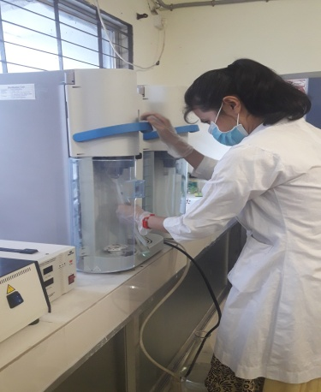
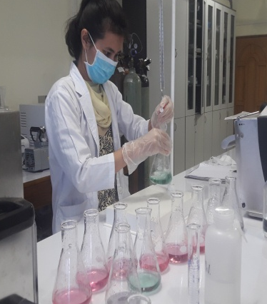
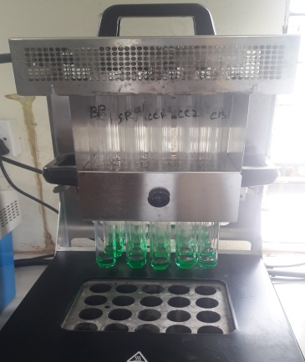

Figure 3.2: Protein determination
Titration
Determination of the amount of nitrogen on the condensate flask can be accomplished by several methods. The most common method is titration of the ammonia with a standard solution of N/10 HCl in the presence of mixed indicator.
The receiving solution was titrated with 0.2N HCl solution until turn into grey color. The percentage of crude protein calculated by following formula:
Calculation: Percentage of nitrogen and protein calculated by the following equation:

Protein % =$\frac{Titration value×Normality of HCl×0.014}{Sample wt }$ × 6.25 × 100

3.2.4 Crude fat determination
Apparatus: Soxhlet apparatus, Thimble
Principle: Fat was determined by dissolving the sample into organic solvents (chloroform, methanol) separating the filtrate by filtration. The filtrate was placed in separating funnels and then separated mixture was dried to measure the extract and the percentage of fat was estimated.
Procedure: The dried sample was taken in a thimble and plugged the top of the thimble with a wood of fat free cotton. The thimble was dropped into the fat extraction tube attached to a Soxhlet apparatus. The anhydrous petroleum ether was poured through the sample in the tube into the flask. Top of the fat extraction tube was attached to the condenser. The sample was extracted for 16 hours or longer on a water bath at 70-80°C.
At the end of the extraction period, the thimble from the apparatus was removed and distilled of the petroleum ether by allowing it or collected in Soxhlet tube. The ether was poured off when the tube was nearly full. When the ether was reached a small volume, it was poured into a small, dry (previously weighed) beaker through a small funnel containing plug cotton. The flask was rinsed and filtered thoroughly using ether. The ether was evaporated on a steam bath at low heat, it was then dried at 100°C for 1 hour, cooled and weighed. The difference in the weights was the ether-soluble material present in the sample.
Calculation: The percent of crude fat was expressed as follows:

Fat % of sample = $\frac{Wt of extract}{Sample wt}$ × 100

3.2.5 Crude Fiber Determination
Apparatus: Liebig condenser, Reflux condenser, Gooch crucible
Reagent required:
1. 0.255N sulphuric acid solution
2. 10.0% Potassium sulphate solution;
3. Asbestos- Gooch grade.
Procedure: Crude fiber is the water insoluble fraction of carbohydrate consists mainly of cellulose, hemicellulose and lignin. It was estimated through digestion of fat free known amount of food sample by boiling it in a weak solution of acid (1.25% H₂SO₄) for 30 minutes followed by boiling in weak solution of alkali (1.25% NaOH) for 30 minutes at constant volume and then deducting ash from the residue obtained.
About 2-5ml of moisture and fat free sample were weighed into 500ml beaker and 200ml of boiling 0.255 N (1.25%w/v) sulfuric acid is added .the mixture was boiled for 30 minutes keeping the volume constant by the addition of water at frequent intervals. At the end of this period, the mixture was filtered through a muslin cloth and the residue washed with hot water till free from acid. The material was then transferred to the same beaker and 200ml of boiling 0.313 N (1.25%) NAOH added. After boiling for 30 min, the mixture was filtered through muslin cloth. The residue was washed with hot water till free from alkaline followed by washing with some alcohol and other. It was then transferred to a crucible, dried overnight at 300-1000⁰C and weighed. The crucible is heated in a muffle furnace at 6000⁰C for 2-3 hrs. Cooled and weighed again. The difference in the weight represents the weight of crude fiber.
Calculation: The loss in weight represents crude fiber
Crude fiber % = $\frac{Weight of residue with crucible-Weight of ash with crucible}{Sample weight}$ × 100

3.2.6 Determination of total carbohydrates
The carbohydrate content was determined by calculating the difference of Nitrogen Free Extractive (NFE). It was given as the difference between 100 and a sum total of the other proximate components. The formula bellow:
% CHO = 100% - % (Protein + Fat + Fibre + Ash + Moisture content).

3.3 Determination of mineral content
This method involves the extraction of minerals from the organic food matrix by digestion through wet digestion. The mineral contents in the digested compounds was determined by spectrophotometer (Humalyzer 3000®).
Apparatus: Beaker, Measuring pipets, Volumetric flask, Analytical balance, Heating mantle or hot plate, Filter paper, Whatman® No. 541
Required Reagent: Nitric acid and Perchloric acid
Procedure: One (01) g of dry sample was weighted in a conical flask. For dried samples, 7.5 mL conc. HNO_{3,} and 2.5mL conc. HClO₄ in the ratio of 2:1 was prepared. For wet sample, 5 mL HNO₃ and 1 mL HClO₄ was added (HNO₃: HClO₄ = 5:1). Then the flask was placed in a hot plate at 200W for 1-2 hours until full digestion. After digestion, it was cooled to room temperature. Then transferred the digested samples into 100 mL volumetric flask and diluted up to 100 mark with Deionized water and mixed well. Later, the solution was filtered through Whatman® filter paper No. 1 and transfer to appen dorf for mineral quantification.
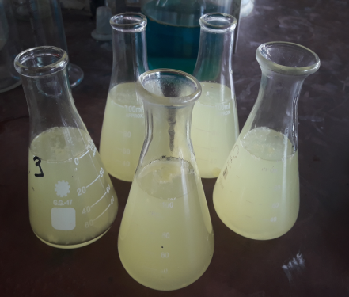
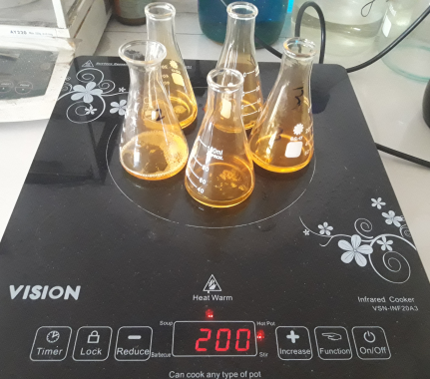

Figure 3.3: Mineral determination

3.3.1 Determination of Calcium (Ca⁺⁺)
Principle: Calcium ions form a violet complex with O-Cresolphthalein complexone in an alkaline medium.
Procedure:
Table 3.1: Calcium (Ca⁺⁺) determination
Pipette into cuvette
 | Reagent blank SO | Standard SI | Sample
Sample | - | - | 25µl
Distilled water | 25 µl | -
Standard | - | 25 µl | -
Working Reagent | 1.0ml | 1.0ml | 1.0ml

Calculations
Concentration in mg / dl = $\frac{\left(A\right)sample}{\left(A\right)standard }$ × Standard conc. (mg/dl)

3.3.2 Determination of magnesium (Mg)
Principle: The method is based on the specific binding of calmagite, a metallochromic indicator and magnesium at alkaline pH with the resulting shift in the absorption wavelength of the complex. The intensity of the cromophore formed is proportional to the concentration of magnesium in the sample.
Table 3.2: Magnesium (Mg) determination
Pipette into cuvette
 | Blank | CAL. Standard | Sample
Sample | - | - | 10µl
CAL. Standard | - | 10µL | -
R1. Reagent | 1.0ml | 1.0ml | 1.0ml

Calculation
Magnesium (mg /dl) = $\frac{(A)sample}{(A)standard}$× Standard conc. (mg/dl)

3.3.3 Determination of phosphorus (P)
Procedure:
Table 3.3: Phosphorus (P) determination
Pipette into cuvette
 | Blank | CAL. Standard | Sample
Sample | - | - | 10µl
CAL. Standard | - | 10µL | -
R1. Reagent | 1.0ml | 1.0ml | 1.0ml

Calculation:
Phosphorus concentration (mg / dl) = $\frac{(A)sample}{(A) Standard}$ × Standard conc. (mg/dl)

3.3.4 Determination of Potassium (K⁺)
Principle: Sodium tetraphenylboron reacts with potassium to produce a fine turbidity of potassium tetraphenylboron. The intensity of turbidity is directly proportional to the concentration of potassium in the sample.
Table 3.4: Potassium (K⁺) determination
Pipette into cuvette
 | Blank | Standard | Sample
Sample | - | - | 0.02ml
Deionized water | 0.02ml | - | -
Standard | - | 0.02ml | -
K⁺ Reagent | 1.0ml | 1.0ml | 1.0ml

Calculations
Potassium (mg /dl) = $\frac{(A)sample}{(A)standard}$ × Standard conc. (mg/dl)

3.3.5 Determination of Chloride Ion (Cl⁻)
Principle: Chloride ions combine with free mercuric ions and release thiocyanate from mercuric thiocyanate. The thiocyanate released combines with the ferric ions to form a red brown ferric thiocyanate complex. Intensity of the color formed is directly proportional to the amount of chloride present in the sample.
Table 3.5: Chloride ion (Cl⁻) determination
Pipette into cuvette
 | Blank | Standard | Sample
Sample | - | - | 0.01ml/200
Deionized water | 0.01ml | -
Standard | - | 0.01ml/200 | -
Reagent | 1.0ml | 1.0ml | 1.0ml

Calculation
Chloride in mmol / L = $\frac{(A)sample}{(A)standard}$ × Standard conc. (mg/dl)

3.3.6 Determination of Iron (Fe)
Principle: The iron is dissociated from transferring-iron complex in weakly acid medium. Liberated iron is reduced into the bivalent form by means of ascorbic acid. Ferrous ions give with FerroZine a colored complex. The intensity of the color formed is proportional to the iron concentration in the sample.
Table 3.6: Iron (Fe) determination
Pipette into cuvette
 | Blank | Standard | Sample
Sample | - | - | 200µl
Standard | - | 200µl | -
Reagent | 1.0ml | 1.0ml | 1.0ml

Calculations:
Iron in μg / dl= $\frac{(A)sample –(A)sample blank}{(A)standard}$ × Standard conc. (mg/dl)

3.3.7 Determination of Vitamin E
Apparatus: centrifuge tube, centrifuge machine, colorimeter
Required reagents: Absolute alcohol, Aldehyde free, Xylene, Ferric chloride solution, Standard solution of DL-α-tocopherol

Procedure:
- Into three stoppered centrifuge tubes, 1.5ml sample, standard or water (blank) was measured, respectively.
- To the test and blank tubes 1.5ml ethanol and 1.5ml water was added respectively
- Then added 1.5ml xylene to each tube, stopper, mixed well and centrifuged.
- 1.0ml of each xylene layer into a clean stoppered tube was transferred and carefully excluding any protein or ethanol
- 1.0ml dipyridyl reagent to each tube, stopper and mixed was added.
- Then pipetted 1.5ml of the mixture into colorimeter cuvettes and read the absorbance (A₄₆₀) of the test and standard against the blank at 460nm.
- Then, in turn, beginning with the blank added 0.33ml ferric chloride solution, mixed, set the wavelength to 520nm and 1.5min after mixing read the absorbance (A₅₂₀) of the test and standard against the blank.
Calculation:
Αlpha tocopherols (mg/l) = $\frac{A^{'} of unknown}{A^{'}of standard}$ × 100
Where A’= A₅₂₀ – 0.29 × A₄₆₀

Statistical analysis
Data were recorded and entered into the MS Excel-2013 and exported to Statistical Package for Social Sciences (SPSS version 20.0). Descriptive statistics were performed including mean, standard deviation, percentage and results were shown in bar diagram. Comparison for weight distribution of eggs, minerals contents and Vitamin E among different types of eggs were done throw analysis of variance (ANOVA). Level of significance was shown at P<0.05.

Chapter IV: Result

4.1 Overall weight distribution of different types of poultry egg
Table 4.1 showed (MEAN±SD) of overall weight distribution of different poultry such as commercial layer chicken, native chicken and duck eggs of Chattogram division. The whole egg weight of duck had the highest weight (65.30±6.65) g whereas the weight of native egg had the lowest weight (39.55±2.70) g. In raw egg, the albumin content was found the highest in layer chicken egg (37.29±2.12) g whereas this was found the lowest in native chickens egg (16.19±3.21) g. On the other hand, the yolk and shell weight of duck egg had the highest weight (26.06±3.70; 8.46±1.02) g among other types of eggs. In case of dried condition, the albumen content was found the highest in layer chicken eggs (4.80±0.40) g while this was found lowest in native chicken eggs (2.25±0.39) g. The highest weight of dried yolk was found in duck eggs (11.49±1.50) g whereas in the native chicken eggs this was found the lowest (6.07±1.04) g.
Table 4.1: Overall weight distribution of commercial layer chicken, native chicken and duck egg
Types of egg | Raw |  |  |  | Dried
 | Whole | Albumin | Yolk | Shell | Dried albumin | Dried yolk
Commercial layer chicken(n=10) | 61.27±2.66ª | 37.29±2.12^{abc} | 15.88±0.91^{ac} | 7.65±0.71^{ab} | 4.80±0.40^{ab} | 7.14±0.47^{ac}
Native chicken(n=10) | 39.55±2.70^{ba} | 16.19±3.21^{abc} | 17.31±4.48^{bc} | 5.22±0.59^{bac} | 2.25±0.39^{bac} | 6.07±1.04^{bc}
Duck(n=10) | 65.30±6.65^{b} | 30.03±5.83^{abc} | 26.06±3.70^{cab} | 8.46±1.02^{bc} | 4.40±0.75^{ca} | 11.49±1.50^{cab}
P-value | *** | *** | *** | *** | *** | ***
The mean difference is significant at the 0.05 level
Legends: All values showed ME±SD of data and expressed in percentage. ME= Mean, SD= Standard Deviation. Sig= Significance, *= Significant (P< 0.05); **=Significant (p< 0.01); ***=Significant (p< 0.001); NS= Not significant. Superscripts (a, b, c) denotes significant difference (P<0.05) between samples.

4.2 Nutritional composition of different poultry

4.2.1 Nutritional composition of layer egg

Figure 4.1: Chemical analysis of commercial layer egg
Above diagram showed the proximate analyses of commercial layer chicken eggs. In layer chicken eggs,dried albumen contains more moisture than the yolk. Albumen had higher protein percentage (81.43%)as compared to yolk (36.52%). The yolk contains higher fat (51.93%) whereas albumen had no fat content in it. Over all yolk contain more carbohydrate (4.44%) than albumen.Ash content found higher in albumen (4.46%) as compared to yolk (3.75%). There was no fibre in any part of dried commercial chicken eggs (Figure-41).

4.2.2 Nutritional composition of Native chicken egg (Deshi)
The proximate analysis of Native egg showed above diagram. Albumin portion contained higher moisture, protein and ash content than yolk portion. The higher and lower protein content found in albumin 84.58% and yolk 36.16% respectively. On the other hand yolk had higher fat percent 49.18% compared with albumin portion. Yolk also had higher CHO content 4.1% whereas albumin contain lower 2.17%. But in case of fiber content albumin contained more than yolk.

Figure 4.2: chemical analysis of Native chicken egg (Deshi)

4.2.3 Nutritional composition of Duck egg

Figure 4.3: chemical analysis of Duck egg
The proximate analysis of duck egg showed in the diagram. In the analysis we found albumin portion contain higher moisture, protein, ash and CHO content. The higher value of moisture 8.87%, protein 81.84%, ash 4.71% and CHO 4.43% were found in albumin portion where yolk portion contain lower moisture 4.78%, protein 38.5%, ash 3.52% and CHO 1.28% respectively. But yolk portion contained higher fat content 51% whereas yolk contains only 0.15% fat. In case of fiber content both albumin and yolk contain very little.

4.3 Mineral composition of different types of poultry egg
Table 4.2: Mineral composition of commercial layer chicken, native chicken and duck egg
Types of eggs | Mineral contents (mg/gm)
 | Albumin |  |  |  |  |  | Yolk
 | Ca | Mg | P | K | Cl | Iron | Ca | Mg | P | K | Cl | Iron
Commercial layer chicken(n=5) | 2.78±  1.38 | 0.94±  0.16 | 6.10±  2.65 | 1.00±  0.07^{ab} | 8.93±  7.08 | 0.002±  0.001 | 3.38±  0.96 | 0.32±  0.10^{ab} | 11.16±  1.11^{abc} | 2.22±  0.72^{ab} | 5.09±  2.92 | 0.002±  0.001
Native chicken(n=5) | 2.87±  0.85 | 1.30±  0.40 | 6.26±  1.54 | 2.48±  0.77^{ab} | 3.96±  0.76 | 0.001±  0.007 | 3.17±  2.01 | 0.62±  0.19^{abc} | 17.78±  1.66^{ab} | 4.28±  0.67^{ab} | 5.95±  1.35 | 0.006±  0.003
Duck(n=5) | 2.30±  1.50 | 0.70±  0.41 | 3.00±  0.29 | 1.80±  0.58 | 5.45±  2.55 | 0.002±  0.001 | 3.24±  1.32 | 0.22±  0.10^{bc} | 16.78±  3.50^{ac} | 3.18±  0.96 | 36.37±  33.74 | 0.007±  0.012
P-value | NS | NS | NS | ** | NS | NS | NS | ** | ** | ** | *** | NS
The mean difference is significant at the 0.05 level
Legends: All values showed ME±SD of data and expressed in percentage. ME= Mean, SD= Standard Deviation. Sig= Significance, *= Significant (P< 0.05); **=Significant (p< 0.01); ***=Significant (p< 0.001); NS= Not significant. Superscripts (a, b, c) denotes significant difference (P<0.05) between samples.

The mineral content of different poultry eggs is shown in the table 4.2. In dried albumen part, potassium content showed significant difference among the commercial layer chicken, native chicken, and duck eggs. Potassium content found higher in native chicken eggs, than ducks and commercial layer chicken, respectively. However, the remaining mineral contents including calcium, magnesium, phosphorus, chloride and iron were not differed significantly among them.
Contents of Mg, K, P and Cl were found significantly different among different types of dried egg yolk. Magnesium, potassium, phosphorus were found higher in native chickens egg yolk than other poultry eggs. However, the chloride content found higher in ducks egg yolk.

4.4 Vitamin E in different poultry egg yolk

Table4.3: Vitamin E content
Types of egg | Vitamin E (IU) | P-value
Commercial chicken(n=5) | 8.26±.21 | 0.401
Native chicken(n=5) | 8.19±.26
Duck(n=5) | 8.38±.17
The mean difference is significant at the 0.05 level
Legends: All values showed MEAN±SD of data and expressed in percentage. SD= Standard Deviation. Sig= Significance, *= Significant (P< 0.05); **=Significant (p< 0.01); ***=Significant (p< 0.001); NS= Not significant. Superscripts (a, b, c) denotes significant difference (P<0.05) between samples.

Above table 4.3 showed the vitamin E content in different poultry egg yolk. Layer, native and duck egg yolk had different vitamin E content which is 8.26±.21 IU, 8.19±.26 IU and 8.38±.17 IU respectively. Duck egg yolk had the highest vitamin E (8.38±.17) IU and native egg yolk had the lowest (8.19±.26).

Chapter V: Discussion
Poultry eggs consume all over the world irrespective of ethnicity, religion, and age. Nutrient composition of egg of different genotypes varies widely. Among the various kinds of food sources, the egg is a kind of complete food, which contains almost all nutrients required for human being. In the current study, we found differences in nutrient composition of eggs obtained from three different types of poultry including Galus domesticus (hybrid and domestic) and Anas platyrhynchos (duck). In the current study, the average weights of eggs were found between 40-66 gm. These variations depend on different factors including genotype, breed, age and feeds (Washburn, 1990).Considering three poultry species the duck egg weight found higher compared to other two species egg. We also found that Duck egg had the highest whole weight, yolk, shell and dried yolk weight. Owing to the varieties in laying duck species worldwide the duck egg weight variety is 60–90 g. In addition to the weight probabilities of the eggshell, egg white and egg yolk to that of the whole egg ranged from 11–13%, 45–58, and 28–35%, respectively (Chang, 1992; Chen, 2001). Duck eggs have a relative higher percentage of egg yolk compared to other avian eggs (Lin, 2000a; Congjiao et al. 2017).

In this study,in raw state of egg, the albumen content found 2.3 times higher than yolk whereas in dried condition the content of yolk nearly 1.4 times higher as compared to albumen in hybrid chicken. But, in both native chicken and duck, this proportion was almost same. The variation of albumen to yolk ratio was attributed to breed (Campo, 1995), age (Ahn et al., 1997) and egg size (Marion et al., 1964).The evidence from earlier study suggests that the eggs from native chicken and duck are more favorable for making products from yolk than from consumption as table eggs (Suk and Park, 2001).

On the other hand, we found from analysis native egg had the lowest whole weight, albumin, shell weight, dried albumen and dried yolk weight. The increase in egg weight in the course of everyday production cycle is associated with an age. The percent contribution made by means of the yolk increases at some stage in lay ensuing in a decrease in the percentage of yolk to albumen over time (Ternes et al., 1994).

The nutrient composition analysis shows that the albumen portion contains higher moisture content in layer egg compared to others. Duck egg albumen had higher protein, carbohydrates and ash than yolk. And fat content found higher in yolk than albumen. Native chicken egg had higher protein than commercial layer egg. In the present study, we found the albumen portion contains more protein than the yolk portion which has been reported by (Bashir et al., 2015; Genchev, 2012) that generally egg white contained slightly higher protein than egg yolk when dried. In general, egg yolk possesses higher lipids than egg white. Further, native chicken egg white powder showed slightly higher fat contents compared to the corresponding to layer and duck egg white.

We found that duck egg weight is higher than the other two species but in case of nutritional composition, duck egg had lower nutritional value compared with the native egg. Native egg can be a good protein source where its albumen contains almost 85% protein. It is also found that native chicken egg had higher nutritional component with smaller size compared to other two species.

In the current study, the overall mineral contents were higher in the egg yolk than the egg white. Both egg yolk and egg white contain iron at daily recommended level. The recommended daily requirement of iron for man is 6-40 mg/kg (Bolt and Bruggenwert, 1978). Moreover, the egg yolk contains more iron than the white, which is dissimilar with the previous study (Tanasorn et al, 2013). The reason for this is that iron is present in ferric form and interacts with the phosvitin found in egg yolk. Additionally, the presence of eggs in the diet reduces the bioavailability of iron from other food sources. Combining eggs in the diet with enhancing factors such as vitamin C, citric acid, cysteine-containing peptides or ethanol results in significantly increased bioavailability of iron (Hallberg and Hulthen, 2000).
The recommended dietary allowance value of calcium is 600-1400mg/kg (Bolt and Bruggenwert, 1978). The present study shows that both egg yolk and white powder of commercial layer chicken contain high amount of calcium as compared to the native chicken and duck egg. On the other hand, both native chicken egg albumen and yolk powder contain higher potassium than other two types of poultry egg powder. Moreover, native egg yolk also contain higher Mg and P content compared to others egg powder which is higher than the USDA recommended (1999) value.

We need a minimum amount of vitamins in our everyday life. Egg is a good source of vitamins compared to other food products. Results of the current study showed that the dried eggs of poultry contains considerable amount of vitamin E. Moreover, duck egg yolk powder contained higher vitamin E content compared to commercial layer and native chicken egg powder which is nearly higher than USDA recommended value. The genetics, rate of egg production and it varies with the composition of the poultry diet, which influenced the concentration of vitamins (Leeson, Caston, 2003). As the concentration of fat-soluble vitamins in the feed increases, the content of vitamins also increases in the egg yolk (Sirri, Barroeta, 2007).

Finally, from the above discussion we found that, egg powders of different types of poultry have considerable amount of nutrient. It also found that, each egg albumen powder contain almost 85% protein where yolk powder contain nearly 50% fat content. In case of mineral content, we found, commercial egg albumen and yolk powder had higher calcium. But potassium found higher in both native chicken egg albumen and yolk. However, native chicken egg yolk powder also contain higher magnesium, potassium and phosphorus content than other two types of poultry egg powder. Duck egg had lowest mineral content compared to commercial layer chicken and native chicken egg powder.

We may suggest that egg albumen powder might be good choice for people who are suffered from protein deficiency whereas egg yolk powder could be regarded as good fat source. Native chicken egg powder which yolk part contains almost higher mineral content than other poultry eggs powder. So native chicken egg powder may be regarded as a good source of minerals.

Chapter VI: Conclusion
Eggs are considered as complete food, which are excellent source of high quality protein, lipids, vitamins and minerals. Egg powder is easy to handle, transport and showed excellent functional properties like foaming, firmness.From the investigations of the present work, it can be concluded that the duck egg weight was higher than other two types of poultry egg. There were significance differences in overall weight. Further, all egg powders differed in nutritional composition where native egg albumen powder had the highest nutrient content compared to commercial layer and duck albumen powder. Moreover, in dried yolk, commercial layer egg showed comparatively higher nutritional content. But duck egg yolk had the highest protein compared to native chicken and commercial layer egg. In case of ash (minerals) nativechicken egg yolk powder showed higher content compared to corresponding commercial layer chicken and duck egg yolk powder. Despite lower whole egg weight, the native chicken egg albumen powder exhibited higher nutritional component, minerals than that of corresponding commercial layer chicken and duck egg conversely commercial chicken egg yolk powder contained the highest nutritional component.

Chapter VII: Strength & Weakness

6.1 Strength of the study
- There are limited research on egg powder. In this study we produce egg powder separately (egg white and egg yolk powder) and evaluate their nutritional component.
- We used common poultry eggs which were available in the local market.
- Compared the nutritional comparison among three different types of poultry egg.

6.2 Weakness of the study
- Less fund
- The eggs could not collect from different location and different season
- Sample size was small
- Other minerals parameters like selenium, zinc, copper and fat soluble vitamins like A, D & K were not done.
- The other important properties of egg powder like foaming properties, gel properties, pH were not analyzed.
- The physical characteristic tests and the self-life of the samples were not analyzed.

Chapter VIII: Recommendations & future perspectives

This study on the Nutrient Composition of Locally Available Chicken and Duck egg powder suggests the following recommendations:
- The egg should be collected from different area and from different species and in different seasons.
- The other minerals parameter like selenium, zinc, copper and the fat soluble vitamin (except Vitamin E) A, D & K should be analyzed.
- The physical characteristics test and the shelf life of the egg powder should be analyzed.
- The other important properties of egg powder like foaming properties, gel properties, pH etc. should be analyzed.
- Effect of different drying methods on powdered egg of different poultry should be considered.
- Drying losses should be measured and appropriate dryer should be developed for drying of egg keeping the original quality.

References

Ahmed S, & Islam N. 1985, February. Backyard poultry development project in 100 villages. In Proceeding of the 1st conference of Bangladesh Animal Husbandry Association pp. 13-138.
Ahn D U, Kim S M,& Shu H. 1997. Effect of egg size and strain and age of hens on the solids content of chicken eggs. Poultry Science, 76(6), p. 914-919.
Alamprese C, Casiraghi E & Rossi M. 2009. Modeling of fresh egg pasta characteristics for egg content and albumen to yolk ratio. Journal of food engineering, 93(3), p.302-307.
Anas A Z M 2015. Branded meat sector grows as middle class demand rises. Published in Financial Express on 1st February.
Anonymous, 2015. www.davafoods.com/the-egg/structure-of-the-egg.aspx.
Anonymous, 2017. http://www.chickens.allotment-garden.org/eggs/structure-egg/
AOAC. 2005. Official methods of Analysis. 17th edition. Association of Official Analytical Chemists. Washington DC, USA.
Bashir L, Ossai P C, Shittu O K, Abubakar, A N & Caleb T. 2015. Comparison of the nutritional value of egg yolk and egg albumin from domestic chicken, guinea fowl and hybrid chicken. Journal of Experimental Agriculture International, pp. 310-316.
Bellairs R & Osmond M. 2005. Atlas of chick development. Elsevier.2nd 1-4
Bellairs R, Harkness M & Harkness R D 1963. The vitelline membrane of the hen's egg: a chemical and electron microscopical study. Journal of Ultrastructure Research, 8(3-4), p. 339-359.
Bergquist D H, Cunningham F E & Eggleston R M. 1978. U.S. Patent No. 4,115,592. Washington, DC: U.S. Patent and Trademark Office. 48 , p.3.27–3.32.
Bergquist D H. 1995. Egg dehydration’, in Stadelman, W.J. And Cotterill, O.J. (eds), Egg science and technology 4th edition, New York, The Haworth Press, p.335–376.
Bergquist DH. 1980. Measurable difference in quality of egg products. Proc Eur Poult Conf World Poultry Science Association 1:p. 232– 243.
Bolt G H, & Bruggenwert M G M. 1978. Soil chemistry. A. Basic elements. Elsevier Scientific Publishing Company. p.145.
Caboni M F, Boselli E, Messia M C, Velazco V, Fratianni A, Panfili, G & Marconi E. 2005. Effect of processing and storage on the chemical quality markers of spray-dried whole egg. Food Chemistry, 92(2), p.293-303.
Campo J L. 1995. Comparative yolk cholesterol content in four Spanish breeds of hens, an F2 cross, and a White Leghorn population. Poultry science, 74(7), p.1061-1066.
Chandak A J & Chivate M R. 1972. Recent development in foam-mat drying. Indian Food Packer, 26(6), p. 26-32.
Chen I, Huang C, Lai M, Lin C, Huang J & Lin Y. 2000. Effect of dietary fish oil and soybean oil combination on ω-3 polyunsaturated fatty acids content in duck eggs. Journal of the Chinese Society of Animal Science, 29(2), p.147-156.
Chen I, Huang C, Pan C, Lin C, Huang J & Lin Y. 2000. Effects of fish oil addition on ω-3 polyunsaturated fatty acids in duck eggs. Journal of the Chinese Society of Animal Science, 29(3), p. 243-253.
Chen Y C, Chang H S, Wang C T & Cheng F Y. 2009. Antioxidative activities of hydrolysates from duck egg white using enzymatic hydrolysis. Asian-Australasian Journal of Animal Sciences, 22(11), pp. 1587-1593.
Chen Y C. 2009, Studies on development of duck egg white products with anti-oxidative activities, Ph D Thesis, National Chung Hsing University, Taichung, Taiwan.
Chojnacka K. 2005s. Biosorption of Cr (III) ions by eggshells. Journal of Hazardous Materials, 121(1-3), p.167-173.
Congjiao S, Junnian L, Wenbo L, Guiyun X, Ning Y. 2017.Divergent proteome pattern of egg albumen from domestic chicken, duck, goose, turkey, quail and pigeon. Proteomics 17:1700145-1700157.
EC 2008, Commission Directive 2008/100/EC amending Council Directive 90/496/EEC on nutrition labelling for foodstuffs as regards recommended daily allowances, energy conversion factors and definitions – OJ, L285, 28.10.2008, 9.
Fernandez-Perez V, Tapiador J, Martı́n A & de Castro, M L. 2004. Optimization of the drying step for preparing a new commercial powdered soup. Innovative Food Science & Emerging Technologies, 5(3), pp. 361-368.
Forsythe RH 1963. Chemical and physical properties of eggs and egg products. Cereal Science Today 8:309-310, p. 321, 328.
Franke K & Kießling M. 2002. Influence of spray drying conditions on functionality of dried whole egg. Journal of the Science of Food and Agriculture, 82(15), pp. 1837-1841.
Galet O, Cassin D And Jeantet R. 2010. Les Ovoproduits, In Nau, F., Gu É Rindubiard, C., Baron, F. And Thapon, J.L. (Eds), Science Et Technologie De L’ Oe
Genchev A. 2012. Quality and composition of Japanese quail eggs (Coturnix japonica). Trakia Journal of Sciences, 10(2), p. 91-101.
Guardiola F, Codony R, Miskin D, Rafecas M & Boatella J. 1995. Oxysterol formation in egg powder and relationship with other quality parameters. Journal of Agricultural and Food Chemistry, 43(7), pp. 1903-1907.
Hallberg L & Hulthén L. 2000. Prediction of dietary iron absorption: an algorithm for calculating absorption and bioavailability of dietary iron. The American Journal of Clinical Nutrition, 71(5), pp. 1147-1160.
Hammershøj M, Peters L V & Andersen H J. 2004. The significance of critical processing steps in the production of dried egg albumen powder on gel textural and foaming properties. Journal of the Science of Food and Agriculture, 84(9), pp. 1039-1048.
https://www.researchgate.net/publication/250045341_Preparation_of_powdered_egg_yolk_using_a_mini_spray_dryer. Accessed Jan 08 2020.
https://www.researchgate.net/publication/250045341_Preparation_of_powdered_egg_yolk_using_a_mini_spray_dryer. Accessed Jan 08 2020.
Huang Q, Qiu N, Ma M H, Jin Y G, Yang H, Geng F & Sun S H. 2012. Estimation of egg freshness using S-ovalbumin as an indicator. Poultry Science, 91(3), pp. 739-743.
Huopalahti R, Anton M, López-Fandiño R & Schade R(Eds.) 2007. Bioactive egg compounds (pp. 33-42). Berlin: Springer.
Huque KH, Saleque MA, Khatun R. 2011. Commercial poultry production in Bangladesh. Proceedings of the 7th international poultry show and seminar, Dhaka, Bangladesh.
Hwang I H 2002, Studies on changes of physicochemical properties of salted duck egg during pickling, Ph D Thesis, National Taiwan University, Taipei, Taiwan.
Jaekel T, Dautel K & Ternes W. 2008. Preserving functional properties of hen’s egg yolk during freeze-drying. Journal of Food Engineering, 87(4), pp. 522-526.
Jay M J. 2000. Modern Food Microbiology. 6th ed. Aspen Publishers Inc., Gaithersburg, Maryland. p. 68-70.
Jayaraman K S, KS J & LA R. 1976. Development of dehydrated omelette mix based on spray, foam-mat and accelerated freeze dried egg powder.
Kiosseoglou Vd (1989), `Egg yolk', in Charalambous G and Doxastakis G, eds, Food Emulsifiers: Chemistry, Technology, Functional Properties and Applications,London, Elsevier.
Kudra T & Ratti C. 2006. Foam-mat drying: Energy and cost analyses. Canadian Biosystems Engineering, 48, p. 3.
Landecker Hannah. Culturing life: how cells became technologies. Cambridge, MA: Harvard University Press, 2007, p. 49.
Lechevalier V, Croguennec T, Anton M & Nau F. 2011. Processed egg products. In Improving the safety and quality of eggs and egg products pp. 538-581. Woodhead Publishing.
Lechevalier V, Jeantet R, Arhaliass A, Legrand J & Nau F. 2007. Egg white drying: Influence of industrial processing steps on protein structure and functionalities. Journal of Food Engineering, 83(3), pp. 404-413.
Lechevalier V, Nau F, Jeantet R. 2013. Handbook of Food Powders Processes and Properties Woodhead Publishing Series in Food Science, Technology and Nutrition, p. 484-512
Leeson S & Caston L J. 2003. Vitamin enrichment of eggs. Journal of Applied Poultry Research, 12(1), p. 24-26.
Li-Chan E C. 1995. The chemistry of eggs and egg products. Egg science and technology, pp. 105-175.
Lin C W 2000A, Egg science and utilization in other avian species, in Chemistry and Utilization of Eggs, Taipei, Taiwan, Hua Shiang Yuan Publishing Company, pp. 555–583.
Marion W W, Nordskog A W, Tolman H S & Forsythe R H. 1964. Egg composition as influenced by breeding, egg size, age and season. Poultry Science, 43(1), pp. 255-264.
Martin S. 1987. Foam drying in the food industry. The Avi Publishing Company, Limited. Connecticut, p. 35 - 57.
Mine Y. 1995. Recent advances in the understanding of egg white protein functionality. Trends in Food Science & Technology, 6(7), pp. 225-232.
Mizutani K, Mikami B, Aibara S & Hirose M. 2005. Structure of aluminium-bound ovotransferrin at 2.15 Å resolution. Acta Crystallographica Section D: Biological Crystallography, 61(12), pp. 1636-1642.
Muthukumaran A, Ratti C & Raghavan V G. 2008. Foam-mat freeze drying of egg white and mathematical modeling Part I optimization of egg white foam stability. Drying Technology, 26(4), pp. 508-512.
Nys Y & Sauveur B. 2004. Valeur nutritionnelle des oeufs. Productions animales, 17(5), pp. 385-393.
Nys Y, Gautron J, McKee M D, Garcia-Ruiz J M & Hincke M T. 2001. Biochemical and functional characterisation of eggshell matrix proteins in hens. World's Poultry Science Journal, 57(4), pp. 401-413.
Panda P C. 1995. Slaughtering techniques. Textbook on Egg and Poultry Technology. Vikas Publications, New Delhi, India.
Potter N. and J Hotchkiss. 2006. Food Science. 5th ed. CBS Publisher and Distributors, Dehli, India.
Powrie W D & Nakai S. 1986. The chemistry of eggs and egg products. Ch. 6 in Egg Science and Technology, WJ Stadelman and OJ Cotterill.
Raha S K. 2013. Poultry industry in Bangladesh: ample opportunities for improvement. In proceedings of the seminar, 8th international Poultry Show and Seminar. World’s Poultry Science Association, Bangladesh Branch pp. 13-19.
Rao Q, Rocca-Smith J R, Schoenfuss T C & Labuza T P. 2012. Accelerated shelf-life testing of quality loss for a commercial hydrolysed hen egg white powder. Food chemistry, 135(2), pp. 464-472.
Rao S. 1995. Standardization of parameters for enhancing the shelf-life of boiled egg. Journal of Food Science and Technology(Mysore), 32(1), p. 46-49.
Rao T S S, Murali H S and Rao K R G. 1987 Preparation of foam-mat dried and freeze-dried whole egg powder, Journal of Food Science Technology Mysore, 24 (1), p. 23–26.

Ruff K J, Winkler A, Jackson R W, DeVore D P & Ritz B W. 2009. Eggshell membrane in the treatment of pain and stiffness from osteoarthritis of the knee: a randomized, multicenter, double-blind, placebo-controlled clinical study. Clinical rheumatology, 28(8), pp. 907-914.
Seuss-Baum, I. 2007. Nutritional evaluation of egg compounds. In Bioactive egg compounds pp. 117-144. Springer, Berlin, Heidelberg.
Simon P C. 2009. Commercial egg and poultry meat production and consumption and poultry trade worldwide. In Proceedings of the 6th International poultry show and seminar, Dhaka, Bangladesh.
Sirri F & Barroeta A. 2007. Enrichment in vitamins. In Bioactive egg compounds pp. 171-182. Springer, Berlin, Heidelberg.
Site, P. 2015. Global poultry trends 2014: rapid growth in Asia's egg output.
Stadelman W J and Cotterill O J. 1995. Egg science and technology. Fourth Edition. Food Product Press. New York. Pp. 7-45.
Strixner T and Kulozik U. 2011. Egg proteins, in PHILLIPS, G.O. and WILLIAMS, P.A. (eds), Handbook of food proteins, Cambridge, Woodhead publishing, pp. 150–209.
Strixner T, Kulozik U. 2011. Egg Proteins. In Handbook of Food Proteins, Phillips, G. O., Williams, P. A., Eds; Woodhead Publishing: Cambridge, UK; pp 150–209.
Suyama K, Fukazawa Y & Umetsu Y. 1994. A new biomaterial, hen egg shell membrane, to eliminate heavy metal ion from their dilute waste solution. Applied biochemistry and Biotechnology, 45(1), pp. 871-879.
Takehiko Yamamoto, Mujo Kim. 1996. Hen eggs.ISBN 9780849340055.
Tanasorn T, Wanna T, Wattasit S. determination of chemical composition of snail-eating turtle (Malayemys macrocephala) eggs egricultural science developments.2013;2(4), p. 31-39.
Ternes W & Leitsch S. 1997, September. Chemistry of egg yolk. In Proceedings of the VII European Symposium on the Quality of Eggs and Egg Products. Poznan, Poland. WPSA Polish Branch, Poznan, Poland pp. 127-144.
Ternes W. 2008. Naturwissenschaftliche Grundlagen der Lebensmittelzubereitung. 2Behrs Verlag, Germany.
Terns W. Acker L, Scholtyssek S. 1994. Ei und Eiprodukt, Verlag Paul Parey, Berlin, Germany.
Thapon J L. (Ed.). 1994. L'oeuf et les ovoproduits. Lavoisier.
Thirupathi V, Sasikala S & Rajkumar P. 2008. Studies on foam mat drying of whole egg liquid in cabinet dryer. Madras Agrl. J, 95(1-6), pp.141-150.
Tilgner M. 2009. Thermische Behandlung von Eiklarproteinen – Phänomene, Denaturieurungskinetik, Verschäumungsverhalten. Dissertation TU-München, Germany.
Tullet Sg 1987. Egg shell formation and quality, in Egg quality current problems and recent advances, RG Wells and CG Belyavin (Eds.), Butterworth, London, pp 123–146. uf , Paris Lavoisier eds Tec&Doc, pp. 223–278.
US Department of Agriculture, Agricultural Research Service. 1999. USDA Nutrient Database for Standard Reference, Release 14. Nutrient Data Laboratory home page.
Wang S Y, Liu S C, Huang J F, Chen G M and Lin C C 2009. The analysis of the antioxidant complex in the extract of blue eggshell, Journal of Chinese Social of Animal Science, 38 (suppl.), 211 (abstract).
Washburn K W. 1990. Genetic variation in egg composition [in poultry]. Developments in Animal and Veterinary Sciences (Netherlands). Pp. 781–798.
Watkins B A. 1995. The nutritive value of the egg. Egg science and technology, 4, pp. 177-194.
Weijers M, van de Velde F, Stijnman A, van de Pijpekamp A & Visschers R W. 2006. Structure and rheological properties of acid-induced egg white protein gels. Food Hydrocolloids, 20(2-3), pp. 146-159.
Yadunandan Lal Dar, Jhpyso M .L thgi, Technology & Engineering, 2014. https://books.google.co.in/books?isbn=1118766121.

Appendix: Photo Gallery

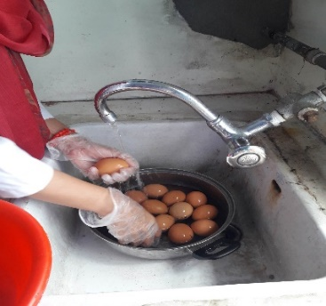
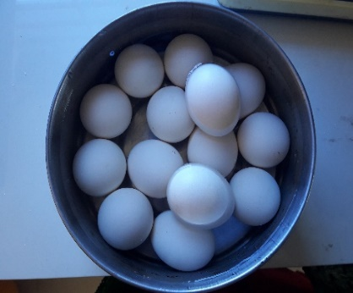

Cleaning
Egg collection
Breaking

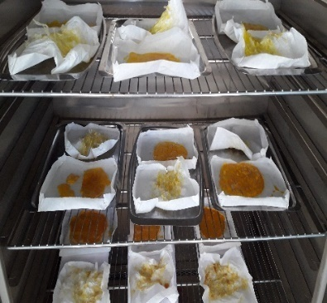
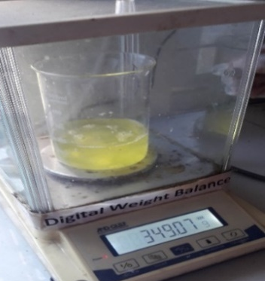
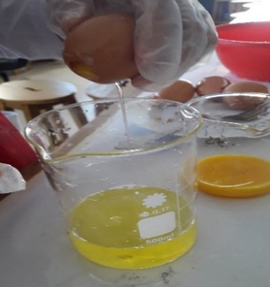

Egg separation
Weighing
Drying
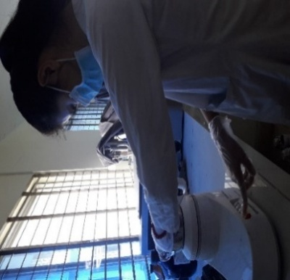
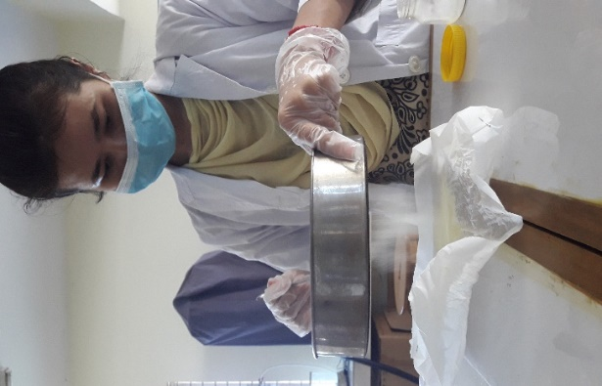
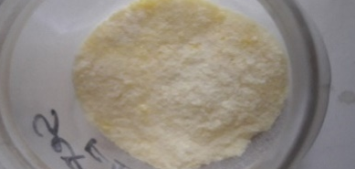
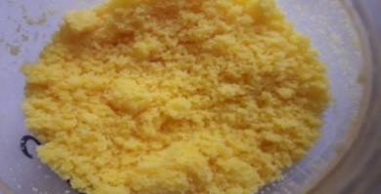

Blending
Sieving
Yolk and albumen powder

Brief Biography
Waichingnu Chowdhury passed the Secondary School Certificate Examination in 2010 and then Higher Secondary Certificate Examination in 2012.She obtained her B.Sc. (Hon’s) in Food Science and Technology from the Faculty of Food Science and Technology of Chattogram Veterinary and Animal Sciences University, Chattogram, Bangladesh. Now, she is a candidate for the degree of Master of Science in Applied Human Nutrition and Dietetics under the Department of Applied Food Science and Nutrition, Faculty of Food Science and Technology, Chittagong Veterinary and Animal Sciences University (CVASU). She has immense interest to work in improving health status of poor people through proper guidance and suggestions and create awareness among people about Food Science and Nutrition.

