CHAPTER-I
INTRODUCTION
Poultry farming plays an important role in improving livelihood, food security and poverty alleviation in rural and semi-urban communities in developing countries including Bangladesh. Broiler production has become a specialized and speedy business at present time for the people of the country due to short life cycle of the broiler and requirement of relatively less amount of capital attributed to its popularity to the farmers (Ahmed et al., 2009). A study report on the impact on Smallholder Livestock Development Project (SLDP) in rural community at different rural areas of Bangladesh revealed that the overall socio-economic condition of the beneficiaries, their egg and meat consumption capability, empowerment of rural women in decision making issues and employment opportunities were significantly increased after the intervention made by SLDP (Alam, 1997). Another study showed that commercial broiler farming provided employment opportunities for unemployed family members, improved socio-economic conditions and increased women empowerment among rural people of Bangladesh (Rahman et al., 2006).
The present farming systems of poultry in Bangladesh can be broadly divided into two categories: traditional rural backyard or scavenging/semi-scavenging system and commercial farming system. Traditional poultry production is an essential part of rural farm household activities; a few birds are reared with little or no feed supplement to produce eggs and meat for home consumption and any surplus is sold. Commercial poultry farms are defined as those that raise birds in confined conditions based on high yielding breeds, commercial feeds and management practices (Ali, 1993). However, the Department of Livestock Services (DLS) and a non-governmental organization (NGO), Bangladesh Rural Advancement Committee (BRAC), have promoted a small-scale semi-scavenging commercial poultry model using local or crossbreeds and partial supplementation with concentrate feeds (Saleque, 2000; Islam and Jabbar, 2005).

In response to rapidly increasing demand for animal products and expanding market opportunity in the early 1990s, a commercial broiler and layer sector has emerged in Bangladesh. The sector is characterized by intensive production techniques (exotic and crossbred birds, concentrate feeds and drugs) and technical and policy support (subsidized credit, local production and import of day-old chicks, drugs etc). The traditional poultry sector, where poor smallholder producers dominate, still remains the major supplier of poultry meat and eggs in the rural areas. However, the rural poor have been unable to capture any significant share of the rapidly expanding urban market (Islam and Jabbar, 2005).

Most commercial poultry farms in Bangladesh are small-scale (less than 5000 birds per batch). In 1995, large- and small-scale commercial poultry farms respectively accounted for 12 and 2% of total poultry meat production in the country with the scavenging system accounting for the rest (Alam, 1995). The newly established commercial poultry farms were fairly small in the early 1990s. Most farms still rear between 1000 and 2500 birds but the average size of farm has been increasing slowly over time. A recent study showed economies of scale in poultry farming, part of which arose from hidden subsidies such as cheap credit and inputs which generally are not accessible to smallholder poor farmers. Rapid industrialization of poultry production could wrongly harm the mechanism of income generation for the poor in the country (Jabbar et al., 2005).
Protein intake is recommended to be in range of 0.8 to 1.6 g per kg body weight for human (Anonymous, 1998) Broiler meat contains high quality protein and micro-nutrients which has had a tremendous impact on health and nutrition for the poor people in rural areas (Neumann et al., 2002; Barroetoa, 2007). Again, another study reported that it can be the main source of family earning or can provide sufficient income and gainful employment opportunity to rural farmers throughout the year (Bhende, 2006). For this reason, broiler farming has been playing a key role in providing meat to overcome the malnutrition and serve as a tool for employment generation and poverty alleviation (Raha, 2007).

Eggs contain complete protein and can supply essential amino acids. Eggs also contain nine non-essential amino acids, vitamins, minerals, antioxidants, saturated, monounsaturated and polyunsaturated fatty acids, cephalin, lecithin, and cholesterol. The content of low-calorie eggs benefits populations throughout the world at every stage of the human life cycle. So layer farming is very much important to fulfill the egg demand and to improve socio-economic condition of the farmers. (Ottinger et al., 2009).

The district Chittagong occupies an important place in Bangladesh in respect of poultry farming because of availability of all facilities. It is one of the most common poultry belt of Bangladesh. So, the present study was undertaken to evaluate the existing management system of poultry farming and understanding the socio-economic condition of the broiler and layer farmers. Considering the above facts, present study was targeted to fulfill the following aims and objectives.
- To study the management system of broiler and layer farm in Bangladesh.
- To determine the productivity, profitability, cost and return aspects of different types of poultry farms under different management practices.
- To find out the marketing system of the poultry products.
- To collect information for policy maker to take necessary action for improvement of this sector.

CHAPTER-II
MATERIALS AND METHODS
2.1. Study area and duration
The investigation was conducted aiming to find out the management system of poultry farms and marketing system of the poultry products. One of the major poultry based region of Chittagong (Banshkhali), Bangladesh were taken in consideration for this study during the period of January to April, 2017.

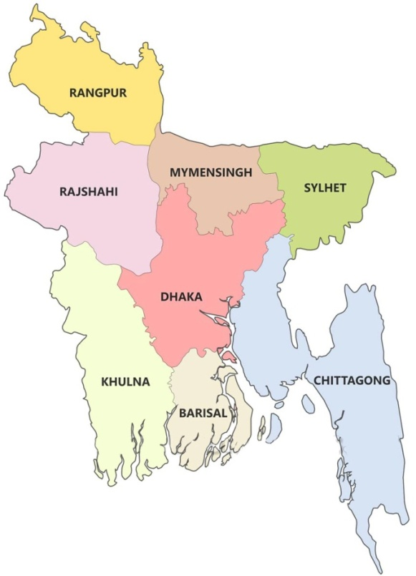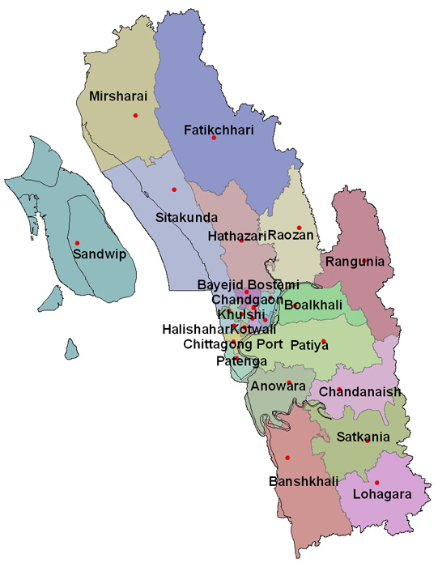
Fig 1: Map of Bangladesh and location of study areas in Chittagong.

2.2 Sources of data
Data for this study was obtained from both primary and secondary sources. The primary data were collected from the production performance, activities and economic condition of the chicken producers using structured questionnaires and the secondary data was obtained from Upazila Livestock Office at Banshkhali upazila under Chittagong district.

2.3 Sampling Procedure
The aim is to devise a sampling scheme which is economical; easy to operate; and, provides unbiased estimates with small ‘variance’ (Barnett, 1991). Given limitations in terms of money; time; efforts; and, data management - sampling is more appropriate method. Further, sampling not only saves cost and time but can also give more accurate results than a census which are more acceptable (Kinnear and Taylor, 1987; Casley and Kumar, 1988). Following steps have been involved in the sampling procedure:
2.3.1 Defining the Population
Classification of the population is the first step in the sampling procedure, namely, the sector or element under investigation, the sampling unit, the area or extent of investigation, and the duration of investigation (Kinnear and Taylor, 1987). All the poultry farms of the district engaged in poultry production were classified as population of the study.
2.3.2 Sample size
Casely and Kumar, (1988) suggested that a good survey sample should have both a small sampling error and minimum standard error. This can be obtained if one has unlimited resources. However, given constraints, such as finance, time and data management compromises have to be made in selecting the sample size (Poate and Daplyn, 1993).
Thus on the basis of - nature of research and analysis; number of variables; resource constraints; and, the importance of decision, a sample size of 40 (20 broiler and 20 layer farms) poultry
farms engaged in poultry production was selected.
2.3.3 Methods of data collection
Data were collected through direct interview schedule and recorded in a questionnaire/interview schedule. The schedule was prepared maintaining relevance with the objectives of the study. Before launching the survey, the questionnaire was pretested and improved accordingly. In order to collect the more purified data of various farms an organized questionnaire was formatted (Nauta et al., 2001; De Jong and Van Soest, 2001). Key informant technique was also employed to get the basic relevant information of the proposed study.

2.3.4 Data analysis
The data were put on the master sheet in Microsoft Office Excel 2007 and were arranged in tabular form. The obtained data imported to software STATA/IC-11.0 for analysis. Descriptive statistics (i.e. means, frequencies etc) was done to estimate the different variables. Unpaired unequal t-test was used to determine the level of significance (p<0.05 and p<0.01) between categorical variables ( Uddin et al., 2012 ).

CHAPTER-III
RESULTS AND DISCUSSIONS
3.1 Housing
The poultry houses in the Chittagong district, that are found in this study are mainly made of concrete (75% of the broiler and 80% of the layer houses) and remaining are made of mud (25% of broiler and 20% of layer houses). Corrugated iron sheet made roof were found 85% cases of both broiler and layer houses, concrete roof were found 10% of broiler and 15% of layer houses. Roof made of bamboo and leaf was found in 5% cases of broiler house but not found in layer house. In most of the cases sidewall of the house consists of wire netting (95% cases in broiler and 100% cases in layer house). Only one case of broiler (5%) the sidewall consists of bamboo splint netting. (Table 1 and 2).
The poultry house floor should made by concrete. Farooq et al., (2002) showed the mortality of bird lower in concrete floor than in those on brick and mud made floors Farooq et al., (2002) also reported that, maintenance of broiler under good hygiene conditions on well finished concrete floor, providing the required space per broiler following recommended vaccination are the key factors to reduce mortality among the broilers.
3.2 Floor management
In current study it was revealed that in 100% cases broilers are reared in floor and 35% of the layer farm rears their bird in floor (Table 1 and 2). Ratsaka et al., (2012) conducted a study to compare floor and case rearing of broiler. Feed intake, body weight gain and FCR of the chickens in that study were not affected by the system of rearing.
About 75% of the broiler farmer use rice husk, 15% use saw dust and 10% use wood shavings these findings are found in current study (Table 1 and 2). Mizu et al., (1998) reported that in Bangladesh different types of litter such as saw dust, sugarcane bagasses, rice husk, wheat straw, sand and ash are used.

3.3 Feeding
In present study it was revealed that 85% of the broiler and 20% of the layer farmer use hanging plastic feeder, 15% of both broiler and layer farmer use pot / bucket feeder and in 65% of the layer farm the feeder are attached with case (Table 1 and 2).
In terms of type of feed used, 15% of the broiler farmer used self prepared and readymade mash feed and remaining 70% use readymade pellet feed. In layer none of the farmer use readymade pellet but, 60% use readymade mash and remaining 40% use self prepared feed (Table 1 and 2). Jahan et al., (2006) in a study on poultry farm of Bangladesh Agricultural University, found the highest, intermediate and lowest body weight gain by crumble, pellet and mash feeding respectively. Mendes et al., (1995) showed that, bird feed mash diet had a better feed conversion ratio (FCR) than pellet.
3.4 Water management
In this study it was found that, 85% and 20% of layer farmer, 15% of both broiler and layer farmer use hanging plastic feeder and pot/bucket respectively. In 65% of the layer farms, the drinker is attached with the cage (Table1 and 2).
The scenery of water supply is that, 40% of broiler and 30% of layer farm perform water supply manually and 60% of broiler and 70% of layer farm use pump (Table 1 and 2).
3.5 Waste management
In terms of waste management there were found 15% of the broiler and 25% of the layer farmer dispose waste material (droppings and litter) to open air, 20% of broiler and 25% of layer farmer dispose to a pit, 25% of broiler and 15% of layer farmer used the litter in biogas plant, 5% of the broiler and 10% of the layer farmer sell to the market, 10% of the both broiler and layer farmer use as fish feed and 25% of broiler and 15% of layer farmer use to crop production (Table 1and 2). Similar study was conducted by Sarker et al., (2009) they showed that 20% of small farmer could not use their poultry litter for any particular work.

3.6 Biosecurity
The Biosecurity practices of the farms involved in present study is not so good. In broiler farms there is no enclosure found, footbath present only in 10% of the farm, disinfectant spray use only 25% of the farm, in about 35% of the farm the visitors are allowed, 90% of the farm have no isolation facilities and about 35% of the farms have chance to entry of migrating bird. In layer farm these parameters are 5%, 55%, 50%, 35%, 90%, and 25% respectively. (Table 1 and 2).
3.4 Common management Practices in poultry farms under study

Table 1: Management of broiler farm in study area of Chittagong district (N=20).
Variables | Categories | No. of farms | % of farms
Housing
Floor | Concrete | 15 | 75
 | Muddy | 5 | 25
 | Slats | 0 | 0
Rearing system | Floor | 20 | 100
 | Case | 0 | 0
Litter material | Rice husk | 15 | 75
 | Saw dust | 3 | 15
 | Wood shavings | 2 | 10
Feeding
Feeder type | Hanging plastic feeder | 17 | 85
 | Pot/ bucket | 3 | 15
 | Attached | 0 | 0
Water
Drinker type | Hanging drinker | 17 | 85
 | Pot/ bucket | 3 | 15
 | Attached | 0 | 0
Water supply | Manual | 8 | 40
 | Pump | 12 | 60
Waste disposal  (litter material) | To open air | 3 | 15
 | To a pit | 4 | 20
 | Biogas plant | 5 | 25
 | Sell | 1 | 5
 | Fish feed | 2 | 10
 | Crop field | 5 | 25
Biosecurity
Footbath | Present | 2 | 10
 | Absent | 18 | 90
Disinfectant spray | Use | 5 | 25
 | Not | 15 | 75
Visitors | Restricted | 4 | 20
 | Moderately restricted | 9 | 45
 | Allowed | 7 | 35
Migrating birds | Restricted | 13 | 65
 | allowed | 7 | 35

Table 2: Management of layer farm in study area of Chittagong district (N=20).
Variables | Categories | No. of farms | % farms
Housing
Floor | Concrete | 16 | 80
 | Muddy | 4 | 20
 | Slats | 0 | 0
Rearing system | Floor | 7 | 35
 | Case | 13 | 66
Feeding
Feeder type | Hanging plastic feeder | 4 | 20
 | Pot/ bucket | 3 | 15
 | Attached with cage | 13 | 65
Water
Drinker type | Hanging drinker | 4 | 20
 | Pot/ bucket | 3 | 15
 | Attached | 13 | 65
Water supply | Manual | 6 | 30
 | Pump | 14 | 70
Vaccination | Regular | 14 | 70
 | Irregular | 4 | 20
 | Not at all | 2 | 10
Waste disposal  (litter material) | To open air | 5 | 25
 | To a pit | 5 | 25
 | Biogas | 3 | 15
 | Sell | 2 | 10
 | Fish feed | 2 | 10
 | Use in crop production | 3 | 15
Biosecurity
Footbath | Present | 9 | 45
 | Absent | 11 | 55
Disinfectant spray | Use | 10 | 50
 | Not | 10 | 50
Visitors | Restricted | 5 | 25
 | Moderately restricted | 8 | 40
 | Allowed | 7 | 35
Migrating birds | Restricted | 15 | 75
 | allowed | 5 | 25

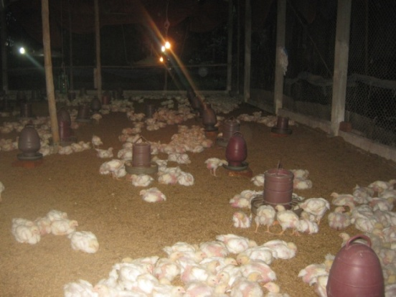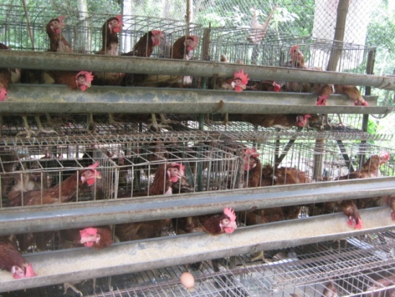
Fig.1: Broiler farm Fig. 2: Layer farm

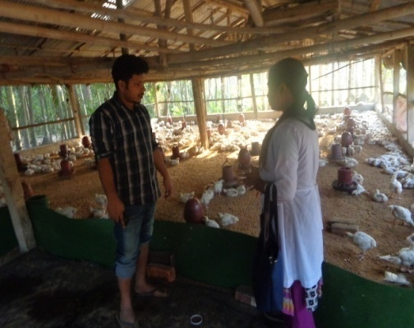
Fig. 3: Data collection from farmer

3.8 Marketing channel of poultry products
Marketing channel is the alternative routes of product flows from producers to consumers(khols and Uhls, 1980). The main objectives of broiler and layer farming is to earn profit by placing the meat and eggs at the disposal of the consumers. It involves a number of important activities at different stages which are performed by a series of intermediaries, linking the producers with the consumers. The channel of marketing of poultry products as found in the study areas are shown in the figure 3.1. The participants in the marketing channels of poultry products in the study areas are described briefly below:
Farm owner
Aratdar- cum-wholesaler
Retailer
Supplier
Consumer
Institutional Buyer

Fig : 4.1 Marketing Channels of meat and eggs
On the basis of Fig. 4.1 the following channels is identified for meat and egg marketing system in the study areas:
Channel - 1 : Farm Owner → Aratdar- cum- wholesaler→ Retailer → Consumer.
Channel - 2 : Farm Owner→Aratdar - cum- wholesaler → Supplier→ Institutional Buyer.
Channel - 3 : Farm Owner → Aratdar - cum - wholesaler → Institutional Buyer.
Channel -4 : From Owner →Aratdar-cum- wholesaler → Retailer → Institutional Buyer.
Channel - 5 : L Farm Owners → Institutional Buyer.
CHAPTER-IV
CONCLUSION
Poultry farming is a great opportunity for the rural people and youth as a means of income generation. Socioeconomic development might be achieved with the help of household poultry farming. There is a wide scope for the development of poultry farming in the countrywide because rural poor people have enough opportunity for rearing poultry. It would be really very helpful for income generation, women empowerment, and filling up nutritional gap for the rural family. Socio-economic position on subsidiary occupation, monthly household income and expenditure, cash in hand, savings with bank, household assets, number of school going children, monthly consumption of meat, eggs, vegetables, milk and fish, sources of drinking water, condition of latrines and health status of farmers have improved and the annual cost for treatment has reduced after adopting farming. Since most of the people irrespective of caste and religion prefer chickens and eggs, their demand and price are going up day by day. Most of the poultry farmers were small farmers while some of them were landless. Some improvements in the status of clothing, toilet condition, medical facilities, drinking water and housing have taken place because of poultry farming. It was also revealed that layer farming is more profitable than broiler, so farmers can adapt layer farming for maximum profit. In the present study, in terms of overall socio-economic improvement it was found that poultry farming helped to improve their socioeconomic condition. As a result, tendency to initiate poultry farming is widely observed in rural areas.

CHAPTER-V
LIMITAIONS AND RECOMMENDATIONS
5.1 Limitations
There were some limitations in my study. They are:
- The study period was limited and study area restricted to a particular district.
- The findings may not reflect the whole country.
- There was limited recording system in poultry farms under study as a result it was difficult to select valid data.
- Some of the farmers were not cooperative to give information.
5.2 Recommendations
To overcome the difficulties of poultry rising and to make poultry production more profitable in the country as well as uplifting the socio-economic status of the farmers, the following recommendations are put forward for the improvement of existing production of poultry.
- Regular vaccination is a prerequisite for any improvement in poultry production. Necessary steps should be taken to reduce the losses from diseases.
- The existence of a local market offering good sales opportunities and adequate transportation and communication system facilities are an obvious prerequisite for development of poultry industry.
- Availability of day old chicks should be ensured.
- Frequent training should be arranged for the poultry farmers.
- Regular supply of electricity should be ensured.
- Price stabilization should be ensured.
- Farmers need to be trained on chickens health care and management and concerned local NGO can take this responsibility.
- Farmers should establish the biosecurity cheek list, establishment standard for each of the cheek points, strictly maintaining these points and regular correction and standardization of biosecurity steps.

References

Ahmed, J.U., Mozumdar, L., Farid, K.S. and Rahman, M.W. 2009. Broiler farming: An approach to improve rural livelihood. Journal of Bangladesh Agricultural University, 7(2): 395-402.
Alam, J. 1995. Livestock resources in Bangladesh: Present status and future potential. University Press Limited, Dhaka, Bangladesh.
Alam, J. 1997. Impact of smallholder livestock development project in some selected areas of rural Bangladesh. Livestock for Rural Development, 9(3).
Ali, MA. 1993. An economic analysis of poultry farming in some selected areas of the Dhaka city. M.S. thesis, Bangladesh Agricultural University, Mymensingh, Bangladesh.
Anonymous, 1998. Food and nutrition guidelines for healthy adolescents. Ministry of health, New Zealand, Printed from, http://www.moh.govt.nz/moh.nsf/0/0697f789b648d3304c25666f0039933a/$FILE/fngha.pdf, pp: 18.
Barnett, V. 1991. Sample Survey Principles and Methods. Third edition, Edward Arnold Publisher Ltd, London. 1991.
Barroetoa, A.C. 2007. Nutritive value of poultry meat: relationship between vitamine E and PUFA. World Poultry Science Journal, 63.
Bhende, M.J. 2006. Production and cost of broiler meat: A case study of Karnataka. Agricultural Development and Rural Transformation Centre, Institute for Social and Economic Change, Bangalore, India.
Casely, D. and Kunnar, K. 1988. The collection, analysis and use of monitoring and evaluation data Baltimore. The Hohnces Hopkins University Press, Department of Agricultural Economics and Business, Wye College.
De Jong, H. and Van Soest, Y. 2001. De biologische melkveehouderijsector in kaart gebracht. Productschap Zuivel, Rijswijk.
Farooq, M., Zahir-ud-Din, Durrani, F.R., Mian, M.A., Chand, N. and Ahmed, J. 2002. Prevalent diseases and overall mortality in broilers. Pakistan Veterinary Journal, 22(3): 112-115.
Islam, S.M.F and Jabbar, M.A. 2005. Smallholder poultry model for poverty alleviation in Bangladesh: A review of evidence on impact. Livestock Research for Rural Development, 17(10).
Jabbar, M.A, Islam, S.M.F., Delgado, C., Ehui, S., Akanda, M.A., Khan,I. and Kamruzzaman, M. 2005b. Policy and scale factors influencing efficiency in dairy and poultry production in Bangladesh. ILRI (International Livestock Research Institute), Nairobi, Kenya: 89
Jahan, M.S., Asaduzzaman, M. and Sarkar, A.K. 2006. Performance of Broiler Fed on Mash, Pellet and Crumble. International Journal of Poultry Science, 5 (3): 265-270.
Kinnear, T.C. and Tayler, J.R. 1995. Marketing Research: An Applied Approach. Mc Grow. Hill Book Company, Singapore.
Mendes, A.A., Polity, E.S., Garcia, E.A. and Sartori, J.R. 1995. Effect of ground of pelleted diets on performance and carcass yield of broiler chicken. Veterinaria-e-zootecnia, 7: 31-40.
Mizu, M. M. R., Chowdhury, S. D., Karim, M. J. and Debnath, S.C. 1998. Influence of rice husk litter on broiler performance , litter dampness and its Coccidial oocysts population during winter. Asian-Australasian Journal of Animal Sciences, 11(4): 450-454.
Nauta, W.J., Baars, T., Groen, A.F., Veerkamp, R.F. and Roep, D. 2001. Animal Breeding in Organic Farming. Discussion paper, Louis Bolk Institute, Driebergen.
Neumann, C., Harris, D.M. and Rogers, L.M. 2002. Contribution of animal source foods in improving diet quality and function in children in the developing world. Nutrition Research, 22(1): 193-220.
Ottinger, M.A., Pike, T., Wilkinson, A. and Sandercock, D. 2009. Multidisciplinary use of chicken egg. Avian Biology Research, 2(13): 107-119.
Poate, C.D. and Daplyn, P.F. 1993. Data for Agrarian Development. First edition, Cambridge University Press.
Raha, S.K. 2007. “Broiler industry in Bangladesh: some issues”. Proceedings of the fifth International Poultry Show and Seminar, Organized by World’s Poultry Science Association, Bangladesh Branch, Dhaka, Bangladesh.
Rahman, S.M.A., Sayeed, M.A., Sarker, N.R. and Alam, J. 2006. Impact of improved poultry management technique on socio-economic condition of broiler beneficiaries. Journal of Bangladesh Agricultural University, 4 (2): 401-411.
Ratsaka, M., Ngambi, J. W. and Ndlovu, L. R. 2012. Effect of Potable Cage Rearing System and Stocking Density on Growth, Feed Intake and Carcass Characteristics of Ross 308 Broiler Chickens. Journal of Animal Science Advances, 2(3.2): 312-320.
Saleque, A. 2000. Scaling-up critical factors in leadership, management, human resource development and institution building in going from pilot project to large-scale implementation: The BRAC poultry model in Bangladesh. In: Dolberg F and Petersen PH (eds), Poultry as a tool in poverty eradication of gender equality. Proceedings of a workshop held at Tune, Denmark, 22–26 March 1999.
Sarker, B.C., Alam, M. A., Rahman, M.M., Islam, T. A. F. M. and Chowdhury, M.G.F. 2009. Waste Management of Commercial Poultry Farms in Bangladesh. Journal of Innovation & Development Strategy,2(3): 34-37.
Uddin, M. N., Uddin, M. B., Mamun, M., Hassan, M. M. and Khan, M. M. H. 2012. Small Scale Dairy Farming for Livelihoods of Rural Farmers: Constraint and Prospect in Bangladesh. Journal of Animal Science Advances, 2(6): 543-550.

