

**Determinants of Malnutrition of the Rohingya Refugee Children Living in Ukhia, Cox’s Bazar, Bangladesh**

**Moshfequa Rahman Khan**

Roll No. 0117/06; Registration No. 00426

Session: 2017-2018

A thesis submitted in the partial fulfillment of the requirements for the degree of Masters of Science (MS) in Applied Human Nutrition and Dietetics

Department of Applied Food Science and Nutrition

Faculty of Food Science and Technology

Chattogram Veterinary and Animal Sciences University

Chattogram-4225, Bangladesh

**June 2019**

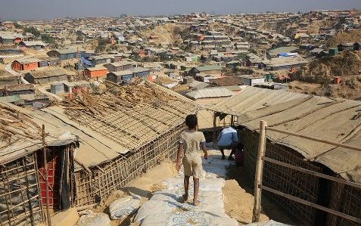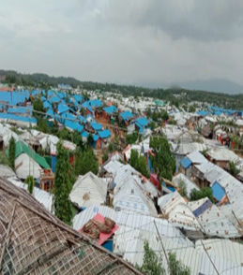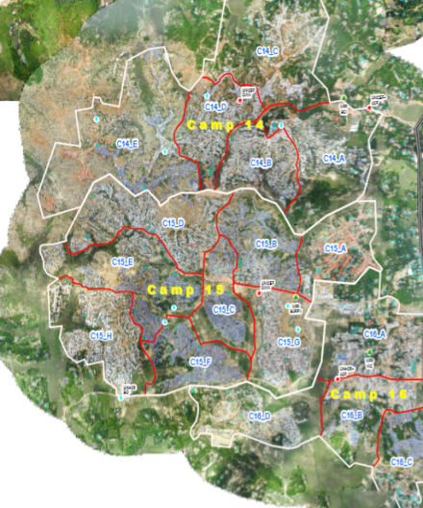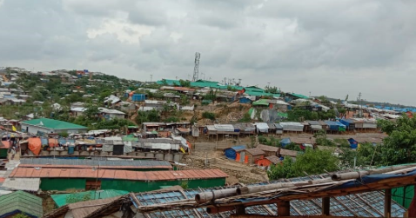

**Determinants of Malnutrition of the Rohingya Refugee Children Living in Ukhia, Cox’s Bazar, Bangladesh**



**Moshfequa Rahman Khan**

Roll No.: 0117/06; Registration No.: 00426

Session: 2017-2018

This is to certify that we have examined the above Master’s thesis and have found that the thesis is complete and satisfactory in all respects and that all revisions required by the thesis examination committee have been made

|  |  |
| --- | --- |
| **_____________________________**  **(Prof. Md. Emran Hossain)**  Supervisor  Department of Animal Science and Nutrition, CVASU | **_______________________________**  **(Prof. Md. Ahasanul Hoque)**  Co-supervisor  Department of Medicine and Surgery, CVASU |
| **_________________________________**  **(Asst. Prof. Md. Altaf Hossain)**  Chairman of the Examination Committee  Department of Applied Food Science and Nutrition  Chattogram Veterinary and Animal Sciences University  Khulshi, Chattogram-4225, Bangladesh | |

**June 2019**

# Authorization

I hereby declare that I am the sole author of the thesis. I also authorize the Chattogram Veterinary and Animal Sciences University (CVASU) to lend this thesis to other institutions or individuals for the purpose of scholarly research.

I further authorize the CVASU to reproduce the thesis by photocopying or by other means, in total or in part, at the request of other institutions or individuals for the purpose of scholarly research.

I, the undersigned, and author of this work, declare that the **electronic copy** of this thesis provided to the CVASU Library, is an accurate copy of the print thesis submitted, within the limits of the technology available.

Moshfequa Rahman Khan

June 2019

**I dedicate this thesis to my beloved parents, brothers and teachers**

# Acknowledgements

Firstly, I would like to express the deepest sense to "The Almighty Allah" who enables the author to complete the research work and dissertation successfully for the degree of Master of Science in Applied Human Nutrition and Dietetics.

I extend my gratefulness to my supervisor Professor Md. Emran Hossain, Department of Animal Science and Nutrition, Chattogram Veterinary and Animal Sciences University (CVASU) for his scholastic guidance and supervision of the report work and write up of the dissertation. I express my special thanks to Md. Ahasanul Hoque, Professor, Department of Medicine and Surgery for helping me in analysis, reporting and other supports related to this thesis work.

I am thankful from core of my heart to Md. Ariful Kabir Sujan, Senior Program Manager –Nutrition, SCI for his kind cooperation, valuable suggestions, instructions and constructive criticism throughout the research period.

It is with sincere gratitude that I wish to thank SCI (Save the Children International in Bangladesh), ACF (Action Contre la Faim), SARPV (Social Assistance and Rehabilitation for the Physically Vulnerable) for their kind approach in data collection and also their continuous guidance.

I would express my deep sense of gratefulness to Rahul Biswas, Project Officer- FSL & DRR, ACF, Jahid Alam, Assistant Project Officer- Nutrition, ACF, Shahed Hossain, and Ziaul Hasan Rashel, OTP Assistant, SCI for their support at the time of my data collection. Their active participation helped me to collect individual information with measurements and supported me to communicate with interviewers by their local language to fill-up questionnaire.

I would like to express my gratitude and cordial thanks to the National Science and Technology (NST) and University Grants Commissions (UGC), Bangladesh for the financial aid during the study period.

Finally, I am expressing ever indebtedness to my beloved parents, family members, friends and well-wishers for their understanding, endless patience and encouragement when it was most required.

The author

June 2019

# Table of Contents

Authorization IV

Acknowledgements VI

Table of Contents VII

List of Tables X

List of Figures X

List of Abbreviations XII

**Abstracts** XIII

**Chapter I: Introduction** 1

1.1 Rationale of the study 2

1.2 General objective 2

1.3 Specific objectives 3

**Chapter II: Review of Literature** 4

2.1 Malnutrition 4

2.2 Types of malnutrition 4

2.3 Driving factors of malnutrition 5

2.3.1 Diseases 5

2.3.2 Dietary practices 6

2.3.3 Poverty and food prices 6

2.3.4 Breastfeeding 6

2.4 Consequence of malnourishment 7

2.5 Measurement parameters 7

2.5.1 Mid upper arm circumference (MUAC) 7

2.5.2 Z- Score 7

2.6 Food insecurity and malnutrition in refugee situation 8

2.7 Health and nutritional status of the refugee 9

2.8 Similar studies conducted elsewhere 10

2.9 Identification of research gap 10

**Chapter III: Materials and Methods** 11

3.1 Study area 11

3.2 Study design and period 12

3.3 Population 12

3.4 Sampling frame 12

3.5 Sample size calculation and study population 12

3.6 Study parameter 13

3.7 Ethical issue 13

3.8 Data collection tool 13

3.9 Data collection 14

3.10 Calculation of mid upper arm circumference (MUAC) 14

3.11 Calculation of Z-score 14

3.12 Measurement of body weight 14

3.13 Measurement of height 16

3.14 Measurement of nutrition status 16

3.15 Data verification 16

3.16 Statistical evaluation 16

**Chapter IV: Results** 18

4.1 Descriptive statistics 18

4.2 Anthropometric factors influencing MUAC score 19

4.3 Hygiene, sanitation, nutrition and health factors affecting MUAC 22

4.4 Association of the factors affecting MUAC 27

**Chapter V: Discussion** 28

5.1 Anthropometric factors influencing MUAC 28

5.2 Hygiene and sanitation factors affecting MUAC 29

5.3 Health and immunization issues affecting MUAC 30

5.4 Nutrition factors affecting MUAC 30

5.5 Association of the factors affecting MUAC 31

5.6 Conclusion 31

5.7 Limitations 31

5.8 Recommendations 32

5.9 Future directions 32

**References** 33

**Appendix I**: Questionnaire 41

**Appendix II**: Measurement of Length 44

**Appendix III**: Measurement of Height 45

**Appendix IV**: Measurement of MUAC 46

**Appendix V**: Distribution of MUAC-score 47

**Appendix VI**: Generalized Linear Model 48

**Appendix VII**: Z-score 49

**Appendix VIII**: Sample database for data collection 51

**Appendix IX**: Acceptance letter of the thesis manuscript 53

# List of Tables

**Table 2.1** Number of globally undernourished children 7

**Table 4.1** Influencing factors of MUAC1 score according to nutritional status of the Rohingya children……………………………………………………………………19

**Table 4.2** Effects of family size on MUAC score of the Rohingya children 20

**Table 4.3** Effects of mother’s parity on MUAC score of Rohingya children 20

**Table 4.4** Hygiene, sanitation, nutrition, immunization and health factors affecting MUAC score in the under-5 Rohingya children 23

**Table 4.5** Correlation coefficient matrix of the factors affecting MUAC and Z-score in the under-5 Rohingya children 27

# List of Figures

**Figure 2.1** Driving factors of malnourishment 5

**Figure 2.2** Global comparison of Rohingya children (<5 years) with other refugee children across the world 9

**Figure 4.1** Distribution of MUAC score according to father’s level of education and sex of the Rohingya children 18

**Figure 4.2** Distribution of MUAC score according to mother’s level of education and sex of the Rohingya children 19

**Figure 4.3** Distribution of MUAC score according to parity and sex of the Rohingya children 21

**Figure 4.4** Distribution of MUAC score according to family size and sex of the Rohingya children 22

**Figure 4.5** Distribution of MUAC score according to use of footwear and sex of the Rohingya children 24

**Figure 4.6** Distribution of MUAC score according to use of tube well and sex of the Rohingya children 24

**Figure 4.7** Distribution of MUAC score according to disposal type of feces and sex of the Rohingya children 25

**Figure 4.8** Distribution of MUAC score according to nutritional status and sex of the Rohingya children 25

**Figure 4.9** Distribution of MUAC score according to frequency of breastfeeding and sex of the Rohingya children 26

**Figure 4.10** Distribution of MUAC score according prevalence of diarrhea and sex of the Rohingya children 26

# List of Abbreviations

|  |  |  |
| --- | --- | --- |
| BCG | - | Bacillus Calmette - Guerin |
| CiC | - | Camp-in-Charge |
| cm | - | Centimeter |
| DHS | - | Demographic and Health Survey |
| ESP | - | Essential Services Package |
| FAO | - | Food and Agriculture Organization |
| GAM | - | Global Acute Malnutrition |
| GoB | - | Government of Bangladesh |
| GoM | - | Government of Myanmar |
| IYCF | - | Infant and Young Child Feeding |
| kg | - | Kilogram |
| MAM | - | Moderate Acute Malnutrition |
| mm | - | Millimeter |
| MoH | - | Ministry of Health |
| MoU | - | Memorandum of Understanding |
| MUAC | - | Mid Upper Arm Circumference |
| NGO | - | Non-Governmental Organization |
| NNP | - | National Nutrition Project |
| OTP | - | Out Patient Therapeutic Program |
| RRRC | - | Refugee Relief and Repatriation Commission |
| RUTF | - | Ready to Use Therapeutic Diet |
| SAM | - | Severe Acute Malnutrition |
| SE | - | Standard Error |
| UN | - | United Nations |
| UNHCR | - | United Nations High Commissioner for Refugees |
| UNICEF | - | United Nations Children ‘s Fund |
| WFP | - | World Food Program |
| WHO | - | World Health Organization |

# Abstracts

Malnutrition is a severe problem of the Rohingya refugee children in Bangladesh. A cross-sectional study was conducted to assess the determinants of malnutrition of the children (N=500) of Myanmar Rohingya Refugee living in Ukhia, Cox’s Bazar, Bangladesh. The children were measured for height, weight, Mid Upper Arm Circumference (MUAC) and Z-score while their parents were interviewed for the socio-demographic, dietary, sanitation and health information. Results indicated that, the difference between the age of father and mother in Rohingya people was substantially higher (mean 37.3 *vs.* 26.9 for father and mother, respectively). The gradually increasing trend of the age of father and mother was significantly associated with similar propensity of the MUAC score of the children. As the status of nutrition improved from Severe Acute Malnourished (SAM) to Normal, there was a subsequent fall off for the parity score of mother exhibiting overall best parity at 4.9. Similarly, chronological drop off in the family size evolved surprisingly better nutritional status of the children measured in terms of MUAC. Similar to age of the parents, progression in the expanding trends of the age, height and weight of the children, gradually ruled out their susceptibility towards malnutrition. Better educational qualification of the parents, vividly precipitated improved MUAC score in the children. There was a strong and positive significant relationship between father and mother age (r=0.81; P<0.05), parity and mother age (r=0.77; P<0.05), parity and family size (r=0.89; P<0.05) and child age and height (r=0.84; P<0.05). The Rohingya children who used to put on clean dress, bath regularly, cut nail properly, have footwear and tooth brush exhibited markedly better (P<0.001) MUAC score compared to those children who did not have those full practices. Similarly, children having practice of hand wash prior to eat, habit of not eating from floor and use of drinking water from the tube well had improved MUAC score compared to those who ignored them. Use of sanitary latrine compared to throwing feces in the hole or letting it open was tightly pertinent to better MUAC score. Frequency of 7-8 times breastfeeding a day deliberately pushed forward elevated MUAC. In all respects, normal children pursued the highest MUAC score compared to Moderate Acute Malnourished (MAM) or SAM. Therefore, better hygiene, sanitation, immunization, nutrition and health practices are recommended to boost up nutrition status of the Rohingya refugee children.

­

**Keywords:** Bangladesh, Height, Malnutrition, MUAC, Rohingya, Z-score

# Chapter I: Introduction

The nutritional status of the children is a reflection of their overall health (Bidlack, 2013). Malnutrition refers to getting too little or too much of certain nutrients which can lead to serious health issues including stunted growth (Emanuella *et al*., 2018), eye problem (Motbainor and Taye, 2019), diabetes (Vinicius *et al*., 2011) and heart disease (Osmond and Barker, 2000). Malnutrition is marked by a deficiency of energy, essential proteins, fats, vitamins and minerals in a diet (Kemmer *et al*., 2003; Luxemburger *et al*., 2003; Abudayya *et al*., 2007). Over 10 million children aged less than five years die annually from preventable and treatable illnesses and almost all of these deaths occur in poor countries (WHO, 2002). Currently, 195 million under-5 children are affected by malnutrition and 90% of them live in sub-Saharan Africa and South Asia. Out of 195 million, at least 20 million children suffer from severe acute malnutrition and 175 million are undernourished (Albelti *et al*., 2006).

The issue of forced migration is of global concern today (Ullah, 2011). The world is witnessing the largest number and magnitude of the exodus since the second world war (Smith, 1995). Millions of people flee from their homelands in various Asian and African countries and seek shelter in other countries (Abrar, 1994). They become desperate enough to embark on a journey they don’t know the outcome. Thousands of people dare to cross perilous oceans and rivers in the hope of mere survival. Many of them do not even live to see the end of their journey, while some of them face a worse fate as they fall victim to human trafficking (Devitt, 2011). This refugee crisis is becoming more and more crucial in context of Bangladesh owing to the frequent and intensified conflicts in the neighboring country Myanmar. Due to recent outbreaks of military massacres in the Rakhine state of Myanmar, thousands of Rohingyas are pouring into Bangladesh every day (Ahmed, 2010; MSF, 2010).

The Rohingya people are a stateless Indo-Aryan ethnic group who reside in Rakhine State, Myanmar and now considered as refugee in Bangladesh. Refugees, most of the time are forced to flee leaving a major portion of their assets behind (Feeny, 2001). Even if they find asylum in other countries, a lack of work permit and limited options in the labor market in the host community shrink the chances of achieving their financial stability and education except minimum access to religious/informal schools organized by United Nations High Commissioner for Refugees UNHCR and other non-governmental agencies (UNHCR, 2007). As a result, the refugees lack access to markets and are unable to afford nutritious foods which make them vulnerable to food insecurity and malnutrition (WFP, 2013).

## 1.1 Rationale of the study

Though Bangladesh has improved over few indicators regarding health and nutrition of the under-5 children but still refugee people are discriminated because still now they are responsible by UNHCR. Additionally, they have many traditional beliefs (e.g. They don’t want to feed the colostrum because they think it will disturb the stomach of the neonatal) and misconceptions (e.g. Iron folic acid intake makes the fetus larger than the normal required size) that are related to eating behavior and health issues, mainly because of lack of education.

Very few accessible studies have been done regarding health issues of refugee people. Moreover, these works do not cover all the areas of health and nutritional status of under-5 children of the refugee people. Children are the more vulnerable group but no systematic research, has so far been conducted on the health behavior and nutritional status among the refugee Rohingya people in Cox’s Bazar district as this is a recent issue.

This study, therefore, aims to facilitate the visibility of this community to policy makers, NGO workers and donors for increasing their understanding of the main causes of malnutrition and the ways to improve the health and nutritional status of the under-5 children of the forcibly displaced Rohingya refugee people in Bangladesh.

**1.2 General objective**

Observe the overall determinants associated with child malnutrition of the Rohingya refugee people in the selected areas of Cox’s Bazar.

* 1. **Specific objectives**

1. To measure the anthropometry of Rohingya children in Cox’s Bazar.
2. To assess the hygiene and sanitation practices in the Rohingya camp.
3. To evaluate the nutritional status of the Rohingya children.
4. To assess the health status of the Rohingya children.

**Chapter II: Review of Literature**

Very few researches have health reflected the problems of Rohingya people in Bangladesh. This thesis attempts to present some literature related to the research previously conducted in Bangladesh as well as in other countries of the world. Therefore, the aim of this paper is to analyze the nutrition status and health behavior of under-5 year children of Rohingya people in Bangladesh.

## 2.1 Malnutrition

Malnutrition is a condition that results from eating a diet in which one or more nutrients are either not enough or are too much such that the diet causes health problems (UNICEF, 2010). It may involve calories, protein, vitamins or minerals (UNICEF, 2010). Not enough nutrients are called undernutrition or under- nourishment while too much is called over nutrition (Young, 2012). Malnutrition is often used to specifically refer to undernutrition where an individual is not getting enough calories, protein, or micronutrients (Manoj and Ashutosh, 2011; Young, 2012). Undernourishment is most often due to not enough high-quality food being available to eat (WHO, 2014). This is often related to high food prices and poverty (UNICEF, 2010; WHO, 2014). A lack of breastfeeding may contribute, as may a number of infectious diseases, e.g., gastroenteritis, pneumonia, malaria, and measles, may increase nutrient requirements (WHO, 2014).

## 2.2 Types of malnutrition

There are two main types of undernutrition: [protein-energy malnutrition](https://en.wikipedia.org/wiki/Protein-energy_malnutrition) and dietary deficiencies (Manoj and Ashutosh, 2011). Protein-energy malnutrition has two severe forms: [marasmus](https://en.wikipedia.org/wiki/Marasmus) (a lack of protein and calories) and [kwashiorkor](https://en.wikipedia.org/wiki/Kwashiorkor) (a lack of just protein) (Young, 2012). Common micronutrient deficiencies include: a lack of [iron](https://en.wikipedia.org/wiki/Iron_deficiency), [iodine](https://en.wikipedia.org/wiki/Iodine_deficiency), and [vitamin A](https://en.wikipedia.org/wiki/Vitamin_A_deficiency) (Young, 2012). Malnutrition can be divided into two different types, SAM and MAM. SAM refers to children with severe acute malnutrition. MAM refers to moderate acute malnutrition (Sathish *et al.*, 2014). However, the term malnutrition is commonly used to refer to undernutrition only (Nikolaos, 2011).

## 2.3 Driving factors of malnutrition

Major causes of malnutrition include poverty and food prices, dietary practices and agricultural productivity, with many individual cases being a mixture of several factors. [Clinical malnutrition](https://en.wikipedia.org/wiki/Clinical_malnutrition), such as [cachexia](https://en.wikipedia.org/wiki/Cachexia), is also a major burden in [developed countries](https://en.wikipedia.org/wiki/Developed_country). Various scales of analysis also have to be considered in order to determine the sociopolitical causes of malnutrition. For example, the population of a community that is within poor governments, may be at risk if the area lacks health-related services, but on a smaller scale certain households or individuals may be at an even higher risk due to differences in income levels, access to land, or levels of education (Fotso and Kuate, 2005). UNICEF conceptual framework of causes of malnutrition (UNICEF, 1997) is given in Figure 2.1.

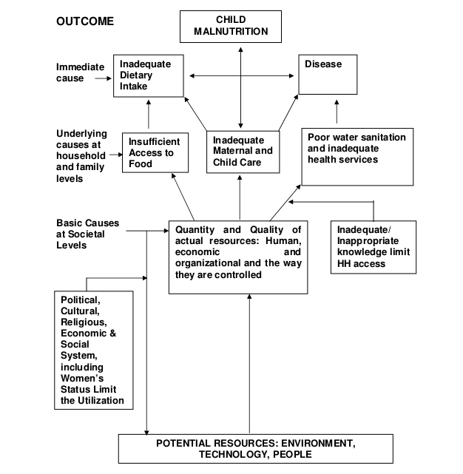

Figure 2.1 Driving factors of malnourishment

### 2.3.1 Diseases

Malnutrition can be a consequence of health issues such as [gastroenteritis](https://en.wikipedia.org/wiki/Gastroenteritis) or [chronic illness](https://en.wikipedia.org/wiki/Chronic_illness) (Mandell *et al.*, 2010), especially the [HIV/AIDS pandemic](https://en.wikipedia.org/wiki/HIV/AIDS_pandemic) (Baro and Deubel, 2006). [Diarrhea](https://en.wikipedia.org/wiki/Diarrhea) and other infections can cause malnutrition through decreased nutrient absorption, decreased intake of food, increased metabolic requirements, and direct nutrient loss (Musaiger *et al.*, 2011). Parasite infections, in particular [intestinal worm infections](https://en.wikipedia.org/wiki/Helminthiasis) (helminthiasis) can also lead to malnutrition (Musaiger *et al.*, 2011). A prime cause of [diarrhea](https://en.wikipedia.org/wiki/Diarrhea) and intestinal worm infections in children in developing countries is lack of [sanitation](https://en.wikipedia.org/wiki/Sanitation) and [hygiene](https://en.wikipedia.org/wiki/Hygiene).

### 2.3.2 Dietary practices

A lack of adequate breastfeeding leads to malnutrition in infants and children, associated with the deaths of an estimated one million children annually. Illegal advertising of breast milk substitutes contributed to malnutrition and continued three decades after its 1981 prohibition under the WHO International Code of Marketing Breast Milk Substitutes (Brady, 2012).

### 2.3.3 Poverty and food prices

In Bangladesh, poor socioeconomic position was associated with chronic malnutrition since it inhibits purchase of nutritious foods such as milk, meat, poultry, and fruits (Khan and Kraemer, 2009). As much as food shortages may be a contributing factor to malnutrition in countries with lack of technology, the [FAO](https://en.wikipedia.org/wiki/FAO) (Food and Agriculture Organization) has estimated that eighty percent of malnourished children living in the developing world live in countries that produce food surpluses (Gardner and Halweil, 2000).

### 2.3.4 Breastfeeding

Lack of breastfeeding is another cause of malnutrition. As of 2016 is estimated that about 823,000 deaths of children less than five years old could be prevented globally per year through more widespread breastfeeding (Victora *et al.*, 2016). In addition to reducing infant death, breast milk feeding provides an important source of micronutrients, clinically proven to booster the immune system of children and provide long-term defenses against non-communicable and allergic diseases (Lessen and Kavanagh, 2015).

## 2.4 Consequence of malnourishment

The United Nations estimated that there are 804 million undernourished people in the world in 2016 (Table 2.1) UN's definition of 'undernourishment', where it refers to insufficient consumption of raw calories, and so does not necessarily include people who lack micro nutrients (FAO, 2019). The undernourishment occurred despite the world's farmers producing enough food to feed around 12 billion people – almost double the current world population (FAO. 2017).

Table 2.1 Number of globally undernourished children

|  |  |  |  |  |  |  |  |  |  |  |  |  |
| --- | --- | --- | --- | --- | --- | --- | --- | --- | --- | --- | --- | --- |
| Year | 2005 | 2006 | 2007 | 2008 | 2009 | 2010 | 2011 | 2012 | 2013 | 2014 | 2015 | 2016 |
| No. (million) | 945 | 911 | 877 | 855 | 840 | 821 | 813 | 806 | 795 | 784 | 784 | 804 |
| Percentage | 14.5% | 13.8 | 13.1 | 12.6 | 12.2 | 11.8 | 11.5 | 11.3 | 11.0 | 10.7 | 10.6 | 10.8 |

## 2.5 Measurement parameters

### 2.5.1 Mid upper arm circumference (MUAC)

The elaboration form of MUAC is Mid Upper Arm Circumference. The mid upper arm circumference can be an objective confirmation of the clinical observation of thinness or fatness. The major determinants of MUAC are muscle and sub-cutaneous fat. MUAC is less affected than height and weight based index (e.g., Body Mass Index is influenced by accumulation of fluids, i.e., oedema and ascites). Thus, MUAC is a good predictor of malnutrition (Dasgupta *et al*., 2010). MUAC is recommended for use between six and fifty-nine months of age and for assessing acute energy deficiency in adult during famine. MUAC predicted death in children better than any other anthropometry indicator (WHO, 2002).

### 2.5.2 Z- Score

Z-score is the number of standard deviations from the mean a data point. Technically it’s a measure of how many standard deviations below or above the population mean a raw score is. A z-score is also known as a standard score and it can be placed on a normal distribution curve. Z-scores range from -3 standard deviations (which would fall to the far left of the normal distribution curve) up to +3 standard deviations (which would fall to the far right of the normal distribution curve). In order to use a Z-score, need to know the mean μ and also the population standard deviation σ. Z-score is the most appropriate description of malnutrition, health and nutrition centers have been in practice reluctant to adopt its use for individual assessment (WHO, 1995).

## 2.6 Food insecurity and malnutrition in refugee situation

A high proportion (more than 90%) of refugees faces food insecurity in Australia. Inadequate access to jobs, social services and financial aid by the government results in increased vulnerability to food insecurity (McKay and Dunn, 2015). The food insecurity condition of Ethiopia has further deteriorated because of the mass exodus of asylum seekers from South Sudan and Somalia. Ethiopia provides refuge to about 700000 people (Nkunzimana *et al*., 2016). As of August 2013, the nutrition situation in this camp can be summarized as follows:

|  |  |  |  |  |  |
| --- | --- | --- | --- | --- | --- |
| Indicator | Prevalence ( % ) | Lower boundary | Upper boundary | Confidence interval (%) | Categorization |
| GAM1 | 3.9 | 2.5 | 5.9 | 95 | Acceptable |
| Stunting | 46.8 | 42.5 | 51.1 | 95 | Critical |
| Underweight | 15.2 | 12.3 | 18.5 | 95 | Poor |

1Global Acute Malnutrition

By the end of 2014, 59.5 million persons faced forced migration due to oppression, war, violence or desecrations of human rights. The top 3 countries of origin were Syrian Arab Republic, Afghanistan and Somalia, accounting for more than half of the global refugees. Turkey hosted the highest number of asylum seekers followed by Pakistan, Lebanon, Iran, Ethiopia and Jordan. About 25 percent of the refugees found shelter in the least developed countries (World at war, 2015).

In 2015, the Syrian Arab Republic produced more than half of the new refugees. Other countries of origin include Afghanistan, Burundi and South Sudan Global Trends Forced Displacement in 2015, 2016. Jordan has been the refuge of more than half a million of Syrians for a long time. Due to the prolonged nature of the emergency, Jordan is now facing food insecurity along with disruption in several aspects such as livelihoods, health and organization (FAO, 2014). For children of Syrian refugee anemia prevalence was the highest Za‘atri camp in Jordan was (48.4 %).

Figure 2.2 Global comparison of Rohingya children (<5 years) with other refugee children across the world

The nutritional status (Wasting) of refugee children of Bangladesh are poor. In this figure wasting rate is very high in Rohingya refugee children than other refugee children like Iraqi, Somalia and Syrian (Abudayya *et al.*, 2007)*.*

## 2.7 Health and nutritional status of the refugee

In Bangladesh there are limited published papers conducted on health or nutritional status of under-5 children of Rohingya community and very few of them conducted on health status of Rohingya people (Smith, 1995; Ullah, 2011). The general health status of refugees in various countries is reported to be poor with malnutrition being the major health problem due to lack of access to sufficient food and nutrient intakes (Luxemburger *et al*., 2003; Kemmer *et al*., 2003; Abudayya *et al*., 2007). Other health problems among refugees include mental illnesses, intestinal parasites, hepatitis B, tuberculosis, diarrhea, malaria and anemia (Osmond and Barker, 2000). Infants and young children are often the earliest and most frequent victims of violence, disease, and malnutrition which accompany population displacement and refugee outflows (Devitt, 2011).

## 2.8 Similar studies conducted elsewhere

A study conducted in Bangladesh about factors causing malnutrition among under five children (Rayhan and Khan, 2000). This study investigated differential impact of socio-economic environmental and health related factors on nutritional status among under five children in Bangladesh. The analysis revealed that 45 percent of the children under five were suffering from chronic malnutrition, 10.5 percent were acutely malnourished and 48 percent had under-weight problem. The main contributing factors of malnutrition were found to be previous birth interval, size at birth, mothers body mass index at birth and parents. Another study conducted in Ethiopia about risk factors for Severe Acute Malnutrition (SAM) in children under the age of five (Amsalu and Tigabu, 2008). The findings of this study confirmed the association of severe acute malnutrition with inappropriate child feeding practices.

## 2.9 Identification of research gap

In Bangladesh there are several studies about the factors causing malnutrition and their health and nutritional status of under five children (Ahmed, 2010). In those studies, the malnutrition factors are education, medical care, socio-economic condition, mother health status, hygiene practice, knowledge about balanced diet, breastfeeding and complementary feeding practices (Smith and Hadded, 2000). The issue of forced migration and refugee is of global concern today but there was no published data about their health and nutritional status and the factors effect malnutrition (Ullah, 2011). From this perspective, it appears, there is a clear research gap for finding the actual determinants of malnutrition of the Rohingya refugee children.

# Chapter III: Materials and Methods

## 3.1 Study area

The study was conducted at Jamtoli camp in the Ukhiya upazila of Cox’s Bazar district. Jamtoli is the biggest camp with highest population that’s why we choose it for study purpose. The Jamtoli camp (Latitude 21°09′22″ N and Longitude 92°08′22″ E) located in the south-eastern part of the Ukhia upazila was selected for the study. During the study period, the average ambient temperature of the study area was 32.5°C, humidity 78.0%, precipitation 0.0% and wind speed was 13 km/h.

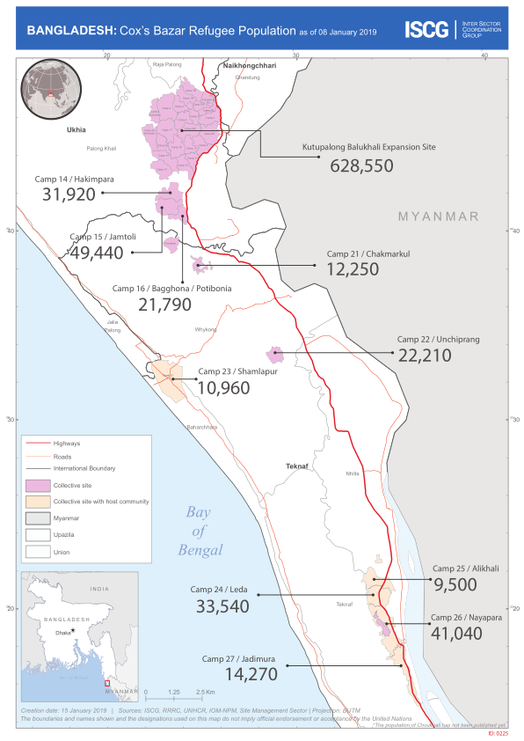**Figure 3.1** Map of the study area

## 3.2 Study design and period

A cross sectional study was conducted during July 2018 to February 2019 of children of Myanmar up to 5 years at Jamtoli camp, Ukhia, Cox’s Bazar.

## 3.3 Population

All the children (up to 59 months) living in Ukhia, Cox’s Bazar except Jamtoli camp were considered as reference population. All children (up to 59 months) of the Rohingya refugee living only in the Jamtoli camp in Ukhia, Cox’s Bazar was considered as source population.

## 3.4 Sampling frame

A sample frame of 4000 households was constructed based on following predetermined criteria:

* The household must belong to Rohingya.
* Father and mother must be present in the family.
* The family must have at least one child up to 5 years.
* The family is willingly interested to participate the interview.
* Family size must be within 3 to 20.

## 3.5 Sample size calculation and study population

The sample size for the study was determined by using the following formula (Kadam and Bhalerao, 2010):

n *= ${\left(\frac{z}{m}\right)}^{2}×p(1-p)$*

Where,

n= required sample size; z= confidence interval 95% = 1.96

p= prevalence of malnutrition among Rohingya children= 11% (Emergency Nutrition Assessment Round-3, 2018)

m= margin of error at 2.75%

Therefore,

n= ${\left(\frac{1.96}{0.0275}\right)}^{2}×0.110\left(1-0.110\right)$ ≈ 496

The sample size was further increased by 1% to account for contingencies such as non-response or recording error. Thus the total sample size was 500 (N + 1% = 496 + (496×0.01) = 500). The households to be interviewed were identified by walking door to door from the entrance to the end of the camp until the target sample size was reached. A structured questionnaire containing both open and close ended questions were developed to collect required information of the households.

## 3.6 Study parameter

The anthropometry, socio-economic and demographic characteristics, hygiene, sanitation, nutrition, health and behavioral practices of the households in the Rohingya camp were studied.

## 3.7 Ethical issue

Ethical guidelines of the Declaration of Helsinki IV, 2001 were followed for the study. Ethical approval was obtained from the nutrition and health partner NGO who worked in that camp to take care of them. Written consent of each respondent was taken before interview. The questionnaire was designed considering the privacy of the subject. The respondent’s personal information was kept confidential.

## 3.8 Data collection tool

A structured questionnaire (Appendix I)was used for collection of anthropometric, demographic, dietary, health, nutrition, hygiene and sanitation related data. Child Height Board and Weight scale were used for the measurement of child height (Appendix II, III) and weight. Mid Upper Arm Circumference (MUAC) tape was used for the measurement of MUAC (Appendix IV) (WHO, 2006). The Z-score was calculated using standard charts (Appendix VII) (WHO, 2006).

## 3.9 Data collection

The primary data were collected by myself in a face to face interview. The secondary data related to MUAC and Z-score were calculated from WHO Standard Charts (WHO, 2006). The questionnaire was pretested in zones outside the sampling area and re-examined on the premise of feedback (Tinson *et al*., 2008). After the pilot test, the questionnaire was validated with the real situation to ensure reliability of the study.

## 3.10 Calculation of mid upper arm circumference (MUAC)

Mid Upper Arm Circumference is the circumference of the left upper arm and is measured at the mid-point between the tip of the shoulder and elbow. Procedure to measure MUAC (Appendix IV), (WHO, 2006) is as follows: (a) Bend the left arm, find and mark with a pen in the olecranon process and acromion (b) Mark the mid-point between these two marks (c) with the arm hanging straight down, wrap a MUAC tape around the arm at the midpoint mark (d) Measure to the nearest 1 mm.

## 3.11 Calculation of Z-score

There are three ways of measuring z-score such as height-for-age, weight-for-age and weight-for-height (WHO, 2006). In this study we used weight-for-height z-score (WHO, 2006). At first child weight was measured (kg) with SECA weight scale and then child height was measured in cm by height board. After collecting height and weight, Z-score was calculated by WHO Child Growth Standard (Appendix VII)(WHO Multicentre Growth, 2006).

## 3.12 Measurement of body weight

A seca scale (WHO, 2006) was used to determine the body weight of the study respondents. The scale was placed on an even floor to reduce bias. Children were weighed with light underclothes without shoes. Children stood upright in the middle of the scale, facing the field worker and looking straight ahead. They stood with feet flat and slightly apart until the measurement was recorded on the questionnaire. If the

|  |  |
| --- | --- |
|  |  |
| MUAC measurement I | MUAC measurement II |
|  |  |
| Length measurement | Height measurement |
|  |  |
| Indirect weight measurement | Direct weight measurement |
|  |  |

child could not stand up, then at first mother stood on the weight scale and then the weight scale point was set up on 0.00 mood. After that mother held up the child and then child was weighted. The scale was calibrated to zero reading before each weighing session by the researcher. The weight measurements were taken before breakfast to avoid diurnal variations.

## 3.13 Measurement of height

A standard wooden height board was used to measure the height of the children. Height was measured, with the child facing the field worker, shoulders relaxed, buttocks and heels touching the board. The child's arms were relaxed at the sides, legs straight and knees together and head in the plane board. Each child's height was taken barefooted. A direct reading of height was recorded to the nearest five millimeters (0.5 cm) and then repeated and the average of the two measurements were recorded. If height was less than 87 cm, then height was taken as length (Appendix II) and if 87 cm or above then it was taken as height (Appendix III) (WHO, 2006).

## 3.14 Measurement of nutrition status

Nutrition status was measured by both MUAC and Z-Scores (WHO, 2006). In this report, child nutrition status indicated as severe acute malnourished (SAM), moderate acute malnourished (MAM) and as well as normal when they met requirements of MUAC and Z-score range (WHO, 2006).

## 3.15 Data verification

The data set was first checked, scrutinized, cleaned and entered into MS excel file in computer from categorical to the numerical codes. The data was edited to check if there was any discrepancy (blank, double entry, wrong entry). After summarizing the collected data for each of the suggested indicators to answer the question on the objectives of the study, the analysis was preceded according to the plan.

## 3.16 Statistical evaluation

Both qualitative and quantitative data were analyzed for descriptive statistics, i.e., mean, median, minimum, maximum and standard error. A flexible generalized linear model (Appendix VI) was constructed considering MUAC score as the principal response variable. The model was as follows:

Yij= µ + Ti + εij

Where:

Yij: The dependent variable (MUAC score)

µ: The overall mean

Ti: The effects of factors (i=1, 2)

εij: The random residual error

Since the sample size per arm was >30 and the main explanatory variables were dichotomous, the ‘Z’-test was used to differentiate the influences of hygiene, sanitation, nutrition, immunization and health factors on MUAC score. The interrelationship among the principal driving factors of malnutrition were determined by using multiple correlation coefficient matrix in STATA (Stata/SE 14.1, Stata Statistical Software, Stata Corporation, College Station, TX, USA). Stat/Transfer (Stat/Transfer 64 Bit, Circle systems, 1001 Fourth Avenue, #3200 Seattle Road, WA 98154) was used to transfer all the data before analysis. The significance of all tests was set at 5% level.

# Chapter IV: Results

## 4.1 Descriptive statistics

Age difference between father and mother in Rohingya people was substantially higher (Mean 39.9 *vs.* 28.3, 36.7 *vs.* 26.9, 36.7 *vs.* 25.4 in SAM, MAM and Normal groups, respectively). Age of father and mother was significantly associated with the increasing trends of the MUAC score for the children and the vice versa (Table 4.1). As the status of nutrition improved from SAM to Normal, there was a subsequent fall off for parity score of mother. Similarly, chronological drop off in the family size evolved surprisingly better nutritional status of the children measured in terms of MUAC. Progression in the expanding trends of the age, height and weight of the children, gradually ruled out their susceptibility towards malnutrition and the other ways around. Higher educational qualification of father (Figure 4.1)and mother (Figure 4.2)of the Rohingya peopleprecipitated apparently improved MUAC score in the children. Overall, normal children pursued the highest MUAC score followed by MAM and SAM.



Figure 4.1 Distribution of MUAC score according to father’s level of education and sex of the Rohingya children (N=500)



Figure 4.2 Distribution of MUAC score according to mother’s level of education and sex of the Rohingya children (N=500)

## 4.2 Anthropometric factors influencing MUAC score

The progressive trends of the age of the children significantly (P<0.05) converged MUAC score stepping forward SAM to Normal groups followed by MAM (Table 4.1-4.3). Similar to age, height and weight of the children exhibited indicative changes (P<0.05) in their MUAC score. Overall, the MUAC score went of plateau hitting the apex while parity as well as family size was 5 (Figure 4.3 & 4.4).

Table 4.1 Influencing factors of MUAC1 score (N=500) according to nutritional status of the Rohingya children

|  |  |  |  |  |  |
| --- | --- | --- | --- | --- | --- |
| Variable | Nutritional status | | | SE4 | P-value |
| SAM2 | MAM3 | NORMAL |
| Father age | 39.9 | 36.7 | 36.7 | 0.36 | 0.374 |
| Mother age | 28.3 | 26.9 | 25.4 | 0.20 | 0.198 |
| Mother parity | 5.5 | 5.1 | 3.7 | 0.10 | 0.634 |
| Family size | 8.1 | 8.2 | 6.6 | 0.09 | 0.068 |
| Child age | 14.0 | 18.1 | 21.1 | 0.45 | 0.002 |
| Child height | 70.5 | 74.7 | 76.7 | 0.39 | 0.002 |
| Child weight | 6.7 | 8.2 | 6.6 | 0.17 | 0.036 |

1Mid-Upper Arm Circumference; 2Severe Acute Malnourished

3Moderate Acute Malnourished; 4Standard Error

**Table 4.2** Effects of family size on MUAC score of the Rohingya children (N=500)

|  |  |  |  |  |
| --- | --- | --- | --- | --- |
| Family size | MUAC1 score | SE2 | [95% Conf. Interval] | |
| 3 | 116.0 | - | - | - |
| 4 | 122.0 | 1.02 | 120.0 | 124.0 |
| 5 | 124.3 | 1.12 | 122.1 | 126.5 |
| 6 | 123.6 | 0.76 | 122.1 | 125.1 |
| 7 | 123.5 | 0.67 | 122.2 | 124.8 |
| 8 | 121.6 | 0.55 | 120.6 | 122.7 |
| 9 | 122.0 | 0.65 | 120.7 | 123.2 |
| 10 | 121.9 | 0.83 | 120.3 | 123.6 |
| 11 | 121.1 | 1.38 | 118.4 | 123.8 |
| 12 | 121.3 | 1.41 | 118.6 | 124.1 |
| 13 | 118.2 | 1.18 | 115.9 | 120.5 |
| 14 | 115.8 | 1.47 | 112.9 | 118.7 |
| 15 | 114.0 | 3.00 | 108.1 | 119.9 |
| 16 | 120.0 | - | - | - |

1Mid-Upper Arm Circumference; 2Standard Error

Table 4.3 Effects of mother’s parity on MUAC score of Rohingya children (N=500)

|  |  |  |  |  |
| --- | --- | --- | --- | --- |
| No. of parity | MUAC1 score | SE2 | [95% Conf. Interval] | |
| 1 | 116.0 | - | - | - |
| 2 | 122.0 | 1.02 | 120.0 | 124.0 |
| 3 | 124.3 | 1.12 | 122.1 | 126.5 |
| 4 | 123.6 | 0.76 | 122.1 | 125.1 |
| 5 | 123.5 | 0.67 | 122.2 | 124.8 |
| 6 | 121.6 | 0.55 | 120.6 | 122.7 |
| 7 | 122.0 | 0.65 | 120.7 | 123.2 |
| 8 | 121.9 | 0.83 | 120.3 | 123.6 |
| 9 | 121.1 | 1.38 | 118.4 | 123.8 |
| 10 | 121.3 | 1.41 | 118.6 | 124.1 |
| 11 | 118.2 | 1.18 | 115.9 | 120.5 |
| 12 | 115.8 | 1.47 | 112.9 | 118.7 |
| 13 | 114.0 | 3.00 | 108.1 | 119.9 |

1Mid-Upper Arm Circumference; 2Standard Error



Figure 4.3 Distribution of MUAC score according to parity and sex of the Rohingya children (N=500)



Figure 4.4 Distribution of MUAC score according to family size and sex of the Rohingya children (N=500)

## 4.3 Hygiene, sanitation, nutrition and health factors affecting MUAC

Hygiene, sanitation, nutrition, immunization and health factors had substantial impacts (P<0.001) on MUAC score in the study population. It was evident that, children who used to put on clean dress, bath regularly, cut nail properly, have footwear and tooth brush had markedly better (P<0.001) MUAC score compared to those children who did not have full practices (Table 4.4; Figure 4.5). Similarly, children having practice of hand wash prior to eat, habit of not eating from floor and use of drinking water from secured sources, i.e., tube well had improved (P<0.001) MUAC score compared to those who ignored them (Figure 4.6). Use of sanitary latrine compared to throwing feces in the hole or letting it open was tightly in accordance with good (P<0.001) MUAC score (Figure 4.7). Better nutritional status (Figure 4.8) and frequency of 7-8 times breastfeeding a day deliberately pushed forward elevated (P<0.001) MUAC (Figure 4.8 & 4.9). Overall, better nutrition, immunization and health practices boosted up higher (P<0.001) MUAC score in Rohingya children.

Table 4.4 Hygiene, sanitation, nutrition, immunization and health factors affecting MUAC score in the under-5 Rohingya children

|  |  |  |  |
| --- | --- | --- | --- |
| Variable | MUAC score (Mean ± SE) | | P-value |
| Yes | No |
| ***Hygiene factors*** |  |  |  |
| Clean Dress up | 123.5±0.05 | 115.5±0.12 | <0.001 |
| Baby Bath Regularly | 126.3±0.07 | 120.2±0.06 | <0.001 |
| Nail Cutting Regularly | 124.0±0.05 | 118.4±0.08 | <0.001 |
| Use of Footwear | 125.6±0.08 | 121.1±0.05 | <0.001 |
| Use of Tooth Brush | 124.0±0.07 | 121.3±0.06 | <0.001 |
| ***Sanitation factors*** |  |  |  |
| Hand Washing Prior to Eat | 128.6±0.10 | 120.8±0.05 | <0.001 |
| Eat from Floor | 120.9±0.05 | 126.3±0.08 | <0.001 |
| Source of Water | 119.0±0.10 | 123.4±0.05 | <0.001 |
| ***Nutrition factors*** |  |  |  |
| Knowledge about Balanced Diet | 125.6±0.08 | 121.4±0.05 | <0.001 |
| Breastfeeding | 121.9±0.06 | 120.8±0.08 | <0.001 |
| Complementary Feeding | 122.9±0.05 | 117.4±0.16 | <0.001 |
| Knowledge of IYCF | 124.0±0.05 | 118.8±0.08 | <0.001 |
| ***Immunization factors*** |  |  |  |
| BCG | 123.4±0.05 | 117.0±0.12 | <0.001 |
| ***Health factors*** |  |  |  |
| Skin diseases | 119.9±0.10 | 123.2±0.05 | <0.001 |
| Cold and fever | 120.2±0.07 | 123.8±0.06 | <0.001 |
| Diarrhea | 116.5±0.10 | 123.9±0.05 | <0.001 |



Figure 4.5 Distribution of MUAC score according to use of footwear and sex of the Rohingya children (N=500)



Figure 4.6 Distribution of MUAC score according to use of tube well and sex of the Rohingya children (N=500)



Figure 4.7 Distribution of MUAC score according to disposal type of feces and sex of the Rohingya children (N=500)



Figure 4.8 Distribution of MUAC score according to nutritional status and sex of the Rohingya children (N=500)



Figure 4.9 Distribution of MUAC score according to frequency of breastfeeding and sex of the Rohingya children (N=500)



Figure 4.10 Distribution of MUAC score according prevalence of diarrhea and sex of the Rohingya children (N=500)

## 4.4 Association of the factors affecting MUAC

A multiple correlation coefficient matrix was constructed to determine the relationship between indicators of nutritional status, anthropometric measurements, child age, father and mother age, mother parity and family size (Table 4.5). There was a strong, positive, significant relationship between father and mother age (r=0.81; P<0.05), parity and mother age (r=0.77; P<0.05), parity and family size (r=0.89; P<0.05) and child age and height (r=0.84; P<0.05). On the other hand, there was a negative, significant relationship between z-score and family size (r=-0.38; P<0.05), Z-score and parity (r=-0.32; P<0.05) and MUAC and parity (r=-0.24; P<0.05).

Table 4.5 Correlation coefficient matrix (N=500) of the factors affecting MUAC and Z-score in the under-5 Rohingya children

|  |  |  |  |  |  |  |  |  |  |
| --- | --- | --- | --- | --- | --- | --- | --- | --- | --- |
| Variable | FA | MA | MP | FS | CA | CW | CH | ZS | MS |
| Father age (FA) | 1 |  |  |  |  |  |  |  |  |
| Mother age (MA) | 0.81* | 1 |  |  |  |  |  |  |  |
| Mother parity (MP) | 0.61* | 0.77* | 1 |  |  |  |  |  |  |
| Family size (FS) | 0.46* | 0.64* | 0.89* | 1 |  |  |  |  |  |
| Child age (CA) | 0.10* | 0.12* | -0.04 | 0.06 | 1 |  |  |  |  |
| Child weight (CW) | -0.01 | -0.02 | -0.09 | -0.04 | 0.38* | 1 |  |  |  |
| Child height (CH) | 0.03 | 0.05 | -0.06 | 0.04 | 0.84* | 0.42* | 1 |  |  |
| Z-Score (ZS) | -0.14* | -0.21* | -0.32* | -0.38* | 0.02 | 0.11* | -0.07 | 1 |  |
| MUAC (MS) | -0.16* | -0.18* | -0.24* | -0.19* | 0.42* | 0.28* | 0.43* | 0.03* | 1 |

# Chapter V: Discussion

This study highlights the driving factors of malnutrition of the Rohingya children aged less than 5 years. Anthropometric, socio-economic, demographic, hygiene, sanitation, immunization and health factors associated with malnutrition and their impacts under global perspectives have been discussed in this chapter.

## 5.1 Anthropometric factors influencing MUAC

Studies conducted over the last few years in world indicated that multiple anthropometric factors can affect child nutrition.Mother’s level of education (Demissie and Worku, 2013), low household wealth index (Souza *et al*., 2012), inadequate purchase power and access issues(Jesmin *et al*., 2011), low health literacy(Shibulal, 2013) and misconceptions regarding proper nutrition (Asgary *et al*., 2015)affect child nutrition. In the makeshift camps of Ukhia, most of the living women are less educated and their knowledge of nutrition is very poor which is associated with malnutrition of their children on the present study.

Poor growth rate of children has been associated with insufficient household income (WFP and UNHCR, 2013; Dawson-Hahn *et al*., 2016), low education level of caregivers (Teng and Zaliah, 2011; WFP and UNHCR, 2013), big household size and large number of children (WFP and UNHCR, 2012), parity and age of the children (Engebretsen *et al*., 2008). The parents with low level of education cannot ensure proper care of their children which probably leads to the malnutrition of their children (Teng and Zaliah, 2011; WFP and UNHCR, 2013).

Literacy of mother, in particular mother’s level of education played a highly important role in their own and children's health. Many studies considered the role of mothers' education level on children's nutrition as an effective factor in reducing malnutrition (Ansari *et al*., 2009; Ramazanpour *et al.*, 2013). Our study also showed that when mother educational background was low then her child was malnourished. A literate mother can effectively utilize scarce resources in adequate for the welfare of the children than an illiterate mother with higher resources does (Yarparvar, 2006).Thus, the effect of women's education on the nutritional status of their children is exerted through their roles as providers of household health and nutrition (Yarparvar, 2006).

Our study demonstrated that, parity of mother and family size had leading effect on child nutrition. If one mother has lots of children, then nutrition status of them fall day by day because mother cannot take care her children properly (Demissie and Worku, 2013). Large family size induces food insecurity, inadequate care practice, lack of hygiene and sanitation as well as insubstantial health services resulting malnutrition (Shibulal, 2013). It was reported that, family size and mother parity adversely affect child MUAC (Fotso and Kuate, 2006). In addition, age of father and mother highly influenced child nutrition, when mother age increased and father age decreased, then child status was good (Shibulal, 2013).

## 5.2 Hygiene and sanitation factors affecting MUAC

Nutrition and health are highly associated with hygiene and sanitation (Souza *et al*., 2012). For children, maintenance of personal hygiene helps improve the quality of their life and longevity (Yarmohamadin *et al.,* 2010). Hygiene, sanitation, nutrition and health are important determinants of malnutrition in the refugee populations (Teng and Zalilah, 2011). Our study illustrated that, clean dress up, regular bath, nail cutting, wearing footwear and tooth brushing habit had positive effect on the health and nutrition status of the children. Similar results were reported elsewhere (Richmond and Kotelchuck, 1984; Smith and Hadded, 2000).

Pure drinking water reduces the risk of child malnutrition (Yarmohamadin *et al*., 2010). Therefore, the children having access to tube well water had improved the MUAC score compared to those who did not have. Sources of drinking water is also important for health (Islam *et al.*, 2004)*.* Hygiene practices and sanitation behaviors are another important factor for maintaining good nutrition status (Islam *et al.*, 2004). Our study demonstrated that, use of sanitary latrine compared to throwing in the hole or letting it open was responsible for good MUAC since indiscriminate disposal of feces is an important predisposing factor of child health.

## 5.3 Health and immunization issues affecting MUAC

Diarrheal diseases (Balk *et al*., 2005),skin diseases (Khajeh and Rrujabian, 2004), worm infestations (Shibulal, 2013) and dental diseases (Khajeh and Rrujabian, 2004)are most commonly associated with poor personal hygiene which lead to the malnutrition (Yarmohamadin *et al*., 2010). Among children under 5 years old, about 17% of all the deaths occur due to diarrhea and annually at least 1500 million episodes of diarrhea occur in this group and about 4 million children’s death occur due to diarrhea (Onyango and Angienda, 2010).Child malnutrition is highly associated with diarrhea which substantially increases the risk of child mortality (Black *et al*., 2003).

Repeated infections in children could be prevented by childhood immunization (Balk *et al*., 2005; Casapia *et al*., 2006). Our study highlighted that, Rohingya children with higher immunization score had better growth status. Complete immunization during childhood reduces the risk of getting common childhood infections and infectious diseases (Balk *et al*., 2005; Casapia *et al*., 2006). Sickness in children is always associated with loss of appetite and reduced food intake which could lead to significant weight loss. It was reported that, children who had recent fever or diarrhea were more likely to be less MUAC and that children with complete immunization were less likely to be less MUAC (UNICEF, 2010; Hossain *et al*., 2016).

## 5.4 Nutrition factors affecting MUAC

It was reported that, breastfeeding play crucial role on nutrition of children, if the children were not breastfed in time and frequency then it increases the risk of malnutrition because both are important in breastfeeding (CARE, 2010). It was also reported that, the best IYCF (Infant and Young Child Feeding) practices, i.e., breastfeeding and complementary feeding reduced the risk of malnutrition of the children (WHO, 2002).

## 5.5 Association of the factors affecting MUAC

Our study revealed that, there was a strong relationship between father and mother age and MUAC. When father and mother were in middle age, then child MUAC score was good because when parents are adult and physically strong then they can take care of their children, so we may assume that, the age of father and mother is one kind of driving factors of malnutrition (Shibulal, 2013). Our study showed very good association of parity and family size with child MUAC. When parity and family size increased then child MUAC decreased and malnutrition increased. From this study it is appeared that, parity and family size is one of the root causes of malnutrition (Fotso and Kuate, 2006). On the other hand, when family size and parity increase then Z-score decrease with increased rate of malnutrition (Fotso and Kuate, 2006).

## 5.6 Conclusion

Anthropometric, hygiene, sanitation, BCG immunization, nutrition and health issues are the principal determinants of malnutrition of the under-5 children of Rohingya refugee living at Jamtoli camp in Ukhia, Cox’s Bazar, Bangladesh. The malnutrition and their determinants among Rohingya refugee children observed in the present study is alarming which need to be addressed immediately.

## 5.7 Limitations

The MUAC is one of the best parameters of identifying nutrition status, but it is specific to small age, i.e., for 6 to 59 months’ child MUAC range is the same. The Z-score can be calculated as weight-for-height, weight-for-age and height-for-age but we used only weight-for-height Z-score. The sample size used in this study was ok but not to cover wider area may limit the generalization of the study findings to the Rohingya population in other locations of the country. Additionally, some information may be biased, i.e., exact age of the children, frequency of breastfeeding, vaccination record etc. due to language and cultural barriers. The anthropometric measurements are sometimes misleading to reflect the actual health conditions of the children. Above all, recall biases of respondents are prone to occur due to military massacre and forced displacement of the Rohingya from Myanmar to Bangladesh.

## 5.8 Recommendations

* Level of education of the Rohingya parents needs to be improved.
* A maximum parity of 5.0 with medium size family (≤5) can be suggested.
* Child age, height and weight should be monitored regularly.
* Hygiene and sanitation programs should be strengthened.
* Breastfeeding and complementary feeding should be encouraged.
* Deworming and immunization campaigns need to be boost up.

## 5.9 Future directions

* An extended focus for scaling up the proposed interventions in more locations, and potentially with large scale sample size needs to be conducted.
* Association of reproductive health of Rohingya parents and its subsequent effects on their children could be explored.
* An extended immunization program with broad spectrum vaccines are warranted in the vulnerable zones.
* Association of blood glucose, haemoglobin, copper, iron, zinc and malnutrition might be investigated.

# References

Abrar CR. 1994. Repatriation of Rohingya refugees. Available from: http://www.burmalibrary.org/docs/Abrar-repatriation.htm.

Abudayya A, Thoresen M, Abed Y, Holmboe-Ottesen G. 2007. Overweight, stunting, and anemia are public health problems among low socio-economic groups in school adolescents (12-15 years) in the North Gaza Strip. 27: 762-771.

Ahmed I. 2010. The plight of the stateless Rohingyas: Responses of the state, society and the international community. Dhaka: The University Press Ltd. 72: 331.

Albelti MG, Asaias MI, Genene MB. 2006. Ethiopia Demographic and Health Survey, 2005. Central Statistical Agency Addis Ababa, Ethiopia, ORC Macro Calverton, Maryland, USA. 32 (3): 74.

Ansari H, Zareban I, Norouzi M, Fallah S, Lotfi B. 2009. Predictors of malnutrition of Zahedan children age ranging from 2-5 years old in 2007-2008. Joint Shahrekord University Medical Science. 11: 46-54.

Asamalu S, Tigabu Z. 2008. Risk factors for severe acute malnutrition in children under the age of five: Ethiopia Joint Health Division. 22 (1): 64.

Asgary R, Liu M, Naderi R, Grigoryan Z, Malachovsky M. 2015. Malnutrition prevalence and nutrition barriers in children under 5 years: A mixed methods study in madagascar. International Health. 7: 426-32.

Balk D, Storeygard A, Levy M, Gaskell J, Sharma M, Flor R. 2005. Child hunger in the developing world: An analysis of environmental and social correlates. Food Policy. 30: 584-611.

Baro M, Deubel TF. 2006. Persistent Hunger: Perspectives on Vulnerability, Famine, and Food Security in Sub-Saharan Africa. Annual Review of Anthropology. 35: 521-38.

Bidlack WR. 2013. Interrelationships of food, nutrition, diet and health: The National Association of State Universities and Land Grant Colleges White Paper. Journal of the American College of Nutrition. 15 (5): 422-433.

Black RE, Allen LH, Bhutta ZA, Caulfield LE, Onis M, Ezzati M. 2008. Maternal and Child Undernutrition Study Group. Maternal and child undernutrition: global and regional exposures and health consequences. 371: 243-60.

Black RE, Morris SS, Bryce J. 2003. Where and why are 10 million children dying every year. 361: 2226-34.

Brady JP. 2012. [Marketing breast milk substitutes: problems and perils throughout the world](https://www.ncbi.nlm.nih.gov/pmc/articles/PMC3371222). 97 (6): 14.

CARE. 2010. IYCF Practices. Collecting and Using Data: A Step by Step Guide. Available from: <https://www.ennonline.net/iycfdataguid> [Accessed 26 April 2019].

Casapia M, Joseph SA, Nunez C, Rahme E, Gyorkos TW. 2006. Parasite risk factors for stunting in grade 5 students in a community of extreme poverty in Peru International Joint Parasitology. 36: 741-74.

Dasgupta A, Butt A, Saha TK, Basu G, Chattopadhyay A, Mukherjee A. 2010. Assessment of malnutrition among adolescents: Can BMI be replaced by MUAC. Indian Joint Community Medical. 35: 276-9.

Dawson-Hahn EE, Pak-Gorstein S, Hoopes AJ, Matheson J. 2016. Comparison of the nutritional status of overseas refugee children with low income children in Washington state. 11 (1): 0147854.

Demissie S, Worku A. 2013. Magnitude and factors associated with malnutrition in children 6-59 months of age in pastoral community of Dollo Ado district, Somali region, Ethiopia. Science Joint Public Health. 1: 175-83.

Devitt R. 2011. Burma, Bangladesh and the Rohingya: A failur e to protect. Available from: <http://www.e-ir.info/2011/09/06/burma-bangladesh-and-the-rohingya-a-failure-to-protect/> [Accessed 12 April 2019].

Emanuella DLR, Giovanny VAF, Vianna CA, Denise P, Gigante, J, John S, Yudkin, Bernardo L, Ken K. 2018. PLoS One. 13 (4): 0192196 [Published online 11 April 2018].

Emergency Nutrition Assessment Round-3, Cox’s Bazar. 2018. Available from: 181223-ENA-R3-MS-&-NYP-Prelim-Results_NUT_SECTOR_DEC2_2018.

Engebretsen IM, Tylleskar T, Wamani H, Karamagi C, Tumwine JK. 2008. Determinants of infant growth in Eastern Uganda: A community-based cross-sectional study. BMC Public Health. 8: 418.

FAO. 2014. Resilient Livelihoods for Agriculture and Food and Nutrition Security in Areas of Jordan Affected by the Syria Crisis. Amman, Jordan.

FAO. 2017. The future of Food and Agriculture-Trends and challenges. 11-30.

FAO. 2019. [The State of Food Insecurity in the World. 2018.](http://www.fao.org/state-of-food-security-nutrition/en/) Food and Agricultural Organization of the United Nations [Accessed 11 January 2019].

Feeny T. 2001. Rohingya refugee children in Cox’s Bazar, Bangladesh. A discussion document prepared for UNICEF Regional Office South Asia. Dhaka: UNICEF. 11-20.

Fotso JC, Kuate DB. 2005. Measuring socioeconomic status in health research in developing countries: Should we be focusing on households, communities or both. Social Indicators Research. 72 (2): 189-237.

Fotso JC, Kuate DB. 2006. Socioeconomic inequalities in early childhood malnutrition and morbidity: Modification of the household-level effects by the community health and place. 11: 205-225.

Gardner G, Halweil B. 2000. [Escaping Hunger, Escaping Excess](http://www.worldwatch.org/node/488). World Watch. 13 (4): 24.

Hossain SM, Leidman E, Kingori J, Al Harun A, Bilukha OO. 2016. Nutritional situation among Syrian refugees hosted in Iraq, Jordan, and Lebanon: cross sectional surveys. Conflict and health. 10 (1): 26-30.

Islam MS, Kabir MS, Khan SI, Ekramullah M, Nair GB, Sack RB, Sack, DA. 2004. Wastewater-grown duckweed may be safely used as fish feed. 50 (1): 51-56.

Jesmin A, Yamamoto SS, Malik AA, Haque MA. 2011. Prevalence and determinants of chronic malnutrition among preschool children: A cross-sectional study in Dhaka City, Bangladesh. Joint Health Population Nutrition. 29: 494-9.

Kemmer TM, Bovill ME, Kongsomnoon W, Hansch SJ, Geisler KL, Cheney C, Shell-Ducan BK, Drewnowski A. 2003. Iron deficiency is unacceptably high in refugee children from Burma. Nutrition. 133: 4143-4149.

Khajeh M, Rrujabian R. 2004. Anthropometric indicators in urban in less 6 years’ child old in Tabas. Joint Mashhad University Medical Science. 46: 89-93.

Khan MM, Kraemer A. 2009. Factors associated with being underweight, overweight and obese among ever-married non-pregnant urban women in Bangladesh. Singapore Medical Journal. 50 (8): 804-13.

Lessen R, Kavanagh K. 2015. [Position of the Academy of Nutrition and Dietetics: Promoting and Supporting Breastfeeding](http://jandonline.org/article/S2212-2672(14)01876-0/fulltext). Journal of the Academy of Nutrition and Dietetics. 115 (3): 444-49.

Luxemburger C, White NJ, Kuile TF, Singh HM, Allier-Frachon I, Ohn M, Chongsuphajaisiddhi T, Nosten F. 2003. Beri-beri: the major cause of infant mortality in Karen refugees. Transactions of the Royal Society of Tropical Medicine and Hygiene. 97: 251-255.

Mandell GL, Bennett JE, Dolin R, Douglas RG. 2010. Mandell, Douglas, and Bennett's principles and practice of infectious diseases (7th edn.). Philadelphia: Churchill Livingstone/Elsevier.

Manoj S, Ashutosh A. 2011. Essentials of International Health. Jones and Bartlett Publishers. 2011. 194. [ISBN](https://en.wikipedia.org/wiki/International_Standard_Book_Number) [978-1-4496-6771-9](https://en.wikipedia.org/wiki/Special:BookSources/978-1-4496-6771-9).

McKay F, Dunn M. 2015. Food security among asylum seekers in Melbourne. Australian and New Zealand Journal of Public Health. 39 (4): 344349. Available from: https://www.ncbi.nlm.nih.gov/pmc/articles/PMC4744670/ [Accessed 2 October 2017].

Motbainor A, Taye A. 2019. BMC Pediatric. 19: 300. Published online 2019 Aug 28  [Accessed 12 March 2019].

MSF. 2010. Bangladesh: Violent crackdown fuels humanitarian crisis for unrecognized Rohingya refugees. Available from: http:// www.doctorswithoutborders.org/ news-stories/ special- report/ bangladesh-violentcrackdown-fuels-humanitarian-crisis-unrecognized.

Musaiger AO, Hassan AS, Obeid O. 2011. [The Paradox of Nutrition-Related Diseases in the Arab Countries: The Need for Action](https://www.ncbi.nlm.nih.gov/pmc/articles/PMC3194109). International Journal of Environmental Research and Public Health. 8 (9): 3637-71.

Nikolaos K. 2011. [Clinical Nutrition in Practice](https://books.google.com/books?id=pJHU1m7BEP8C&pg=PT46). John Wiley and Sons. 39.

Nkunzimana T, Custodio E, Thomas AC, Tefera N, Perez Hoyos A, Kayitakire F. 2016. Global analysis of food and nutrition security situation in food crisis hotspots; EUROPE 27879.

Onyango and Angienda. 2010. Epidemiology of Waterborne Diarrhoeal Diseases among Children Aged 6-36 Months Old in Busia - Western Kenya. International Journal of Biological and Life Sciences. 6: 2-5.

Osmond C, and Barker DJ, 2000. Fetal, infant, and childhood growth are predictors of coronary heart disease, diabetes, and hypertension in adult men and women. Available from: <https://org/10.1289/ehp.001083545> [Accessed 14 May 2019].

Ramazanpour M, Akaberi A, Khoshnoud Ostad E, Shoraka H. 2013. Investigation into malnutrition Prevalence rate and effective factors on under Five-Year-Old children in Maneh Semelghan city. Joint North Khorasan University Medical Science. 5: 374.

Rayhan MI, Khan MSH. 2000. Factor Causing Malnutrition among Under Five Children in Bangladesh. Pakistan Journal of Nutrition. 5 (6): 558-562.

Richmond JB, Kotelchuck M. 1984. Personal health maintenance for children. West Joint Medical Sciene. 141: 816-823.

Sathish S, Sayeeda H, Tanya Y, Rashidul H, Mustafa M, Mohammed AA. 2014. Persistent gut microbiota immaturity in malnourished Bangladeshi children. 510-515.

Shibulal A. 2013. A study on the prevalence of under-nutrition and its determinants in anganwadi children of Malappuram district, Kerala. Trivandrum, Achutha Menon Centre for Health Science Studies, Street Chitra Tribunal Institute for Medical Sciences and Technology. 9 (3): 61-101.

Smith LC, Hadded L. 2000. Explaining Child Malnutrition in Developing Countries: A Cross-Country analysis. Research Report 111, International Food Policy Research Institute, Washington DC. 15: 21-23.

Souza OF, Benicio MH, Castro TG, Muniz PT, Cardoso MA. 2012. Malnutrition among children under 60 months of age in two cities of the state of acre, Brazil: Prevalence and associated factors. Rev Bras Epidemiology. 15: 211-221.

Teng TS, Zalilah, MS. 2011. Nutritional status of Rohingya children in Kualalumpur. Malaysian Joint Medical Health. 7 (1): 41-91.

Tinson J, Nancarrow C, Brace I. 2008. Purchase decision making and the increasing significance of family types. Journal of Consumer Marketing. 25 (1): 45-56.

Ullah AA. 2011. Rohingya refugees to Bangladesh: Historical exclusions and contemporary marginalization. Journal of Immigrant & Refugee Studies. 9: 139-161.

UNHCR. 2007. Statistical year book 2005. Trends in displacement, protection and solutions. United Nations High Commissioner for Refugees.

UNICEF. 1997. The State of the World’s Children 1998. Available from: <https://www.unicef.org/sowc98/fig5.htm>.

UNICEF. 2010. New York: United Nations Children's Fund. 61 and 75.

Victora CG, Bahl R, Barros AJ, França GV, Horton S, Krasevec J, Murch S, Sankar MJ, Walker N, Rollins NC. 2016. Breastfeeding in the 21st century: epidemiology, mechanisms, and lifelong effect. 387 (10017): 475-90.

Vinicius JB, Martins, Telma MM, Toledo F, Luciane P, Grillo, Maria CP, Franco, Paula A, Martins, Ana PG, Clemente, Carla DL, Santos, Maria FA, Vieira, Ana LS. 2011. Internatonal Joint Environment Research Public Health. 8 (6): 1817-1846.

WFP, GoB, UNHCR. 2012. JOINT ASSESSMENT MISSION Myanmar Refugees in Cox’s Bazar District, Bangladesh.

WFP, UNHCR. 2013. Synthesis Report of the Joint WFP and UNHCR Impact Evaluations on the Contribution of Food Assistance to Durable Solutions in Protracted Refugee Situations. 10 (9): 13.

WFP. 2013. Syrian refugees and food insecurity in Iraq, Jordan and Turkey: Secondary Literature and Data Desk Review. 8. Available from: http:// documents.wfp.org/stellent/groups/public/documents/ena/wfp256922.pdf [Accessed 28 September 2017].

WHO Multicentre Growth. 2006. Reference Study Group: WHO Child Growth Standards, Methods and Development. Geneva, World Health Organization. Available from: http:// www.who. int/childgrowth/ standards/ technical_report/ en/ index.html [Accessed 23 April 2019].

WHO. 1995. Physical status: the use and interpretation of Anthropometry. Report of a WHO Expert Committee. WHO Technical Report Series No. 854. Geneva: World Health Organization. 8 (2): 45.

WHO. 2002. Global strategy for infant and young child feeding. WHA 55/15, April 2002.

WHO. 2006. The WHO child growth standard. Available from: http://www.who.int/ childgrowth/ standard/techinical_report/en/index.html [Accessed 16 August 2007].

WHO. 2014. Maternal, newborn, child and adolescent health. Available from: <http://www.who.int/maternal_child_adolescent/topics/child/malnutrition/en/> [Accessed 12 March 2019].

World at war. 2015. Global Trends Forced Displacement in 2014. UNHCR. 2-3.

Yarmohamadin MH, Bahrami S, Forughi A. 2010. Educational Administration and Planing. Isfahan: Isfahan University of Medical Sciences. 5: 45-66.

Yarparvar A, Omidvar N, Golestan B, Kalantari N. 2006. Assessing the nutritional status of the preschool 6-59 month old children and some related factors in earthquake affected areas of Bam. Nutrition Science Food Technology. 1: 33-43.

Young EM. 2012. [Food and Development](https://books.google.com/books?id=XhwKwNzJVjQC&pg=PA36). Abingdon, Oxon Routledge. 36-38.

# Appendix I: Questionnaire



**Driving Factors of Malnutrition of the Under-5 Children of Forcibly Displaced Myanmar Nations Living in Ukhia, Cox’s Bazar, Bangladesh**

|  |  |  |  |  |  |  |  |
| --- | --- | --- | --- | --- | --- | --- | --- |
| Date: | | | | | | I/D: | |
| Address: | | | | | |  | |
| Name of the Recipient (Mother/Caregiver): | | | | | | Religion: | |
| Father Name: | | | | | |  | |
| Child Name: | | | | | | Child Sex: | |
| **Demographic Questions:** | | | | | | | |
| 1. Mother’s Age: | | | | | | | |
| 1. Father’s Age: | | | | | | | |
| 1. Child’s Age: | | | | | | | |
| 1. How many years living in this area: | | | | | | | |
| 1. Number of the family member: | | | | | | | |
|  | **Surroundings Condition Economic information:** | | | | | | |
|  | 1. Last educational status: (Mark properly). | | | | | | |
|  | Academic level | | | | | | |
|  | No academic background | Madrasa | Primary | Secondary | Higher Secondary | | Others |
| Child |  |  |  |  |  | |  |
| Father |  |  |  |  |  | |  |
| Mother |  |  |  |  |  | |  |
| 1. What’s the main earning source of your family? | | | | |  | | |
| 1. Who is the main earner of your family? | | | | | Father/Mother/Both/None | | |
| 1. What is the total monthly (Tk.) income of your family? | | | | |  | | |
| **Marital Information:** | | | | |  | | |
| 1. What is your marital status? | | | | | Married/ Non married/ Divorced / Widow | | |
| 1. Are you pregnant? | | | | | Yes/No | | |
| 1. How many children you have? | | | | |  | | |
| 1. Did you ever get abortion? | | | | | Yes/No | | |
| 1. When and How? | | | | |  | | |
| **Nutrition Information:** | | | | |  | | |
| 1. Is your child do breastfeed? | | | | | Yes/No | | |
| 1. What is the frequency of BF? | | | | | 5 times/ 6 times/ 7 times/ 8 times/ 9 times/ 10 times/ others | | |
| 1. Is your child take extra food except breastmilk? | | | | | Yes/No | | |
| 1. How many times you feed your child in a day? | | | | | 1 time/ 2 time / 3 time / others | | |
| 1. What your child eat in last 24 hour? | | | | |  | | |
| 1. Do you know about food category? | | | | | Yes/No | | |
| 1. What you know about food category? | | | | |  | | |
| 1. Do you take extra nutritious food/ iron supplements? | | | | | Yes/No | | |
| 1. Do you know about IYCF? | | | | | Yes/No | | |
| 1. How and where you know about IYCF? | | | | |  | | |
| 1. Do you know about Balanced Diet? | | | | | Yes/No | | |
| 1. What you know about Balanced Diet? | | | | |  | | |
| **Skipping Meals:** | | | | |  | | |
| 1. Do you skip your child meals often? | | | | | Yes/No | | |
| 1. If yes, then when? | | | | | Breakfast/Midday food/Lunch/Evening food/Dinner | | |
| 1. What are the reasons behind skip meals? | | | | |  | | |
| 1. Did you ever skip any food because of superstition? | | | | | Yes/No | | |
| 1. What was the food and what was the superstition? | | | | |  | | |
| **Household Cleaning System:** | | | | |  | | |
| 1. What's the resource of your drinking water? | | | | | Tube well/ Well /Others | | |
| 1. Do you boil your drinking water? | | | | | Yes/No | | |
| 1. Do you have a toilet in your home? | | | | | Yes/No | | |
| 1. How many people use your toilet? | | | | |  | | |
| 1. How often to clean your toilet? | | | | | Yes/No | | |
| 1. Are your child feces open? | | | | | Yes/No | | |
| 1. Do you and your child wash your hands before eating? | | | | | Yes/No | | |
| 1. Do you and your child wash your hands after coming out from toilet? | | | | | Yes/No | | |
| 1. Which material you use for handwashing? | | | | | Soap/Soil/Water/Other | | |
| 1. Do your child use sandle? | | | | | Yes/No | | |
| 1. Do your child teeth brush regularly? | | | | | Yes/No | | |
| **Illness Issue:** | | | | |  | | |
| 1. Have you been sick in the last month? | | | | | Yes/No | | |
| 1. What happened? | | | | | Fever/ Cough or cold/ Diarrhea/Dysentery/Stomach pain/Breathing Problem/ Skin Diseases/ Ear-Eye problem/ Other | | |
| 1. How many days you were sick? | | | | |  | | |
| 1. Did you have diarrhea in last month? | | | | | Yes/No | | |
| 1. How many days you were sick? | | | | |  | | |
| 1. Did you complete your child immunization dose? | | | | | Yes/No | | |
| 1. Did your child eat deworming tablet in last 3 months? | | | | | Yes/No | | |
| 1. Did your child eat Vitamin-A capsule in last 3 months? | | | | | Yes/No | | |
| **Child Anthropometric Measurement Information:** | | | | |  | | |
| 1. Child MUAC? | | | | |  | | |
| 1. Child Height? | | | | |  | | |
| 1. Child Weight? | | | | |  | | |
| 1. Child Z-score? | | | | |  | | |
| **Observational Information:** | | | | |  | | |
| 1. Child clean dress up? | | | | | Yes/No | | |
| 1. Child nail cutting? | | | | | Yes/No | | |
| 1. Is child eat from floor? | | | | | Yes/No | | |

**_________________________________**

**(Signature/Thumb)**

# Appendix II: Measurement of Length

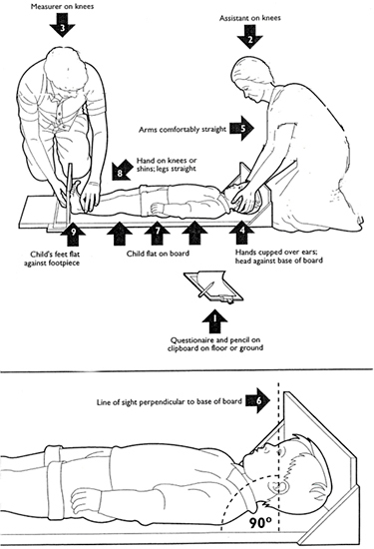

# Appendix III: Measurement of Height

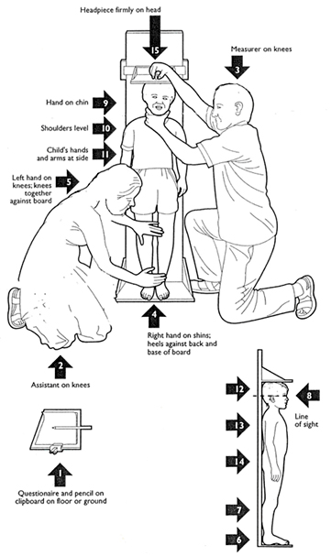

# Appendix IV: Measurement of MUAC

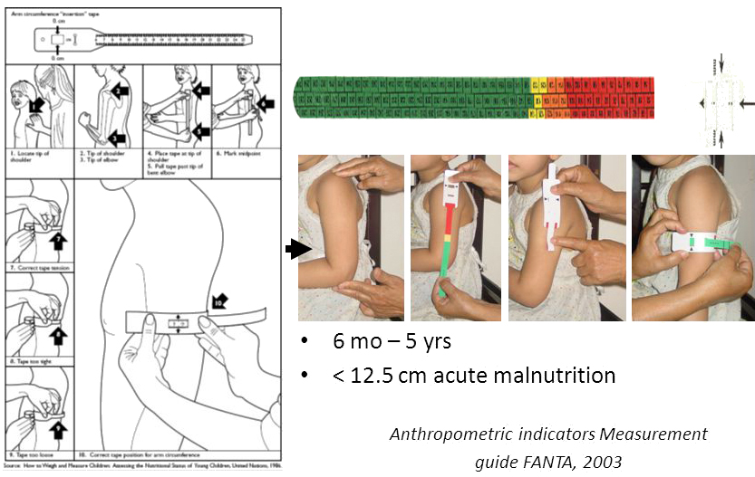



# Appendix V: Distribution of MUAC-score



**Distribution of MUAC-score**



**Transformation of MUAC-score by histograms**

# Appendix VI: Generalized Linear Model

___ ____ ____ ____ ____ (R)

/__ / ____/ / ____/

___/ / /___/ / /___/ 14.2 Copyright 1985-2015 StataCorp LLC

Statistics/Data Analysis StataCorp

4905 Lakeway Drive

Special Edition College Station, Texas 77845 USA

800-STATA-PC http://www.stata.com

979-696-4600 stata@stata.com

979-696-4601 (fax)

Single-user Stata perpetual license:

Serial number: xxxxxxxxxxxxxxxxx

Licensed to: Md. Emran Hossain

Chittagong Veterinary and Animal Sciences University

. glm MUAC_mm Father_Age_Year Mother_Age Mother_Parity Family_Size Child_Age_Months Child_Height_cm Child_Weight_kg

Iteration 0: log likelihood = -1555.3691

Generalized linear models No. of obs = 499

Optimization : ML Residual df = 491

Scale parameter = 30.33279

Deviance = 14893.39929 (1/df) Deviance = 30.33279

Pearson = 14893.39929 (1/df) Pearson = 30.33279

Variance function: V(u) = 1 [Gaussian]

Link function : g(u) = u [Identity]

AIC = 6.266008

Log likelihood = -1555.369119 BIC = 11843.01

----------------------------------------------------------------------------------

| OIM

MUAC_mm | Coef. Std. Err. z P>|z| [95% Conf. Interval]

-----------------+----------------------------------------------------------------

Father_Age_Year | -.0760015 .0504241 -1.51 0.132 -.1748309 .0228279

Mother_Age | -.1099915 .1159541 -0.95 0.343 -.3372574 .1172744

Mother_Parity | .1534736 .3174121 0.48 0.629 -.4686427 .7755899

Family_Size | -.4953539 .2637654 -1.88 0.060 -1.012325 .0216168

Child_Age_Months | .152029 .0460366 3.30 0.001 .061799 .242259

Child_Height_cm | .1529344 .0537392 2.85 0.004 .0476075 .2582613

Child_Weight_kg | .153307 .0721097 2.13 0.034 .0119745 .2946394

_cons | 116.0899 3.939301 29.47 0.000 108.369 123.8108

----------------------------------------------------------------------------------

# Appendix VII: Z-score

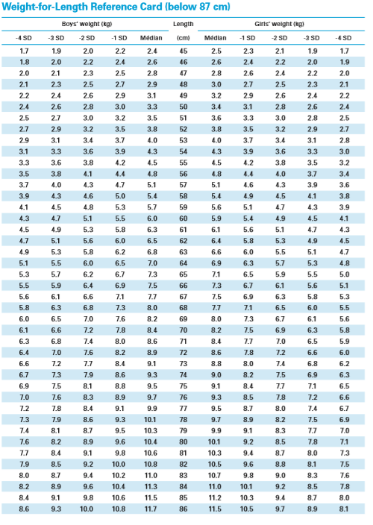

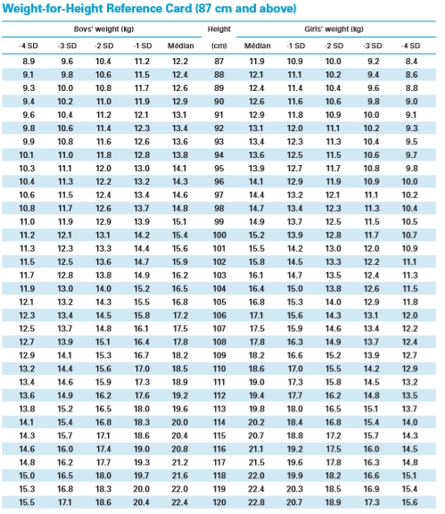

# Appendix VIII: Sample database for data collection

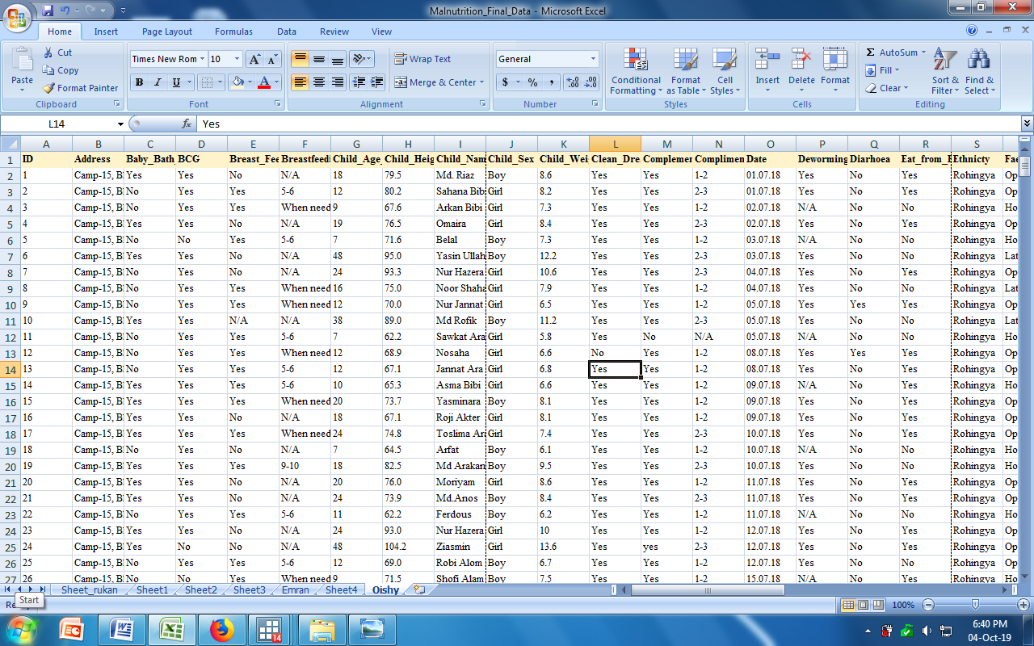

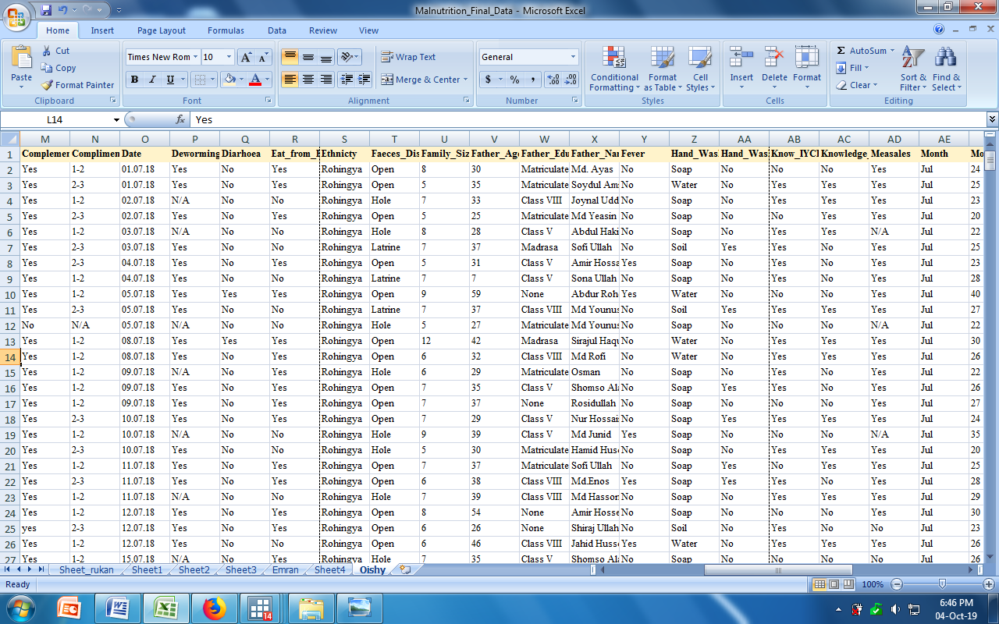

# Appendix IX: Acceptance letter of the thesis manuscript

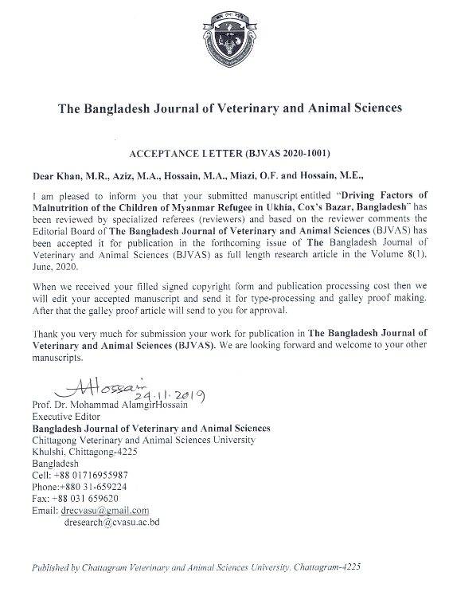



Moshfequa Rahman Khan has been awarded the B.Sc. (Hons) in Food Science and Technology (FST) degree from the Faculty of Food Science and Technology, Chattogram Veterinary and Animal Sciences University, Khulshi, Chattogram-4225, Bangladesh in 2015.

She passed her Higher Secondary Certificate Examination in 2010 with GPA 5.0 from Pabna Government Shaheed Bulbul College and Secondary School Certificate Examination in 2008 with GPA 5.0 from Pabna Government Girls’ High School.

Ms. Khan is currently a MS student in applied human nutrition and dietetics under the Department of Applied Food Science and Nutrition at Chattogram Veterinary and Animal Sciences University. She has been awarded the National Science and Technology Fellowship from the University Grants Commission, Bangladesh. She is the daughter of Dr. M. R. Khan and Mahfuza Rahman Khan in Pabna sadar upazila under Pabna District.