CONTENTS
Contents
TITLE |  | PAGE
CONTENTS |  | 1
LIST OF TABLES |  | 2
LIST OF FIGURES |  | 2
ABSTRACT |  | 3
CHAPTER 1 | INTRODUCTION | 4-6
CHAPTER 2 | MATERIALS AND METHODS  2.1 Study area and period  2.2 Taking photographs  2.3 Browsing internet and information collection  2.4 Direct observation | 7
CHAPTER 3 | RESULT AND DISCUSSION  3.1 Species  3.2 Classification  3.3 Distinctive identification  3.4 Diet  3.5 Habitat  3.6 Behavioral characteristics  - Foraging behavior  - Resting behavior  - Social behavior  - Vocal communication  - Locomotion  - Breeding  3.7 Status and conservation | 8-15  8  9  9-10  11  12  13-14  12  13  14  14  14  13-14  15
CHAPTER 4 | LIMITATION | 16
CHAPTER 5 | CONCLUSION | 17
 | REFERENCES | 18-19
 | ACKNOWLEDGEMENT | 20

LIST OF TABLES
Contents
NO | TABLE | PAGE
1 | Subspecies of yellow-footed green pigeon available in Bangladesh | 8
2 | Common foods of yellow-footed green pigeon available in Bangladesh | 11

LIST OF FIGURES
NO | FIGURE | PAGE
1 | Close observation of the bird | 6
2 | Global position of Yellow footed green pigeon including Bangladesh | 7
3 | Different body structures of Yellow footed green pigeon found in Bangladesh | 9
4 | Yellow footed green pigeon eating fig and banyan fruits. | 10
5 | Yellow footed green pigeon eating berries | 10
6 | Yellow footed green pigeons drinking water | 10
7 | Yellow footed green pigeons forage in flocks | 12
8 | Yellow footed green pigeon foraging | 12
9 | Yellow footed green pigeons perching | 12
10 | Flight of yellow footed green pigeon | 14
11 | Courtship of yellow footed green pigeon | 14
12 | Nurturing the egg | 14
13 | Feeding juvenile bird | 14
14 | Conservation Status by IUCN(International Union for Conservation of Nature | 15

ABSTRACT
Abstract
Yellow legged green pigeon (Holdepa Hariyal) is a beautiful social bird with varied distribution across the globe specially in India, Srilanka, Thailand, Myanmar, Cambodia, Pakistan, Bhutan, Nepal including Bangladesh. Among 5 species of yellow legged green pigeon, there are 2 subspecies ,T. p. phoenicopterus and T. p. chlorigaster are available in Bangladesh. The study was conducted on the basis of information available on internet, books, journals , periodicals, magazines and direct observation of the bird along with their feeding, breeding behavior, nesting and other behaviors in different roosting sites in different areas of Bangladesh. They have yellowish olive-green body, dark golden olive-yellow tinged greenish neck, dull green abdomen, slaty grey tail, bright yellow legs, outer pink-red inner pale blue iris and silver grey bill. They are herbivores specially frugivorous. Their common foods are drupes, berries, wild figs, ficus, buds and shoots of various crops and various grains. The breeding season of the bird is in between March to June in Bangladesh. Its nest is made of grasses, leaves or shrub on a slight platform of twigs in a tree. The bird usually lays one or two eggs in a clutch which are white, glossy in color and incubation period of egg is varies between 13 to 15 days. They forage in flocks in the early morning. At the time of resting, they often perches on the highest branches of a tall tree in pairs or small groups. The bird makes a series of about ten beautiful, mellow and musical whistles.The infestation of different diseases of the pigeon are not common in wild but there is reports of infection of Newcastle disease,colibacillosis and pigeon pox in case of the domesticated bird. The flight of the bird is noisy, swift, strong, and direct. Yellow footed green pigeon is classified as Least Concern by the IUCN. Although the bird is not yet considered as endangered or vulnerable, but to maintain the ecological balance this beautiful species of bird needs to be conserved.

Key words : Yellow legged green pigeon, Holdepa Hariyal, subspecies, social, frugivorous, nest, incubation, forage, whistles, perch, ecological

CHAPTER 1
Introduction
Introduction
Birds ( class Aves) are a group of endothermic vertebrates , characterized by feathers, a beak with no teeth, the laying of hard shelled eggs, a high metabolic rate, a four chambered heart,and a lightweight but strong skeleton. Birds are considered as a symbol of fortune, peace, scavengers, angel of heaven etc around the world. According to the IOC World Bird List(2015) , there are about 10,612 extant species and 153 extinct species of birds in the world. All birds are categorized under about 239 families .The yellow footed green pigeon falls under kingdom Animalia, phylum Chordata, class Aves, order Columbiformes, family Columbidae, genus Treron and species Treron phoenicoptera.
The yellow-footed green pigeon (Treron phoenicoptera), also known as yellow-legged green pigeon, is a common species of green pigeon found in the Indian subcontinent. It is the state bird of Maharashtra.( Rebello, S et al) In Marathi it is called Hariyal. Allied to African Treron species; closest affinities appear to be with T. waalia. In North India, nominate and chlorigaster occur in mixed flocks, but very few intergrades or apparent hybrids reported; they possibly represent two separate species, but further study required. Race phillipsi very similar to chlorigaster and possibly better subsumed within it. Five subspecies are recognized which are T. p. phoenicopterus in North India through Himalayan foothills and Gangetic Plain from Himachal Pradesh to Assam, Madhya Pradesh, Odisha and Bangladesh(Latham, 1790); T. p. chlorigaster in Pakistan and India specially West Bengal(Blyth, 1843); T. p. phillipsi in Sri Lanka (Ripley, 1949); T. p. viridifrons in China Myanmar and Thailand Blyth, 1846; T. p. annamensis in Thailand, Laos, Cambodia and S Vietnam (Ogilvie-Grant, 1909) .Among them, two subspecies are available in Bangladesh which are T. p. phoenicopterus and T. p. chlorigaster (Baptista et al.).
The yellow footed green pigeon has different names in different parts of the world like Colombar commandeur in French, Rotschultertaube in German, Vinago patigualdo in Spanish, Yellow-footed Green-Pigeon in English, holub fialovoramenný in Czech, Gyldenhalset Papegøjedue in Danish, huiluviherkyyhky in Finnish, Yellow-footed Pigeon in Icelandic, Piccione verde piedigialli in Italian, kiashiaobato in Japanese, Geelpootpapegaaiduif in Dutch, Kragegrønndue in Norwegian, treron zlotoszyi in Polish, Yellow-footed Pigeon in Portuguese, Yellow-footed Pigeon in Portuguese (Brazil), gulfotad grönduva in Swedish etc (Clements Checklist).In South Asia it known as Yellow-legged/Common/Bengal/Southern/Ceylon/Burmese Green Pigeon (Ali & Ripley 1987).
Yellow footed green pigeon is a beautiful social bird. Size of adult ones is between 29 to 33 cm. They have yellowish olive-green body. Neck is dark golden olive-yellow tinged greenish. Abdomen is dull green with greyer flanks. Lower belly and leg feathers are bright sulphur-yellow. Bright yellow legs is always diagnostic for this species. Tail is slaty grey tinged olive basally, especially on the central feathers. Outer ring of iris is pink-red and inner ring is pale blue. The bill is silver grey with light green color. Female is slightly duller than male. Adult female is very similar to the male but tends to be duller and with a more restricted mauve shoulder patch. Juvenile is paler and duller than the female, lacking or almost lacking the mauve shoulder patch.( Boonsong & Round 1991).
Introduction
They prefer semi evergreen forests, deciduous forest, wooded habitats and secondary forests. They commonly found in road side trees particularly Banyan and Peepal trees. Also visits gardens even inside towns, groves of trees in open country, agricultural land, villages, overgrown gardens and tree lined roads. They are social birds. They found in pairs or small groups (up to 5 to 10 individuals) and sometime large groups. They are gregarious and arboreal, only rarely descending to the ground.( Rasmussen et al. 2005). Yellow footed green pigeons are herbivores especially frugivores. They feed on various fruits, berries, buds and shoots of various crops and various grains. They forage in flocks. In the early morning they are often seen on the tops of emergent trees in dense forest areas.( Goodwin 1983). The breeding season is in between March to June. Nest is a relatively slight platform of twigs in a tree or shrub. The bird usually lays one or two eggs in a clutch which are white, glossy in color. Incubation period of egg is varies between 13 to 15 days. Both sexes share domestic duties (Ali et al. 1991)
Yellow footed green pigeon occupying an important part of natural ecosystem. IUCN listed yellow footed green pigeon as a bird of least concern due to their large range. In Bangladesh, two subspecies are available. Due to the disturbance of human to their habitat, they are facing a threat to their living. There is no specific conservation strategy in Bangladesh for yellow footed green pigeon. But Bangladesh government has a strong wild life conservation act. It can be said that application of existing acts along with rising public awareness can assure the existence of this beautiful bird in Bangladesh leading to maintaining ecological balance.

The objectives of the study are as follows:
Introduction
1. To address some fundamental question of ecology using reference studies in an environment largely untouched by civilization.
2. To analyze their feeding, breeding, bio-physical and other related traits.
3. To evaluate the conservation value of the region including presence of a near-pristine landscape, occurrence of species which are threatened or elsewhere.
4. To analyze of communities in primeval habitats as references for the assessment of anthropogenic impact on species communities in Bangladesh.
5. To determine the extent and location of existing habitat suitable for meeting the habitat requirements.
6. To know the species of yellow footed green pigeon in context to Bangladesh.

CHAPTER 2
Materials and Methods
MATERIALS AND METHODS

2.1 Study Area and Period:
The study was conducted in some specific areas in Bangladesh as per convenience to accomplish the study on yellow footed green pigeon in Bangladesh. As an intern student some areas of Chittagong (Sitakund and Mirsarai) were visited to collect information and photography during January to August, 2017.
2.2 Taking Photographs:
It was a very difficult task to taking photographs of the bird. However, some photographs were taken during my study period.
2.3 Collection of Information :
Information were collected through direct observation, photography, books, journals , periodicals, magazines are etc. The relevant data were collected from websites also. Beside this, many data were collected from relevant persons, wild life conservation team etc. Some other data were collected from direct field survey.
2.4 Direct Observation:
Observation used as a tool for studying about of yellow footed green pigeon. This facilitates to study their body characteristics , habitats, feeds and feeding, breeding, diseases etc. Binocular and digital cameras were used for distance observation and roasting sites were visited physically to observe the habitats and nests.

Materials and Methods

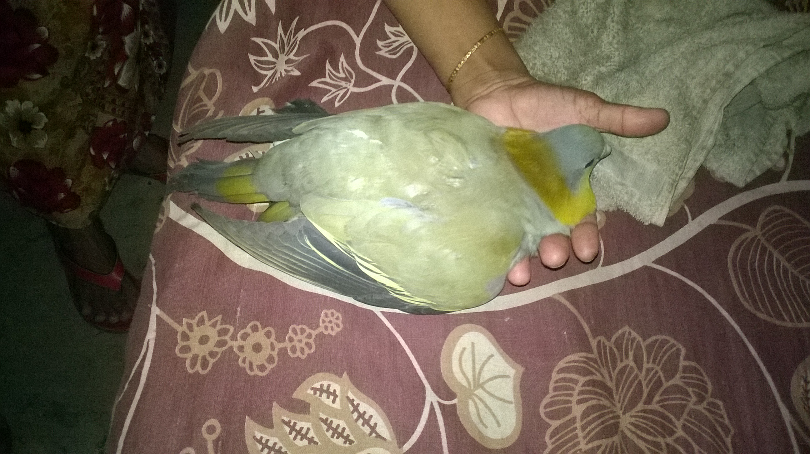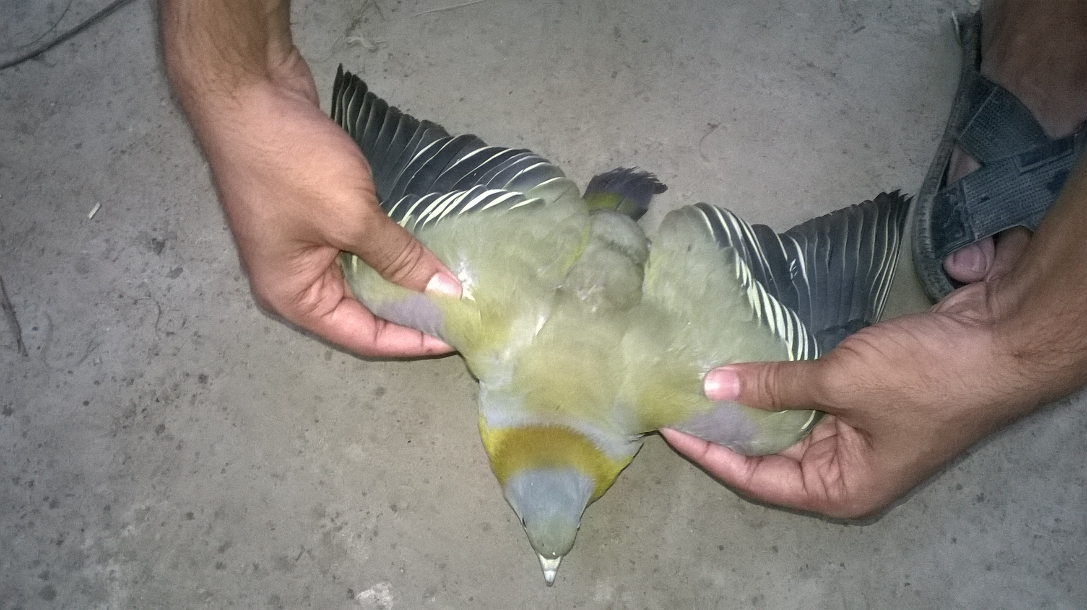

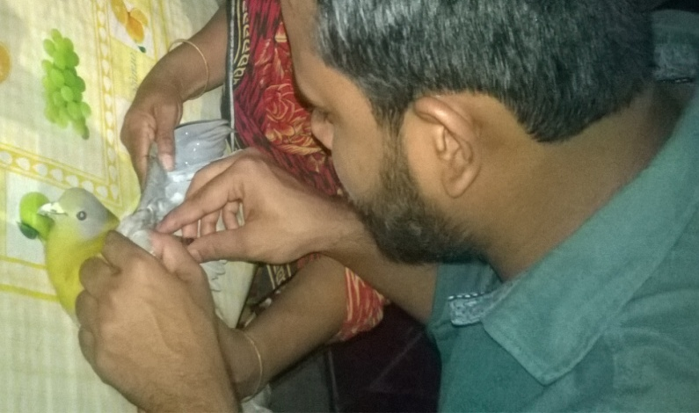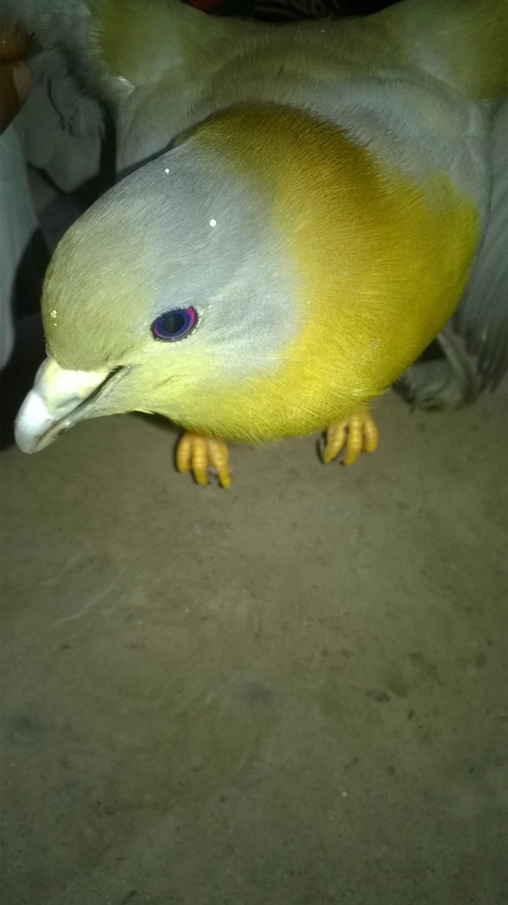

Figure 1 : Restraining of the bird

Figure 2 : Close observation of the bird

CHAPTER 3

RESULTS AND DISCUSSION
Result and Discussion

3.1 Species:

The yellow-footed green pigeon (Treron phoenicoptera), also known as yellow-legged green pigeon or Bengal/Southern/Burmese Green-Pigeon, is a common species of green pigeon found in Bangladesh.
Subspecies of yellow-footed green pigeon available in Bangladesh: There are Five subspecies are recognized all over the world (Clements et al). Among these subspecies, two are found in Bangladesh .( Ali & Ripley 1987). They are in Table 1.

Subspecies | Distribution
T. p. phoenicopterus (Latham, 1790) | Bangladesh, Himalayan foothills and Gangetic Plain from Himachal Pradesh to Assam, Madhya Pradesh and Odisha, North India
T. p. chlorigaster (Blyth, 1843) | Bangladesh, Pakistan India, West Bengal.

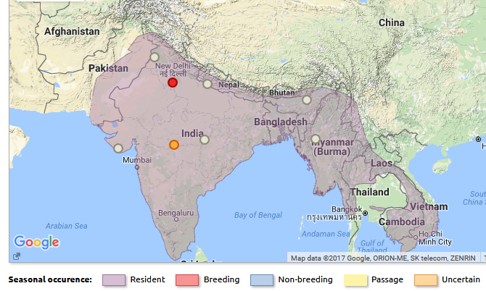

Figure 3 : Global position of Yellow footed green pigeon including Bangladesh (Image source: birdlife.org)

3.3 Distinctive Identification:
Yellow footed green pigeon is a beautiful bird. Size of adult Yellow footed green pigeon is between 29 to 33 cm. The length of the tail is between 8 to 10 cm. Weight of adult is between 225 to 260 g. They have a wingspan of 17 to 19 cm.

They have yellowish olive-green body, duller above with a blue grey crown. Forehead and lores often suffused pale olive-green. They have lilac patch on the shoulders and a conspicuous yellow bar in the blackish wings. Bright yellow legs always diagnostic for this species. Neck is dark golden olive-yellow tinged greenish, mauve shoulder patch, bright yellow fringes to the wing coverts. Abdomen is ashy-green with greyer flanks and bright sulphur-yellow lower belly and leg feathers.
Result and Discussion
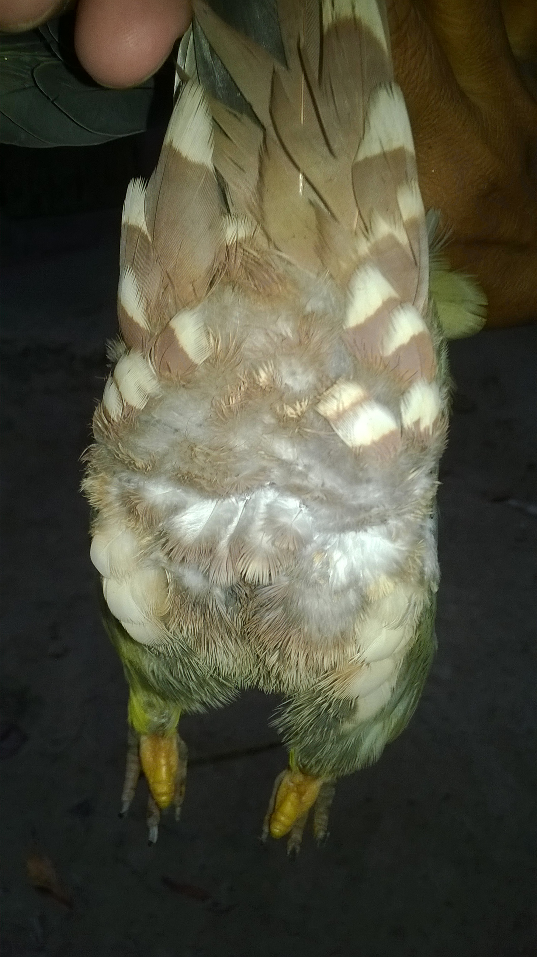
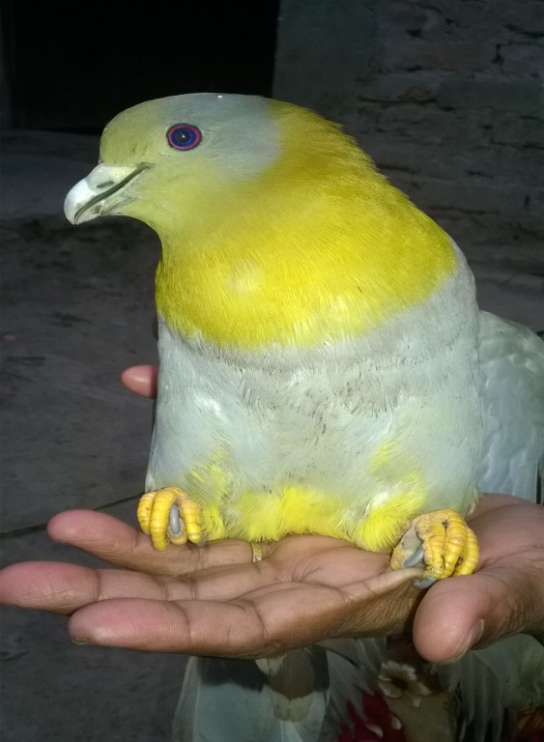
Figure 4 : Different body structures of yellow footed green pigeon found in Bangladesh
Image source: As captured on 14 July at Sitakund.
Ashy-grey abdomen
Bright yellow legs
Bright greenish-golden neck
Slaty grey tail

Result and Discussion
Mantle and scapulars are dull grey green, the mantle bordered above with a distinct blue grey band. Lesser coverts olive with those near the bend of the wing mauve. Median and greater coverts grey tinged olive, with pale yellow fringes to the apical halves of the outer webs. Outer greater coverts blackish. Tail slaty grey tinged olive basally, especially on the central feathers. Upper tail light greenish with broad, dark grey terminal bar. Under tail black basally, apical half ashy grey. Under wing pale grey tinged olive on the leading edge. Iris outer ring pink-red, inner pale blue, and the bill is silver grey with light green color. Female slightly duller than male. Adult female very similar to the male but tends to be duller and with a more restricted mauve shoulder patch. Juvenile paler and duller than the female, lacking or almost lacking the mauve shoulder patch.( Ali & Ripley 1987).
Result and Discussion
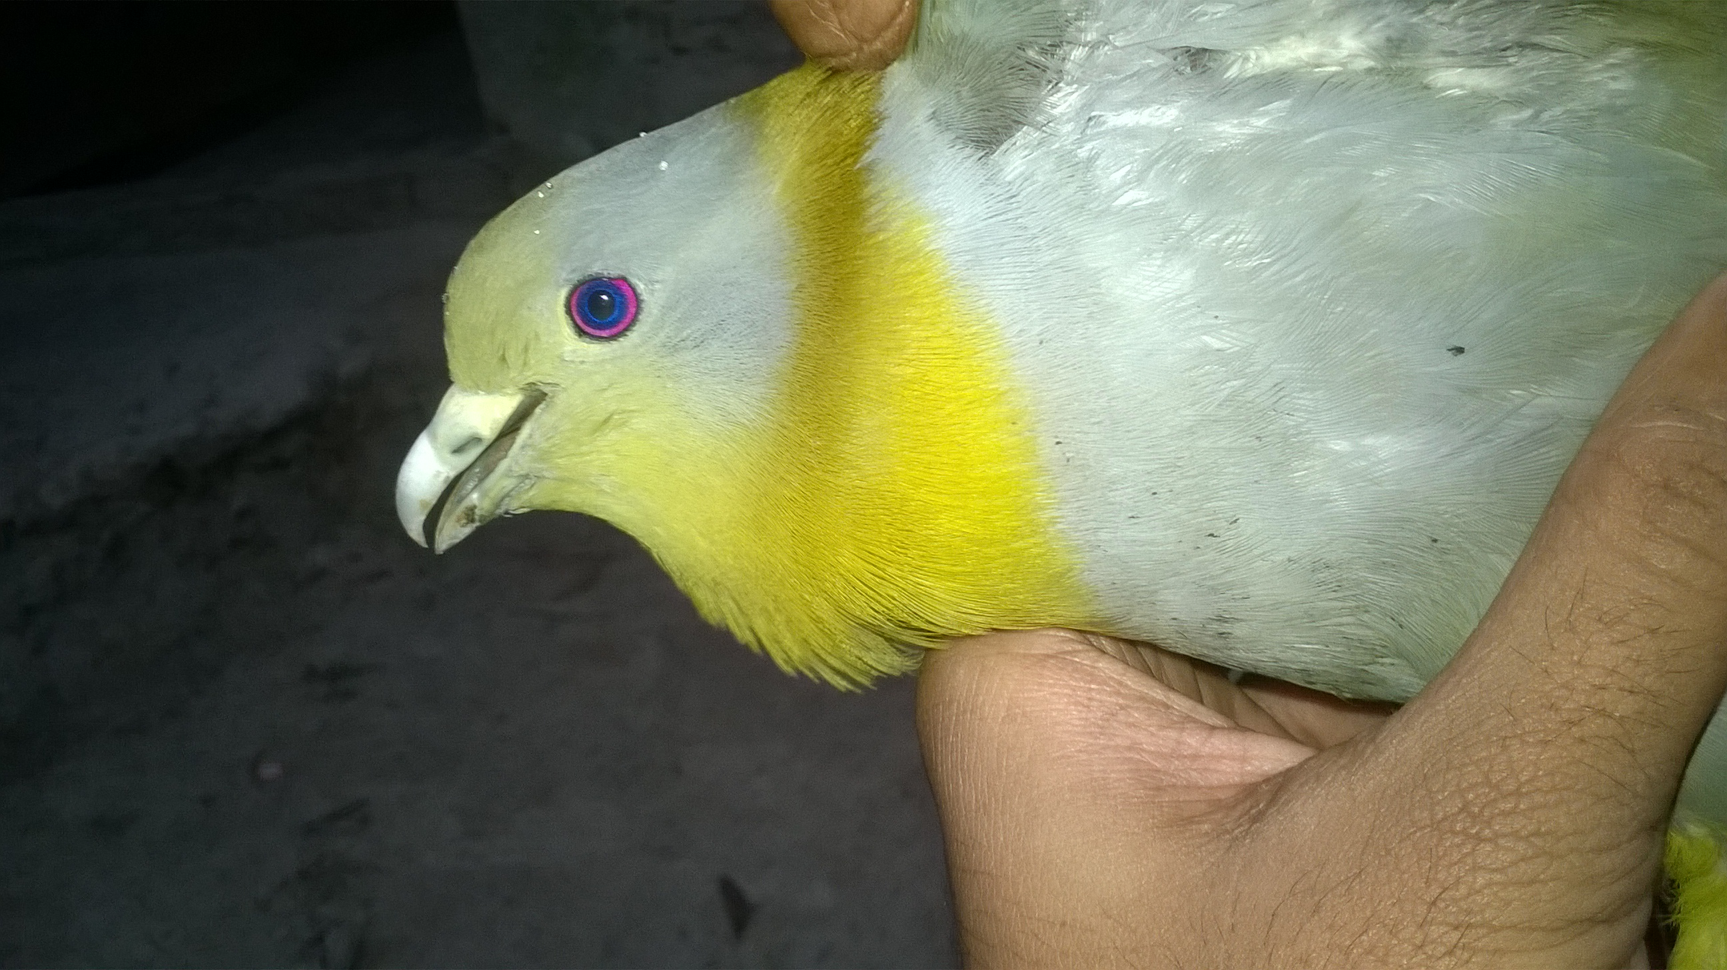
Iris outer ring pink red
Iris inner pale blue

Silver grey bill with light green color.

Figure 4 : Different body structures of yellow footed green pigeon found in Bangladesh
Image source: As captured on 14 July at Sitakund.

3.4 Diet:
All yellow footed green pigeons found in Bangladesh are herbivores specially frugivorous. The birds deftly climb about the twigs of fruit-bearing trees, often clinging upside down to get at some fig or berry, they keep in locks of from 10 to 50 birds, and sometimes collect in enormous numbers on banyan or peepal trees to gorge themselves on the ripe figs (King et al. 1975).
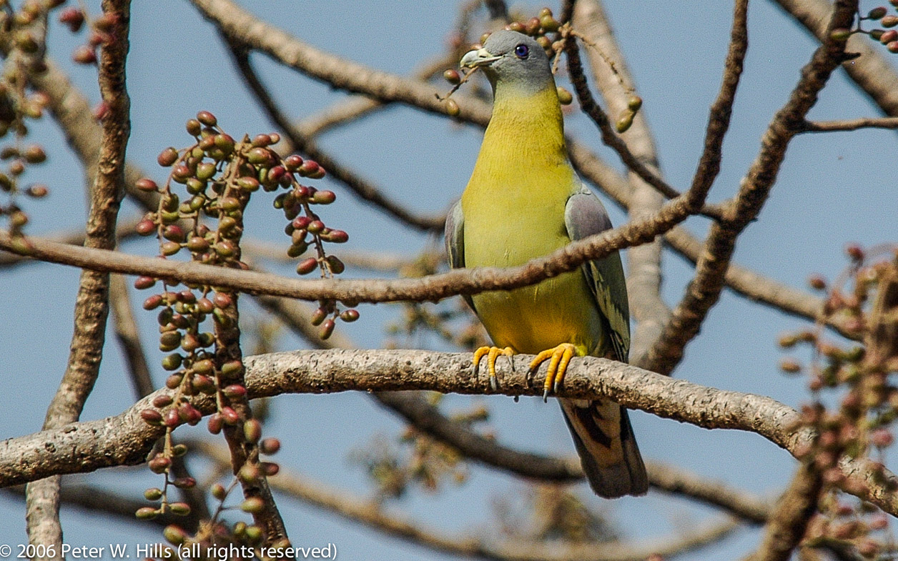
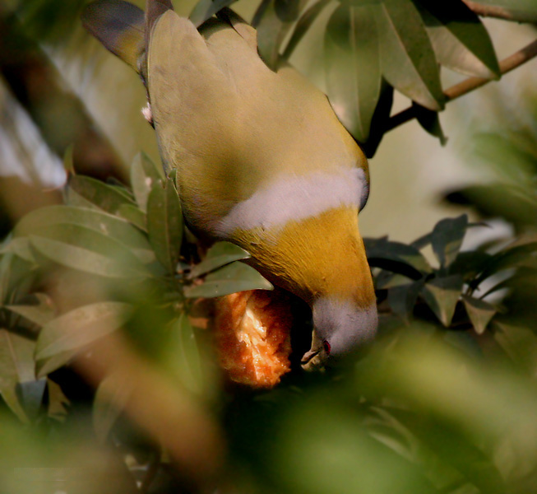

Figure 6 : Yellow footed green pigeon eating berries (Image source: Peter W. Hills, 2006)

Figure 5 : Yellow footed green pigeon eating fig(Image source: Birdforum.com)

The species common foods are noted in Table 2.
Result and Discussion
Species | Common foods
T. p. phoenicopterus  T. p. chlorigaster | Drupes, berries (including mulberries),wild figs (Moraceae),ficus, buds and shoots of various crops and various grains.
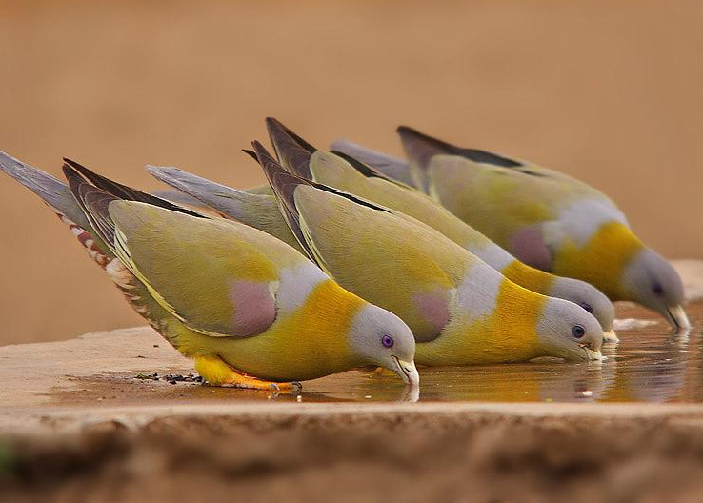
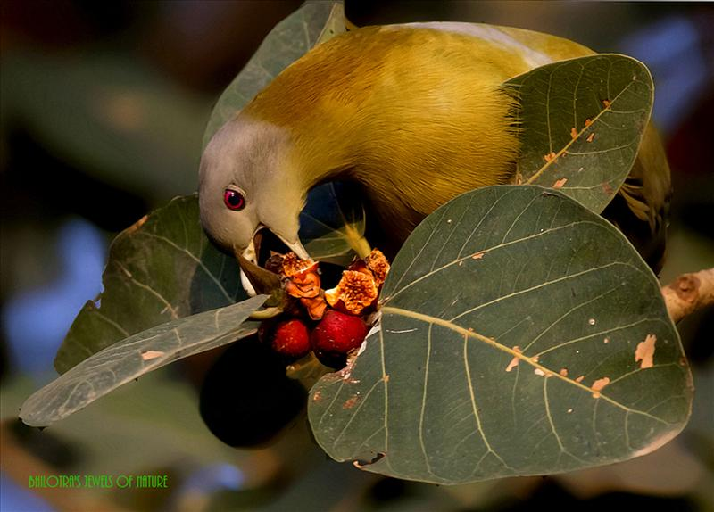

Figure 5 : Yellow footed green pigeon eating banyan fruits. (Image source: Birdforum.com)

Figure 7 : Yellow footed green pigeons drinking wate( Image source : Sharad Agarwal, India)

3.5 Habitat:

Yellow footed green pigeon are found in a wide range of wooded habitats including dry and moist deciduous forest, , groves of trees in open country, agricultural land, villages, overgrown gardens, scrubland, secondary growth, tree-lined roads and secondary forests up to 800 meter. They commonly found in road side trees particularly Banyan and Peepal trees. Also visits gardens even inside towns (Boonsong & Round 1991).

3.6 Behavioral Characteristics:
- Foraging behavior: They forage in flocks. In the early morning they are often seen on the tops of emergent trees in dense forest areas.
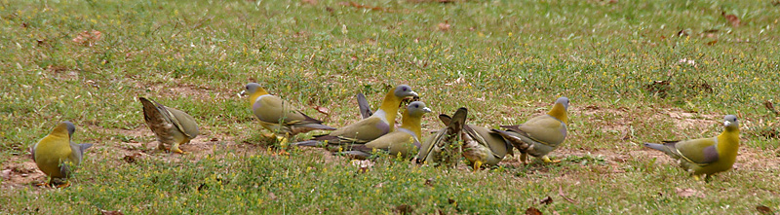

Figure 8 : Yellow footed green pigeons forage in flocks(Image source:beautyofbirds.com)

- Resting behavior: At the time of resting, they often perches on the highest branches of a tall tree in pairs or small groups.
Result and Discussion
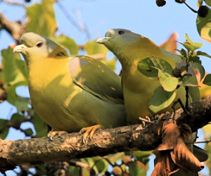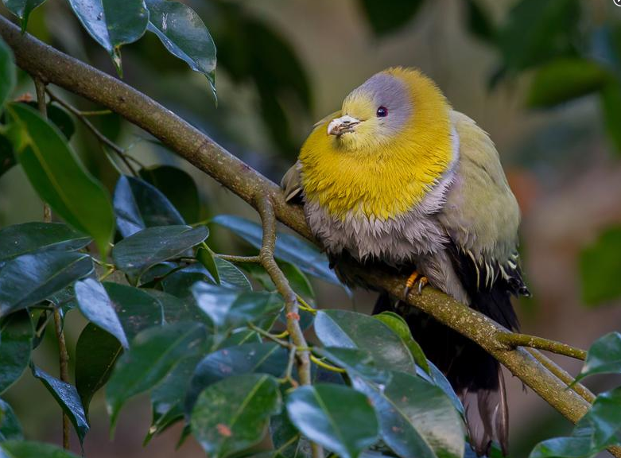
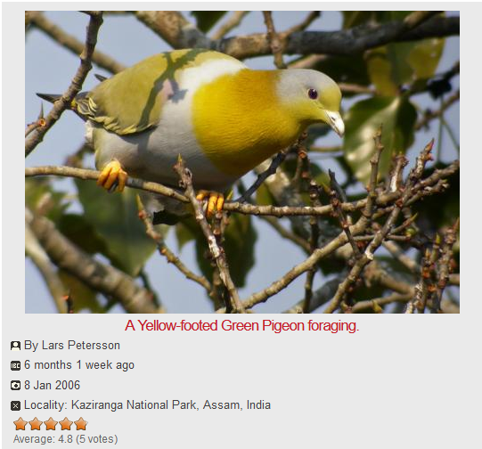

Figure 10: Yellow footed green pigeons perching(Image source:Kaziranga,Assam,2006)

Figure 9: Yellow footed green pigeon foraging(Image source: Kaziranga ,Assam,2006)

- Social behavior: Yellow footed green pigeons are social birds. They found in pairs or small groups (up to 5 to 10 Individuals) and sometime large groups. They are gregarious and arboreal, only rarely descending to the ground.

- Vocal communication: Yellow footed green pigeon makes a series of about ten beautiful, mellow, musical whistles likened to the equivalent calls of T. bicincta but louder and lower (Ali & Ripley 1987).

- Locomotion: The flight of yellow footed green pigeon is noisy, swift, strong, and direct, and the call is a series of about ten beautiful, mellow, musical whistles, which usually give the first indication of their presence in a locality.
When a tree is approached, the green pigeons become immobile. Their plumage blends so perfectly with the surrounding leaves that in spite of their large size the birds become completely obliterated.
The birds spend the day doing the rounds of fruiting trees, resting at intervals on the topmost branches of a dry or leafless one.

Result and Discussion
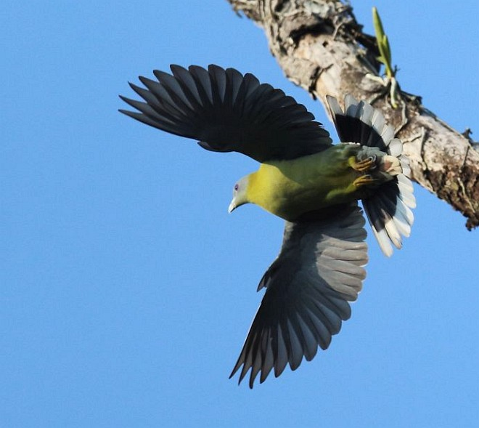
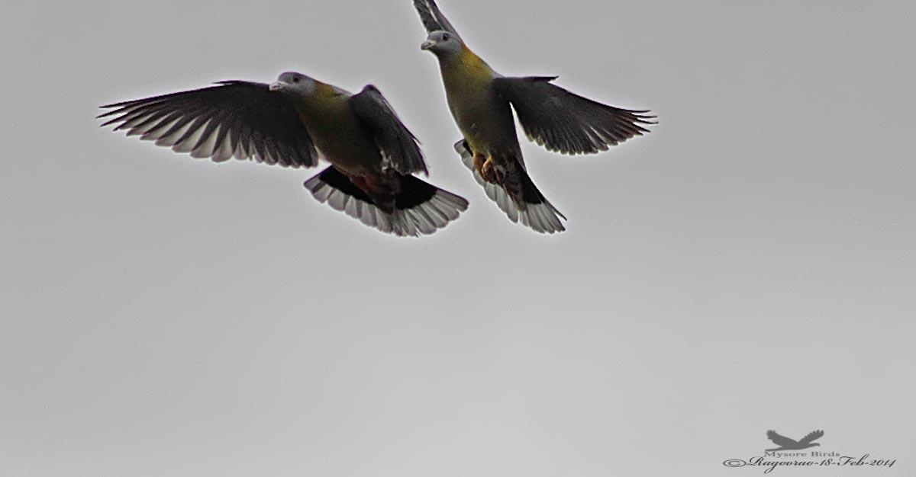

Figure 11 : Flight of yellow footed green pigeon(Image source: BirdForum.com)

- Breeding: The breeding season of yellow footed green pigeon is between March to June in Bangladesh; Mar–Apr in India.During the courtship the male puffs out his throat and breast, lowers his wings, ruffles out his feathers, then prances solemnly up and down the branch, continually bowing his head and whistling softly as he makes his way backwards
and forwards to and from the female. Sometimes the female responds with a similar but less intense version of this display (Ali & Ripley 1987).

Nest is a relatively slight platform of twigs in a tree, grasses, leaves or shrub. The bird lays one to two eggs in clutch which white, glossy in color. Incubated period is varies between 13 to 15 days. Both sexes share domestic duties.
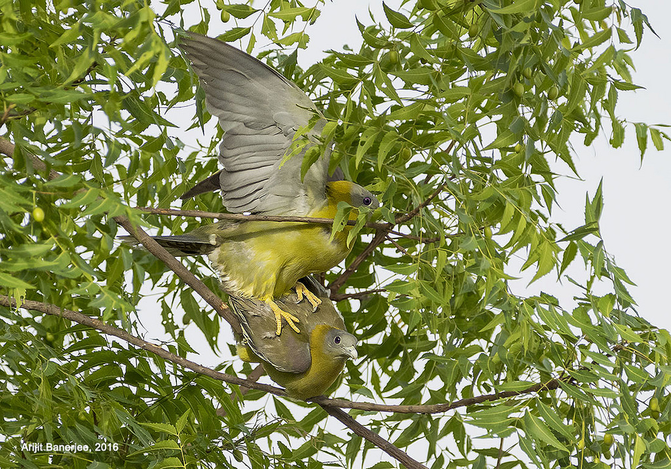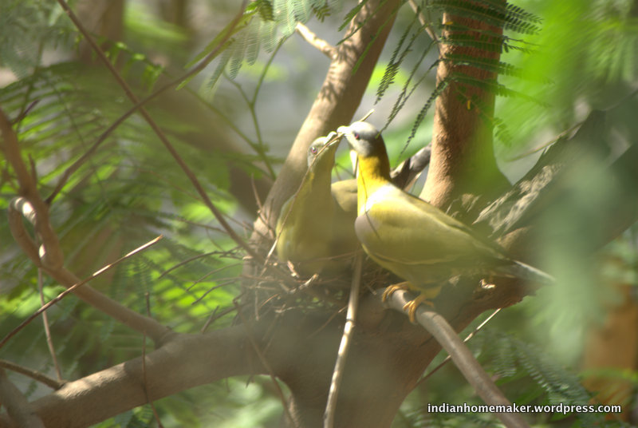
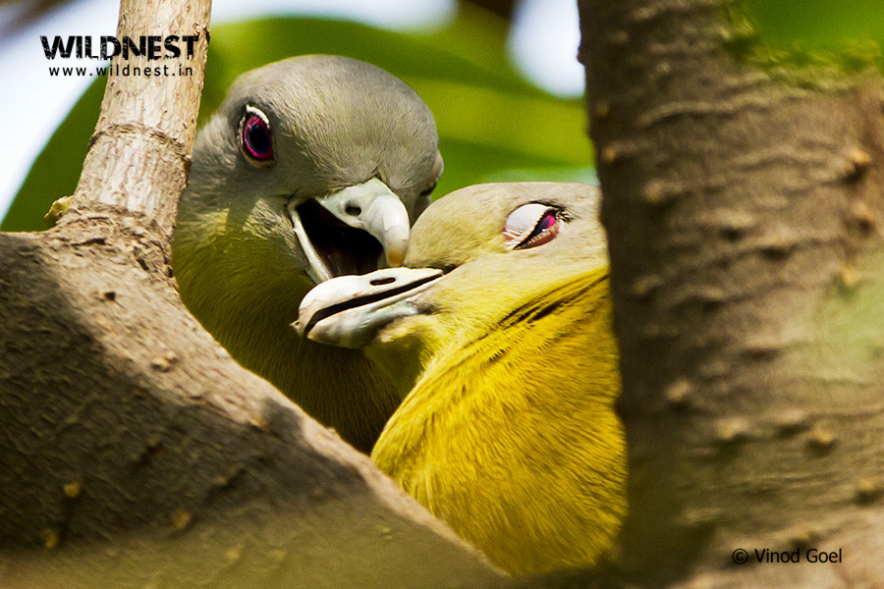

Figure 12 : Courtship of two yellow footed green pigeon(Image source: Wlidnest.in )

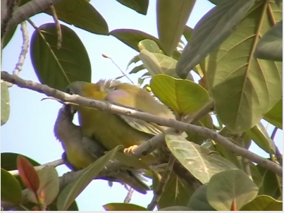
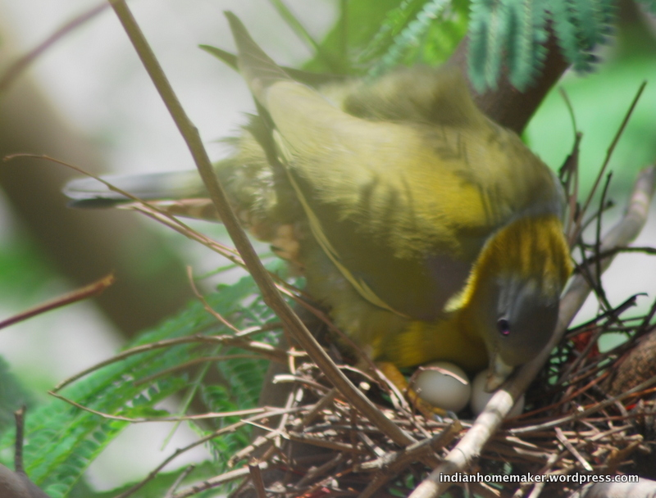

Figure 14 : Feeding juvenile bird(Image source: hbw.com)
Figure 13 : Nurturing the egg(Image source: hbw.com)

3.7 Status and conservation:
Result and Discussion
Yellow footed green pigeon is a Schedule – IV bird, according to wildlife (Protection) act, 1972 and classified as Least Concern (LC) by the IUCN.
This species has an extremely large range, and hence does not approach the thresholds for Vulnerable under the range size criterion (Extent of Occurrence <20,000 km2 combined with a declining or fluctuating range size, habitat extent/quality, or population size and a small number of locations or severe fragmentation). The population trend appears to be increasing, and hence the species does not approach the thresholds for Vulnerable under the population trend criterion (>30% decline over ten years or three generations). The population size has not been quantified, but it is not believed to approach the thresholds for Vulnerable under the population size criterion (<10,000 mature individuals with a continuing decline estimated to be >10% in ten years or three generations, or with a specified population structure). For these reasons the species is evaluated as Least Concern. (Image source: Website)

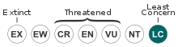

Figure 15 : Conservation Status by IUCN(International Union for Conservation of Nature)
(Image source: NatureConservation.in)

The yellow-footed green pigeon is the State bird of Maharashtra, India. The global population size has not been quantified, but the species is reported to be common and widespread (del Hoyo et al. 1997).

CHAPTER 4
Limitation
Limitation
Limitation:
The limitations of this study were-
1. As the study period was short, it was difficult to collect all information by direct observation.
2. It was difficult to take pictures as the birds were so fidgety.. So some reiated pictures were collected from different websites.
3. Research papers on yellow footed green pigeon is very less in number. So it was difficult to collect all relevant information of the bird in detail.

CHAPTER 5
Conclusion
Conclusion
Birds are the beautiful gift of nature that make our crops safe from harmful insects , helps in pollination and seed dispersing in nature. Yellow legged green pigeon (Holdepa Hariyal) is a beautiful social bird. Among 5 species of yellow legged green pigeon, there are 2 subspecies ,T. p. phoenicopterus and T. p. chlorigaster are available in Bangladesh. The study was conducted on the basis of information available on internet, books, journals , periodicals, magazines and direct observation of the bird along with their feeding, breeding behavior, nesting and other behaviors in different roosting sites in different areas of Bangladesh. They have yellowish olive-green body, dark golden olive-yellow tinged greenish neck, dull green abdomen, slaty grey tail, bright yellow legs, outer pink-red inner pale blue iris and silver grey bill. They are herbivores specially frugivorous. Their common foods are drupes, berries, wild figs, Ficus, crops, buds, shoots and various grains. The breeding season of the bird is between March to June in Bangladesh. Its nest is made of grasses, leaves or shrub on a slight platform of twigs in a tree. The bird usually lays one or two eggs which are white, glossy in color and incubation period of egg is between 13 to 15 days. They forage in flocks in the early morning. At the time of resting, they often perches on the highest branches of a tall tree in pairs or small groups. The bird makes a series of about ten beautiful, mellow, musical whistles. The flight of the bird is noisy, swift, strong, and direct. IUCN listed yellow legged green pigeon as a species of least concern at global aspect due to its wide range. In Bangladesh, it is not yet considered as endangered or vulnerable bird species. But number of some species is declining day by day. We all should remain concerned about the conservation of this bird to keep safe the ecological balance.

References
References

Avibase taxonomic concepts v. 05 (Jan 2017).
Ali, S and Ripley S.D.,1996,In: Handbook of the birds of India and Pakistan, Volume 6. Second Edition Oxford University Press.
Abhinav Nature Conservation Organization.
Baptista, L.F., Trail, P.W., Horblit , H.M., Boesman , P. & Kirwan, G.M. (2017). Yellow-footed Green- pigeon (Treron phoenicopterus). In: del Hoyo, J., Elliott, A., Sargatal, J., Christie, D.A. & de Juana, E. (eds.). Handbook of the Birds of the World Alive. Lynx Edicions, Barcelona.
BirdLife International (2012). "Treron phoenicopterus". IUCN Red List of Threatened Species. Version 2013.2. International Union for Conservation of Nature. Retrieved 26 November 2013.

BirdLife International (2017) Species factsheet: Treron phoenicopterus. Recommended citation for factsheets for more than one species: BirdLife International (2017) IUCN Red List for birds. 2017.
BirdLife International. 2016. Treron phoenicopterus. The IUCN Red List of Threatened Species 2016: e.T22691203A93305971.
Birdlife checklist version 09.1 (Jun 2017).
Boonsong & Round(1991).
Clements, J. F., T. S. Schulenberg, M. J. Iliff, D. Roberson, T. A. Fredericks, B. L. Sullivan, and C. L. Wood. 2016. The eBird/Clements checklist of birds of the world: v2016, with updates to August 2016.
Commission internationale pour les noms français des oiseaux (1993, révision 2009)
eBird version 2016.
Goodwin (1983).
Handbook of the Birds of the World Alive (3/07/2017).
Howard and Moore 4th edition (incl. corrigenda vol.1-2).
HBW and BirdLife International Illustrated Checklist of the Birds of the World. Volume 1: Non-passerines. Lynx Edicions BirdLife International, Barcelona, Spain and Cambridge, UK.
IOC World Bird Names, version 7.02.
International Union for Conservation of Nature and Natural Resources (IUCN).
India Biodiversity Portal.
References
Inskipp & Inskipp (1991).,
James Lee Peters (2nd edition).
Jerdon, T. C., In: The Bird of India, Volume 2. Part 1, Military Orphan Press, Calcutta.
Morony, Bock and Farrand.
Meyer de Schauensee (1984).
Oriental Bird Club.
Rasmussen, P. C. and Anderton, J. C. (2005) Birds of South Asia. The Ripley Guide. Vol 1 and 2. Smithsonian Institution and Lynx Editions.
Rebello, S. Yellow-footed green pigeon retains the state bird tag. Hindustan Times June 29, 2011.
Sibley and Monroe 2nd edition (1996).
Yellow-footed green pigeon to remain Maharashtra state bird. GovernanceNow.com June 28, 2011.

Yellow-footed green pigeon to remain Maharashtra's State bird , The Hindu, Mumbai:, June 29, 2011 .

Zoonomen - Zoological Nomenclature Resource.

Web sites :

Wikipedia

BirdForum.com
beautyofbirds.com/yellowfootedgreenpigeons.html
https://en.wikipedia.org/wiki/List_of_birds_of_Bangladesh
http://www.ebanglapedia.com
http://www.hbw.com/node/54297
http://www.birdlife.org

http://www.birds.cornell.edu/clementschecklist/download/

NatureConservation.in , 2017

Acknowledgements
Acknowledgements

The author is ever grateful and indebted to the Almighty Allah without whose grace it would never been possible to pursue this study in this field of science and to complete this clinical report for the Degree of Doctor of Veterinary Medicine(DVM).
The author would like to thank his beloved teacher and supervisor Dr. Gauranga Ch. Chanda
MSc, PhD, MBA, Professor, Head, Department of Dairy and Poultry Science, Chittagong Veterinary and Animal Sciences University, for his valuable advice, suggestions and kind co-operation during the study period.

The author would like to thank to the Director of External Affairs, Professor Dr. A.K.M Saifuddin , Dept. of Physiology, Biochemistry and Pharmacology, Chittagong Veterinary and Animal Sciences University for his valuable suggestion.

