Chapter –1
INTRODUCTION

Livestock are an integral component of agriculture in the study area and make multifaceted contributions to the growth and development in the agricultural sectors. Cattle farming are an important subsidiary to agriculture and playing a significant role in rural economy in Bangladesh (Hashem et. al. 1999). It is an emerging sector for employment and income generation for the rural poor. Cattle fattening for beef production has become an important business of the small farmers in Bangladesh. Cattle fattening helps to meet the rising demand for high-protein foods in the country and plays a great role in: (i) enhancing food security, (ii) providing households with employment, income, investment opportunity and a store of value, and (iii) providing draught power and manure for sustainable agriculture and (iv) cattle fulfilling cultural roles (Sarma et. al. 2014). A cattle farming is a way of rearing cattle for profitable production of meat. Cattle fattening package is a four-steps rearing programme of male and/or infertile female emaciated cattle for harvesting their compensatory growth within a period of 60 to 120 days. Collection of animals considering their body characteristics followed by de-worming and feeding for effectively up to achieve a considerable level of live weight gain and marketing them readily are the four major factors to make the fattening package profitable. It is relatively easy and profitable system of cattle rearing to reduce poverty, unemployment and generate income for the rural people.

During the holy Eid-Al Azha festival Muslims always goes for Kurbani (sacrificing slaughtered livestock). Animals including cows, goats, camels and sheep are slaughtered each year to mark the festival. Bangladeshi Muslims celebrate the Eid-ul-Azha in every year. So, the demand for cattle especially beef cattle increases several times higher during the holy Eid -Ul- Azha festival. The price of cattle is also increased in this time. Keeping this occasion in mind, a large number of poor people are involved in bull fattening just before 3 or 4 months of Eid-Ul-Azha, when they sell the animals at prices which results in high margin.
One of the advantages of the cattle fattening by the rural farmers during this period is that they use locally available cattle feed resources. Farmers use rice straw of traditional varieties, green grass, sugarcane tops, wheat and rice bran, molasses, pulse bran and locally available resources such as vegetable by- products, rice gruel, boiled rice bran, oil cakes etc for cattle fattening. Use of urea molasses straw treatment in beef cattle resulted higher body weight, dressing percentage and also in better carcass quality than untreated straw. The acute shortage of feeds and fodder has long been identified as a serious constraint to optimum livestock production in Bangladesh (Saadullah, 1995).

To develop a sustainable beef cattle production system in Bangladesh which starts at the farmers’ level for production and ending at consumers’ level for consumption , it is necessary to find out the existing beef cattle production, marketing, processing systems and consumers’ perceptions. For this it is prime important to find out the existing cattle fattening system and those factors which are directly related with cattle in Bangladesh. So far I aware a few literatures are available regarding socioeconomic status of cattle fattening farmers in northern Bangladesh, there are no documented studies in Chittagong to show the profitability of beef fattening. This study is an attempt to investigate the profitability of cow fattening enterprise in the study area.
Therefore, the present study was undertaken with the following objectives:

- To assess the socio-economic characteristics of beef cattle fattening operators in the study area.
- To determine profitability of beef cattle fattening enterprises.
- To identify the problems that affect profitability of beef cattle fattening enterprises.

Chapter - 2
MATERIALS AND METHODS

2.1: Study area:
The present study was conducted to investigate the cattle fattening program practiced by the rural farmers in Chittagong districts of Bangladesh. The data was collected through an interview schedule from respondents of this districts from different upazilla who were involved in cattle fattening before Eid-ul-Azha. The respondents were selected mainly from six upazilla –Anwra, Banshkhali, Chadanaish, Patia, Satkania and Raozan. The interview was taken from the different Haat (cattle market) before Eid-Ul-Azha . In total 150 respondents were chosen for collecting data to address the objectives. The interview schedule was prepared based on the objectives of the study.

2.2 : Survey design:

Interview method of data collection was used. This survey was conducted with the aid of a detailed structured questionnaire. The questionnaire is attached with the report.

2.3 : Data collection:

A structured questionnaire was prepared for required data collection. Information was collected from respondents through face to face interview. Just prior to data collection the objective of the
study was clearly explained to the respondents. The data were basically taken regarding the economic analysis. Besides farmers’ sex, age, education, farm size, social status, supply in market, expenditure and household size as well as some factors associated with cattle fattening such as breed, source of fund, feeding and nutrition, deworming treatment, etc. And also about the problem faced by farmers.
2.4 : Data analysis technique:

The following analytical techniques were used to achieve the objectives of the study. Descriptive statistics such as measures of central tendency like mean, percentages and frequency Sarma et al. for first objectives. The cost benefit analysis is a useful tool in determining the profitability of a beef cattle fattening enterprise when the fixed cost can be calculated. The economic analyzed the determinants;

NM=TR-TC………………………….…………… (1) (Rahman, et al., (2002)
Where,
NM = Net Margin;
TR= Total Return;
TC = Total Cost;

TC=TVC+TFC…………………………………… (2)
Where,
TVC = Total Variable Cost
TFC = Total Fixed Cost

This was employed to assess profitability of the enterprise. The following variables were calculated, where;

a) Gross margin (GM) is the difference between the total revenue earned and the total variable costincurred, GM = TR-TVC.

b) Variable cost (VC) is the cost that varies with changes in output; it is a function of output level. The variable cost includes transportation, labour cost and cost price of live cattle for wholesalers.

c) Fixed Cost is the cost that does not vary with respect to output (land rent, tools and equipment.

d) Total cost is the total expenditure for beef fattening enterprise including addition of both variable and fixed costs TC= TFC+TVC.

e) Total revenue (TR) is the total income realized on output produced that is, quantity sold multiplied by price per unit.

f) Net Revenue is the difference between the total revenue and the total cost.

g) Benefit cost ratio i.e. (BCR) is the total revenue divided by the total cost,
BCR=TR/TC.
When BCR is greater than 1, the business is profitable.

Chapter -3
RESULTS AND DISCUSSION

3.1 : Socioeconomic Characteristics of Cattle fattening farmers of the study areas:

Table 3.1 shows the socioeconomic characteristics of the respondents. From the data generated from the field survey, and the frequency distribution of the respondents according to sex, age, education, farming experience, farm size and household size. About 54.7 percent of the farmers comprise those that have attained the age of fourty to fifty years , a farmer's age affects her efficiency in performing farm management decisions. A cattle farming is less laborious than other root and tuber crops and does not require a lot of physical strength. 8 percent of the farmers had no formal education, while only 40.7 percent attended primary school and 24.7 percent attended secondary school. Educated farmers are expected to be more receptive to improved farming techniques (Okoye et. al. 2007).

Cattle fatteners were well experienced in farming , only10 percent had below 5 years experience, the highest participated farmers was had experiences of 11-16 years in farming that mean this farmer group was more engage in beef cattle fattening. Respondent fatteners were asked about the duration of fattening, about 16 percent said the duration is between 1 to 3 months, while 52 percent of them said they took 4-6 months to fatten their cattle. They told that they bought young calves and start their nutritional management. From the conversation came to know that they follow four step at their nutrition supply – adaptation , start, growth , finishing. 5-6 cattle were reared by about 46 percent farmers while large numbers 7-8 animals were by only 14 percent farmers.

Table 3.1: Socio-economic characteristics of cattle fattening farmers
Parameters | Variables | Frequency (n=150) | Percentage (%)
Ages | 21-30 | 19 | 12.7
 | 31-40 | 38 | 25.3
 | 41-50 | 82 | 54.7
 | >50 | 11 | 7.3
Ethnic Origin | Muslim | 138 | 92
 | Hindu | 12 | 8
 | Others | 0 | 0
Educational status | No formal education | 8 | 5.3
 | Primary level | 61 | 40.7
 | Secondary level | 37 | 24.7
 | Higher secondary level | 41 | 27.3
 | Graduate and above | 3 | 2
Farming Experience(Year) | <5 | 15 | 10
 | 5-10 | 45 | 30
 | 11-16 | 58 | 38.7
 | 17-22 | 18 | 12
 | >22 | 14 | 9.3
Number of animal fattened | 2-4 | 53 | 35.3
 | 5-6 | 69 | 46
 | 7-8 | 21 | 14
 | 8-15 | 7 | 4.7
Duration of fattening  (Months) | 1-3 | 24 | 16
 | 4-6 | 78 | 52
 | 7-9 | 39 | 26
 | 9 > | 9 | 6

3.2 Profitability analysis for beef cattle fattening:

The result of the farm budgeting analysis revealed that the cost of cattle constitute two main components, as variable and fixed cost. Variable cost of fattening comprise of various inputs cost such as cost of calves, feeds, health care service, water and salt-lick ,labour charges, commission, market toll etc (Mulla,1997). On the other hand, fixed cost covered depreciation on fixed capital and equipment such as durable drinkers, spade, bucket and rakes. Table 3.2 reveals that purchase value of animal was the highest about 85.61 percent , operating expenses accounting for about 99.35percent of the total variable costs and .64 percent only fixed cost of production. These were partially consistent with other previous reports who recorded operating expenses accounting for about 98.47 percent of the total variable costs and 1.53 percent only fixed cost of production ( Sarma et. al.) Feeder cattle/calve is the most important input used in the fattening program which constituted the greatest cost component.

The study reveals that the average cost of cattle purchasing was about BDT 53343.48.The component of feed used in fattening includes hay, grass, urea, molasses, concentrated, gain, crop residuals, water etc. At the time of this study the average cost of feed for cattle fattening was BDT 10120.66 which is 15.38 percent of the total variable costs which were consistent with other previous reports where it was also 15.37 percent (Sarma et. al.)Drugs/vaccines are another important input used for cow fattening. Antibiotics are typically viewed as tool for improving the health status of cattle (Mckinley , and Parish, 2007). The common drugs/medicine that were administered to animals during the fattening program include invermectin injection, oxytetracyclin L.A. injection, B Complex injection , multivitamin injection , Cataphos . But now a days farmers are aware of health issue they avoid any kind of steroid injections. The study reveals that the total cost of drugs and vaccines including veterinary services per beef cattle for an average of four months was BDT 352.63.

Table 3.2: Cost and income from beef cattle fattening (Per cattle)
Return |  | Cost
Line items | Amount (BDT) | Line items | Amount (BDT)
Selling price of fattened beef cattle | 97658.06(98.64) | Variable Costs (VC)
Sales of manure | 1349.8(1.36) | Purchase of cattle before fattening | 53343.48 (81.05)
 |  | Feed | 10120.66(15.38)
 |  | Drug/vaccine/Veterinary cost | 352.63 (.54)
 |  | Labour charges | 615.55(.94)
 |  | Ropes | 81.57 (.12)
 |  | Toll given | 290.47 (.44)
 |  | Commission | 100.83 (.15)
 |  | Transportation | 294.34 (.45)
 |  | Miscellaneous | 190.69(.3)
 |  | Total variable cost (TVC) | 65390.22(99.35)
 |  | Fixed Cost (Depreciation cost)
 |  | Feeders | 63.61(.1)
 |  | Drinkers | 37.97(.06)
 |  | Rakes | 13.34(.02)
 |  | Spade | 16.67(.03)
 |  | Shade Bucket | 26.89(.04)
 |  | Land rent | 267.67 (41)
 |  | Total Fixed Cost (TFC) | 426.15(.64)
Total returns (TR) | 99007.86(100) | Total Cost (TC) =TVC+TFC | 65816.37 (100)
Net Margin, NM = TR-TC = 33191.49
Ratio = 0.51

Note: Figures within the Parentheses indicate percentage of total
The labour used for cattle fattening program including both family labour and hired labour. Since farmers fattened an average of five cows per batch, the average cost of labour per head of cattle was estimated as BDT 615.55 as few people run their own farm without labour.

Fixed cost including depreciation cost of equipment which was used for cattle fattening including feeders, drinkers, rake, spade wheel, barrow, buckets and rental value of land. In the study, total fixed cost was BDT 426.15 which was lower than variable cost. Net margin earned by the farmer was BDT 33191.49 per cattle. It implies that cattle fattening enterprise is profitable alternative income opportunities in rural areas. Most of the participating farms were satisfied with the supplemental net income earning from cattle fattening with short duration. Similarly, (Sumberg and Cassaday 2010) reported that cattle fattening is highly profitable because
investment in them show much quicker even more than large ruminants.

The benefit cost ratio of the cattle fattening enterprise was 0.51. That means for every one BDT invested in cattle fattening BDT 0.51 was realized as net profit. The average return on every BDT invested in the beef cattle fattening business (51%) is higher than the prevailing public and private manages 16-20%, which implying that beef cattle fattening operators.

3.3 : Factors associated with beef fattening:
Factors associated with beef fattening by the farmers are shown in table 3.3. About 55.3 % farmers used both deshi and cross bred bull cattle for fattening, 12.7 % deshi and 32% used cross breed. For faster growth people prefer cross breed now a days. More than 30% farmers had taken short training on beef fattening whereas about 70% did not take any training on beef fattening. Out of 150 farmers, 94% used vaccine against infectious disease like Foot Mouth Disease, Rabies, Black Quarter etc regularly for fattening cattle. Therefore, in this study, the major factors involved in small scale beef fattening are capital, feeds and fodder, grazing land, availability of cattle and their price, labor and labor management, health care and treatment, training on cattle fattening and location of market.

Table 3.3 : Factors associated with beef fattening
Parameters | Categories | Number of  Respondents  n= 150 | Percent of  total respondents
Breed type | Deshi | 19 | 12.7
 | Cross | 48 | 32
 | Both | 83 | 55.3
Vaccination | Regularly | 141 | 94
 | Irregularly | 9 | 6
Technology used | UMB | 32 | 21.3
 | UMS | 74 | 49.3
 | Tablets | 31 | 20.7
 | None | 13 | 8.7
Govt. office support | Yes | 89 | 59.3
 | No | 61 | 40.7
Training taken | yes | 45 | 30
 | No | 105 | 70

UMS

Figure 3.1: Technology used by farmer for beef fattening

Straw is the important crop residue; contribute the major portion of the fibrous part of the diet of the beef cattle. Rice straw is the basal feed for ruminants with low nutritive value and low digestibility. Farmers use rice straw of traditional varieties, green grass, sugarcane tops, wheat and rice bran, molasses, pulse bran and locally available resources such as pumpkin, carrot, banana, vegetable by products, rice gruel, boiled rice bran, oil cakes etc for beef fattening (Baset et. al.) .The chemical treatment of straw is the most effective and economic method to improving the quality. Straw is mainly treated with urea and molasses and in some cases chemical treatment also done by the farmers. Urea molasses straw treatment in beef cattle resulted higher body weight, dressing percentage and also in better carcass quality than untreated straw. The acute shortage of feeds and fodder has long been identified as a serious constraint to optimum livestock production in Bangladesh.
  - : Problems faced by beef fatteners:

The problems faced by the fatteners in the study area shown in Table 3.4 shows that about 25.7 percent reported that there is a high cost in feeding the animals, 18.3 percent reported price fluctuation, while the third highest problem was inadequate credit to improve their business which was 11.7 percent. About 3 percent of the respondents reported that disease as a threat to the business due to cross border cattle trade without veterinary check up in our country weak enforcement of policies, laws, regulations and standards has led to spread of diseases. Notably 18.3 percent reported price fluctuation as a factor that affects the profitability of the business because Indian businessmen were selling cattle on credit. Our businessmen make payment after selling the cattle in Bangladeshi market.

Table 3.4: Problems affecting beef cattle fattening as perceived by respondents

Problems | No. of respondents | Percentage(%)
High cost of feeds | 136 | 25.7
Inadequate credit facilities | 62 | 11.7
Cattle theft | 11 | 2.1
Disease attack | 19 | 3.6
Price fluctuation | 97 | 18.3
Higher transportation cost | 46 | 8.6
Lack of extension services | 29 | 5.5
Shortage of cattle feed | 107 | 20.2
High cost of labour | 9 | 1.7
Lack of knowledge about fattening | 14 | 2.6

About 8.6 percent of the respondents were of the opinion that higher transportation cost has been a problem affecting business because high toll charge in cattle market. They said that trucks carrying cattle from border areas to different places including Dhaka have to pay tolls at different places. Toll has to be paid to police while the truck crosses a district. Highway police has to be paid separately.

The respondents mentioned, lack of extension service as reported by 5.5%, Shortage of cattle feed by 20.2% which is mainly at the near time of Eid-Ul-Azha, high cost of labour about 17% and 2.6% reported lack of knowledge about fattening. High cost of feeds and inadequate credit facilities (11.7%) constituted the major problem to cattle fattening in the study area. Similarly, inadequate credit could be as a result of lack of collateral which has made it almost impossible for them to access of credit from the bank. The feed for livestock is a chronic problem. Ali and Anwar (1987) is corroborated by the finding of present study, shortage of animal feed was the greatest problem of the farmers for rearing cattle. Hashem et al. (1999) also reported that lack of training, lack of credit facilities, price variation in different markets, disorganized marketing system were the problems for beef fattening in Bangladesh.

Chapter -4
CONCLUSION

Cattle fattening enterprise is a potential and effective option for poor and extreme poor and gained prominence as an important agribusiness sector in Bangladesh. It gives the farmer year round work and provides them with extra income. From the findings of this study, net profit is BDT 33191.49 per fattened cattle for the average duration of four months. This implies that the cattle fattening business is profitable and worth venturing as a source of year round income and play a vital role in poverty reduction, creation of self employment opportunities in rural areas and animal protein supply. A beef cattle farming contributes directly to the increase in the domestic beef meat production and indirectly to the decrease in the beef cattle imports (smuggling), and also to the improvement in the farmers’ income, especially in the village area. There is no doubt the livestock sub-sector faces certain problems relating to high feed cost which ranks highest. This implies that the small-scale cattle enterprises in the study area lack any access to formal credit facilities. The following recommendations are made on the results of the study;

- Cattle fattening was able to additional income and create employment for farm household members, especially the unemployed family members like housewife.

- Cattle fattening entrepreneur should be enlighten on how to access credit in order to increase their capital base to expand their scale of production. Facilitate access to finance for cattle farmers by strengthening the savings and loan for further investment.

- Effective beef cattle agribusiness strategies plan was improved char livelihood and alternative year round income sources. Govt. support services and establishment policy can enhancing small scale cattle farming transferred in to beef cattle sub-sector agribusiness and deliver market driven agro-food products.

- To have dynamic public and private finance and investment programs that help to stimulate growth and expansion of the agribusiness of Cattle fattening sector of Bangladesh.

- The major constraint for the participating households is to continue the cattle fattening borrowing loan with high interest rate from Banks, NGOs and MFTs, due to shortage of investment fund, farmer cannot utilized their opportunities. Govt. and other donor agencies can take initiative to develop beef cattle fattening enterprise in study areas.

- To develop farmer association in the study areas for participatory beef cattle agribusiness through better utilization their land, feed, cattle breeds, calves, technology and disease controlling technique Also need to linkage with meat processing industries

- Provide training on beef fattening, seasonal credit support, information on fattening technology and suitable breed to char dweller for improving beef cattle productivity.

Acknowledgement
The author is ever grateful and obliged to Allah the Almighty, on whom ultimately we depend for sustenance and guidance.
It is indeed proud privilege to express ever indebtedness, deepest sense of gratitude, sincere appreciation, profound regards to her supervisor Prof. Mohammed Abdul Halim, Department of Agricultural Economics and social sciences, Chittagong Veterinary and Animal Sciences University (CVASU) for his guidance, patience, valuable suggestions and encouragement throughout the work.
Heartfelt appreciation & special thanks to Veterinary Surgeon Shetu Bhusan Das , District Livestock Service ,for his guidance during data collection and also fellow friend Mishuk Shaha for helping during communicate with farmer and questionnaire fillup .
I also would like to express my sincere thanks to my respected teacher Professor Dr. A.K.M. Saifuddin, Director (External affairs) for his valuable advice and inspiration.
Finally the author expresses very profound gratitude to her Parents for providing her unfailing support and continuous encouragement throughout year of study and through the process of work. This accomplishment would not have been possible without them.

………………
The Author
November 2017

REFERENCES

Ali, M.A. and Anwar, A.B.M.N., 1987 .Cattle problem confrontation in a union of Mymensingh. Bangladesh Journal Extension Education, 2, pp. 41-49

Baset, M.A., Rahman, M.M., Islam, M.S., Ara, A., Kabir, A.S.M., 2003. Beef Cattle Production in Bangladesh- A Review. Online Journal of Biological Sciences, 3 (1), pp.8-25.

Hashem, M.A.M., Moniruzzaman, S., Akhter and Hossain, M.M., 1999. Cattle fattening by rural farmers in different district of Bangladesh. Bangladesh Journal of Animal Science, 28(1-2), pp. 81-88.

Mckinley, B. and Parish, J. (2007). Stoker cattle forum. Feed Additives Basics. Cattle Network. Com.

Mulla, NI,1997. Marketing costs and Price Spread-Cattle Marketing in Haveri Cattle Market of Karnataka. Journal of Agricultural Marketing, 40 (2) , pp. 42-47.

Okoye, B.C., Okorji, E.C., and Asumugha, G.N., 2007. Economic efficiency of small-holder Cocoyam farmers in Anambra State Nigeria. Agricultural Journal , 2. pp. 535-542.

Rahman, M.A., Hossain, M.M., Azad M.A.K. and Akhter, S., 2009. Factors affecting beef cattle production from farmers to consumers. Bangladesh Journal of Environmental Science, 17, pp. 182-187.

Saadullah, M., 1995. Integrated farming system for rural poor (Livestock based). Journal of Biological Sciences ,3 (10), pp. 898-902.

Sarma, P.K., Raha, S.K., and Jorgensen, H., 2014. An economic analysis of beef cattle fattening in selected areas of Pabna and Sirajgonj Districts . Journal of Bangladesh Agricultural University ,12(1), pp. 128-134.

Sumberg, J.E. and Cassaday, K., 2010. Sheep and Goats in humid West African-A Strategy for small ruminant development in Africa. FAO Corporate Document Repository.

BIOGRAPHY

I am Arjuman Lima, daughter of Md. Mahabubur Rahaman and Mst. Zarna Tara Begum. -We are two siblings. I was born in Chittagong. I passed my Secondary School Certificate (SSC) examination in 2008 from Kapashgola Girls High School, Chittagong and Higher Secondary Certificate (HSC) in 2010 from Govt. Women’s college, Chittagong. Now I am an Intern student under the Faculty of Veterinary Medicine in Chittagong Veterinary and Animal Sciences University. I firmly believe that two factors important for one’s success. Determination is the main while getting support from others is another factor. In future, I would like to work devotedly to uphold the dignity of veterinary profession in our society.

Annex

An economic analysis of beef cattle fattening

Name :

Contact No:

Upazilla :
Gender:
- M
- F

Ethnic origin :
- Muslim
- Hindu

Farming system
- Full time
- Seasonal

Age :  - 21-30  - 31-40  - 41-50  - 51-60  - >60 | Experience (Years)  - <5  - 5-10  - 11-16  - 17-22  - >22

Educational status
- No formal education
- Primary level
- Secondary level
- Higher secondary level
- Graduate and above

Number of animal fattened  - 2-4  - 5-6  - 7-8  - Above ____ | Duration of fattening (Months)  - 1-3  - 4-6  - 7-9  - 9 >

Selling price of fattened beef cattle :
Selling price of manure :
Fixed Cost
- Land rent:
- Utensils :

Variable Costs (VC)
- Purchase of cattle before fattening -
- Feed -
- Drug/vaccine/Veterinary cost -
- Labor charges -
- Ropes -
- Toll given -
- Commission -
- Transportation -
- Miscellaneous –

Breed type  - Deshi  - Cross  - Both  Vaccination  - Regularly  - Irregularly  Technology used  - UMB  - UMS  - Tablets  - None  Govt. office support  - Yes  - No  Training taken  - Yes  - No | Problems :  - High cost of feeds  - Inadequate credit facilities  - Cattle theft  - Disease attack  - Price fluctuation  - Higher transportation cost  - Lack of extension services  - Shortage of cattle feed  - High cost of labor  - Use of human drugs for cattle fattening  - Lack of knowledge about fattening

IMAGE GALLERY
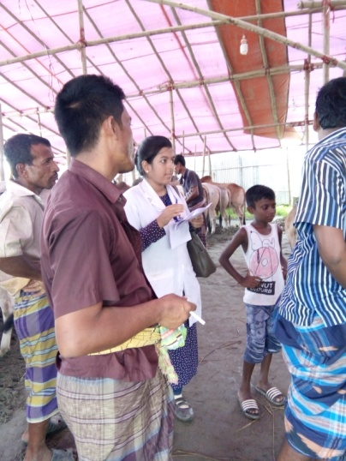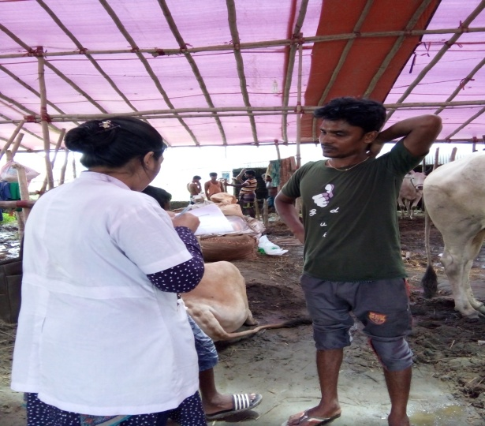
Collecting data of Questionnaire from the owner by Interview method

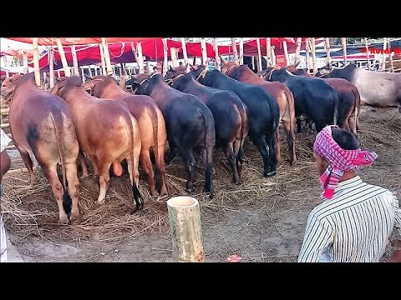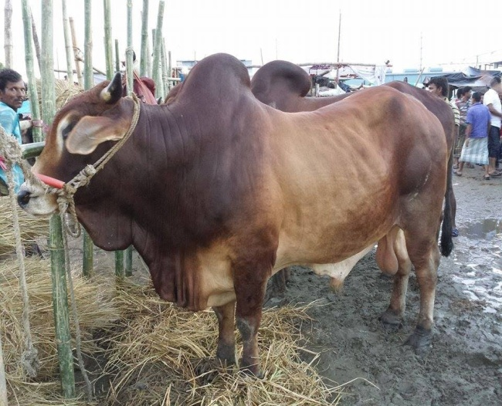
Kurbani Haat (Cattle market )

