**Study on the local chicken (Deshi) rearing system under backyard farming condition in Muktagacha, Mymensingh.**



**A Report**

**By**

**Sharmin Akhter Mili**

Roll No: 11/ 113

Reg. No: 00691

Intern ID: F-55

Session: 2010 – 2011

A production report submitted in partial satisfaction of the requirements for the degree of

**Doctor of Veterinary Medicine**

Faculty of Veterinary Medicine

Chittagong Veterinary and Animal Sciences University

Khulshi, Chittagong, Bangladesh, November **2017**

**Study on the local chicken (Deshi) rearing system under backyard farming condition in Muktagacha, Mymensingh**



**Approved as to style and content by**

**(Signature of Supervisor)**

**Dr. M. A. Hosain (Rony)**

**Associate Professor**

Department of Dairy and Poultry Science

Faculty of Veterinary Medicine

Chittagong Veterinary and Animal Sciences University

Khulshi, Chittagong, Bangladesh

**November 2017**

**INDEX**

|  |  |
| --- | --- |
| **NAME OF THE CONTENT** | **PAGE** |
| ABSTRACT | **4** |
| INTRODUCTION | **5-6** |
| MATERIALS & METHOD | **7-10** |
| RESULTS & DISCUSSION | **11-14** |
| FIGURES | **10** |
| CONCLUSION | **15** |
| REFERENCES | **16-17** |
| ACKNOWLEDGEMENT | **18** |
| BIOGRAPHY | **19** |
| QUESTIONAIRE | **20-21** |

**List of tables**

|  |  |  |
| --- | --- | --- |
| **Table** | **Title** | **Page** |
| **Table 1** | Information included in the questioner and record keeping sheet for studying of indigenous chicken rearing system. | **7** |
| **Table 2** | Response of vaccine in indigenous chicken | **9** |
| **Table 3** | Categories of farmers according to number of indigenous chicken rearing in my study areas. | **12** |
| **Table 4** | Morphological characteristics of indigenous Deshi chicken of Bangladesh. | **13** |
| **Table 5** | Production performance of indigenous chicken in Bangladesh | **14** |

**Study on the local chicken (Deshi) rearing system under backyard farming condition in Muktagacha, Mymensingh**

**ABTRACT**

The study was conducted at the different areas of Muktagacha in Mymensingh to observe the local chicken rearing system in relation with socioeconomic status of farmers, phenotypic characters of indigenous chicken, production and reproduction performance of chicken and disease occurrences.Rural people preferred to rear the indigenous chicken, because it needs minimal care, input, resources, management and so on for their marginal income and high quality protein source, though it is a secondary matter of business of agriculture. Most of the farmer rare around 10 or 12 chicken in their house. Although indigenous chicken are poor producers of eggs near 45/year and meat, they are hardy and thrive well in the harsh rural environment. Some varieties of rural chickens has a superior genetic constitution which has not been fully explored. Poultry sheds in rural areas are made of local raw materials, birds are fed with household wastes, and most of their time is spent in scavenging. There is no systematic breeding program, and close inbreeding occurs among indigenous stocks. The average sexual maturiry is 234 days and egg weight is average 45 gm. Shortage of feed and a high incidence of diseases are the main constraints to rural poultry development. Response against the vaccine is around 60 %. In spite of such constraints, indigenous chicken production in the country will continue to grow in response to an increasing demand for eggs and meat.

**Introduction**

Livestock especially poultry is a promising sector for poverty reduction in Bangladesh. Approximately 140 millions chickens are scattered throughout 68,ooo villages in the country, mostly of those birds is of indigenous or non-descript type of chicken. The production system for indigenous chickens is smallholder backyard scavenging in nature, each family keeping an average of 6-7 chickens to meet family requirements, and from which a cash income can also be derived when necessary. Indigenous chickens produce about 75% of the eggs and 78% of the meat consumed domestically. Among said indigenous chicken, the genetic resources of non-descript Deshi, Aseel and Naked Neck breeds are noteworthy. The non-descript Deshi chicken constitutes about 90% of the indigenous population. This population has been undergoing genetic erosion since the 1960s following the introduction of improved stock from developed countries (*Bhuiyan & amin,*1999.)

The economy of Bangladesh heavily depends on its agricultural resources. Livestock is the most viable sector in the economy of the four sub-sectors of agriculture (crop livestock fisheries and forestry). At present livestock contributes 6.5% to GDP on the basis of value added through its production of milk eggs meat and hides and skins. Poultry production and poultry related industry contributes most significantly to the total livestock sector in Bangladesh, the livestock sub-sector contributed 12 to 14% to total agricultural GDP in 1998 - 99 at current prices (Khan and Roy, 2003). It is estimated that there are about 140 million chickens in the total poultry population (DLS, 2000).

Poultry production in Bangladesh is dominated by indigenous chickens. Indigenous chickens constitute nearly 80% of the total chicken population of the country (DLS, 1998). Even in some areas about 96-98 percents of the households keep only chickens (Islam, 1987; Maijer, 1987). Indigenous poultry are poor producers of eggs and meat, they are hardy and thrive well in the harsh rural environment and some varieties have a superior genetic constitution which has not been fully explored. Poultry sheds in rural areas are made of local materials, birds are fed with household wastes, and most of their time is spent in scavenging. There is no systematic breeding programmer and close inbreeding occurs among indigenous stocks. Shortage of feed and a high incidence of diseases are the main constraints to rural poultry development. In spite of such constraints, poultry production in the country will continue to grow in response to an increasing demand for eggs and poultry meat. Poultry provide a major income-generating activity from the sale of birds and eggs. Occasional consumption provides a valuable source of protein in the diet. Poultry also play an important socio-cultural role in many societies. Poultry keeping uses family labour and women (who often own as well as look after the family flock),are major beneficiaries. Women often have an important role in the development of family poultry production as extension workers and in vaccination programmers.

Poultry is an emerging business and getting much popularity to the people of Bangladesh. Chicken is the main species of poultry which dominates over all other poultry species in Bangladesh. Indigenous chicken is the main species of poultry in Bangladesh, it is available in the rural areas. The data on the indigenous chicken are inadequate. Further extended study is required to make this chicken popular and familiar to the world context. Therefore, two month study was carried out for the testing of tools intended to be used for main study. The study was conducted to explore the socio economic status of farmers, phenotypic characters of indigenous chicken, production and reproduction performance of chicken and disease occurrences.

**Objectives of the study :**

1. To evaluate productive and reproductive performance of indigenous chicken.
2. To explore the socio-economic status of the farmers
3. To assess the phenotypic characters of the indigenous chicken

**Materials and Methods**

**Study area**:

The experiment has been carried out at the north border areas of Bangladesh covering 10 different villages of the Muktagacha Upazila, Mymensingh, using an interview schedule. It has been done as a part of my internship program to prepare production report mainly focusing on the socio-economic status, productive and reproductive performances, phenotypic characters and disease occurrence of indigenous chicken at the farmers level. The indigenous chicken farmers are categorized according to chicken flock sizes. According to distribution of chicken, farmers are divided into four categories having 03-10, 10-15, 15-20, and >20 chicken per farm. From each village farmer was interviewed with a pre-formed questionnaire (attached in the appendix) by visiting their household farms individually. The village farmer of Bangladesh had not kept any written record. All the information was recorded from the farmers by their verbal speech. The data was collected through individual interviews and analyzed finally. The duration of study was 2 months. The main consideration for selection of this study area was due to following causes: availability of chicken in the study area, good communication facilities and no study had been done in this area before. The information included in the questionnaire and record keeping sheet for studying of indigenous chicken rearing system are given below in Table 1.

Table 1: Information included in the questionnaire and record keeping sheet for studying of indigenous chicken rearing system are given below:

|  |  |
| --- | --- |
| **Key point** | **Main questions** |
| **Identification information** | **Farmers name, area, address details.** |
| Socio economic information | Profession, existing family members, age and education , total number of chicken. |
| Housing and its managemental information | Housing with ventilation, placeof housing, treatment and prevention of disease. |
| Feeds, feeding and water source related information | Time of feeding, feed sources, type of feed supply, frequency of feed. |
| Production and managemental related information | Age of sexual maturity, laying time, percentages of egg production, fertility, hatchability, mortality, |
| Disease information | Infectious and non -infectious disease and parasitic infestation. |
| Prevention of disease | Vaccine and vaccination schedule. |

After the collected data were put on the sheet. Then the data were arranged in a tabular form and analyzed as per the objectives of the study.

**Housing conditions of chickens**

Village chicken raisers construct chicken house of various types. The majority of the respondents did not have separate chicken house. The chickens are reared by the village farmers mostly under scavenging system or backyard condition giving a night shelter or coop. The raw materials of the coop are bamboo, wood, tin, mud and so on. As the response of the farmers, some of the respondents shelter theirs birds in the kitchen, some share common night shelter with household members and shelter in ceiling of the house, and also in basket made up of wood and shelter in the house with separate perching. The chicken owners clean the chicken house daily or once a week or twice a week indicating most farmers give attention for the bio-security measures of the chickens.

**Feeding and watering of the chicken :**

All the farmers provide supplementary feeds for their chicken daily. Feed sources for chicken include home produced feeds, market purchased feeds and both. They scavenge all the period during day time and search their own feeds themselves around the yards of the farmer’ houses. The farmers supplement their chicken three times a day, twice a day and once a day. Feeds offered to chicken using plastic material and broken pot of clay. The current study revealed that all the respondents practice supplementary feeding using home grown crops such as maize, barley, wheat, sorghum and household leftovers. Wheat and maize grains are commonly supplemented to the chickens. The grains are either home produced or market purchased feeds. Recent studies we have seen that farmers offer supplementary feeds to their chickens. Young chicks (1-4 weeks old) are given priority towards supplementary feed. The supplementary feeds are provided to increase egg production, encourage growth and maintain flock health. The major source of water for village chicken is tap water. All the chicken owners have watering trough, made up of plastic equipment, broken pot of clay and purchased watering trough. Farmers clean the watering trough when they found the equipment dirty, once a week, daily, once on two days , once on three days, and once per four days. The chicken owners provide water to their chickens year round with particular emphasis during the dry season.

**Frequency of disease incidences :**

A total of 20 (twenty) dead bird was collected from post mortem in the Mymensingh Upozilla in my study period to diagnose the case. Eight samples were identified for Ranikhet (55%), eight sample were coccidiosis, six samples were fowl pox, three samples were infectious coryza, two sample were ascitis. Ranikhet was the most frequent disease identified in the study areas. Vaccine is available for Ranikhet disease, but sometimes it does not work well. The Fowl pox vaccine was also available. But in case of infectious coryza and ascitis, rearing management must be improved. The positive response and negative response and mortality after vaccination are given below (Table 2).

**Table no 2: Response of vaccine in indigenous chicken.**

|  |  |  |  |  |  |
| --- | --- | --- | --- | --- | --- |
| Name of disease | Positive response | Negative response | Mortality after vaccination | Bio-security maintain by farmer | People who administered vaccine |
| Ranikhet vaccine | 60% | 40% | 40% | poor | Most of all |
| Fowl pox vaccine | 30% | 60% | 60% | poor | Most of all |

**Mothering and brooding ability**

Farmer said that local chicken have good mothering and brooding ability than the exotic breed. So farmers choose local chicken in hatching egg and breeding purpose to increase the flock size. Their mothering ability can contribute m6re than better survival of the chickens. But sometimes chickens break or eat their own egg that cause loss of economic aspect of the farmers. It might happen due to some vitamin or mineral deficiency.

**Chicken missing or loses or mortality:**

The chickens are most often attacked by the predators, as they are reared under free range condition in the rural areas. But most of the farmer said that local chicken are capable of escaping from predator attack. Local chicken are also noted for their good disease resistant and heat tolerance, there is no variation between the male and female chickens of either breed in disease and heat tolerance.

As per the respondent farmers the most striking problem in village chicken production systems is the high mortality rate which could reach as high as 90% within the first few weeks after hatching, due to diseases and predation.  The interview with the local farmers showed that the local chickens are more easily available at the time of need when compared with the availability of the exotic breeds**.** A farmer can easily access the local chicken from different source (local market, neighbor, gift etc.). local farmers need not any extra pressure for feeding of local breed. Most of the time they use concentrate (rice polish, broken rice, rice husk, ). As a result, feed cost is low in case of Indigenous chicken.

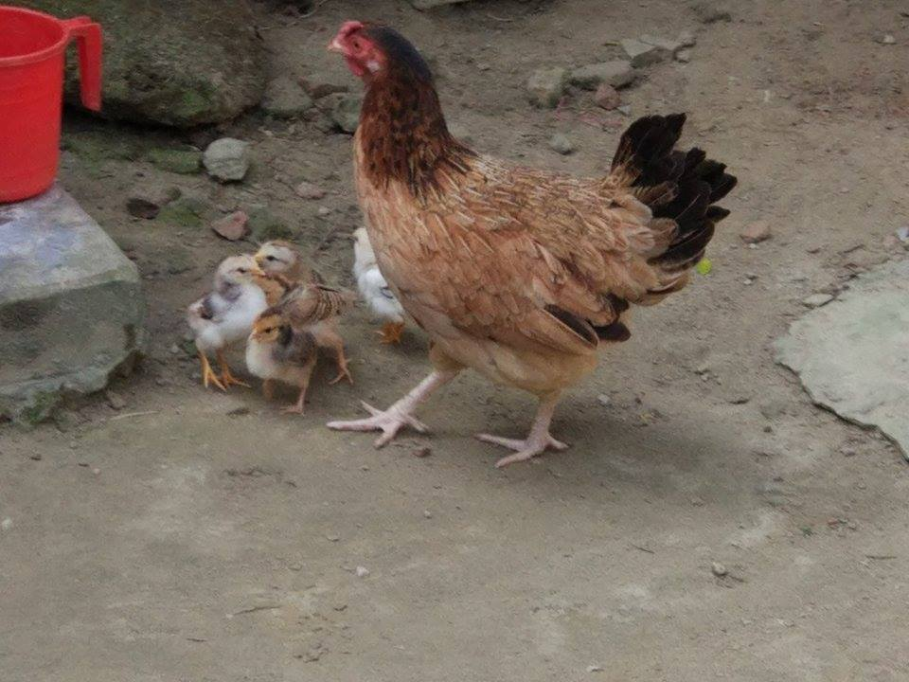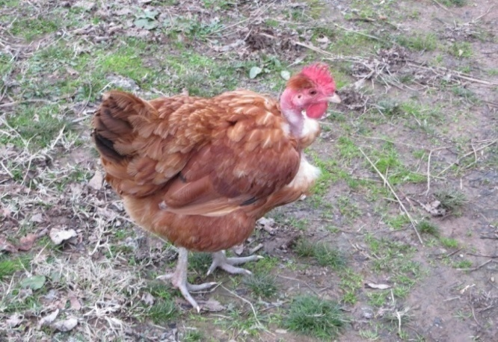

**Fig: Indigenous chickens; Fig : Naked neck chicken.**

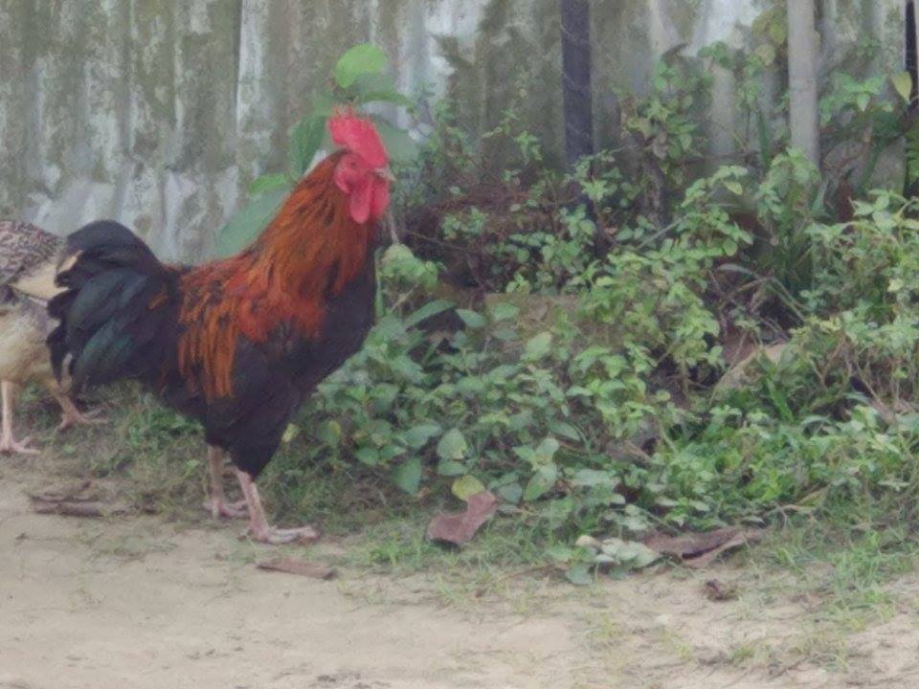 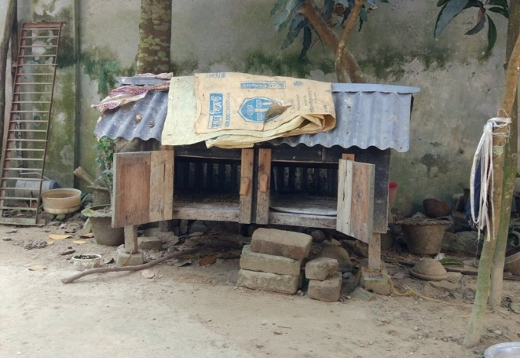

**Fig : Deshi chicken. Fig : Housing system of chicken.**

**Data collection:**

Data on the number of indigenous chickens of each farmers, morphological characteristics of indigenous chickens, different local breeds, production performances, mortality and income sources and so on were collected during my study period. All the collected data were subjected to normal statistical analyses.

**Results and Discussion**

**Indigenous chicken rearing according to farmer condition.**

The farmers are distributed into four categories according to the farm size 03-10, 10-15, 15-20 and >20 as shown in Table 3. Sometimes the farmers rear the indigenous chicken according to their land categories. Most of the people in our village are landless. marginal, medium or small farmers. The average number of indigenous chicken was 4, 6, 7, 8 in case of landless, marginal, medium and small farmers, respectively. According to the farm size most of the farmers in my study areas are categorized as given below in Table 3.

Table 3: Categories of farmers according to number of indigenous chicken rearing in my study areas.

|  |  |  |  |  |  |  |  |  |  |  |
| --- | --- | --- | --- | --- | --- | --- | --- | --- | --- | --- |
| No. of farms | 1 | 2 | 3 | 4 | 5 | 6 | 7 | 8 | 9 | 10 |
| Categories of farmers | One | Two | One | Two | Two | Three | One | One | One | Two |
| No of indigenous chicken /farmer | 8 | 12 | 9 | 15 | 15 | 18 | 9 | 10 | 10 | 14 |

**Breeds/Types of Chicken available in my areas:**

The indigenous chicken population is composed of a number of breeds such as non-descriptive Deshi, Aseel, Naked Neck and Hilly. Some dwarf chickens and Red Jungle Fowls can also be seen in the country. In my study areas, non-descriptive Deshi chicken is more common as an important source of meat and eggs. The farmers rear this birds due to its low nutritional demand with higher resistance to diseases and heat stress. These rural Deshi chickens provide about 78% of poultry meat and 75% of eggs for domestic consumption.

**Morphological characteristics of indigenous chicken** :

The following morphological characteristics of indigenous chicken were observed in our study areas (Table 4). The indigenous chicken have different traits, which differ from breed to breed. The traits were plumage colour, eye colour, ear lobe colour, comb colour, skin colour, egg shell colour, feather color, comb type and spur. The morphological character that I observed are given below (Table 4).

**Table 4. Morphological characteristics of indigenous Deshi chicken of Bangladesh.**

|  |  |  |  |
| --- | --- | --- | --- |
| **Traits** | **Type of Local Chickens** | | |
| **Deshi** | **Necked neck** | **Aseel** |
| Plumage colour | Black and red. | Black, reddish | Purple |
| Eye colour | Black | Black | Black |
| Shank colour | Black, yellow | yellow | yellow |
| Ear loabcolour | Red, white | Red | Red |
| Comb colour | Bright red and pale | Purple, red | Red |
| Skin colour | White, yellow | Yellow | White / yellow |
| Egg shell colour | Light brown, white | Brownish | Brownish |
| Feather pattern | No definite | No definite | No definite |
| Comb type | Mainly single | Single | -single |
| Spur | Rudimentary | Rudimentary | Rudimentary |

**Sexual maturity of indigenous chicken :**

In our country, Deshi chickens attain sexual maturity late as compared to other type of chickens. Most of the farmers said that the sexual maturity of Deshi chicken and necked chickens are 234 and 175 days, respectively. The highest age at sexual maturity was 240-300 days in Aseel birds. The mature body weight of Deshi and Naked Neck chickens was very similar (Table 5) and it varied from 1.0 to 1.3 kg. But the Aseel bird was heavier than other indigenous chicken.

**Production performances of indigenous chicken.**

The indigenous chicken typically begin producing eggs in their 29th or thirty first week and continue egg production for slightly over a year. This is the best laying period and eggs tend to increase in size until the end of the egg production cycle. Mainly optimum body weight is very important in laying period. And it should be around 1.5 kg, although this varies according to breed. According to my survey, the optimum body weight of chicken was 1.3 to 1.6 (Table 5). The average number of egg production are varies from breed to breed. Annual egg production per hen was 50-55 in Naked Neck and was 45-50 in Deshi chickens under scavenging conditions. In general, the eggs of indigenous chicken are much smaller than those of exotic breeds/strains. Egg weight varied from 35-39g (Table 5) in Deshi to 42 g in Naked Neck chickens.

**Table 5: Production performance of indigenous chicken in Bangladesh**

|  |  |  |  |  |  |  |
| --- | --- | --- | --- | --- | --- | --- |
| Farmers no. | Name of breed | Mature body weight (kg) | Egg production/hen /year | No. of egg /clutch | No. of clutch /year | Egg weight (g) |
| 1 | Deshi | 1.3 | 45 | 10 | 3 | 35 |
| 2 | Deshi | 1.2 | 40 | 8 | 3 | 36 |
| 3 | Deshi | 1.3 | 45 | 10 | 3 | 35 |
| 4 | Deshi | 1.4 | 45 | 9 | 3 | 35 |
| 5 | Deshi, | 1.3 | 45 | 5 | 3 | 35 |
| Naked nack | 1.2 | 50 | 7 | 2 | 40 |
| 6 | Deshi, | 1.3 | 45 | 9 | 4 | 35 |
| Naked neck | 1.3 | 40 | 7 | 2 | 40 |
| 7 | Deshi, | 1.2 | 50 | 10 | 4 | 35 |
| Naked neck. | 1.3 | 40 | 6 | 2 | 40 |
| 8 | Deshi | 1.4 | 50 | 9 | 3 | 35 |
| 9 | Deshi | 1.3 | 50 | 8 | 3 | 35 |
| 10 | Deshi | 1.3 | 50 | 10 | 3 | 35 |

**Yearly income level of farm owners**

The yearly income level of the studied farms is categorized as five groups such as up to Tk 10000, Tk (10000-20000), Tk (20000-30000) and above Tk 30000.

**Morbidity and mortality :**

The morbidity and mortality rates in desi chicken is due to various diseases during 2 year period as reported by the farmers. Both morbidity and mortality rates of desi chicken due to Ranikhet disease were found highest. It can also be added here that the indigenous medicines which they use against Ranikhet disease are not effective. Due to lack of protection against Ranikhet disease, the mortality was very high. In case of fowl pox, it is also happened morbidity and mortality rate is high. Morbidity and mortality also depend on age of chicken. The highest mortality was recorded in chicks at the age of 0 to 8 weeks, and reduced in growers and adults. The farmers clean chicken’s house as bio-security measures to address health problem. Lack of frequent cleaning of poultry house can easily cause diseases and increase morbidity and mortality rate.

**Conclusions, recommendation and limitation of the study**

This study focused on the backyard indigenous chicken rearing systems, morphological characters, productive and reproductive performances and disease frequency. This study also discussed the socio-economic condition of farmers. It can be concluded that from the study that indigenous chicken rearing condition appeared to be very good, because of the farmers awareness and environmental condition. So, it can be earned more profit by rearing indigenous chicken in rural areas, because it has much potential to enrich meat and egg production for the people of Bnagladsh. Regular vaccination and management can have decisive effect on indigenous chicken rearing. In some cases particular production was reported higher than expected. However, the introduction of training, breeding management, creating more extended provision of healthcare and prevention of disease may be a positive initiatives of chicken rearing in the Mymensingh district. The study period was very short just for two month only, proper data recording was not available to the female farmers, Some farmers were not cooperative to the researcher, Proper data by the interviewer sometimes becomes difficult. Further study may be undertaken to explore the local chicken farming condition for available data on the productive performances of the chicken.

**References**

**Ambar M.A.J A.K.F.H. Bhuiyan M.A. Hoque& M.R. Amin**. 1999. Ranking of some pure and crossbred chicken using scoring indices. Indian Journal of Poultry Science. 34 (2): 140 -146.

**Ahmed S. & N. Islam**. 1985. Backyard poultry development project in 100 villages. Proceedings of the 1st Conference of Bangladesh Animal Husbandry Association. February 23-24 1985. BARC. Dhaka 133-138

**Khan M.R. & P.C. Roy**. 2003. Credit policy; disbursement and its impact on poultry industry in Bangladesh. Third International Poultry Show and Seminar Dhaka Bangladesh: 43-51

**DLS**. 1998. Expansions and Activities. Department of Livestock Services. Dhaka. Bangladesh pp. 131.

**DLS**. 2000. Expansions and Activities. Department of Livestock Services. Dhaka. Bangladesh pp. 31.

Mohanty, G. (1987) In: FAO Expert consultation on rural poultry development in Asia, Dhaka, 23-28 March, 1987; cited by Bessei, 1988

Galal A, Ahmed AM, Ali UM, Younis HH (2007)[Influence of Naked Neck gene on laying performance and some hematological parameters of dwarfing hens. International Journal of Poultry Science 6: 807-813.](http://www.docsdrive.com/pdfs/ansinet/ijps/2007/807-813.pdf)

**Haque Q.M.E. & U. Assaduzzaman**. 1990. Feeding pattern of birds (chicken and ducks) under scavenging condition and formulation of supplementary ration using the local ingredients. Second Annual Progress Report Poultry Production Research Division Bangladesh Livestock Research Institute Savar Dhaka Bangladesh pp. 47.

**Haque Q.M.E. M.H. Ebadul& E.M. Rigor**. 1990. The effect of chick separation on productivity of the hen and chick. Asian-Aust. Journal of Anim. Sci. 3 (2): 121-123.

**Hoque M. A. Ali & Q.M.F. Rahim**. 1975. A study on the upgrading of indigenous chickens of Bangladesh with White Leghorn New Hampshire and White Cornish. Poultry Breeding Project. Department of Animal Breeding and Genetics. Bangladesh Agricultural University Mymensingh Bangladesh pp. 28.

**Hoque M.E. M.A.R. Howlider& Q.M.E. Huque**. 2003. Laying performance of Naked Neck exotic chicken and their crosses under rural scavenging condition. Proceedings of 3rd International Poultry Show and Seminar. Organized by World Poultry Science Association Bangladesh Branch Dhaka 276-278.

**Huque Q.M.E. & M.H. Ebadul**. 1990. The onset of lay in indigenous hens following hatching of chicks. Poultry Adviser. vol. XXIII (VIII): 57-60.

**Huque Q.M.E**. 1999. Poultry research and development in Bangladesh. Proceedings of the 1st Seminar and International Poultry Show. Organized by the Would Poultry Science Association Bangladesh Branch. April 24-26 Dhaka 70-80.

**Okada I. Y. Maeda K. Ota T. Namikawa T. Amano Y. Kurosawa M.A. Hasnath M.O. Faruque. M.A. Majid & M.D.R. Karim**. 1987. Genetic studies on native chickens in Bangladesh. In: Genetic studies on breed difference action of the native domestic animals in Bangladesh Part. 2. Hiroshima University: 11-26

**Rahman M. P. Sorensen H.A. Jensen & F. Dolberg**. 1996. Exotic hens under semi scavenging conditions in Bangladesh.*www.cipav.org.co/Irrd9/3/bang 931.htm*.

**Sazzad M.H**. 1986. Reproductive performance of Deshi hens under scavenging and intensive system of rearing. Proceedings of 1stAnnual Livestock Research Workshop Bangladesh Livestock Research Institute Savar Dhaka 60-62.

**ACKNOWLEDGMENTS**

The author is ever grateful and indebted to the immeasurable grace and profound kindness of the **Almighty “GOD”,** the soul authority and supreme ruler of the universe, who enabled me to complete the work successfully.

The author feels proud in expressing his deepest sense of gratitude, sincere appreciations, indebtedness to respected teacher and supervisor **Dr. M. A. Hosain (Rony), Associate**  Professor, Department of Dairy and Poultry science, Chittagong Veterinary and Animal Sciences University (CVASU), for his ingenuous and scholastic supervision, constant inspiration, providing valuable suggestions, necessary corrections to report writing and for affectionate help in completion of this report.

The author would like to express his deepest sense of respect and affection to the honorable Vice Chancellor **Prof. Dr. Gautom Buddha Das** and Dean **Prof. M. A. Halim**, Faculty of Veterinary Medicine, CVASU.

The author express his sincere gratefulness and thanks to **Prof. Dr. AKM Saifuddin**, Director, External Affairs (CVASU) for his valuable suggestions for completion of this report.

The author is also greatful to all of her teachers of CVASU and her parents for their impressive support, suggestions, cordial help and inspiration regarding my study from its inception to the last.

The author

November 2017

**BRIEF BIOGRAPHY**

I am Sharmin Akhter Mii, daughter of Md.Mokbul Hossain and Shalina Akhter . I have completed my Secondary School Certificate (SSC) examination from PDB High school (2008),Kaptai, Chittagong and then Higher Secondary Certificate (HSC) examination from Muktagacha College (2010), Mymensingh. Then I got admitted in Doctor of Veterinary Medicine (DVM) course under CVASU. During my internship programme I got a short term research on aural hematoma in dogs at Madras Veterinary College, Chennai, India.

**APPENDIX**

**QUESTIONAIRE**

**Upazila Veterinary Hospital, Muktagacha, Mymensingh**

|  |  |
| --- | --- |
| Case No: | Date: |

Name of the owner’s…………………………………………………………..

Address of the owner’s……………………………………………………….

Occupation ………………………………………………………………………

Husbandry practice……………………………………………………………..

Type of feed : roughage/concentrate……………………………………………

Source of feed : homemade feed/market feed………………………………….

Frequency of feed : two/three times in a day…………………………………..

Frequency of watering: two/three times in a day……………………………….

Housing of the poultry……………………………………………………………

Proper ventilation present or not…………………………………………………

Disease prevalence ……………………………………………………………….

Mobidity mortality percentage……………………………………………………..

Vaccination on the chicken…………………………………………………………

Response on vaccination : yes/not………………………………………………….

Production statistics………………………………………………………………….

Brooding system……………………………………………………………………..

Any training on chicken rearing : ys/no………………………………………………..

Treatment of diseased chicken : yes/no………………………………………………

Incubation of egg : natural/artificial…………………………………………………..

Phenotypic character : color, plumage color,shank color…………………………….

Purpose of rearing : egg/meat………………………………………………………….

Income of rearing : income/eating…………………………………………………..

Go to hospital for treatment or not…………………………………………………..

Reason of rearing……………………………………………………………………..

Cost of rearing………………………………………………………………………..

Breed of chicken…………………………………………………………………..

Condition of farmer…………………………………………………………………

Signature : Sharmin Akhter Mili