CHAPTER-I
INTRODUCTION
Mankind has practiced with pigeon keeping about 10,000 years in almost every part of the world (Levi A, 1977). Probably pigeon is the first bird species to have been reared by humans (Johnston and Janiga 1995). The white pigeon or dove appears as an object of a symbol of peace. The pigeon was first domesticated in the Middle East around 3,000 BC (Levi B, 1977). After domestication, it would produce fresh meat during the winter months. Commercial squab production started in USA (Levi A, 1977) then it gained popularity in European countries, Australia and Indian subcontinents.. Pigeons are used for meat production, ornamentals, sports and experimental animals (Rahman, 1999). Chinese people consider the meat of pigeons as having medicinal value and squab is a part of celebratory banquets for holiday such as Chinese New Year (Hsiung et al., 2005). Egyptians raised pigeon for food (Levi, 1972). Pigeons were popular in Romans, France and England as a means of livelihood to produce squab (Goodwin, 1967). Squab meat is very lean, easily digestible, and richer in protein, mineral and vitamin. It is also used as tasty, delicate and fancy meat (Aliza, 2005; Jane, 2005; Richard, 2006; Morgan, 2006).
Pigeon farming has been practiced in Bangladesh from the time immemorial. Many people of this country are engaged in different poultry rearing where pigeon is one of them. More than 80 percent of the rural households rear poultry (Haque 1987 and Ahmed 1988). The contributions of pigeon have not yet been considered in relation to the contribution of livestock sub-sector and whole poultry production though the pigeons provide alternative source of animal protein. Comparatively low investment, care less, less feed and housing cost involved, easy and economic husbandry practices, short reproduction cycle and less disease occurrence are observed for pigeon farming. Pigeons are used in natural beautification and ornamental birds as source of recreation, source of palatable, delicious and easily digestible animal protein, sources of bio-fertilizer especially for family gardening and used as the laboratory animal in case of genetic and hormonal studies. Hence profitable pigeon farming may be an easy and reliable source of employment opportunity, way of family labour utilization and cash income. Sustainable and increasing rate of pigeon farming may enhance the rate of reducing the gap of animal protein consumption/deficiency; increase the rate of poverty reduction and it may improve the socio-economic status of the rural poor community (Asaduzzaman et al., 2007).
Pigeons are monogamous. Eight to 12 days after mating, the females lay 1 or 2 eggs which hatch after 18 days. The male provides nesting material and guards the female and the nest. The young are fed pigeon milk, a liquid- solid substance secreted in the crop of the adult (both male and female) that is regurgitated. The young leave the nest at 4 to 6 weeks of age. More eggs are laid before the first clutch leaves the nest. Breeding may occur at all sea- sons, but peak reproduction occurs in the spring and fall. A population of pigeons usually consists of equal num- bers of males and females. In captivity, pigeons commonly live up to 15 years and sometimes longer. In urban populations, however, pigeons seldom live more than 3 or 4 years. Natural mortality factors, such as predation by mammals and other birds, diseases, and stress due to lack of food and water, reduce pigeon populations by approximately 30% annually (David and Robert, 1994).
The pigeon is able to consume simple feeds consisting of grains and a little good grit; the pigeon also needed clear water (Anggorodi, 1995). Drevjany (2001) also reports that pigeon could be fed with feed that was made up of crumble ration or mixed of grains, minerals, grit and water. Among the feeds, pigeon liked grains such as corn, soya bean, peanut and wheat grain (Alwazzan, 2000).
Though pigeons are reared in Bangladesh from the very beginning but total statistics is still unknown. In Bangladesh pigeon production in the rural areas is of great importance to the supply of meat and as source of income especially to the young energetic peoples. Pigeons reared in Bangladesh are predominantly belongs to Gola breeds for squab production (Rahman, 1999). The pigeon is being reared by both urban and villagers people across the country. The system of rearing pigeon in either area of pigeon rearing is almost similar, but farming condition might vary from urban to village areas. Most of the people follow tradition system to rear pigeon under large and small scale in order to meet their family income, hobby, protein need and so on. But the actual data of pigeon farming in the urban areas still scarce or not available. For this why, the present study was undertaken to investigate the farming condition (e.g different breeds, housing, feeding, disease management, marketing of pigeon and problems of farming) of pigeon raisers around the urban areas of the Chittagong, Bangladesh.

CHAPTER-II
MATERIALS AND METHODS
The study was conducted to investigate the pigeon farming condition of the urban areas in the Chittagong metropolitan areas of Bangladesh.
2.1 Study area: The urban area of Chittagong was selected for my study area as a part of my intern program. The study area was the pigeon farms which were selected purposefully and randomly to collect data for my production report. The selected pigeon farms were located in the different areas of Chittagong metropolitan areas. These were Dewanhat, Agrabad, Monsurabad, Boubajar, Nayabajar, Rongipara, Majhirghat, Nasirabad and Muradpur Ten pigeon farms were chosen based on the information that the pigeon farmownershave been rearing different breeds and varieties of pigeons since long time. The name of the pigeon farm owners, location, breed, number of pigeon reared by the farmersare shown in Table 1.
2.2 Data collection: Data were collected from 10 selected farms located in the study area. A questionnaire (shown in the Appendix Table) was developed to collect data from the selected farms located in the different urban areas of Chittagong Metropolitan city (Table 2). Interview schedule was carefully designed containing both open and closed form of questions. Most easy, simple and direct questions were asked the pigeon raisers to obtain information The information on farmers occupation, duration of farming, different breeds, housing, feeding, disease management, marketing of pigeon and problems of farming were collected, as shown in the Table 2.
2.3 Data compilation: Collected data were complied, tabulated and analyzed. Qualitative data were converted into quantitative forms by means of suitable score whenever needed and the local units were converted into standard unit scales. Simple tabular techniques were used to explain the data. Percentage were used mainly to illustrate the results.
2.4 Housing system: Pigeons were reared in both intensive and extensive system. Among the ten households, I found four intensive and six extensive system of rearing pigeon, meaning that 40% intensive and 60% extensive systems of rearing. The dovecote size varies from 2 to 2.5 sq. ft. per bird in intensive system and 0.6 to 1 sq. ft. per bird in extensive system. The housing material were mainly iron, wood and canister. In 50% households, the dovecotes were made of iron cage, in 30% made of wood and 20% of households had canister dovecote.
Table 1: Name of the pigeon farm owners, location, breed, number of pigeon reared by the farmers
Farms | Name of the farm owner | Name of pigeon breed | No. of pigeon reared (in pair) | Location
H1 | OviChy | Lakha,Chila,Deshi | 12 | Nayabajar
H2 | Tanvin | Giribaz | 12 | Mansurabad
H3 | Md. Wasim | Siraji,Racer,Giribaz,Deshi | 25 | Agrabad
H4 | KamrulHasan | Giribaz,Deshi | 5 | Nayabajar
H5 | AbulKalam Azad | Giribaz,Siraji,Lakha,Red king,,Chila | 25 | Rangipara
H6 | Shibli | Giribaz,Siraji, | 25 | Muradpur
H7 | Shahjalal | Giribaz | 7 | Boubajar
H8 | Md. Khokon | Giribaz,Lakha,Peshwary,Meghraj | 15 | Dewanhat
H9 | Forhad | Siraji,Giribaz,Egyptian swift | 25 | Nasirabad
H10 | Jahangir | Meghraj,Racer,Homer,Kalduma,Giribaz | 45 | Majhirghat

[H1 refers to pigeon farm owned by OviChy, similarly, H2 refers to Tanvin, H3 refers to Md. Wasim, H4 refers KamrulHasan, H5 refers to AbulKalam Azad, H6 refers to MdShibli, H7 refers to Shahjalal, H8 refers to Md. Khokon, , H9 refers to Md. Khokon,, , H10 refers to Md. Khokon,]
2.5 Feeding system: In case of intensive system, the pigeons were fed in individual method which comprises 40% of households, and in case of extensive system feed were given in group which comprises 60%. In 70% households feeds were given two times, morning and evening. On the other hand, 30% households gave three times, morning, evening and night. The feed ingredients given were mainly rice, wheat, maize, different types of pulse and mustered. Along with the feed different types of calcium and vitamin supplements were also given. Clean drinking water were also provided minimum two times a day.
2.6 Disease incidence and medication: Pigeon farmers were faced different type of diseases during rearing conditions of pigeon. These diseases were assumed to be due to infection by different bacteria, virus, fungus and parasites. The pigeons were seemed to be affected by Newcastle disease, Pox, Salmonellosis, and mineral deficiency as per the sign and symptoms shown by the bird and explained by the farm owner. Treatment were given mainly on the basis of sign and symptoms by the owner himself or by registered veterinarian.
Table 2: Data collection from the ten farms
Parameters | Farms
 | H 1 | H 2 | H 3 | H 4 | H 5 | H 6 | H 7 | H 8 | H 9 | H 10
Dovecote size (sq. ft./pair) | 1.5 | 2 | 1.3 | 1.3 | 5 | 4.6 | 1.3 | 5 | 3.36 | 1.5
No. of pigeon reared | 24 | 24 | 50 | 10 | 50 | 50 | 14 | 30 | 50 | 90
Feed intake (gm/day/bird) | 50 | 40 | 60 | 40 | 30 | 40 | 40 | 50 | 60 | 60
Feed cost (Tk/day/bird) | 69.75 | 55.8 | 83.7 | 55.8 | 41.85 | 55.8 | 55.8 | 69.75 | 83.7 | 83.7
No. of squab /year | 100 | 60 | 200 | 40 | 120 | 100 | 56 | 180 | 200 | 720
Body wt. of squab (gm) | 150 | 150 | 150 | 150 | 200-350 | 150 | 100-150 | 150-200 | 150-200 | 250-350
Mortality (%) | - | 20 | 3 | 15 | - | 18 | 7 | - | - | -
Selling price of squab (Tk/bird) | 100-500 | 350-400 | 150-400 | 100-150 | 250-700 | 400 | 100-150 | 250-700 | 500-700 | 500-700

2.7 Vaccination: In 40% households, vaccination of pigeon were done by BCRDV as eye drop at 1 to 7 days old. But in case of 60% households they did not do any vaccination.
2.8: Predatory attack and loses of birds: Among the ten households three households were found predatory attack. Two of them faced problems of rat and one faced problem of cockroach. Owner reported that the predators mainly attack the feathers of pigeon and sometimes took away the pigeons if they can. One of the households also reported about missing pigeons due to theft.

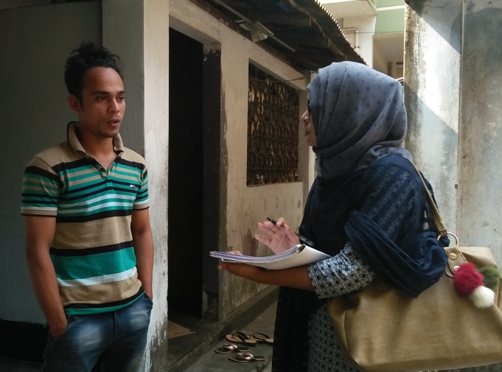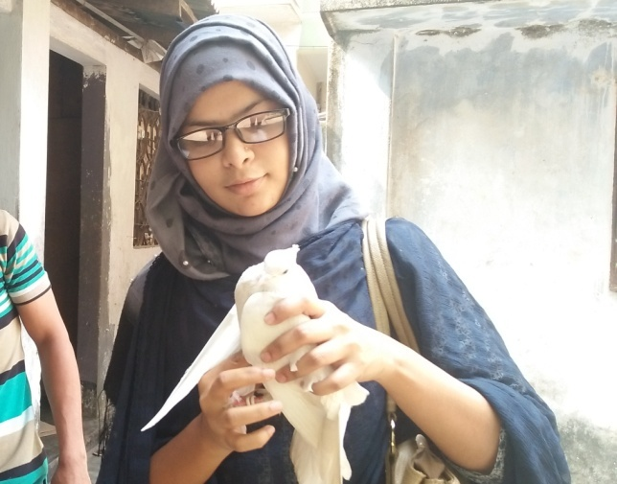
Fig.2: Collection of data Fig.3: Examination of pigeon
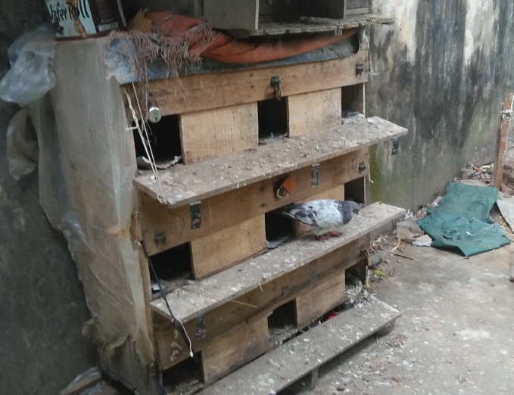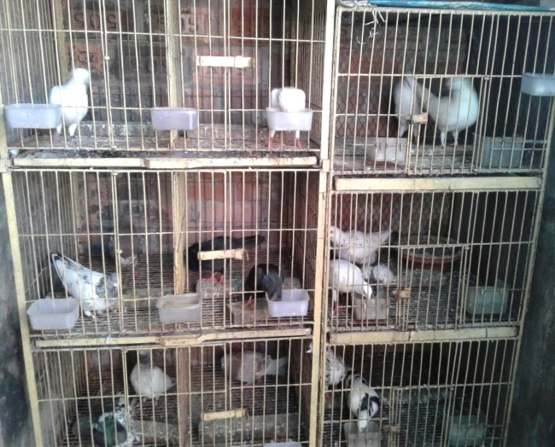
Fig.4: Different housing system of pigeon
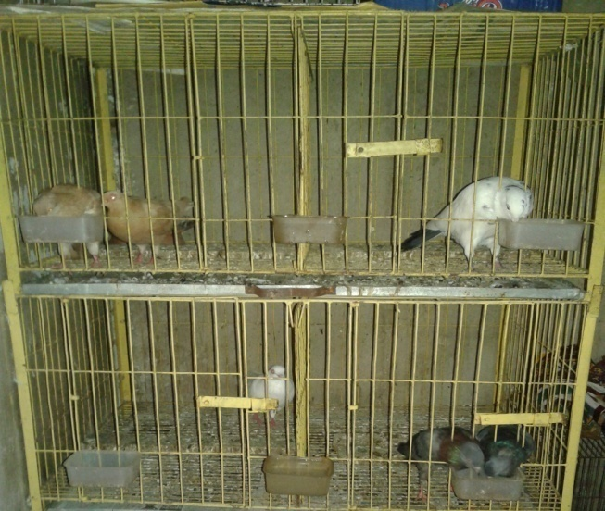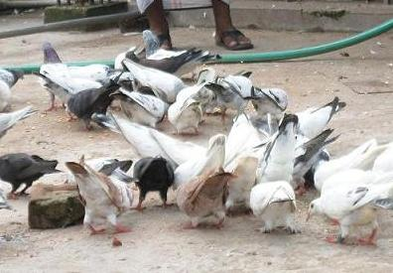
Fig.5: Individual and group feeding system
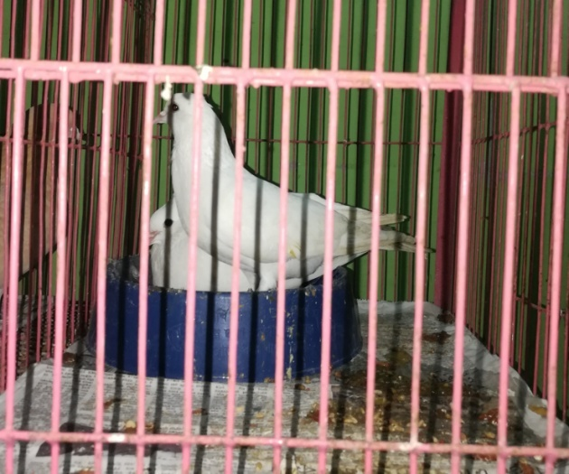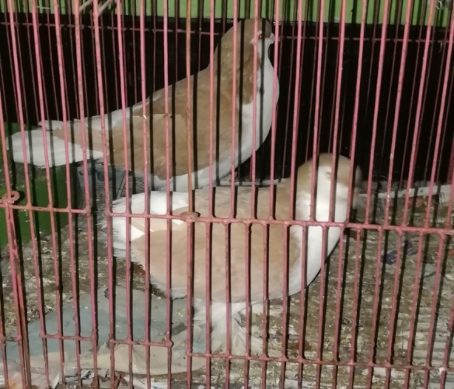
Giribaz Siraji

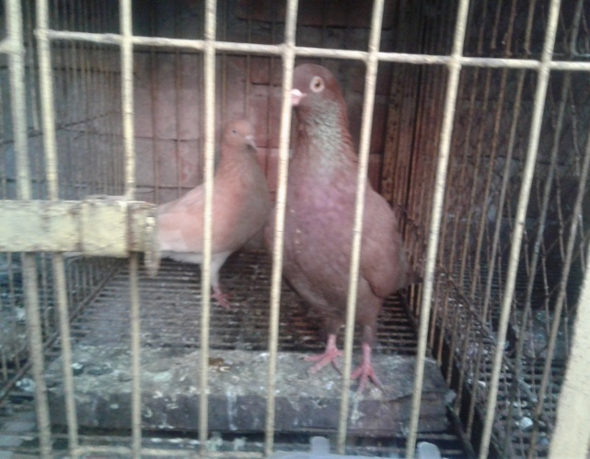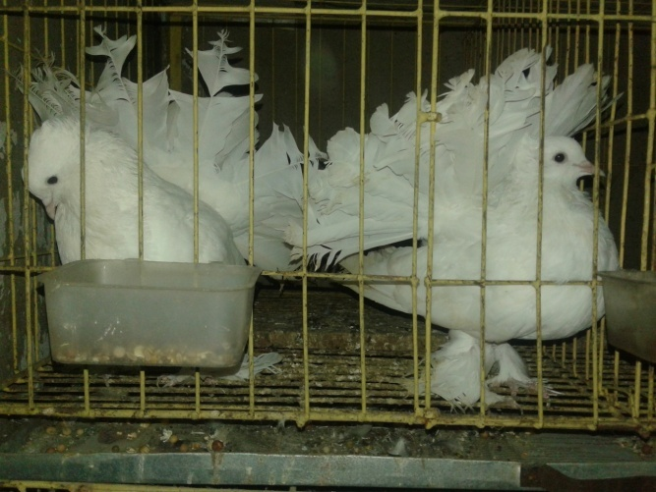
Chila Lakha

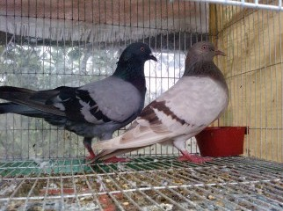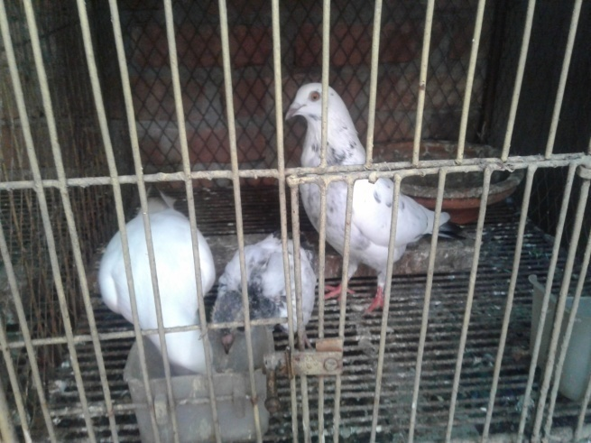
Deshi Meghraj
Fig.6: Different breeds of pigeon
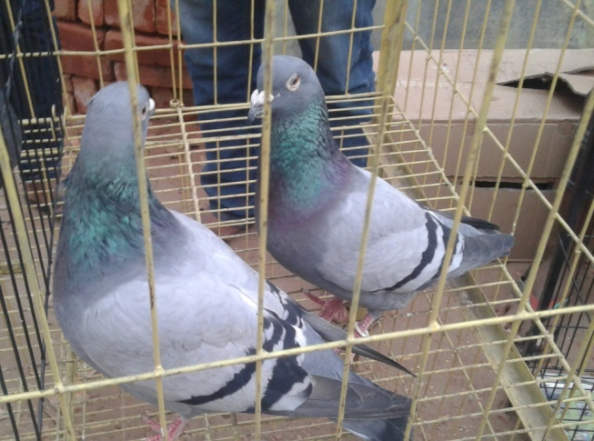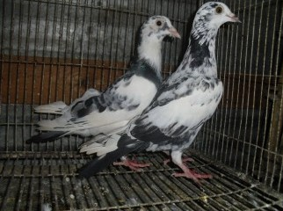
Homer Racer
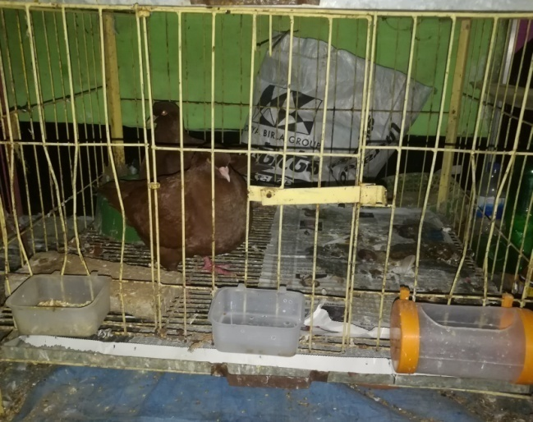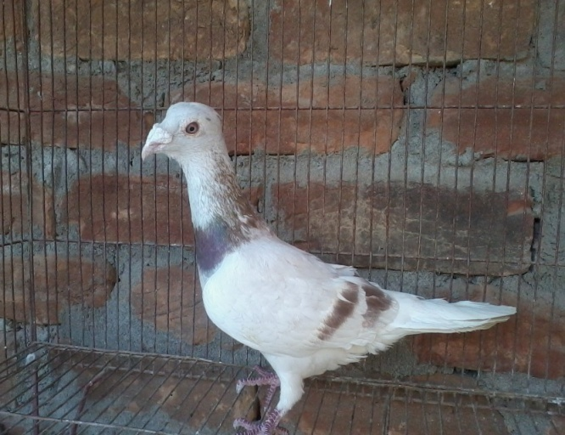
Red king Peshwary
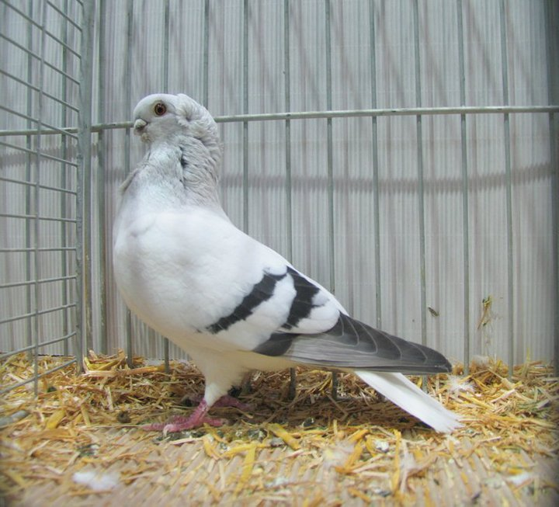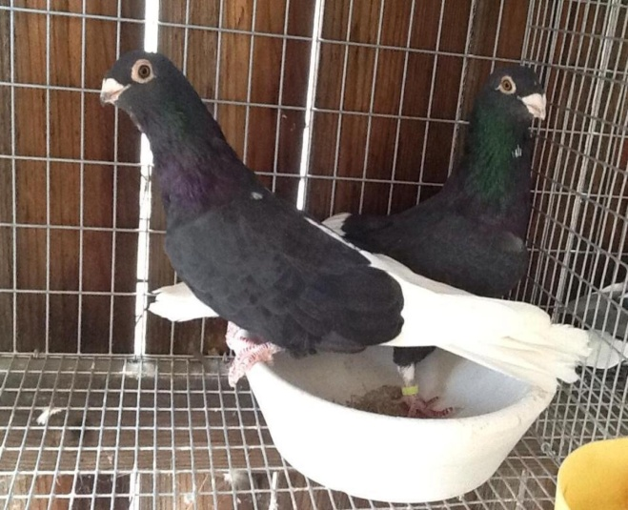
Kalduma American swift
Fig.6: Different breeds of pigeon

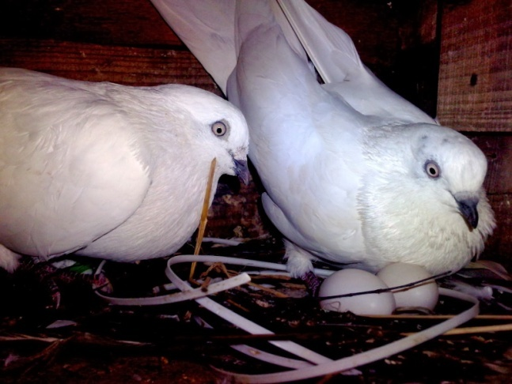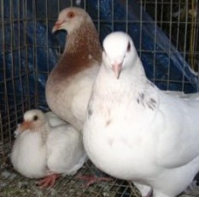
Fig.7: Pigeon with egg Fig.8: Pigeon with squab
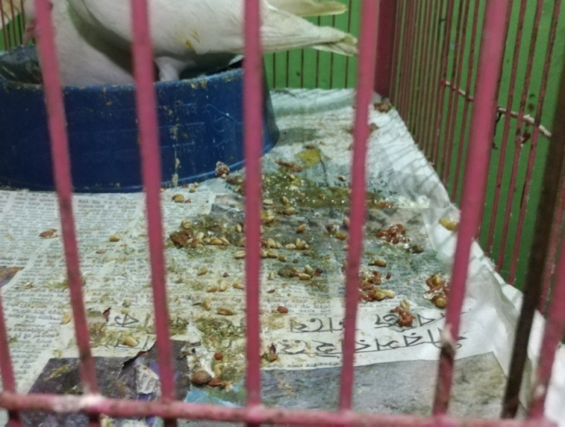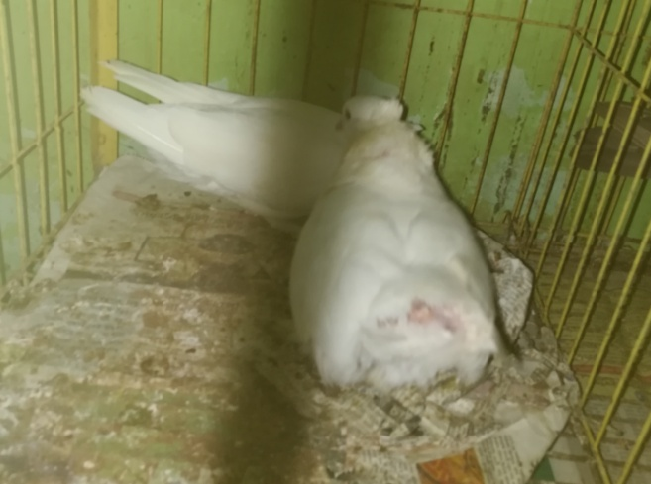
Fig.8: Diarrhoea in pigeon Fig.9: Pigeon attacked by predator

CHAPTER-III
RESULTS
Growth performance and mortality of pigeons of ten households
Body weight of pigeons: The average body weight (BW) of pigeons at one month of age was shown in the Table 3. The result showed that the average body weight of different breeds of pigeon ranges from 125 gram to 300 gram, and on an average BW was 195g.
Table 3: Body weight of squab at one month of age
Parameters | Farms (H1 to H10)
 | H 1 | H 2 | H 3 | H 4 | H 5 | H 6 | H 7 | H 8 | H 9 | H 10 | Av.
Body wt. of squab (gm) | 150 | 150 | 150 | 150 | 200-350 | 150 | 100-150 | 150-200 | 150-200 | 250-350
Average body wt. (gm) | 150 | 150 | 150 | 150 | 275 | 150 | 125 | 175 | 175 | 300 | 195

Feed intake of pigeons: The average feed intake (FI) of pigeons rearing in the ten households was shown in Table 4. The result showed that the average feed intake lies between 30 gram to 60 gram for per bird per day. The range is due to calculating the feed intake of both light and heavy breeds of pigeon together.
Table 4: Feed intake of pigeons in 10 farms

 | Farms (H1 to H10)
Parameters | H 1 | H 2 | H 3 | H 4 | H 5 | H 6 | H 7 | H 8 | H 9 | H 10 | Av.
Feed intake (gm/day/bird) | 50 | 40 | 60 | 40 | 30 | 40 | 40 | 50 | 60 | 60 | 47

Mortality: The mortality (%) of pigeon varied from farm to farm as the birds were not reared for commercial purpose. The mortality (%) ranges from 3% to 20% in five households, as reported by the pigeon raisers. On the other hand, the remaining 50% pigeon raisers reported no mortality at all. The mortality (%) of pigeon of five pigeon farms showed below in Fig.1.

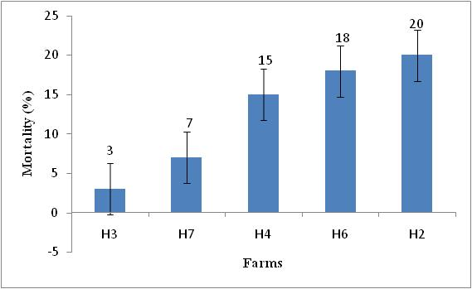
Fig.1: Mortality (%) of pigeon obtained from five farms/households
Cost benefit analysis of pigeons rearing in 10 households: The cost benefit analysis of pigeons rearing in 10 households was shown in Table 6. The data showed that the total average income from pigeon of different household ranges from 2500 to 25000 TK/year. The feed cost of bird of ten household lies between 41.5 to 83.7 Tk/bird.
Table 6: Cost benefit analysis of pigeons rearing in 10 farms
Parameters | Farms (H1 …H10)
 | H 1 | H 2 | H 3 | H 4 | H 5 | H 6 | H 7 | H 8 | H 9 | H 10 | Av.
No. of pigeon reared | 24 | 24 | 50 | 10 | 50 | 50 | 14 | 30 | 50 | 90 | 39.2
No. of squab /year | 100 | 60 | 200 | 40 | 120 | 100 | 56 | 180 | 200 | 720 | 177.6
Feed intake (gm / day / bird) | 50 | 40 | 60 | 40 | 30 | 40 | 40 | 50 | 60 | 60 | 47
Feed cost (Tk/day/ bird) | 69.75 | 55.8 | 83.7 | 55.8 | 41.85 | 55.8 | 55.8 | 69.75 | 83.7 | 83.7 | 59.99
Body wt. of squab (gm) | 150 | 150 | 150 | 150 | 200-350 | 150 | 100-150 | 150-200 | 150-200 | 250-350 | 195
Marketing age of squab (week) | 4 | 4 | 4 | 4 | 4 | 4 | 4 | 4 | 4 | 4 | 4
Mortality (%) | - | 20% | 3% | 15% | - | 18% | 7% | - | - | - | 6.3
Selling price of squab (Tk/bird) | 100-500 | 350-400 | 150-400 | 100-150 | 250-700 | 400 | 100-150 | 250-700 | 500-700 | 500-700 | 270-480
Average selling price of squab (Tk/bird) | 300 | 375 | 275 | 125 | 475 | 400 | 275 | 475 | 600 | 600 | 390
Average selling price of adult pigeon (Tk/bird) | 550 | 450 | 750 | 400 | 1000 | 750 | 200 | 1000 | 1250 | 1250 | 760
Total average income (Tk/month) | 4500 | 4500 | 10000 | 2250 | 10000 | 10000 | 2500 | 10000 | 20000 | 25000 | 9875
CHAPTER-IV
DISCUSSION
The aim of this study was to focus on the farming system of pigeon specifically in the urban areas of Chittagong. There were 12 different breeds in the ten households. Among all of them, Giribaz was the largest proportion as reared by 90% household and second largest proportion was Siraji reared by 40% household. The Lakha and Deshi were reared in equal proportion. The other breeds were Chila, Meghraj, Racer, Homer, Red king, Peshwary, Egyptian swift, Kaldum. Asaduzzaman et al. (2007) reported that most of the pigeon farmers of Bangladesh had no idea about the breeds or varieties of pigeon. They also reported that usually pigeons reared as pairs. So, male female ratio should be 1.0. Among all the pigeons half were male and half were female in the current observation which correlates with our observation.
Pigeons are quite territorial about their housing or nesting area (Castoro and Guhl, 2008). From the study, it was observed that the provided space measurement to each pair of pigeon was from 30×24×18 cubic inches to 20×10×10 cubic inches. These results disagreed by Lewis et al. (2003) who reported that the length, width and height of the cages should be 27 inches or 69 cm, 32 inches or 81 cm, 24 inches or 61 cm for two hens. The size of the cages in the current study was less than the above data because the body size of pigeon is lower than chicken. The size of dovecote may vary depending on the breed, size, rearing system of pigeon.
In this study it was observed that, grain mixture and different supplements like calcium, vitamin were supplied to the pigeon. The average feed intake was 47 gm in ten households which fully agrees with Anonymous (1901) and Bretton (1914). They reported that the feed intake per pigeon per day was 47.35g . According to Sturtevant and Hollander (1978) feed consumption is about one-tenth of the pigeon’s body weight.
Pigeons have a special character to mate pair only. If one lost from a pair then remaining one should keep with another opposite sex in a coop at least 7 days for regular mating or making a new pair (Ensminger, 1980). Production of squabs by a pair of breeder pigeons was ranging 2-8 pair per year which is lower the findings as reported by Levi (1969). He reported that a pair of breeder pigeon could produce 18- 20 squabs per year. This might be due to less knowledge about disease management and predatory attack.
In this study, the overall mortality rate was from 3% to 20% which is more or less similar with the findings of Asaduzzaman et al. (2007) who found 5-15 %. Most of the mortality and missing occurred from the attack of predators and disease. Transportation mortality was negligible in case of pigeon and squab. This may be an advantage over chicken.

CHAPTER-V
CONCLUSION, SUGGESTIONS AND LIMITATIONS

From the study it is obvious that pigeon farming in the urban area of Chittagong is not so well organized. Most of the pigeon raisers does not have proper knowledge of management. People are rearing pigeon traditional way with little care and management to increase their family income and protein need. Some owners rear pigeon just as a hobby. The result from this study indicated that the production level (squab) of pigeon per year is low, or not up to the mark as reported by the different pigeon farm owners. The production level can be enhanced by improving feeding, breeding, disease management and other environmental support. On the other hand, it can be a great source of income as price of pigeon meat is high and preferred by the most consumers. In the future, further extensive studies on pigeon of larger population and of different areas should be done to know the management practice of individual breed and varieties. However, it can be concluded from the study that pigeon farming in the urban areas might be a potential source of family income generation and be a way to fulfill the huge protein gap of the country.

CHAPTER-VI
REFERENCES

Ahmed, S. (1988). Role of farming system research in identification of problems of poultry production. Proceeding of the workshop on Livestock Component of Farming System Research in Bangladesh, 21st December 1988, Bangladesh Agricultural Research Council, Dhaka, Bangladesh.
Alam J (1995). Livestock resources Bangladesh: Present status and future potential. University Press Limited. p. 12-29.
Aliza, G. (2005). Field guide to meat: How to identify, select and prepare virtually every meat, poultry and game cut. Quirk books. pp 221-223. ISBN 9781594740176.
Alwazzan (2000). Pigeon Meat Farm. Victoria. http://www.Alwazzan.com/
Anggorodi R (1995). Nutrisi Aneka TernaUnggas. PT. Gramedia Pustaka Utama. Jakarta.
Anonymous (1901). The only pigeon ranch in the world. The Strand Magazine. April, pp. 534–535.

Asaduzzaman, M., Mahiuddin, M., Howlider, M.A.R., Hossain, M.M. and Yeasmin, T. ( 2009). Pigeon farming in gouripur upazila of mymensingh district. Bang J Anim Sci, 38(1&2), 142 – 150.
Blakely J, Bade DA (1989). Ilmu Peternakan Umum. Terjemahan (B. Srigandono). Gajah Mada University Press.Yogyakarta.
Bretton, P. (1914) Pigeons for profit. London: C, Arthur Pearson Ltd.

Castoro and Guhl.(2008).“Pairing Behavior of Pigeons Related To Aggressiveness and Territory” (Web article). The Wlson Bulletin. http:// elibrary. unm. edu/ sora/ Wilson/ v070n01 /p0057-p0069.pdf. Retrived 2008-04-07.
Drevjany L (2001). Nutritional properties of squab meat. Research paper Hubbel Farm Canada http://www.Magma.ca/~laded/nutrition.html.
Ensminger, M. E. (1980). Poultry Science 2nd Ed. Interstate Printers & Publishers, Illinois.
Goodwin, D. (1967). Pigeons and Doves of the World. Britain Museum National History, London, United Kingdom.
Haque, Q.M.E. (1987) Characteristics of two villages for farming system research. Farming System Research Programs, Bangladesh Livestock Research Institute, Savar, Dhaka, Bangladesh.
Hsiung DT, Simonds N, Lowe J (2005). The food of China: A Journey for food lovers. Murdoch books. p. 125. ISBN 9781740454636. http://www.Magma.ca/~laded/nutrition.html
Jane C (2005). Monuments to the birds: Dovecotes and pigeon eating in the land of fields. Gastronomica. 5 (2): 50-59. Doi:10.1525/gfc.
Johnston RF, Janiga M (1995). Feral pigeons. Oxford University Press, New York.
Levi, W. (1972). Making pigeons pay. Levi Publishing Company, Inc. Sumter, SC.
Levi W (1957). The Pigeon Sumter, S. C. Levi Publishing Company, Inc. p. 537. ISBN 0853900132.
Levi, W.M. (1969). The pigeon. Levi Publishing, Sumter SC.

Levi, A. W. (1977). The Pigeon Sumter, S. C. Levi Publishing Company, Inc. p. 507. ISBN 0853900132.
Levi, B. (1977). The Pigeon Sumter, S. C. Levi Publishing Company, Inc. p. 524. ISBN 0853900132.
Lewis, E.C., Charles, J.W., Edward, T.M. and Elton, I.J. (2003) Homemade comfort cages for small poultry flocks. Maryland Cooperative Extension, Factsheet 429.

Morgan, J. L. (2006). Culinary creation: an introduction to food service and world cuisine. Butterworth-heinemann hospitality management series.
Rahman, M. A. (1999). Pigeon World. 1st published, Khatun, A. A. Savar, Dhaka, Bangladesh
Richard, C. (2006). Pigeon fancier uses pigeon as their hobby and recreation. (http:l//www.rheage.com.au/news/epicure/ pigeonfanciers/1153593241.html)
Sturtevent, J. and Hollander, W.F. (1978). Breeding pigeons at the lab. Pigeon science and genetics newsletter 8 (suppl.), 7.

Williams, David E. and Corrigan, Robert M., "PIGEONS (Rock Doves)" (1994). The Handbook: Prevention and Control of Wildlife Damage. Paper 69. http://digitalcommons.unl.edu/icwdmhandbook/69

CHAPTER-VII
APPENDIX
A SAMPLE OF QUESTIONNAIRE
Name of the farmer/pigeon raiser:
Address:
Occupation: Contact No:
Age of farming:
No. of pigeon:
Name of breed:
No. of squab production per year:
Squab marketing age and weight:
Housing system (Intensive/Extensive):
Dovecote or pigeon hole : size /length/breadth/height
Feeding system:
- Feed ingredients:
- Supplements (if any):
- Feeding time:
- Feeding method (Individual/Group):
- Feed intake (gm/bird):
- Feeding cost:
Any disease incidences or parasitic infestation occurred?:
Vaccination & medication done : 1)Yes 2)No
If yes, name of the vaccine or medicine:
Mortality: squab/pigeon
Disease symptoms before dying:
Price /Purchased adult per bird or squab:
Selling price:
Predatory attack or missing birds (pigeon):
Limitations or problem of rearing:
Income :

CHAPTER-VIII
ACKNOWLEDGEMENT
The author is ever grateful and indebted to the immeasurable grace and profound kindness of the Almighty “ALLAH”, the soul authority and supreme ruler of the universe, who enabled her to complete the work successfully.

The author feels proud in expressing his deepest sense of gratitude, sincere appreciations, indebtedness to respected teacher and supervisor Dr. M. A. Hossain (Rony), Associate Professor, Department of Dairy and Poultry Science, Chittagong Veterinary and Animal Sciences University (CVASU), for his ingenuous and scholastic supervision, constant inspiration, providing valuable suggestions, necessary corrections to report writing and for his affectionate help in completion of this report.
The author would like to express her deepest sense of respect and affection to the honorable Vice Chancellor Prof. Dr. Gautom Buddha Das and Dean Prof. M. A. Halim, Faculty of Veterinary Medicine, CVASU, Khulshi, Chittagong.
The author also expresses her sincere gratefulness and thanks to Prof. Dr. AKM Saifuddin, Director, External Affairs (CVASU) for his valuable suggestions for completion of this report.

The author is ever indebted to her beloved parents for their sacrifices, blessing and inspiration to put me in this position. I am also grateful to all of my beloved teachers, friends and well wishers for their help, encouragement and inspiration during the study period.

The Author
December, 2017

BIOGRAPHY
I am Umme Nazifa Alam, daughter of Mr. Md. Monjur Alam and Mrs. Bibi Fatema Alam. I passed Secondary School Certificate examination in 2008 from BMS Girls’ High School, Chittagong followed by Higher Secondary Certificate examination in 2010 from Agrabad Mahila College, Chittagong. Now I am an intern veterinarian under the Faculty of Veterinary Medicine in Chittagong Veterinary and Animal Sciences University.

In the future I would like to work as a veterinary practitioner and do research on clinical animal diseases in Bangladesh.

