INTRODUCTION:
The domesticated turkey (Meleagris gallopavo), which originated from North America, is raised throughout the world but its wild progenitor descends from Eastern and Southwestern United States and central/northern Mexico (Thornton et al., 2012). The worldwide poultry sector consists of chickens (63%), ducks (11%), geese (9%), turkeys (5%), pigeons (3%) and guinea fowls (3%) (Besbes et al., 2009). From the last decade, demand for poultry products has been increased rapidly in Bangladesh, and propelled by rising levels of income, population and urbanization. Poultry meat alone contributes 37% of the total meat production in Bangladesh (Begum et al., 2011). In the whole world, total production of turkey meat was 5.6 million ton in 2012, which was higher than 5.1 million ton in 2003, a decade earlier (FAOSTAT, 2012). Turkey is an excellent insect forager and most crops that are troubled by insect population including vegetables are candidates for insect control by turkeys (Grimes et al., 2007). One of the main objectives in turkey production is to increase the number of poults produced. It was reported that egg yield, egg fertility and hatchability were usually lower compared to that in other poultry species and successful turkey breeding primarily requires the determination of factors that affect hatchability. The production cost of poults can be lowered by increasing egg yield, fertilization capacity and hatchability. In addition, low egg yield, unsatisfactory egg fertility and hatchability constitute a major problem for breeding enterprises (Ozcelik et al., 2009). Turkey is quite suitable for upliftment of small and marginal farmers as it can be easily reared with little investment for housing, equipment and management (Anandh et al., 2011). Bangladeshi climate is suitable for rearing different poultry species. At first farmers were rearing turkeys as an ornamental bird with a limited extent without having prior experience. Commercial turkey farming is becoming popular in Bangladesh and farmers started to show interest in rearing turkey bird. Its popularity is increasing gradually because of gamey flavor of meat with lower fat content (Asaduzzaman et al., 2017). Since there is scanty study conducted previously regarding turkey production in Bangladesh. Therefore, the present study was conducted to determine the phenotypic characters and reproductive performance of turkey.

MATERIALS AND METHODS:
The study was conducted from July 2017 to November 2017 at Chittagong metropolitan area. Chittagong lies at 22°22′0″N 91°48′0″E. It straddles the coastal foothills of the Chittagong Hill Tracts in southeastern Bangladesh.
Animals and Parameters measured:
A total of 50 turkeys adult age (25 males and 25 females) have been measured. Each animal has been the subject of a qualitative description (plumage, eyes and shank colors and beak shape), quantitative traits measured were the weight of body, length of body, length of beak, length of shank, length of drumstick. Qualitative traits were described through visual observations. Body weight was measured using a (Xpart digital weighing scale maximum 30 kg, minimum 2gm). The following body measures were then recorded using one ribbon meter; beak length (BkL) is the distance between the ends of the upper mandible and commissure of the down and upper mandibles. Drumstick length (DL) was taken as the distance between the hock joint and the ankle. Shank length (SKL) is the distance between the calcaneus and the ankle. Body length (BL) is the distance between the tip of the upper mandible and the tail (without pen).
Data analysis:
Physical characteristics (colors of plumage, shank, beak and eyes, and beak shape) were expressed in percentage/frequency. Data were analyzed by using STATA 11.

RESULTS AND DISCUSSIONS:
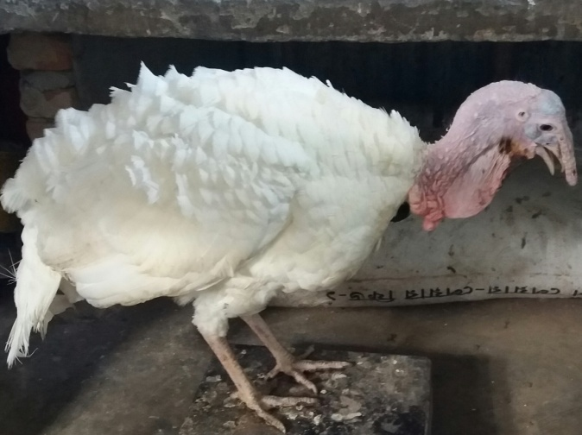
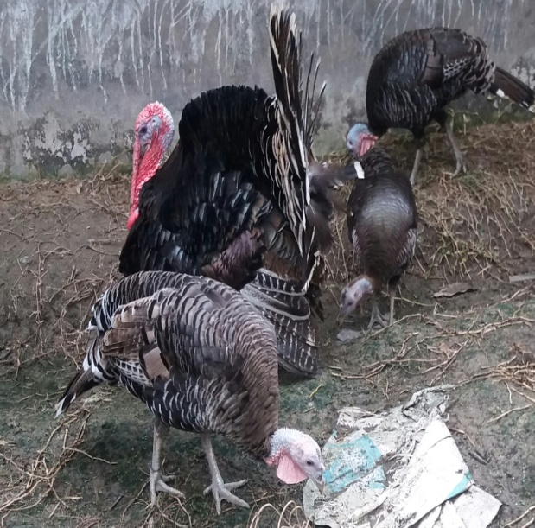
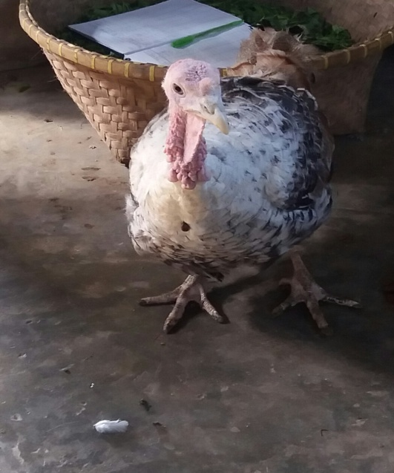
C
B
A

A: - Broad breasted bronze
B: - Black and White (Royal palm)
C: - White (Beltsville Small White)

Picture: Different phenotypes turkey in Chittagong

Qualitative traits:
Table 1: Morphological characteristics of turkey
Trait | Characteristics | Frequency | Percentage %
Plumage color | Bronze  Black & White  White | 34  10  6 | 68  20  12
Eye color | Black  Grey | 40  10 | 80  20
Beak color | Yellow  Black | 44  6 | 88  12
Shank color | Grey  Black | 45  5 | 90  10
Beak shape | Curve | 50 | 100

The wide variation of plumage color of turkey population indicates the existence of a genetic variability. According to this study, the turkey population consists of three phenotypes, the broad breasted bronze (68%), Black & White (20%) and the white (Beltsville Small White) (12%) respectively (Table 1). Turkeys are of different plumage colors: white/black, bronze, black and red, these results are in disagreement with the results of Halbouche et al. (2010). The bronze color frequencies is higher (68%) to those of the study of Savage and Zakrzewska et al. (2006) who found a frequency of 30% of bronze and Djebbi et al. (2014) who found 26% of bronze. The black & white frequency is low (20%) from Djebbi et al. (2014) who found black & white frequency 29.85%. The white color frequency is higher (10%) from Djebbi et al. (2014) which was 6%
.

Quantitative trait:
Table 2: Descriptive statistics of body weight and body measurements of turkey by sex:
Traits | Bronze |  | Black & White |  | White
 | Average | Male | Average | Male | Average | Male
 |  | Female |  | Female |  | Female
Body weight  (Kg) | 5.04±0.89 | 5.83±0.45 | 4.85±0.99 | 5.64±0.66 | 4.63±1.04 | 5.53±0.37
 |  | 4.25±0.33 |  | 4.06±0.49 |  | 3.73±0.37
Beak length (cm) | 4.94±0.58 | 5.28±0.44 | 4.82±0.80 | 5.50±0.50 | 5.00±0.77 | 5.67±0.28
 |  | 4.61±0.50 |  | 4.14±0.21 |  | 4.33±0.28
Body length (cm) | 32.53±2.40 | 34.12±1.85 | 32.5±2.82 | 33.90±2.96 | 30.92±1.74 | 32.0±1.00
 |  | 30.94±1.77 |  | 31.10±2.07 |  | 29.83±1.75
Drumstick length  (cm) | 14.90±2.13 | 16.26±2.09 | 15.1±2.31 | 16.50±2.64 | 15.17±2.48 | 17.33±1.15
 |  | 13.53±0.99 |  | 13.70±0.44 |  | 13±0.00
Shank Length (cm) | 10.13±1.03 | 10.69±1.07 | 10.61±1.22 | 11.48±1.11 | 10.5±1.04 | 11.0±1.00
 |  | 9.56±0.60 |  | 9.74±0.48 |  | 10.0±1.00
Mean ± Std. Dev.

The descriptive statistics of body weight and body measurements of the indigenous turkey by sex and phenotype are presented in Table 2. The present study shows that the males are significantly heavier (5.83±0.45 kg) than the females (3.73±0.37 kg). The value is higher than those reported by Ogah et al. (2011) from Nigeria turkey (3.38 Kg for male and 2.65 Kg for female, respectively), but lower than reported by Kabalin Ekert et al. (2009) (7.18 Kg for male and 4.26 Kg for female) in Dalmatian turkeys and Djebbi et al. (2014) (6.44 kg for males and 3.59 kg for females). López-Zavala et al. (2008) reported that the weigh ranged between 6.70 and 8.90 kg in males and between 2.90 and 4.35 kg in females contrast to males and females of this study. This variation in size of the male and female is linked to the effect of various hormones that leads to a different growth rate (Beaza et al, 2001).
Morphometric measurements (Beak length, Body length, Drumstick length, shank length) are higher in male compared to female. This result does not agree with those of Ekert Kabalin et al. (2009) in Dalmatian and Ogah (2011) in Negeria.and Djebbi et al. (2014) in Tunisia due to variation of measurements. Environmental and managemental factors play an important role in variation of size of birds. The variation in the size of the bird is due to the combined effects of humidity, temperature and altitude reported by James (1970).

Reproductive traits:
Table 3: Reproductive performance of turkey in Chittagong
Parameters | Mean±S.E.
Egg laying age | 7.65±0.17
Average egg production/hen/year(no) | 68.3±1.26
Average egg weight(gm) | 67.9±0.51
Number of clutch/year | 2.37±0.23
Duration of clutch(months) | 2.57±0.17
Ratio of Male to Female((♂:♀) | 1:4.61±0.32
Total egg hatchability | 49.6±1.98
Poults hatched weight(gm) | 40.2±0.91
Mean±S.E:- Mean±Standard Error

Table 3: Female laid egg at the age of (7.65±0.17) months. Each hen laid (68.3±1.26) egg/year. This result is lower than Asaduzzaman et al. (2017) Average egg weight was (67.9±0.51) gm which is higher than Asaduzzaman et al. (2017) reported 66.13 gm and lower than Anandh et al. (2011) who reported 68.72 gm. Number of clutch was (2.37±0.23) and duration of clutch was (2.57±0.17) months which is higher than Asaduzzaman et al. (2017). The ratio of male and female was (1:4.61±0.32). Total egg hatchability was (49.6±1.98) which is higher than Asaduzzaman et al. (2017) reported that 32 and lower than Anandh et al. (2011) reported that 52.85. Hatching poults weight was (40.2±0.91) gm. This weight is lower than Anandh et al. (2011) reported 42.08 gm.

CONCLUSION:
Present study represents Broad breasted bronze color was dominant than black & white and white in Chittagong. The values of measurements of quantitative traits vary with different phenotypes (Beak, body, drumstick, shank length, body weight). Male body weight was higher than female. Female laid egg 68 per year and average egg weight was 67.9 gm. Since turkey is rearing commercially to improve its production and reproduction government facilities like research, training to farmers should be increased.
LIMITATIONS:
The study was conducted in less number of farms and birds. Duration of the study was short time of period.

REFERENCES:
Asaduzzaman, M., Salma, U., Ali, H. S., Hamid, M. A., and Miah, A. G. 2017. Problems and prospects of turkey (Meleagris gallopavo) production in Bangladesh. Res. Agric. Livest., Fish., 4 (2): 77-90.
Begum I. A., Alam, M. J., Buysse, J., Frija, A., and Van Huylenbroeck, G. 2011. A comparative efficiency analysis of poultry farming systems in Bangladesh: A Data Envelopment Analysis approach. Applied Economics, 44: 3737-3747.
Besbes, B. 2009. Genotype evaluation and breeding of poultry for performance under sub-optimal village conditions. World’s Poultry Science Journal, 65: 260-271.
Baeza, E., Williams, J., Guemene, D., Duclos, M. J. 2001. Sexual dimorphism for growth in Muscovy ducks and changes in insulin-like growth factor I (IGF- I), growth hormone (GH) and triiodothyronine (T3) plasma levels. Reprod. Nutr. Dev., 41: 173–179.
FAOSTAT. 2012. Livestock Primary Production Data. Retrieved from http://faostat.fao.org.
Grimes J., Beranger, J., Bender, M., and Walters, M. 2007. How to raise heritage turkey on pasture. American livestock Breeds conservancy Pittsboro, NC27312 USA. Headquarters, 233 S.WAckes Drive, 11th floor Chicago, Illinois- 60606.
.Halbouche, M., Mouats, A., Belhadi, A., Homrani, A., Didi, M. 2010. Ponte, Reproduction et Développement Sexuel Chez la dinde Domestique (Meleagris Gallopavo) en Algérie. Influence du Phénotype et du Niveau Protéique des Aliments.European Journal of Scientific Research ISSN 1450-216X Vol.47 No.3, pp.473-483.
James, F. C. 1970. Geographic size variation in birds and its relationship to climate. Ecology 51(3): 365-390.
Ogah, D. M. 2011. Assessing size and conformation of the body of Nigerian indigenous turkey. Slovak J. Anim. Sci., 44, 2011 (1): 21-27 © 2011 CVŽV ISSN 1337-9984.

Savage, T. F., Zakrzewska, E. I. 2006. Single Gene Traits of the Turkey. <http://oregonstate.edu/ dept/animal-sciences/poultry/tc.html>. Oregon State University. Corvallis, Oregon
Thornton, E. K., K. F. Emery., Steadman, D. W., Speller, C., Matheny, R., and Yang, D. 2012. Earliest Mexican turkeys ( Meleagris gallopavo ) in the Maya region: Implications for pre-hispanic animal trade and the timing of turkey domestication. PLoS ONE,Vol. 7.10.1371/journal.pone. 0042630.

ACKNOWLEDGEMENTS:
Firstly I am grateful to my parents as they support me all the time for my education. I am thankful to the farm owners who permitted me to work their farm populations. I am also thankful to my teacher and supervisor Dr. Omar Faruk Miazi, Associate Professor, Department of Genetics and Animal Breeding, CVASU for his valuable suggestion and guidance.

BIOGRAPHY
I am Kanchan Kumar Roy son of Mr. Darpa Narayn Roy and Mrs. Mira Rani Roy. I was born in 17 August 1992 at Khatsinga village under Pirganj Upazila in Thakurgoan District. I have passed my Secondary School Certificate examination from Pirganj Pilot High School in 2008 and Higher Secondary School Certificate from Cant. Public School and College, BUSMS in 2010. Now I am an intern doctor under the Faculty of Veterinary Medicine in Chittagong Veterinary and Animal Sciences University. In future I want to be a renowned practitioner.

