Chapter 1
Introduction
Feed additives are added in poultry feed to improve nutritive value of ingredients and enhance broiler performance by increasing growth rate and improving feed conversion efficiency. Chemical feed additives e.g. Antibiotic growth promoters (ABGP), have been intensively used in broiler’s ration to improve productivity. However, they are notorious for bacterial resistance and their negative impacts on the consumers’ health (Rehman et al., 2014). Thus, use of ABGP has been banned in poultry industry. Now, nutritionists are shifting from chemical growth promoter to phytogenic growth promoters. Thus, it is important to explore the potential of innate feed additives to replace the chemical ones. The utilization of growth promoters of natural origin as an essential alternative to antibiotic has become an interest in recent years to scientists (Iji et al., 2001). Herbs could be expected to serve as feed additives due to their suitability and preference, lower cost of production, reduced risk of toxicity, minimum health hazards and environment friendliness (Devegowda et al., 1996).
Garlic (Allium sativum) is extensively used worldwide as a spice, and also in folk, traditional medicine for control of some infectious, non-infectious diseases, including reduction of blood plasma and liver cholesterol (Lukanov et al., 2015). It can be used as an essential alternative to antibiotic. It has bioactive components like sulfur containing compounds like alliin, diallylsulfides and Allicin that act as antibacterial, antifungal, anti parasite, antiviral, antioxidant, antithrombotic, anticancerous agent with vasodilator characteristics. Moreover, garlic powder contains fructooligosaccharides (FOS) with prebiotic activity (Campbell et al., 1997). It also has a rich vitamin content (vitamin C, thiamine, riboflavin and niacin), selenium and potassium (USDA, 2014).
Garlic has been found to lower serum and liver cholesterol and that inhibits bacterial growth, platelet growth and reduce oxidative stress. In broilers, it was reported that garlic, as a natural feed additive, improved broiler growth and feed conversion ratio (FCR), and decreased mortality rate (Tollba, 2003). The addition of garlic powder to the feed of chickens had a beneficial effect on their growth and meat performance (Raeesi et al., 2010). It was reported that feeding GP at levels of 1.5, 3 and 4.5% caused a significant reduction in birds serum and liver cholesterol (Kamal et al., 2012). However, Horton et al. (1991) concluded that triglyceride level was not affected by garlic in broiler chickens. Serum cholesterol was decreased with feeding garlic to layers showed that addition of plant extracts to broilers’ diet has some effects on performance and microbial activity of intestinal tract but, none of them were significant (Chowdhury et al., 2002). However, using GP in broilers’ diet had no significant effect on performance but it influenced meat quality and carcass yield positively (Horton et al., 1991).
Therefore, the objectives of the present study were,
- To investigate the effect of feeding of garlic powder on growth performance of broiler chickens.
- To observe the serum lipid profile in broiler chicken.

Chapter 2
Materials and Methodology
2.1 Study area
The current experiment was conducted from April to September 2017, at the Experimental Poultry Shed and Laboratory of Department of Animal Science and Nutrition, Chittagong Veterinary and Animal Sciences University (CVASU), Khulshi, Chittagong, Bangladesh.
2.2 Preparation of poultry shed
The broiler shed was at first thoroughly swiped and then washed up by using tap water mixed with caustic soda. Brooding boxes and broiler cages were also cleaned up similarly. Then copper sulphate solution was sprayed for 2 days. Formalin solution was also used as disinfectant for two days.Then potassium permanganate solution was used for two days. After cleaning and disinfecting, the house was left for seven days to dry. All windows were kept open for proper ventilation. Finally lime was spread all around the shed for bio-security after one week.

2.3 Experimental design
The experiment was conducted for a period of 28 days where starter period was 0-14 days and grower period was 15-28 days. The design of this experiment was CRD (Completely Randomized Design) where total 108 birds were allocated into three treatment groups (36 birds/treatment) having three replicates (12 birds/replication) in each. Chicks were equally and randomly distributed in three dietary treatment groups (T_{0,} T₁ and T₂).The T₀ was control group, T₁ group was supplemented with 1% GP and T₂ group was supplemented with 1.5% GP. Layout of the experiment is shown in Table 2.1.

Table 2.1: Layout of the experiment showing the distribution of DOC to the treatment group and replication
Dietary treatment groups | No. of broilers/replication |  | Total no. of broilers/treatment
T₀ (Control)  (Basal Diet) | R₁ | 12 | 36
 | R₂ | 12
 | R₃ | 12
T₁  (Basal Diet+1% GP) | R₁ | 12 | 36
 | R₂ | 12
 | R₃ | 12
T₂  (Basal Diet+1.5% GP) | R₁ | 12 | 36
 | R₂ | 12
 | R₃ | 12
Grand total = |  |  | 108

2.4 Collection of day old chicks and Garlic Powder: A total of 108 day-old unsexed chicks (Cobb 500 strain) were purchased from an agent of Nahar Agro Complex Limited, Jhautala Bazar, Khulshi, Chittagong, Bangladesh. During purchasing all chicks were examined for any kind of abnormalities and ensuring that all chicks were of uniform size. Garlic powder was collected from local market of Chittagong, Bangladesh.
2.5 Feeding standard: Feeding standard maintained in the study was the Bangladesh standard specification for poultry feed (2nd Revision, BDS 233: 2003; Bangladesh Standards and Testing Institution). The birds were provided with dry mash feed throughout the experimental period. All the rations were iso-caloric and iso-nitrogenous. Feeds were supplied ad-libitum along with fresh clean drinking water for round the clock.
2.6 Ration formulation: The birds were fed dry mash feed. Mash feed was prepared manually from raw feed ingredients, which were collected from retail and wholesale market. Two types of ration were used such as broiler starter and broiler grower. Ration was formulated according to the requirement of birds. Starter ration was given from day 0 to 14 days, and grower ration was given from day 15 to 28. Feed was supplied ad-libitum along with fresh clean drinking water. Feed and drinking water were given three times in a day. The composition of different feed ingredients and nutritive value of starter and grower rations are given in Table 2.2.
Table 2.2: Feed ingredients used in experimental broiler diets
Ingredients (kg/100kg) | Starter ration(0-14 days) | Grower ration (15-28 days)
Maize | 53.5 | 55
Molasses | 0.85 | 0.635
Soya meal | 35 | 33.75
Protein con | 1.5 | 0.8
Rice polish | 3.7 | 3.5
Salt | 0.25 | 0.25
Methionine | 0.2 | 0.1
Lysine | 0.1 | 0.233
Vit-min Premix | 0.25 | 0.25
Feed Enzyme | 0.025 | 0.025
Soya oil | 2.5 | 3.5
Lime stone | 1.103 | 1.35
Maduramycin | 0.06 | 0.06
Antioxidant | 0.012 | 0.012
D.C.P | 0.95 | 0.535
Total | 100 | 100
Estimated chemical composition (DM basis)
Parameters | Starter ration (0-14 days) | Grower ration (15-28 days)
ME (Kcal/kg) | 2939.40 | 3014.69
CP (%) | 22.04 | 21.16
CF (%) | 3.51 | 3.44
EE (%) | 3.08 | 3.1
Ca (%) | 0.95 | 0.87
P (%) | 0.62 | 0.52
Lysine (%) | 1.20 | 1.24
Methionine (%) | 0.90 | 0.77
N.B: T₀= control, T₁= Basal Diet + 1% Garlic Powder, T₂ = Basal Diet + 1.5% Garlic Powder, ME: Metabolizable energy, CP: Crude protein, CF: Crude fibre, EE: Ether extract, Ca: Calcium, P: Phosphorus.
The rations were made manually through proper mixing ensuring that all kind of ingredients were mixed evenly. Before mixing, individual ingredients were weighed by an eclectic balance. After mixing, formulated feed was packed in air tight plastic bags.
2.7 Management procedure
The management procedures of rearing broilers which were uniform among treatment groups of the study are stated below:
2.7.1 Brooding of the chicks
After proper cleaning and drying, the brooding boxes were ready for DOCs rearing under strict hygienic conditions. Dry and clean newspaper was also placed in the brooding box. Newspapers were changed for four times in a day from the floor of the brooding box. It was continued for seven days. During the brooding period chicks were brooded at a temperature of 90-95°F during 1st week and 90-85°F during 2nd week respectively with the help of electric bulbs. Each box brooder having 2.38 ft. X 2.08 ft. was allocated for 30 birds and floor space for each bird in the brooding box was 0.17 sq. ft.

2.7.2 Maintenance of room temperature and lighting
Basis on requirement temperature was increased and decreased in the brooding box as well as the whole house. The key concern was the comfort of broiler birds. Electric bulbs and fans were used to maintaining the temperature. The birds were exposed to a continuous lighting of 24 hours of photoperiod.
Table 2.3: Temperature schedule maintained in the house
Days | Temperature °F
0-7 | 95
8-14 | 90
15-21 | 85
22-28 | 80

2.7.3 Floor space, feeder and drinker spaces
After brooding period, broiler birds were transferred to cage having 3.5 ft. X 1.63 ft. for 10 birds. The floor space for each bird in the cage was 0.57 sq. ft.
In the early stage of brooding feed and water were given to birds on paper and small drinker. Feeding and watering were performed by using one small round plastic feeder and one round drinker with a capacity of 1.5 liter in each brooding box. The feeders and drinker were fixed in such a way so that the birds could eat and drink conveniently. After 5th day small round feeder was replaced by small liner feeder (2.21 ft. X 0.25 ft.) in each brooding box. During the period of cage rearing large liner feeder (3.5 ft. X 0.38 ft.) and large round drinker with a capacity of three liters was used for feeding and drinking.
2.7.4 Litter management
Fresh and dried rice husk was used as litter material at a depth of 3-4 inch during the brooding period. After the ends of brooding period birds were replaced in the cage for rearing until the end of experiment. Each and every day feces materials were cleaned and disinfected hygienically.
2.7.5 Vaccination and chemo prophylaxis or medication
All birds were vaccinated properly against Newcastle disease (eye drop) on the 4th day and booster dose again on 14th day. Against Infectious Bursal Disease (eye drop), the broilers were vaccinated (eye drop) on the 14th day of rearing. After each vaccination, Rena-WS multivitamin was supplied at 1g/5 liter of drinking water along with vitamin-C to overcome the stressed effect of vaccination and cold weather. Chemo prophylactic measures/medication with water soluble vitamins, minerals and electrolyte were used at different ages of birds. Rena-WS, Electrolyte and Gluco-C were administered in water for first seven days of rearing and then repeated from 10th day to 17th day of rearing. From the 18th day of age to 28th day of age of birds, Rena-WS was administered through water along with electrolyte, guar and lemon.
2.7.6 Bio-security
Drinkers were washed with caustic soda and dried up daily in the morning, and feeders were also cleaned and washed with caustic soda every 3 days after. Potassium permanganate was used for washing the floor & nearer places of the shed. Lime powder and bleaching powder was also used for strict bio-security measures those were followed during the whole experimental period.
2.8 Record keeping
In order to maintain record, parameters like body weight, feed intake and mortality of broilers were kept into consideration during the experimental period. Body weight of the chicks was recorded at first day and then regular basis at the weekly intervals by a digital weighing balance for whole experimental period. Weekly feed intake was recorded by deducting the left over feeds from the total amount of supplied feed to the broilers. Mortality was recorded throughout the experimental period when death occurred in any replication.
2.9 Calculation of data

2.9.1 Body weight gain
By deducting initial body weight from the final body weight of the birds, the body weight gain was calculated weekly. It was represented as gm/bird.
Body weight gain = Final body weight – Initial body weight
2.9.2 Feed consumption
Weekly, quantity of offered feed was measured. Refusal feed was recorded to determine the feed intake per week. Feed intake was expressed as gm/bird.
Feed consumption = Offered feed – Refused feed
2.9.3 Feed conversion (FC)
Feed conversion is the amount of feed intake per unit of weight gain of birds. This was calculated by using following formula.
FC = Feed intake (kg) ÷ Weight gain (kg)

2.9.4 Mortality
It was calculated on the basis of total number of birds housed and number of birds died during the experimental period. The mortality was represented in percent.
% Mortality = (No of dead birds / No of live birds) × 100
2.10 Blood parameter estimation
Blood was collected without anticoagulant from a total of 6 birds from each group (2 birds from each replicate) at 28th days of age of broilers. Serum was separated after centrifugation at 3,000 rpm for 15 min. Serum lipid profile parameters like Cholesterol, Triglycerides, LDL-Cholesterol, HDL-Cholesterol were measured in the post graduate laboratory under the department of Physiology, Biochemistry and Pharmacology, CVASU using standard kits (BioMereux, France) and automatic analyzer (Humalyzer 300, Merck®, Germany) according to the manufacturer’s instruction (FVMAAU; Addis Ababa, Ethiopia).
2.11 Statistical analysis
All the data like live weight and its gain, feed consumption, feed conversion ratio of broilers were entered into MS excel (Microsoft office excel-20007, USA). Data were compared among the groups by one way ANOVA in STATA version-12.1 (STATA Corporation, College Station, Texas) and subsequent Duncan’s Multiple Range Tests (DMRT) were done. Results were expressed as means and SEM. P values of ≤0.05 and ≤0.01 were considered as significant and highly significant, respectively.

Picture gallery
Fig 1: Brooding of chicks  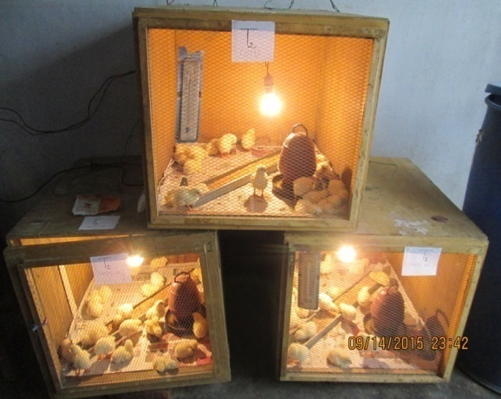 |  | Fig 2: Measuring Weight of broiler
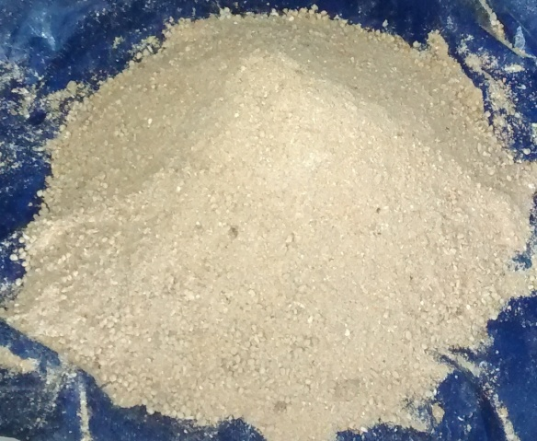 |  | 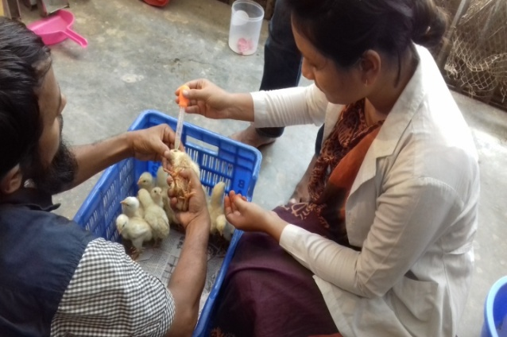

Fig 4: Vaccination of chicks
Fig 3: Mixing of feed

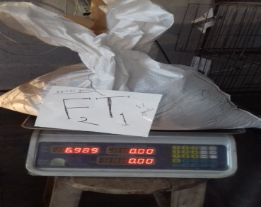
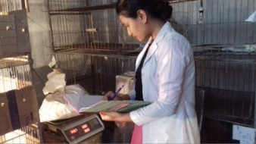

Fig 5: Measuring feed

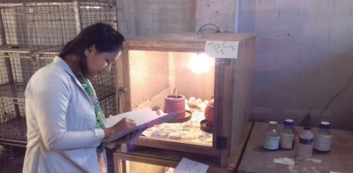
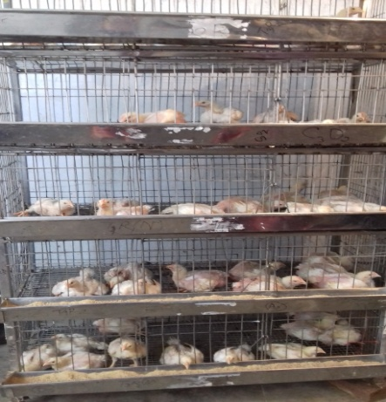

Fig 7: Record keeping
Fig 6: Birds in cage

Chapter 3
Results
3.1. Feed consumption
3.1.1 Weekly feed intake of broilers among different dietary treatment groups (g/broiler)
Age of birds | Diets |  |  | P value | Level of sig.
 | T₀ (Mean ± SE) | T₁ (Mean ± SE) | T₂ (Mean ± SE)
1st week | 126.02ª±6.46 | 129.56ª±4.89 | 139.00^{b}±7.79 | 0.00 | **
2nd week | 298.63±6.26 | 304.29±5.35 | 312.51±3.96 | 0.10 | NS
3rd week | 812.83ª±3.26 | 818.7^{b}±1.95 | 820.49^{b}±1.86 | 0.00 | **
4th week | 1043.3ª±4.68 | 1158.01^{b}±5.25 | 1265.82^{c}±1.33 | 0.00 | **
Mean values having uncommon superscripts differ significantly, T₀ = Control, T₁ = 1% GP, T₂ = 1.5% GP, SE = Standard error, NS = Non significant at 5% level, ** = significant at 1% level

Table 3.1.1 represents the amount of feed consumption of birds at from 1st to 4th weeks of age. There was a significant difference (P<0.01) in feed consumption of birds in different groups at 1st week of age of broilers. Highest feed consumption was found in birds of 1.5% GP treatment group. Feed consumption by birds was found insignificantly (P>0.01) increased in birds treated with GP at 2nd weeks of age. At the end of the experiment (3rd and 4th weeks of age) feed consumption by birds was found significantly (P<0.01) increasing again with the increased dietary level of GP Highest feed consumption was found in 1.5% GP treatment group.

3.1.2 Cumulative feed intake of broilers among different dietary treatment groups (g/broiler)
Age of birds  (Weeks) | Diets |  |  | P value | Level of sig.
 | T₀ (Mean ± SE) | T₁ (Mean ± SE) | T₂ (Mean ± SE)
1-2 | 424.65ª±4.18 | 433.85^{b}±6.35 | 451.51^{c}±5.53 | 0.00 | **
1-3 | 1237.48ª±5.13 | 1252.55^{b}±2.9 | 1272^{c}±3.3 | 0.00 | **
1-4 | 2280.78ª±3.27 | 2410.56^{b}±1.35 | 2537.82^{c}±5.23 | 0.01 | **
Mean values having uncommon superscripts differ significantly, T₀ = Control, T₁ = 1% GP, T₂ = 1.5% GP, SE = Standard error, NS = Non significant at 5% level, ** = significant at 1% level

From table 3.1.2, differences in cumulative feed intake of birds in different treatment groups was significant (P>0.05), statistically throughout the whole experiment. However, feed consumption was significantly (P<0.01) increased in 1.5% GP treatment group among all the groups.

3.2. Body weight
3.2.1 Weekly live weight of broilers among different dietary treatment groups (g/broiler)
Age of birds (Weeks) | Diets |  |  | P value | Level of sig.
 | T₀ (Mean ± SE) | T₁ (Mean ± SE) | T₂ (Mean ± SE)
Initial weight | 45.00±0.02 | 45.12±0.02 | 44.57±0.03 | 0.56 | NS
1st week | 144.23ª±0.79 | 152.20^{b}±0.94 | 164.4^{c}±1.21 | 0.00 | **
2nd week | 342.00ª±0.47 | 359.20^{b}±0.56 | 379.93^{c}±0.63 | 0.00 | **
3rd week | 876.76ª±1.58 | 905.00^{b}±3.05 | 940.14^{c}±2.10 | 0.00 | **
4th week | 1486.9ª±6.24 | 1602.6^{b}±13.09 | 1756.8^{c}±5.54 | 0.00 | **
Mean values having uncommon superscripts differ significantly, T₀ = Control, T₁ = 1% GP, T₂ = 1.5% GP, SE = Standard error, NS = Non significant at 5% level, ** = significant at 1% level

Initially no significant difference (P>0.05) in live weight were found among the birds of different dietary treatment groups. Throughout the whole experiment differences in live weight of broilers were highly significant (P<0.01) among different groups. Increased live weight was found in garlic powder treatment groups. However, highest weight was found in 1.5% treated group and lowest live weight was found in control group (table 3.2.1).

3.2.2 Weekly live weight gain of broilers among different dietary treatment groups (g/broiler)
Age of birds  (Weeks) | Diets |  |  | P value | Level of sig.
 | T₀ (Mean ± SE) | T₁ (Mean ± SE) | T₂ (Mean ± SE)
1st week | 99.23±0.78 | 107.08±1.23 | 119.83±0.83 | 0.20 | NS
2nd week | 197.77±0.41 | 207.00±0.95 | 215.53±1.10 | 0.10 | NS
3rd week | 534.76±1.47 | 545.8±1.80 | 560.21±1.23 | 0.41 | NS
4th week | 610.14ª±1.88 | 697.6^{b}±2.25 | 816.66^{c}±1.37 | 0.00 | **
Mean values having uncommon superscripts differ significantly, T₀ = Control, T₁ = 1% GP, T₂ = 1.5% GP, SE = Standard error, NS = Non significant at 5% level, ** = significant at 1% level

Differences in live weight gain of broilers in control and GP treatment groups were not significant (P>0.05) upto 3rd weeks of age though 1% and1.5% GP treatment groups gained higher body weight than control group. 1.5% treatment group gained better body weight than 1% GP group at the end of the experiment (4th weeks of age) and lowest gain was observed in control. That difference was significant (table 3.2.2).

3.2.3 Cumulative live weight gain of broilers among different dietary treatment groups (g/broiler)
Age of birds  (Weeks) | Diets |  |  | P value | Level of sig.
 | T₀ (Mean ± SE) | T₁ (Mean ± SE) | T₂ (Mean ± SE)
1-2 | 297.00ª±5.98 | 314.08^{b}±6.12 | 335.36^{c}±8.53 | 0.00 | **
1-3 | 831.76±2.43 | 859.88±3.90 | 895.57±1.88 | 0.10 | NS
1-4 | 1441.9ª±3.47 | 1557.48^{b}±2.85 | 1712.23^{c}±3.33 | 0.00 | **
Mean values having uncommon superscripts differ significantly, T₀ = Control, T₁ = 1% GP, T₂ = 1.5% GP, SE = Standard error, NS = Non significant at 5% level, ** = significant at 1% level

Cumulative live weight gain in birds among different dietary treatment groups differed significantly upto 2nd weeks of age of broilers. However, at 3rd and 4th weeks of age there were no significant (P<0.05) differences. In comparison with control groups, 1% and 1.5% GP supplemented groups represented higher cumulative live weight gain (table 3.2.3).

3.3 Feed Conversion
3.3.1 Weekly feed conversion of broilers among different dietary treatment groups
Age of birds | Diets |  |  | P value | Level of sig.
 | T₀ (Mean ± SE) | T₁ (Mean ± SE) | T₂ (Mean ± SE)
1st week | 1.27ª±0.07 | 1.21^{b}±0.07 | 1.16^{c}±0.08 | 0.03 | *
2nd week | 1.51ª±0.22 | 1.47^{b}±0.12 | 1.45^{c}±0.10 | 0.00 | **
3rd week | 1.52ª±0.22 | 1.50^{b}±0.12 | 1.46^{c}±0.10 | 0.00 | **
4th week | 1.71ª±0.08 | 1.66^{b}±0.13 | 1.55^{c}±0.10 | 0.00 | **
Mean values having uncommon superscripts differ significantly, T₀ = Control, T₁ = 1% GP, T₂ = 1.5% GP, SE = Standard error, ** = significant at 1% level, * = significant at 5% level,

Feed conversion was significantly (P<0.05) higher in control group than GP supplemented groups at 1st week of age of broilers. At 2nd weeks of age also there was a highly significant (P<0.01) difference in feed conversion of broiler among the different treatment groups. Feed conversion was significantly (P<0.01) lower or better in 1% and 1.5% GP treatment groups than control group at 3rd weeks of age of broilers. Likewise, it was found significantly (P<0.01) lower in these two groups of broiler at 4th weeks of age of birds. However, 1.5% GP supplemented group showed better feed conversion than 1% GP supplemented group. Highest feed conversion was observed in control group (table 3.3.1).

3.3.2 Cumulative feed conversion of broilers among different dietary treatment groups
Age of birds  (Weeks) | Diets |  |  | P value | Level of sig.
 | T₀ (Mean ± SE) | T₁ (Mean ± SE) | T₂ (Mean ± SE)
1-2 | 1.43±0.05 | 1.38±0.06 | 1.35±0.04 | 0.75 | NS
1-3 | 1.48ª±0.21 | 1.46ª±0.12 | 1.42^{b}±0.08 | 0.00 | **
1-4 | 1.58ª±0.22 | 1.55ª±0.11 | 1.48^{b}±0.12 | 0.00 | **
Mean values having uncommon superscripts differ significantly, T₀ = Control, T₁ = 1% GP, T₂ = 1.5% GP, SE = Standard error, NS = Non significant at 5% level, ** = significant at 1% level,
Cumulative feed conversion in broilers differed significantly (P≤0.01) from 3rd to 4th weeks of age of broilers. Significantly (P≤0.01) better feed conversion was found in GP treatment groups than control group.
3.6 Effect of Garlic Powder on Serum lipid profile parameters of broilers
3.3.3 Serum lipid profile of broiler chickens
Parameters | Mean±SE |  |  | P value | Level  of sig.
 | T₀ | T₁ | T₂
Cholesterol (mg/dl) | 108.6^{b}±2.78 | 102.3ª±3.98 | 100.1ª±2.08 | 0.00 | **
Triglyceride (mg/dl) | 102.27ª±2.7 | 126.9^{b}±1.5 | 85.67^{c}±5.7 | 0.00 | **
HDL Cholesterol (mg/dl) | 15.32ª±2.07 | 16.15ª±1.19 | 18.33^{b}±1.34 | 0.00 | **
LDL Cholesterol (mg/dl) | 72.93ª±1.62 | 70.73ª±1.53 | 65.49^{b}±3.98 | 0.00 | **
T₀ = control, T₁ = 1% GP, T₂ = 1.5% GP, SE= Standard error, NS = Non significant
Table 3.3.3 indicates that there were significant differences (P>0.05) in all the lipid profile parameters in blood of broilers among the different treatment groups.

Chapter 4
Discussion

4.1.1 Feed Consumption of Broilers
Tables 3.1.1 and 3.1.2 represent the amount of feed intake and cumulative feed intake of birds among the different treatment groups at different periods of the experiment. The feed consumption among the treatment groups at 1st week was significantly higher (P<0.01) in garlic powder supplemented groups (T₁, T₂) in comparison with control group (T₀). However, the difference in feed consumption was not significant (P>0.05) at 2nd weeks of age of broilers. In 3rd and 4th weeks of age, the feed intake was significantly higher (P<0.01) in GP supplemented groups. Highest feed consumption was found in 1.5% GP supplemented group. In addition, cumulative feed consumption of broilers upto 4th weeks of age was significantly higher in T₁ (1% GP) and T₂ (1.5% GP) groups and T₀ group (control) showed lowest feed consumption among the groups.
Our result of increased feed intake with supplementation of garlic powder was concordant with the findings of Lukanov et al. (2013). Unlike our data, Abdullah et al. (2010) reported lower feed intake in groups receiving feed supplemented with 0.5% and 1% garlic powder. This difference may be due to difference in temperature and humidity of the experimental environment.

4.1.2 Live weight and weight gain of broilers
There was no significant difference in weight of birds among the experimental groups (table 3.2.1). It represents the possibility of uniformity in birds of different experimental groups. However, along the other whole experimental periods, significantly (P<0.01) increased body weight was observed in both 1% GP (T₁) and 1.5% GP (T₂) supplemented groups in comparison with the control group (T₀). The highest body weight was observed in T₂ group and the lowest body weight was observed on the control group (T₀). Body weight in T₁ group showed better result than that of control group. T₂ gave consistently higher body weight than T₁ and T₀ groups.

The supplementation of garlic powder diet in groups T₁ and T₂ showed increased weekly body weight gain of broiler than control group (T₀) from 1st to 3rd weeks of age though the difference was not significant, statistically (tabe 3.2.2). However, at 4th weeks of age, significantly higher (P≤0.01) live weight gain was observed in garlic powder supplemented groups (T₁ and T₂). The highest body weight gain was observed on 1.5% GP (T₂) supplemented group and the lowest body weight gain was observed on the control group (T₀). Improved cumulative body weight gain was also found in these two groups upto 4th weeks of age of broilers though the difference was not significant at 3rd weeks of age of broilers (tabe 3.2.3).

Similar trend of increasing weight or weight gain with supplementation of garlic powder was also reported by Lukanov et al. (2013); Elagib et al. (2013), Gbenda et al. (2009).Mansoub, (2010). Raeesi et al. (2010), found out that feed supplementation with garlic powder during the finisher period had a positive effect on the growth performance of birds. On the opposite, Abdullah et al. (2010) did not establish any beneficial influence on the growth of broiler chickens. Choi et al. (2010) also had not observed any positive influence on the growth performance of experimental group vs the control one, although the concentrations of the garlic powder supplement were higher. The variation may be due to differences in breed, sex, environment and season.
4.1.3 Feed conversion (FC) of broilers

In this study, improved FC and Cumulative FC was found in both T₁ (1% GP) and T₂ (1.5% GP) groups than the control group (T₀) throughout the whole experimental periods. However, T₂ group showed better FC than T₁ group.

In agreement with our results, a positive effect of the dietary garlic powder supplement was also reported by Elagib et al. (2013), Gbenda et al. (2009),and Mansoub (2010).
4.4 Serum Lipid Profile in Broilers
All of the blood lipid metabolites (COL, TG, LDL and HDL) tested were significantly improved by GP supplementation.
Serum Cholesterol level
The average serum cholesterol content of broilers at different ages of growth fed diets supplemented with fish oil at different percentage or diet without garlic powder has been presented in table 3.6. There was significant variations among mean values of total serum cholesterol level of birds (P<0.01). Both 1% and 1.5% garlic powder supplemented groups showed lower level of total serum cholesterol compared to control group and these differences were significant statistically (P<0.05). Highest values of total serum cholesterol level were found in birds of control group and second highest value was found in birds treated with 1% GP.
These results agree with previous reports where dietary supplementation of GP at both concentrations (i.e., 1.5% and 3.0%) was found to cause a significant decrease in the mean values of total Cholesterol as com-pared to control broilers. Prasad et al., (2009) reported similar findings where total cholesterol level was significantly decreased by garlic supplementation in chicken up to 8 weeks of age in comparison to control group.
Triglycerides level
Table 3.6 shows the effect of supplementation of garlic powder (GP) in the regular diet of broilers in the triglyceride content of broilers. Data in the table show that supplementation of GP resulted a great effect on triglyceride level of blood. Significantly (P<0.01) higher level of triglyceride content was seen in blood of broiler group of control group. Lowest values of triglyceride level were recorded in blood of broilers with 1.5% GP supplemented group.
Similar findings were also recorded previously by several researchers (Prasad et al. 2009; Chi et al., 1982). This effect can be explained by the possible inhi-bition of the Acetyl CoA synthetase enzyme that is necessary for the biosynthesis of fatty acids (Qureshi et al., 1983; Chi et al., 1982). Eidi et al. (2006) also reported that garlic extract significantly decreased triglyceride levels in diabetic rats.

HDL-cholesterol level

Values for average HDL-cholesterol of broilers supplemented with or without GP are presented in table 3.6. Supplementation of GP caused a significant (P<0.01) impact on HDL-cholesterol level in blood of broilers. Higher values of HDL-cholesterol were found in dietary GP supplemented groups compared to control group. 1.5% GP supplemented group showed highest HDL-cholesterol compared to others. The second largest values were seen in birds with 1% fish oil supplemented group. Among these groups, lowest values were observed in control group and the difference was not significant (P<0.01).
The significant effect of GP on the mean values of HDL compared to control can be explained by the mechanism of hypocholesterolaemic and the hypolipidemic action of GP. Results of this study indicate the significant increase of HDL by feeding GP, however, findings of some reports on the effects of GP on HDL in different species are inconsistent (Qureshi et al., 1983; Chi et al., 1982).
LDL-cholesterol level
The data of serum LDL-cholesterol level of broilers at different stages of growth fed on garlic powder in different percentages are presented in table 3.6. LDL-cholesterol level of blood varied significantly (P<0.05) among the different treatment groups which was significantly (P<0.01) higher among the broilers in which no GP was supplemented. However, with increasing percentage of GP there was a decrease in LDL-cholesterol level. 1.5% GP supplemented groups showed lowest value of LDL-cholesterol.
Similar findings of decreasing LDL-cholesterol level with supplementation of GP were also recorded in previous studies (Prasad et al. 2009). This effect can be explained by the possible mechanism of antioxidant and antiperoxide lowering action of GP (S-allyl cysteine sulfoxide) on LDL or the decrease in hepatic production of VLDL which serves as the precursor of LDL in the blood circulation (Kim et al., 2009).

Chapter 5
Conclusion
Feed additives are widely used in poultry industry since long time as tool to increase performances of broiler. Under the intensive management systems, herbal extracts are already being used as feed supplements to improve growth performance. With the status of banning the usage of antibiotics as nutritive feed additives has led to investigations of nonconventional feed additives in animal production. Garlic is widely used in all parts of the world as a spice and herbal medicine for the prevention and treatment of a variety of diseases .As it has antibacterial and antifungal properties, it can be used as an useful alternative to antibiotic. It can also be used to improve the performance and serum lipid profile of broilers.
In our study, 1.5% GP treatment group revealed better result in almost in all the parameters (feed intake, weight gain, FC, serum lipid profile) in comparison with 1% GP treatment group or control. So it can be concluded that 1.5% GP may be supplemented with regular standard diet of broiler.
The results of this experiment are evidencing consumer’s protection by describing the way of increasing production in poultry with the use of GP, as well as demonstrating the potential role of garlic powder on performance, improving blood parameters. This type of research work will be a new dimension for improving poultry industry in Bangladesh.

Recommendations and future perspectives
According to this research work, the following recommendations may be done:
- Farmer may get increased performance of broiler with regular use of garlic powder in diet.
- 1.5% GP may be used in this regard.
- As it is a pilot study, further studies may be conducted on similar field to make a concrete remark.

References
Rehman Z, Haq A. 2014. Effect of garlic and ginger supplementation on broiler performance.Lambert Publishing Company, pp: 182-186.
Devegowda G. 1996. Herbal medicines,an untapped treasure in poultry production. In: Proc. 20th World Poult. Congr. New Delhi, India. 17: 42-45.
Kumar OM. 1991. Effect of Liv-52® syrup on broiler performance in North Eastern region. Indian Poultry Review, 22: 37-38.
Babu M, Gajendran K,Sheriff FR, Srinivasan G. 1992. Crown Growfit® supplementation in broilers improved their performance. Indian Poultry Review, 23: 27-28.
Mishra SJ, Singh DS. 2000. Effect of feeding root powder of Withania somnifera (L.) Dunal (aswagandha) on growth, feed consumption, efficiency of feed conversion and mortality rate in broiler chicks. Bioved, 11: 79-83.
Deepak G, Jogi S, Kumar A, Bais R, Vikas KS. 2002. Effect of herbal liver stimulants on efficacy of feed utilization in commercial broiler chicken. Indian Journal of Animal Research, 36: 43-45.
Abdullah AY, Mahmoud KZ, Nusairat BM, Qudsieh RI. 2010. Small intestinal histology, production parameters, and meat quality as influenced by dietary supplementation of garlic (Allium sativum) in broiler chicks. Italian Journal of Animal Science, 9(4): 414-419.
Afzal M, Hassan RAH, El-kazini AA, Fattah RMA. 1985. Allium sativum in the control of athero-sclerosis. Agricultural and Biological Chemistry, 49: 1187-1188.
Amagase H, Petesch BL, Matsuura H, Kasuga S, Itakura Y. 2001. Intake of garlic and its bioactive components. The Journal of Nutrition, 131: 955-962.
CAFA (Commission on Antimicrobial Feed Additives). 1997. Antimicrobial feed additives. Swedish Official Government Reports 132, Ministry of Agriculture, Stock-holm.
Chi MS, Koh H, Steward TJ. 1982. Effects of garlic on lipid metabolism in rats fed cholesterol or lard. Journal of Nutrition, 112: 241-248.
Choi IH, Park WY, Kim YJ. 2010. Effects of dietary garlic powder and α-tocopherol supplementation on performance, serum cholesterol levels, and meat quality of chicken. Poultry Science, 89: 1724-1731.
Chowdhury SR, Chowdhury SD, Smith TK. 2002. Effects of dietary garlic on cholesterol metabolism in laying hens. Poultry Science, 81: 1856-1862.
Eidi A, Eidi M, Esmaeili E. 2006. Antidiabetic effect of garlic (Allium sativum L.) in normal or strepto-zotocin-induced diabetic rats. Phytomedicine, 9: 624-629.
Elagib HAA, El-Amin WIA, Elamin KM, Malik HEE. 2013. Effect of Dietary Garlic (Allium sativum) Supplementation as Feed Additive on Broiler Performance and Blood Profile. Journal of Animal Science Advances, 3(2): 58-64.
Gbenda OE, Adebisi OE, Fajemisin AN, Adetunji AV. 2009. Response of broiler chickens in terms of performance and meat quality to garlic (Allium sativum) supplementation. African Journal of Agricultural Research, 4 (5): 511-517.
Horton GMJ, Fennell MJ, Prasad BM. 1991. Effects of dietary garlic (Allium sativum) on performance, carcass composition and blood chemistry changes in broiler chickens. Canadian Journal of Animal Science, 71: 939-942.
Ij PA, Saki A, Tivey DR. 2001. Body and intes-tinal growth of broiler chicks on a commercial starter diet. 1. Intestinal weight and mucosal development. British Poultry Science, 42: 505-513.
Islam MS, Choi H. 2008. Comparative effects of dietary ginger (Zingiber officinale) and garlic (Allium sativum) investigated in a type 2 diabetes model of rats. Journal of Medicinal Food, 11: 152-159.
Kim YJ, Jin SK, Yang HS. 2009. Effect of dietary garlic bulb and husk on the physicochemical proper-ties of chicken meat. Poultry Science, 88: 398-405.
Lukanov H, Genchev A, Ribarski S. 2015. Effect of feed supplementation with garlic power on meat productivity and meat quality traits of classic Ross 308 male hybrid chickens. Trakia Journal of Sciences, 13(1): 66-76.
Mansoub NH. 2011. Comparative Effects of Using Garlic as Probiotic on Performance and Serum Composition of Broiler Chickens. Annals of Biological Research, 2 (3): 486-490.
Prasad R, Rose MK, Vermani M, Garg SL, Puri JP. 2009. Lipid profile of chicken (Gallus domesticus) in response to dietary supplementation of garlic (Allium sativum). International Journal of Poultry Science, 8: 270-276.
Qureshi AA, Abuirmeileh N, Din ZZ, Elson CE, Burger WC. 1983. Inhibition of cholesterol and fatty acid biosynthesis in liver enzymes and chicken hepatocytes by polar fractions of garlic. Lipids, 18: 343-348.
Raeesi M, Hoeini-Aliabad SA, Roofchaee A, Zare Shahneh A, Pirali S. 2010. Effect of periodically use of garlic (Allium sativum) power on performance and carcass characteristics in broiler chickens. World Academy of Science, Engineering and Technology, 68: 1213-1219.
Tollba AAH, Hassan MSH. 2003. Using some natural additives to improve physiological and productive performance of broiler chicks under high temperature conditions. Black cumin (Niglla sativa) or Garlic (Allium sativum). Poultry Science, 23: 327-340.

Acknowledgements

All praises are due to the Almighty Allah, the creator and supreme authority of the universe, who empowers me to strength and opportunity to complete the report successfully.
I would like to extend my gratitude to my supervisor, Assistant Professor DR. Mukti Barua , Dept. of Animal Science & Nutrition, Chittagong Veterinary and Animal Sciences University. My heartfelt thanks to her for valuable guidance, suggestion, supervision and encouragements during the entire period of this study to complete this production report.
I express my sincere gratitude and thanks to all the teachers and stuffs of Dept. of Animal science & Nutrition, for their kind co-operation during the study period.
Last but not least, I am profoundly grateful to my family members for their endless sympathies, kind co-operation, sacrifices and prayers.

The Author

