A STUDY ON EFFECT OF GARLIC POWDER ON PERFORMANCE OF BROILER
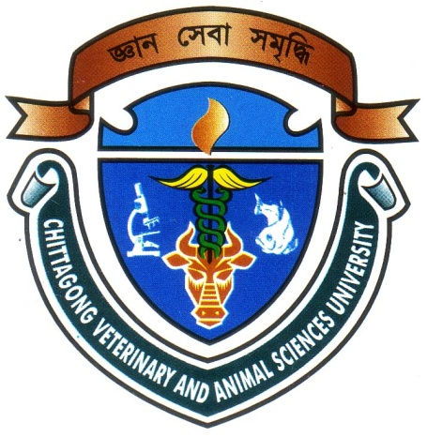

A Clinical report
Submitted as per approved style and contents

Signature of Supervisor
DR. Mukti Barua
Assistant Professor
Dept. of Animal Science & Nutrition
Chittagong Veterinary and Animal Sciences University, Chittagong.

Signature of Author
Tahmina Sultana
Roll. No: 12/15
Registration No: 735
Internship ID: B-15
Session: 2011-2012

Chittagong Veterinary and Animal Sciences University, Khulshi-4202, Chittagong.
December, 2017

Contents
Content Page no
List of tables and figures………………………………………………..III
Abstract…………………………………………………………………IV
Chapter 1: Introduction…………………………………………………1 – 2
Chapter 2: Materials and Methodology…………………………………3-11
Chapter 3: Result……………………………………………………….12-16
Chapter 4: Discussion………………………………………………..…17-20
Chapter 5: Conclusion……………………………………………….…..21
Recommendations & future perspectives…………………………….....22
References……………………………………………………………...23-25
Acknowledgements……………………………………………………...26
List of Tables

Table no. Page no.
2.1: Layout of distribution of day old chick………………………………..…4
2.2: Feed ingredients used in broiler diet……………………………………..5
2.3: Temperature schedule maintained in the house………….........................6
3.1.1: Weekly feed intake of broiler……………………………………….....12
3.1.2: Cumulative feed intake of broiler………………………………….….12
3.2.1: Weekly live weight of broiler…………………………........................13
3.2.2: Weekly live weight gain of broiler……………………………………14
3.2.3: Cumulative live weight gain of broiler……………………………….14
3.3.1: Weekly feed conversion of broiler……………………………………15
3.3.2: Cumulative feed conversion of broiler……………………………….16
3.3.3: Serum lipid profile of broiler………………………………………....16

List of pictures

Fig 1: Brooding of chicks………………………………………………..….10
Fig 2: Measuring weight of broiler……………………………………….....10
Fig 3: Mixing of feed………………………………………………………..10
Fig 4: Vaccination of chicks …..………………..……………………….…..10
Fig 5: Measuring feed weight….....................................................................11
Fig 6: Birds in cage……………………………………………………….…11
Fig 7: Record keeping…………………………………………………….....11
EFFECT OF GARLIC POWDER ON PERFORMANCE OF BROILER

Abstract
Garlic powder contains several biologically active substances with prebiotic activity. The aim of this experiment was to evaluate the influence of dietary supplementation of garlic powder on performance,and serum lipid profile parameters of broiler chickens. A total of 108 day old chicks (DOC’s) were randomly distributed in three groups in a completely randomized design (CRD) having three replications per group. Those birds were treated either without garlic powder (GP) (T₀/control) or with 1% GP (T₁) and 1.5% GP (T₂) in their regular basal diet and reared for four weeks. Data on performance parameters (feed intake, live weight, feed conversion (FC), weight gain etc.) were measured on weekly basis and data on serum lipid profile parameters (i.e. Cholesterol, Triglycerides, LDL-cholesterol and HDL-cholesterol levels), were recorded at the end of the experimental period. Results revealed that there was significant (P<0.01) increase in feed consumption by birds at 1st, 3rd and 4th weeks of age of broilers with supplementation of garlic powder. Initially no significant (P>0.05) difference was observed in body weight of broilers. Then, highly significant (P<0.01) differences were observed in body weight of birds throughout the whole experimental period with highest weight in 1.5% GP supplemented group (T₂). The second highest value was observed in T₁ group (1% GP). FC was significantly improved in 1st (P<0.05), 2nd, 3rd, and 4th weeks of age of birds (P<0.01) with better FC in groups supplemented with GP. Cumulative FC was also significantly (P<0.01) improved upto 3rd and 4th weeks of age of birds both in T₁ and T₂ groups compared to control group. The Cholesterol, triglyceride and LDL-cholesterol levels were significantly (P<0.01) decreased in GP supplemented groups (T₁ and T₂). Significantly higher HDL-cholesterol level (P<0.01) was found in T₁ and T₂ groups than T₀ group. Almost all the performance parameters were best in 1.5% GP treatment group than all the groups. This may be recommended for broilers.
Keywords: broilers, performance, garlic powder, serum lipid profile.

