Chapter 1: Introduction

Rabbits belong to mammals’ family under the order Lagomorpha. There are about fifty different species of rabbits. Rabbits can be found in many parts of the world(Eircom, 2008). A caesarean section is indicated any time of a fetal or maternal obstruction is found unless it can be corrected. Cesarean is a surgical procedure in which unborn kittens are surgically removed from the mother gravid uterus in which an incision is given through the abdominal wall into the abdomen and uterus in order to deliver a kit. It is performed when an animal is having problems while delivering the newborns and is typically an emergency surgery. For certain local breeds prone to dystocia (difficult birth), a cesarean may be planned. A C-section is often necessary in bunny when delivery per vagina is too difficult and when all other methods to deliver the kit naturally have failed, and therefore could endanger the life of the bunny or the life of her kit. The ideal goals in performing a caesarean section are survival of the rabbit and kit, and maintenance of the future reproductive efficiency of the rabbit. The rabbit which is close to parturition should be checked frequently for signs of dystocia. They include persistent contractions, bloody discharge, straining with no obvious progress, or a green-brown discharge from the vagina(Hreiz, 2014)

Dystocia means the inability to expel fetus from the uterus even after completion of full term and may be due to maternal or fetal causes. Dystocia was not common in rabbits as normal delivery was completed within thirty minutes after the onset (Quesenberry KE, 2004). Common causes of dystocia in rabbits included obesity, oversized kids, narrow pelvic canal or uterine inertia (Bishop, 2002). Caesarean section can be an elective procedure but more often it is an emergency procedure that is made necessary because of dystocia. Caesarean section was indicated when medical management was unsuccessful or fetal or maternal obstruction was unable to be corrected manually (Jutkowitz, 2005). A successful outcome for both the maternal and fetal patients is primarily dependent on a thorough understanding of the physiologic alterations during normal and abnormal pregnancy and parturition. This paper reports successful management of dystocia in a rabbit doe with caesarean section.

The objective was to manage dystocia by caesarean section to save the life of a rabbit.

Chapter 2: Materials and Methods
2.1 Study area and duration:
1.2 years-old, 1.5kg weighing local rabbit breed was brought to the Teaching Veterinary Hospital (TVH) of Chittagong Veterinary and Animal Sciences University (CVASU), Chittagong on 22 June 2017.
2.2 Materials and Method:
During my internship period, 1.2 years-old, 1.5kg weighing local rabbit breed was brought to the Teaching Veterinary Hospital (TVH) of Chittagong Veterinary and Animal Sciences University (CVASU). Case history, clinical findings, clinical examinations, diagnostic techniques, surgical management, postoperative care and follow up of this case was maintained by direct contact with the owner. The clinical parameters were recorded prior to the operation. The values are recorded before the operation was considered as control among this respiratory rate, rectal temperature, heart rate, ultrasound, X-ray had done before surgery.

2.3 Case History and Description
Two years-old, 1.5kg weighing local rabbit breed was brought to the Teaching Veterinary Hospital (TVH) of Chittagong Veterinary and Animal Sciences University (CVASU), Chittagong on 22 June 2017. It has delivered only one kit early morning with a lot of bloody discharge. During clinical examination the doe was found calm, alert but straining with an edematous vulva and bloody discharge from vagina. The femoral pulses were clearly palpated; mucous membranes were pink and moist. On abdominal palpation, nothing was found. The X-Ray confirmed that two fetuses remaining inside the uterus (Fig. 1).So it was decided to do the manual removal of fetus from the uterus following this regime. 5 ml of Calcium preparation (Syp Calx®; Eskayef Bangladesh Ltd, Mirpur) was mixed with 5 ml sterile water to make a total of 10 ml and was administered orally .The rabbit was kept in a quiet examination room for observation. 40 minutes later, 2 units of Oxytocin (Inj Ocin®; Opsonin Pharma Ltd) was administered in the right lumbar muscle. After 6 hours of administration of Oxyotocin no labour was found and hence it has been decided for caesarean section.

2.4 Physical examination:
Mental status | Calm, Weakness, Lateral recumbency
General appearance | Straining with an edematous vulva and bloody discharge from vagina
MM color | pink
Cardiovascular | HR 135 bpm, CRT < 2 sec
Body temperature | 100.8˚ F
Weight | 1.5 kg
Respiratory rate: | 20 bpm

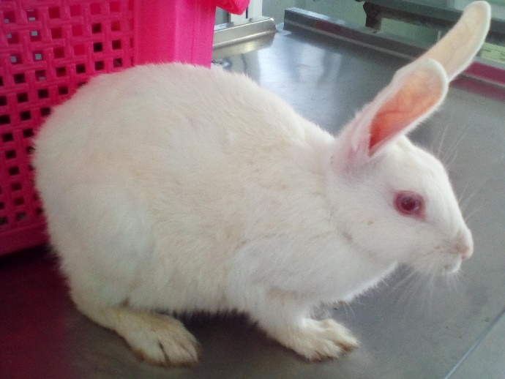

Fig 1: The rabbit has been suffering from dystocia

2.5 Clinical Examination:
Diagnosis plan:
- Radiography of abdomen
- Ultrasound of abdomen
Radiography:
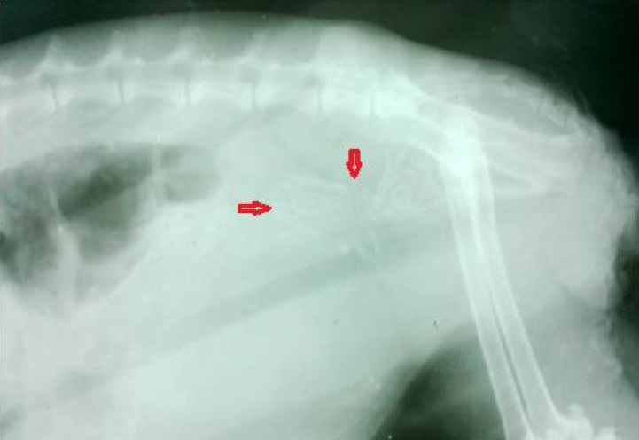

Fig 2(A): left caudo-lateral image of the rabbit which suffering from dystocia and the pointer noticed that the presence of fetus

Ultrasonography:
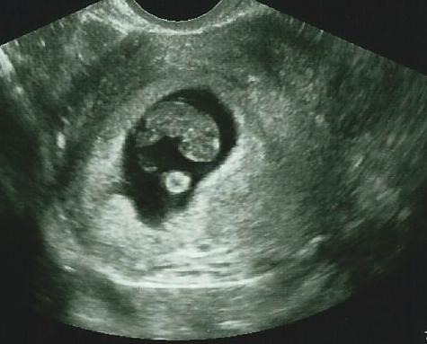

Fig 2(B): presence of kit in the uterus was noticed clearly under ultrasonograpic observation

2.6 Preparation of patient:
The rabbit was placed on the table in patient preparation room in dorsal recumbency with slightly elevated head and was restrained physically by the assistants. The operation site was clipped, shaved and cleaned with antiseptic

2.7 Anesthesia
The rabbit was anaesthetized by intramuscular injection of 0. ml (@5mg/kg body weight xylazine (Inj. Xylazine®, 20 mg/ml, India Immunologicals Ltd., Hyderabad, India) along with ml Ketamine (G-ketamine®, 50 mg/ml, Gonoshasthaya Pharmaceuticals Ltd., Mirzanagar Dhaka, Bangladesh).The pet became unconscious within two minutes. Heart rate and eye reflex was monitored regularly.

2.8 Surgical procedure
Following anesthesia, warm towel was used to wrap the pet because the rabbit was sensitive to hypothermia under anesthesia. So, it was necessary to monitor the temperature, heart rate and respiration rate. The surgical area was scrubbed with 7.5% povidone iodine (Liq. Povisep; Jayson Pharmaceuticals Ltd) solution for 3 times. Later, when the pet was shifted to the operation table, the area was again sterilized with povidone iodine solution and spirit alternatively twice.
The incision was given through midline into the abdominal cavity (laparotomy). The gravid uterus was easily palpated and can be quickly exteriorized in order to take out the fetuses. After surgery and expel out of the fetus from the uterus, the fetus were dead due to immature growth. But the doe is alive and get recovery within a few hours.

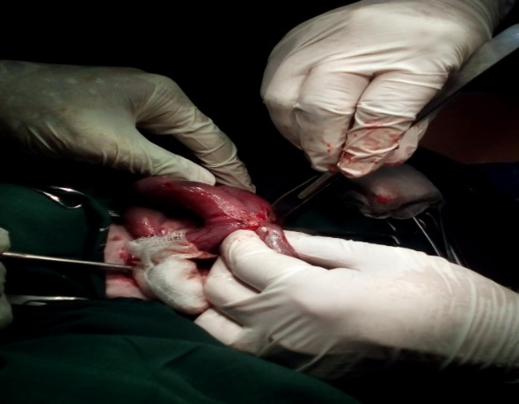
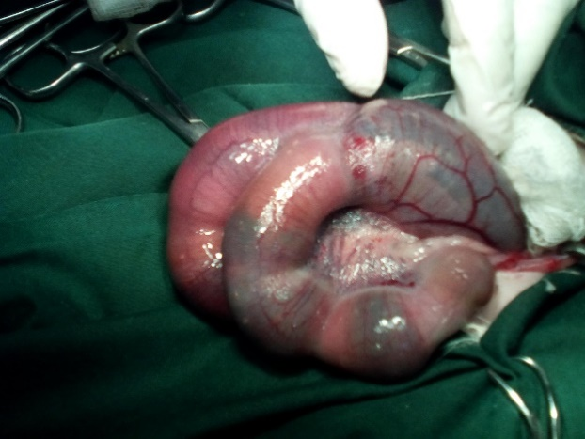
B
A

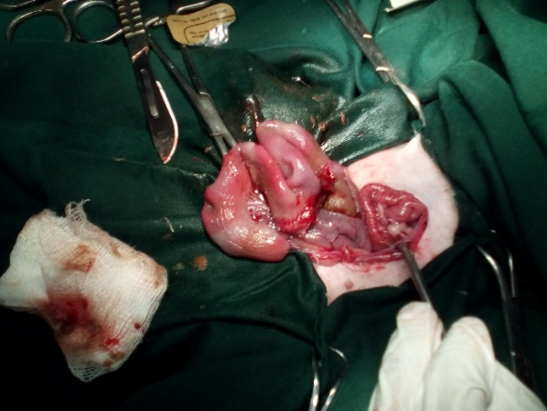
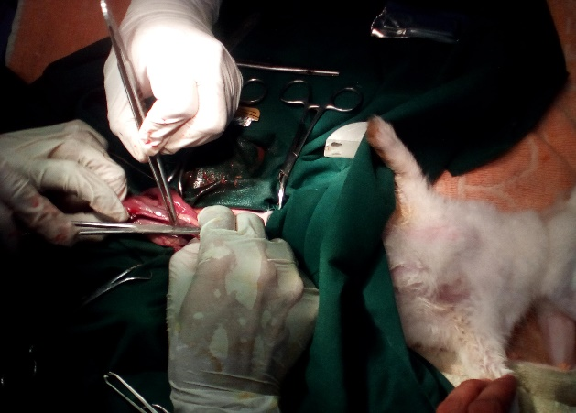
D
C

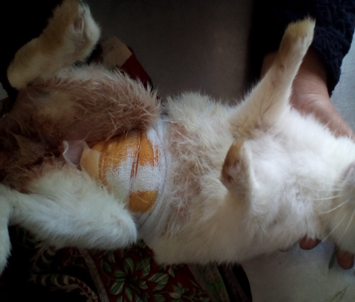
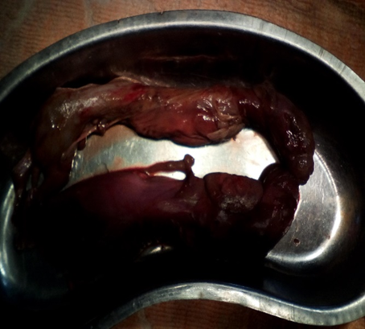
F
E

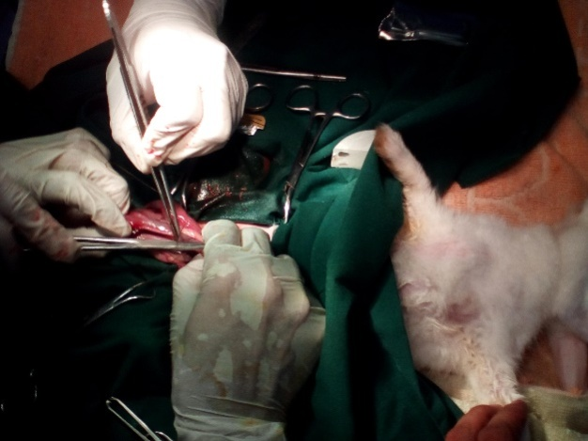
Fig 2: Surgical procedure of caesarian section in rabbit: A- Gravid uterus, B- Incision in the uterus, C- Suturing of uterus, D- Situation after suturing, E- Dead fetus, F- Condition after surgery

2.9 Postoperative Treatment and Care
The owner was advised to keep the surgical site clean and apply Povidone iodine ointment twice daily and Antibiotic Ceftriaxone @60 mg /Kg bodyweight (Inj. Ceftron 250mg®, Square Pharmaceuticals, Bangladesh) was administered intramuscularly daily for7 days. Antihistaminic Chlorpheneramine maleate @1mg/Kg body weight (Inj. Renacin®, Renata Ltd, Bangladesh) was administered intramuscularly daily for 7days. Analgesic Meloxicam @40 mg/Kg body weight (Inj.Melvet®, Acme Laboratories Ltd., Bangladesh) was administered subcutaneously daily for
5 days for pain management. The patient was monitored and observed for 14 days under a Veterinarian. No complication was noted and the rabbit recovered uneventfully. On the 14th day, the suture was removed and it was noticed that the surgical site was healed completely.

Chapter 3: Results and Discussion
Female rabbit reproductive tract is unique as it lacks a uterine body and each uterine horns has its own cervix which opens directly into the vagina (Quesenberry KE, 2004). The mesometrium and surrounding the ovaries contain abundant adipose tissue, to identify and ligation of uterine vessels is very much challenging for an ovariohysterectomy or caesarean section. Gestation ranges from 29 to 35 days, average is 30 to 32 days (Harkness and Wagner, 1989; Bishop, 2002; Quesenberry KE, 2004). The litter sizes for smaller breeds and primiparous does are 4 to 5 kits and larger breeds may produce 8 to 12 kits (Quesenberry KE, 2004). Birth weight also varies breed to breed which ranges is in between 30 to 80 g (Meredith A, 2002).It will takes several days to hours prior to parturition (kindling), fur will be pulled by the rabbit from her dewlap, abdomen, and flanks to make a nest which is considered as normal behavior and aids in exposing the nipples for nursing. The mammary glands develop rapidly in the last week of gestation, many a times milk let down is delayed until after kindling (Manning PJ, 1994). The first stage is mainly characterized by in apparent uterine contractions, dilatation of the cervix that ends with the rupture of the chorio-allantoic membrane (Pretzer, 2008). The expulsion of the fetuses and placenta are involving as the second and third stages. The first and second stages of labor in rabbits occur almost simultaneously as parturition typically lasts 30 min (Harcourt-Brown, 2002). Kits are typically born that considered altricial as they are usually hairless and helpless with closed both eyes and ears (Meredith A, 2002; Quesenberry KE, 2004)
The inability to expel fetuses from the uterus during parturition and may be due to maternal or fetal conditions preventing a normal delivery is called dystocia. Maternal factors are the abnormalities of pelvis, vagina or uterus such as small pelvic size and uterine inertia or may be due to malnutrition, parasitism, obesity and also the hereditary causes (Jutkowitz, 2005; Pretzer, 2008). Malpresentation, malposition, or malposture, oversize, fetal death, or malformations are included as fetal cause, such as fetal monsters. In many species, the most common maternal cause of dystocia is uterine inertia, and may be considered either primary or secondary. The gestation beyond its expected length with no progression into stage 2 labor defined as primary uterine inertia which may be associated with hypocalcaemia, obesity, overstretching of the myometrium from large litters. On the other hand inadequate uterine stimulation from small litters are also associated with it (Pretzer, 2008). Secondary uterine inertia is very common than the primary uterine inertia. Secondary uterine inertia, or uterine fatigue, occurs due to exhaustion and lack of myometrial contraction after prolonged attempts to expel an obstructed fetus, which persists following the relief of the obstruction (Jutkowitz, 2005; Pretzer, 2008). Dystocia is not common in rabbits as normal delivery is typically completed within 30 min after onset (Easson, 2001; Harcourt-Brown, 2002; Quesenberry KE, 2004). Obesity, oversized kits, a narrow pelvic canal or uterine inertia are included as the common causes of dystocia in rabbits (Easson, 2001; Bishop, 2002; Quesenberry KE, 2004). Indications of dystocia in rabbits are persistent contractions, straining, and bloody or greenish-brown vaginal discharge. Mainly obstetrical problems are rare in rabbits and parturition is very quick with minimal physical exertion, any indication of labor can be interpreted as a sign of dystocia.
Assistance of a doe presenting with dystocia usually requires gentle manual extraction of the fetuses and their fetal membranes (Quesenberry KE, 2004). It is important to ascertain the position of the fetuses to aid in the correction of any malpresentation, malposition, or malposture. Abdominal palpation, digital vaginal examination, radiographs and ultrasound are useful tools in this measure. Presentation is the association between the long axis of the fetus and the maternal birth canal. Anterior and posterior presentations are normal for rabbits. Position is the alignment of the dorsal part of the fetus with the maternal birth canal. A dorsal-sacral or dorsal position is considered normal and dorsal-pubic or dorsal-ilial positions are abnormal. Posture describes the disposition of the head, neck, and limbs (Arthur and Bee, 1996). Any flexion of joints or deviations of the head and neck are considered abnormal. Attempts to correct malpostures involve repelling the fetus back into the uterus and working to extend the affected extremity.
Ecbolic agents, such as oxytocin and calcium may be used in the medical management of dystocia. Medical management should not be considered if any cause of birth canal obstruction is present, as uterine rupture is a potential serious complication (Pretzer, 2008). Oxytocin promotes the influx of calcium into the myometrial cells, increasing the frequency and strength of uterine contractions. Postpartum, oxytocin is also used to promote uterine involution, control uterine hemorrhage, and assist in expulsion of retained placentas. In rabbits, doses of 1 to 3 units of oxytocin can be administered intramuscularly to assist in uterine contraction. Calcium gluconate may also be used as an uterotonic agent in combination with oxytocin (Jutkowitz, 2005; Pretzer, 2008). The current recommended treatment for uterine inertia in a doe is oral administration of 5 to 10 mL of 10% calcium gluconate given 30 min prior to intramuscular injection of oxytocin (Quesenberry KE, 2004). The rabbit should then be allowed to rest alone in a quiet area or her cage for an additional 30 to 60 min. Surgical management, such as caesarean section or ecbolic ovariohysterectomy, is indicated if medical management is unsuccessful or if a fetal or maternal obstruction cannot be corrected (Biddle and Macintire, 2000; Jutkowitz, 2005)The prognosis for a rabbit presenting with dystocia and non-responsive to oxytocin is guarded.
In rabbits, prenatal mortality before 3 weeks gestation will likely result in resorption of the fetus, whereas fetal death after 3 weeks results in abortion (Manning PJ, 1994; Quesenberry KE, 2004). Stillbirth occurs during the last part of gestation when the fetus is independently viable. Small litters, usually stillborn, and may contain 1 or 2 abnormally large or abnormal fetuses are often result as prolong gestation(Manning PJ, 1994; Harcourt-Brown, 2002)Other possible explanations are heredity, breed, and delayed implantation or development of a small fetus in utero (Arthur and Bee, 1996) (Turner PV. OVC, personal communication, 2010). Litters retained longer than 35 days will die in utero resulting in mummification or maceration (Harcourt-Brown, 2002). Fetal loss can be occurred during the gestation days of 13 or 23, times at which the placentation changes and when dislodge of the fetuses, respectively (Manning PJ, 1994)Possible causes of fetal loss include excessively large or small litters, stress, genetic predisposition, dietary imbalances, heat, trauma, drug use, infection (Listeriosis, Pasteurellosis, Salmonellosis, Aspergillosis, Chlamydial, and Staphylococcal infection), and systemic disease. Infection with Listeria monocytogenes is an important differential diagnosis in rabbits with late-term abortion as the gravid uterus is a predilection site for replication of the organism and pregnant rabbits are more susceptible to the disease (Manning PJ, 1994; Quesenberry KE, 2004). Special enrichment or selective procedures are required because isolation of the organism may be difficult.
Rabbits are popular pets which will be seen by the small animal practitioner. A special consideration is necessary for this species, such as nutritional needs and choice of medications, especially antibiotics. Fiber plays an important role in stimulating normal peristalsis that helps to maintain proper dental occlusion (Quesenberry KE, 2004). The diet of rabbit should consist of good quality grass hay such as timothy hay and a small amount of a high-fiber (18% to 24%). Commercial diet of protein levels is around 15%(Meredith A, 2002; Quesenberry KE, 2004). Discharge instructions for this rabbit included a recommendation to add hay to the current feeding regimen. Gastrointestinal dysbiosis may occur following oral administration of gram-positive and anaerobic spectrum antibiotics resulting in overgrowth of enterotoxic Clostridium spp. (Laber-Laird K, 1996; Quesenberry KE, 2004) Fluorquinolone, Trimethoprim-sulphonamide combinations and Aminoglycosides are considered safe; however, Penicillin, Cephalosporin, Lincosamide such as clindamycin and Lincomycin, and macrolides such as erythromycin, should be avoided in rabbits.

Conclusion
Rabbit are one of the small pet mammals for the recreation of high class people. This paper will be helpful for field veterinarian and owner to know how they can care their pet rabbit. C-section can be considered as 100% safe for dystocia rabbit rather than forceful manual traction.

Acknowledgement
All praises are due to “ALMIGHTY ALLAH”, who has given the opportunity to accomplish of this report successfully. The author wishes to express his deepest gratitude, sincere appreciation, indebtedness and profound regards to hid respected supervisor Dr. Mohammad Alamgir Hossain, Professor &head of the department of pathology and parasitology, Chittagong Veterinary and Animal Sciences University, for his constructive and constant guidance in planning and execution of this research work, encouragement, sand affectionate feelings throughout the course of clinical research work. The author also wishes to express his gratitude to Dr. A. K. M Saifuddin, Professor and Director of External Affairs, Chittagong Veterinary and Animal Sciences University, for his supervision and kind co-operation during the period of internship. Finally the author expresses thanks and warmest sense of gratitude to his parents and all well-wishers.

The author
October 2017

Chapter 4: References

1. Arthur, G., Bee, D., 1996. Fetal dystocia: Aetiology and incidence. Veterinary Reproduction & Obstetrics. 7th ed. Londres: WB Saunders, 120-127.

2. Biddle, D., Macintire, D.K., 2000. Obstetrical emergencies. Clinical techniques in small animal practice15, 88-93.

3. Bishop, C.R., 2002. Reproductive medicine of rabbits and rodents. Veterinary Clinics of North America:Exotic Animal Practice5, 507-535.

4. Easson, W., 2001. A review of rabbit and rodent production medicine. In, Seminars in Avian and Exotic Pet Medicine, 131-139.

5. Eircom, 2008. Irish Mammals – Rabbits.

6. Harcourt-Brown, F., 2002. Skin diseases. Textbook of rabbit medicine, 224-248.

7. Harkness, J., Wagner, J., 1989. Biology and husbandry. The biology and medicine of rabbits and rodents, 3rd ed. Philadelphia: Lea & Febiger, 372.

8. Hreiz, J.E., 2014. exotics practice in the Charlotte. NC-area.

9. Jutkowitz, L.A., 2005. Reproductive emergencies. Veterinary Clinics: Small Animal Practice35, 397-420.

10. Laber-Laird K, S.M., Flecknell P, 1996. Handbook of Rodent and Rabbit Medicine Tarrytown.

11. Manning PJ, R.D., Newcomer CE, 1994. Academic Press San Diego.

12. Meredith A, R.S., 2002. BSAVA Manual of Exotic Pets. Gloucester.

13. Pretzer, S., 2008. Medical management of canine and feline dystocia. Theriogenology70, 332-336.

14. Quesenberry KE, C.J., 2004. Ferrets, Rabbits, and Rodents: Clinical Medicine and Surgery. Saunders St. Louis, Missouri.

Biography
Me Mohammad Mohiuddin Akram, the author of this case report would like to introduce as Intern. Dr. of Chittagong Veterinary and Animal Sciences University (CVASU) have passed four years academic career in faculty of veterinary medicine and attended several clinical training programs on Veterinary Medicine in Bangladesh and India. As a student of Veterinary science, with a passion for animal welfare, a high interest in the natural sciences, a desire to be involved in education, and a dedication to life-long learning. My goal is to be a competent and contributing member of the veterinary profession. This case report is the first step to fulfill my dream. I strongly assure that I have done all the works that can be furnished here in this report and I hold entire responsibility of the information given here which are collected from different books, journals and websites.

