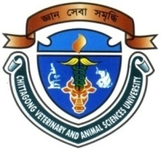

Surgical management of dystocia by caesarean section in rabbit

NAME: Mohammad Mohiuddin Akram
INTERN ID: F-59
ROLL NO: 11/117
REG NO: 00701
SESSION: 2010-11

Report Presented in Partial Fulfillment for the Degree of Doctor of Veterinary Medicine

Faculty of Veterinary Medicine
Chittagong Veterinary and Animal Sciences University
Khulshi, Chittagong

OCTOBER 2017

Authorization
I hereby declare that, I am the sole author of the clinical report. I also authorize the Chittagong Veterinary and Animal Sciences University (CVASU) to lend this report to other institutions or individuals for the purpose of scholarly research. I further authorize the CVASU to duplicate the report by photocopying or by other means, in total or in part, at the request of other institutions or individuals for the purpose of scholarly research.
I, the undersigned, and author of this work, declare that the electronic copy of this report provided to the CVASU library, is an accurate copy of the print report submitted, within the limits of the technology available.

....................................................
Mohammad Mohiuddin Akram
(Author)
OCTOBER 2017

Surgical management of dystocia by caesarean section in rabbit

NAME: Mohammad Mohiuddin Akram
INTERN ID: F-59
ROLL NO: 11/117
REG NO: 00701
SESSION: 2010-11

This is to certify that I have examined the above Intern report and have found that is complete and satisfactory in all respects

………………………………

(Supervisor)

Dr. Mohammad Alamgir Hossain

Professor and Head

Department of Pathology and Parasitology

Faculty of Veterinary Medicine
Chittagong Veterinary and Animal Sciences University
Khulshi, Chittagong

OCTOBER 2017

