Chapter 1: Introduction

Pyometra is a condition mainly of middle aged female dogs that have not been spayed. It is a hormonally mediated, diestrual disorder that results in abnormal uterine endometrium. By definition, pyometra is accumulation of pus within the lumen of uterus which is due to progesterone dominance along with bacterial infection (Mohesh et al.,2014). Pyometra usually diagnosed after four weeks to four months of estrus (Smith, 2006). This disease causes very negligible changes in the early stages, so diagnosis is often made late in the disease process. Many studies indicate an increased incidence of pyometra in nulliparous bitches and in bitches more than four years of age (Chastain et al., 1999). The incidence of pyometra in bitch is usually 24% before she reached ten years of age (Hagman, 2000).
The etiology of pyometra is mainly E.coli, Klebisiella, Pasterurella and Staphylococcus; most of organisms are gram negative bacteria (Okano et al., 1998). Almost 82-100 percent of clinical cases is caused by Escherichia coli ( Bassessar et al., 2013). The pathogenesis of pyometra is not fully understood, but the influence of estrogen followed by subsequent progesterone stimulation during a long period of time (Dow, 1959) in combination with bacterial infection which are normally remain in the vagina.
During diestrous period the progesterone level is remain high. The elevated progesterone level increase glandular proliferation and secretion. This progesterone-primed condition stimulates uterine glandular secretions within the uterus, which suppresses uterine contraction (Kumar et al., 2016). During the estrus period cervix become open. In this time the activity of the WBC also suppressed due to ensure the proper and safe movement of sperm into the female genital tract so that fertilization can occur (Cramer, 2010). During this time, bacteria that normally found in vaginal tract and urinary infection and also fecal contamination (Rafee et al., 2015) can easily enter into the uterus. At this time the uterine muscle becomes thicken, so the contraction power remain minimum. After getting proper nutrient and environment from uterus, bacteria proliferate at this condition (Ukwueze and Orajaka, 2014 ). This bacterium produces endotoxins that are capable of initiating the cytokine cascade and the release of many inflammatory mediators. E. coli cause both local and systemic inflammatory reaction that associated with pyometra (Rafee et al., 2015).
The incidence of pyometra also depends on the breeds of dog. Some breeds reported to be predisposed to pyometra include the Rottweiler, Saint Bernard, Chow Chow, Golden Retriever, Miniature Schnauzer, Irish Terrier, Spitz, Poodle, Airedale Terrier, Cavalier King Charles Spaniel, Rough Collie, and Bernese Mountain dog (Smith, 2006; Crook et al., 1960). Breeds with a low risk for pyometra include Drevers, German shepherd, Daschunds, and Swedish hounds (Egenvall et al., 2001).
Pyometra can be classified as two types which are open cervix pyometra and closed cervix pyometra (Smith, 2006). There is an another type of pyometra which is occurred in improperly spayed bitch. Called as uterine stump pyometra (Musal and Tuna, 2005).
Clinically, the bitch may present with inappetence, depression, polydipsia, lethargy and abdominal distension. She may or may not have vaginal discharge and fever (Rafee et al., 2015). Clinical sign of pyometra mainly depends on whether the cervix allows pus to drain out or not. The most common clinical finding in bitches with open-cervix pyometra is a malodorous, sanguinous to mucopurulent vaginal discharge (Renton et al., 1993). Bitches with open-cervix pyometra are generally less systemically ill than bitches with closed-cervix pyometra and early in the course of the disease affected bitches may show no clinical signs other than vaginal discharge (Dow, 1969). Additional clinical findings may include lethargy, depression, inappetance/anorexia, polyuria, polydipsia, vomiting, and diarrhea (Wheaton et al., 1989). In contrast, bitches with closed-cervix pyometra are generally very ill at presentation, with marked clinical signs of depression, lethargy, polyuria, polydipsia, vomiting, diarrhea, and possibly abdominal distension. Affected bitches are often dehydrated and septicemic, toxemic, and in shock. Fever may be present in bitches with pyometra, but those with toxemia may actually be hypothermic (Hardy and Osborne, 1974). There is typically no evidence of vulvar discharge in case of closed cervix pyometra.
The diagnosis of canine pyometra can be done by clinical signs that mainly include purulent vaginal discharge which can be confirmed by the ultrasonography and radiography (Bigliardi et al., 2004). In case of ultasonography findings typically include an enlarged uterus with convoluted, tubular horns filled with anechoic to hypoechoic fluid (Voges et al., 1996; Hosken et al., 1991). The luminal contents are usually homogenous, but the contents may also be echo dense with slow, swirling patterns (Nyland and Mattoon, 2002). In case of radiography non pregnant and early pregnant uterus are of soft tissue or fluid radiopacity (Ackerman,1981). Other uterine conditions that have similar soft-tissue radiographic characteristics are pyometra, mucometra, and uterine torsion (Root,1984). The hematological and biochemical test results from blood and urine also give necessary information for diagnosis (Shah et al., 2017).
In case of treatment of pyometra, both medicinal and surgical treatments are available. Medicinal treatment is effective in case of open cervix pyometra and in young age dog (Ukwueze, 2014). Severe pyometra sometimes leads to fatal and systemic infection and infertility. Different treatment methods have been applied during pyometra but the popular and effective methods is ovario-hysterectomy (OHE) (Feldman and Nelson, 2004; Johnston et al., 2001).
In Bangladesh, there are a few number of studies have found in literature about canine pyometra. Therefore, the present study was aimed to diagnose, treat and surgical management as well as post operative care of canine pyometra.

Chapter 2: Methodology
2.1 Study area and duration:
My study was conducted at Madras Veterinary College, Chennai, India and Teaching Veterinary Hospital, Khon Kaen University, Thailand. During my internship placement at Madras veterinary college from 22nd April to 6th may 2017 and Teaching Veterinary Hospital, Khon Kaen, Thailand from 8th October to 22nd October.
2.2 Study population
During the study period total five cases of pyometra were observed and handled both in MVC, India and TVC, Khon Kaen University, Thailand. Pyometra usually occurs in middle age un spayed female dog. It includes both open cervix pyometra and close cervix pyometra.
2.3 Case history:
In Madras Veterinary College, three cases of pyometra were presented. The descriptions are given below in a table:
Table 1: Description of cases found in TANUVAS, India.
Case number | Species | Breed | Age | Body weight
Case 1 | Canine | German Shepherd | 9years | 34.5kg
Case 2 | Canine | Spitz | 5years 3month | 15kg
Case 3 | Canine | Golden Retriever | 7year 8 month | 29.6kg
These three dogs were bought to the small animal gynecology and obstetrics unit with the history of purulent vaginal discharge and inappetite. These cases were managed surgically after proper diagnosis.
In the Teaching Veterinary Hospital, KKU, two cases of pyometra were presented. The descriptions are given below in a table:
Table 2: Description of cases found in KKU, Thailand.
Case number | Specise | Breed | Age | Body weight
Case 4 | Canine | Shit zuu | 4years | 5.6kg
Case 5 | Canine | Poodle | 7years | 6kg
These two cases also successfully managed by surgical method.
2.4 Gross Examination:
In the all cases the dogs were dull and depress. In four cases there were purulent vaginal discharge noticed from the vulva. Perineal area was moist due to discharge (Figure 1.1).
2.5 Clinical Examination:
In case of close cervix pyometra the vaginal discharge were not usually seen, the abdomen remain more distended and this type was more dangerous. In case of open cervix pyometra there was presence of purulent vaginal discharge from the vulva. (Figure 1.2). The abdomen was not as distended as the close cervix pyometra . During the clinical examination the body temperature of most of the dogs were in between 100°F to 102°F. Other clinical features of the cases are given in the table:
Table 3: Clinical features of the cases.
Case no. | Body temp.(°F) | G/A | Vaginal discharge | Lethargy | Vomition | Abdominal distension | Mucous membrane
1 | 100.2 | Dull | Purulent | Present | Present | Less | Pale
2 | 101 | Dull | Purulent | Present | Present | Less | Pale
3 | 101.6 | Dull | Purulent | Present | Present | Moderate | Pale
4 | 100.8 | Alert | Purulent | Absent | Absent | Less | Pink
5 | 102 | Recumbent | Absent | Present | Present | High | Pale
2.6 Diagnosis:
Tentative Diagnosis of canine pyometra can be done by observing the clinical signs of the bitch. But for the confirmatory diagnosis imaging techniques are widely used by the veterinarian.
2.6.1 Ultrasonography:
This is the best methods for the diagnosis of canine pyometra. Ultrasound was performed in the caudoventral portion of the abdomen. The excess hair was clipped for the better imaging. (Figure 1.4). K Y gelly was used. The diagnosis of pyometra is best made with the aid of ultrasonography and findings typically include an enlarged uterus with convoluted, tubular horns filled with anechoic to hypoechoic fluid. The luminal contents are usually homogenous, but the contents may also be echodense with slow swirling patterns.
2.6.2 Radiography:
Radiography is also a effective technique for the diagnosis of canine pyometra. The animal was put on the lateral recumbency and lateral view was taken. The normal non-pregnant and early pregnant uterus is of soft tissue or fluid radiopacity. Other uterine conditions that have similar soft-tissue radiographic characteristics are pyometra, mucometra, and uterine torsion.
2.6.3 Blood test:
Blood was collected from cephalic vein with sterile syringe and was sent for the complete blood count and biochemical analysis specially BUN, creatinin.
2.7 Surgical Management:
The treatment options for the canine pyometra are both medicinal and surgical management. Young bitches can be treated by using prostaglandin until uterus returns to its normal size. As medicinal management is not fit for the old age dog, The best way to save the life of old animal is the surgical management. Overiohysterectomy is performed to remove the pus filled uterus to save the animal from the toxic shock that leads to death. Bitches that are seriously ill should be medically stabilized with appropriate intravenous fluid therapy and broad spectrum antibiotics prior to surgery.
2.7.1 Restraining of the animal:
The dog was restrained in the dorsal recumbency (Figure 1.5).
2.7.2 Surgical site preparation:
The caudoventral portion of the abdomen was clipped and shaved with sterile blades. After shaving, the surgical site was aseptically prepared with tincture iodine and alcohol. (Figure 1.9).
2.7.3 Premedication and Anaesthesia:
The owner was said to stop feeding for 12 hours and watering for 6 hours prior to surgery. After restraining, Atropin sulphate @ 0.04 mg/kg body weight intramuscularly and Diazepam@0.5mg/kg body weight intravenously were used as premedication. After that Propofol@4mg/kg body weight intravenously as general anaesthetics. The anaesthesia was maintained by gaseous anaesthesia by using isoflurane.
2.7.4 Surgical Procedure:
After aseptic preparation of surgeon and surgical site, a 5-8 cm incision was made on the skin which initiates 2cm behind from the umbilicus by using scalpel. (Figure 1.10). Muscle layers and peritoneum were incised with the scalpel and blunt incision method was performed. (Figure 1.11) The blood vessels were ligated and bleeding checked by coagulation method by using electric cauterize (Figure 1.12) After locating the pus filled uterus, it was exteriorized through the incision carefully. (Figure 1.13). The ovarian pedicle was located and a ligature was placed anterior to the ovary to check the bleeding. Another ligature also placed just behind the first ligature to protect the bleeding. ( Figure 1.14). After the ligature two artery forceps were placed anterior to the ligature and ovarian pedicle was cut between two artery forceps. Same procedure was applied for another horn of the uterus. Uterus was exteriorized along with overy.
Then proper ligature was placed just anterior to the cervix to ensure hemostasis. After that two artery forceps were placed posterior to the ligature and the stump was cut between two artery forceps. (Figure 1.15) Thus the whole uterus and ovary was removed (Figure 1.16). The abdominal cavity was flushed with normal saline solution. Peritoneum and muscle were sutured together by using catgut(case 1,2,3) and PGA(case 4,5) with simple continuous suture pattern(Case 1,2,3)(Figure 1.17) and simple interrupted suture pattern (case 4,5). The skin incision was closed by using horizontal mattress suture with nylon. (Figure 1.18)

2.7.5 Post operative care:
After the surgery the incision was cleaned with iodine solution and a bandage was placed to protect the surgical wound from the contamination. (Figure 1.18). A broad spectrum antibiotic was given to protect the secodary bacterial infection. Ceftriaxone@ 40mg/kg body weight, NSAID Meloxicam@ 0.5mg/kg body weight and Pheneramine meleate@ 0.5mg/kg body weight were prescribed. . Fluid therapy was continued throughout the surgical procedure. The skin suture was removed after complete healing usually after 7-10 days of surgery.

Chapter 3: Result
From the ultrasonography the pyometra was successfully diagnosed in all the cases. In case of case 1, case 2, case 5 there found distinct pus pocket into the uterus which were anechoic and hypoechoic in nature. (Figure 1.6). In case of case 3 and case 4 no distict outline of pus pocket were found. Thickening of the wall were noticed and the uterus was filled with hypoechoic fluid that was diagnosed as pus. (Figure 1.7). This was the confirmatory and effective diagnostic tools in all the cases.
From the radiograph in all the cases the normal non-pregnant and early pregnant uterus are of soft tissue or fluid radiopacity. Other uterine conditions that have similar soft-tissue radiographic characteristics are pyometra, mucometra, and uterine torsion. In all the cases fluid filled radio opacity was present. Abdominal radiograph represent a fluid filled uterus (Figure 1.8)
There was a distinct change in the blood cell count and biochemical test of the blood. Anemia was found in most of the cases due to les number of RBC. Also peripheral lecocytosis is a very common finding from CBC. A mild normocytic, normochromic and non degenerative anemia was found. This results the low amount of PCV. Clinical biochemical result revealed that in 80% cases (4 out of 5) have mild increase in Alanine aminotransferase (ALT). In case of renal insuffiency creatinin, BUN were slightly increased and total protein is decreased due to urinary loss of protein. On admission elevated blood urea nitrogen was observed. It was probably due to the purulent process of the pyometra and the dehydration.

Table 4: Results of blood tests of the cases.
Parameters | Ref. value | Case 1 | Case 2 | Case3 | Case4 | Case5
RBC(*10^6cell/µl) | 5.6-8.7 | 3.76 | 3.99 | 6.2 | 7.1 | 5.6
WBC(*10^3cell/µl) | 6-17 | 48.09 | 37.56 | 39.66 | 29.47 | 45.12
PCV(%) | 41-58 | 25 | 26 | 37 | 40 | 27
Hb(gm/dl) | 12-18 | 9.5 | 8.8 | 11 | 13.9 | 8.9
ALT(IU/dl) | 25-92 | 121 | 109 | 96 | 140 | 106
BUN(mg/dl) | 7-24 | 34.2 | 29.5 | 31.4 | 25.44 | 37
Creatinin(mg/dl) | .7-1.4 | 1.9 | 1.6 | 2.4 | 1 | 1.6
After the diagnosis of all the case the cases were handled surgically. The best protocol of treatment for the old age dog and also for the closed cervix pyometra is ovarihysterectomy. All five cases were treated successfully by ovariohysterectomy. And after proper post operative care and treatment all the dogs were completely cured.
Table 5: Follow up of the cases after surgery.
Case no. | Complication | Day of complication after surgery | Type of complication | Treatment | Complete recovery(after surgery)
Case 1 | No | ---- | ----- | ----- | 7 day
Case 2 | No | ---- | ----- | ----- | 7day
Case 3 | Yes | 3rd day after surgery | Stop feeding and recumbent | Fluid therapy | 9day
Case 4 | No | ---- | ----- | ----- | 6day
Case 5 | Yes | 2nd day after surgery | Pus come from surgical wound | Antibiotic treatment | 13day

In the case 1, 2 and 4 no complication were found. These dogs were completely recovered within 7days. But in case 3 the dog stopped feeding in that case 5% dextrose saline was given and the dog was recovered after 9days. In the case 5, the surgical wound was contaminated by pyogenic bacteria. That caused pus come out from surgical wound. The surgical site was cleaned with iodine solution and broad spectrum antibiotic was given intramuscularly. This dog was completely recovered after 13 days.
Chapter 4: Discussion

Pyometra is a common and lethal problem of middle aged dog. The high incidence of pyometra usually occurs in the unspayed female dog. In this study all five dogs were affected by pyometra before 10 years of age. This is supported by the previous studies 24% of bitch affected by pyometra before she reaches 10 years of age. (Hagman, 2000).
The main causal agent for the pyometra is the hormonal influence along with bacterial infection. About 84-90% of the clinical cases are caused by Escherichia coli ( Bassessar et al., 2013). There are found the clinical signs including lethargy, purulent vaginal discharge, anorexia and vomition also found in the previous studies. (Rafee et al., 2015)
In this study among five cases four were open cervix pyometra another one was closed cervix pyometra. Clinical signs of both types differ from each other. Bitches with open-cervix pyometra are generally less systemically ill than bitches with closed-cervix pyometra and early in the course of the disease affected bitches may show no clinical signs other than vaginal discharge (Dow, 1969). In contrast, bitches with closed-cervix pyometra are generally very ill at presentation, with marked clinical signs of depression, lethargy, polyuria, polydipsia, vomiting, diarrhea, and possibly abdominal distension. Affected bitches are often dehydrated and septicemic, toxemic, and in shock. Fever may be present in bitches with pyometra, but those with toxemia may actually be hypothermic (Hardy and Osborne, 1974). There is typically no evidence of vulvar discharge in case of closed cervix pyometra.
The diagnosis in this study was done by ultrasongraphy which is the best method for the diagnosis of canine pyometra. Ultrasonograohy also used for diagnosis in other studies (Pretzer, 2008; Bigliardi et al., 2004; Nyland and Mattoon, 2002). In this study ultrasonography revealed enlarged uterus with convoluted, tubular horns filled with anechoic to hypoechoic fluid which is similar in other study (Hosken et al., 1991). Other technique used is radiography. This is used in previous study for the diagnosis of canine pyometra (Ackerman,1981). Fluid filled radioopaque consistency found in the uterus (Root, 1984).
The treatment options for the canine pyometra are both medicinal and surgical management. Young bitches can be treated by using prostaglandin until uterus returns to its normal size (Ukwueze and Orajaka, 2014). In young age dog medicinal treatment with prostaglandin is used. It is effective in open cervix pyometra (Baithalu et al., 2010).
The medicinal management is not fit for the old aged dog, the best way to save the life of old animal is the surgical management. (Rafee et al., 2015). Overiohysterectomy is performed to remove the pus filled uterus to save the animal from the toxic shock that leads to death. Bitches that are seriously ill should be medically stabilized with appropriate intravenous fluid therapy and broad spectrum antibiotics prior to surgery.
In this study all the dogs were treated with ovariohysterectomy. This is the widely used method in other studies also (Biswas et al., 2012) . In this study dorsal recumbency was used and aseptic surgical methods followed in this study for all the cases. (Feldman and Nelson, 2004). In this study the recovery rate from the pyometra after surgery was 100%. All the cases were successfully recovered after surgery along with some complications in two cases. In other studies showed that the success rate was also high after ovariohysterectomy(Johnston et al., 2001).

Conclusion
In this case study the all cases of pyometra were successfully recovered after ovariohysterectomy with proper post operative care. So in case of middle aged and old aged dog, canine pyometra can be managed by ovariohysterectomy to save the life of the animal.

References
Ackerman, N. 1981. Radiographic evaluation of the uterus: a review. Veterinary Radiology, 22:252.
Bassessar, V., Verma, Y., Swamy ,M. 2013. Antibiogram of bacterial species Isolated from canine pyometra. Veterinary World, 6:546–9.
Bigliardi, E., Parmigiani, E., Cavirani, S., Luppi, A., Bonati, L., Corradi, A. 2004. Ultrasonography and cystic hyperplasia–pyometra complex in the bitch. Reproduction of Domestic Animal, 39:136–40.
Biswas, D., Das, S., Das, B.C., Saifuddin, A. K. M. 2012. Pyometra in a German shepherd dog. Asian journal of Animal and veterinary Advances, 7(5): 446-451.
Cox, J. E. 1970. Progestagens in bitches: A review. Journal of Small Animal Practice, 11:759-778.
Dow, C. 1959. Experimental reproduction of the cystic hyperplasia pyometra complex in the bitch. Journal of pathology and bacteriology, 78:267–78.
Egenvall, A., Hagman, R., Bonnet, B., Hedhammar, A., Olsson, P., Lagerstedt, A.S. 2001. Breed risk of pyometra in insured dogs in Sweden. Journal of Veterinary Internal Medicine, 15:530–8.
Feldman, E.C., Nelson, R.W. 2004. Cystic Endometrial Hyperplasia/ Pyometra. Canine and Feline Endocrinology and Reproduction.W.B. Saunders Company, 3:847-860.
Hagman, R., Kuhn, I. 2002. Escherichia coli strains isolated from the uterus and urinary bladder of bitches suffering from pyometra: comparison by restriction enzyme digestion and pulsed-field gel electrophoresis. Veterinary Microbiology, 84:143–53.
Hardy, R.M., Osborne, C.A. 1974. Canine pyometra: pathogenesis, physiology, diagnosis and treatment of uterine and extra-uterine lesions. Journal of American Animal Hospital Association, 10:245–68.
Hosken , R.A., Mahaffey, M., Liebl, D. M., Candle, A.B. 1991. Early diagnosis of canine pyometra using ultrasonography. Veterinary Radiology, 32:287–9.
Krook, L., Larsson, S., Rooney, J.R. 1960. The interrelationship of diabetes mellitus, obesity, and pyometra in the dog. American Journal for Veterinary Research, 21:120–4.
Kumar, A., Rohi, R.R., Pawar, P., Kumar, P., Yadav, R. 2016. Pyometra and its complication in bitches A case report. International Journal of Science, Environment and Technology, 5:774 – 780.
Mahesh, R., Devi, P.V., Devarathnam, J., Sumiran, N., Kamalakar, G. Suresh Kumar R.V..2014. Successful Management of a Critical Case of Pyometra in a Bitch: A Case Report. Journal of Animal, Veterinary and Fishery Sciences , 2(8):21-23.
Musal, B., Tuna, B. 2005. Surgical therapy of complicated uterine stump pyometra in five bitches: a case report. Veterinary Medicine, 12: 558–562.
Nyland, T.G., Mattoon, J.S. 2002. Ovaries and uterus. In: Kersey R, editor. Small Animal Diagnostic Ultrasound, 2:231–49.
Okano, S., Tagawa, M., Takase, K. 1998. Relationship of the blood endotoxin concentration and prognosis in dogs with pyometra. Journal of Veterinary Medical Science, 60:1265-1267.
Rafee, M. A., Amarpal., Mahendra Baghel, M. 2015. Pyometra in a Great Dane: A Clinical Case Report. Journal of Advanced Veterinary Research , 5:95-98.
Root, C.N. 1974. Interpretation of abdominal survey radiographs. Veterinary Clinics of North America, 4:763.
Shah, S.A., Sood, N. K., Wani, B.M., Rather, M.A., Beigh, A. B., Amin , U. 2017. Haemato-biochemical studies in canine pyometra. Journal of Pharmacognosy and Phytochemistry , 6(4): 14-17.
Smith, F. O. 2006. Canine pyometra. Theriogenology, 66:610–2.
Ukwueze, S. C., Orajaka, F.C. 2014. Medical Management of Open Cervix Pyometra in a Bitch: A Case Report. IOSR Journal of Agriculture and Veterinary Science, 7:75-78.
Voges, A.K., Neuwirth, L. 1996. Ultrasound diagnosis-cystic uterine hyperplasia. Veterinary Radiology and Ultrasound, 37:131–2.
Wheaton, L.G., Johnson, A.L., Parker, A.J., Kneller, S.K. 1989.Results and complications of surgical treatment of pyometra: a review of 80 cases. Journal of the American Animal Hospital Association, 25:563–8.

Image Gallery
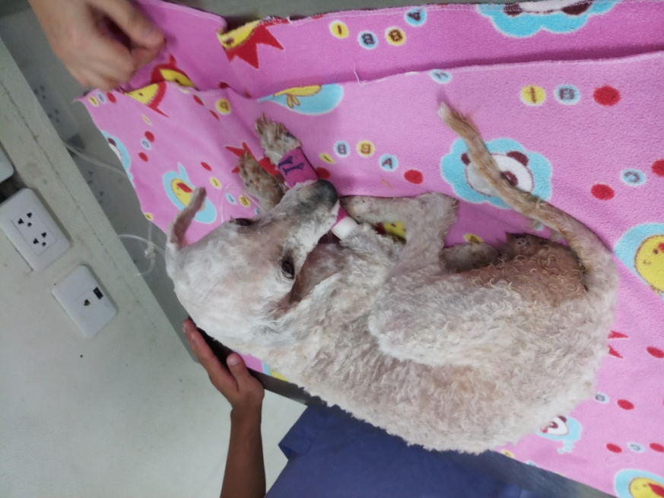
Figure 1.1: Moist perineal area due to vaginal discharge.

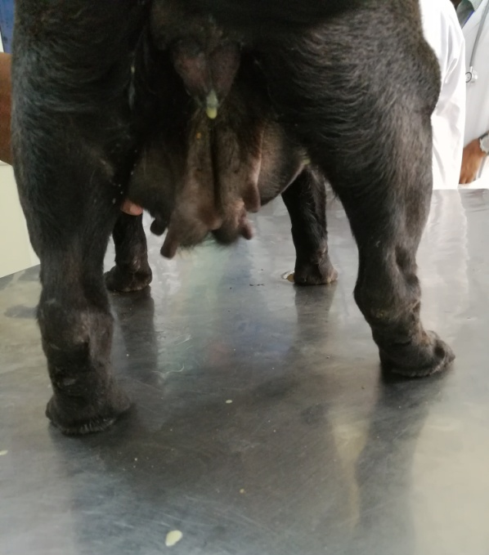
Figure 1.2: Purulent vaginal discharge from vulva
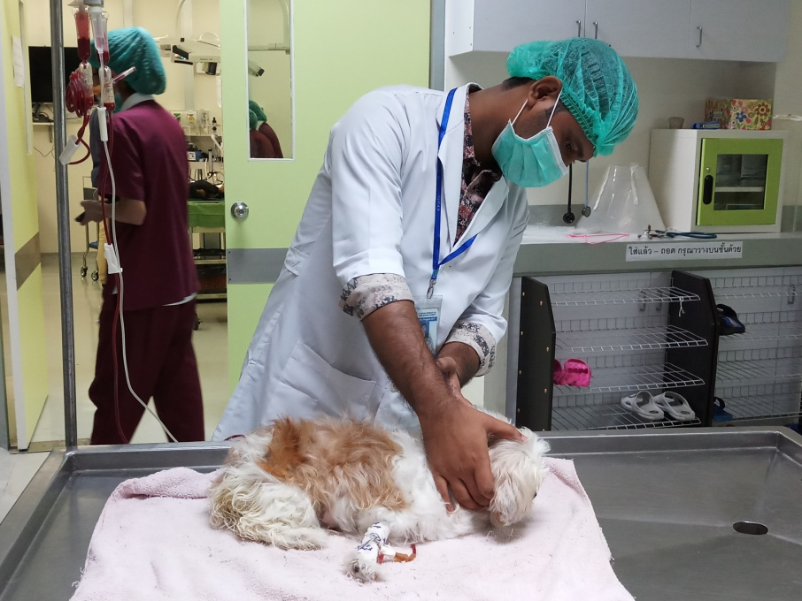
Figure 1.3: Physical examination of recumbent bitch.

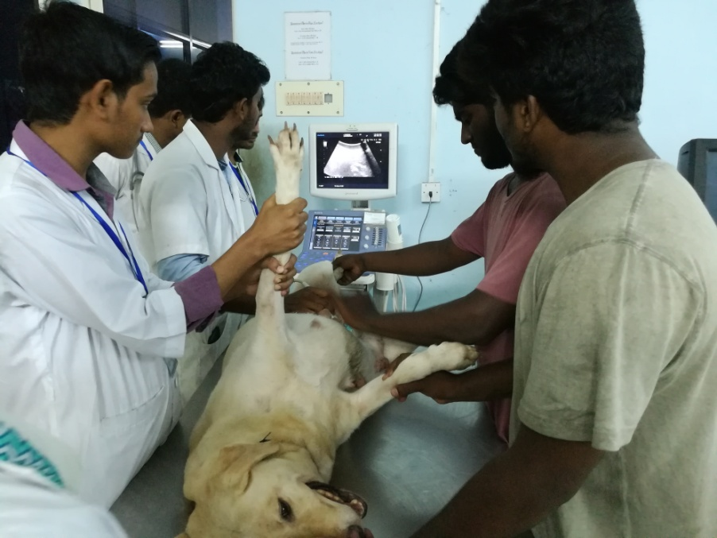
Figure 1.4: Ultrasonography of bitch

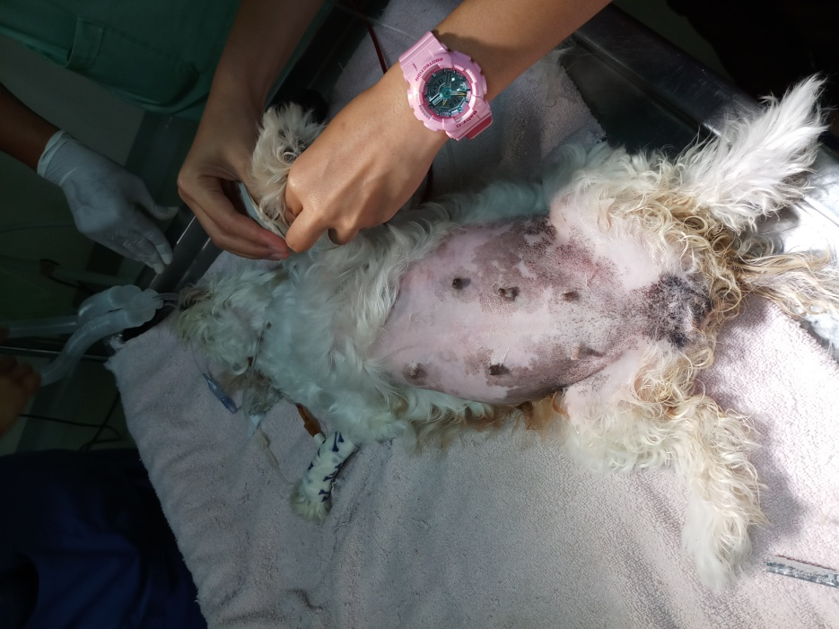
Figure 1.5: Restraining in dorsal recumbency.

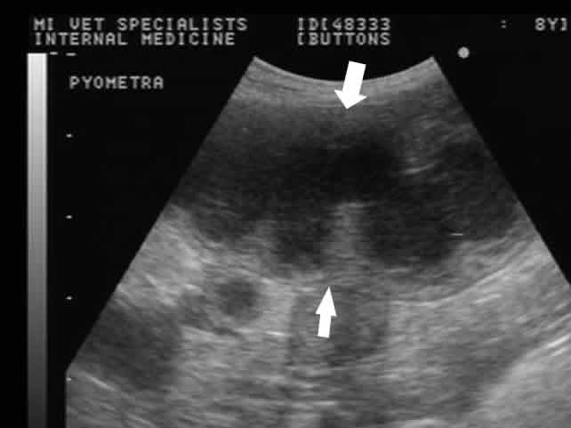
Figure 1.6: Pus pocket found in the uterus in ultrasonograph.

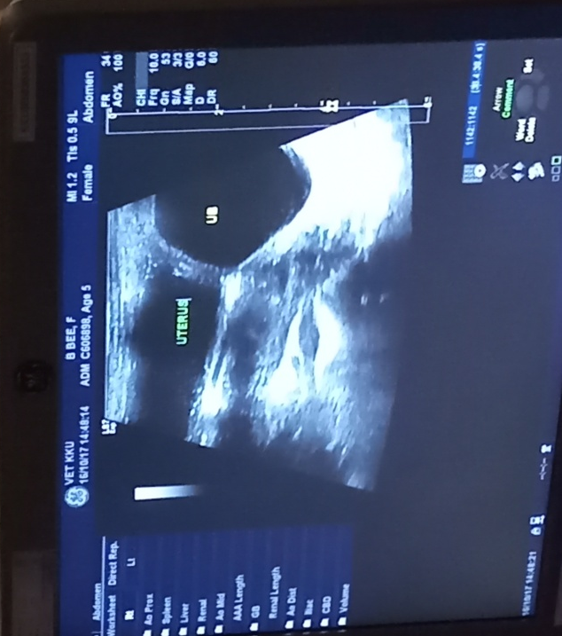
Figure 1.7: Thickening of uterine wall found in ultrasonograph.

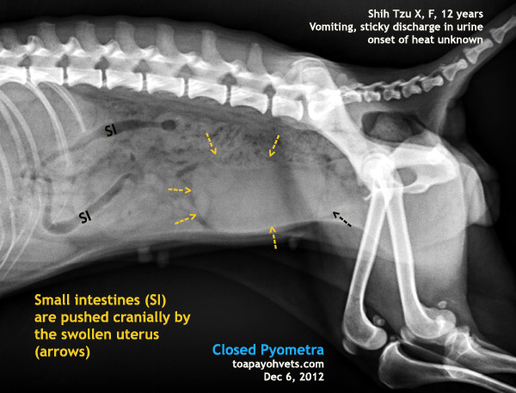
Figure 1.8: Fluid filled uterus in radiograph.

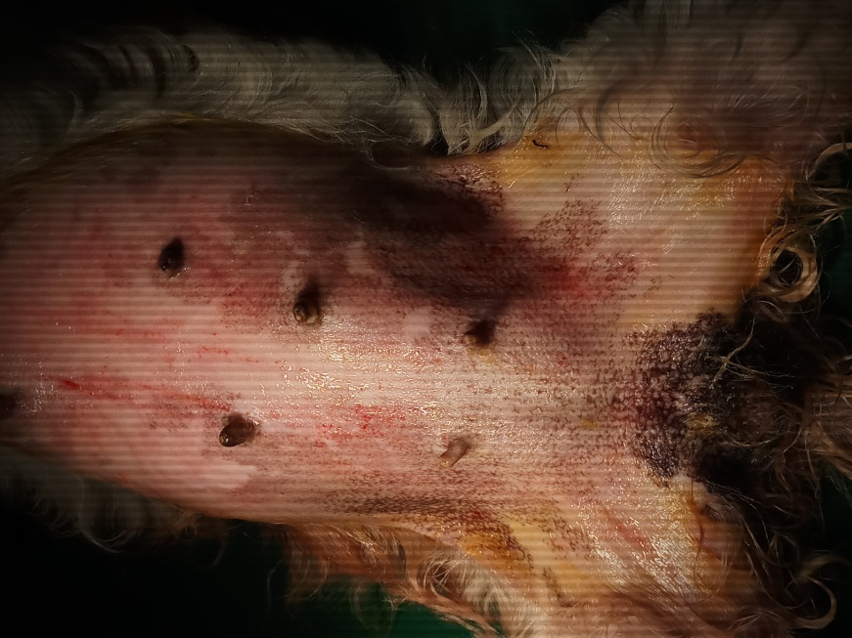
Figure 1.9: Surgical site preparation for aseptic surgery.

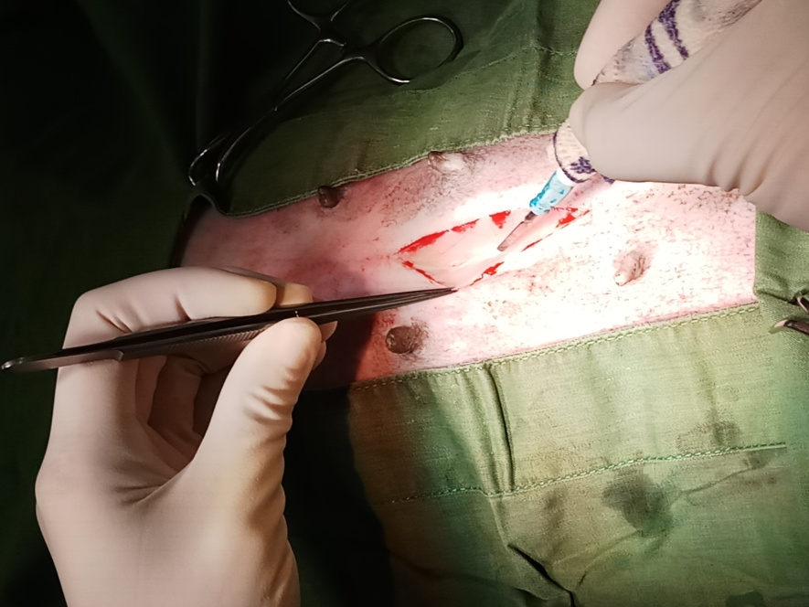
Figure 1.10: Skin incision

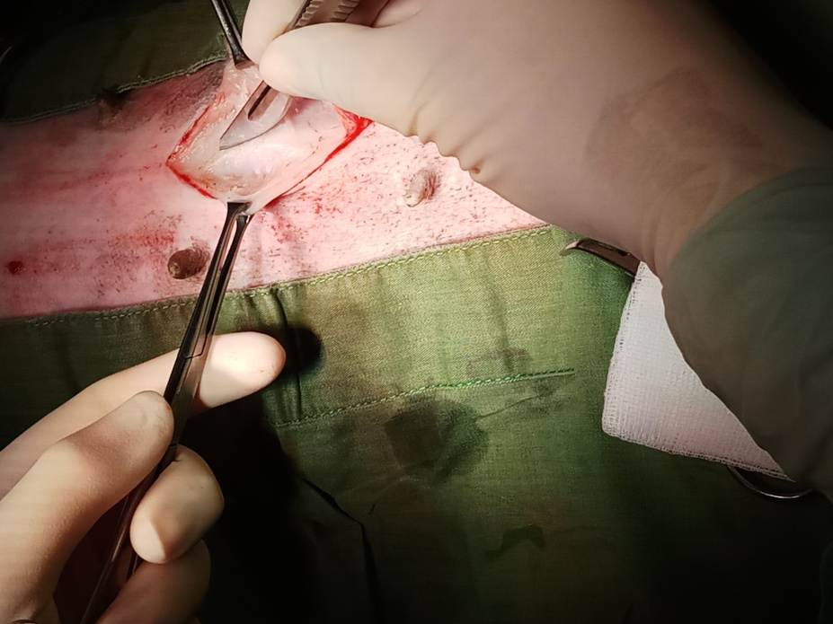
Figure 1.11: Muscle incision

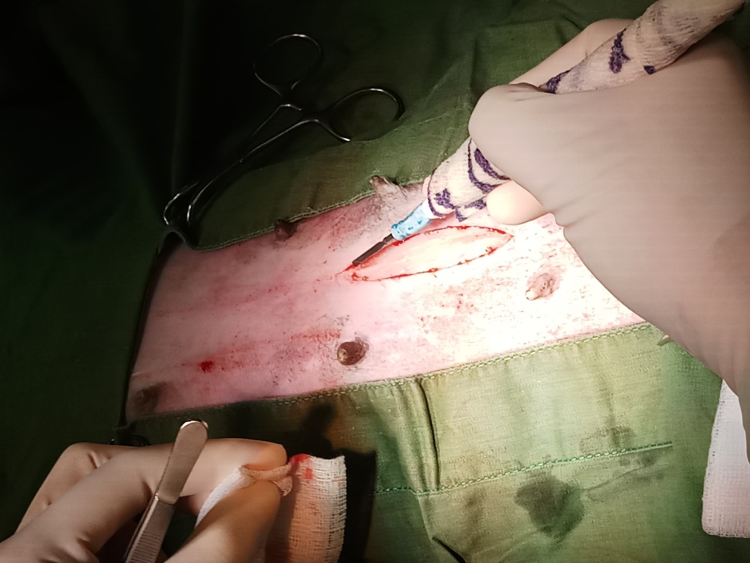
Figure 1.12: Bleeding check by electric cauterizer

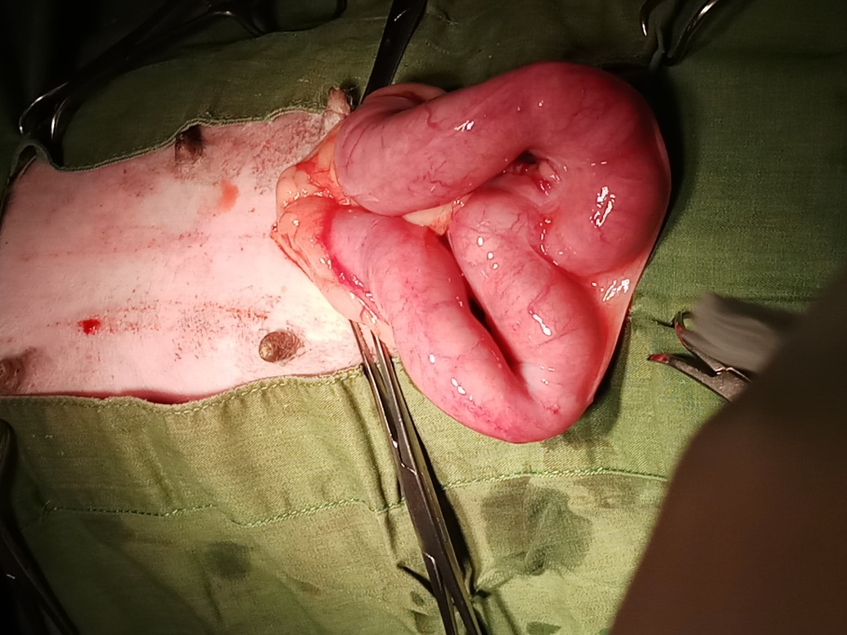
Figure 1.13: Exteriorized pus filled uterus

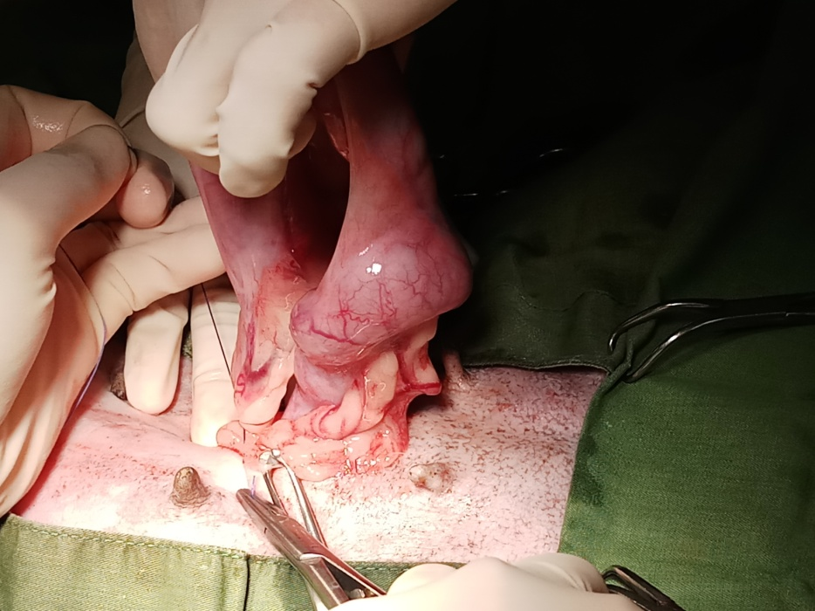
Figure 1.14: Ligature of the ovarian pedicle

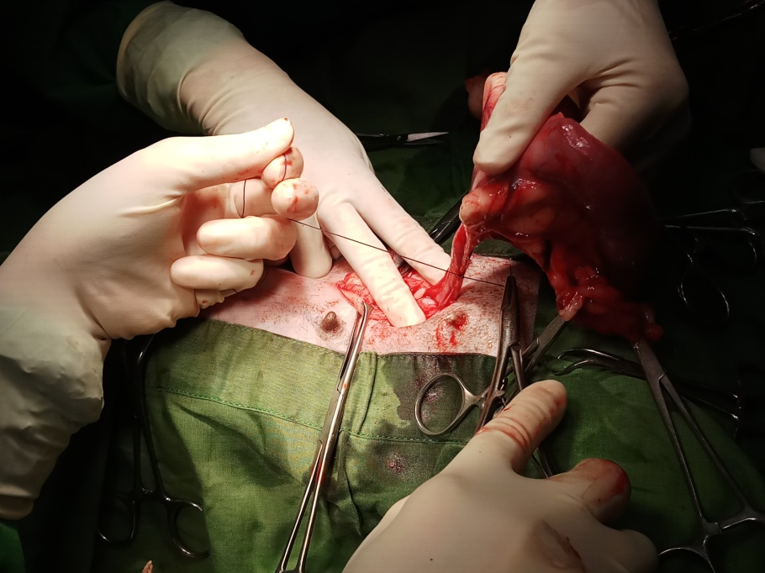
Figure 1.15: Ligature placed anterior to the cervix

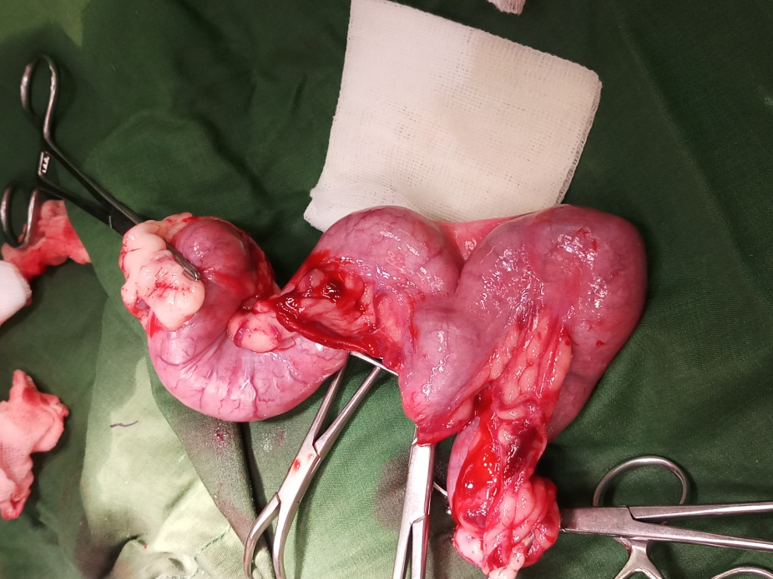
Figure 1.16: Removed pus filled uterus
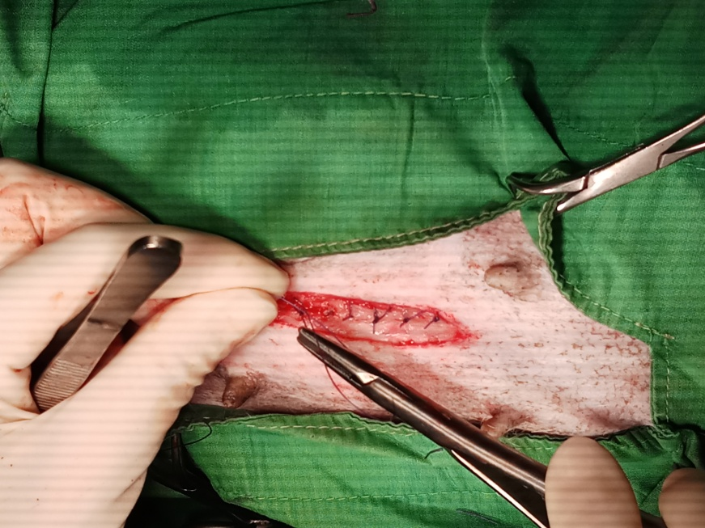
Figure 1.17: Muscle suture

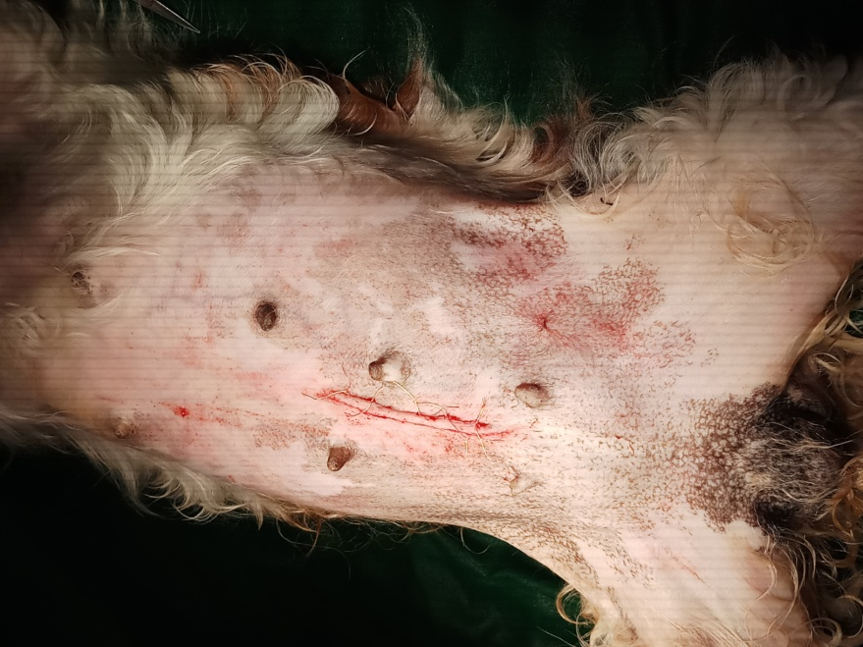
Figure 1.18: Skin suture.

Acknowledgements
The author wishes to acknowledge the immeasurable grace and profound kindness of Almighty “GOD” the supreme authority and supreme ruler of universe, who empowers the author to handle the cases and to complete the report successfully.
The author wishes to express his deep sense of gratitude and thanks to DR. Abdul Ahad. Professor and Head, Department of microbiology and Veterinary Public health, Faculty of Veterinary Medicine of Chittagong Veterinary and Animal Sciences University for his skillful supervision and guidance to make this report.
The autor would like to thank to the Director of External affairs, Professor. Dr. A.K.M. Saifuddin, Dept. of Physiology, Biochemistry and Pharmacology, Chittagong Veterinary and Animal Sciences University and Dr. Tuli Dey, Lecturer, Department of medicine and surgery for her guidance.
The author also grateful to the teachers of Madras Veterinary college, TANUVAS, Chennai, India and Teaching veterinary College, Khon Kaen university, Khon Kaen, Thailand for their cordial information and help at the time of handling the case.
Finally the author expresses thanks and warmest sense of gratitude to his parents and all well-wishers.

The author,
October, 2017.
Biography
Intern Doctor of Veterinary Medicine
Chittagong Veterinary and Animal Sciences University
E-mail: abhiovi@yahoo.com
Mobile: +8801816805221

Personal Profiles:
Name: Avijit Dhar
Father’s name: Anil Kumar Dhar
Mother’s name: Ratna Dhar
Permanent address: Vill: Dharmapur, Upazilla: Satkania
District: Chittagong.
Date of birth : 1st November 1993.
Nationality: Bangladeshi
Religion: Hindu
Blood group: B+

Academic Qualification:

Name of the Examination/  Course | Educational Institution | Educational Board | Year of passing | Grade
SSC | Bajalia High School | Chittagong | 2008 | 5.00(out of 5)
HSC | Govt City College College | Chittagong | 2010 | 5.00(out of 5)
DVM | Chittagong Veterinary and Animal Sciences University | CVASU | ----- | -------

My Goal:
Seeking a challenging position where I may utilize my qualifications, experience, skills meaningfully through disciplinary hard work. To build up myself as a competent, self-motivated, dynamic and successful person by implementing my educational and technical skills as well as to serve in the field of veterinary medicine with an emphasis on clinical practice, animal welfare, and infectious disease research for the greater development of Bangladesh.

