CASE REPORT ON TETANUS IN GOAT

…………………………
Signature of Supervisor
Professor Dr. Mohammad Mejbah Uddin
Department of Anatomy and Histology
Chittagong Veterinary and Animal Sciences University
Khulshi, Chittagong-4225, Bangladesh

…………………………
Signature of Author
Md Abdullah Al Mamun
Roll no : 11/35, Reg no:00584
Intern ID:G-61
Session:2010-2011
A Clinical Report of Submitted in partial satisfaction of the requirements for the degree
Of
Doctor of Veterinary Medicine
Faculty of Veterinary Medicine
Chittagong Veterinary and Animal Sciences University
Khulshi, Chittagong-4225, Bangladesh
November-2017

Table of contents

Abstract ……………………………………………………………………………………... 1

Case report on tetanus in goat ……………………………………………………………… 2-5
Limitations …………………………………………………………………………………... 5
Acknowledgement ………………………………………………………………………… 6
References ………………………………………………………………………................... 7
Biography ............................................................................................................................... 8

List of the figures

Fig 1: Deep wound caused by sharp old metallic rod .........................................................4
Fig 2: Froathy Salivation from mouth ................................................................................4
Fig 3: Bending neck …………………………………..……………………......................4
Fig 4: Wooden Horse Shape Standing Condition ................................................................4
List of tables
Table 1: Hematological Parameters analysis ..........................................................................3
Table 2: Biochemical Parameters analysis ..............................................................................3

Abstract
A 2-year-old female goat (weight-15kg) was referred to S. A. Qaderi Teaching Veterinary Hospital (SAQTVH), CVASU, Chittagong, Bangladesh with a 2 week history of deep wound caused by sharp object of iron made rod in hip region. On clinical examinations the goat showed frothy salivation, bending of neck, muscle stiffness, hyperesthesia and convulsions. Haematological and biochemical investigation were performed. On the basis of clinical and laboratory findings the goat was presumptively diagnosed that it was infected with tetanus. The treatment was combination of penicillin, tetanus antiserum, diazipum and normal saline. The goat was recovered after 7 days. Outcomes of the study will be useful for proper treatment of the disease.
Keywords: deep wound, goat, hyperesthesia, treatment, tetanus

Tetanus is a non contagious, non febrile infectious disease of mammals caused by exotoxin tetanospasmin produced by the vegetative stage of Clostridium tetani under anaerobic conditions. Almost all mammals are susceptible, although dogs and cats are relatively more resistant than any other domestic or laboratory mammal. Horses and lambs seem to be the most sensitive of all species. Tetanus occurs in all over the world and is most common in closely settled areas under intensive cultivation. In general, the occurrence of C tetani in the soil, especially in cultivated soil, and the incidence of tetanus in people, horses, and lambs is higher in the warmer parts of the various continents. It occurs in farm animals as individual or sporadic cases but outbreaks are common following wounding management procedures. Although recovery rate is very less in goats and the case fatality rate may be as high as 80% in young ruminants (Radostitt et al.,2000). The sharp old metal injury that causes deep wound is a common factor for being infected by tetanus. Another common factors of neonatal tetanus occurring due to unsanitary management of umbilical cord during parturition (Suleman,1982) and castration without preventive measures.

The objective of the present study was aimed to report a clinical case on tetanus in goat by traumatic wound and its presumptive diagnosis, treatment strategy.
A 2-years-old crossbreed female goat was deeply wounded by a sharp metallic object in thigh muscle (Figure 1) before 15days ago of coming to the hospital. Initially it was treated by local veterinarians when it was injured by pain killer and antibiotic. Now it shows muscle stiffness, rigid body, bending of neck (Figure 3), froathy salivation from mouth (Figure 2), inability to feed, hyperthermia(104’F), drooling of saliva, stiffness of all limbs, shows “sawhorse” or “wooden horse” shape (Figure 4), unable to stand and walk, the jaw was completely locked (locked jaw) and difficult to open, opisthotonus markedly, no prolapse of the third eyelid and stiffed tail. The wound is not properly healed.
Findings of hematological investigation were shown in table 1. The biochemical investigation of blood serum was shown in table 2. The calcium value is 9.8 mg/dl, Magnesium is 2.2 mg/dl, potassium is 6.3 mg/dl, Phosphorus is 5.6 mg/dl, Glucose is 70 mg/dl.

Table 1: Hematological Parameters analysis
Name of The Test | Result | Reference Value
Haemoglobin (mg/dl) | 9.8 | 10-15
Total count of RBC (million/cumm) | 10.3 | 10-12
Total count of WBC (Thousand/ cumm) | 8.4 | 7-10
PCV (%) | 28 | 26-50
Differential count of WBC
Lymphocytes (%) | 42 | 30-50
Neutrophils (%) | 34 | 25-60
Eosinophils (%) | 2.4 | 2-8
Monocytes (%) | 2 | 1-5
Basophils (%) | 0 | 0-3

Table 2: Biochemical Parameters analysis
Name of The Test | Result | Reference Value
Total Protein (g/L) | 74 | 60-90
Glucose (mg/dl) | 64.32 | 50-80
Blood Urea Nitrogen (mg/dl) | 6 | 5-12
Creatinine (mg/dl) | 1.8 | 1.5-2.5
Aspertate Amino Transferase (u/l) | 320 | 226-336
Alanine Amino Transferase (u/l) | 12.4 | 3-23
Calcium(mg/dl) | 9.8 | 7-15
Magnesium(mg/dl) | 2.2 | 1-4
Phosphorus (mg/dl) | 5.6 | 4-12
Potassium(mg/dl) | 6.3 | 5-10

Due to deep wound caused by old metallic object the organism invade the wound and get favorable anaerobic condition. After completing incubation period (10-14 days), the organism produces tetanospasmin which acts upon the muscle and is responsible for spasm which is a classical sign of the disease (Safarov et al.,1972). Locked jaw, erected ears and constipation are due to the spasm of related muscle. The various clinical signs observed in this case are almost similar to those reported in a cross breed goat. Penicillin being drug of choice helped in the elimination of causative bacteria. Antitoxin neutralizes he toxins. The wound should clean and administration of antitoxin locally. Maintenance of hydration and nutrition is necessary particularly in cases where the animal is unable to eat due to locked jaw. Diazepam is given for muscle relaxation.

Soon after diagnosis, the treatment was initiated as per the principles –The elimination of causative bacteria, neutralization of residual toxin, control of muscle spasm, maintenance of hydration and nutrition. The goat was injected with pronapen vet (penicillin) at 40000IU/kg body weight i/m ly along with 500ml of injection normal saline solution (NSS). Injection Diazepam was given 0.4mg/kg body weight intra muscularly. Tetanus antiserum was administered 1000IU i/v
Figure-1 : Deep wound
Figure-2 : Froathy salivation from mouth
Figure-4 : Wooden horse shape
Figure-3 : Bending of neck
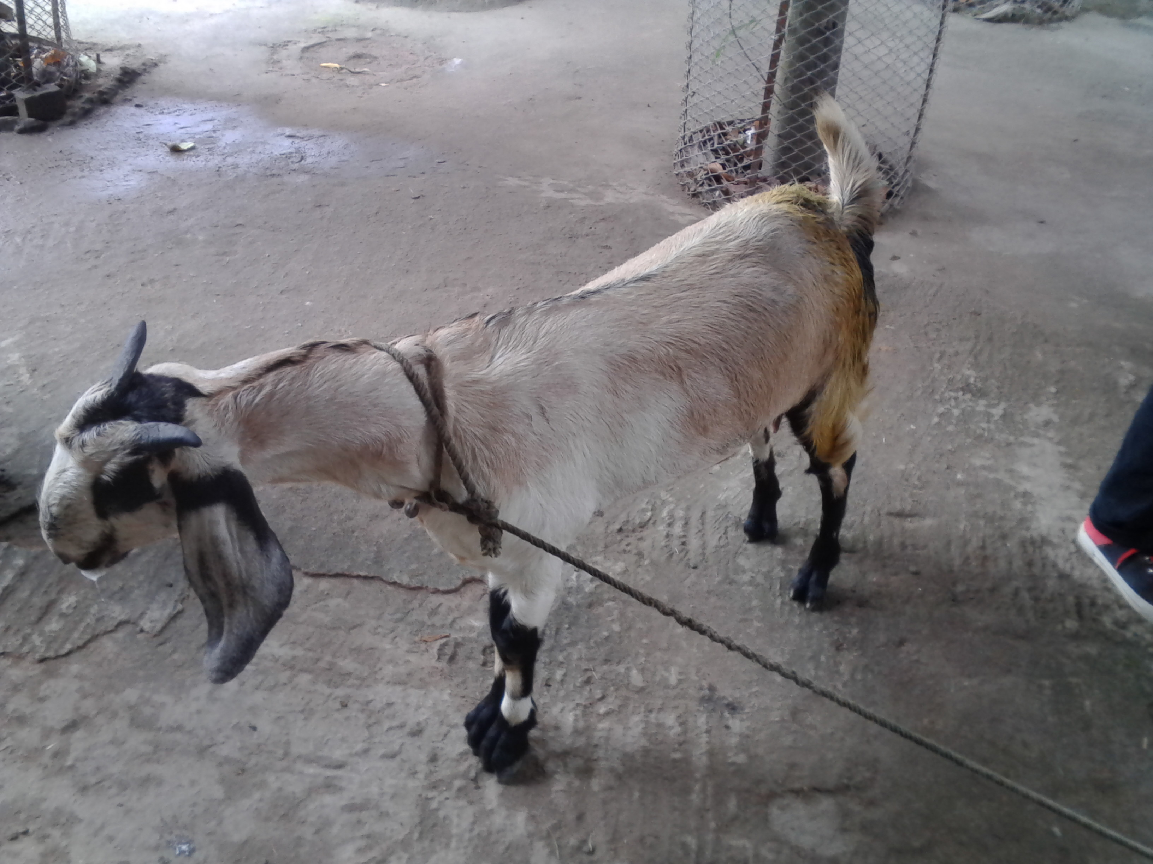
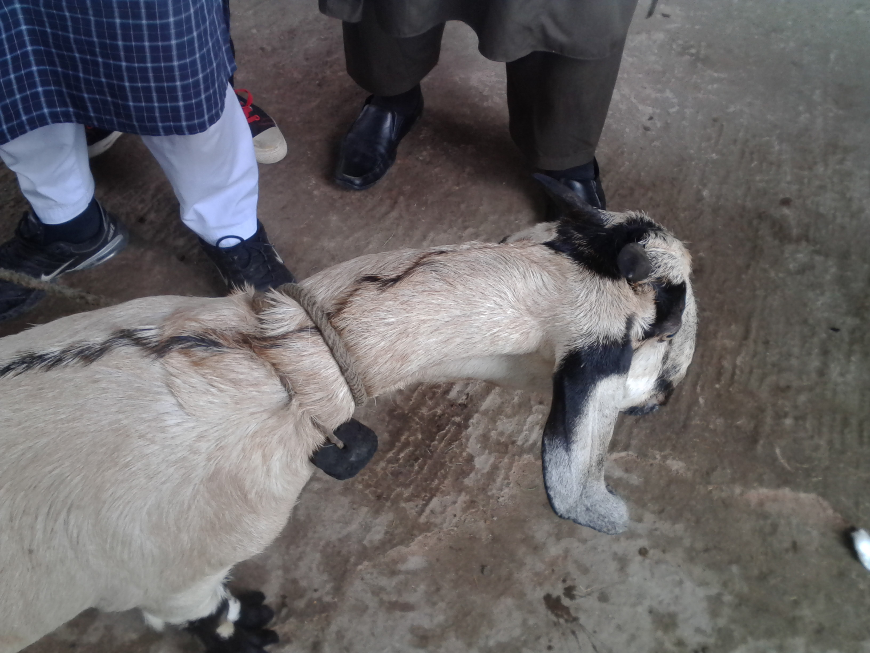
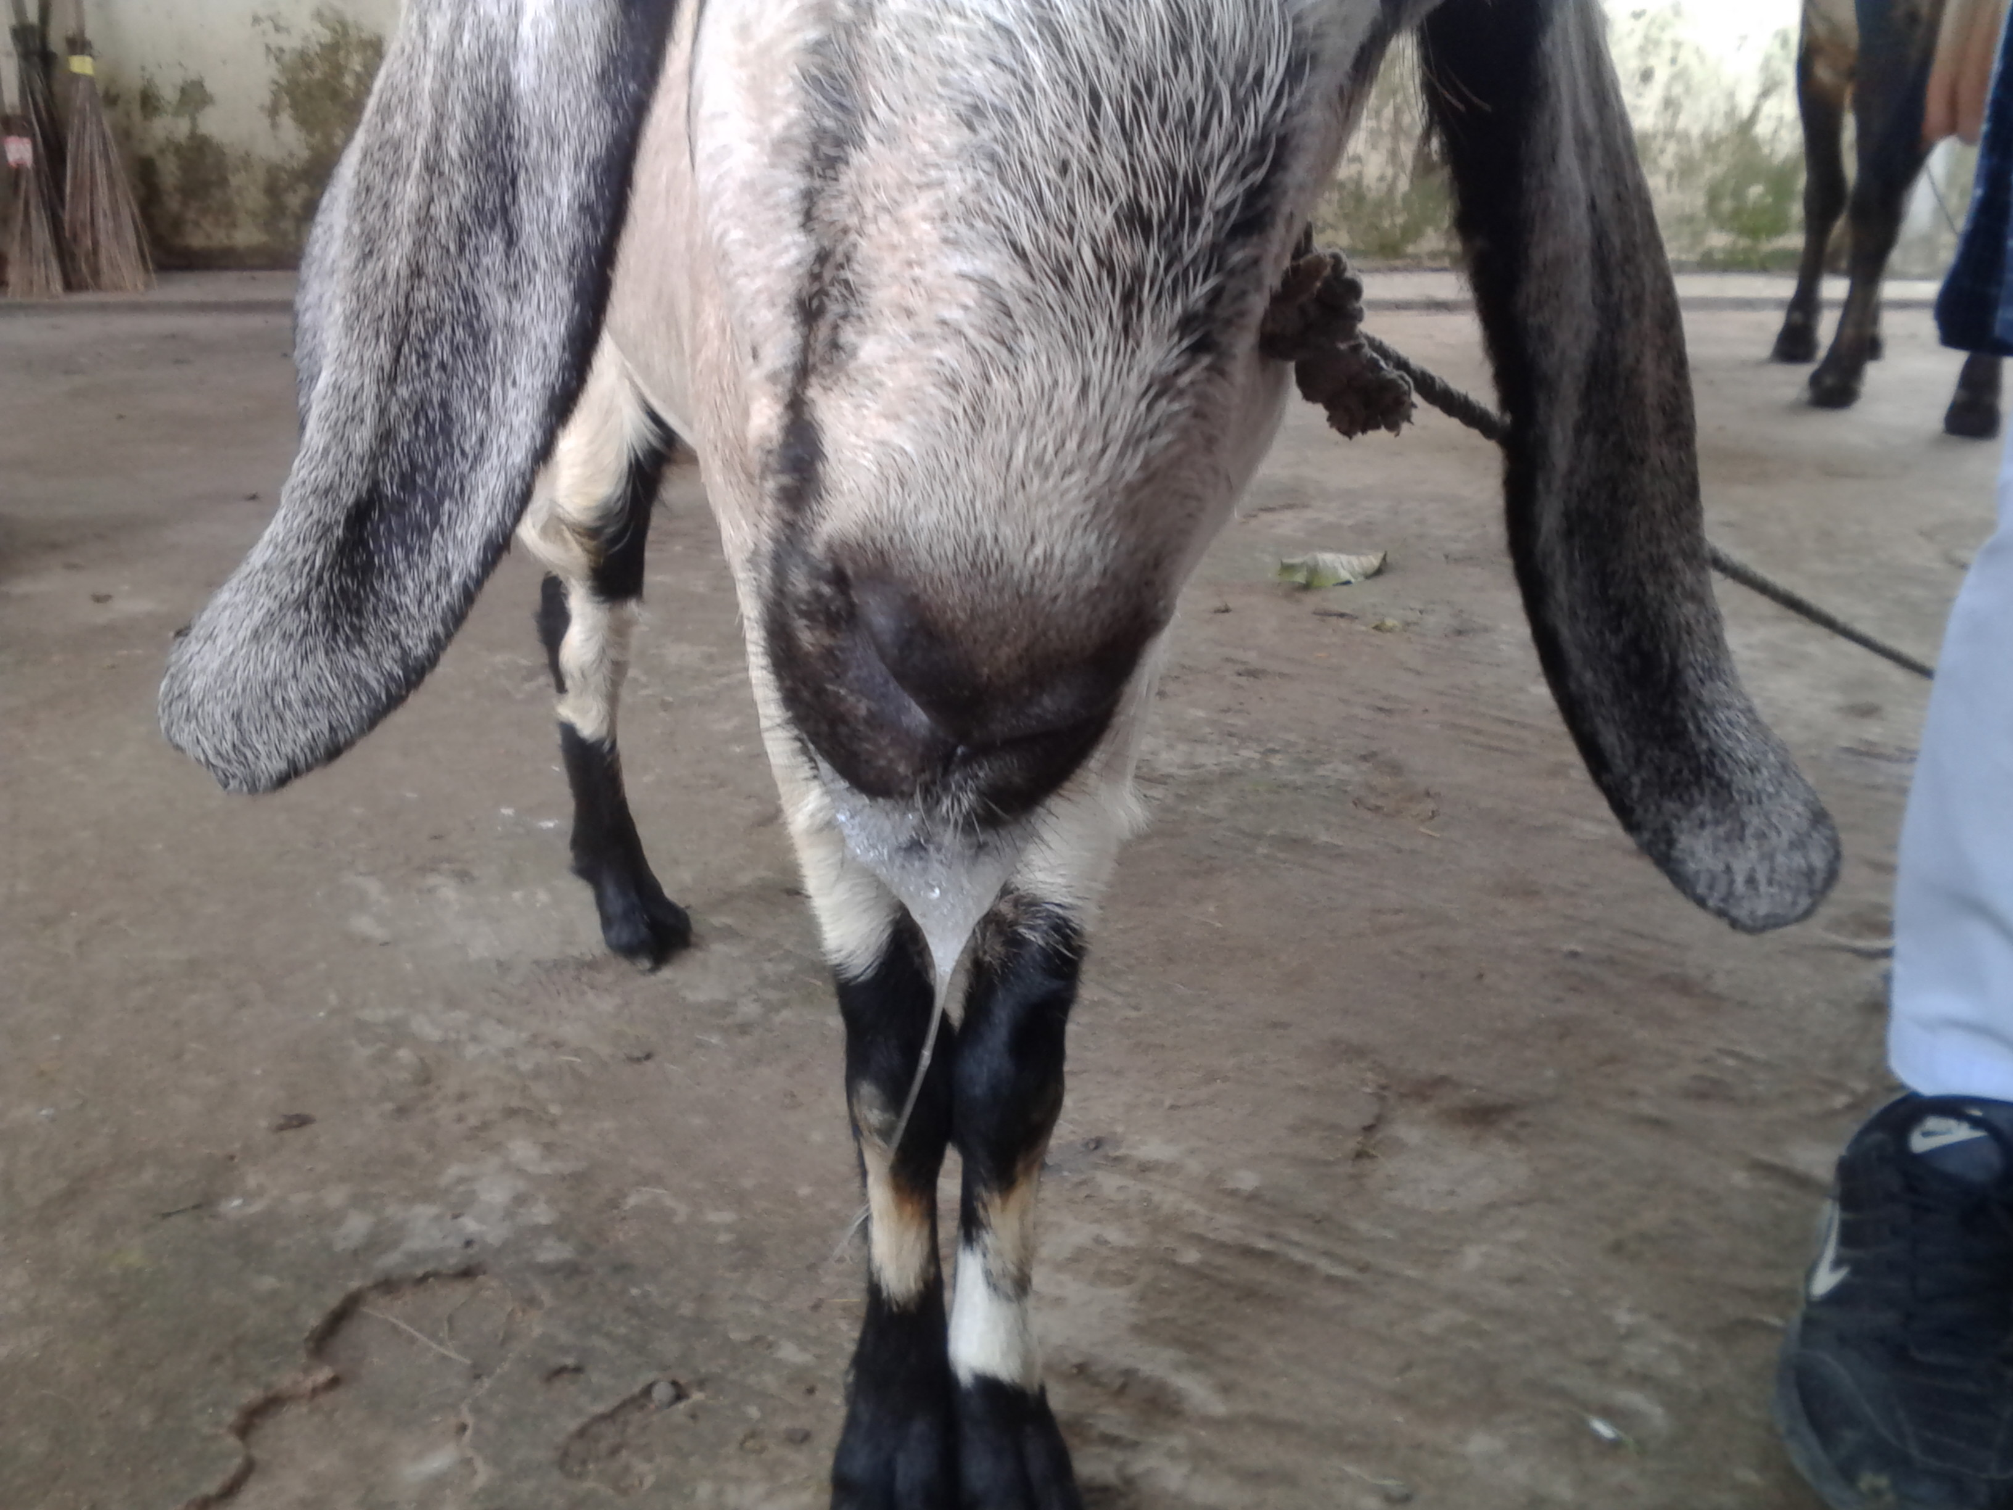
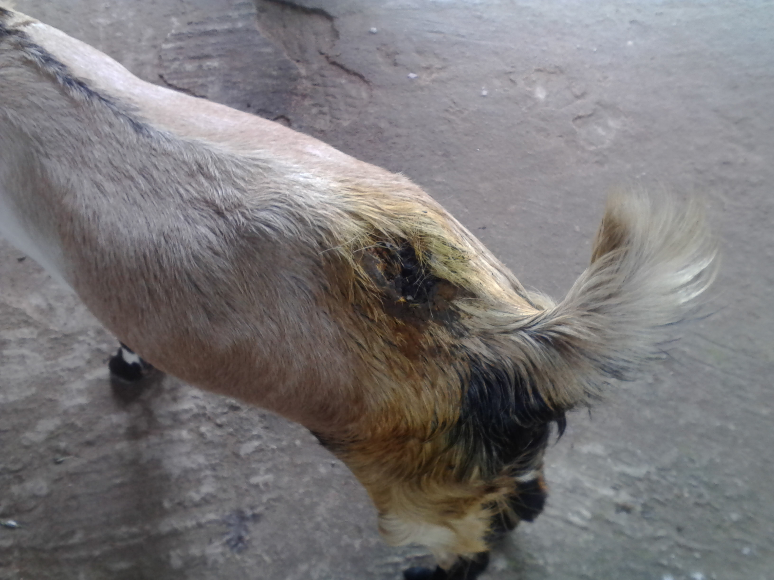
When the goat had come to the hospital I had observed the clinical examinations (rectal temperature, respiration rate, heart rate etc). The rectal temperature is 104F, the respiration rate is 30/min, heart rate is 75/min. Then I had observed the clinical signs and symptoms. The froathy salivation from mouth, bending of neck, inability to feed, drooling of saliva, stiffness of all limbs, shaking of body. Then I had proceeded to laboratory diagnosis like as haematological (table-1) and biochemical (table-2) test of blood. All of the test and examinations cleared that it was tetanus infection (Safarov et al.,1972), (U. Wernery et al.,2004).
In case of young animal, case fatality is higher than old animal (Radostitt et al.,2000). The later stage of infection, most of the animal are not recovered but at early stage can recovered very few cases (Gary Pfalzbot et al,.2000).
In this case, goat was recovered satisfactorily by following the line of treatment for 10days. It could be possible due to intensive care of treatment and the early stage of infection.

Limitations
The organism and toxin were not isolated due to insufficient laboratory facilitiesConclusion
Most of the cases of tetanus infection are fatal though recovery is possible if taking proper clinical management during early stage of the disease.

Acknowledgements
The author wishes to acknowledge the immeasurable grace and profound kindness of Almighty “ALLAH” the supreme authority and supreme ruler of universe, who empowers the author to complete the work successfully.
The author feels proud in expressing his deep sense of great gratitude and indebtedness to respected teacher and tutor Dr. Mohammad Mejbah Uddin, Professor, Department of Anatomy and Histology, Faculty of Veterinary Medicine, Chittagong Veterinary and Animal Sciences University for his trustworthy and scholastic supervision.
The author also would like to expense deepest sense of respect and appreciation to DR. Mizanur Rahman, MS student, Department of Medicine and Surgery for his intimate co-operation.
The author also feels grateful to Director, External affairs, CVASU for his kind support in this regard.

Reference
Addas PA, Midau A, Babale DM, 2010. Haemato-biochemical findings of Indigenous Goats in Mubi Adamawa State, Nigeria. J. Agric Soc Sci., 6: 14-16.
Bhikane AU and Kulkarni DD, 1998. Tetanus in a Cross Bred Calf and it’s Clinical Management. Indian Vet. J., 75: 243-244.
Bishnu C P, 2016. Evaluation of Hematological and Biochemical Parameters of Goats of Central Odisha Environment fed on Natural Grazing land of Odisha, India. The Tharma Innovation Journal 5(5): 83-90.
Dumas BT, 1971. Instruction Leaflet for Serum Protein. Clinical Chem., 31: 87-96.
Radostis OM,.Gay CC, Blood DC and Hinchcliff KW, 2000. Veterinary Medicine: A text book of the Diseases of Cattle, Ship, Pigs, Goats and Horses, 9th ed.W.B.Saunders Co. Ltd., London, UK. 1358-1362.
Upadhyay SR, Kafil H and Rajib S, 2013. Bovine Neonatal Tetanus- A Case Report. Buffalo Bulletin 32: 25-30.
Safarov YB,. Mamedov TA, Rustoma NM and Mamedov M, 1972. Tetanus in buffalo. Veterinaiya Moscow., 4: 45-46.
Stouder WC, 1973. An Economical Approach to Treatment of Bovine Tetanus.Vet.Med.Sm.Anim.Clin., 68: 523-524.

Biography
This is Md. Abdullah Al Mamun from Birganj, Dinajpur. He completed his Secondary School Certificate (SSC) examination in 2007 with GPA-5.00 from Golapganj High school, Birganj,Dinajpur and Higher Secondary Certificate (HSC) examination in 2009 with GPA 5.00 from Syedpur Cantonment Public School and College,Nilphamari. Currently he has been doing his internship program which is the compulsory of DVM degree under the Faculty of Veterinary Medicine, Chittagong Veterinary and Animal Sciences University . His favorite hoppy is reading newspaper and doing social work. He feels massive interest in the livestock farm management and commercial poultry farm.

