Waste Management of Poultry in relation to public health in Burichang Upazila, Cumilla

By:

Shishir Chandra Das
Roll: 15/32
Reg. No: 01447
Intern ID: 30
Session: 2014-2015

A Production Report submitted in partial satisfaction of the requirements for the Degree of Doctor of Veterinary Medicine (DVM)

Faculty of Veterinary Medicine
Chattogram Veterinary and Animal Sciences University
Khulshi, Chattogram-4225, Bangladesh

Waste Management of Poultry in relation to public health in Burichang Upazila, Cumilla

Approved By:

_____________________________
Ms. Shahnaz Sultana
Professor,
Department of Agricultural Economics & Social Sciences,
Faculty of Veterinary Medicine,
Chattogram Veterinary and Animal Sciences University
Khulshi, Chattogram-4225, Bangladesh

Table of contents

Content | page
List of tables………………………………………………………………...... | 01
List of figures………………………………………………………………… | 01
List of abbreviations………………………………………………………… | 02
Abstract………………………………………………………………………. | 03
Chapter 1: Introduction…………………………………………………...... | 04-05
Chapter 2: Materials and Methods………………………………………… | 06-07
Study area…………………………………………………………. | 06
Study period ……………………………………………………… | 06
Study population …………………………………………………. | 06
Questionnaire and data collection………………………………… | 06
Statistical evaluation……………………………………………… | 06
Figures…………………………………………………………….. | 07
Chapter 3: Results…………………………………………………………… | 08-10
Chapter 4: Discussion……………………………………………………….. | 11-12
Chapter 5: Limitations…..………………………………………………….. | 13
Chapter 6: Conclusion ...……………………………………………………. | 14
References……………………………………………………………………. | 15-16
Acknowledgement…………………………………………………………… | 17

List of Tables
Table No. | Table Title | Page no
1. | Farmers demographic characteristics of Burichang, Cumilla | 08
2. | Farm characteristics of Burichang, Cumilla | 09
3. | Bio-security of farms, Burichang, Cumilla | 09
4. | Public health concern of farms, Burichang, Cumilla | 10

List of Figures
Figure No. | Figure name | Page No.
1. | Data collection at broiler farm | 07
2. | Cage rearing of layer
3. | Broiler shed near pond
4. | Long tree and other unwanted establishment near poultry shed
5. | Using poultry wastes as fish feed
6. | Using poultry wastes as fertilizer

List of Abbreviations

DLS- Department of Livestock Services
DVM- Doctor of Veterinary Medicine
SSC- Secondary School Certificate
HSC- Higher Secondary School Certificate
B- Boron
C- Carbon
Ca- Calcium
Cu- Copper
Fe- Iron
IBD- Infectious bursal disease
K- Potassium
Mo- Molybdenum
Mn- Manganese
Mg- Magnesium
N- Nitrogen
ND- Newcastle Disease
NH3 – Ammonia
P- Phosphorus
S- Sulfur
Zn- Zinc

Abstract
The study was conducted to determine the present condition of waste and bio-security management of poultry farms in relation to public health located in Burichang Upazila, Cumilla. The study was conducted from 13th October to 12th December and the study area was consisting of three villages (Haripur, Jogotpur and purnoboti). A total of 22 farms were considered for this study. From each farm, the data was collected individually from the farm owners by using a well designed questionnaire. From the study, we see that 85% of the farm owners were male and most of them were educated. The ratio of broiler and layer farm was (72.73:27.27) %. Different types of litter materials were used in these farms and most commonly used litter material was rice husk (82.81%). 77.27% farms had long trees and 22.73% farms had bushes surrounding them. As sanitizers and disinfectants different types of components (water, calcium hydroxide, and potassium permanganate) were used individually or combined; the combination of potassium permanganate and water (54.51%) was mostly used. The litter materials were used for different purposes and 86.36% users were satisfied with the result the achieved after using those litter materials. About 95.7% farms had no foot bath facility. Dead birds (68.18%) and spoiled eggs (81.82%) were thrown into the water or surroundings. About 86.36% farms cause water pollution. 22.73% farms cause noise, 13.64% farms cause bad smell and 63.63% farms cause both noise and smell. Overall, the waste and bio-security management facilities were not sufficient. They need to be improved soon; otherwise it could be major concern for public health. With lack of training facilities, it was always bound to happen. The Government need to take necessary initiatives to increase the training facilities and awareness campaigns and the farmers should also be conscious about proper waste disposal, farm bio-security and public health.

Keywords: Poultry, Waste Management, Bio-Security and Public Health
Chapter 1: Introduction
In Bangladesh, more than half of the people are based on agricultural and livestock farming. The poultry sector is an integral part of farming systems and has created both direct and indirect employment opportunity, improved food security and enhanced supply of quality protein to people’s meals, contributing country’s economic growth and reducing poverty level in rural and urban areas of Bangladesh. The present meat and egg production can meet only 68 and 64% of the national demand. The demand for meat, egg and meat and egg products have been expanding dramatically with income growth, population growth, urbanization and dietary changes. (M.A. Hamid, M. A. Rahman, S. Ahmed and K.M. Hossain, 2017. Status of Poultry Industry in Bangladesh and the Role of Private Sector for its Development. Asian Journal of Poultry Science, 11: 1-13).

With the growing trends of intensive poultry farming, concerns regarding environmental pollution and public health issues posing significant challenge on the prospects of poultry industry. Poor litter and bio-security management increase the occurrence of different diseases like- Salmonellosis, colibasilosis, mycoplasmosis, fowl cholera, infectious bursal disease (IBD), Newcastle disease (ND), etc. Besides, improper management of poultry wastes has been shown to contribute in contamination of surface waters and nitric oxide pollution of ground waters. Because, the manures, litters, composts, and wastewaters originating from poultry production operations are normally used in large-scale land application programs and are rarely concentrated enough to be considered a point source of nitrogen and phosphorus (Liebhardt et al., 1979; Ritter and Chirnside, 1987; Magette et al., 1989; Weil et al., 1990; Edwards and Daniel, 1992). Some exceptions exist, such as manure storage areas, the direct discharge of wastewaters from poultry processing plants into streams or rivers, and the disposal of large quantities of dead poultry in landfills due to a major disease outbreak. Excessive richness of nutrients from poultry litter in water causes accelerated growth of algae or water plants, depletion of dissolved oxygen, increased turbidity, and a general degradation of water quality (Liebhardt et al., 1979; Ritter and Chirnside, 1987; Magette et al., 1989; Weil et al., 1990; Edwards and Daniel, 1992).

Poultry wastes contain all essential plant nutrients (C, N, P, K, S, Ca, Mg, B, Cu, Fe, Mn, Mo, and Zn) and have been well-documented to be excellent fertilizers (Hileman, 1967; Sommers and Sutton, 1980; Stephenson et al., 1990; Simpson, 1991; Edwards and Daniel, 1992). Therefore, poultry wastes could be a better option to fertilizer and biogas production. Broiler litter is a mixture of manure, bedding material, wasted feed, feathers and in some cases soil (Jacob et al., 1997). While on the other hand, litter from cased layer includes all above-mentioned items except bedding and casing material. These wastes can be used successfully for crop production, but require soil testing, crop nutrient requirement, nutrient value of manures and proper storage and application. Moreover, poultry litter can also be used as feed ingredient for cattle and as fuel in powerhouse (DLS, 2000).
There is no existing protocol or guideline available in Bangladesh about proper waste management and bio-security of poultry farms or how it can impact on public health. Hence, the study was undertaken to evaluate the present condition of waste management and bio-security of poultry farms and also public health concerns related to them.

Study Objectives:
- To learn about the waste management facilities available in certain locations.
- To know about the bio-security practices in different poultry farms.
- To understand how waste management and farm biosecurity impacts public health.

Chapter 2: Materials and Method
2.1 Study area:
The study was conducted in three villages (Haripur, Jogotpur and purnoboti) of Burichang upazila, Cumilla. The study area was selected based on the information provided by the local people on the availability of poultry farms (Broiler and Layer).
2.2 Study period:
The study was conducted during the placement of Upazila Veterinary Hospital (UVH). Farm visits and data collection was done during this period (13th October to 12th December).
2.3 Study population
A total of 22 farms were considered for this study (both broiler and layer farms combined). The total number of poultry was 11290. The number of broilers and layers are 7100 and 4190 respectively.
2.4 Questionnaire and Data collection:
A well designed questionnaire was developed to collect information from the farmers about their farm. Farmer’s information includes- name, age, educational status, economical status, and mobile number. Farms information include- type of farm, type and number of poultry, number of sheds, type of housing, type and duration of litter, management of dead birds, litter and rotten eggs, type of sanitizers and disinfectants used. Bio-security related information like- foot bath or any unwanted establishment near shed was collected. Information about public health concern and water pollution surrounding farm was also collected.
2.5 Statistical evaluation:
The collected data were put into the MS Excel 2013 and then exported to STATA-14SE for statistical analysis. The results were expressed in frequency numbers and percentage.

Figures

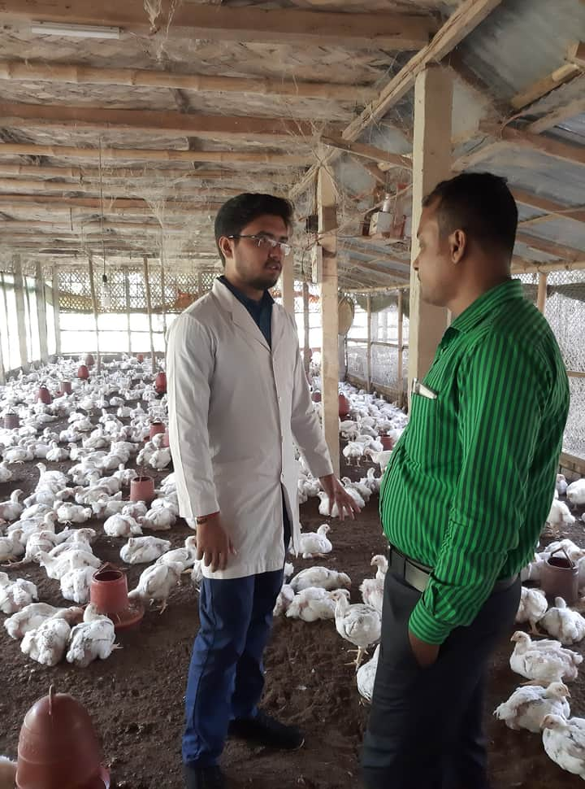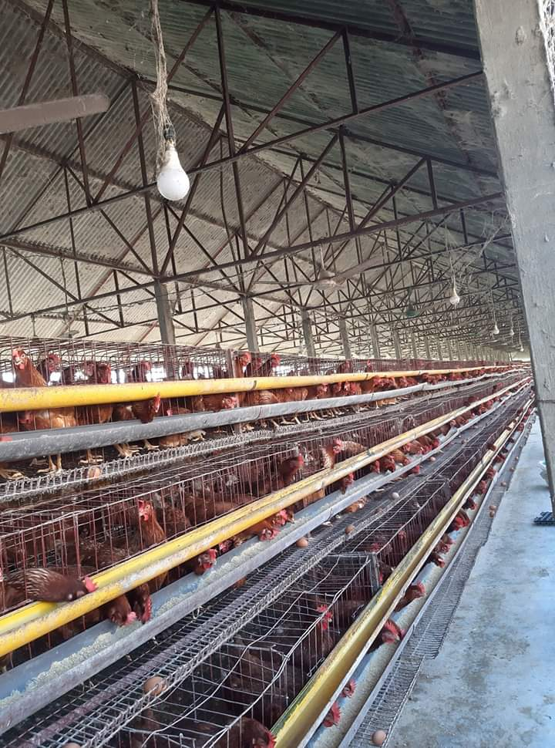
Fig 1: Data collection at broiler farm
Fig 2: Cage rearing of layer

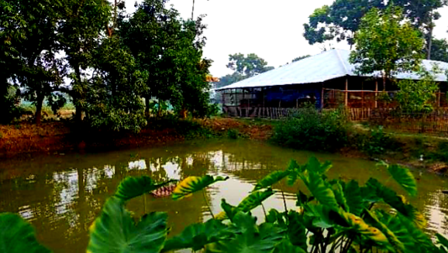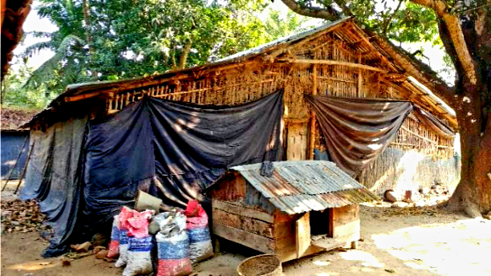
Fig 4: Long tree and other unwanted establishment near poultry shed
Fig 3: Broiler shed near pond

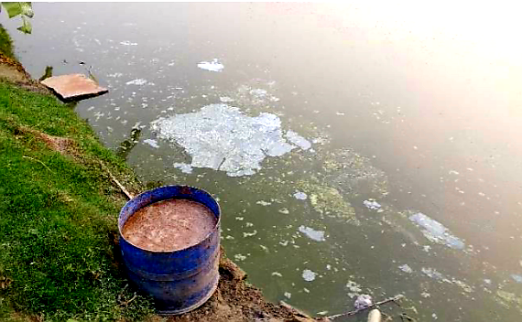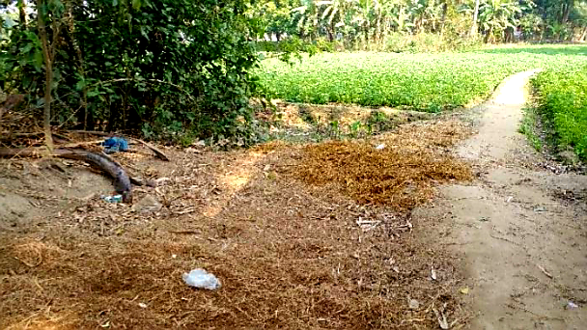
Fig 6: Using poultry wastes as fertilizer
Fig 5: Using poultry wastes as fish feed

Chapter 3: Results
The study was conducted visiting 22 farms (broiler and layer combined) and the collected data was analyzed to determine the present status of waste management facilities available in certain locations of Bangladesh (Burichang, Cumilla) and to know about the farm bio-securities and public health concerns surrounding these farms. All the results are provided in detail in the following tables (1-4).

3.1 Farmers demographic Characteristics
Table-1 shows that most of the farm owners in Burichang Upazila, Cumilla are male (85%) and the proportion of educated person (70%) is higher than un-educated persons (30). It also indicates that young persons (25-35 years) are way behind in number (35%) when compared to older persons (65%) in poultry farming.
Table 1: Farmers demographic characteristics of Burichang, Cumilla (N=20)
Factor | Category | Number(N) | Percentage (%)
Gender | Male | 17 | 85
 | Female | 03 | 15
Educational Status | Educated | 14 | 70
 | Un-educated | 06 | 30
Age | 25-35 years | 07 | 35
 | 36-55 years | 13 | 65

3.2 Farm Characteristics
Table 2 shows that the numbers of broiler farms (72.73%) are significantly higher compared to layer farms (27.27%) in the study area. Hence, the number of cage rearing (22.73%) shows much lower when compared to other rearing systems. The most common litter materials used in the study area is rice husk (81.81%).

Table 2: Farm characteristics of Burichang, Cumilla (N=22)
Factor | Category | Number (N) | Percentage (%)
Type of Poultry | Broiler | 16 | 72.73
 | Layer | 06 | 27.27
Type of rearing system | Cage | 05 | 22.73
 | Floor | 17 | 77.27
Type of litter materials | No | 01 | 04.55
 | Straw | 03 | 13.64
 | Rice husk | 18 | 81.81

3.3Bio-security of farm

Table-3 shows that 77.27% farms had long trees surrounding them and 22.73% farms had open spaces around them. It also shows that more than half the farms in the study area had bushes around them (54.55%). The kind of sanitizers and disinfectants used in these farms also shows a lot of variety. In 13.67% farms only water is used whereas the mixture of Calcium hydroxide, potassium permanganate, water is used in 31.82% farms and Potassium permanganate, water is used in 54.51% farms as sanitizers and disinfectants. The used litter materials are used by the farm owners or sold to local customers for different purposes and most of them had given a very satisfied feedback (86.36%) and few of them were not satisfied (13.64%).
Table 3: Bio-security of farms, Burichang, Cumilla (N=22)
Factor | Category | Number  (N) | Percentage (%)
Long tree | Yes | 17 | 77.27
 | No | 05 | 22.73
Bush | Yes | 12 | 54.55
 | No | 09 | 45.45
Type of sanitizers and disinfectants | Only water | 03 | 13.67
 | Calcium hydroxide, potassium permanganate, water | 07 | 31.82
 | Potassium permanganate, water | 12 | 54.51
Feedback after using litter | Satisfied | 19 | 86.36
 | Not satisfied | 03 | 13.64

3.4 Public health concern
Table-4 shows that the management of dead bird and spoiled eggs, water pollution and public health concern varies from farm to farm. In 18.18% farms the dead birds are buried and in 68.18%, 04.55% and 09.09% farms the dead birds are thrown up, used for bio-gas and fed to cat fish respectively. Management of spoiled eggs is also the same. They are buried (13.67%), thrown up (81.82%), or used with litter (04.51%). 86.36% farms cause water pollution. 22.73% farms cause noise, 13.64% cause bad smell and 63.63% farms cause both noise and smell.
Table 4: Public health concern of farms, Burichang, Cumilla (N=22)
Factor | Category | Number(N) | Percentage (%)
Management of dead birds | Bury | 04 | 18.18
 | Throw up | 15 | 68.18
 | Bio gas | 01 | 04.55
 | Cat fish | 02 | 9.09
Management of spoiled eggs | Bury | 03 | 13.67
 | Throw up | 18 | 81.82
 | Bio gas | 0 | 0
 | With litter | 01 | 4.51
Water pollution | Yes | 19 | 86.36
 | No | 03 | 13.64
Public health concern | Noise | 5 | 22.73
 | Smell | 3 | 13.64
 | Noise and smell | 14 | 63.63

Chapter 4: Discussion
From the study, it is observed that most of the farms are owned and operated by males. Although most of the farm owners are educated, the number of uneducated farm owner is not negligible. It means that now people are showing more interest in poultry farming than ever before. But they don’t get sufficient training on different aspects of poultry farming, like- rearing system, waste management, bio-security and public health. The number of younger farm owner is lesser than the older ones.
The study shows that most people of prefer broiler farming to layer farming because they wish to profit quickly. In the layer farms, majority of them have cage rearing facility. Rice husk is used as the most preferred litter material; other than this, they also use rice husk.
The study also shows that most of the farms are surrounded by long trees which provide shade to the poultry shed and the birds feel more comfortable there. More than half the farms have bushes around them which can cause many unpleasant scenarios like- snake hiding, rodents’ availability or any undesirable growth of tree.
The type of sanitizers and disinfectants used in those farms vary from each other. Many farms use mixture of calcium hydroxide, potassium permanganate and water; some farms use only water. Most of the farms seem to prefer the combination of potassium permanganate and water. But they are not used on a regular basis. Bio-security is not maintained properly. It introduces many pathogenic microorganisms to the farm which causes many diseases in the long run.
The farm owners use the old litter materials for different purposes or sell them to local customers. Poultry waste contains a huge amount of nitrogenous substance (Jackob et al., 1997), which enhances the plant growth and the growth of phytoplankton and zooplankton in the pond, which are the basic feed for fish. Most of the farm owners were satisfied about using litter as fish feed or biogas but some of them were not satisfied as using poultry litter as fish feed or fertilizer.
Most of the farmers did not maintained proper bios-security around farm. They prefer tighten house designs. This can moisture, relative humidity levels, nitrogen content in the litter. These conditions have the potential to increase the NH3 concentrations in poultry houses. Ammonia can have detrimental effects on poultry production performance, animal health and welfare, and on the environment. Bird performance and health can be affected by both respiratory disease challenge and physical damage due to high NH3 concentration (Ritz et al., 2004).

Disposal of litters, dead birds and spoiled eggs are poorly performed. In most farms, they just throw the waste materials of infected flocks or too old litters into the ponds, rivers, which cause water pollution. Contamination of groundwater and surface water with pathogenic microorganisms is frequently observed. Fecal coliform and Escherichia coli are generally used as indicators of pathogens in water sources (Edberg et al., 2000).

Most of the farms are close to houses or roadside, they are a major concern for public health. These farms not only produce sound and bad smell but also can be a great headache as it possesses a great threat of zoonotic diseases. Acute noise originating from the farms do not cause permanent health problems; however, effects of long-term noise exposure can increase the risk of physical damage and mental stress (Ising and Kruppa, 2004).

Chapter 5: Conclusion
Poultry industry is a very large and promising sector in our country and it continues to grow day-by-day. Now-a-days, more people are getting involved in poultry farming. But it’s an irony that there are very little training facilities available for them. So, they are not getting optimum production as they should have. They know very little about the proper ways of waste disposal, farm bio-security and public health which can be a matter of concern in the near future and can pose a big threat. Government should take necessary initiatives for providing them with the required training opportunities. Modern technologies (e.g., biogas plant) need to be introduced in converting the litters and other waste materials into productive and profitable outcomes. Awareness needs to be raised among the farm owners and they should also be more careful about waste management, farm bio-security and public health.

Chapter 6: Limitations
- Only a few farms were considered for the study.
- Most of the farm owners tried to hide the truth about litter and waste management, bio-security and public health.
- Some of the farm owners didn’t allow entering the poultry shed.
- Some of the farm owners didn’t allow taking pictures inside the poultry shed.
- Many farm owners didn’t want their farm to be a part of their study.

References

- M. A. Hamid, M. A. Rahman, S. Ahmed and K.M. Hossain, 2017. Status of Poultry Industry in Bangladesh and the Role of Private Sector for its Development. (Asian Journal of Poultry Science, 11: 1-13)

Edwards, D. R., & Daniel, T. C. (1992). Environmental impacts of on-farm poultry waste disposal—A review. Bioresource Technology, 41(1), 9-33.

- Hileman, L. H. (1967). Fertilizer value of broiler litter.

- Ising, H., & Kruppa, B. (2004). Health effects caused by noise: evidence in the literature from the past 25 years. Noise and Health, 6(22), 5.

- Jacob, J. P., Kunkle, W. E., Tervola, R. S., Miles, R. D., & Mather, F. B. (1997). Broiler litter, Part 1: A feed ingredient for ruminants. Florida Cooperative extension service, Institute of feed and Agricultural Sciences, University of Floride, USA.

- Liebhardt, W. C., Golt, C., & Tupin, J. (1979). Nitrate and Ammonium Concentrations of Ground Water Resulting from Poultry Manure Applications 1. Journal of Environmental Quality, 8(2), 211-215.

- Magette, W. L., Weismiller, R. A., Angle, J. S., & Brinsfield, R. B. (1989). A nitrate groundwater standard for the 1990 farm bill. Journal of soil and water conservation, 44(5), 491-494.

- Sommers, L. E., & Sutton, A. L. (1980). Use of waste materials as sources of phosphorus. Use of waste materials as sources of phosphorus, 515-544.

- Stephenson, A. H., McCaskey, T. A., & Ruffin, B. G. (1990). A survey of broiler litter composition and potential value as a nutrient resource. Biological wastes, 34(1), 1-9.

- White, J. W., Holben, F. J., & Richer, A. C. (1944). Production, composition and value of poultry manure.

- Simpson, T. W. (1991). Agronomic use of poultry industry waste. Poultry Science, 70(5), 1126-1131.

- Sims, J. T. (1987). Agronomic Evaluation of Poultry Manure as a Nitrogen Source for Conventional and No-Tillage Corn 1. Agronomy Journal, 79(3), 563-570.

- Ritz, C. W., Fairchild, B. D., & Lacy, M. P. (2004). Implications of ammonia production and emissions from commercial poultry facilities: A review. Journal of applied poultry research, 13(4), 684-692.

- Edberg, S. C. L., Rice, E. W., Karlin, R. J., & Allen, M. J. (2000). Escherichia coli: the best biological drinking water indicator for public health protection. Journal of applied microbiology, 88(S1), 106S-116S.

Acknowledgement

At first, I am really thankful to the Almighty who has given me strength and opportunity to complete the report on waste management of poultry at Burichang Upazila, Cumilla.

Completion of any work or responsibility gives nice feelings but the accomplishment of this work as the partial fulfillment of the requirements for the degree of Doctor of Veterinary Medicine (DVM) in CVASU, not only has given me the pleasure but also given me the confidence to move ahead and showed me a new opening to knowledge. I feel proud in expressing his deep sense of gratitude and indebtedness to Professor Dr. Gautam Buddha Das, Vice Chancellor of Chattogram Veterinary and Animal Sciences University, honorable Professor Dr. A.K.M Saifuddin, Directorate of External Affairs, Faculty of Veterinary Medicine and honorable Professor Dr. Abdul Ahad, Dean Faculty of Veterinary Medicine, CVASU for placing this type of production report as a compulsory part of internship program.

I would like to extend my gratitude to my supervisor Ms. Shahnaz Sultana, Professor, Department of Agricultural Economics & Social Sciences, CVASU. I’m thankful to her for the support and creative directions she provided to me.

I would also like to thank Dr. Tarek Mahmud, Veterinary Surgeon, Burichang Upazila, Cumilla. He helped immensely by introducing me to the local farm owners and convincing them to help me with information related to this study.

The Author

