CHAPTER I
INTRODUCTION
Nitrate poisoning can contribute to the death of large number of livestock when new feed is improperly introduced to a herd. Nitrate toxicosis in cattle is commonly associated with grazing or feeding stem or stalk portions of sorghum, sorghum–Sudan grass hybrids, corn, oats, Johnson grass, pigweed, thistle, lamb’s-quarter, and nightshade etc. Environmental factors such as heavy rainfall after drought stress and excessive nitrogen fertilization are usually considered as etiological conditions for nitrate accumulation in forages.
Nitrate-nitrite poisonings are observed mostly in bovines. Orally taken nitrate is converted to very toxic nitrite by bovine ruminal microflora which is further converted to ammonia (Blood et al., 1991). Poisonings usually develop after consuming nitrate-containing forage of fodder crops or water or taking nitrate-containing substances accidentally. Acute poisonings are frequently observed in ruminants because they consume ammonium nitrate-containing fertilizers with appetite (Issi et al., 2008). Acute poisonings result in the increase of methaemoglobin ratios in blood. Consequently, the tissue is not supplied with sufficient oxygen and anemic hypoxia develops (Schneider, 1998). Nitrate that is transported into the bloodstream does not create the initial problem, but can be recycled back into the rumen via saliva or intestinal secretions. Nitrate that is recycled to the rumen can be converted to nitrite and then be reabsorbed into the bloodstream, therefore intensifying the problem. The amount of nitrate being recycled back into the rumen along with the rate of nitrite breakdown influences what the toxic nitrate level is for different animals. Individual animals have different levels of tolerance to nitrites because of the breakdown and recycling rates. This is reflected in the variability between animals in the amount of methemoglobin that can form before production or reproduction is affected, or death occurs. Chronic nitrate toxicity is a form of nitrate poisoning where the clinical signs of the disease are not observed. It is more common to see a reduction in weight gain, lower milk production, depressed appetite, and a greater susceptibility to infections. These production related problems or loses are not often recognized and will occur when nitrate levels are at 0.5 to 1.0 per cent of the feed consumed (on a dry basis).Chronic nitrate poisoning can cause abortions to occur within the first 100 days of pregnancy because nitrates interfere with the implantation of the egg in the uterus. During the first trimester of pregnancy, no obvious signs of an abortion are seen. Reproductive problems may also occur due to a nitrate or nitrite induced hormone imbalance, but most are usually not recognized as feed related. Calves affected by nitrate poisoning during the last three months of gestation are usually born one to four weeks premature, and most appear normal but die within 18 to 24 hours of birth. Newborn calves that survive, but are affected by nitrate poisoning, may have convulsions and seizures. With acute poisoning the signs of poisoning are observed and the animal is in critical condition. Nitrate is rapidly converted to nitrite in the rumen and is immediately absorbed in large amounts into the bloodstream. Animals can die within a few hours of initial ingestion of a high nitrate feed. If cattle are fed once a day, maximum methemoglobin levels occur approximately eight hours after feeding. When cattle are fed twice daily, maximum levels occur four to five hours after feeding. The once a day feeding program results in higher total methemoglobin levels than twice a day feeding. With once a day feeding, a larger quantity of feed is consumed at once and a greater amount of nitrate is released from the feed in a short period of time. Signs of acute poisoning in cattle are: increased heart rate, muscle tremors, vomiting, weakness, blue-grey mucous membranes, excess saliva and tear production, depression, labored or violent breathing, staggering gait, frequent urination, low body temperature, disorientation and an inability to get up. Animals are often found in lying position after a short struggle. In most cases of acute poisoning, animals are found dead before any signs of toxicity are observed. This study was, therefore, focused on the acute nitrate poisoning in cattle of Shaghatta Upazilla, Gaibandha to find out the causes behind death of cattle. The main objectives of this study was to identify the specific causes of death based on clinical findings and circumstansial evidence and their correlation with that of nitrate poisoning.
CHAPTER II: MATERIALS AND METHODS

Study area: The animals studied during this study was brought to Upazilla veterinary hospital, Shaghatta, Gaibandha and the owner reported that cattle (two pregnant and one calf) had been showing serious illness after eating some grasses (locally known as Ban tulsi,). Following the complaint, the animal was visited immediately. A close clinical observation was made and the owner was interviewed. Blood samples were sent for laboratory examination.
Case history: The cattle were regularly fed with green fodder added with concentrate. A day before the sickness, the affected cattle were offered 3-4 kg of newly born Ban tulsi grasses (Fig no :1). After almost 15-20 hr of feeding, the cattle started showing symptoms include labored breathing (dyspnea), salivation, tachycardia, tympani, loss of appetite (Fig no:2) , cyanotic color of mucous, increased body temp.(103-104 F), diarrhea and brown to chocolate colored partially clotted blood on feces and around rectal opening (Fig no:3). Immediate veterinary attention were sought from the vet clinic and medication given. Unfortunately, two cattle died on following day after giving treatment.
Treatment given: After observing the clinical signs, following drugs were prescribed: Antizymotic drug ( Pow. Bovi vet®), Probiotic with amino acid (Bol. Acilac plus®), Inj. Normal saline 1L for each one, Sodibocarb (Inj. Sobi vet®). Carminative mixture (Sus. No bloat®).
Postmortem inspection: Not done as owner did not allowed it.
Laboratory test: Green grasses were collected and blood sample from the recovering cow was collected for laboratory test. The samples were packed properly with sterile zipper clip bag and brought to CVASU (Toxicology and Physiology laboratory) for confirmatory diagnosis (Fig no: 5). For a quick confirmation, the Diphenylamine test (a qualitative wet chemical test to detect the presence of nitrate ion) was carried out to detect the presence of nitrates in the fodder fed to the animal. Briefly, at first the sample was grinded by mortar and pastel then few drop of prepared reagent (Diphenylamine & sulfuric acid) was added on sample. After 2-3 min, development of an intense blue color will be visible (Fig no: 6). In the presence of nitrates, diphenylamine is oxidized and giving a blue coloration (Roberts, 1949). Blood sample was analyzed at the Physiology laboratory, of CVASU and hemoglobin level was found 7mg/dl (Normal value 8-15mg/dl).

FIGURES
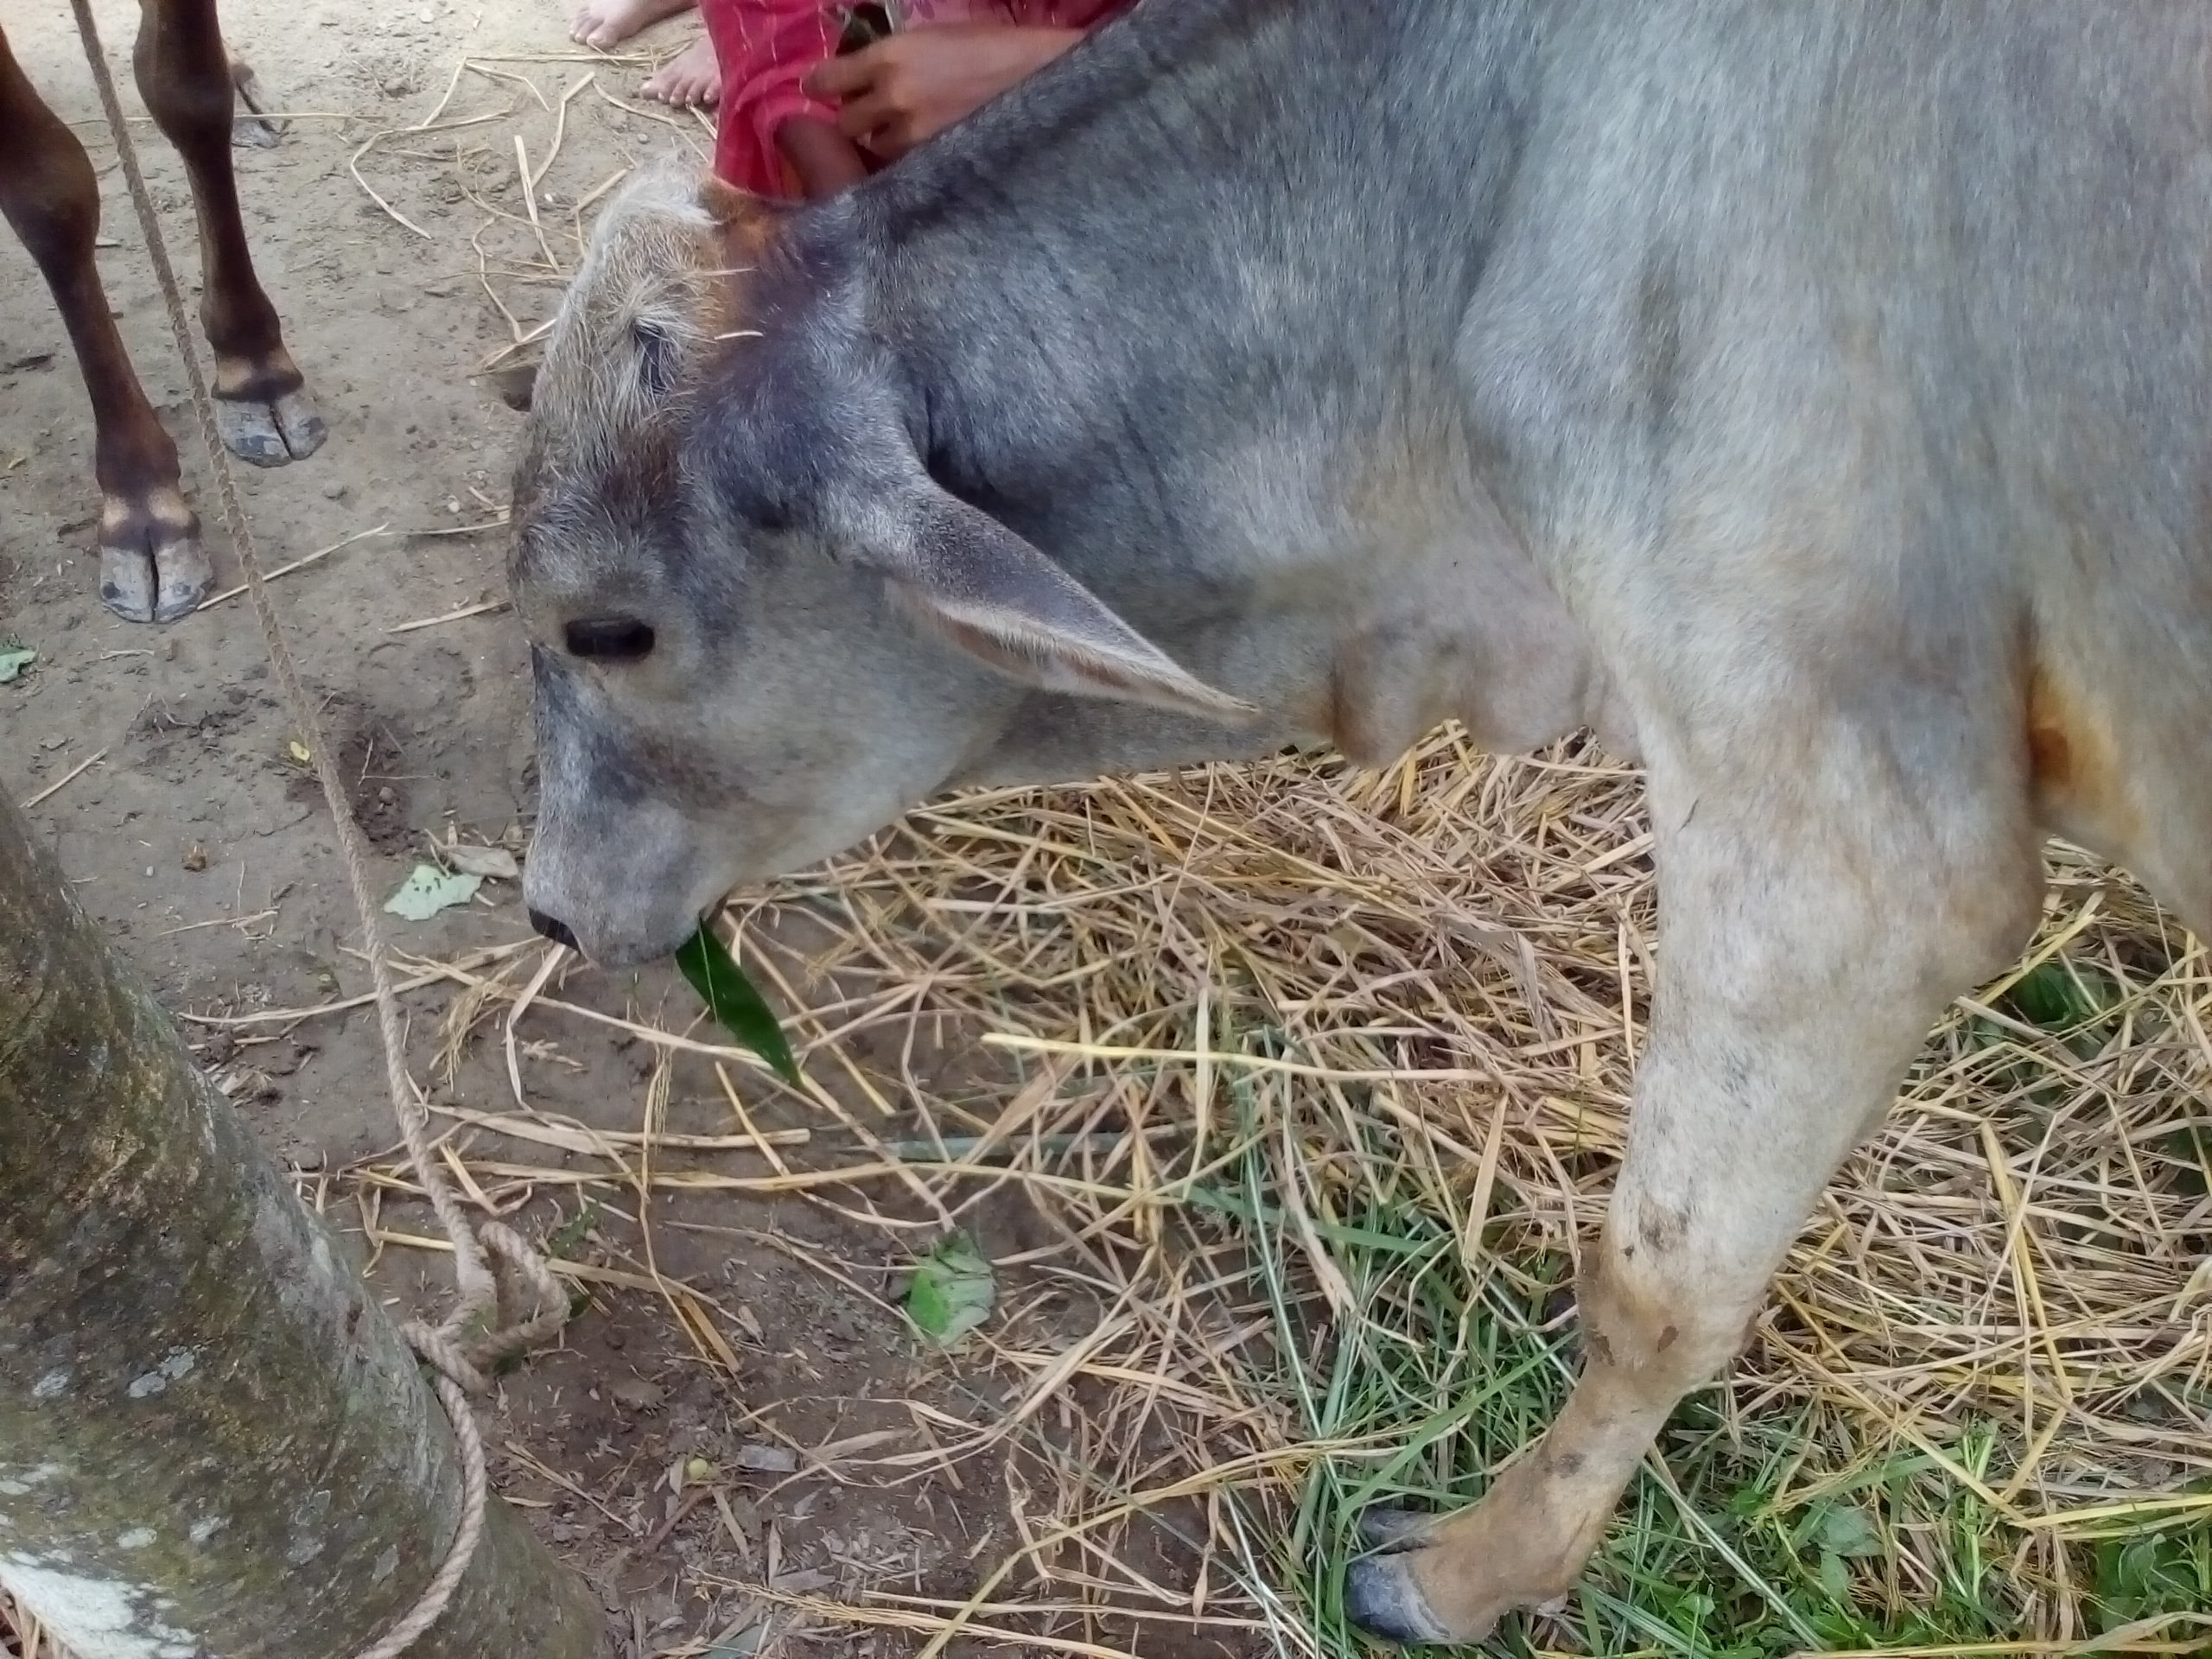
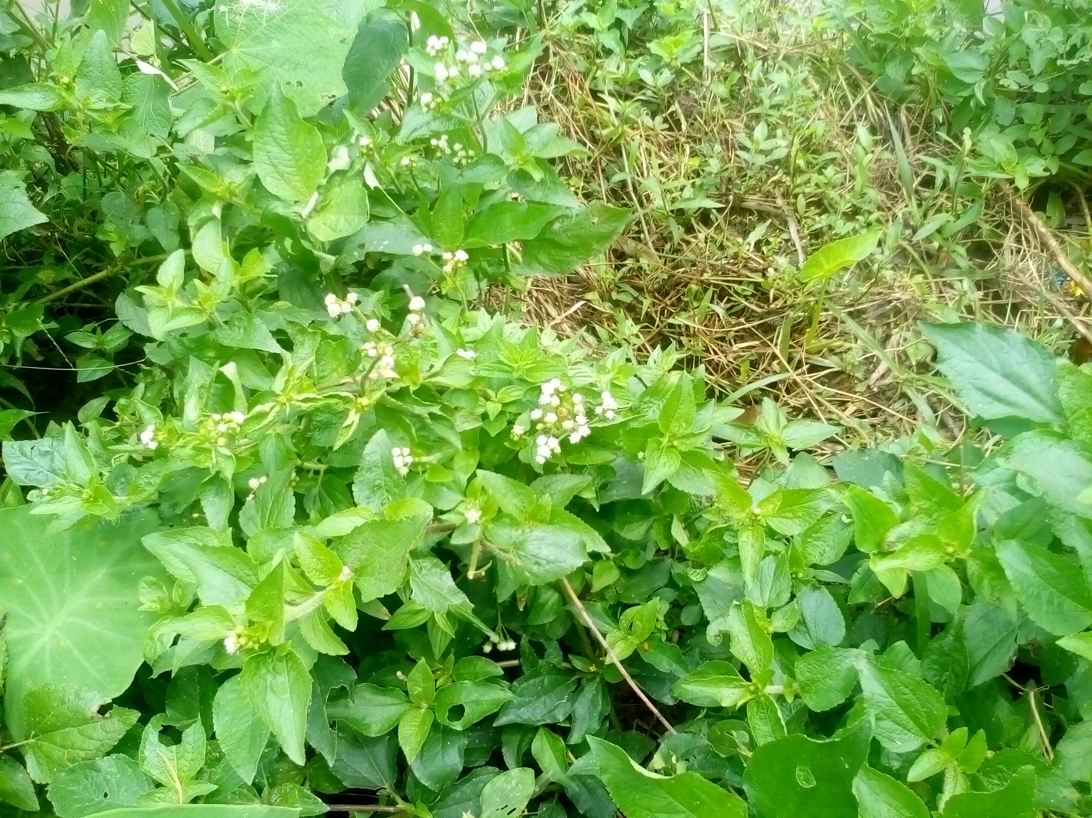

(Fig no: 1) Ban tulsi
(Fig no: 2) Loss of appetite

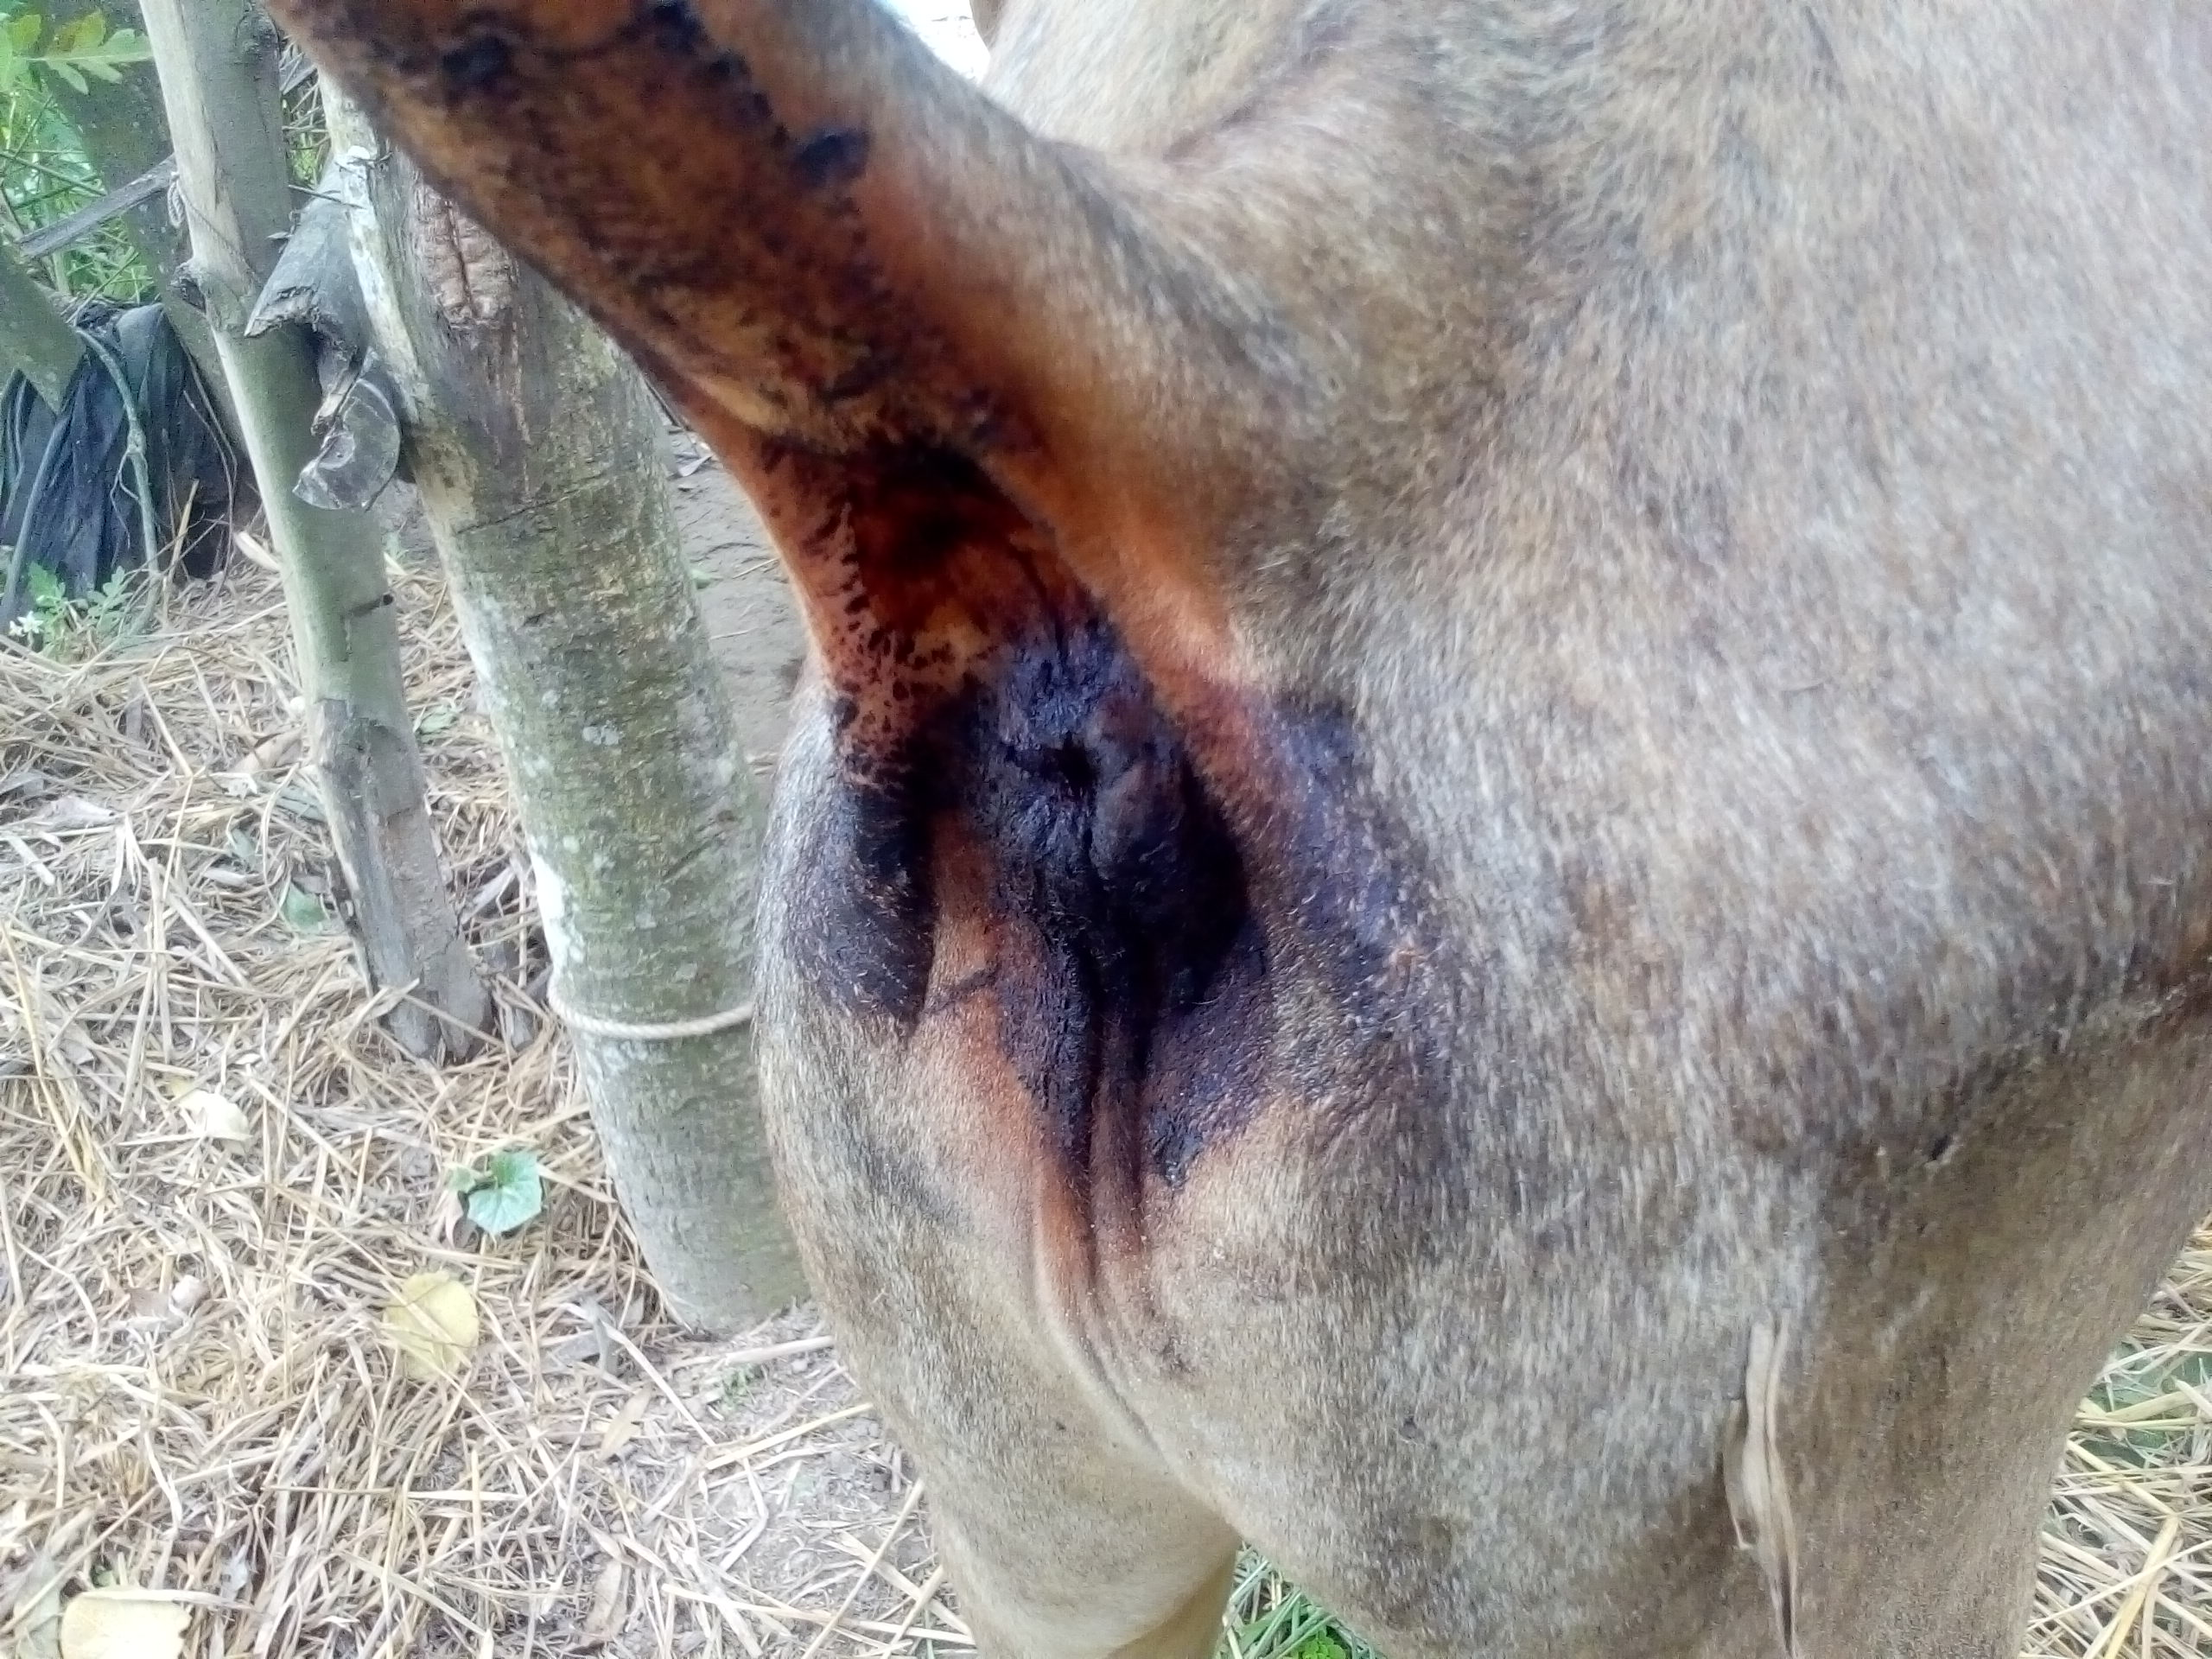
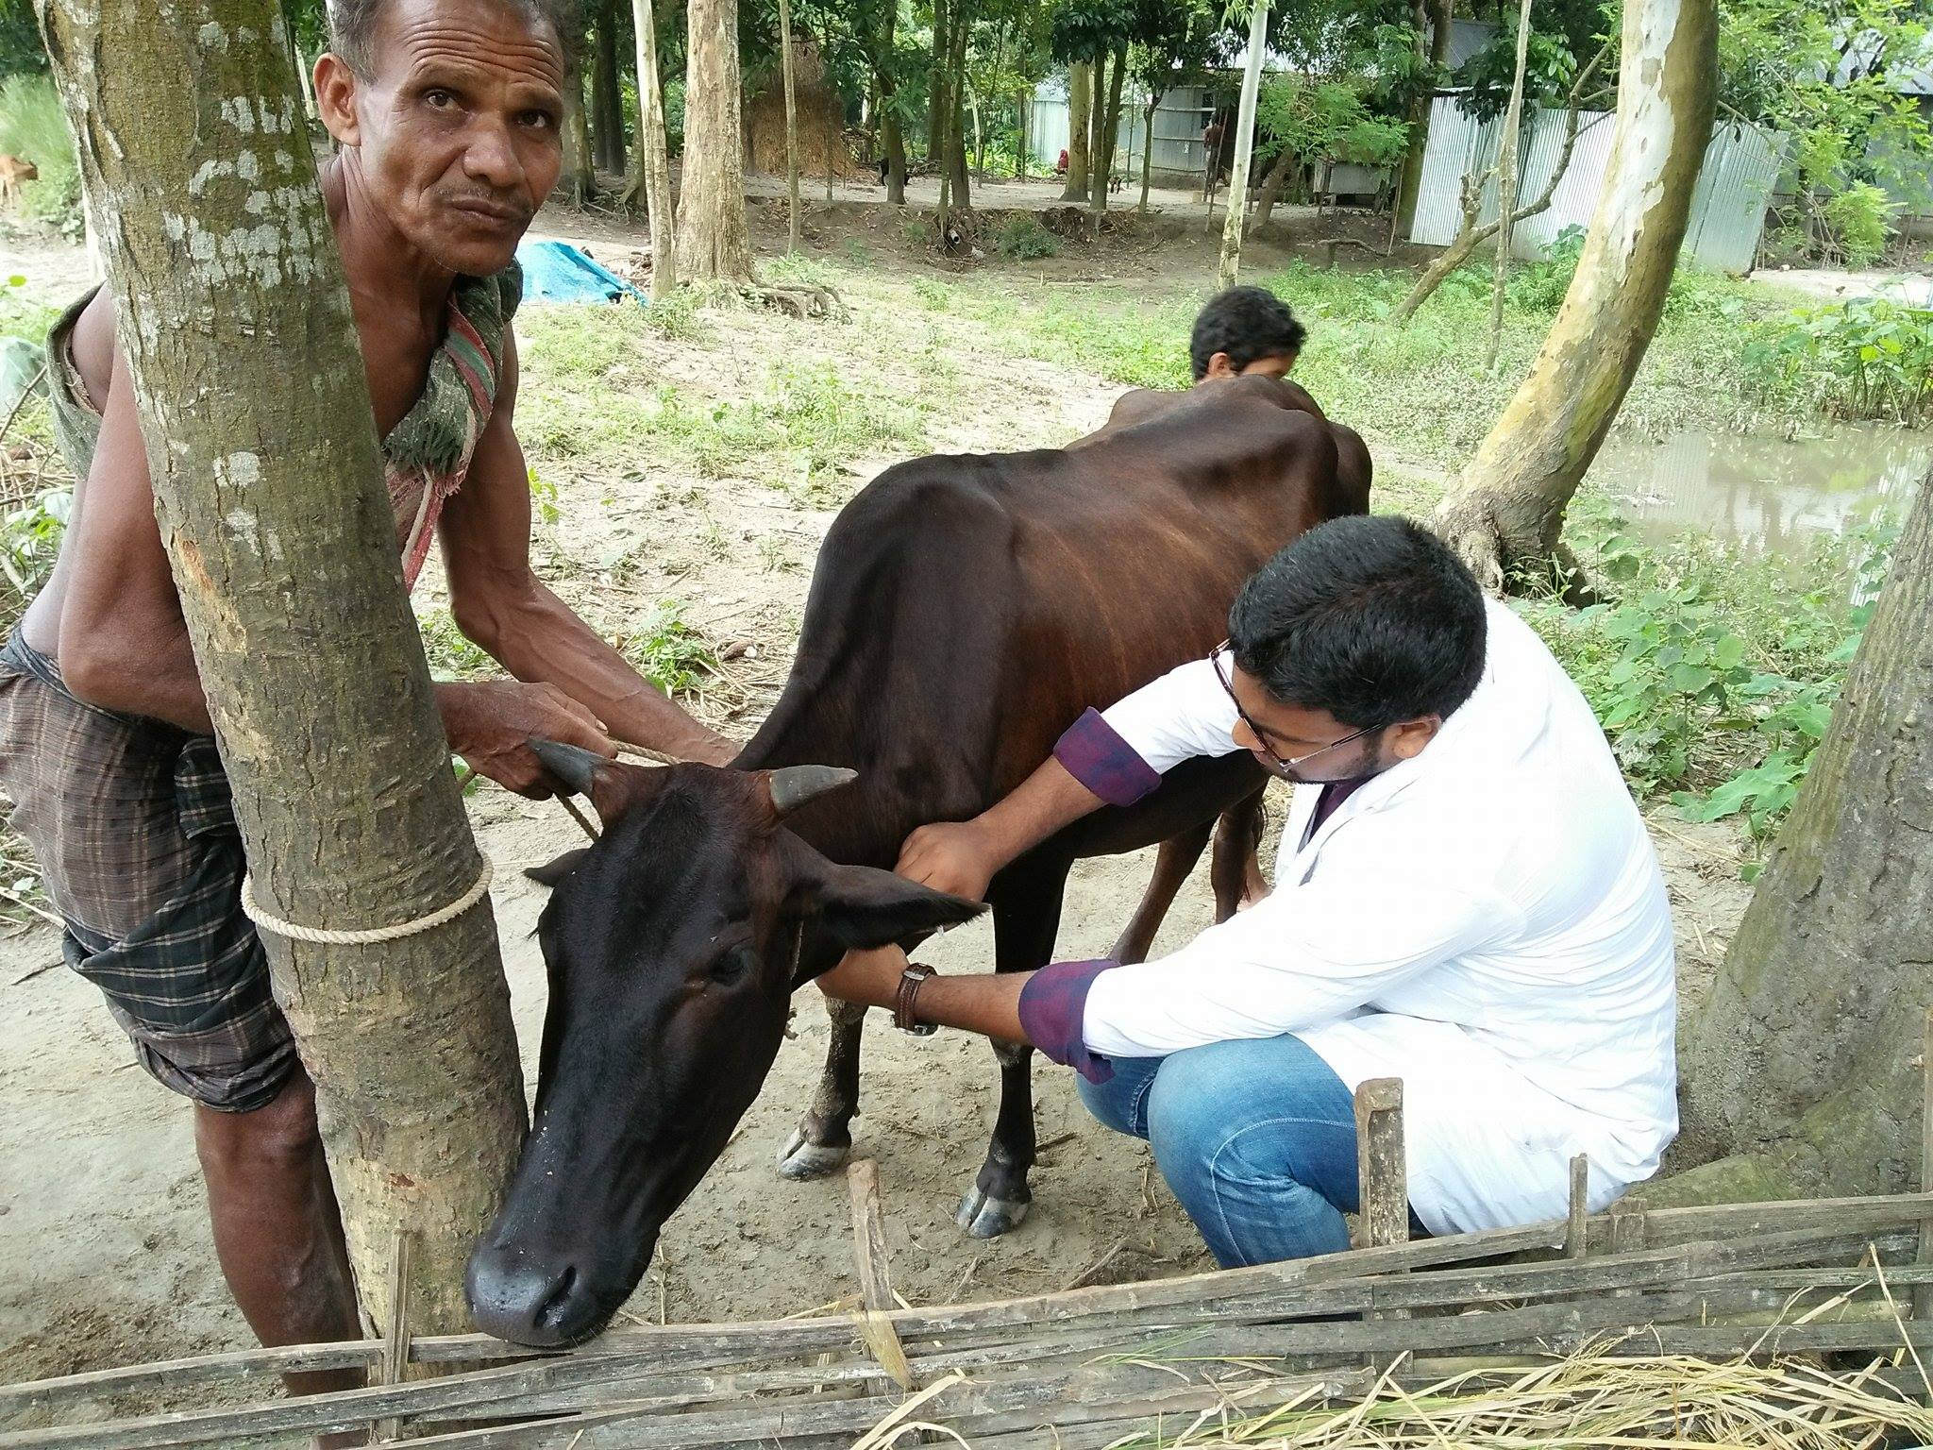

(Fig no: 6) Nitrate poisoning positive
(Fig no: 5) Laboratory test
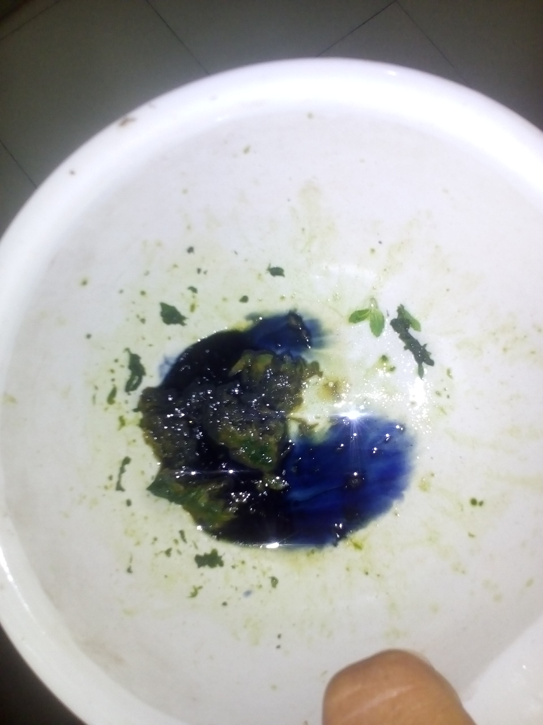
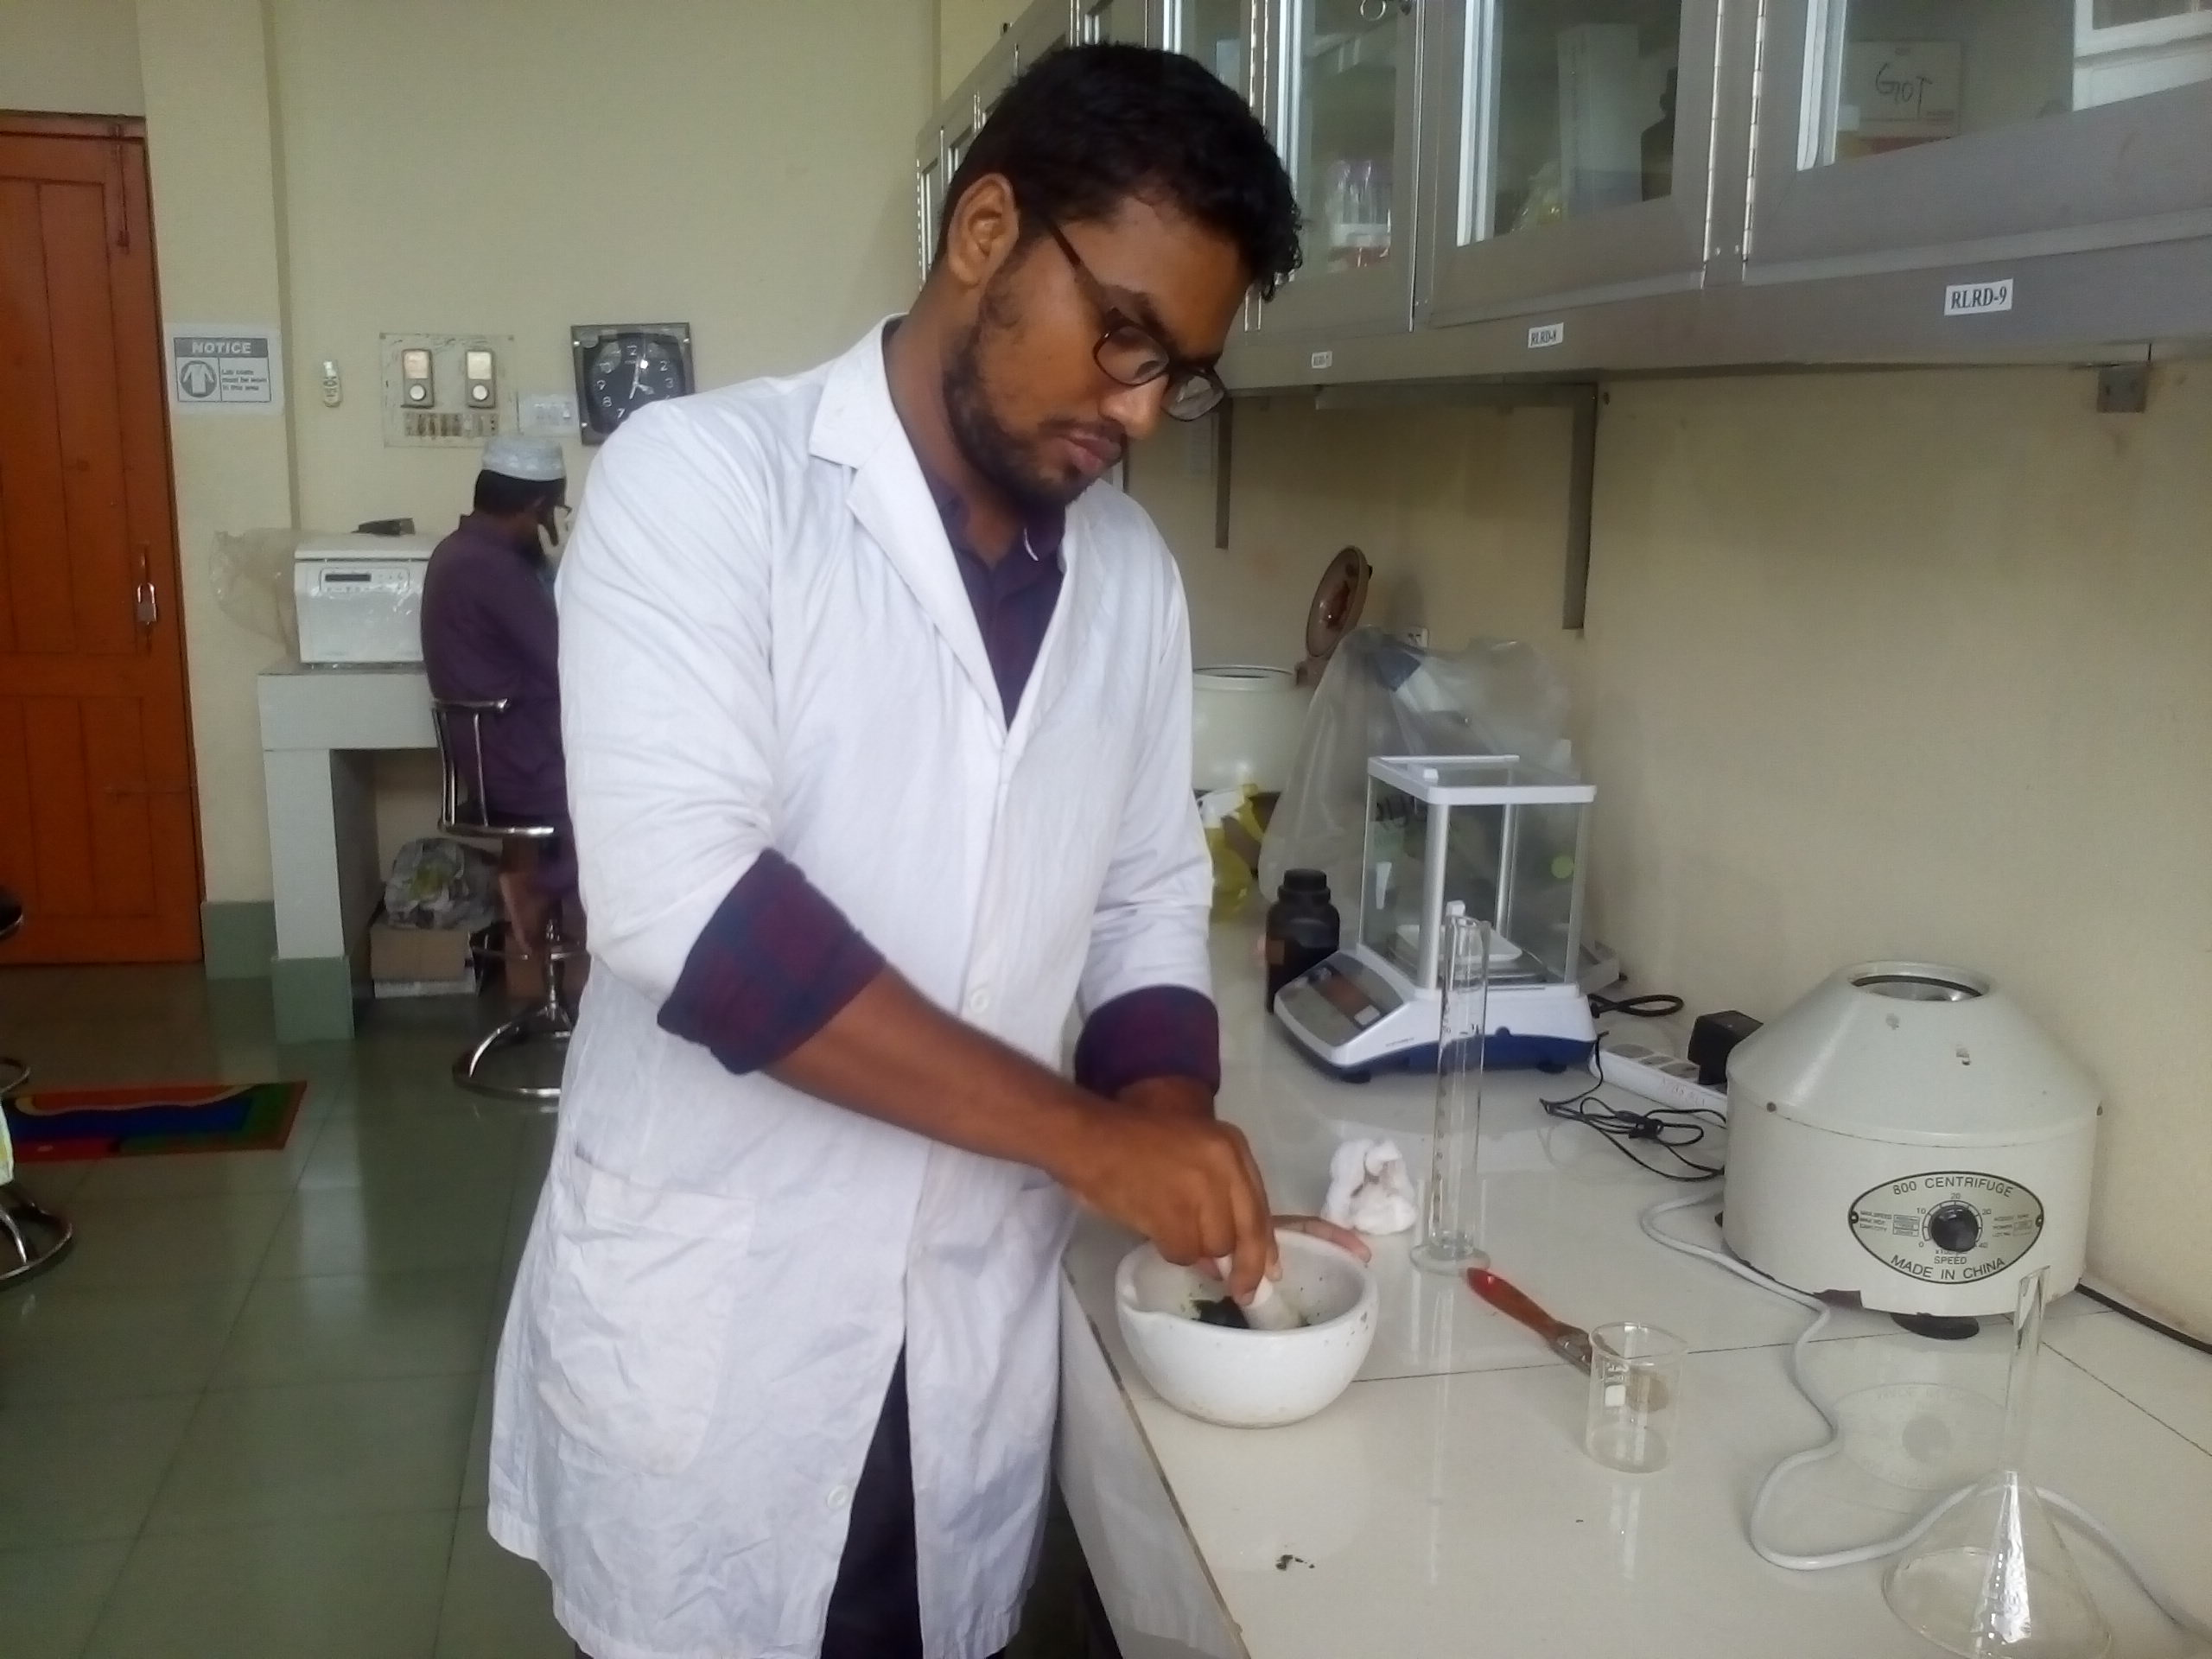
(Fig no: 4) Blood sample collection
(Fig no: 3) Chocolate colored clotted blood
(Fig no: 6) Nitrate poisoning positive
(Fig no: 5)Laboratory test

CHAPTER III: RESULTS AND DISCUSSIONS

During external examination, brown to chocolate color partially clotted blood were seen around the anus, with cyanotic color of mucous in two animals. These signs alongs with history of feeding Ban tulsi grasses at rainy season was suggestive of nitrate poisoning as a tentative diagnosis. Toxicological analysis was done by diphenyl amine test and nitrate positive reaction was found in both leaves and flowers of the green grass (Ban tulsi) . Further analyses of the blood samples indicated a low hemoglobin level (7mg/dl).

The cows died suddenly without any clinical sign of disease as recorded during this study. Spearman (1989) also reported that in nitrate poisoning, the cattle usually found dead on the pasture without any overt clinical signs. Aslani and Vojdani (2007) reported clinical signs like posterior incoordination, weakness, trembling of the muscles of the hind limbs, depression, diarrhea and extensive ventral subcutaneous edema in nitrate poisoning cases. However, in some cases, death followed in 1-14 days after onset of clinical signs. In acute cases clinical signs appear 2-6 h after intake of feed containing high level of nitrate. Signs include polypnoea, dyspnea, tachycardia, abdominal pain, tympani, diarrhea and frequent urination. Muscle tremor, weakness, intolerance to exercise, convulsions, and death is possible in just few hours (Stober, 2006). The cows in this case died with dyspnea, tympani, convulsion (as described earlier Stober, 2006). Ammonium nitrate and urea fertilizers have been implicated in poisoning cases. As cattle graze pastures, or forage around buildings, they might get fertilizer spills and quickly consume the material. When urea fertilizer is consumed, the urea molecule is broken down into two ammonia units. Rumen and blood ammonia levels increase dramatically within 20-30 minutes of consumption (Mathew, 1989). Ammonia toxicity prevents the release of carbon dioxide from the red blood cells while nitrites prevent the red blood cells from carrying oxygen to body tissue. Some cattle may survive after treating with vinegar.

During the farm visit, it was found that the forage provided to the cows were with high nitrate content. Diphenylamine test of the fodder both leaves and flowers developed blue color within a few seconds that is result for nitrate poisoning. Further confirmation can be made by necropsy. However this was not possible as the farmer did not allowed it.
Nitrate and nitrite are closely related in effects of poisoning. Besides, excess intake of nitrates may cause inflammation of rumen and intestines. They are the routes to a supply of more toxic product, before and after absorption. Nitrate is reduced to nitrite, an intermediary-product, by bacteria of the digestive tract. On the other hand, nitrite is converted to ammonia in the same way. After an animal consumes feed that contains nitrate, rumen ammonia levels may increase significantly and it is unusual to have blood ammonia levels increased (Kemp, 1977). Healthy animals usually have methemoglobin levels that are relatively constant at 2-3% of total hemoglobin. When high nitrate feeds are consumed, moderate nitrate poisoning symptoms appear and 20-40% of the hemoglobin is converted to methemoglobin (Johnson, 1983; Pfister, 1988) and severe symptoms or death can occur when blood methemoglobin levels rise up to 67-90% (Asbury and Rhode, 1964). Hemoglobin level of the blood sample collected from animals during this study was 7mg/dl which is lower than the normal level of hemoglobin (8-15mg/dl). Therefore this observation was correlated with the previously published reports.
Various drugs and antidotes are in use to relieve from acute nitrate poisoning. Chronic cases are not cured by the administration of these products. Methylene Blue is able to convert methemoglobin back to hemoglobin. The dosage must be within a specified narrow range otherwise it can intensify the problem. Intravenous injection of methylene blue in saline solution (4%) for horses must be in the 1-2 mg/kg range while cattle and sheep require 20 mg/kg to obtain satisfactory results (Blood et al., 1989).
CHAPTER IV: CONCLUSION

The laboratory findings suggested that the sudden mortality of two indigenous cattle out of three were due to acute nitrate poisoning. Chemical reactions and clinical findings of the affected animals correlated well with the lesions observed by other authors. One would assume that; the green grass (Ban tulsi) known to contain nitrates accumulated after heavy rainfall may contribute to this type of poisonings. Farm owners should avoid feeding this grass during rainy and immediate after rainy season. If farmers interested to add those grass to their cattle feed, it is recommended that grass should be dried before use. Further investigation of the quantity of nitrate in per kg of different other grass can be useful to select the fodder in different season in different parts of the country.

REFERENCES

Asbury AC, & Rhode E.A. 1964. Nitrate Intoxication in Cattle: The Effects of Lethal Doses of Nitrite on Blood Pressure. American Journal of Veterinary Research. 25: 1010-1017.
Aslani MR, Vojdani M (2007). Nitrate intoxication due to ingestion of pig weed red-root (Amaranthus retroflexus) in cattle. Iranian Journal of Veterinary Research, 8: 377-380.
Blood DCH, Handerson JA, Rodstititis OM. (1991). Veterinary medicine. 8th Edn. London: Bailliere, Tindall.
Deebs BS, Sloan KW (1975). Nitrates, nitrites and health. - Illinois Agricultural Experiment station. Bulletin; 750.
Galey FD, (2002). Disorders caused by toxicants. In Smith BP, Ed. Large animal internal medicine. 3rd Edn., St. Luis, Mosby; 1614-1637.
Horner RF, (1982). Suspected ammonium nitrate fertilizer poisoning in cattle. - Veterinary Record. 110: 472-474.
Issi M, Gul Y, Atessahin A, Karahan I (2008). Acute nitrate poisoning in two cattle. Toxicology and Environmental Chemistry, 90: 135-140.
Johnson JL, Schneiderm, NR., Kelling, C. L., Doster, A. R. 1983. Nitrate Exposure in perinatal Beef Calves. American Association of Veterinary Laboratory Diagnosticians, pp 167-180. 30th Proceedings.
Kemp A, Geurink, JH., Haalstra, RT, and Malestein, A. 1977. Nitrate Poisoning in Cattle: Changes in Nitrate in Rumen Fluid and Methaemoglobin Formation in Blood After High Nitrate Intake. Netherlands journal of agricultural science. 25:51-62.

Mathew IG, 1989. Large Animal Neurology: a handbook for veterinary clinicians. 380, Philadelphia: Lea & Febiger.
Roberts AG, (1949). Diphenylamine test for nitrates in mixtures of cellulose esters. Analytical Chemistry, 21: 813–815.
Salyi G, Molnar T, Ratz F (1996). Renal injury caused by feeding redroot pigweed (Amaranthus retroflexus) in swine. Case report. Magy Allator Lap., 51: 603-606.
Schneider NR, (1998). Nitrate and nitrite poisoning In: Aiello SE, Mays A, editors. The Merck Veterinary Manuel 8th Edn., Philadelphia, PA: National Publishing; 2091-2094
Spearman G, (1989). Redroot pigweed toxicosis in cattle. Canadian Veterinary Journal, 30: 255-256.
Stober M, (2006). Nitrat- Nitritvergiftung. In: Dirksen G, Gründer HD, Stöber M, Eds. Innere Medizin und Chirurgie des Rindes. 5th Edn., Stuttgart, Parey; 235-239.

