Chapter-1: Introduction
Bangladesh’s agricultural sector contributes 12.68% (DOF, 2018-19) of GDP and fisheries are an enormous part of our agricultural sector. Bangladesh has achieved remarkable progress within the fisheries sector since its independence in 1971. This sector is contributing a vital role in socio-economic development and deserves potential for future development within the agrarian economy of Bangladesh. It contributes 3.50% to our national GDP and quite one-fourth (25.72%) to the agricultural GDP, employing 12% of the working population, with 20 million people looking on the fisheries sector for his or their livelihoods through fishing, farming, fish handling, and processing(DOF, 2018). This sector provides a significant share (60%) of all consumed animal protein (DOF, 2018). Despite shrinking water bodies for fish cultivation, sustained growth has been possible because of the utilization of higher inputs and modern technology contributing to higher yield. Although the country has gained self-sufficiency in terms of agricultural production, the population is growing and can reach 185 million by 2030. (Light castle analytics, 2019)
For thousands of years, people have harvested the bounties of the ocean and also cultivated its “crops." As global demand for fish increases, these farm-raised stocks will become more important to the food supply. The world organization reports that around 47 percent of the world's total fish supply comes from aquaculture. Aquaculture could be a catch-all term that encompasses the subsistence, medium-scale, or industrial production of commercially important finfish (such as catfish, trout, salmon, tilapia, and various marine species); reptiles (such as turtles, crocodiles, and alligators); mollusks (oysters, mussels and clams) and crustaceans (lobsters, shrimp, crabs, and crawfish). In 2019, the highest five producing countries were China (63.7 million metric tons), Indonesia (16.6 million metric tons), India (5.7 million metric tons), Vietnam (3.6 million metric tons), and Bangladesh (2.2 million tons). Asia accounted for 89 percent of world aquaculture production by volume, with China remaining, by far, the biggest aquaculture producing country (FAO 2018). Aquaculture is and will remain a significant food-producing sector within the future. Using advanced production methods and commercial feed, fish production has increased over the years. With an increasing demand for fish protein and a decline in capture fisheries production, aquaculture is shifting towards intensification. To become more efficient and successful within the aquaculture industry, operations must provide good nutrition. World-renowned nutritionists and feed technologists explore practical ways for the aquaculture industry to expand and remain competitive and discuss ways to develop more cost-effective alternative sources of protein. The increase in costs and demand for protein from conventional resources necessitate fish farmers in developing countries including Bangladesh to include cheap and locally available ingredients in fish diets. Recent works of literature reported that the use of high food value aquatic plants is employed to supplement fish diets. A floating freshwater Azolla is an honest source of fish feed. Azolla is extremely rich in proteins, essential amino acids, vitamins (vitamin A, cobalamin, beta carotene), growth promoter intermediaries, and minerals including calcium, phosphorous, potassium, ferrous, copper, magnesium. On a dry weight basis, Azolla has 25-35% protein content, 10-15% mineral content, and 7-10% comprising a mixture of amino acids, bio-active substances, and biopolymers (Kamalasanana .2002). Azolla’s carbohydrate and oil content are very low. Despite its attractive nutritional qualities and relative ease to provide in ponds, reports on the utilization of Azolla in aquaculture are extremely limited. Diet costs take up a large chunk of operating expenditures, with organic fertilizer being one of the foremost expensive ingredients within the aquaculture diet. Azolla is often a decent source of protein-based diet for fish. The aquatic free-floating fern Azolla pinnata belongs to the Azollaceae, which grows in association with the eubacterium, Anabaena azollae, and is taken into account to be a promising feed due to its good nutritive value, simple cultivation, and high productivity (Prabina and kumar.2010; Maitya and patra.2008). A. pinnata appears like a decent source of protein and contains most essential amino acids that are superior to wheat bran, maize, offal’s, etc. (Cherry et al.,2014; Basak et al.,2002). Generally, the crude protein content of that plant species is found within the range from 25% to 30% in dry matter basis at optimum growth conditions (Basak et al., 2002). Under natural conditions, protein values near 20% to 22% are frequent. Therefore, the protein content of A. pinnata is comparable or on top of that of most other aquatic macrophytes. This plant is rich in minerals like iron, calcium, magnesium, potassium, phosphorus, manganese, etc., but appreciable quantities of A, precursor beta-carotene, and B (Anitha et al., 2016). It is also found that Azolla plants contain some probiotics and biopolymers (Pillai et al., 2002). Azolla pinnata is common in most Asian rice fields, ponds, and roadside ditches, and has considerable potential in fish culture, especially within the rice-fish system. It proliferates at a high rate in natural ponds and, if necessary, for a big supply, is often grown at a really low cost (Basak et al., 2002). Increased fish production has been demonstrated in integrated rice-fish, Azolla production systems where the plant served as an in-place fresh food for the macro phytophagous fish (Cagauan et al., 2002). It's attracted attention as a nitrogenous fertilizer and as a source of dietary nitrogen for herbivorous fish and livestock. Azolla pinnata as a fresh feed, together with a food level of natural feeding, is beneficial to fish production (Cagauan et al., 1994). Therefore, it can be a wonderful inexpensive feed for B. gonionotus. Dried and processed Azolla has been tested as a feed ingredient in several fish species (e.g., tilapia, carp, etc.) for its effect on growth and yield (Mohanty and Dash, 1995; Fiogbé et al., 2004). However, its acceptability within the fresh or unprocessed form as supplementation of business fish feed (CFF) has not been contemplated for the silver barb. Feeding A. pinnata in its fresh form could reduce the value of feed immensely and would be very convenient and farmer-friendly if its application is often established. Azolla has enormous potential as a fish feed thanks to its high content in proteins, essential amino acids, vitamins (vitamin A, cobalamin, Beta Carotene), growth promoter intermediaries, and minerals. Its ability to proliferate without inorganic nitrogen fertilization. Its high rate of growth in water without the necessity to displace existing crops or natural ecological systems. Azolla is potential food for seafood farming for 2 reasons. The first limiting factor for the productivity of tropical aquatic ecosystems is usually the bioavailability of nitrogen, which might be supplied by Azolla-Anabaena. Approximately 95% of the value of formulating a mean production diet is said to meeting the protein and energy needs of the fish, it's been used for hundreds of years in China to extend rice production by the incorporation of atmospheric nitrogen into the water accustomed to grow rice. Azolla-rice cultivation is now also getting used in conjunction with fish farming, and lead to increased rice production of 20% and fish production of 30% in keeping with Azolla. (Kamalasanana .2002).Fiogbe et al.(2004) have also investigated the employment of Azolla as supplementary food for fish, because: “In many developing countries people lack sufficient animal protein. In Benin, the most protein source is fish; however, consumption thereof is extremely low (7 kg year) compared to the adult requirement of fish or animal meat per annum (30 kg year).” Fish culture may be a way to extend animal protein consumption not only in Benin but also in most of the developing countries that lack sufficient animal protein. However, in an exceedingly project financed by the ECU Union from 1978 to 1990, fish production in Benin fell due mainly to the high cost of the feed.” They investigated Azolla microphylla’s potential to supply low-cost feeds for the omnivorous–phytoplanktonophagous tilapia, Oreochromis niloticus with diets starting from zero to 45% diet dry weight of Azolla. (Fiogbe et al. 2004) found that each one diet level with incorporated Azolla meal exhibited weight gain, indicating that Azolla may be used with local products to market fish culture development. They concluded that the smallest amount of expensive diet, which comprised 45% Azolla, may well be used as a complementary diet for tilapia raised in fertilized ponds and recommended Azolla’s use for fish culture in rural areas, and mainly wetlands. Other trials have focused on Azolla’s use as a feed for the grass carp Ctenopharyngodon idell. This species incorporates a short, inefficient systema digestorium and, at suitable water temperatures, will consume daily quite their weight of aquatic weeds. The fish showed a marked preference for Azolla, Lemna, and other small floating weeds (Edwards, 1975). Azolla could be a convenient feed for fish. It is often readily grown locally often in waste ponds that are polluted. It is fed fresh and since it floats, by the judicious setting of the rates of application it should be employed by fish. It's used very efficiently by fish like tilapia and carp but other species might well deal with Azolla as a component of the diet since it's particularly low in fiber and high in protein when grown under ideal conditions.

1.1 Objectives
The objectives of the present research are as follows:
1. To evaluate the growth rate of Azolla pinnata cultured with fertilizer(Nitrogen & phosphorus) and water quality(pH & DO)in different concentrations
2.To see the Effects of fertilizer (nitrogen and phosphorus) and water quality (oxygen and pH) on the protein content of Azolla.
1.2 Scope of the study
It is hoped that the study will provide a higher understanding of the potential of Azolla-based systems in Bangladesh by the low-cost natural purification process. It'll help people to understand about different requirements of Azolla for its better growth and highest protein content. By using Azolla as feed, it'll improve the fisheries industry, production of fish, and fishery product manufacturer in Bangladesh.

Chapter-2: Review of literature
Before conducting research, it's important to prepare a plan of the previously conducted research activities on the related topics. So, a review of the literature relevant to this research work has been given below:
2.1 Azolla
Azolla (Azolla sp.) is a fern consisting of a brief, branched, floating stem, bearing roots that hang down within the water. The leaves are alternately arranged, each consisting of a thick aerial dorsal lobe containing green chlorophyll and a rather larger thin, colorless, floating ventral lobe. Under some conditions, an anthocyanin pigment gives the fern a reddish-brown color. Plant diameter ranges from 1-2.5 cm for tiny species like Azolla pinnata, to fifteen cm or more for Azolla nilotica. Azolla plants are triangular or polygonal in shape, and float on the surface of the water, individually or in mats. They provide the looks of a dark green to reddish carpet, except Azolla nilotica doesn't produce the red anthocyanin pigment. Azolla floats on the surface of the water using numerous small, closely overlapping scale-like leaves, with their roots hanging within the water. The everyday limiting thinks about its growth is phosphorus, another essential mineral. The foremost remarkable characteristic of Azolla is its symbiotic relationship with the nitrogen-fixing blue-green alga (cyanobacterium) Anabaena azollae. The fern provides nutrients and a protective cavity in each leaf to Anabaena colonies in exchange for fixed atmospheric nitrogen and possibly other growth-promoting substances (Lumpkin. 1980). This has led to the plant being dubbed a "super-plant" because it can readily colonize areas of freshwater, and grow at great speed - doubling its biomass every two to a few days Azolla encompasses a historical role in agriculture. For hundreds of years, it's been recognized as a useful plant in Southern China and Northern Vietnam, where it's been used as a biofertilizer and manure for the rice crop thanks to its N-fixing abilities. Azolla production was heavily promoted within the early 1960s in China and Vietnam, leading to a rapid expansion in these countries. It attracted international attention within the 1970s as a result of the oil crisis and therefore the economic process of fossil fuel-dependent N fertilizers. Azolla became a possible replacement for these because it was believed that it could bolster rice production in many tropical countries. However, enthusiasm for Azolla faded within the 1980s and was followed by a period of skepticism. Azolla production in China and Vietnam declined (perhaps thanks to the increasing use of land for food production) and Azolla development worldwide didn't live up to initial expectations, because of serious constraints like water availability, difficulties in maintenance and handling, high labor requirements, and limited knowledge on the particular needs of every Azolla species (Van Hove. 1996). Azolla is typically called ‘small duckweed’, but this can be a misleading name. Azolla may be a pteridophyte, whereas duckweed (also referred to as ‘water lens’ or ‘bayroot’) is an aquatic angiosperm (flowering plant) of the Family Lemnoideae which has five genera: Spirodela, Landoltia, Lemna, Wolffiella, and Wolffia. Unlike Azolla, duckweed doesn't contain endosymbiotic cyanobacteria. The Classification of Azolla pinnata is given in Table 1.

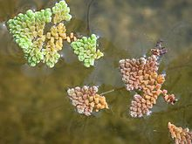
Table 1: Classification of Azolla:

Domain | Eukaryota
Kingdom | Plantae
Subkingdom | Tracheobionta
Phylum | Pteridophyta
Class | Filicopsida
Family | Azollaceae
Genus | Azolla
Species | Azolla pinnata

2.2 Morphology of Azolla:
Azolla’s morphology is unlike that of other ferns and, particularly, its leaf structure has evolved to produce an environment that's ideal for Anabaena. Azolla’s life cycle also makes it possible for Anabaena to pass uninterruptedly from one generation of Azolla to the subsequent. This has enabled the 2 organisms to evolve continuously together for over 90 million years, a relationship unknown elsewhere in the world.
Azolla’s leaves occur in two rows along both sides of the plant’s stem. Each leaf features a very thin ventral lobe and a thick, greenish, or reddish photosynthetic dorsal lobe containing a cavity that's the key to the Azolla and Anabaena symbiosis. The cavity could be a highly specialized structure that's formed during Azolla’s growth by a part of the leaf epidermis folding inwards during Azolla’s development (Peters & Meeks, 1989). The cavity measures approximately 0.15 x 0.3 mm and opens to the external environment through a pore that's surrounded by two cell layers.
The center of the cavity is stuffed with a gas or liquid and therefore the bacteria are immobilized within the peripheral area of the cavity by a mucilaginous fibrillar network (Carrapiço 1991, 2002, 2010). Azolla’s leaf cavities provide a perfect micro-environment for the heterocyst-forming nitrogen-fixing filamentous bacterium Anabaena azollae. This can be the key to Azolla’s ability to sequester enormous amounts of atmospheric CO2.
2.3 The plant and its habitat
Azolla occurs in ponds, ditches, and rice fields of warm-temperate and tropical regions throughout the globe. Each species includes a specific native range: Azolla caroliniana, Eastern North America and therefore the Caribbean; Azolla filiculoides, Southern South America through Western North America including Alaska; Azolla microphylla, tropical and subtropical America; Azolla mexicana, Northern South America through Western North America; Azolla nilotica, upper reaches of the Nile to Sudan; Azolla pinnata, most of Asia and also the coast of tropical Africa. These species are dispersed by man and may be found outside their native regions (Lumpkin. 1980). Water is the fundamental requirement for the expansion and multiplication of Azolla because the plant is extremely sensitive to a lack of water. Although Azolla can grow on wet mud surfaces or wet pit litters, it prefers a free-floating state. Azolla can survive within a pH range of 3.5 to 10, but optimum growth is observed within the range of 4.5 to 7. The optimum temperature for growth and biological process depends on the species. It's usually within the 20-30°C range, though Azolla mexicana is more tolerant of temperatures over 30°C. Outside this range, growth decreases until the plant begins to die at temperatures below 5°C and above 45°C. Azolla filiculoides can withstand temperatures as low as -5°C without apparent harm. The expansion rate of Azolla pinnata was found to say no as salinity increased above 380 mg/l. At about 1.3% salt (33% of seawater) the expansion of water fern ceased and better concentrations resulted in death. Azolla filiculoides are reported to be the foremost salt-tolerant. During times of stress, anthocyanin is assumed to guard the photosynthetic apparatus against damaging high light intensities by absorbing a number of the sunshine and converting it to heat. For that reason, Azolla often exhibits a red color under field conditions, especially where phosphorus is deficient. Azolla grows best fully to partial shade (25-50% of full sunlight). Growth decreases quickly under heavy shade (lower than 1500 lux) and over 50% of full sunlight reduces photosynthesis. The optimum ratio for Azolla growth is between 85 and 90%. Azolla becomes dry and fragile at a ratio not up to 60% (Hasan .2009; Lumpkin.1980) Successful cultivation of Azolla requires the appliance of a specific amount of phosphorus fertilizer (0.5 to 1.0 kg P/ha/week), but this doesn't necessarily mean a rise within the amount of phosphorus fertilizer required to provide a crop of rice (Lumpkin.1985).
2.4 Ecological impacts of Azolla
2.4.1 Weed
Because Azolla can form dense mats on water surfaces, it's classified as a water weed in many areas. It’s been reported to disrupt fishing, access to water by livestock, impede water flow in ditches, clog pipes, pumps, and floodgates and interfere with watercress cultivation (Lumpkin.1980).
2.4.2Environmental benefits
2.4.2.1 N-fixation and manure
The main reason for the enduring popularity of Azolla among agriculturists is its ability to mend nitrogen, valuable in paddy fields under waterlogged or flooded conditions where N-fixating legumes cannot grow. It’s also a source of manure for upland rice growing on the foremost fertile soils that farmers are reluctant to use for legume crops. Azolla also contributes to maintaining soil fertility, by providing nutrient-rich humus through its decomposition (Lumpkin.1985).
2.4.2.2 Limitation of N volatilization
By reducing candlepower underwater, Azolla inhibits algae photosynthesis and also the subsequent increase in pH and NH3 volatilization. Because up to 50% of N fertilizer applied to paddy fields is lost in volatilization, Azolla could help to cut back the number of N fertilizers in rice crops (Van Hove.1996).

2.4.2.3 Weed control
It has been empirically observed, and well appreciated by rice farmers, that Azolla suppresses the expansion of some aquatic weeds by forming a thick mat that deprives weed seedlings of sunlight while mechanically preventing them from emerging (Lumpkin.1985; Van Hove.1996).
2.4.2.4 Mosquito control
The ability of Azolla to forestall mosquito breeding and thus the spread of paludism was suggested within the early 20th century (hence the name "mosquito fern") but was demonstrated only within the late 1980s by Indian and Chinese researchers. For instance, a Chinese experiment in controlled conditions showed that full or 2/3 Azolla cover could prevent or limit the oviposition of Culex mosquitoes. It failed to prevent the ovipositing of Anopheles sinensis but limited the emergence of adult insects (Lu BaoLin, 1988). These findings were later confirmed in field trials that showed that larval density was greatly reduced when 75% of the water surface was covered by Azolla (BaoLin et al., 1989). However, there are some doubts about the efficiency of Azolla in mosquito control, since the coverage required for a big reduction in mosquito populations could also be impossible to get in practice (Van Hove .1996).
2.4.2.5 Bioremediation
Azolla can accumulate excessive amounts of pollutants like heavy metals, radionuclides, dyes, pesticides, etc. For that reason, it's been extensively studied and tested since the 2000s as a candidate for the bioremediation of wastewaters and effluents (Sood et al., 2012).
2.5 Azolla’s Nutritive value
Because Azolla features a higher crude protein content (ranging from 19 to 30 percent) than most green forage crops and aquatic macrophytes and a rather favorable essential organic compound (Essential Amino Acid) composition for animal nutrition (rich in lysine), it's also attracted the eye of livestock, poultry and fish farmers (Cagauan and Pullin, 1991). Azolla’s high protein value was confirmed in 2012 by Erik Sjödin in his book ‘The Azolla Cooking and Cultivation Project’:
“Azolla’s nutritional value is comparable thereto of Alfalfa sprouts and Spirulina – a dietary supplement made of the cyanobacterium Arthrospira. it's a chic source of minerals (10-15% of dry weight), essential amino acids (7-10% of dry weight), vitamins, and carotenoids. 20 – 30% of Azolla’s dry weight is protein, which may be a lot for a vegetable. The standard of the protein in Azolla is sweet, although there are some deficiencies of the amino acid methionine, histidine, and lysine. 2 to 5 percent of Azolla’s dry weight is nitrogen.”
Basing on the research papers reviewed, Azolla seems to be an honest replacer of protein from expensive sources like ﬁsh meal. Among reviewed papers, suggest that Nile tilapia and Tilapia mozambicus can perform better in a very range of 20% to 42% of Azolla inclusion diet (Ebrahim et al., 2007 and Fiogbé et al., 2004). In recent biochemical studies on Tilapia mossambicus reported that the increased protein, carbohydrate, and lipids content within the liver when ﬁshfed with the Azolla diet (Sithara .2008).

Table 2: Azolla’s Nutrient value (wet weight basis) (Feedpedia)
Main  Analysis | Unit | Average | Minimum | Maximum
Dry  Matter | % as fed | 6.7 | 5.1 | 8.7
Crude  Protein | %DM | 20.6 | 13.9 | 28.1
Crude  Fiber | %DM | 15 | 11.3 | 22.8
Lignin | %DM | 11.4 | 9.3 | 13.5
Ether  Extract | %DM | 3.8 | 1.9 | 5.1
Ash | %DM | 15.9 | 9.8 | 21.6
Gross  Energy | MJ/kg DM | 17

Feedipedia - Animal Feed Resources Information System - INRAE CIRAD AFZ and FAO © 2012-2020
  - Azolla as fish feed
Azolla may be a suitable supplement feed for herbivorous fish like tilapia. some trials have shown that tilapia can consume Azolla by 50-80% of their weight per day(Jagdish.2020). Azolla meal protein can replace up to about 100% of the soy flour protein within the diet of black tiger shrimp with no adverse effect. Though, the low–cost feed has been formulated using Azolla as a protein supplement within the extensive system of fish rearing. Azolla-based diets have given quite encouraging results when fed to juvenile tilapia fish. The high level of crude protein of Azolla and better lysine concentration indicated that Azolla plants may be an honest source of fish feed. And, among protein plant sources, the plant seems to be an honest replacer of protein from expensive sources that are feed and oil reckoning on the feeding habits of the fish spaces.
2.7 Effects of Nitrogen on Azolla Growth
Nitrogen is one of the foremost important minerals for living organisms. Azolla is thought of as a tiny low fern that will fix nitrogen through the symbiotic association with the cyanobacteria Anabaena. In contrast to other minerals, the provision of nitrogen and to some extent dissolved oxygen doesn't seem to be considered as limiting factors for Azolla growth, but the expansion of algae-free plants relies on combined nitrogen. Consistent with a study (Sadeghi et al., 2012a), a rise in nitrate concentration might end in low coverage of Azolla within the Anzali wetland. The rationale is that through its symbiosis with Anabaena, Azolla can have free access to atmospheric nitrogen (N2) for fulfilling all of its N requirements (Costa et al., 2009), while algae-free plants are empty of such opportunities. The upper lobes of Azolla have free contact with air, which is vital for the organic process. supported a study by (Costa et al., 2009), high ammonium concentrations in wastewater failed to affect organic process dynamics. The nitrogen-fixing ability of Azolla makes it ready to grow in nitrogen-deficient waters (Watanabe and Berja.1979; Hussner, 2010). The nutrient N is very important for Azolla growth but due to its N fixing ability, it's capable of growing in N-free media (Hussner, 2010). External N has been shown to inhibit the activity of acetylene reductase activity (Yatazawa et al., 1980).
Although Azolla doesn't require nitrogen in its growing medium, the extent of nitrogen within the water affects its growth and nitrogen-fixation rates because nitrogen is assimilated by both Anabaena and Azolla from the atmosphere and also the water respectively. For tissue formation of the Azolla plant nitrogen fertilizer is required. Relative growth rates of Azolla. caroliniana and Azolla. pinnata are higher at a nitrate level of 5 mM than during a nitrogen-free medium, but higher levels of nitrate reduced growth (Singh et al., 1992). Azolla. azollae to the nitrogen element is incredibly low because of Azolla. azollae could fixate N from the air directly, while phosphorus element is that the main nutrient limiting the expansion and development of Azolla sp. (Rai A.K.2003)
2.8 Effects of Phosphorus on Azolla Growth
Similar to many other photoautotrophic aquatic organisms, some nutrients like phosphorus (in the shape of phosphate) are major limiting nutrients for Azolla growth. Phosphorus is a crucial nutrient to yield a successful and ascent of those species (Katony et al., 1996). The effect of this important nutrient on the overgrowth of Azolla has also been confirmed within the Anzali wetland (Sadeghi et al., 2012a, b). In laboratory experiments, Janes (1998) found that increasing phosphorus supply and/or plant density led to increased sporulation. If there's enough phosphorus within the aquatic environment, Azolla is going to be ready to grow without the necessity to supply combined nitrogen like NH4NO3 (Costa et al., 1999). There are different reports about the degree of phosphorus needed for sustained Azolla spp. Growth. The optimum growth of various Azolla species responds to different concentrations of phosphorus (Kushari. 1992). Phosphorus represents a serious limiting think about the sector for the expansion of the Azolla- Anabaena symbiotic nitrogen-fixing system (Budunkila et al., 1981)). However, its growth is restricted by the nutrient element P (Kitoh et al., 1993). (Kondo et al., 1989) reported a maximum rate for Azolla under application of 3.1ppm P with a threshold limit of 0.5-0.6% P. The extent of phosphorus in water bodies is varied and might be high thanks to fertilizer use and runoff. This could cause Azolla blooms in paddies or floodwaters. Counting on the water nutrient status, Azolla multiplies fast; doubling its biomass in but 10 days, and readily colonizes new areas (Campbell, 2011). Hussner (2010) reported a doubling rate of 3-10 days, while Kitoh (1993) reported a doubling rate of 2-3 days under laboratory conditions. Nutrient P is very important for Azolla growth and reproduction (Sadeghi, 2012). However, excess levels of nutrient P are reported to own a negative effect on Azolla growth (Pitt et al., 2014). in line with (Rains et al. 1979) a P level of 0.34ppm is that the lower threshold limit below which there's a deficiency. (Subudhi et al., 1981) reported that an external P level of 5ppm is that the higher threshold limit beyond which Azolla tissue N content is affected negatively. It also found that Azolla. fliculoides can double its biomass in one week in an exceedingly N-free nutrient solution growing in a P-rich environment, entirely looking forward to the symbiosis with diazotrophs for its N supply. The expansion rates measured are within the range reported within the literature (Cary.1992). The expansion rate and N content were reduced during the high-temperature period over 30°C on a mean. (Kondo et.al., 1989).
2.9 Effect of pH on Growth of Azolla
The response of Azolla to pH depends on many factors like temperature, intensity level, nutrients (nitrogen and phosphorus), and also the presence of soil and iron (Wagner, 1997). Azolla can survive within a pH range of 3.5 to 10. It cannot grow in acidic soils with a pH below 3.5 (Singh, 1977). The optimum pH for the IRRI2 medium is between 5.5 to 6.5. The dry weight, water content, and chemical composition of Azolla pinnata collected from a variety of natural aquatic habitats were studied. Dry weight per plant ranged from 0.53 to 1.04 mg and water content varied from 84.6 to 93.3%. Azolla pinnata grown under natural light at three pH levels (4.5; 6.5 and 7.5) in a very water culture experiment showed that the increasing pH levels caused a decrease in Azolla growth. The growth of the plants was best at pH 4.5 and worse at 7.5 suggesting that these plants grow better under acidic conditions. The qualitative analysis of plants collected from various natural aquatic habitats showed very high calcium and potassium accumulation followed by phosphorus and nitrogen. Plants grown at pH 4.5 contained 3 and a pair of times more phosphorus than those grown at pH 6.5 and natural aquatic habitats respectively. (Islam A.K.M.N, 1993).
Azolla pinnata showed maximum growth and acetylene reduction activity at 65% of natural intensity (82 Klux) and pH 5–7. In contrast, three A. filiculoides strains showed maximum values during a wider range of sunshine intensity (50–100%) and pH (5–9). (Moretti .1988). Azolla can survive a water pH starting from 3.5-10, reported optimum growth occurring at pH 4.5-7.0. Finally, optimum growth in Azolla depends not only on pH but also on other environmental conditions.
2.10 Effects of Different Oxygen level (DO) on Azolla growth
Oxygen deficiency of the nutrient solution had immediate effects on the water and nutrient uptake of the entire plant. The plant would use the oxygen from the reduction reaction to make sure the water and nitrate uptake processes which are the 2 most vital limiting factors of plant nutrition. No nutrient absorption occurs in the foundation zone unless oxygen is present. Oxygen concentration within the leaf cavities from the apex to the bottom of Azolla filiculoides Lam. was measured by an oxygen microprobe. The oxygen values within the leaf cavities were within the aerated water and were within the range of 0.157–0.183 atm. At 140 µE m−2 s−1 irradiance, oxygen decreased within the leaf cavities where acetylene reduction activity and heterocyst frequency were highest.

Chapter-3: Materials and Methods
The methodology is an important and integral part of any research. In the research project, the acceptability of the results depends on a good out to the acceptable methodology. This chapter deals with the methods that are followed and materials that are wont to achieve the objectives of the study. The results are also erroneous for the employment of the imperfect methodology. During this study, a scientific and logical methodology has been followed by the researcher. The current study was administrated at Chattogram Veterinary and Animal Sciences University by providing facility and maintaining optimum conditions for experimental procedures. To attain the objectives of this research, the subsequent steps were followed:
3.1 Materials
The materials of the experiment were Azolla, water, urea fertilizer as a source of nitrogen, TSP fertilizer as a source of phosphorus, pH meter (HI 2211 • HI 2210
Benchtop pH Meters) , aerators, DO meter, Kjeldahl apparatus, and plastic containers.
3.2 Collection of Azolla
In Bangladesh Azolla pinnata species is obtainable. Azolla (Azolla pinnata) was collected from a natural pond within the area of Khulshi, Chattogram.
3.3 Azolla stock culture
This species was collected from an area and acclimatized to the procedure for one month in an exceeding tank on the rooftop before the beginning of the experiment. During the period, the parameter of water quality was examined like pH, temperature.
3.4 Sources of Nitrogen and Phosphorus
Urea fertilizer was used as fertilizer which is on the market in our country where 46% nitrogen presents. Fertilizers were bought from the local market. TSP fertilizer was used as fertilizer which is offered in our country where 46% Phosphorus presents. Fertilizers were bought from the local market.

Table 3: Nutrient ingredients used in experiment and energy provided by Urea and TSP
Fertilizer Name | Nutrient Ingredients
Urea | 46% Nitrogen
TSP | 46% phosphorus

3.5 Set up the experiments
At first, the materials like plastic containers, aerator, weight machine, pH meter, etc. were collected from the local marketplace for fixing the experimental setup for conducting Azolla culture. The dimensions of the containers were 1.5 feet × 2 feet ×1.5 feet. These containers contained over 5 liters of water. All containers were tagged individually for correct identification of treatments.
3.6 Water quality management
The mat of Azolla floating on the surface of a pond heats within the sun much faster than the water column below it. The temperature differential several centimeters below the mat cans be as great as 30°C. As surface temperature rises above 33°C, Azolla shows signs of warmth stress which, if unrelieved, can damage the colony. There are two basic approaches to alleviate heat stress: (1) passive measures like shading and (2) active processes like aerator. Shading and aerator used in the experiments within the wet lab to cut back heat stress. The typical water temperature was 25°C.
3.7 Experimental design
The method used in this study was experimental and performed in a factorial complete randomized design. The concentration of N₂ (Urea), P (TSP), DO express in mg atom/L, and pH was used as variables. The Azolla were grown in sterile cultures for 35 days. Experiments were administered in 500 ml of water-containing containers. For the continuation of the experiment, 12 plastic containers were set within the laboratory. The research consists of 5 experiments and each experiment was conducted with four treatments (T0, T1, T2, and T3) and each treatment was performed in triplicate.

3.7.1 Experiment 1(Effect of combination of nitrogen and phosphorus on growth performance of Azolla)
The Azolla were grown in sterile cultures for 7 days during a series comprising different concentrations of nitrogen & phosphorus. Experiments were applied in 500 ml of water-containing containers. For the continuation of the experiment, 12 plastic containers were set within the Wet Laboratory. 1st experiment was started with 10 Azolla cells. After 2 days, all treatments Azolla were dead except treatment- T0 thanks to the hyper nutrient for 10 Azolla cells all told other treatments. So next week 1st experiment was continued within each treatment container with 30 Azolla cells. The experiment was conducted with four treatments and every treatment had three replications to attenuate the error. The experiments were conducted for 7days.

Table 4: The Nutrient ingredients with inclusion level
Fertilizer | Nitrogen Fertilizer |  | Phosphorus Fertilizer
Treatment | Fertilizer Concentration (mg Urea) | Nutrients Concentration in Urea (mg/l) | Fertilizer Concentration (mg TSP) | Nutrient concentration in TSP (mg /l)
1=T0 | 0 | 0 | 0 | 0
2=T1 | 10 | 109 | 30 | 327
3=T2 | 5 | 55 | 20 | 218
4=T3 | 20 | 218 | 5 | 55

3.7.2 Experiment 2(Effect of phosphorus on Growth performance of Azolla)
After completing the first experiment, It found that Azolla needed a huge amount of phosphorus for top growth when it was treated with combined nitrogen and phosphorus (N=10mg/L and phosphorus=30mg/L). Azolla can get nitrogen from nature by its Azolla –Anabaena symbiosis process. So Azolla doesn’t need nitrogen from an external source. The Azolla were grown in sterile cultures for 7 days serial comprising different concentrations of phosphorus. Experiments were dispensed in 500 ml water-containing containers or the continuation of the experiment, 12 plastic containers were set within the Wet Laboratory. Within the 2nd week, the experiment was continued within each treatment contains 30 Azolla cells. The experiment was conducted with four treatments and every treatment had three replications. The experiments were conducted for 7days.
Table 5: The Nutrient ingredients with inclusion level
Fertilizer | Phosphors
Treatment | Fertilizer Concentration (mg TSP) | Nutrient Concentration in  TSP (mg /L)
1=T0 | 0 | 0
2=T1 | 2.5 | 27.17
3=T2 | 4 | 43.47
4=T3 | 6.5 | 70.65

3.7.3 Experiment 3(Effect of different oxygen level (DO) on growth performance of Azolla)
In the 3rd week, the experiment was conducted with a different number of aerators for determining Azolla growth in different levels of oxygen. The different number of aerators used to create different concentration levels of oxygen to determine Azolla growths.
Table 6: Different oxygen level (DO)
Treatment | Oxygen Concentration (mg-  p/L)
1=T0 | 4.5
2=T1 | 7.01(one aerator)
3=T2 | 7.31(two aerators)
4=T3 | 8.02(three aerators)

3.7.4 Experiment 4 (Effect of different level of pH on Growth performance of Azolla)
In the 4th week, the experiment was conducted with different p^{H} levels for determining the growth and protein concentration of Azolla. For this, Three treatments containing 3 replications were used to minimize error. In 1st treatment lemon juice was used to reduce the pH level to make an acidic condition in 2nd treatment lime was used to increase the p^{H} level to 9.

Table 7: Different pH level
Treatment | PH level (mg- p/L)
1=T0 | 6.5
2=T1 | 9
3=T2 | 4

3.7.5 Experiment 5 (Based on the best result of Experiment 1-4)
For the 5th experiment, all the doses gave the best results in the previous experiment and combined them as treatment T1 and treatment T2. In the 5th experiment, the value of the combination of nitrogen & phosphorus from the 1st experiments, DO from 3rd experiments, and pH from 4th experiments took as treatment T1 which all gave good results in each experiment. For Treatment T2, combined the value of phosphorus from the 2nd experiments, DO from the 3rd experiments, and P^{H} from the 4th experiments which all gave good results in each experiment.

Table 8: Combination of treatments (N, P, DO, and pH) which gave the best result in Experiment 1-4
Treatment | 1=T0 | FACTORS
 |  | Control
 | 2=T1 | FACTORS
 |  | Combination of nitrogen and phosphorus | DO | pH
 |  | (N=10mg/l and P=30mg/l) | 7.01 | 6.5
 | 3=T2 | FACTORS
 |  | Phosphorus | DO | pH
 |  | (P=6.5mg/l) | 7.01 | 6.5
3.8 Growth performance
Azolla cell was counted daily basis and cell number was recorded for the determination of which treatment gave the best result in terms of cell number Azolla.
Average cell number=𝑇𝑜𝑡𝑎𝑙 𝑛𝑢𝑚𝑏𝑒𝑟 𝑜𝑓 𝑐𝑒𝑙𝑙 𝑜𝑓 𝑒𝑎𝑐ℎ 𝑡𝑟𝑒𝑎𝑡𝑚𝑒𝑛t
Replication of each treatment

The weight of Azolla was counted on the last day of each treatment by using a weight machine to identify which treatment gave the best result in terms of weight.
Average total weight =𝑇𝑜𝑡𝑎𝑙 𝑤𝑒𝑖𝑔ℎ𝑡𝑜𝑓 𝐴𝑧𝑜𝑙𝑙𝑎 𝑜𝑓 𝑒𝑎𝑐ℎ 𝑡𝑟𝑒𝑎𝑡𝑚𝑒𝑛t
Replication of each treatment
3.9 Determination of protein by Micro Kjeldahl Apparatus
After the completion of the research period, Azolla was collected from each treatment for analysis of protein Concentration. Collected Azolla was weighted and kept within the oven for further analysis. After 24 hours of drying Azolla were collected from the oven and kept during a desiccator. Samples were prepared before analysis. Protein determination is done within the “Nutrition laboratory” of the faculty of fisheries. Protein was determined by using the Kjeldahl apparatus by following Kjeldahl methods. For protein determination, took a 0.3g sample within the digestion tube. Then added 4g catalyst and 5 ml conc. H2SO4 into digestion tube. After that, placed the digestion tube within the digestion unit and digested it for a half-hour. Then cooled the digestion tube at temperature for half-hour and added 25 ml H2O to the digestion tube. Then took 10ml mixed indicator within the conical flask of the distillation unit and took 25ml NaOH (white pipe) and H2O (black pipe) in blowpipe of the distillation unit. Finally, titrated the sample with 0.2 N HCL.

Determination of protein:

%of N= 𝑚𝑙 𝑜𝑓 𝑡𝑖𝑡𝑟𝑎𝑛𝑡∗𝑠𝑡𝑟𝑒𝑛𝑔𝑡ℎ 𝑜𝑓 𝐻𝐶𝐿 (0.2𝑁) ∗𝐸𝑞𝑢𝑖𝑣𝑎𝑙𝑒𝑛𝑡 𝑜𝑓 (0.014)
Weight of sample
*100
% protein = % N*5.85

Photo gallery
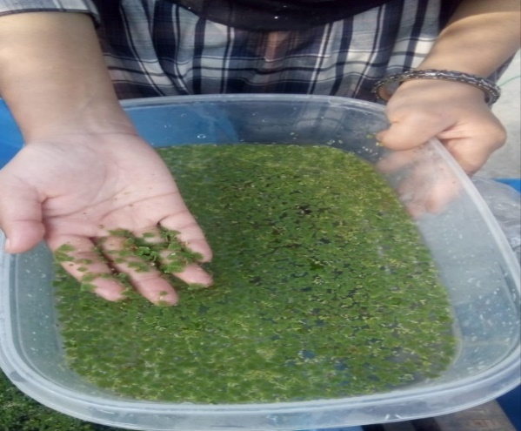

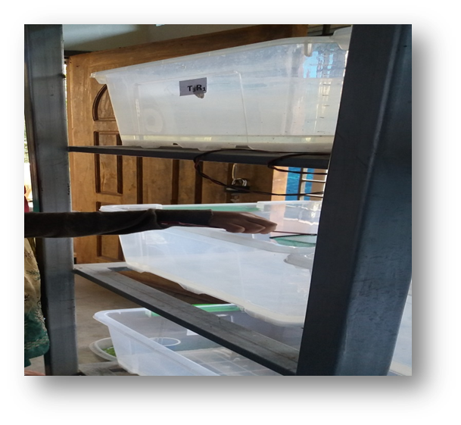
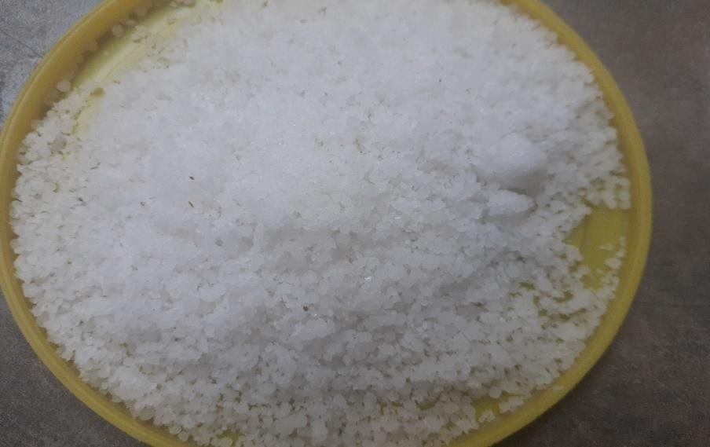
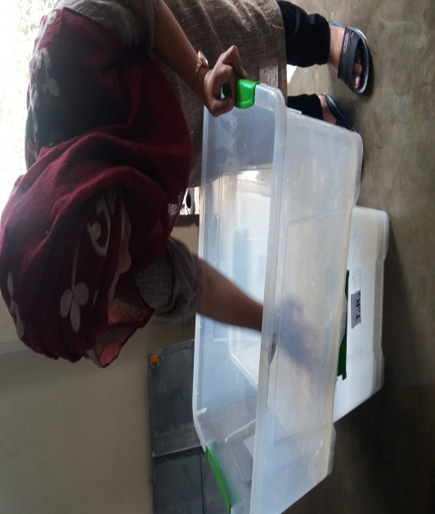
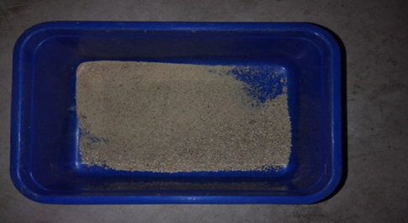
Plate 2: Plastic container set up for Azolla culture

Plate 3: Fertilizer treatment (TSP and UREA)
Plate 1: Azolla collection

Plate 5: pH Treatment
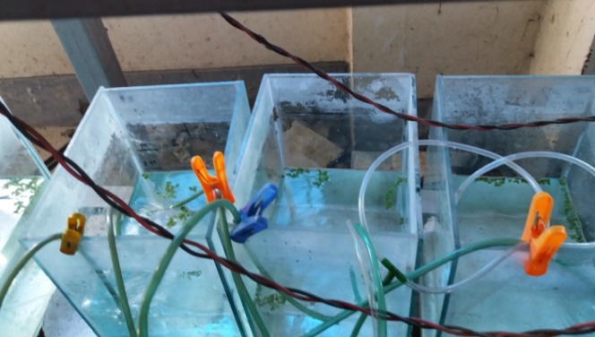

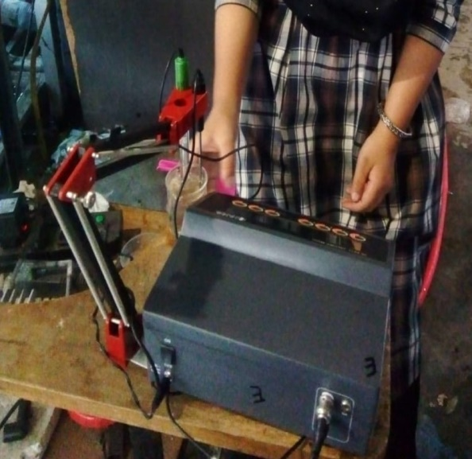
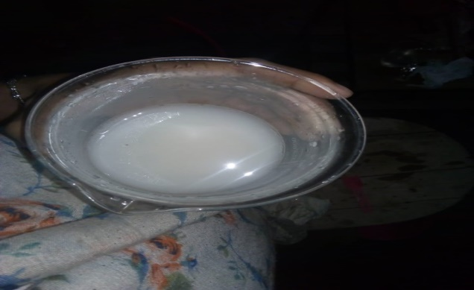
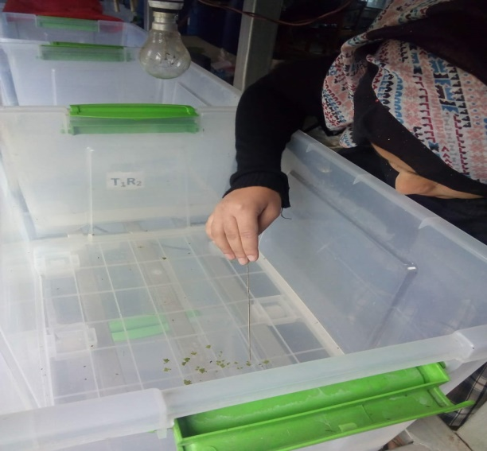
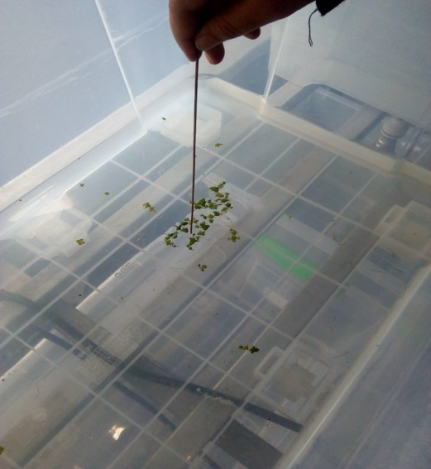
Plate 4: Aerator treatment
Plate 6: cell counting
Plate 5: pH Treatment
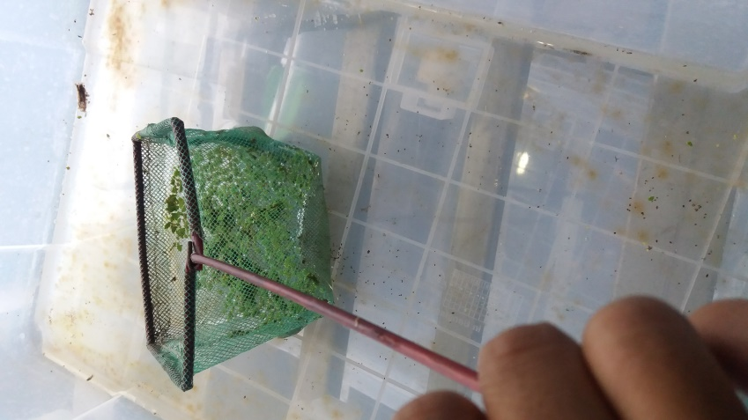
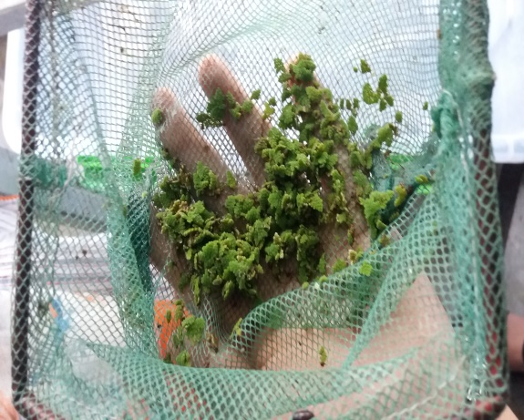
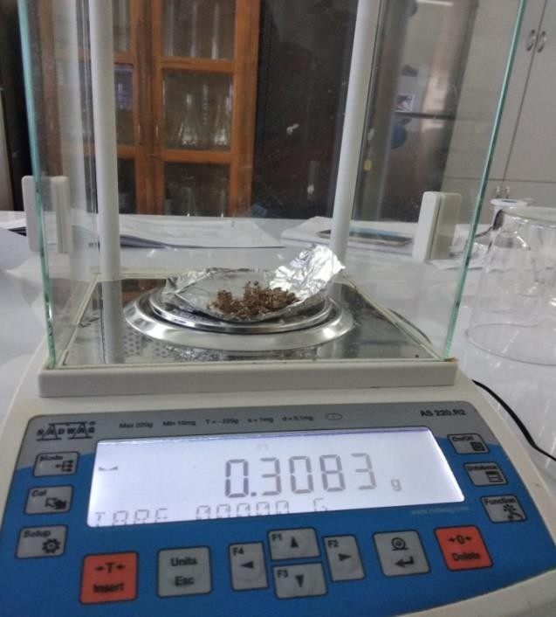
Plate 8: Weighting of sample
Plate 7: Sampling
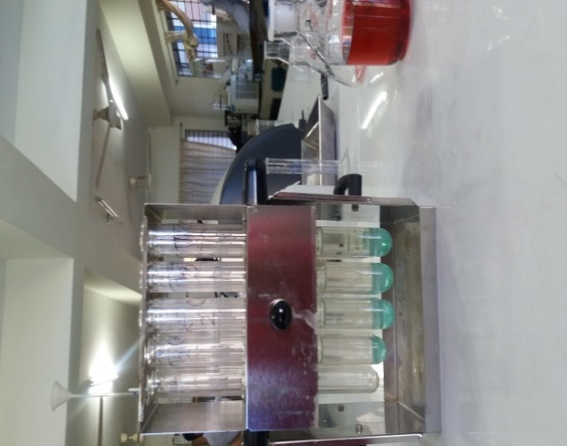
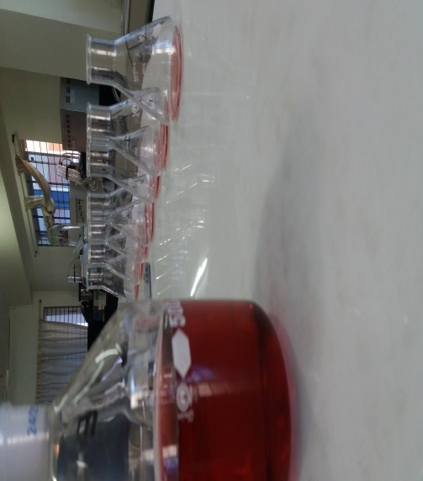

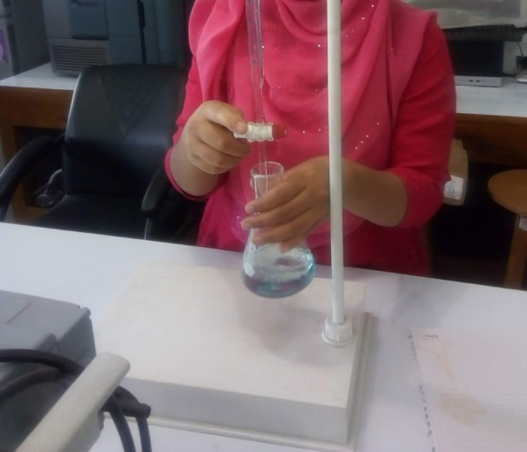
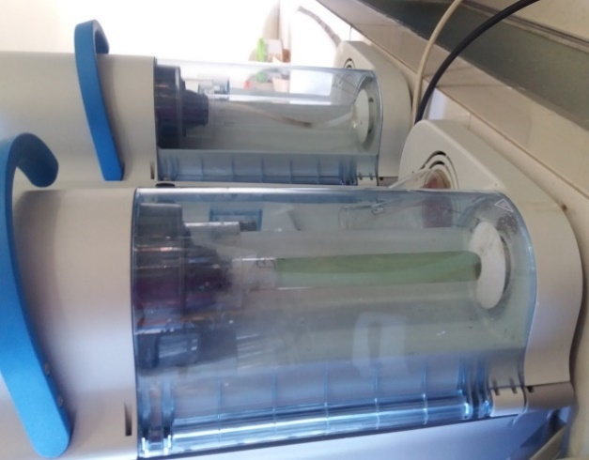

Plate 9: Laboratory analysis

Chapter-4: RESULT
Fertilizer (Nitrogen and Phosphorus), different oxygen levels, different pH levels have a wide range of effects on the aquatic plant (Azolla pinnata). An attempt has been undertaken in the present study to demonstrate the effects of all the parameters on Azolla culture.
4.1 Effect of Different treatments on growth performance of Azolla
4.1.1 Experiment 1 (the combination of nitrogen and phosphorus)
In the final sampling of 1st experiments, it showed that the total average cell number of each treatment such as T0, T1, T2, and T3 were 56.67±10.693, 79.33±5.508, 61.00±2.00, 54.00±6.557, and the average weight of each treatment such as T0, T1, T2 and T3 was 0.5633±0.10066g, 0.7833±0.11504g, 0.5967±0.07506g, and 0.5367±0.07767g respectively.
Data in Table 9 showed that the Azolla provided with ‘Treatment-1(T1)” means treatment with a combination of fertilizer (Nitrogen=10mg/L, Phosphorus=30mg/L) plays role in higher growth in terms of cell number (figure- 1) and weight(figure- 2) while comparing with other treatments.
Table 9: Growth performance of Azolla (Experiment 1)
Experiments | Treatments | Cell no | Level of significance | Weight | Level of significance
Experiment no 1  (N & P) | T₀ | 56.67±10.693^{b}  (30.10-83.23) | 0.008 | 0.5633±0.10066ab  0.3133-0.8134 | 0.045
 | T₁ | 79.33±5.508ª (65.65-93.01) |  | 0.7833±0.11504ª  (0.4976-1.0691)
 | T₂ | 61.00±2.00^{b}  (56.03-65.97) |  | 0.5967±0.0750^{ab}  (0.4102-0.7831)
 | T₃ | 54.00±6.557^{b}  (37.71-70.29) |  | 0.5367±.07767^{b}  (0.3437-0.7296)
- Values are means ± S.D. Within a row, means with the same letters are significantly different (P < 0.05).
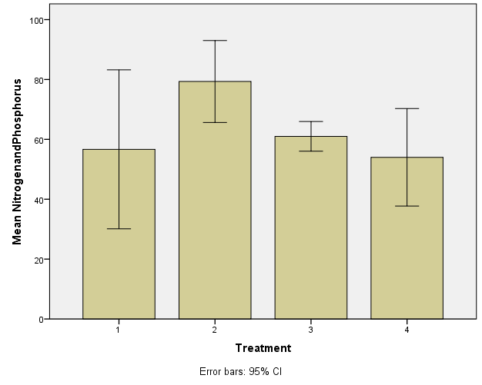
a
b
b
b

T0 T1 T2 T3

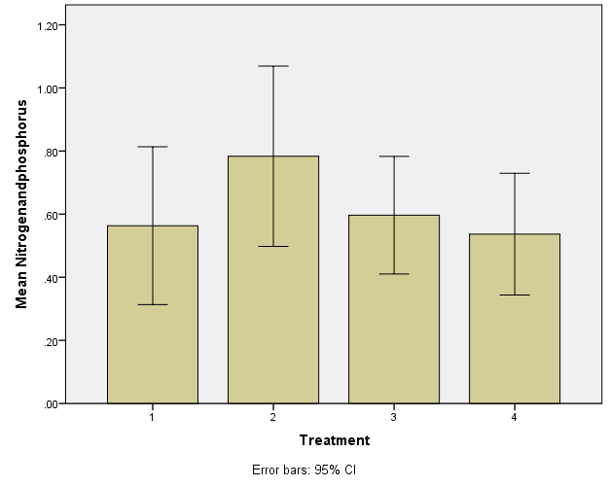
Figure 1: Effects of combination Nitrogen and Phosphorus on the cell number of Azolla (Mean ± SD). The cell number of Azolla of T₁, T_{2,} and T₃ were compared to the control group. Values accompanied by different letters are statistically significantly different (p < 0.05, n=4).
a

b
ab
b

T0 T1 T2 T3

Figure 2: Effect of the combination of Nitrogen and Phosphorus on the weight of Azolla (Mean ± SD). The weight of Azolla of T₁, T_{2,} and T₃ was compared to the control group. Values accompanied by different letters are statistically significantly different (p < 0.05, n=4).
4.1.2 Experiment 2(Phosphorus)
In 2nd experiments, it showed that the total average cell number of each treatment such as T0, T1, T2 and T3 were 57.67±10.693, 73.00±7.550, 101.67±17.559, and 109.00±21.284 and the total average weight of each treatment such as T0, T1, T2 and T3 was 0.5700±0.13077g,0.7233±0.09018g,0.9867±0.21008g, and 1.0300±0.35384g respectively.
Data in (Table 10) showed that the Azolla provided with Treatment-4(T3) means experiments with fertilizer (P=6.5mg) plays role in higher growth in terms of cell number (Figure - 3) and weight (Figure-4) while comparing with other treatments.
Table 10: Growth performance of Azolla (Experiment 2)
Experiments | Treatments | Cell no | Level of significance | Weight | Level of significance
Experiment no 2  (P) | T₀ | 57.67±10.693^{b} (31.10-84.23) | 0.01 | 0.5700±0.13077 ^{ab}  (0.2452-.8948) | 0.098
 | T₁ | 73.00±7.550^{ab} (54.25-91.75) |  | 0.7233±0.09018ª  (0.4993-0.9474)
 | T₂ | 73.00±7.550^{ab} (54.25-91.75) |  | 0.9867±.21008ª  (0.4648-1.5085)
 | T₃ | 109.00±21.284ª  (69.19-101.47) |  | 1.0300±.35384ª  (0.1510-1.9090)

- Values are means ± S.D. Within a row, means with the same letters are significantly different (P < 0.05).

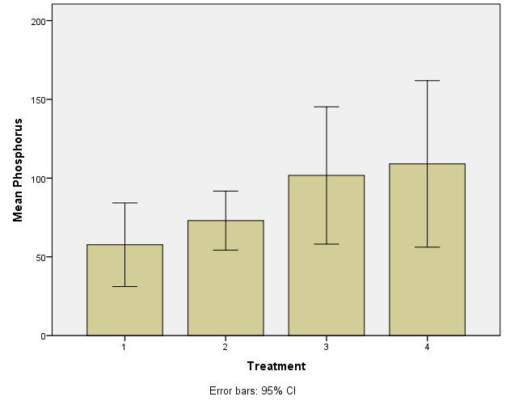
a
ab

ab
b

T0 T1 T2 T3

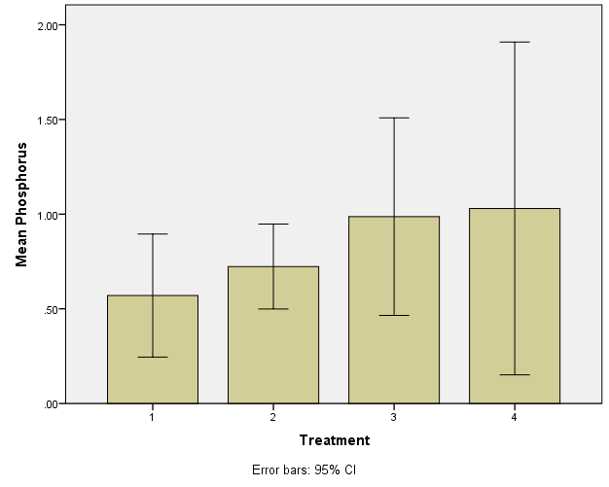
Figure 3: Effects of Phosphorus on cell number of Azolla (Mean ± SD). The cell number of Azolla of T1, T2, and T3 were compared to the control group. Values accompanied by different letters are statistically significantly different (p < 0.05, n=4)
a

a

ab
a

T0 T1 T2 T3

Figure 4: Effect of Phosphorus on the weight of Azolla (Mean ± SD). The weight of Azolla of T₁, T_{2,} and T₃ were compared to the control group. Values accompanied by different letters are statistically significantly different (p < 0.05, n=4.)
4.1.3 Experiment 3 (Different Oxygen Level)
In the 3rd experiments, after final sampling, the total average cell number of each treatment such as T0, T1, T2, and T3 were 57.00±10.149, 78.33±29.19, 52.33±4.509, and 30.67±6.028 and the total average weight of each treatment such as T0, T1, T2 and T3 was 0.5667±0.08083g, 0.7700±0.16462g, 0.5200±0.05568g, 0.3000±0.05000g respectively.
The data (Table 11) showed that the Azolla provided with Treatment-2(T1) mean Experiments with the oxygen level (DO=7.01) plays role in higher growth in terms of cell number (Figure-5) and weight (Figure-6) while comparing with other treatment.
Table 11: Growth performance of Azolla (Experiment 3)
Experiments | Treatments | Cell no | Level of significance | Weight | Level of significance
Experiment no 3  (D0) | T₀ | 57.00±10.149ab  (31.79-82.21) | 0.039 | 0.5667±0.08083 ª  0.3659-0.7675 | 0.003
 | T₁ | 78.33±29.195a  (5.81-150.86 |  | 0.7700±.16462ª  (0.3611-1.1789)
 | T₂ | 52.33±4.509^{ab}  (41.13-63.53) |  | 0.5200±0.05568^{ab}  (0.3817-0.6583)
 | T₃ | 30.67±6.028^{b}  (40.42-68.75) |  | 0.3000±0.05000^{b}  (0.1758-0.4242)

- Values are means ± S.D. Within a row, means with the same letters are significantly different (P < 0.05).

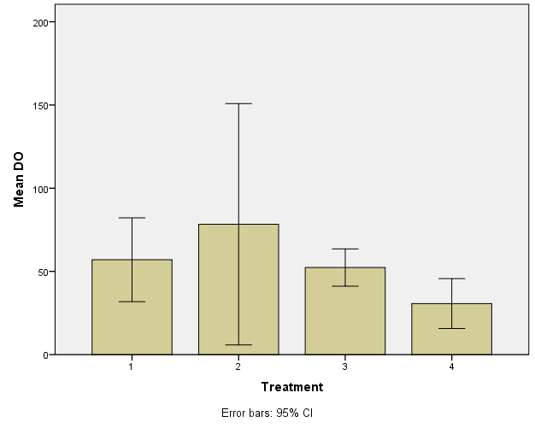
a

ab
ab
b

T0 T1 T2 T3

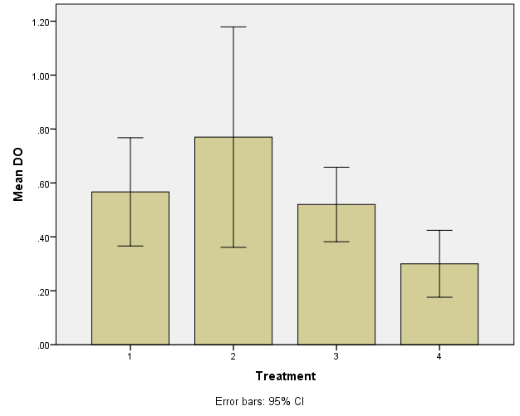
Figure 5: Effects of Different Oxygen level (DO) on cell number of Azolla (Mean ± SD). The cell number of Azolla of T₁, T_{2,} and T₃ were compared to the control group. Values accompanied by different letters are statistically significantly different (p < 0.05, n=4).
a

a
ab

b

T0 T1 T2 T3

Figure 6: Effect of Different Oxygen Level (DO) on the weight of Azolla (Mean ± SD). The weight of Azolla of T₁, T_{2,} and T₃ was compared to the control group. Values accompanied by different letters are statistically significantly different (p < 0.05, n=4).
4.1.4 Experiment 4(Different pH Level)
In the last sampling of 4th experiments, it showed that the total average cell number of each treatment such as T0, T1, and T2 were 59.67±7.638, 49.67±7.638, and 37.33±2.517, and the total average weight of each treatment such as T0, T1, and T2 was 0.5833±.08083g, 0.4800±.07937g and 0.3767±.04163g respectively.
Data in (Table 12) showed that the Azolla provided with Treatment-0(T0) means experiments with the level of (pH=6.5) plays role in higher growth in terms of cell number (Figure -7)and weight(Figure -8) while comparing with other treatments.
Table 12: Growth performance of Azolla (Experiment 4)
Experiments | Treatments | Cell no | Level of significance | Weight | Level of significance
Experiment no 4  (pH) | T₀ | 59.67±7.638ª  (40.69-78.64) | 0.015 | 0.5833±0.08083ª  0.3825-0.7841 | 0.031
 | T₁ | 49.67±7.638^{ab} (30.86-68.48) |  | 0.4800±0.07937^{ab}  (0.2828-0.6772)
 | T₂ | 37.33±2.517^{c}  (31.08-43.58) |  | 0.3767±0.04163^{b}  (0.2732-0.4801)

- Values are means ± S.D. Within a row, means with the same letters are significantly different (P < 0.05).

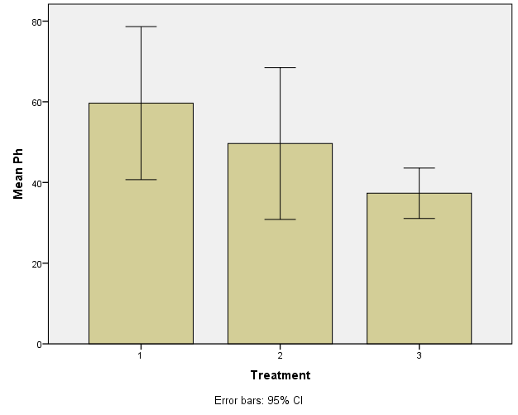
ab
a

c

T0 T1 T2 T3

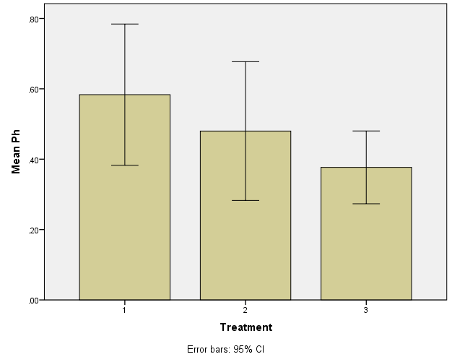
Figure 7: Effects of Different level of pH on cell number of Azolla (Mean ± SD). The cell number of Azolla of T₁ and T₂ were compared to the control group. Values accompanied by different letters are statistically significantly different (p < 0.05, n=3).
a
ab

b

T0 T1 T2

Figure 8: Effect of Different level of pH on the weight of Azolla (Mean ± SD). The weight of Azolla of T₁ and T₂ were compared to the control group. Values accompanied by different letters are statistically significantly different (p < 0.05, n=3).

4.1.5 Experiment 5 (Based on the best result of Experiment 1-4)
In the terminal sampling of 5th experiments, it presented that the total average cell number of Azolla of each treatment 101.00±18.52, 116.67±20.207, and the total average weight of Azolla of each treatment such as T0, T1, and T2 was 0.5767±0.07024g, 0.9933±0.12503g and 1.1400±0.06928g respectively. The data showed that the Azolla provided with Treatment T2 means experiments with the level of (Combination of phosphorus=6.5mg/l, DO=7.01, pH= 6.5) plays role in higher growth in terms of cell number (Figure-9) and weight (Figure-10) while comparing with other treatments such as T0, T1, and T2 were 59.00±9.16, 101.00±18.52, 116.67±20.207 and the total average weight of Azolla of each treatment such as T0, T1, and T2 was 0.5767±0.07024g, 0.9933±0.12503g and 1.1400±0.06928g respectively.
Data in Table 13 showed that the Azolla provided with Treatment-3(T2) means experiments with the level of (Combination of phosphorus=6.5mg/l, DO=7.01, pH= 6.5) plays role in higher growth in terms of cell number (Figure-9) and weight (Figure-10) while comparing with other treatments.
Table 13: Growth performance of Azolla (Experiment 5)
Experiments | Treatments | Cell no | Level of significance | Weight | Level of significance
Experiment no 5 | T₀ | 59.00±9.165^{b} (36.23-81.77) | 0.014 | 0.5767±0.07024 ^{b}  (0.4022-0.7511) | 0.001
 | T₁ | 101.00±18.52ª (54.99-147.01) |  | 0.9933±0.12503ª  (0.6827-1.3039)
 | T₂ | 116.67±20.207a  (66.47-166.86) |  | 1.1400±0.06928ª  (0.9679-1.3121)

- Values are means ± S.D. Within a row, means with the same letters are significantly different (P < 0.05).

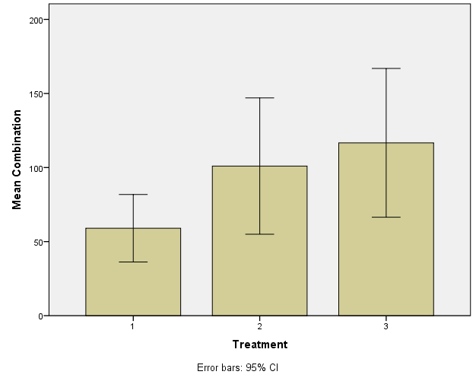
a
a

b

T0 T1 T2

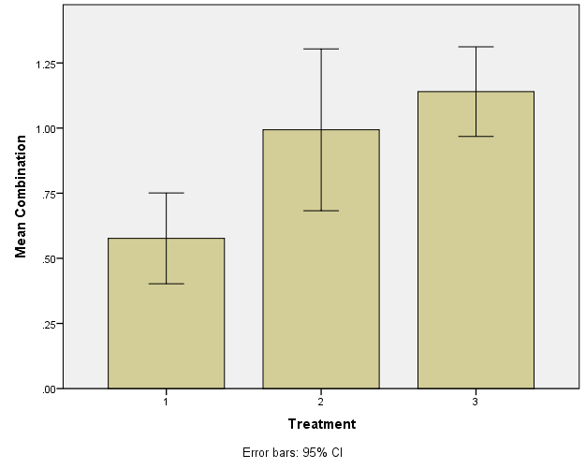
Figure 9: Effects of the combination of the best result of experiments 1-4 on cell number of Azolla (Mean ± SD). The cell number of Azolla of T₁ and T₂ were compared to the control group. Values accompanied by different letters are statistically significantly different (p < 0.05, n=3).
a
a

b

T0 T1 T2

Figure 10: Effect of (the combination of best result of experiment 1-4) on the weight of Azolla (Mean ± SD). The weight of Azolla of T₁ and T₂ were compared to the control group. Values accompanied by different letters are statistically significantly different (p < 0.05, n=3).

4.2 The protein content of experimental Azolla

In the 1st experiment, the highest protein content was found in treatment-3(T2) than other treatments. The protein content of each treatment such as T0, T1, T2 and T3 was 26.84%, 30.20%, 32.93%, 28.02% respectively. In the 2nd experiment, the highest protein content was found on treatment T3 than other treatments. The protein content of each treatment such as T0, T1, T2 and T3 was 26.84%, 29.47%, 32.65%, 33.47% respectively. In the 5th experiment, the highest protein content was found on treatment -3(T2) than other treatments. The protein content of each treatment such as T0, T1, and T2 was 26.84%, 32.75%, 35.66% respectively.

Table 14: Protein content of Azolla
Treatments | Factors
 | Experiment 1  N & P | Experiment 2  P | Experiment 5  Based on the best result of Experiment 1-4
T0 | 26.84% | 26.84% | 26.84%
T1 | 30.20% | 29.47% | 32.75%
T2 | 32.93% | 32.65% | 35.66%
T3 | 28.02% | 33.47%

The highest protein content was found on treatment T2 in Experiment 5 which was 35.66%.

Chapter-5: Discussion

The present study was conducted to grasp the effect of fertilizer (Nitrogen & Phosphorus) and water quality parameters (DO and pH) on the expansion and protein content of Azolla. Several changes are documented during this present study like cell number, weight, protein content, etc.
5.1 Experiment 1(Effect of the combination of nitrogen and phosphorus on Azolla growth)
The results of the study showed an interaction between treatments employing a combination of N₂ and P to the cell number, weight, and protein content of plant Azolla pinnata. After completion of the first experiment, the average dry weight, cell number were evaluated using one-way ANOVA (P<0.05). It might be observed from the study that combination treatment T1 (10 mg atom/L N + 30 mg atom/L P) accelerated the cell number, which was 79.33±5.508 and total weight 0.7833±0.11504g. On the opposite hand, treatment combinations T3 (20mg atom/L N + 5 mg atom/L P) obtained the lower result for cell number and dry weight, which were 54.00±6.557 and 0.5367±0.07767 because the high amount of Nitrogen gave a negative result. These experiments showed that a combination of much more phosphorus and less nitrogen gave the highest growth. Besides the combination of the high amount of nitrogen and less amount of phosphorus showed a negative result. So excess nitrogen showed negative results. Azolla can manage nitrogen from nature. Nitrogen fertilizer is not the limiting factor for Azolla. Azolla growth was highly affected by the presence of phosphorus fertilizer. When nitrogen and phosphorus were used together then much more phosphorus is required. This work represents that Azolla without fertilizer show lower growth than the Azolla with fertilizer supplementation (p<0.05) which undoubtedly indicates that fertilizer has great effects on Azolla growth. It would be caused by P which is the limiting factor for Azolla growth.
Based on the results of the study (Handajani H. 2011) the addition of combination N (Urea) and P (TSP) concentration could increase the yield Azolla pinnata fresh and dry weight and accelerate the cell growth of A.pinnata. (Handajani H.2011) reported that the best results of dry weight were shown by treatment using T1 at 10 mg atom/L N and 30 mg atom/L P. It would be caused by N jointly of the macronutrients required for cell biosynthesis during photosynthesis to yield energy. It is, then, utilized for the formation of plant tissues of A. pinnata. It may be, also, influenced by the supply of the P element, which is that the main nutrient limiting the expansion and development of A. azollae, and also the addition of N. Treatment with the high amount of Nitrogen gave negative result on the premise of Azolla cell number and weight. Besides, Azolla with a high amount of nitrogen fertilizer also showed lower growth performance. Azolla needs a little amount of nitrogen due to Azolla –Anabaena symbiosis. The Azolla-Anabaena symbiosis has been called a super organism that mixes the individual talents of two very different organisms. The cyanobacteria Anabaena evolved during the first history of the planet quite three billion years ago when the planet’s atmosphere was empty of oxygen. The opposite organism is that the fern Azolla. Azolla’s floating leaves contain cavities that provide a microenvironment for Anabaena which pulls down up to 1000 kg of atmospheric nitrogen per acre each year. The nitrogen provides a natural fertilizer for Azolla growth, freeing the plant from its reliance on soil and enabling it to grow free-floating on freshwater bodies. Therefore, the provision of N elements will affect biomass production ( Heide T.V.D.2006). In common, the addition of N in a very high number will cause a negative effect on the association (Arora A. 2005).
5.2 Experiment 2 (Effect of phosphorus on Azolla growth)
After finishing Experiment 1, It showed that external nitrogen supply was not necessary for azolla growth. Besides, it required a high amount of phosphorus when it is treated with a combination of nitrogen and phosphorus. For this reason, only phosphorus fertilizer without nitrogen is used to know the effect and optimum requirement of p for the high growth of Azolla.
In the current study period, supplementation of phosphorus improved the expansion performances of Azolla, and therefore the highest (p<0.05) final cell number and weight were found in 6.5mg/l phosphorus fertilizer than the control Azolla. Azolla with phosphorus has better growth performance than the Azolla without phosphorus. It may well be observed from the study that treatment T3 (6.5 mg atom/L P) accelerated the cell number, which was 109.00±21.284, and also the weight, which was 1.0300±0.35384g. Phosphorus is one of the foremost plant nutrients for the plant. It's a constituent of plant cells, essential for the organic process and also the development of the growing tip of the plant. The phosphorus content in Azolla increased linearly with increased external phosphorus concentration (0 to 10 ppm) altogether strains (Budunkila et al., 1981).On the opposite hand, treatment combinations T0 (without phosphorus fertilizer) obtained the lower result for cell number, which was 57.67±10.693, and also the weight, which was 57.00±.13077. Phosphorus deficiency limits Azolla growth. Without phosphorus, the expansion of all varieties was severely affected. With phosphorus, the fresh matter production increased from the lower to the upper doses up to 5 ppm P, following a quadratic form of relationship (Budunkila et al., 1981).
In the experiment, Azolla with treatment T1 (2.5 mg/l) showed deficiency symptoms. The quantity of the nutrient is sufficient at the start but becomes deficient later thanks to the increased requirement of the exponentially growing biomass (INGEST AD, T.,1977). The same observation (Budunkila et al., 1981) also found that, at 2.5 ppm P, the gathering from Cuttack exhibited deficiency symptoms-browning, fragility, and poor growth. During this experiment, it was also found that Azolla treated with 4mg/l and 6.5mg/l gave a quite similar result. It could happen because Increasing the phosphorus to over 5 ppm within the medium didn't increase the expansion significantly, indicating a luxury consumption of phosphorus an identical observation has been made by Budunkila et al., 1981.
5.3 Experiment 3 (Effect of Different Level of Oxygen on Azolla growth)
In 3rd experiments, after final sampling, the entire average cell number of every treatment like T0, T1, T2 and T3 were 57.00±10.149, 78.33±29.19, 52.33±4.509, and 30.67±6.028 and therefore the total average weight of every treatment like T0, T1, T2, and T3 was 0.5667±0.08083g, 0.7700±0.16462g, 0.5200±0.05568g and 0.3000±0.05000g respectively. The info showed that the Azolla given Treatment-2(T1) means experiments with the oxygen level (DO=7.01) plays role in higher growth in terms of cell number and weight while comparing with other treatments. Azolla with an aerator can grow well in treatment T1 (DO=7.01) because it gave them optimum oxygen than Azolla without an aerator in treatment T0 (DO=4.5) which isn't optimum for Azolla to soak up the nutrient. Within the compilation of experiments, Azolla with treatment T2 (D0=7.31) and T3 (D0=8.02) gave poor results because excess oxygen harms the expansion of Azolla. The biological process in Azolla is regulated by light, in vivo, and in vitro, and occurs only upon illumination.
5.4 Experiment 4 (Effect of Different level of pH on Azolla growth)
After completion of research work, within the last sampling of 4th experiments, it showed that the common total cell number of every treatment like T0, T1, and T2 were 59.67±7.638, 49.67±7.638, and 37.33±2.517, and also the total average weight of every treatment like T0, T1, and T2 was 0.5833±0.08083g, 0.4800±0.07937g, 0.3767±0.04163g respectively. The information showed that the Azolla supplied with Treatment-0(T0) means experiments with the amount of (pH=6.5) plays role in higher growth in terms of cell number and weight while comparing with other treatments.
The present work represents that Azolla in moderate acidic condition show higher growth than Azolla in severe acidic and alkaline water (p<0.05) which undoubtedly indicate that pH has great effects on Azolla growth. Because such a lot of acidic conditions or alkalinity incorporates a negative impact on Azolla(fern). Usually, Azolla prefers a medium around neutrality or to some extent, acidic conditions. The optimal growth of pH varies from 4.5 to 7.5 (Cary and Weerts, 1992).
A. filiculoides and A. pinnata can, however, grow well at pH values between 5 and 7, while A. pinnata can grow relatively well in a very pH range between 5 and 8, while A. filiculoides only grow well within the 5 and 7 range (Cary and Weerts, 1992). The range of the given pH was also very near the expansion of A. filiculoides within the Anzali wetland (Sadeghi et al., 2012b). (Serag et al. 2000) demonstrated that optimal growth is at pH of the culture solution between 4.5 and 7, but Azolla can survive even at pH values starting from 3.5 to 10 (provided all important elements are available). Mousa (1994) demonstrated that under Egyptian conditions, Azolla grows well with a pH starting from 7.1 to 9.0. Finally, optimum growth in Azolla relies not only on pH but also on other environmental conditions.
5.5 Experiment 5 (Effect of the combination of best result of experiment 1-4 on Azolla growth)
In the terminal sampling of the 5th experiments, the info presented that the Azolla supplied with Treatment-2(T2) means experiments with the extent of the combination of (phosphorus=6.9mg/l, DO=7.01, pH= 6.5) plays role in higher growth in terms of cell number and weight while comparing with other treatments. Because Azolla with treatment T2 got optimum DO, pH, and phosphorus fertilizer which is that the most limiting factor for Azolla growth than Azolla with treatment T0 (without any external supplement). Besides Azolla with treatment T2(phosphorus=6.9mg/l, DO=7.01, pH= 6.5) gave better leads to terms of growth performance of Azolla than treatment T1 means experiments with the extent of the combination of (the combination of N=10 mg/l & P=30 mg/l, DO=7.01 mg/l, pH=6.5) because Azolla needs phosphorus supplement rather than nitrogen. Azolla shows high growth performance when treated with less amount of phosphorus (p=6.5mg/l) in n- free nitrogen and optimum water quality. It also found that A. fliculoides can double its biomass in one week in a very N-free nutrient solution growing in a P-rich environment, entirely hoping on the symbiosis with diazotrophs for its N supply. The expansion rates measured are within the range reported within the literature (Cary, P. R.1992). In laboratory experiments, Janes (1998) found that increasing phosphorus supply and/or plant density led to increased sporulation. If there is enough phosphorus in the aquatic environment, Azolla will be able to grow without the need to provide combined nitrogen such as NH₄NO₃ (Costa et al., 1999).
Azolla spp. can reach high growth rates by reproduction and are very strong phosphorus (P) and nitrogen (N) accumulators (Lumpkin. 1980) which makes them very suitable for phytoremediation, bio-gas production, animal(fish) food, and crop fertilization (Wagner. 1997) and (Valderrama et al.,2013) (van Hove. 2002). Because of their symbiosis with atmospheric nitrogen (N₂) fixing microorganisms (diazotrophs), the first production of the plants is seldom N- limited under natural conditions.
5.6 Effect of fertilizer and water quality parameter on the protein content of Azolla
A ﬂoating freshwater, Azolla pinnata is one in each of the aquatic plants with high biomass and protein production which might be used as an instantaneous ﬁsh feed or diet ingredient of another protein source (Radhakrishnan S. et al., 2014). Azolla has gained importance in aquaculture thanks to higher crude protein content (13% to 30%) and essential aminoalkanoic acid (EAA) composition (rich in lysine) than most green forage crops and other aquatic macrophytes (Panigrahi et al., 2014).
In the 1st experiment, the best protein content (32.93%) found on treatment- T2 (Nitrogen =5mg/l and phosphorus =20mg/l) than other treatments. Meanwhile, the best protein content was found in a very combination of 5 mg atom/L N and 20 mg atom/L P (Handajani H. 2011). In the 2nd experiment, the best protein content (33.47 %) was found on treatment T3 (phosphorus=6.5mg/l) than other treatments. within the 5th experiment, the best protein content (35.66%) was found on treatment -T2 (the combination of P=6.5mg/l, DO=7.01mg/l, and pH=6.5) than other treatments. Because with this treatment Azolla got optimum water quality (DO and pH) and phosphorus, which is that the most significant limiting factor for Azolla than nitrogen.
On a dry weight basis, Azolla has 25-35% protein content, 10-15% mineral content, and 7-10% comprising a combination of amino acids, bio-active substances, and biopolymers (Kamalasanana. 2002). Azolla meal contains 25.78% crude protein, 15.71% crude fiber, 3.47% ether extract, 15.76% ash, and 30.08% nitrogen-free extract on an air-dry basis (Basak et al., 2002).
Azolla seems to be an honest replacer of protein from expensive sources like ﬁsh meal counting on the feeding habits of the species. This can be because of proper corroboration between the activity patterns of the digestive enzymes in ﬁsh and therefore the essential nutrients like ω-6fatty acids from the Azolla diet. Also, the dietary Azolla supplementation shows to possess a positive effect on the expansion performance of ﬁsh and reduce the value of feeding on ﬁsh meal and ﬁsh oil diet. Besides, a rise of the biochemical parameters in various ﬁsh’s tissues revealed that the protein conversion ratio, mobilization, and utilization of glycogenic amino acids are very high, in ﬁsh fed with the Azolla diet. However, an excessive amount of Azolla incorporation within the diet will decrease ﬁsh growth performance and food conversion, probably because of low protein digestibility and high ﬁber contents.

Chapter 6: Conclusions
Throughout human history, people always attempt to experiment with novel and unconventional practices to higher the assembly and economic aspects of their operations. With current concerns of waste and by-product under management and mismanagement, the realm of other feeds has found itself on the frontline of improving agriculture together with the environment. Azolla may be a good source of other feed for the fish. Much of the research conducted on the feasibility of Azolla as a feed or feed supplement originates from Asia. The current study was conducted supported an analysis of the results of Fertilizer (N and P) and water quality (DO and pH) on Azolla which is used by fishes. The results of this research showing that every one of the factors has a possible role in better growth performance (final cell number, final weight) the protein content of Azolla. In aquaculture, most of the farming cost goes towards feeding costs to attenuate this problem we will use unconventional feed ingredients like Azolla which is one of the foremost available and cheap ingredients. this kind of research work will add a replacement dimension to enhance the fisheries industry as a result production of fish in Bangladesh. I hope the Azolla culture will get popularity within the fish farming community which eventually will minimize fish feed cost, thus fish farmers getting more profits from their production and as a result, improving their livelihood.

Chapter 7: Recommendation and Future perspectives
According to my search work, the following recommendations can be done:
- Azolla is exclusive because it's one of the fastest-growing plants on the earth – yet it doesn't need any soil to grow. So people can culture Azolla in their backyard to ponds.
- It can produce bio fertilizer, livestock feed, food, and biofuel as per people’s needs.
- Azolla seems to be an honest alternative source of protein from other expensive sources like ﬁsh meal looking at the feeding habits of the intended culture species.
- Azolla helps to draw down large amounts of CO₂ from the atmosphere, thus helping to scale back the threat of temperature change.
- It is comparatively inexpensive to provide or even regarded to possess no cost where the chance costs of family labor don't seem to be taken into consideration.
- It has long been evident that Azolla has the potential to become a significant protein commodity.
- It is readily grown locally often in waste ponds that are polluted. If Azolla grown on wastewater is to be considered as an animal feeding supplement in any meaningful way.
- Azolla has not yet been accepted as an ad crop.
As it's a pilot study, further studies could also be conducted in similar fields to create a concrete remark on Azolla’s culture.

References

Anitha KC, Rajeshwari YB, Prasanna SB, Shree JS.2016. Nutritive evaluation of Azolla as livestock feed. Journal of Experimental Biology and Agricultural Sciences. 4(6), pp.670-674.
Arora A, Saxena S. 2005. Cultivation of Azolla microphylla biomass on secondary-treated Delhi municipal effluents. Biomass and Bioenergy. 29(1), pp.60-64.
BaoLin L, FengXiang G, ZhaoHong N, RongMan X, Neng W, JiaRong Y.1989. Integrated rice field breeding mosquitos’ management in China. Yixue Dongwu Fangzhi, Pest Control .Volume, 5 (2): 87-93.
BaoLin L.1988.In: Vector-borne disease control in humans through rice agro ecosystem management. Proc. Research and Training Need in the Field of Integrated Vector-borne Disease Control in Riceland Agro ecosystems of Developing Countries.
Bar E, Tel-Or E. 1994. Effect of Light and Oxygen on Nitrogenase Activity and Dinitrogenase Reductase (Fe-protein) Content in AzollaAnabaena Association. Journal of plant physiology.144 (4-5), pp.438-443.
Budunkila Prakash Rao Subudhi & Iwao Watanabe (1981) Differential phosphorus requirements of Azolla species and strains in phosphorus-limited continuous culture, Soil Science and Plant Nutrition, 27:2, 237-247
Basak B, Pramanik MAH, Rahman MS, Tarafdar SU, Roy BC. 2002. Azolla (Azolla pinnata) as a feed ingredient in broiler ration. Int. J. Poult. Sci, 1(1), pp.29-34.
Cagauan AG, Branckaert RD, Van HC.2000. Integrating fish and azolla into rice- duck farming in Asia. Naga ICLARM Q. vol.23, pp.4–10.
Cagauan AG, Pullin RSV. 1991. Azolla in aquaculture: Past, present, and future. In J. Muir & R.J. Roberts, eds. Recent Advances in Aquaculture. Oxford, Blackwell Science. pp. 104-130.
Cagauan AG,Pullin RSV. 1994. Azolla in aquaculture: past, present and future. Recent advances in aquaculture 5. pp.104-130.
Cagauan AG, Pullin RSV.1994. Azolla in aquaculture: Past, present, and future. In Recent Advances in Aquaculture.Muir J, Roberts RJ, Eds.; Blackwell Science: Oxford, UK, pp. 104–130.
Cagauan AG, Branckaert RD, Hove C.2000. Integrating fish and Azolla into rice-duck farming in Asia.
Caiola MG, Canini A, Moscone D. 1989. Oxygen concentration, nitrogenase activity, and heterocyst frequency in the leaf cavities of Azolla filiculoides Lam, FEMS Microbiology Letters. Volume 59(3), pp.283–287.
Campbell R.2011. Azolla growth in farm dams. Agriculture Victoria. onlinehttp/agriculture. vic. gov. au/agriculture/farm. Date accessed. 14(3), p.2016.
Carrapiço F. 1991. Are bacteria the third partner of the Azolla-Anabaena symbiosis? P1. & Soil. vol. 137, pp. 157-160.
Carrapiço F.2010. Azolla as a super organism. Its implication in the symbiotic studies. In “Stress Biology”. Seckbach, J. and Grube, M. (Eds). Published by Springer.
Carrapico FJ.2002. Azolla-anabaena-bacteria system as a natural microcosm. In Instruments, Methods, and Missions for Astrobiology IV .Vol. 4495, pp. 261-265. International Society for Optics and Photonics.
Cary PR, Weerts PGJ. 1992. Growth and nutrient composition of A. pinnata R. Brown and A. filiculoides Lam. as affected by water temperature, nitrogen and phosphorus supply, light intensity, and pH. Aquatic Botany, vol. 43, pp. 163- 180.
Costa ML, Santos MCR, Carrapico F.1999. Biomass characterization of A. filiculoides grown in natural ecosystems and wastewater. Hydrobiology.vol. 415, pp. 323- 327.
Costa ML, Santos MCR., Carrapico F, Pereirac AL.2009.Azolla-Anabaena’s behavior in urban wastewater and artificial media-Influence of combined nitrogen. Water Resource. 43, 3743-3750.
DM C, Prasad RMV, JagadeeswaraRao S, Jayalaxmi P, Kumar, DS.2014. A study on the nutritive value of Azolla pinnata.
DoF.2018.Yearbook of Fisheries Statistics of Bangladesh 2018-2019. Fisheries Resources Survey System, Department of Fisheries. Bangladesh: Director General. DoF, 2-7.
Ebrahim MSM, Zeinhom MM, Abou-Seif RA.2007. Response of Nile tilapia (Oreochromis niloticus) fingerlings to diets containing Azolla meal as a source of protein. Journal of the Arabian Aquaculture Society. 2(1), pp.54-69.
Edwards DJ. 1975. Taking a bite at the waterweed problem. New Zealand Journal of Agriculture. 130(1), pp.33-36.
EL Katony TM, Serao MS, Badway AM, Mous MA. 1996. Effect of phosphorus on growth and uptake of nutrients by A. filiculoides Lam. Journal of Environmental Sciences. 12, 69-88.
Fang Y, Babourina O, Rengel Z, Yang XE, Pu PM. 2007. Spatial distribution of ammonium and nitrate fluxes along with the roots of wetland plants. Plant Science. 173, 240- 246.
FAO.2014. Food and Agriculture Organization of the United Nations; Euro span distributor, Rome, London, UK. pp.: 39-44
FAO .2018.Fisheries and Aquaculture Department, United Nations (UN), 2012.
Fiogbé ED, Micha, JC,Van Hove C. 2004. Use of a natural aquatic fern, Azolla microphylla, as a main component in food for the omnivorous–phytoplanktonophagous tilapia, Oreochromis niloticus L. Journal of Applied Ichthyology. 20(6), pp.517-520.
Reddy j.2020.Azolla as livestock feed,Agricultural farmimg,2020.
Handajani H. 2011. Optimation of nitrogen and phosphorus in Azolla growth as biofertilizer. Makara Journal of Technology. 15(2), p.7.
Hasan MR, Rina C. 2009. Use of algae and aquatic macrophytes as feed in small-scale aquaculture: a review (No. 531). Food and Agriculture Organization of the United Nations (FAO).
Van der Heide T, Roijackers RM, Van Nes EH, Peeters ET.2006. A simple equation for describing the temperature dependent growth of free-floating macrophytes. Aquatic Botany. 84(2), pp.171-175.
Hussner A. 2010. NOBANIS–Invasive alien species Fact Sheet–Azolla filiculoides, online http/ www.nobanis.org.
Ingestad T. 1977. Nitrogen and plant growth; maximum efficiency of nitrogen fertilizers. Ambio, pp.146-151.
Islam AKMN. 1993. Growth water content and chemical composition of Azolla pinnata R.Br. in relation to acidity [Bangladesh].
Janes R.1998. Growth and survival of A. filiculoides in Britain.1. Vegetative reproduction. New Phytologist. 138, 367-376.
Kamalasanana PP. 2002. Azolla-A sustainable feed substitute for livestock. Leisa India, 4, pp.15-17.
Katony ETM, Serao MS, Badway AM, Mousa MA. 1996. Effect of phosphorus on growth and uptake of nutrients by A. filiculoides Lam. Journal of Environmental Sciences. 12, 69-88.
Kitoh S, Shiomi N. 1991. Effect of mineral nutrients and combined nitrogen sources in the medium on growth and nitrogen fixation of the Azolla anabaena association. Soil Science and plant nutrition. 37(3), 419-426.
Kitoh S, Shiomi N, Uheda E. 1993. The growth and nitrogen fixation of Azolla filiculoides Lam. in polluted water. Aquatic botany.46, 129-139.
Kondo M, Kobayashi M, Takahashi. 1989. Effect of phosphorus on Azolla and its utilization in rice culture in Niger. Plant Soil. 120, 165-170.
Kushari DP, Watanabe I.1992. Differential responses of azolla to phosphorus deficiency: II. Screening method under concentration controlled conditions. Soil Science and Plant Nutrition. 38(1), pp.65-73.
Light castle analytics.2019. Bangladesh Fisheries sector: Growth Prospects Opportunities. Databd.co https://databd.co/stories/bangladesh-fisheries-sector-growth-prospects-and-opportunities-1374.
Lumpkin TA, Plucknett DL. 1980. Azolla: Botany, physiology, and use as green manure. Economic Botany, 34 (2): 111-153.
Lumpkin TA, Plueknett DL.1985. Azolla, a low cost aquatic green manure for agricultural crops. In: Office of Technology Assessment, Innovative biological technologies for lesser developed countries: workshop proceedings.107-124.
Lumpkin T, Plucknett D.1980. Azolla: Botany, physiology, and use as green manure.Economic Botany 34, 111–153.
Maity J, Patra BC. 2008. Effect of replacement of fishmeal by Azolla leaf mael on growth, food utilization, pancreatic protease activity and RNA/DNA ratio in the fingerlings of Labeo rohita (Ham.). Canadian Journal of pure and applied sciences. 323.
Mohanty SN, Dash S.P .1995. Evaluation of Azolla caroliniana for inclusion in carp diet. Journal of Aquaculture in the Tropics. 10, pp.343-354.
Moretti A, Gigliano GS.1988. Influence of light and pH on growth and nitrogenase activity on temperate-grown Azolla. Biology and fertility of soils.6(2), pp.131-136.
Mousa MA. 1994. Eco-physiological studies on the Azolla plants in Damietta District. M.Sc. Thesis, Fac Sci, Damietta, Mansoura Univ, Egypt.
Panigrahi S, Choudhary D, Sahoo JK, Das SS, Rath RK. 2014. Effect of dietary supplementation of Azolla on growth and survivability of Labeo ruhita fingerlings Asian j Animal sci.9:33-37.
Panigrahi S., Choudhury, D., Sahoo, J.K., Das, S.S. and Rath, R.K., 2014. Effect of dietary supplementation of Azolla on growth and survibility of Labeo rohita fingerlings. Asian Journal of Animal Science, 9(1), pp.33-37.
Peters GA, Meeks JC. 1989. The Azolla-Anabaena symbiosis: basic biology. Annu.Rev. Plant Physiol. Plant Mol. Biol. vol. 40, pp. 193-210.
Pillai K, Premalatha S, Rajamony S. 2002. Azolla – A sustainable feed substitute for livestock. Leisa India, pp. 15-17.
Prabina BJ, Kumar K.2010. Dried Azolla as a nutritionally rich cost effective and immuno-modulatory feed supplement for broilers. Asian Journal of Animal Science. 5(1), pp.20-22.
Radhakrishnan S, Bhavan PS, Seenivasan C, Shanthi R, Muralisankar T. 2014. Replacement of fishmeal with Spirulina platensis, Chlorella vulgaris and Azolla pinnata on non-enzymatic and enzymatic antioxidant activities of Macrobrachium rosenbergii. The Journal of Basic & Applied Zoology. 67(2), pp.25-33.
Rai AK, Rai V.2003. Effect of NaCl on growth, nitrate uptake and reduction and nitrogenase activity of Azolla pinnata–Anabaena azollae.Plant Science.164(1), pp.61-69.
RAINs, D.W. and TALLEY, S.N., Use of Azolla in North America, In Nitrogen and Rice, International Rice Research Institute, Los Banos, Philippines, 1979. pp. 419-431
Rao BP, Subudhi, Watanabe I.1981.Differential phosphorus requirements of Azolla species and strains in phosphorus-limited continuous culture. Soil Science and Plant Nutrition, vol.27:2, pp.237-247.
Sadeghi R, Zarkami R, Sabetraftar K, Van Damme P. 2012a. Use of support vector machines (SVMs) to predict distribution of an invasive water fern Azolla filiculoides (Lam.) in Anzali wetland, southern Caspian Sea, Iran. Ecological Modelling. 244, 117–126.
Sadeghi R, Zarkami R, Sabetraftar K, Van Damme P. 2012b. Application of classification trees to model the distribution pattern of a new exotic species Azolla filiculoides (Lam.) at Selkeh Wildlife Refuge, Anzali wetland, Iran. Ecological Modelling. 243, 8–17.
Sadeghi R, Zarkami R, Sabetraftar K, Van Damme P. 2013. Application of genetic algorithm and greedy stepwise to select input variables in classification tree models for the prediction of habitat requirements of Azolla filiculoides (Lam.) in Anzali wetland, Iran. Ecological Modelling.251, 44–53.
Sabetraftar K, Zarkami R, Sadeghi R, Van Damme P. 2013. A review of some ecological factors affecting the growth of Azolla spp. Caspian Journal of Environmental Sciences. 11(1), pp.65-76.
Serag MS, El-Hakeem A, Badway M, Mousa MA. 2000. on the ecology of A. filiculoides Lam. in Damietta District, Egypt. Limnologica. 30, 73-81.
Shiomi N, Kitoh S. 2001. Culture of Azolla in a pond, nutrient composition, and use as fish feed. Soil science and plant nutrition. 47(1), pp.27-34.
Singh PK. 1977. Azolla plants as fertilizer and feed. Indian Farming. vol. 27, pp. 19- 22.
Singh PK, Singh DP, Singh R P. 1992. Growth, acetylene reduction activity, nitrate uptake, and nitrate reductase activity of Azolla caroliniana and Azolla pinnata at varying nitrate levels. Biochem. Physiol. Pflanzen.vol. 188, pp. 121-127.
Sithara K, Kamalaveni K.2008. Formulation of low-cost feed using Azolla as a protein supplement and its influence on feed utilization in fishes. Current Biota 2: 212-219.
Sood A, Uniyal PL, Prasanna R, Ahluwalia AS. 2012. Phytoremediation potential of aquatic macrophyte, Azolla. Ambio. 41 (2),pp. 122–137.
Subudhi BPR, Singh PK.1979.Effect of phosphorus, and nitrogen on growth, chlorophyll, amino nitrogen, soluble sugar content, and heterocyst of water fern Azolla pinnata. Biologia Plantarum. 21(6), pp.401-407.
Tran G. 2015. Azolla, Feedpedia, a programme by INRAE, CIRAD, AFZ and FAO.
Valderrama A, Tapia J. Peñailillo P, Carvajal DE. 2013.Water phytoremediation of cadmium and copper using Azolla fliculoides Lam. in a hydroponic system. Water and Environment Journal. 27, 293–300.
Van Hove C, Lejeune A. 1996. Does Azolla have any future in agriculture? In: Biological Nitrogen Fixation Associated with Rice Production (Rahman M, Podder AK, Van Hove C, Begum ZNT, Heulin T, and Hartmann A eds.) pp. 83-94.
Van Hove C, Lejeune A. 2002. In Cyanobacteria in Symbiosis (Eds N. Rai, B. Bergman & U. Rasmussen).
Vandna AR. 2003. Effect of NaCl on growth, nitrate uptake and reduction and nitrogenase activity of Azolla pinnata–Anabaena azollae, Plant Science. 164. 61-69.
Wagner GM.1997. Azolla: a review of its biology and utilization, Botanical Review. 63, 1-26.
Watanabe I, Berja SN. 1979. Growth of Azolla in paddy field as affected by phosphorus fertilizer. Soil Science and Plant Nutrition, Volume 26.
Yatazawa MN, Tomomatsu N, Hosoda N, Nunome K. 1980. Nitrogen fixation in AzollaAnabaena symbiosis as affected by mineral nutrient status. Soil Science and Plant Nutrition. 26, 415-426.

Appendix 1: Cell number of Azolla in the 1st experiment
DAY | DAY 1  (cell number) | DAY 2  (cell number) | DAY3  (cell number) | DAY 4  (cell number) | DAY 5  (cell number) | DAY 6  (cell number) | DAY 7  (cell number)
Treatment
T₀R₁ | 35 | 36 | 40 | 43 | 43 | 48 | 50
T₀R₂ | 33 | 34 | 39 | 41 | 42 | 46 | 51
T₀R₃ | 34 | 38 | 44 | 47 | 56 | 60 | 69
T₁R₁ | 37 | 45 | 50 | 57 | 66 | 75 | 82
T₁R₂ | 36 | 42 | 48 | 56 | 62 | 67 | 73
T₁R₃ | 40 | 49 | 55 | 63 | 73 | 75 | 83
T₂R₁ | 37 | 39 | 43 | 50 | 56 | 60 | 63
T₂R₂ | 36 | 36 | 40 | 48 | 54 | 59 | 61
T₂R₃ | 35 | 37 | 41 | 47 | 49 | 54 | 59
T₃R₁ | 32 | 36 | 40 | 46 | 45 | 52 | 53
T₃R₂ | 34 | 34 | 39 | 44 | 44 | 51 | 48
T₃R₃ | 35 | 37 | 41 | 49 | 51 | 62 | 61

Appendix: 2 Average cell number of Azolla in 1st week
Treatment | Day 1  (cell number ) | Day 2  (cell number) | Day 3  (cell number) | Day 4  (cell number) | Day 5  (cell number) | Day 6  (cell number) | Day 7  (cell number)
T₀ | 34 | 36 | 41 | 43.66 | 47 | 51.33 | 57
T₁ | 37.66 | 45.33 | 51 | 58.66 | 67 | 72.33 | 79.33
T₂ | 36 | 37.33 | 41.33 | 48.33 | 53 | 57.66 | 61
T₃ | 33.66 | 35.66 | 40 | 46.33 | 46.66 | 55 | 54

Appendix 3: Cell number of Azolla in 2nd Experiments

Day | Day 1  (cell number) | Day 2  (cell number) | Day 3  (cell number) | Day 4  (cell number) | Day 5  (cell number) | DAY 6  (cell number) | Day 7  (cell number)
Treatment
T0R1 | 35 | 36 | 40 | 43 | 43 | 48 | 52
T0R2 | 33 | 34 | 39 | 41 | 42 | 46 | 51
T0R3 | 34 | 38 | 44 | 47 | 56 | 60 | 70
T1R1 | 32 | 32 | 33 | 33 | 42 | 58 | 65
T1R2 | 38 | 40 | 43 | 43 | 53 | 69 | 80
T1R3 | 32 | 33 | 36 | 36 | 38 | 40 | 74
T2R1 | 35 | 33 | 36 | 42 | 51 | 74 | 85
T2R2 | 40 | 42 | 48 | 48 | 72 | 94 | 100
T2R3 | 41 | 48 | 52 | 52 | 64 | 98 | 120
T3R1 | 38 | 45 | 50 | 79 | 99 | 113 | 132
T3R2 | 42 | 48 | 53 | 61 | 73 | 85 | 90
T3R3 | 45 | 50 | 53 | 53 | 69 | 87 | 105

Appendix 4: Average cell number of Azolla in 2nd Experiments
Treatment | Day 1  (cell number) | Day 2  (cell number) | Day 3  (cell number) | Day 4  (cell number) | Day 5  (cell number) | Day 6  (cell number) | Day 7  (cell number)
T₀ | 34 | 36 | 41 | 43.66 | 47 | 51.33 | 57.66
T₁ | 34 | 35 | 37.33 | 37.33 | 44.33 | 55.66 | 73
T₂ | 38.66 | 41 | 45.33 | 47.33 | 62.33 | 88.66 | 101.66
T₃ | 41.66 | 47.66 | 52 | 64.33 | 80.33 | 95 | 109

Appendix: 5 Cell number of Azolla in the 3rd experiment

DAY | DAY 1  (cell number) | DAY 2  (cell number) | DAY 3  (cell number) | DAY 4  (cell number) | DAY 5  (cell number) | DAY 6  (cell number) | Day 7  (cell number)
Treatment
T₀R₁ | 36 | 37 | 39 | 34 | 42 | 50 | 55
T₀R₂ | 32 | 33 | 40 | 42 | 43 | 49 | 48
T₀R₃ | 35 | 37 | 45 | 46 | 57 | 59 | 68
T₁R₁ | 40 | 47 | 51 | 53 | 55 | 59 | 66
T₁R₂ | 45 | 50 | 65 | 70 | 79 | 97 | 112
T₁R₃ | 31 | 28 | 35 | 45 | 51 | 56 | 60
T₂R₁ | 42 | 49 | 55 | 57 | 57 | 54 | 48
T₂R₂ | 39 | 42 | 50 | 49 | 50 | 51 | 52
T₂R₃ | 45 | 51 | 39 | 57 | 54 | 56 | 57
T₃R₁ | 30 | 33 | 39 | 39 | 39 | 35 | 30
T₃R₂ | 31 | 30 | 31 | 32 | 35 | 36 | 37
T₃R₃ | 30 | 27 | 26 | 21 | 21 | 30 | 25
Appendix 6: Average cell number of Azolla in 3rd experiments
Treatment | Day 1  (cell number) | Day 2  (cell number) | Day 3  (cell number) | Day 4  (cell number) | Day 5  (cell number) | Day 6  (cell number) | Day 7  (cell number)
T₀ | 34 | 35.66 | 41.33 | 40.66 | 47.33 | 52.66 | 57
T₁ | 38.66 | 41.66 | 50.33 | 56 | 61.66 | 70.66 | 79.33
T₂ | 42 | 47.33 | 48 | 54.33 | 31.66 | 33.66 | 30.66
T₃ | 30.33 | 30 | 32 | 30.66 | 31.66 | 33.66 | 30.66

Appendix 7: cell number of Azolla in 4th experiments
DAY | DAY 1  (cell number) | DAY 2  (cell number) | DAY 3  (cell number) | DAY 4  (cell number) | DAY 5  (cell number) | DAY 6  (cell number) | DAY 7  (cell number)
Treatment
T₀R₁ | 32 | 37 | 35 | 47 | 42 | 50 | 55
T₀R₂ | 36 | 37 | 40 | 42 | 43 | 49 | 58
T₀R₃ | 35 | 33 | 39 | 50 | 57 | 61 | 68
T₁R₁ | 30 | 33 | 35 | 38 | 40 | 45 | 53
T₁R₂ | 31 | 33 | 33 | 34 | 36 | 38 | 41
T₁R₃ | 30 | 37 | 44 | 45 | 48 | 54 | 55
T₂R₁ | 32 | 40 | 48 | 51 | 49 | 44 | 40
T₂R₂ | 38 | 49 | 57 | 74 | 55 | 45 | 37
T₂R₃ | 34 | 38 | 42 | 45 | 40 | 38 | 35

Appendix 8: Average cell number of Azolla in 4th experiments
Treatment | Day 1  (cell number) | Day 2  (cell number) | Day 3  (cell number) | Day 4  (cell number) | Day 5  (cell number) | Day 6  (cell number) | Day 7  (cell number)
T₀ | 34.33 | 35.66 | 38 | 46.33 | 47.33 | 53.33 | 60.33
T₁ | 30.33 | 34.33 | 37.33 | 39 | 41.33 | 45.66 | 49.66
T₂ | 34.66 | 42.33 | 49 | 56.66 | 48 | 42.33 | 37.33

Appendix 9: Cell number of Azolla in 5th experiments
DAY | DAY 1  (cell number) | DAY 2  (cell number) | DAY 3  (cell number) | DAY 4  (cell number) | DAY 5  (cell number) | DAY 6  (cell number) | DAY 7  (cell number)
Treatment
T₀R₁ | 35 | 36 | 40 | 43 | 43 | 48 | 57
T₀R₂ | 33 | 34 | 39 | 41 | 42 | 46 | 51
T₀R₃ | 37 | 38 | 44 | 47 | 56 | 60 | 69
T₁R₁ | 37 | 40 | 48 | 60 | 88 | 91 | 100
T₁R₂ | 34 | 52 | 69 | 80 | 89 | 105 | 120
T₁R₃ | 40 | 49 | 55 | 63 | 73 | 75 | 83
T₂R₁ | 39 | 49 | 56 | 73 | 89 | 96 | 105
T₂R₂ | 38 | 45 | 50 | 79 | 99 | 113 | 140
T₂R₃ | 45 | 50 | 53 | 53 | 69 | 87 | 105

Appendix 10: Average cell number of Azolla in 5th experiment
Treatment | Day 1  (cell number) | Day 2  (cell number) | Day 3  (cell number) | Day 4  (cell number) | Day 5  (cell number) | Day 6  (cell number) | Day 7  (cell number)
T₀ | 35 | 36 | 41 | 43.66 | 47 | 51.33 | 59
T₁ | 37 | 47 | 57.33 | 67.66 | 83.88 | 90.33 | 101
T₂ | 40.66 | 48 | 53 | 68.33 | 85.66 | 98.66 | 116.66
Appendix 11: Total cell number of Azolla on the 7th day of each experiment
Experiment | N+P(Exp-1) | P(Exp-2) | DO(Exp-3) | PH(Exp-4) | Combination of previous treatment(Exp-5)
Treatment
T₀R₁ | 50 | 52 | 55 | 53 | 57
T₀R₂ | 51 | 51 | 48 | 58 | 51
T₀R₃ | 69 | 70 | 68 | 68 | 69
T₁R₁ | 82 | 65 | 63 | 53 | 100
T₁R₂ | 73 | 80 | 112 | 41 | 120
T₁R₃ | 83 | 74 | 60 | 55 | 83
T₂R₁ | 63 | 85 | 48 | 40 | 105
T₂R₂ | 61 | 100 | 52 | 37 | 140
T₂R₃ | 59 | 120 | 57 | 35 | 105
T₃R₁ | 53 | 132 | 30
T₃R₂ | 48 | 90 | 37
T₃R₃ | 61 | 105 | 25
Appendix 12: Average of Total cell number of Azolla on 7th day of each experiment (1-5)
Treatment | N+P(Exp-1) | P(Exp-2) | DO(Exp-3) | pH (Exp-4) | Combination of best result of experiment 1-4 (Exp-5)
T₀ | 56.66 | 57.66 | 57 | 59.66 | 59
T₁ | 79.33 | 73 | 78.33 | 49 | 101
T₂ | 61 | 101.66 | 52.33 | 37.33 | 116.66
T₃ | 54 | 109 | 30.66

Appendix 13: The final weight of Azolla on the 7th day of each experiment (1-5)
Treatment | N +P(Exp-1) | P(Exp-2) | DO(Exp-3) | pH(Exp-4) | Combine(Exp-5)
T₀R₁ | 0.55 | 0.48 | 0.48 | 0.51 | 0.57
T₀R₂ | 0.47 | 0.51 | 0.58 | 0.57 | 0.51
T₀R₃ | 0.67 | 0.72 | 0.64 | 0.67 | 0.65
T₁R₁ | 0.78 | 0.63 | 0.68 | 0.51 | 0.99
T₁R₂ | 0.67 | 0.81 | 0.96 | 0.39 | 1.12
T₁R₃ | 0.9 | 0.73 | 0.67 | 0.54 | 0.87
T₂R₁ | 0.67 | 0.79 | 0.47 | 0.41 | 1.1
T₂R₂ | 0.6 | 0.98 | 0.51 | 0.39 | 1.22
T₂R₃ | 0.52 | 1.2 | 0.58 | 0.33 | 1.1
T₃R₁ | 0.56 | 1.18 | 0.3
T₃R₂ | 0.45 | 0.81 | 0.35
T₃R₃ | 0.6 | 1.1 | 0.25

Appendix 14: the average of the final weight of Azolla on 7th day of each experiment
Treatment | N + P(Exp-1) | P(Exp-2) | DO(Exp-3) | pH (Exp-4) | Combine (Exp-5)
T₀ | 0.56 | 0.57 | 0.559 | 0.585 | 0.578
T₁ | 0.78 | 0.72 | 0.768 | 0.487 | 0.99
T₂ | 0.598 | 0.996 | 0.513 | 0.37 | 1.143
T₃ | 0.53 | 1.03 | 0.301

