MATERIALS AND METHODS
The experiment was conducted in circular plastic tanks with recirculation facilities in the Wet Laboratory of the Faculty of Fisheries, Chattogram Veterinary and Animal Sciences University, Chattogram by providing facility and maintaining optimum conditions for experimental procedures for a period of 120 days (September 2019 to December, 2019).
3.1 Description of experiment and treatment system :
The experimental system was conducted in 12 circular plastic tanks (barrel), each of size height 65 cm & diameter 52 cm containing about 18 liters of water. There was another two circular pastic tank for conditioning and stocking of fish. The entire tank was placed on the floor for easier handling, and it facilitated better observation and accessibility. Underground water from deep tube well was used in the barrel during the experimental period. An adequate level of oxygen in each tank was maintained through artificial aeration using aerators, and an effective filtration facility was also provided.
Table – 01: Layout of the experiment showing the distribution of ‘blue gourami’ fishes in tank and the applied treatments:
Dietary treatment groups | Treatment×Replication (T_{n}× R_{n}) | No. of fishes per tank | Total no. of fish per treatments
100% Commercial feed, without natural carotenoid mixing group | T₀R₁ | 08 | 24
 | T₀R₂ | 08
 | T₀R | 08
15% China rose flower mixed | T₁R₁ | 08 | 24
 | T₁R₂ | 08
 | T₁R₃ | 08
15% Marigold flower mixed | T₂R₁ | 08 | 24
 | T₂R₂ | 08
 | T₂R₃ | 08
15% carrot mixed | T₃R₁ | 08 | 24
 | T₃R₂ | 08
 | T₃R₃ | 08

3.2 Tank preparation for aeration and filtration :
An electric motor(Submersible) was used to provide both aeration and filtration facility among the tank. The motor was connected to the electric line, and continuous electricity was provided.. Recirculatory water pipes were placed up to the bottom of each barrel. So that it could siphon sedimented waste particles along with the suspended particles of the barrel. Siphoned water was taken to the biological filter.
3.3 Cleaning and Siphoning:
Experimental tanks were cleaned by siphoning the water along with the fecal matter of every alternate day and the same was replaced by 50% of fresh chlorine-free bore-well water.
3.4 Collection of experimental fish:
The fry of ‘blue gourami’ fishes were purchased from station road, Chattagram. The collected fish were acclimatized in a conditioning tank for 10 minutes. Then gently, fish were released in the conditioning tank for two weeks before stock in the treatment tank. During conditioning, sufficient oxygen supply was maintained through artificial aeration. The fishes were conditioning by treating with commercial feed (without carotenoid sources) for two weeks to equalize their body carotenoid content.
3.5 Selection and Collection of natural carotenoid sources
For experimental feed preparation purposes, China Rose Flower (Hibiscus rosa-Sinensis), Carrot (Daucus carota), and Marigold Flower (Tagetes erecta) were used as a natural carotenoid source. “Tiger Brand EON Nursery Powder Feed-1” used as normal feed (without natural carotenoid) in the whole experiment.

3.6 Carotenoid determination of natural feed sources and proximate analysis:
Carotenoid content of selected natural feed ingredients was determined by using Torrissen and Naevdal (1984) methods (Table-2)
Selected natural feed ingredients proximate analyses were carried out at Processing laboratory, CVASU (Table-2)
Table-2: Proximate analysis & carotenoid content of natural carotenoid sources.
Sl. No. | Ingredients | Protein (%) | Lipid (%) | Ash (%) | Moisture (%) | Carotenoid Value (mg/100g)
1. | Commercial feed | 30 | 6 | 16 | 12 | 0.70
2. | China Rose Flower | 15.7 | 6.8 | 6.2 | 71.02 | 2.90
3. | Carrot | 22 | 8.7 | 5.6 | 75.54 | 9.60
4. | Marigold Flower | 12.3 | 9.3 | 7.21 | 68.05 | 73.3

After preparation of experimental feeds, carotenoid content were determined (Table-3) by appluying Torrissen and Naevdal (1984) method.
Table-3: Carotenoid content of the experimental feed.
Sl. No. | Ingredients Name | Carotenoid Value (mg/100kg)
01 | China Rose Flower Mixed Feed | 1.30
02 | Carrot Mixed Feed | 2.80
03 | Marigold Flower Mixed Feed | 16.50

3.7 Feed preparation and proximate analysis of experimental feed:
The experimental diet was prepared by a combination of “Tiger Brand EON Nursery Powder Feed-1,” and natural carotenoid ingredients including Carrot (Daucus carota), Marigold petal (Tagetes erecta) and China rose petal (Hibiscus rosasinensis). The natural carotenoid sources were thoroughly mixed with the feeds before pillarization at a rate of approximately 15g/100g . The control treatment was prepared without mixing of natural carotenoid sources (100g EON nursery powder feed). Experimental feed proximet analysis are give in below (Table 4)
Table-4: Proximate analysis of the experimental feed.
Content | T₀ (Commercial feed) | T₁ (China Rose Mixed Feed) | T₂ (Marigold Mixed Feed) | T₃ (Carrot Mixed Feed)
Protein % | 30 | 27.82 | 27.34 | 28.8
Lipid % | 06 | 5.47 | 5.11 | 5.58
Ash % | 16 | 14.53 | 14.681 | 14.44
Moisture % | 12 | 11.38 | 11.47 | 12.24

3.8 Stocking and feeding:
This study was carried out in the indoor system. One set of control and three sets of experimental tanks were maintained for the color enhancement test. A fixed amount (12.6 gm, 5% Bodyweight) of the experimental diet was weighted out for each tank of fish for each week. Handling methods were followed during feeding fish in tank. Feeding rate and feeding frequency were adjusted by their body weight. Dry powdered feed was fed 2 times a day. During the experiment, the major physical and chemical parameters were maintained at stable conditions. Feeding management is controlled according to fish body weight.

3.9 Sampling :
Sampling was done at one-week interval. In that time, carotenoid absorption rate, fish weight, water, and air temperature, dissolved oxygen, water pH were measured properly. After each sampling, all data were saved in a notebook and then a laptop for preparing and analyzing the final result and discussion.

3.10 Growth performance :
Growth performance was determined by using following formula
- Length gain (cm) = Mean final length- Mean initial length

- Weight gain (g) = Mean final weight- Mean initial weight
3.11 Carotenoid Analysis:
The carotenoid content of fish skin was extracted according to the method of Torrissen and Naevdal (1984). Four fish were randomly sampled from each treatment per sampling period and used for carotenoid analyses, which were carried out in triplicate. The samples of 1 gram skin were collected from both sides between the abdominal and dorsal regions of the fish. These samples were transferred into 10-ml pre-weighed glass tubes. After the samples were ground in acetone containing 1.5g of anhydrous sodium sulfate with a homogenizer, the extractions were made up to 10 ml with acetone. The samples were stored for three days at 4°C temperature in refrigerator and then extracted three or four times until no more colors could be obtained. The solution was centrifuged at 5000 rpm for 5 min, and then absorption was measured by a spectrophotometer. A similar method was adapted for total carotenoid analysis of Carrot, Marigold, and Hibiscus. Carotenoid content of fish body was measured by the following formula:

Carotenoid Value= $\frac{Abs x 10000 x V}{1900 }$ $x 100$kg
in where Abs= Pigment Absorption rate which measured by spectrophotometer
V=10
3.12 Statistical Analysis:
All the data were analyzed by using MS excel (Microsoft Office Excel-2013) and statistical method SPSS. The one way analysis of variance (One way ANOVA) was performed using SPSS version IBM SPSS Statistics 26 software to determine the significant differences among means.

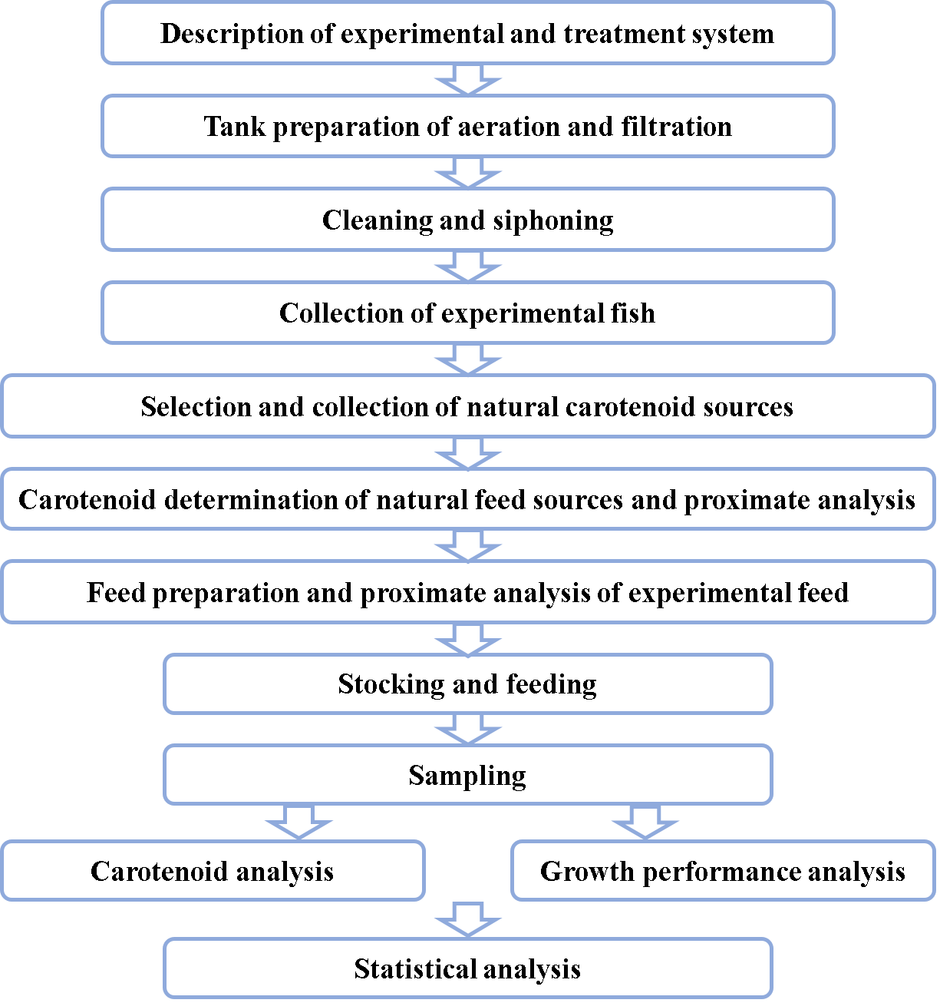

Fig 1 : Flow chart diagram of experiment

