Chapter 1 : Introduction
Black Bangle, Jamunapari and crossbreed goats are breeds of goats available in Chittagong district of Bangladesh. These breeds are frequently affected with some infectious and noninfectious diseases and metabolic disorder. Tetanus, mastitis, metritis, arthritis, dermatitis, urinary tract infection, actinomycosis, upper respiratory tract infection, PPR, viral pneumonia, fungal infection, keratoconjunctivitis, diarrhoea are some common infectious diseases of goats in Chittagong district of Bangladesh (Nath et al., 2014). ShahedulAlamQuadery teaching veterinary hospital (SAQTVH), in Chittagong Veterinary and Animal Sciences University (CVASU) is well known among veterinary school in Bangladesh for its varieties of patient species. Among different ranges of diseases, some noninfectious and metabolic diseases of goats are also recorded in SAQTVH. Fibrous osteodystrophy is one of the important metabolic disorders in goats, but previously no report has been published on it.
Osteodystrophy is any dystrophic growth of the bone. It is defective bone development that is usually attribute to disturbances in calcium and phosphorus metabolism. Fibrous osteodystrophy refers to softening of the bones and an increase in the amount of supportive connective tissue, most commonly affecting the jaw (Foster & Smith).Calcium and phosphorus are the major mineral components of bones. Although bones may seem solid and unchanging, in reality calcium and phosphorus are continually being added to bones and then reabsorbed. The process is very dynamic. In a proper diet, the concentration of calcium compared to phosphorus should be 2:1. In addition, there needs to be an adequate amount of Vitamin D3 to help the body absorb and use the calcium. The main cause of the osteodystrophy is the continuous and extensive action of parathormone (PTH) on bones. The pathogenesis involves the persistent increase in the parathormone (PTH) levels in the plasma, what may be associated with primary or secondary hyperparathyroidism (Thompson, 2007). Nutritional hyperparathyroidism usually affects young animals fed diets with low calcium and relatively high phosphorus contents. This condition includes decreased concentration of serum ionized calcium and consequent increased synthesis and secretion of PTH (Radostits et al., 2007; Weisbrode, 2007).
The main clinical manifestations include bone deformities and enlargements, enhanced susceptibility to fractures, and locomotion or postural disturbs (Radostits et al., 2007). They are painful when bearing weight. The affected bones are mainly the mandible and maxilla. In humans, the disease has been known as von-Recklinghausen disease. Different animal species may be varying in their susceptibility to fibrous osteodystrophy. The disease is frequently observed in horses (Radostits et al., 2007) and sporadically described in goats (Andrews et al., 1983; Yates et al., 1987; Aslaniet al., 2000), foxes (Pelt & Caley, 1974), pigs, dogs (Kawaguchi et al., 1993), reptiles (Mehler& Bennett, 2003), rabbits (Bas et al., 2005), guineapigs (Schwarz, 2001), cats (Crager&Nachreiner, 1993), lemurs (Tomson &Lotshaw, 1978), and budgerigars (Arnold et al.,1973). In ruminants it is most commonly reported in goats (Naghshineh and Sohrabi-Haghdust, 1973; Saha and Deb, 1973; Andrews et al., 1983). However, it is rare in sheep and cattle (Thompson, 2007).
This report on nutritional osteodystrophy emphasizes the clinical, biochemical alterations observed in affected goats. It also emphasizes the distribution of fibrous osteodystrophy according to sex of goats and month of the year. The specific objectives of the present investigation were -
- To study the clinical symptoms found in fibrous osteodystophic goats
- To observe the changes in blood parameters (Calcium, phosphorous, alkaline phosphatase)
- To find out the distribution of fibrous osteodystrophy in goats, according to breed, sex and month of the year

Chapter 2: Materials and methods
2.1. Study Area
This study was conducted at S.A Quadery Teaching Veterinary Hospital, CVASU in Chittagong district of Bangladesh.
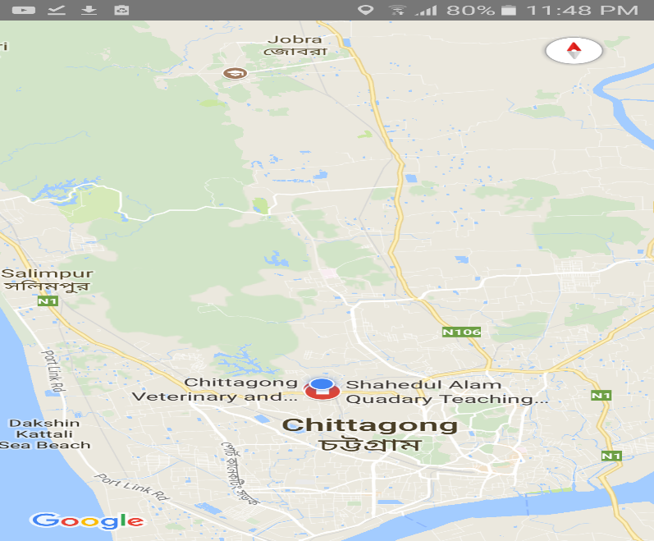
Fig : Location of SAQTVH in Chittagong map

2.2. Disease Diagnosis
Diagnosis of the disease was made by general physical examination of goats, clinical symptoms, and laboratory procedures.
Physical examination
Data recorded for each animal included animal demography (age, sex, body weight and breed), rectal temperature. The date of case occurrence, clinical symptoms, feeding history of the affected goats were also recorded. The goats were examined for any swelling. The limbs were observed to see lameness or any leg deformity. Different joints of the goats were observed through palpation and were examined to detect any swelling or pain.
Case history and Clinical symptoms
The disease was diagnosed according to owner’s complaint, history of the patients and specific clinical signs of the disease. The affected goats were usually brought to the hospital with a history of swollen jaw, lameness, open mouth and tongue protrusion. These animals were from different herds of different ages. Most of the goats had the history of feeding concentrate, bran, pea, maize. The most common symptoms were swelling of the jaw, leg deformity, lameness, open mouth, salivation and tongue protrusion.
Laboratory diagnosis
Collection of serum - Blood samples for biochemical analysis were collected by jugular venepuncture from the affected goats. After collection of the whole blood, it was allowed to clot by leaving it undisturbed at room temperature. This usually takes 15-30 minutes. Then the clot was removed by centrifuging at 1,000-2,000 × g for 10 minutes in a refrigerated centrifuge. The resulting supernatant is designated serum. Serum samples collected from affected goats were used to determine serum levels of calcium, phosphorus and alkaline phosphatase enzyme activity.
Determination of serum level of Calcium
The reaction principleis -Calcium ions form a violet complex with O-Cresolphthaleincomplexone in an alkaline medium. Calcium standard, buffer, chromogen, EDTA are the reagents used for the method. After preparation of reagent blank, standard and sample, the absorbance should be read after 5 to 50 minutes using Humalyzer 3000 (Humalyzer 3000 is a Semi-Autometic Photometer with a large display,Tradesworld company, Germany).
Determination of Phosphorus
The reaction principle is -Inorganic phosphorus reacts with ammonium molybdate in the presence of sulfuric acid to form a phosphomolybdic complex, which is measured at 340 nm (Nanometer). Molybdate and phosphorus standard are the reagents used for this method. After preparation of reagent blank, sample, CAL standard, the absorbance should be read using Humalyzer 3000.
Determination of Alkaline Phosphatase (ALP)
The reaction principleis - The p-nitrophenylphosphate and water produces phosphate and p-nitrophenol in the presence of ALP. Buffer and substrate are the reagents used for this method. After preparation of reagent and sample, the absorbance should be read using Humalyzer 3000.

Chapter 3: Results
  - Temporal distribution of cases
Prevalence of fibrous osteodystrophy in goats due to seasonal variation revealed that highest prevalence (50%) was found in rainy season (August month). The status of feeding of the animal should be known more clearly by further study as it is important to know about other seasonal influence.

Table 1.Percentage of Fibrous Osteodystrophy in goats at S A Quadery Teaching Veterinary Hospital, CVASU, Chittagong according to months (N=10)
Month | No. of cases | % of cases
March | 1 | 10
April | 2 | 20
May | 1 | 10
June | 1 | 10
August | 5 | 50

  - Recorded Clinical Signs
The goats affected with fibrous osteodystrophy presented swollen bone (predominantly in the maxilla and in the mandible), open mouth (10%), protruding tongue (20%), lameness (10%), swelling of joints (20%), leg deformity (40%). Among these signs, swelling of the jaw was predominant in the affected goats (50%).

Fig1 : Distribution of the disease according to different clinical signs

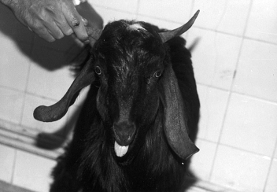
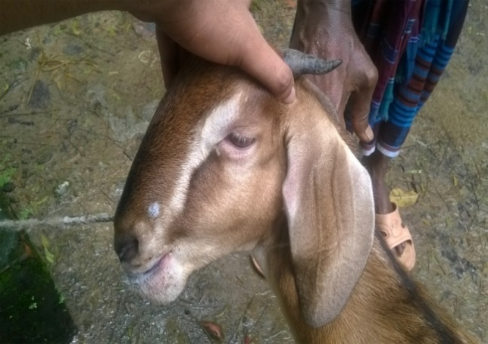
.

Fig 1:Goat with severe maxillary enlargements Fig 2: Bilateral and symmetrical enlargement of the face, protrusion of the tongue and prominent eyes

  - Breed wise distribution of cases
Among the affected goats the Jamunapari and cross breeds were the dominant breed followed by Black Bangle Goat (BBG). The BBG was found to be good in response to disease resistance.

Fig 2: Percentage of the disease according to breed

  - Sex wise distribution of cases
This study found the male goats were predominant in number. The Female was less affected with this disease.

Fig3 : Percentage of the disease according to sex

  - Serum biochemical Value

Table 2- Serum levels of calcium, phosphorus, alkaline phosphatase of goats affected by nutritional osteodystrophy

Sl no | Ca  (mg/dl) | P  (mg/dl) | Ca : P ratio | ALP  (U/L)
1 | 10.45 | 4.75 | 2.2 | 257
2 | 8.25 | 2.85 | 2.89 | 1162
3 | 6.85 | 4.2 | 1.63 | 1942
4 | 10.60 | 5.05 | 2.10 | 1455
5 | 10.2 | 4.65 | 2.19 | 923.35
6 | 6.9 | 10.5 | o.65 | N/A
7 | 12.5 | 5.0 | 2.5 | N/A
8 | 10.35 | 3.8 | 2.72 | 2678
9 | 10.0 | 3.05 | 3.28 | 124.1
10 | 7.75 | 1.8 | 4.30 | N/A

Normal value : Calcium Ca :8.9-11.7 mg/dl; phosphorus P : 3.5-6.7 mg/dl; alkaline phosphate AP : <387 U/L ; not available N/A (kaneko et al., 1997)

Chapter 4 : Discussion
Fibrous osteodystrophy is a metabolic bone disease that characterized by increased osteoclastic resorption of bone and replacement by fibrous connective tissue. The most common cause of the disease is prolonged and excessive secretion of PTH (Radostits et al., 2008; Thompson, 2007; Weisbrode, 2007; Woodard, 1997). Unfortunately, this parameter was not measured in the present study due to lack of logistic facilities. Two types of hyperthyroidism occur in animals and human beings. Primary hyperthyroidism is rare in domestic animals and may be linked to benign and malign parathyroid tumors or idiopathic bilateral parathyroid hyperplasia of the gland. The most commonly seen form is secondary hyperparathyroidism and the fundamental mechanism is a reduced concentration of calcium in the plasma with a relative increase in phosphorus (Weisbrode, 2007; Woodard, 1997). Nutritional fibrous osteodystrophy is the most common pathology due to dietary insufficiency of calcium and/or excessive dietary phosphorous, which results in nutritional secondary hyperparathyroidism. One of the other forms of hyperthyroidism is the renal type characterized by failure to eliminate phosphorous in the urine, which causes hyperphosphatemia. Whether it is nutritional or renal hyperparathyroidism, excessive secretion of PTH promotes bone reabsorption and softening of the bones (Thompson, 2007; Woodard, 1997). Generally head bones effected and they become swollen, soft, deformed and predispose to pathological fractures (Bas et al., 2005; Dunn, 1994; Radostits et al., 2008; Pelt & Caley, 1974; Weisbrode, 2007; Yates et al., 1987). In this study, caprine nutritional osteodystrophy was diagnosed based on clinical and biochemical findings. Elevation of serum alkaline phosphatase is a characteristic laboratory finding in affected animals (Andrews et al., 1983; Radostits et al., 2007; Smith and Sharman, 1994). In this study, excessive ALP blood levels were observed in affected goats supported the diagnosis of fibrous osteodystrophy. The confined management system and concentrate feeding in most of the affected goats were the reasonable causes for this metabolic bone disease. In the cases of fibrous osteodystrophy, respiratory distress may result from the proliferation of poorly ossified tissue that impinges on the nasal cavity. Metabolic bone disease is seen at sites of mechanical stress in adult animals, especially maxilla and mandible as a result of mastication and rumination (Thompson, 2007; Woodard, 1997). Similar findings were also observed in this study. In most of the cases, the disease started at facial bones and in some cases extremity deformities accompanied the lesions.
The disease is known to develop in herbivores fed diets with a Ca:P ratio of 0.8 or lower (Lynch et al., 1999; Simesen, 1980). Other factors that may play a role include vitamin D deficiency (in house animals), reduced calcium absorption due to endoparasitism, or calcium binding substances such as oxalate in the diet (Lynch, 1999; Sidler-Lauffet al., 2010).
In this study, the disease was prevalent in August. In months around August, there is generally heavy rain in Bangladesh and goats might be offered more concentrate than green grass or other leafy feed which may lead to the development of fibrous osteodystrophy.
In Chittagong region, mainly bucks are reared for sacrifice in Monosha puja and their rearing system is intensive with a supply of concentrate feed and that is the reason behind mainly affected male goats.

Limitations

The number of clinical fibrous osteodystrophy cases in this study was small (10 cases). The diagnosis of fibrous osteodystrophy was only based on clinical and biochemical findings. The pathological examinations and other important laboratory examinations were not done. Distribution of the diseases throughout the year were not possible to show.

Conclusion
Fibrous osteodystrophy was seen more commonly in male compared to female. Common clinical findings were swelling of the jaw, swelling of joints, leg deformity, open mouth and protrusion of tongue. Concentrate feeding was the history in most of the affected goats. Feed should be balanced so that the calcium: phosphorous ratio of 2:1 is maintained in the animal which is the principle of the treatment of affected goats (Dunn, 1994).

References

Andrews A.H., Ingram P.L. andLongstaffe J.A. (1983). Osteodystrophiafibrosa in young goats. Vet. Rec. 112:404-406.
Arnold S.A., Kram M.A., Hintz H.F., Evans H. andKrook L. (1973). Nutritional secondary hyperparathyroidism in the parakeet. Cornell Vet. 64:37-46.
Aslani M.R., Movassaghi A.R., Mohri M. andSeifi H.A. (2001). Outbreak of osteodystrophiafibrosa in young goats. J. Vet. Med. A. 48:385-389.
Bas S., Bas A., LópezI., Estepa J.C., Rodríguez M. and Aguilera-Tejero E. (2005). Nutritional secondary hyperparathyroidism in rabbits. Domest. Anim. Endocrinol. 28:380-390.
Crager C.S. andNachreiner R.F. (1993). Increased parathyroid hormone con centration in a siamese kitten with nutritional secondary hyperparathyroidism. J. Am. Anim. Hosp. Assoc. 29:331-336.
Doige, C. E. and S. E. Weisbroge, (1995) : Diseases of bone and joints. In: Carlton, W. W., and M. D. McGavin (eds), Thomson’s Special Veterinary Pathology, 2nd edn. Mosby, St. Louis.
Dunn, P., (1994) : The Goatkeeper’s Veterinary Book. Farming Press, London.
Kaneko J.J., Harvey J.W. andBruss M.L. (1997). Clinical Biochemistry of Domestic Animals. 5th ed., Academic Press, San Diego, p.890-894.
Kawaguchi K., Braga 3rd. I.S., Takahashi A., Ochiai K. andItakura C. (1993). Nutritional secondary hyperparathyroidism occurring in a strain of German shepherd puppies. Jpn. J. Vet. Res. 41:89-96.
Lynch MJ., Slocombe RF., Harrington KEet al. (1999): Fibrous osteodystrophy in Dromedary Camels (Camelusdromedarius). J Zoo Wildlife Med, 30, 577-583.
Mehler S.J. and Bennett R.A. (2003). Oral, dental, and beak disorders of reptiles. Vet. Clin. North. Am., Exot. Anim. Pract. 6(3):477-503.
Naghshineh, R. and I. Sohrabi-Haghdust, (1973) : A case of osteodystrophiafibrosa in a goat. J. Vet. Fac. Uni. Tehran 29 , 87 – 91.
Palmer, N., (1993) : Bone and joints. In: Jubb, K. V. F., P. C. Kennedy, and N. Palmer (eds), Pathology of Domestic Animals. Academic Press, London.
Pelt R.W. and Caley M.T. (1974). Nutritional secondary hyperparathyroidism in Alaskan red fox kits. J. Wildl. Dis. 10:47-52.
Radostits O.M., Gay C.C., Hinchcliff K.W. and Constable P.D. (2007). Veterinary Medicine: A textbook of the diseases of cattle, horses, sheep, pigs, and goats. 10th ed. Saunders, London, p.633-634.
Radostits OM., Gay CC., Hinchcliff KW et al. (2008): Bone Diseases. 632-637. In: Veterinary Medicine: A Textbook of Diseases of Cattle, Horses, Sheep, Pigs, and Goats, 10th ed. Saunders Elsevier.
Saha, A. C. & S. K. Deb, (1973) : Osteodystrophiafibrosa in goat. Ind. Vet. J. 50 , 14 – 17.
Schwarz T., Störk C.K., Megahy I.W.,Lawrie A.M., Lochmüller E.-M. and Johnston P.E.J. 2001. Osteodystrophiafibrosa in two guinea pigs. J. Am. Vet. Med. Assoc. 219:63-66.
Sidler-Lauff K., Boos AandKraenzlin M et al. (2010): Influence of different calcium supplies and a single vitamin D injection on vitamin D receptor and calbindin D9k immunoreactivities in the gastrointestinal tract of goat kids. J AnimSci, 88, 3598-3610.
Smith, M. C. and D. M. Sharman, (1994) : Goat Medicine. Lea &Febiger, London.
Thompson K. (2007). Bones and Joints, p.82-88. In: Maxie M.G. (Ed.), Jubb, Kennedy, and Palmer's Pathology of Domestic Animals. Vol.1. 5th ed. Elsevier, Philadelphia
Tomson F.N. andLotshaw R.R. (1978). Hyperphosphatemia and hypocalcemia in lemurs. J. Am. Vet. Med. Assoc. 173:1103-1106.
Weisbrode S.W. (2007). Bone and joints, p.1075-1076. In: McGavin M.D. & Zachary J.F. (Eds), Pathologic Basis of Veterinary Disease. 4th ed. Mosby, St Louis.
Woodard J.C. (1997). Skeletal system. p.932-936. In: Jones T.C., Hunt R.D. & King N.W. (Eds), Veterinary Pathology. 6th ed. Williams and Wilkins, Baltimore.
Yates N.G., Hoffmann D. andSeripto S. (1987). Mandibular osteodystrophyfibrosa in Indonesian goats fed leucaena. Trop. Anim. Hlth Prod. 19:121-126.
https://en.wikipedia.org/wiki/Osteodystrophy [Accessed 27thOctober2017]
http://www.peteducation.com/article.cfm?c=17+1796&aid=3581 [Accessed 29thOctober 2017]

Acknowledgements

The author wishes to acknowledge the immeasurable grace and immanent kindness of Almighty “Allah” the supreme authority and supreme ruler of the universe, who empowers the author to complete the work successfully. The author feels proud in expressing his deep sense of great gratitude and indebtedness to respected teacher and tutor Prof. Dr. Md. Mizanur Rahman, Head, Department of Medicine & Surgery, Chittagong Veterinary and Animal Sciences University whose ingenuous and scholastic advice, judicious recommendations, constructive criticism, continuous encouragement and untiring assistance have guided the author from the beginning of inception of intern studies until to the completion of this report.
Special thanks to other teachers and staff of Department of Medicine & Surgery and SAQTVH for their valuable advice and co-operation.

Biography
This is Umme Salma Amin from Chittagong , girl of MdNurul Amin and NurJahan.I have completed my Secondary School Certificate from Kulgaon City Corporation High School and Higher Secondary Certificate from Chittagong Cantonment Public College in 2009 and 2011 respectively with CGPA 5.0 out of 5.0 scale in both exams under Chittagong board.As a successful candidate for DVM degree, I have achieved CGPA 3.91 out of 4.00 in the taught courses/ in-campus study placing myself in the 2nd position. Now I am enrolled in the Year long Internship program. I have immense interest to do the higher study and research in the field of Veterinary Medicine.

