1. Introduction
Livestock is an integral component of the complex farming system in Bangladesh as it is not only a source of protein of animal origin but also a major source of farm power services as well as employment. Share of livestock in Agricultural Gross Domestic Product is 14.2% and livestock contributes 1.7% of GDP in the national economy of Bangladesh (BBS, 2016).
Within the livestock sector, poultry farming is playing important role in contribution to GDP and employment facility. There are 2,23,39,95 poultry farms in Bangladesh (DLS, 2015). Broiler chickens are broadly reared for meat purpose, whereas layer chickens are reared for egg purpose. The poultry meat alone contributes 37% of the total meat production in Bangladesh (Begum et al., 2011). Over the last few decades poultry farming has gradually intensified and is now considered one of the intensive forms of agri-business in Bangladesh. To achieve millennium development goal Bangladesh is committed to lift up the poultry sector. Scientific breeding, feeding, management and disease control are the key points of success in poultry improvement programme. Among different poultry diseases Colibacillosis and Salmonellosis are the major problems in the commercial poultry sector.

Colibacillosis is an infectious disease caused by Escherichia coli. It causes high mortality rates or yolk sac infection of chicks during hatching when egg is contaminated by penetration of E. coli through the shell (Kabir, 2010). Avian Pathogenic E. coli (APEC) causes systemic infection when they gain access to the blood stream from respiratory tract or intestine. Some diseases such as infectious bursal disease, mycoplasmosis, coccidiosis, Newcastle disease or infectious bronchitis, as well as nutritional deficiencies predispose the birds to colibacillosis. Risk for colibacillosis increases if the environmental infection pressure increases. A good housing, hygiene and avoiding overcrowding are very important for reducing the risk of colibacillosis. Other factors such as duration of exposure, virulence of the strain, breed, and immune status of the bird also act as risk factor for this disease. (Rosenberger et al.,1985; Gross et al.,1992; McGruder et al.,1998).

Yolk sac infection, omphalitis, respiratory tract infection, swollen head syndrome, septicemia, polyserositis, coligranuloma, enteritis, cellulitis and salpingitis are common findings of colibacillosis. (Haider, 2004). In postmortem, omphalitis and fluid accumulation in the peritoneal cavity of chicks, dark-colored swollen liver and spleen, fibrinopurolent airsacculitis, pericarditis, perihepatitis, hemorrhagic enteritis, arthritis, panophthalmitis, and salpingitis are found (Nakamura et al.,1985).

Incidence of Colibacillosis (Escherichia coli) in Bangladesh is reported to be 4.4% in broiler (Giasuddin et al., 2002, Matin et al., 2017). Higher prevalence of colibacillosis was found in broiler (87.5%) than layer (76.0%) (Srinivasan et al.2003). According to age, adult layer birds were commonly affected than chick and younger layer birds (36.7%) (Rahman et al., 2004). While in broiler age of about one month was found to have more prevalence than more than one month age (0.5%) (Rahman et al., 2004).
Due to incidence of Colibacillosis heavy economic loss occurs in both broiler and layer such as increase of morbidity, mortality, reduced production and chick quality. Mortality may reach up to 94% in severe outbreak of colibacillosis (McPeake et al., 2005 and Biswas et al., 2006).

Salmonellosis is a bacterial disease caused by a variety of Salmonella species under the family Enterobacteriaceae. It may occur in poultry either acute or chronic form. Oral route of infection is the normal route of infection (Brito et al. 1995). In newly hatched chicken nasal and cloacal route of infection is also important. Vertical transmission in chicks may occur from an infected ovary, oviduct or from infected eggs during the passage the the cloacal faeces of infected or carrier birds. Infected young birds can survive from clinical disease but they become carriers (Berchieri et al., 2001). The reproductive organs are the predilection sites for salmonella species which causes infection of ovarian follicles that leads to transovarian transmission of the disease in adult carriers (Kabir, 2010). Some factors such as season( winter or rainy season ), hatchery of origin, feedmils, various hygienic measures(cleaning of litter material, washing of feeder and water trough, water source, feed storage etc)act as the risk factors for salmonellosis. (Angen et al.,1996; Rose et al., 1999; Skov et al., 1999; Cardinale et al., 2004b).

The pathogenicity of Salmonella depends on the invasive properties and its ability of to survive and multiply within the cells, particularly macrophages (Humbert et al.1997). These bacteria mainly multiply in digestive tract, which results into widespread contamination of the environment by bacterial excretion through feces. After invasion through the intestinal mucosa, cecal tonsils and Peyer’s patches, macrophages engulf the organisns and they spread to organs rich in reticuloendothelial tissues (RES) such as liver and spleen, which are the main sites of multiplication through the blood stream and/or lymphatic systems (Barrow et al.,1994).If the body defense mechanism is inadequate, second invasion and localization in other organs, particularly ovary, oviduct, myocardium, pericardium, gizzard, yolk sac and/or lungs happens.(Barrow,1993).

The gross lesions in chicks are unabsorbed yolk sac and turbid yellow color fluids in the peritoneal cavity and in adult peritonitis, discrete, small, white necrotic foci in the liver and enteritis (Hasan et al., 2010). It is one of the most important bacterial diseases in poultry as it cause heavy economic losses through mortality and reduced production (Haide et al, 2004). Incidence of Salmonellosis in Bangladesh is reported to be 5.6 % (Giasuddin et al., 2002,Matin et al.,2017). The reported incidence of Salmonellosis was high in adult layers (53.3 %) followed by brooder 14.6%), grower (16.1%) and pullet (16.1%) layer chickens (Rahman et al., 2004).

For the prevention and control of Colibacillosis and salminellosis, egg contamination can be prevented by fumigating them within two hours after lay. Also the cracked eggs or eggs soiled with faecal material should be removed. Introduction of the diseases must be avoided by suitable house infrastructure, using transition zone for changing clothes and shoes, and washing hands, pest control(Barnes et al.,1997). Bird density, humidity, ventilation, dust and ammonia, housing climate must be kept optimal (Dho-Moulin et al., 1999). Good hygiene and management together with routine serological tests and slaughter policy helps in achieveing successful control programs (Barrow, 1993). Chickes should be placed in a cleaned, sanitized and pathogen free environment with strict biosecurity measures (Pomery et al.1991).

The feed and water should be free from contamination and the dead birds need to be well disposed. Adequate precautions should be applied to prevent infections from mechanical carriers like footwear, human clothing, hatchery disciplines, equipments, litters, crates, trucks and processing plants (Christensen et al.,1994).

Antimicrobial therapy is important tool for the treatment of colibacillosis and salmonellosis. Ciprofloxacin, gentamicin, chloramphenicol were found as sensitive for both E.coli and Salmonella species. Whereas ampicillin was found resistant for this E.coli and (Miles,2006; Matin,2017). In case of salmonellosis, tetracycline, oxytetracycline, penicillin, aminoglycosides, sulfisoxazole, fluoroquinolones were found resistant (Sharma et al.,1996; Rahman et al.,2004).

Although studies on colibacillosis and salmonellosis in different aspects are available in scientific literature, this clinical small intern research added fresh scientific information of proportionate prevalence of these diseases and antimicrobial uses to the existing literature.

Specific objective:
- To estimate the proportionate prevalence of colibacillosis and salmonellosis in commercial poultry
- To describe the frequency of lesions and drugs prescribed against the diseases

2. Materials and Methods

Internship placement and duration: The clinical study was conducted during CVASU internal rotation in January-February2017 and then during the rotation of Upazilla Veterinary Hospital (UVH), Hathazari during March -April and July -August 2017.

Study population: During the rotation a total of 38 poultry in different production types (either sick or dead) were undergone post-mortem. Of the total numbers 10 birds were recruited at CVASU through the private practice of Professor Dr. Masuduzzaman (CVASU) and the rest were recruited at the UVH.

Data collection: Production type, age, source, ventilation and farm size were recorded using a structured record keeping sheet through farmer’s interview.

Post-mortem procedure:
At first the chicken was laid on its back and each leg to expose the internal organs, in turn drawn outward away from the body while the skin was incised between the leg and abdomen on each side. Then the both legs were grasped firmly in the area of the femur and bent forward, downward and outward, until the head of both femurs were broken free of the acetabular attachment so that both legs lied flat on the table. The skin was cut between the two previous incisions at a point midway between keel and vent. The cut edge was then forcible reflected forward, cutting was necessary, until the entire ventral aspect of the body including the neck, was exposed. For exposing of the viscera, knife was used to cut through the abdominal wall transversely mid-way between the keel and vent, then through the breast muscle on each side. Positioning shears were used to cut first the rib cage, the coracoids and clavicle on both side. Then the keel near the abdomen was grasped and pulled upwards to expose the internal organs. Next, we should remove the liver and spleen. A green discoloration of the liver near the gall bladder is a normal finding. The spleen is the reddish, round organ located at the junction of the proventriculus and gizzard. The air sacs were examined for increased thickness and increased cloudiness. The normal air sac surfaces look like soap bubbles or clear cellophane wrap. The outer surface of the heart should be examined for a cloudy, thickened appearance, suggesting pericarditis. Also, excessive fluid located between the heart and the pericardium (membranous covering of the heart) was noted. The gastrointestinal (GI) tract between the esophagus and proventriculus was cut. The proventriculus, gizzard, small intestines, large intestine, ceca were cut off at the level of the cloaca.
Observable post-mortem lesions were noted in a post-mortem sheet and diagnosis was made accordingly with the support of veterinary practitioners. Drugs prescribed for each case were also recorded. This study considered only two bacterial poultry diseases: colibacillosis and salmonellosis.

Colibacillosis is usually described by omphalitis and fluid accumulation in the peritonial cavity of chicks, dark-colored swollen liver and spleen, fibrinopurolent airsacculitis, pericarditis, perihepatitis, hemorrhagic enteritis, arthritis, panophthalmitis, and salpingitis in some cases (Nakamura et al.,1985).

Salmonellosis is usually described by unabsorbed yolk sac and turbid yellow color fluids in the peritoneal cavity in chicks and in adult peritonitis, discrete, small, white necrotic foci in the liver and enteritis (Hasan et al., 2010)

Data entry and statistical evaluation: Data obtained from the study were entered into a MS excel spread sheet and exported to Stata-13, statistical software for analysis. Descriptive statistics were performed. The results were expressed as frequency number and percentage.

3. Results

3.1. Proportionate prevalence of colibacillosis and salmonellosis
Colibacillosis affected the poultry at all age categories (23.5%-45.5%) in this study, whereas salmonellosis only affected adult layer poultry. By production type broiler poultry were frequently affected by Colibacillosis (76.6%) than layer poultry (11.8%). No Salmonellosis was detected in broiler poultry. Birds originated from Nahar Agro Group had comparatively more Colibacillosis and Salmonellosis than that of other sources. No clear trend of the diseases was observed in relation to the farm size categories; however poultry originated from the farm size of 500-1000 and 800-1320 were commonly affected by colibacillosis and salmonellosis, respectively. Poultry housed with moderate ventilation had less frequent of the diseases than that of poultry housed with good ventilation (Table 1).

Table 1: Distribution of avian colibacillosis and salmonellosis in commercial poultry according to different factors.
 | Colibacillosis (N=17) |  |  | Salmonellosis (N=21)
 | Category | Positive | % | Category | Positive | %
Age | 7-13 days | 6 | 35.3 | 27- 53 weeks | 12 | 57.1
 | 14-18 days | 4 | 23.5 | 54-80 weeks | 9 | 42.9
 | 19-57 days | 7 | 45.5
Production type | Broiler | 13 | 76.6 | Broiler | 0 | 0
 | Layer | 2 | 11.8 | Layer | 21 | 100
 | Sonali ( Rhode Island Red * Fayoumi) | 2 | 11.8
Source (Hatchery) | Charoen Pokphand (CP) | 2 | 11.8
 | Nahar Agro Group | 9 | 52.9 | Nahar Agro Group | 11 | 52.4
 | Nourish Poultry and Hatchery Ltd | 5 | 29.4 | Nourish Poultry and Hatchery Ltd | 10 | 47.6
 | Provita | 1 | 5.9
Farm size | 500 | 3 | 17.7
 | 500-1000 | 8 | 47.1 | 800-1320 | 11 | 52.4
 | 1001-1500 | 2 | 11.8 | 1321-3000 | 10 | 47.6
 | 1501-6000 | 4 | 23.5
Ventilation | Good | 13 | 76.5 | Good | 19 | 90.5
 | Moderate | 4 | 23.5 | Moderate | 2 | 9.5

3.2 Post-mortem findings
Commonly recorded lesions of colibacillosis were omphalitis, pericarditis, perihepatitis and air sacculitis. Poultry affected by salmonellosis produced distended ureter with the deposition of urates, necrotic liver, hemorrhagic liver and follicle, degenerated ova, white plaque in intestine and peritonitis and ascites (Table 2).
Table 2: Frequency distribution of different post-mortem lesions due to colibacillosis and salmonellosis in poultry.
 | Colibacillosis (N=17) |  |  | Salmonellosis (N=21)
 | Category | Positive | % | Category | Positive | %
Types of lesions | Omphalitis | 6 | 35.3 | Distended ureter (urates) and hemorrhagic liver | 5 | 23.8
 | Pericarditis, perihepatitis and air sacculitis | 4 | 23.5 | Hemorrhagic follicle and necrotic liver | 5 | 23.8
 | Pericarditis and perihepatitis | 7 | 41.2 | Peritonitis and ascites | 1 | 4.8
 |  |  |  | White plaque in intestine, distended ureter and hemorrhagic liver | 3 | 14.3
 |  |  |  | Degenerated ova and peritonitis | 1 | 4.8
 |  |  |  | Degenerated ova, peritonitis and ascites | 5 | 23.8
 |  |  |  | Degenerated ova and ascites | 1 | 4.8

3.3 Drugs prescribed
Multiple antibiotics were commonly prescribed regardless of the disease type. They were amoxicillin colistin sulphate, erythromycin, neomycin, neofloxacin for colibacillosis and amoxicillin and ciprofloxacin for salmonellosis. In addition supportive drugs were prescribed. Aminomin, CRD cure, nutrilac, superliv were given for colibacillosis affected farms and Electrolyte, glucolyte, kidney and liver tonic, liver tonic, liver tonic and gut balance were given for salmonellosis affected farms (Table 3).
Table 3: Different drugs prescribed for poultry affected by Colibacillosis and Salmonellosis.
 | Colibacillosis (N=17) |  |  | Salmonellosis (N=21)
 | Category | Positive | % | Category | Positive | %
Treatment | Amoxicillin and colistin sulphate | 5 | 29.4 | Amoxicillin | 9 | 42.9
 | Erythromycin and neomycin | 4 | 23.3 | Ciprofloxacin | 12 | 57.1
 | Neofloxacin | 8 | 47.1
Supportive therapy | Aminomin | 1 | 5.9 | Electrolyte | 1 | 4.8
 | CRD cure | 3 | 17.7 | Glucolyte | 7 | 33.3
 | Nutrilac | 5 | 29.4 | Kidney and liver tonic | 5 | 23.8
 | Superliv | 8 | 47.1 | Liver tonic | 3 | 14.3
 |  |  |  | Liver tonic and gut balance | 5 | 23.8

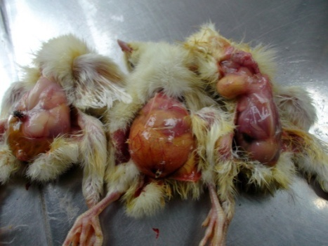
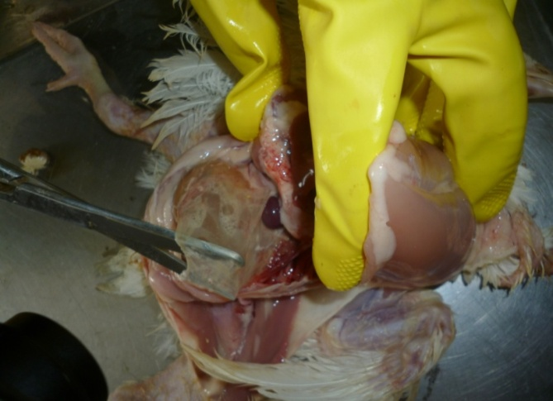
Air sacculitis
Omphalitis
Fig : : Air Sacculitis found in Colibacillosis. Fig: Omphalitis found in Colibacillosis

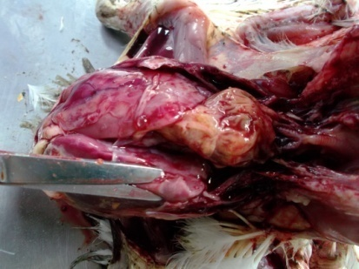
Pericarditis
Perihepatitis
Fig: Colibacillosis in Chicken .

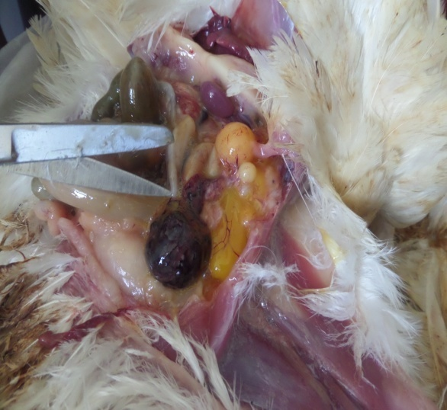
Degenarated ova
Fig: Degenarated ova found in Salmonellosis

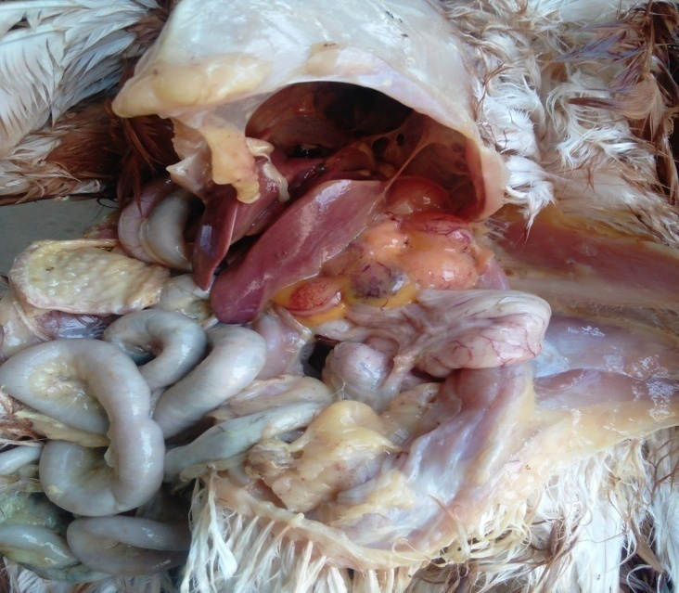
Misshapen ova
Fig: Misshapen ova found in Salmonellosis.

4. Discussion

Development of commercial poultry sector in Bangladesh is being hampered by many factors, of which disease is one of those, causing 30% mortality of chicken per year (Das et al., 2005). Avian colibacillosis and salmonellosis are important bacterial diseases in the poultry industry globally. This section discusses important findings of the current clinical study.

Very high frequency of colibacillosis was estimated in broiler poultry in the present study which is because E. coli usually infects chick and young birds and the current finding is also supported by number of earlier studies (Srinivasan et al., 2003; Tonu et al, 2011; Rahman et al., 2004). Contrarily, the quite high frequency of salmonellosis in layer adult poultry in the present study corresponds to many previous investigation (Sharma et al., 1996; Rahman et al., 2004; Barrow, 1993)

Birds sourced from Nahar Agro Group had higher proportion of colibacillosis and salmonellosis in the present study which suggests the source might be the problem, but it is difficult to explain how the source contributed to the bird infection. This could be due to the faulty farm management practices at the destination broiler farms. There are many published studies that identified poor farm management practices (such as unfavourable housing conditions, flies and other insects, stress, feeding, density of hens on the farms, hatchery of origin, hygienic measures etc) increase the probability of risk of occurrence of colibacillosis and salmonellosis in poultry (Leitner and Heller, 1992; Renwick et al., 1992; Angen et al., 1996; Zander et al.,1997; Rose et al., 1999; Skov et al., 1999; and Cardinale et al., 2004b).

Poultry from small to medium-sized farms (500-1320) had more cases of colibacillosis and salmonellosis in this study which may be explained that small to medium-sized farms might have had poor hygienic management and thus had more cases of the diseases (Henken et al., 1992; Asakura et al., 2001)

This study demonstrates a relatively better farm ventilation facility decreased the occurrence of colibacillosis and salmonellosis which support the earlier argument of necessity of better farm management. Better ventilation always dilutes microorganism and put less stress on birds and thus less disease occurrence. This result agrees with many earlier studies (Barrow et al.,1993; Christensen et al.,1994 and Kabir et al.,2010).

Like many other studies Airsacculitis, omphalitis, pericarditis and perihepatitis were common lesions of colibacillosis recorded in the current study (Nakamura et al.,1985; Haider, 2004;). Other reported lesions of colibacillosis in poultry were congested and consolidated lung , mucus in duodenum, enteritis (Talha et al., 2001; Islam et al., 2003; Ghosh et al.,2006 and Tonu et al,.2011).

Distended ureter with urate deposition and hemorrhagic liver and follicle and necrotic liver, peritonitis and ascites white plaque in intestine degenerated ova and peritonitis were common lesions noted in the cases of salmonellosis in the present study which are aligned with the findings of many previous studies (Barrow et al.,1994; Hasan et al., 2010)
.
A range of antibiotics in different combinations was considered to include in the prescription which suggests vet practitioners did not follow any treatment protocol for specific diseases. The results also reflect indiscriminate use of antibiotics. Combined antibiotics may have been prescribed to have synergistic, potentiation and additive effects and combined drugs also reduced the MIC values, side effects etc, but indicate drugs became resistant (Shuchismita et al.,2007; Jiang et al.,2011; Obeng et al.,2012; Ahmed et al.,2013; Saidi et al.,2013 and Chen et al.,2014)

Along with the antibiotics, Aminomin, CRD cure, Nutrilac, Superliv was prescribed as supportive therapy according to symptoms .Aminomin contains Chelated Minerals and Aminoacids which is helps in oder all returns, improve body weight and FCR in broiler.

Nutrilac is composed of formic acid, lactic acid and it acts as acidifier and helps in the action of antimicrobial for Enterobacteriaceae. Chronic Respiratoey Disease (CRD) cure is given for the protection as E. coli damages of the cilia of the respiratory tract and may cause chronic respiratory disease. Superliv is used for inhibition of bacteria and preventing damage to the liver (Kaur et al., 2005).

5. Limitations

This study concluded the results generated from a small sample size which could misinterpret the findings. True prevalence of the diseases has not been able to estimate as this study did not consider non-colibacillosis and non-salmonellosis cases. Information recorded was relied on farmer’s response so this could have introduced information bias. Diagnosis was based on post-mortem findings which could have introduced diagnostic error; however the diagnosis was made by experienced veterinary practitioners. It was not possible to conduct statistical significant test as there was no negative birds included in the study.

6. Conclusion and Recommendation

This study reflects the distribution of colibacillosis and salmonellosis in layer and broiler in the study areas. Broilers are found to be more susceptible to colibacillosis while only the layers are prone to salmonellosis. Better farm management can reduce the risk of these diseases. Common post-mortem lesions for colibacillosis were airsacculitis, omphalitis, pericarditis and perihepatitis and for salmonellosis, distended ureter with urate deposition and hemorrhagic liver and follicle and necrotic liver, peritonitis and ascites, white plaque in intestine degenerated ova and peritonitis. Multiple antibiotics were used for the treatments of the diseases along with some supportive treatment. For preventing these diseases better farm management and vaccination should be maintained. For the prevention of antimicrobial resistance, confirmatory diagnosis by laboratory test and using of antibiotics after performing the sensitivity test is highly recommended.

REFERENCES

- Ahmed, A.M., Shimamotob, T. and Shimamotob, T. (2013) Molecular characterization of multidrug-resistant avian pathogenic Escherichia coli isolated from septicemic broilers. International. Journal of Medical. Microbiology., 303: 475-483.
- Angen, O., Skov, M.N., Chriel, M., Agger, J.F., Bisgaard, M., (1996). A retrospective study on Salmonella infection in Danish broiler flocks. Preventive Veterinary Medicine 26, 223–237.
- Barrow, P.A.(1993).Salmonella control- past, present and future. Avian Pathology., 22, 651-669.
- Barrow, P.A.; Huggins, M.B.; Lovell, M.A. (1994).Host specificity of Salmonella infection in chickens and mice is expressed in vivo primarily at the level of the reticuloendothelial system. Infection and Immunity., 62, 4602-4610.
- Begum, F.; Khan, M.S.R.; Choudhury, K.A.; Rahman, M.M.; Amin, M.M.
(1993). Studies on immune response of chickens to fowl typhoid vaccines. Bangladesh Journal of Microbiology., 10, 51-56.
- Berchieri, A., Jr.; Murphy, C.K.; Marston, K.; Barrow, P.A.( 2001). Observations on the persistence and vertical transmission of Salmonella enterica serovars Pullorum and Gallinarum in chickens: Effect of bacterial and host genetic background. Avian Pathol., 30, 221-231.
- Biswas PK, Uddin GMN, Barua H, Roy K, Biswas D, Ahad A and Debnath NC (2006). Causes of loss of Sonali chickens on smallholder households in Bangladesh. Preventive Veterinary Medicine 76: 185-195.
- Brito, J.R.; Xu, Y.; Hinton, M.; Pearson, G.R.(1995) Pathological findings in the intestinal tract and liver of chicks after exposure to Salmonella serotypes Typhimurium or Kedougou. British. Veterinary Journal., 151, 311-323.
- Cardinale, E., Tall, F., Gueye, E.F., Cisse, M., Salvat, G., (2004b). Risk factors for Salmonella enterica subsp. enterica infection in senegalese broiler-chicken flocks. Preventive Veterinary Medicine. 63, 151–161.
- Chen, X., Zhang, W., Yin, J., Zhang, N., Geng, S., Zhou, X., Wang, Y., Gao, S. and Jiao, X. (2014). Escherichia coli isolates from sick chickens in China: Changes in antimicrobial resistance between 1993 and 2013. Veterinaey Journal., 202: 112-115.
- Christensen, J.P.; Skov, M.N.; Hinz, K.H.; Bisgaard, M.(1994) Salmonella enterica serovar Gallinarum biovar gallinarum in layers: epidemiological investigations of a recent outbreak in Denmark. Avian Pathology., 23, 489-501.
- Christensen, J.P.; Skov, M.N.; Hinz, K.H.; Bisgaard, M.(1994) Salmonella enterica serovar Gallinarum biovar gallinarum in layers: epidemiological investigations of a recent outbreak in Denmark. Avian Pathology., 23, 489-501.
- Das PM, Rajib DMM, Noor M and Islam MR (2005). Relationship analysis on the proportional incidence of poultry disease in greater Mymensingh of Bangladesh. In: Proceeding of the 4th International Poultry Show & Seminar organized by World’s Poultry Science Association, Bangladesh Branch. pp. 35-39.
- Dho-Moulin, M.; Fairbrother, J.M.(1999) Avian pathogenic Escherichia coli (APEC). Veterinary Research.,30, 299-316.
- Ghosh RC, Hirpurkar SD and suryawnshi PR (2006). Concurrent colibacillosis and infectious bursal disease in broiler chicks. Indian Veterinary Journal 83: 1019-1020.
- Giasuddin M, Shil BK, Alam J, Koike I, Islam MR, Rahman MM (2002), Prevalence of Poultry Diseases in Bangladesh. Journal of Biological Sciences 2(4): 212-213
- Gross, W.B.(1992).Effect of short-term exposure of chickens to corticosterone on resistance to challenge exposure with Escherichia coli and antibody response to sheep erythrocytes. American Journalof Veterinary Research., 53, 291-293.
- Haider, M.G.; Hossain, M.G.; Hossain, M.S.; Chowdhury, E.H.; Das, P.M.; Hossain, M.M.( 2004).Isolation and characterization of enterobacteria associated with health and disease in sonali chickens. Bangladesh Journalof Veterinary Medicine., 2, 15-21.
- Hasan AKM, Ali MH,Siddique MP, Rahman MM and IslamMA(2010). Clinical and laboratory diagnoses of common bacterial diseases of broiler and layer chickens. Bangladesh. Journal Veterinary Medicine. 8(2): 107 – 115
- Henken, A.M., Frankena, K., Goelema, J.O., Graat, E.A.M., Noordhuizen, J.P.T.M.,(1992).Multivariate epidemiological approach to salmonellosis in broiler breeder flocks. Poultry Science. 71, 838–843
- Islam MR, Das BC, Hossain KH, Lucky NS and Mostafa MG (2003). A study on the occurrence of poultry disease in Sylhet Region of Bangladesh. International Journal of Poultry Science 2: 354-356.
- Jiang, H.X., Lü, D.H., Chen, Z.L., Wang, X.M., Chen, J.R., Liu, Y.H., Liao, X.P., Liu, J.H. and Zeng, Z.L. (2011) High prevalence and widespread distribution of multi-resistant Escherichia coli isolates in pigs and poultry in China. Veterinary journal., 187: 99-103.
- Kabir SM Lutful,( 2010) Avian Colibacillosis and Salmonellosis: A Closer Look at Epidemiology, Pathogenesis, Diagnosis, Control and Public Health Concerns.International. Journal of Environmental Researchand Public Health, 7; 89-114.
- Kaur M, Thakur Y,Rana RC.(2005).Antimicrobial properties of Achyranthes aspera. Ancient Science of Life.24(4):168-73
- Leitner, G. & Heller, E.D. (1992). Colonization of Escherichia coli in young turkeys and chickens. Avian Diseases, 36 , 211 _/220.
- McGruder, E.D.; Moore, G.M.(1998) Use of lipopolysaccharide (LPS) as a positive control for the evaluation of immunopotentiating drug candidates in experimental avian colibacillosis models. Researchin Veterinary Science., 66, 33-37.
- McPeake SJ, Smyth JA and Ball HJ (2005). Characterisation of avian pathogenic Escherechia coli (APEC) associated with colisepticaemia compared to faecal isolates from healthy birds. Veterinary Microbiology 110: 245-53.
- Miles, T.D., McLaughlin, W. and Brown, P.D. (2006) Antimicrobial resistance of Escherichia coli isolates from broiler chickens and humans. BMC Veterinary. Research., 2: 112-115.
- Nakamura K, Maecla M, Imada Y, Imada,T and Sato K (1985). Pathology of spontaneous colibacillosis in a broiler flock. Veterinary Pathology 22: 592-597.

- Obeng, A.S., Rickard, H., Ndi, O., Sexton, M. and Barton, M. (2012) Antibiotic resistance, phylogenetic grouping and virulence potential of Escherichia coli isolated from the faces of intensively farmed and free range poultry. Veterinary. Microbiology., 154: 305-315.
- Rahman MA, Samad MA, Rahman MB and Kabir SMI (2004). Bacterio pathological studies on salmonellosis, colibacillosis and pasteurellosis in natural and experimental infections in chickens. Bangladesh Journal of Veterinary Medicine 2: 1-8
- Rose, N., Beaudeau, F., Drouin, P., Toux, J.Y., Rose, V., Colin, P., (1999). Risk factors for Salmonella enterica subsp.enterica contamination in French broiler-chicken flocks at the end of the rearing period. Preventive Veterinary Medicine. 39, 265–277.
- Rosenberger, J.K.; Fries, P.A.; Cloud, S.S.; Wilson, R.A.( 1985). In vitro and in vivo characterization of avian Escherichia coli. II. Factors associated with pathogenicity. Avian Diseases., 29, 1094-1107.
- Saidi, B., Mafirakureva, P. and Mbanga, J. (2013) Antimicrobial resistance of Escherichia coli isolated from chickens with colibacillosis in and around Harare, Zimbabwe. Avian Diseases., 57: 152-154
- Sharma, M.; Katock, R.C.( 1996). Deadly outbreak in chicks owing to Salmonella typhimurium. Indian Journal of Poultry Science. 31, 60-62.
- Shuchismita, C., Kashyap, S.K. and Ghorui, S.K. (2007) Resistotyping of different Escherichia coli isolates of livestock and poultry. Indian Journal of Animal Sciences., 77: 163-166.
- Skov, M.N., Angen, O., Chriel, M., Olsen, J.E., Bisgaard, M., 1999. Risk factors associated with Salmonella enteric serovar typhimurium infection in Danish broiler flocks. Poultry Science. 78, 848–854.
- Srinivasan, P., Rao, G.V.S. and George, V.T. (2003) Survey of spontaneous cases of Colibacillosis in chicken. Indian Veterinary Journal., 80: 93-94.
- Talha A FSM, Hossain MM, Chowdhury EH, Bari ASM, Islam MR and Das PM (2001). Poultry diseases occurring in Mymensingh district of Bangladesh. The Bangladesh Veterinary Journal 18: 20-23.
- Tonu NS, Sufian M.A, Sarker S, Kamal MM, Rahman MH and Hossain MM (2011).pathological study on colibacillosis in chickens and detection of Escherichia coli by pcr. Bangladesh Journal of Veterinary Medicine. 9(1): 17 – 25.

ACKNOWLEDGEMENTS

All praise to Almighty God, who enables the author to complete the report successfully.

I would like to express my deep gratitude and heartfelt appreciation to my tutor Prof. MD. Ahasanul Haque, PhD, Department of Medicine and Surgery, Chittagong Veterinary and Animal Sciences University for his guidance and support in conducting the study and writing the report.

Special thanks to Prof. Dr. Masuduzzaman, Department of Pathology and Parasitology; CVASU who allowed me to conduct my study at the time of poultry post-mortem. , I express my sincere gratitude to Dr Ayub Mia Rana, Upazilla Livestock Officer, Hathazari and to all field assistant of Hathazari UVH.

I am also grateful to the participating farmers for their cooperation with my study.
I would also like to thank my family members, friends and well wishers for encouraging me all the way.

Author.

Biography

I am Joya Chowdhury, daughter of Himangshu Bimal Chowdhury and Rekha Rani Dutta . I passed my Secondary School Certificate (SSC) examination from Chittagong Cantonment High School, Chittagong in 2009 and Higher Secondary Certificate (HSC) examination from Chittagong College, Chittagong in 2011. At present I am an intern veterinarian under the Faculty of Veterinary Medicine in Chittagong Veterinary and Animal Sciences University. I have immense desire to work as good veterinary practitioner and to involve myself in public health related research work.

