Chapter 1: Introduction
Poultry farming is now considered as a growing industry in Bangladesh. It is generally acknowledged as the most efficient and cost-effective way of increasing the availability of high protein food. Poultry sector now plays an important role in poverty alleviation and economic development of Bangladesh. Approximately 37% of total animal protein is now supplied by the poultry industry (Rahman, 1998). Among poultry, broiler rearing is particularly popular to the farmers for its short life span and comparatively low capital investment (Raha, 2007). Broiler farming has been playing a key role in providing meat containing high quality proteins and micronutrients, which has a tremendous impact on health and nutrition for the poor people in rural areas (Neumann et al., 2002; Barroetoa, 2007). However, infectious diseases are the major constraints for developing the poultry industry (Karim, 2003). In recent years poultry farming has been hampered by the outbreak of fatal infectious diseases caused by bacterial (Samonellosis, Colibacillosis), viral (IBD, ND, Avian influenza), Mycoplasmal and other causative agents (Ahmed and Humid, 1991).Among these, Infectious bursal disease (IBD) in broiler is one of the most important. The disease is also known as Gumboro as it was first recognized in the Gumboro district of Delware, USA (Cosgrove, 1962). Since March 1992 IBD has been prevalent in Bangladesh with very high morbidity and mortality (Islam et al., 1994a;1994b; Rahman, 1994).
IBD is a viral infection caused by IBD virus (IBDV), is a non-enveloped virus, belonging to the family Birnaviridae, with a bi-segmented double stranded RNA genome affecting the immune system of poultry (Eterradossi and Saif, 2008). The disease is highly contagious, affects young chickens and is characterized by the destruction of the lymphoid organs and in particular the bursa of Fabricious where B lymphocytes mature and differentiate. The virus targets the B lymphocyte in an immature stage and the infection when not fatal causes immunosuppression. Despite high importance, the grass-root farmers of Ramu upazilla are not well aware about the environmental load and prevalence of IBD. Therefore the study was conducted to estimate the prevalence of IBD in the small-scale commercial broiler farms of Ramu upazila in Cox’s Bazar district.

Chapter 2: Materials and Methods
2.1 Study area:
The study was performed at Ramu upazilla, located at 21.4583˚N 92.1000˚E in Cox’s bazar district which contains nine unions. The total area of this upazilla is
391.71 km².
2.2 Study period:
This study was carried out during my clinical placement at Upazilla Veterinary Hospital (UVH) placement in Upazilla Veterinary Hospital, Ramu during the period of 1st March to 1st of April 2017.
2.3Study design:
A cross sectional study was performed where birds diagnosed with IBD infected based on both clinical and post-mortem examination by the veterinary surgeon of UVH were considered as case whereas birds were taken to the hospital by their owners due to morbidity and mortality in their raised flock suspected under problems. A total of 60 birds from sixty different farms were examined in the study period. The farms less than two thousands broiler birds were considered as study population.
2.4 Data collection:
A preplanned questionnaire was used to collect the data for this study. Information including date, name and address of owner, location of farm, number of flock size, age, strain of birds, rearing system, feeding system, bio-security, vaccination status, number of daily morbidity and mortality status, previous disease status by cross questioning to the farm owners along with post-mortem lesions for each bird were collected for the support of the diagnosis and the study.

Before taking of data regarding encounter of any infectious diseases previously, treatment for that disease, time of last vaccination, mortality rate in the flock, educational status of farmer, bio-security measures, hygienic management of farms, entry of wild birds and native poultry in the farm premises, feeding system and carcass disposal system, hygienic status of vaccine gun and man who administers vaccine to birds were taken by cross questioning to the farm owners for the support of the diagnosis and the study.
2.5 Statistical analysis:
The data obtained from this study were inputted in spreadsheet (Excel 2007) and then analyzed using STATA version 13. Significant difference among the variables was calculated using Pearson’s Chi-square test. P value less than 0.05 were considered as significant.

2.6 Diagnosis of IBD by clinical and Post-mortem examination:
Each bird was examined systematically and gross pathological changes were observed and recorded carefully. Final tentative diagnosis of the disease was done based on clinical history, clinical signs and post-mortem findings.
Clinical signs and post-mortem lesions that were considered to fix the diagnosis of IBD are mentioned below and figure-1.
Clinical signs ( if the bird was live before post-mortem):
- Whitish and watery diarrhoea
- Soiled and wet vent
- Ruffled feathers and birds become dehydrated
- Anorexia, high fever
Post-mortem findings:
- Swollen and edematous bursa
- Bursa with necrotic foci, petechial or echymotic hemorrhage
- Hemorrhage in thigh and breast muscle
- Haemorrhage in the mucosa at the junction of proventriculus and gizzard

QUESTIONNAIRE
Date: Sample no.:
- Name of the owner : ………………………………………………………………..
- Address of the farm :………………………………………………………………..
- Total no. of birds :…………………………………………………………………..
- Total no. of affected birds :………………………………………………………...
- Total no. of dead birds :……………………………………………………………...
- Age of birds :………………………………………………………………………..
- Strain :……………………………………………………………………………….
- Vaccination status : a)Yes b) No
- Bio-security: a) High b) Moderate c) Poor
- Clinical signs :………………………………………………………………………
- Post-mortem findings:
Head………………………………………
Trachea……………………………………
Lungs…………………...............................
Liver………………………………………
Spleen……………………………………..
Intestine………………...............................
Proventriculus…………………………….
Gizzard……………………………………
Air sac…………………………………….
Caecal tonsil………………………………
Bursa………………………………………
Thigh muscle:……………………………..
Breast muscle:……………………………..
Others:……………………………………..
- Tentative diagnosis:…………………………………………………………………

…………………………………………….
Signature of the interviewer

Figure-1: Clinical signs and Post-mortem lesions for IBD:

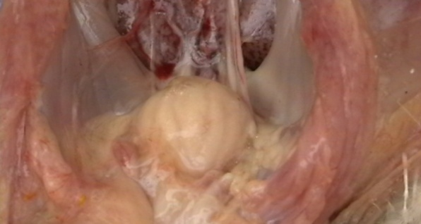
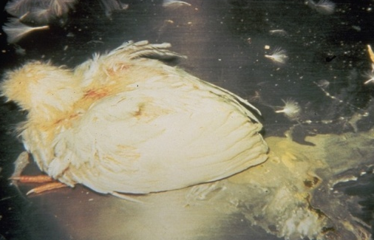

Figure 1(A): whitish and watery diarrhoea
Figure 1(B): swollen, gelatinous bursa
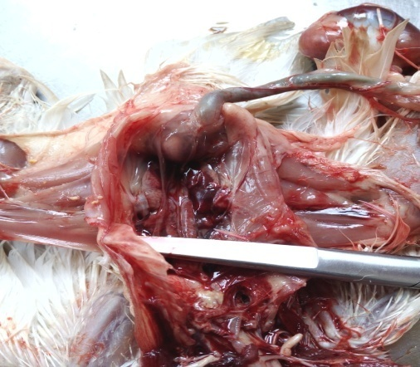
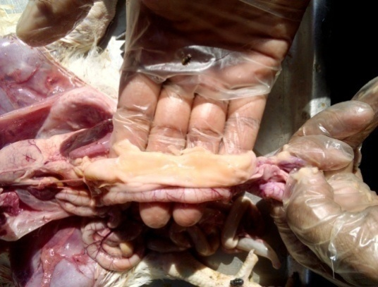
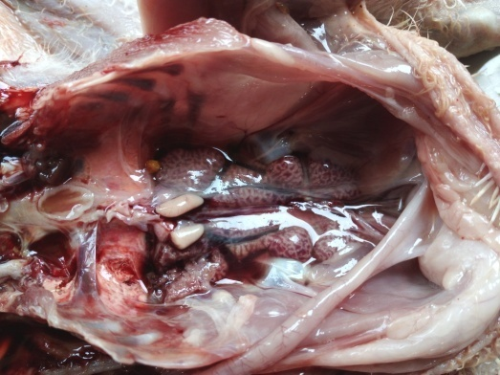
Figure 1(F): duodenum full with mucus
Figure 1(E): swollen kidney
Figure 1(D): hemorrhagic swollen bursal fold
Figure 1(C): swollen hemorrhagic bursa
Chapter 3: Results
3.1 Diagnosis of IBD:
The suspected broiler chickens from flocks with high morbidity and mortality were examined by post-mortem and IBD was confirmed based on gross clinical findings. Haemorrhages were present on the pectoral, leg and thigh muscles in few cases, kidneys were swollen. The principal lesions were found in the bursa of Fabricious, it was swollen (inflamed); appeared edematous and hyperemic and has a gelatinous yellowish transudate. Heamorrhages and areas of necrosis were present in more severe cases (Figure 1). In prolonged cases the bursa of Fabricious were atrophied as compared to hemorrhagic and normal bursa of Fabricious.
3.2 Overall prevalence of IBD in selected farm:
Out of 60 samples 14 were positive out of 60 samples for IBD infection which sum up the overall prevalence of IBD infection in commercial broiler farms of Ramu upazilla in commercial broiler farm was 23.33%. (Table 1)
3.3Prevalence of IBD infection in different age group:
The prevalence of IBD infection was also observed on the basis of different age groups. The estimated prevalence were 0% in 0-9days age, 15.79% in 10-19 days age and 33.33% in 20-35 days age (Table 2). The P value(0.048) was less than 0.05 .So the prevalence were significant.
3.4 Prevalence of IBD infection according to vaccination status:
The prevalence of IBD in IBD vaccinated group was 4.44% and in non vaccinated group it was 80% where P=0.000 (<0.05) which indicates very high significance between vaccination and IBD infection.(Table 2)
3.5 Prevalence of IBD infection according to bio-security status:
Among the 14 IBD positive cases, bio-security was not followed properly in 12 farms where the prevalence was 34.29% .On the other hand, bio-security was followed strongly in rest 2 farms where the prevalence was 8% .It is clear that the prevalence was higher in those farms who did not follow bio-security strongly. Here the P value 0.018(<0.05) indicates that there is a high relationship between bio-security and IBD infection.(Table 3)
3.6 Prevalence of IBD infection in relation to study areas:
The study was conducted among 7 unions of Ramu upazilla. It was observed that the prevalence of IBD infection was 14.29% in Khuniapalong, 16.29% in Mithachori, 0.00% in Kacchapia, 38.89% in Joarianala, 22.22% in Rasid nagor, 0.00% in Kawarkhup and 40% in Rajarkul union respectively (Chart 2). The prevalence of IBD infection was highest in Rajarkul union however the variation was insignificant with IBD infection (P >0.05) .

Table 1: Overall prevalence of IBD infection in broiler in Ramu upazilla
Study area | No. of study sample | No. of IBD positive case | Prevalence % | P value
Ramu upazilla | 60 | 14 | 23.33 | 0.02

Chart 1: Frequency and percentage of prevalence of IBD infection in broiler in different unions of Ramu upazilla

Table 2: Prevalence of IBD infection in broiler at Ramu upazilla for different variables
Variable | Category | No. of samples | No. of  positive  samples |  | Prevalence % | χ2 value | P value
 | 0 – 9 Days | 8 | 0 |  | 0.00%
Age | 10 – 19 Days | 19 | 3 |  | 15.79% | 4.88 | 0.048
 | 20 – 35 Days | 33 | 11 |  | 33.33%
Vaccination | Yes | 45 | 2 |  | 4.44% | 35.900 | 0.000
 | No | 15 | 12 |  | 80%
Status of | Poor | 35 | 12 |  | 34.29% |  | 0.018
bio-security | Moderate | 25 | 2 |  | 8% | 5.6327
Total |  | 60 | 14

Chapter 4: Discussion

The present study was conducted the current status of IBD in small-scale broiler farms in Ramu upazilla. IBD was diagnosed on the basis of clinical history and gross pathological lesions (Islam et al., 2016) .The gross pathological lesions that I observed during necropsy examination were dehydrated and darkened carcass in most of the cases and hemorrhages were present on pectoral, leg and thigh muscles in few cases. The kidneys were swollen. The principal lesion found on the bursa of Fabricious (Okoyo and Dzonkwu, 2005); (Paul, 2004).
In this study the prevalence of IBD in broiler in Ramu upazilla was found 23.33% which is comparatively higher than the earliar studies of Dhaka (11.0%), Mymensingh (19.2%) but lower than Sylhet (24.3%) (Talha et al., 2001; Islam et al., 2003). It may be due to small sample size or difference of managemental practices among the farmers of the following areas.
Significant relationship (P=0.048) was found between age group and IBD infection in (Table 2). The prevalence of IBD infection was higher in age group of 20-35 days (33.33%) than the age group of 10-19 days(15.79%). Others studies have shown most of the birds get infection within the age group of 16-23 days. The chickens of 3 to 6 weeks of age group are most susceptible because maximum development of bursa of Fabricious take place at that time and the bursa follicles are filled up with immature lymphocytes (Shekaro et al., 2015). IBD virus replicates in and cytolytically affects the actively dividing B-lymphocytes in the bursa of Fabricius. IBD have also been recorded at 14-20 weeks in Nigeria (Abdu and Ibe, 2009). In this study the prevalence of IBD in between age 1-9days was 0.00% . (Rahman et al., 2010) did not find any IBD prevalence aging below 14 days. But in another study there was found IBD infection in broiler at 0-7 days old in Narshingdi (Uddin et al., 2010).
In this study the prevalence of IBD in broiler in vaccinated group(4.44%) was comparatively lower than that of non-vaccinated group(80%) and there was strong relationship between non-vaccination and IBD infection (P=0.00).

The prevalence of IBD in farms with poor bio-security was recorded 34.29% whereas it was 8% in farms with moderate bio-security (Table 2). The highest prevalence was estimated in Rajarkul union(40%) and no cases were found in Kaccapia and Khuniapalong union. The test statistics was not significant (P>0.05) for location and IBD infection. This might reflect the limitation of the sampling since the study was only a month long.

Conclusion
This study reflected the prevalence of Infectious bursal disease (IBD) of broiler chickens in Ramu upazilla under Cox’s bazaar district of Bangladesh. The prevalence was 23.33% where the 20-35 days aged birds were affected more. The study showed that vaccination and bio-security status has great effect on causing IBD. IBD causes great economical loss in poultry industry therefore. Proper vaccination and bio-security should be maintained strongly in this upazilla for effective control of occurring IBD infection in broiler chickens.

Limitations and recommendations
The study would be more accurate if isolation , culture and identification of IBD virus would be possible through modern laboratory along with post-mortem examination .Shortage of study period was another constrain as the study had to be done during my internship placement in upazilla veterinary hospital. The results would be more significant if the number of sample size would be more. So, further study may be possible for the most significant result considering the mentioned constrains.

Acknowledgement
The author is ever grateful and indebted to the Almighty Allah without whose grace it would have never been possible to pursue this study in this field of science and to complete this Clinical report writing for the Degree of Doctor of Veterinary Medicine (DVM).
The author would like to thanks his reverend and beloved teacher and supervisor Dr. Mohammad Alamgir Hossain, Professor, Dept. of Pathology & Parasitology, Chittagong Veterinary and Animal Sciences University for his valuable advice, suggestions and kind co-operation during the study period. The author would like to thanks to the Director of External affairs, Professor Dr. AKM Shaifuddin, Dept. of Physiology, Biochemistry and Pharmacology, Chittagong Veterinary and Animal Sciences University for his effective suggestion. Finally the author would like to express his heart felt appreciation & thanks to DR. Rupen Chakma, Upazilla Livestock Officer(ULO), Ramu, Cox’s Bazar for his kind cooperation during the study period.

References
- Cosgrove, AS (1962). An apparently new disease of chickens-avian nephrosis. Avian Diseases, 6: 385-389.
- Eterradossi N, Saif YM (2008). Infectious bursal disease. Diseases of poultry, 12: 185-208.
- Islam MR, Das PM, Chowdhury EH, Dewan ML, 1994b. Some observations on IBD of chicken reproduced experimentally with a highly virulent local isolate. Bangladesh Science Conference, Bangladesh Agricultural University, Mymensingh, 22-24.
- Islam MR, Das PM, Chowdhury EH, Dewan ML, 1994a. Very virulent IBDV – a challenge for poultry industry in Bangladesh.Annual conference of Bangladesh society of Microbiologist, BARC, Dhaka.
- Karim MJ (2003). Current disease pattern in poultry with special emphasis on parasites and their methods of control. Proceeding of the 3rd International Poultry Show and Seminar of World Poultry Science Association-Bangladesh Branch , BCFCC, Dhaka, pp: 119-123.
- Neumann C, Harris DM, Rogers LM (2002). Contribution of Animal Source Foods in Improving Diet Quality and Function in Children in the Developing World. Nutrition Research, 22: 193-220.
- Okoyo JO, Uzoukwu M (2005). An outbreak of infectious bursal disease among chickens between 16 and 20 weeks old. Avian Diseases, 25(4):1034-1038.
- Paul MM (2004). Infectious Bursal Disease - A Pocket guide to poultry health and disease. 34(1): 200-212.
- Rahman MM, Rahman A (1998). Cattle and Poultry development activities. In: Kromobikash O Karjakrom, Directorate of Livestock Services (DLS), Bangladesh. 1st Edn, pp: 31-55.
- Rahman MS, Islam MS, Rahman MT, Parvez NH, Rahman MM (2010). Analysis of prevalence of infectious Bursal disease in broiler flocks in Dinajpur. International Journal of Sustainable Crop Production, 5: 15-18.
- Raha SK (2007). Broiler Industry in Bangladesh: Some Issues. International Poultry Show and Seminar 2007. World's Poultry Science Association, Bangladesh Branch.
- Shekaro A, Josiah IE (2015). Infectious Bursal Disease Outbreak in Fifteen Weeks Old Pullets in Kaduna, Nigeria. Journal of Animal Production Advances, 1: 636-644.
- Talha AFSM, Hossain MM, Chowdury EH, Bari ASM, Islam MR, Das PM (2001). Poultry Diseases Occurring in Mymensingh District of Bangladesh, The Bangladesh Veterinary Journal, 18: 20-23.
- Uddin MB, Ahmed SSU, Hassan MM, Khan SA, Mamun MA (2010). Prevalence of Poultry Diseases at Narsingdi, Bangladesh. International Journal of Biological Research, 1: 9-13.

Biography
This is Sajjad Hossain, son of Mr. Abdu Sukkur and Mrs. Sofia Akter. I am from Cox’s Bazar district. I completed S.S.C in 2008 and H.S.C in 2010 with GPA 5.00 .I got admitted into Doctor of Veterinary Medicine(DVM) course under Chittagong Veterinary and Animal Sciences University in 2011- 2012 session. As an upcoming Veterinarian I would like to dedicate my rest of the life for the welfare of animals. I am keen to be a field veterinarian as well as a skilled poultry practitioner.

