Abstract
A two years old Jersey cow with a history of premature calving was bought to the clinics of Veterinary college and Research Institute, Nammakal. The cow showed protrusion of mass through the vulva after its first calving. On clinical examination animal was apparently healthy and confirmed as uterine prolapse. The Uterine prolapse was corrected manually following proper precautionary measures. To prevent the recurrence, Buhner’s suture was applied. Animal had an uneventful recovery.

Keywords: jersey cow; uterine prolapsed; buhner’s suture.

CHAPTER-I
INTRODUCTION

Uterine prolapse is the protrusion of the uterus from the vulva with the mucosal surface exposed (Gustafsson et al., 2004; Kornmatitsuk et al., 2004). Uterine prolapse occurs most often immediately after parturition and occasionally up to several hours afterward. The presence of a part of the fetal membrane in the genital passage induces strong tenesmus and prolapse. Various predisposing factors have been suggested for uterine prolapse in the cow, e.g. hypocalcaemia, prolonged dystocia, fetal traction, fetal oversize, retained fetal membranes, chronic disease and paresis (Risco et al., 1984; Reynolds et al., 1984; Ishii et al., 2010; Aoki et al., 2010). Prolapsed of the uterus at post parturient period through the genital passage and it’s expulsion outside the body is a frequent sequel to protracted dystocia. Uterine prolapse has been recorded in all species of animal, although most commonly seen in pluriparous dairy cows occurring immediately after parturition and occasionally after several hours (Roberts, 1971; Simon, Gupta et al., 2015). Incidence of post partum uterine prolapse varies from 6.6 % to 12.9 % (Nanda and Sharma, 1982). In the period immediately after prolapse occurs the tissues appear almost normal, but within a few hours they become enlarged and edematous. Some animals will develop hypovolaemic shock secondary to internal blood loss, laceration of the prolapsed organ or incarceration of abdominal viscera (Ramsingh et al., 2013; Mohan et al., 2013). It is regarded as a veterinary emergency because without treatment, the cow is likely to die (Murphy and Dobson, 2002; Miesner and Anderson, 2008). The method of raising the rear end of the cow using a tractor was reported as a quick, easy and essentially practical method of dealing with a prolapsed uterus (Ishii et al., 2010; Aoki et al., 2010). This case report describes the successful correction of uterine prolapse in a cow.

CHAPTER-II

CASE PRESENTATION

2.1. Case presentation & history
The two years old primiparous Jersy cow was presented with history of protrusion of mass through the vulva since seven hours after parturition. She delivered a male calf. On gynaeco-clinical examination the cow was apparently healthy with moderate tenesmus and the physiological parameters were within the normal range. The uterine prolapsed mass was larger, longer (hanging down to the hocks when standing), more deep red in colour and covered with foetal membranes. The prolapsed mass was also edematous and engorged and soiled with faeces, straw, dirt and blood clots.

2.2. Surgical management
a. General approach
Before to the treatment physical examination was done and recorded the temperature, pulse rate, respiration rate, body weight etc. Blood sample was collected for the estimation of hemoglobin, ESR, total count of RBC, total count of WBC, PCV, lymphocyte, neutrophil, eosinophil, monocyte, basophil, serum calcium, serum magnesium, serum phosphorus, S.GOT and S.GPT.

b. Correction of uterine prolapse
Caudal epidural anesthesia was done with 5ml 2% lignocaine HCL for prevention of straining. Then the partial foetal membrane was carefully separated avoiding damage to maternal caruncles and bleeding. The tissue debris was removed by washing and cleaning the prolapsed mass with water (Figure 1). The prolapsed mass was throughly irrigated with 1:1000 potassium permanganate solutions (Figure 2). With gloved and lubricated hand, the everted uterus was pushed through the vagina by manual pressure to regain its normal position (Figure 3 and Figure 4). To prevent further complications, intrauterine four Furea boli were kept in uterus. Re-occurance of prolapse due to tenesmus was prevented by applying Buhner’s sutures (Figure 5).
c. Post operative care
Calcium borogluconate solution [45ml, intravenously], antibiotic [Streptopenicillin, 18ml, intramuscularly], antihistaminic [20ml, intramuscularly] and dextrose saline [(20%) 2000ml, intravenously] were injected for 7 days.

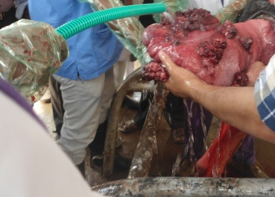
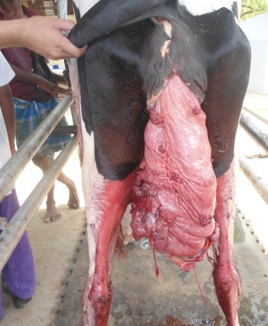

Figure 2.2: Cleaning the prolapsed mass with water

Figure 2.1: Hanging prolapsed uterus

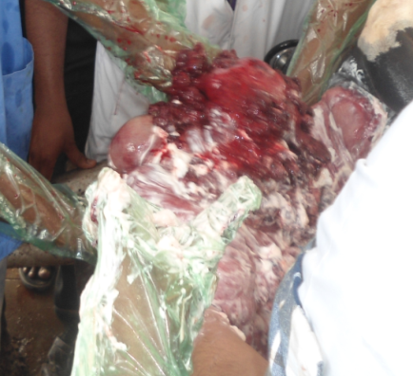
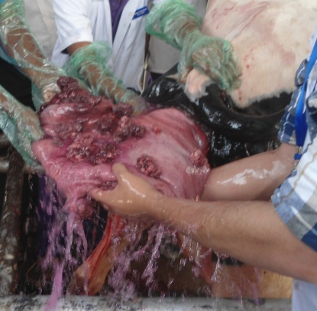

Figure 2.3: Application of potash water in the uterine mass
uterine

Figure 2.4: Application of lubricant in the uterine mass

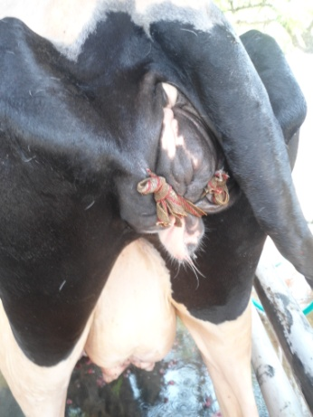
Figure 2.7: Recovered cow

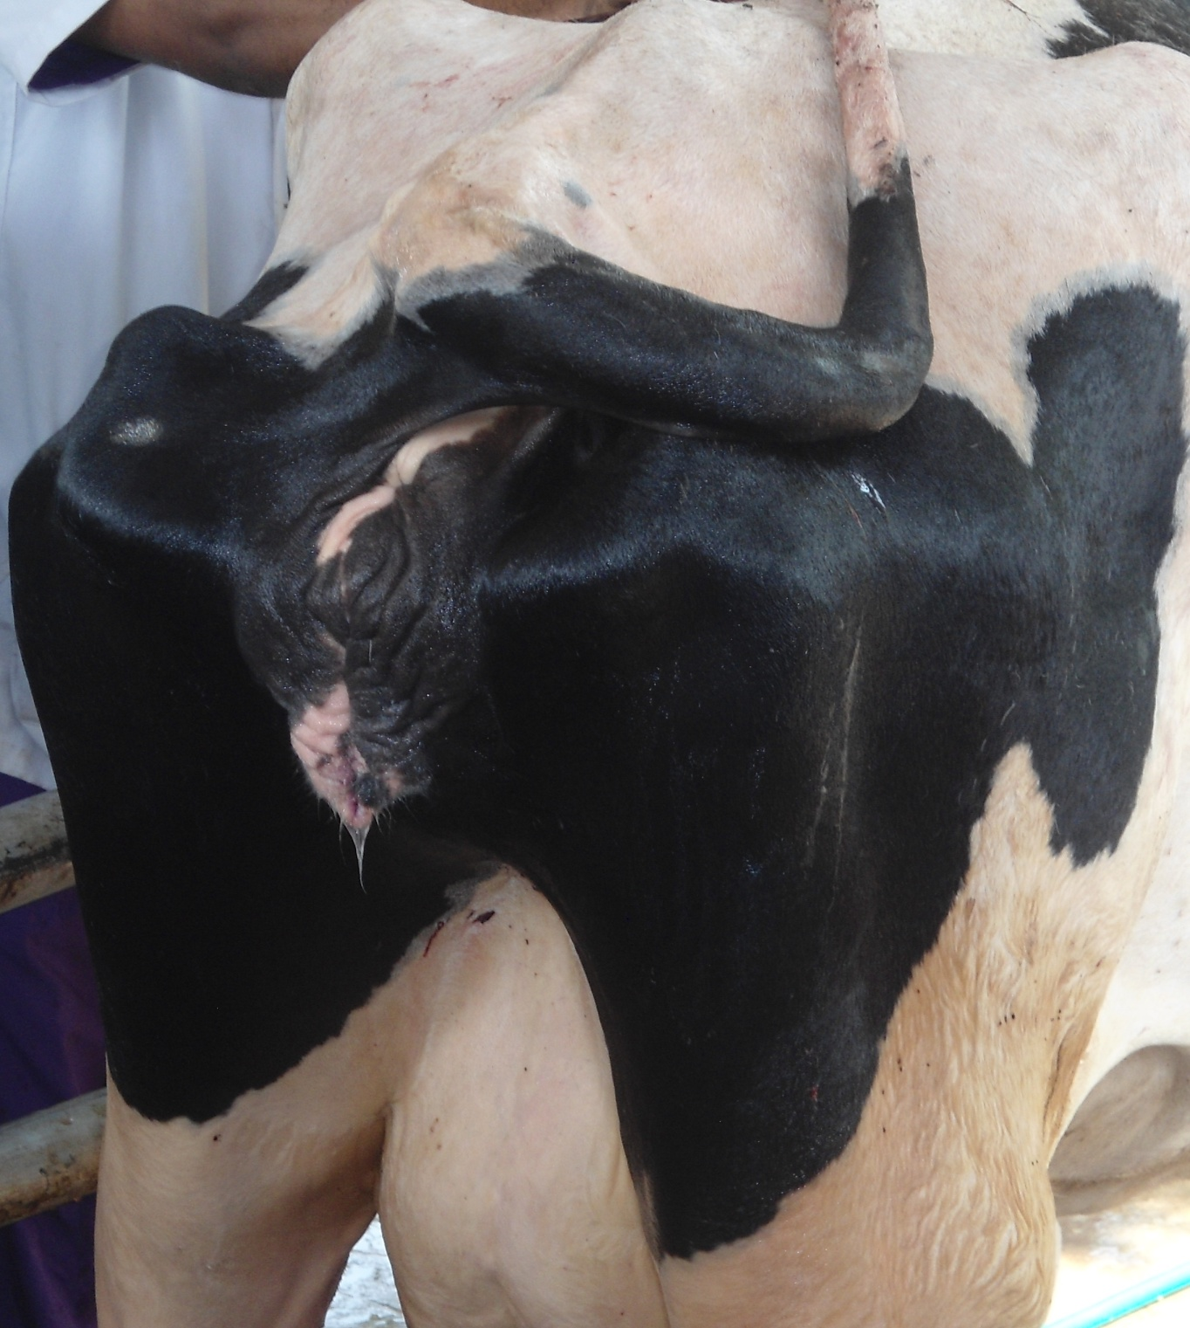
Figure 2.5: Repositioning the prolapsed mass

Figure 2.6: Applying Buhner’s suture

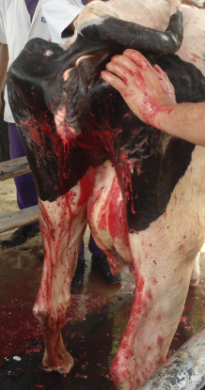
CHAPTER-III
RESULTS AND DISCUSSION

The cow showed good recovery without recurrence and other complications. The suture was removed after two weeks. The incidence of uterine prolapse registered frequently in cattle and sheep (Bhattacharyya et al., 2012; Fazili et al. 2012). It is generally noticed during immediately post-partum especially after dystocia (Sah and Nakao, 2003). But in the reported case, the prolapse was observed in Jersy heifer after normal parturition of premature calf. The objective in the treatment of uterine prolapse was replacement of the organ to its original position and prevention of recurrence. The usual sequel of uterine prolapse is haemorrhage, shock, septic metritis, peritonitis, infertility or death. Bhattacharya et al. (2012) reported 9.09 % mortality rate and 18.18 % cows developed metritis. However, careful removal of dung and dirt materials using potassium permanganate solution prevented the uterine infection in this case as noticed by (Simon et al., 2015; Gupta et al., 2015). Elevation of hind quarters helps in repositioning of prolapsed uterus with good recovery rate (Ishii et al., 2010; Aoki et al., 2010). It was observed that the hygienic handling, proper management and treatment should definitely prevent further reproductive tract damage and aid in quick recovery.
In this case hematological parameter showed low serum calcium level (7.5 mg/dl) (Table 1) indicating hypocalcaemia. Decreased level of calcium can lead to reduced vaginal and uterine muscle tone which predisposes the animal to prolapse (Noakes et al., 2009). Based on the results of the present study, deficiency of calcium (7.5 mg/dl), magnesium (1.6 mg/dl) and phosphorus (3.2mg/dl) might be the possible factor that leads to prolapse of genital track in cow. Besides biochemical observation, the blood sample was also tested to detect different blood parameters (Table 2). The result showed that there was increased level of ESR (12 mm in 1st hour) and decreased PCV (22%). According to Jain (1986), ESR increases in inflammatory conditions and in acute generalized infection. This result is in agreement with those of Kinney (1967), who stated that the decrease in PCV in prolapsed animals might be due to possible release of antidiuretic hormone as a result of stress.

Table: 1. Biochemical blood analysis in cow suffering from uterine prolapse.
Name of the test | Result | Normal Range
Serum calcium | 7.5 | 9.7-12.4 mg/dl
Serum magnesium | 1.6 | 1.8-2.3 mg/ dl
Serum phosphorous | 3.2 | 5.6-6.5 mg/dl

Table: 2. Routine blood test in cow suffering from uterine prolapse.
Name of the test | Result | Normal Range
Hemoglobin | 8 | 8-15 gm%
ESR (Wintrobe tube method) | 12 | 6-10 (mm in 1st hour)
Total count of RBC | 5 | 5-10 million/ cumm
Total count of WBC | 6 | 4-12 thousand/ cumm
PCV | 22 | 24-46%
Lymphocytes | 72 | 45-75%
Neutrophils | 25 | 15-45%
Eosinophils | 6 | 0-20%
Monocytes | 3 | 2-7%
Basophils | 1 | 0-2%

CHAPTER-IV
LIMITATIONS

- Due to short duration, I could not follow up the case
- Inspite of having wish to handle the case, I was just assigned as assistant to help the respective authority of VC&RI.

CHAPTER-V
CONCLUSION

Uterine prolapse may appear in peri-parturient period. Diagnosis and treatment of uterine prolapse is very much important task. Delayed in correction may cause some critical condition such as edema, fibrosis, necrosis, septicemia. So the farmers and veterinarians should be careful about early recovery of the condition which will save the cow from life-threatening condition.
Authors are thankful to the Director of Teaching Veterinary Hospital, Chittagong Veterinary and Animal Science University and All the members of Veterinary college and Research Institute, Nammakal for providing necessary facilities to this case study.

CHAPTER-VI
REFERENCES

Bhattacharyya HK, et al., 2012. Genital prolapse in crossbred cows: prevalence, clinical picture and management by a modified Bühner’s technique using infusion (drip) set tubing as suture material. Veterinarski arhiv., 82: 11-24.

Gustafsson H, et al., 2004. Peripartum and early post partum in the cow-physiology and pathology. Medicine Vet. OPQ., 34: 64-65.

Ishii M, et al., 2010. Uterine prolapse in cows: Effect of raising the rear end on the clinical outcomes and reproductive performance. Vet Med., 55: 113-118.

Jain N, 1986. Schalm’s Veterinary Haematology 4th edition (ed NC Jain) Lea and Febiger, Philadelphia.

Kinney JM, 1967. The effect of injury on metabolism. Br J Surg., 54: 435-437.

Miesner, M. D. and D. E. Anderson (2008). "Management of uterine and vaginal prolapse in the bovine. Vet Clin North Am Food Anim Pract., 24: 409-419.

Murphy A and H Dobson, 2002. Predisposition, subsequent fertility, and mortality of cows with uterine prolapse. Vet. Rec., 151: 733-735.

Nanda AS and RD Sharma, 1982. Incidence and etiology of pre-partum prolapse of vagina in buffaloes. Indian J. Dairy Sci., 35: 168- 171.

Ramsingh L, KM Mohan and KS Rao, 2013. Correction and management of uterine prolapse in crossbred cows. Int. J. Agris. Sci. & Vet. Med., 1: 1-3.
Risco CA, JP Reynolds and D Hird, 1984. Uterine prolapse and hypocalcemia in dairy cows.

J Am Vet Med Assoc., 185: 1517-1519.
Roberts S, 1971. Veterinary Obstetrics and Genital Diseases, 2nd edn, the author. Ithaca, New York, pp. 114.

Sah SK. and T Nakao, 2003. Some characteristics of vaginal prolapse in Nepali buffaloes." J Vet Med Sci., 65: 1213-1215.

Simon MS, et al., 2015. Post-Partum Uterine Prolapse in a Doe and its Management. Indian Vet. J., 92: 68-69.

CHAPTER-VII
ACKNOWLEDGEMENT

The author wish to acknowledge the immeasurable grace and profound kindness of almighty “GOD” the supreme authority and supreme ruler of universe, who empowers me to complete this task successfully.

The author feel proud in expressing her deep sense of gratitude and indebtedness to internship supervisor DR. Tanjila Hasan, Lectrer, Department of Medicine & Surgery, Chittagong Veterinary and Animal Sciences University for his trustworthy and scholastic supervision to make this report.

The author also wishes to thank the teachers and the personnel of unit of gynaecology and obstetrics (large animal), department of clinics, Veterinary College & Research Institute for all the techniques and their assistance in studying this case

The author expresses thanks and warmest sense of gratitude to her parents and all well-wishers.

CHAPTER-VIII
BIOGRAPHY

I am Progayan Chakma, son of Mr. Amar Sneha Chakma and Bina Chakma. I passed my Secondary School Certificate (SSC) examination from Chittagong Residential School & College(CRSC), Chittagong in 2009 and Higher Secondary Certificate (HSC) examination from Bandarban Cantonmenmt Public School and College(BCPSC), Bandarban in 2011. I enrolled for Doctor of Veterinary Medicine(DVM) degree in Chittagong veterinary and Animal Sciences University(CVASU), Chittagong, Bangladesh in 2011-12 session. At present I am doing my Internship Programme which is compulsory for awarding my degree of Doctor of Veterinary Medicine (DVM) from Chittagong Veterinary and Animal Sciences University. In the near future I would like to work and have massive interest in wildlife medicine, conservation of nature and wildlife.

