ISOLATION OF Salmonella spp. And Escherichia coli FROM THE ORAL AND CLOACAL SWAB OF BINOCELLATE COBRA (Naja naja)
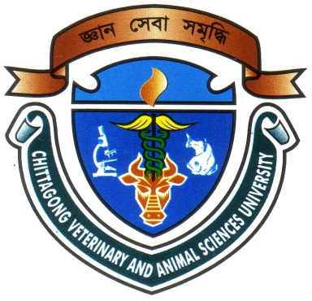

Report presented in partial fulfillment of the requirement for the degree of Doctor of Veterinary Medicine

A Report Submitted by
Roll no: 12/28
Intern ID No: C-25
Reg No: 00750
Session: 2011-2012

Faculty of Veterinary Medicine
Chittagong Veterinary and Animal Sciences University
Zakir Hossain Road, Khulshi, Chittagong-4225

November, 2017

ISOLATION OF Salmonella spp. And Escherichia coli FROM THE ORAL AND CLOACAL SWAB OF BINOCELLATE COBRA (Naja naja)

e

Clinical Report Submitted as per approved style and content

--------------------------------------------- -----------------------------------------
Signature of the student  AJOY DEV NATH  Roll No: 12/28  Reg No: 00750  Intern ID: C-25  Session: 2011-2012 | Signature of the supervisor  Dr. PRANAB PAUL  Lecturer  Department of medicine and surgery  Faculty of Veterinary Medicine  Chittagong Veterinary and Animal Sciences University

Faculty of Veterinary Medicine
Chittagong Veterinary and Animal Sciences University
Zakir Hossain Road, Khulshi, Chittagong-4225

November, 2017

