TABLE OF CONTENTS

CONTENTS | PAGE NO.

LIST OF FIGURES.......................………………………………………………….......01

LIST OF TABLES...…………………………………………………………………......

LIST OF GRAPHS …...……………………………………….................................

LIST OF ABBREVIATION…………………………………………………………

ABSTRACT……………………………………………………………………….......

CHAPTER 1

INTRODUCTION……………………………………………………………….....1-3

CHAPTER 2

MATERIAS AND METHODS .........................................................................4-7
2.1 Samples and Sampling/Study area .................................................... 4
2.2 Epidemiological survey...................................................................... 4
2.3 Sample collection and processing ......................................................4
2.4 Study Design ......................................................................................4
2.5 Bacterial isolation .............................................................................. 5
2.6 Antimicrobial susceptibility testing ................................................... 6
2.7 Data analysis .....................................................................................6
CHAPTER 3

RESULTS………………………………………………………………………….8-10

CHAPTER 4

DISCUSSION……………………………………………………………...…..........11
CHAPTER 5
LIMITATIONS ..................................................................................................12
CHAPTER 6
CONCLUSION………………………………………………………..……….........12
ACKNOWLEDGEMENTS.......................................................................................13

REFERENCES………………….............................................................................14-15

BIOGRAPHY…………………………………………………………………………...16

LIST OF FIGURES
FIGURE NO. | CONTENTS | PAGE NO.
Figure 1 | Broiler Farm | 7
Figure 2 | Collecting fecal samples | 7
Figure 3 | Salmonella on XLD agar | 7
Figure 4 | Culture Sensitivity test | 7
Figure 5 | Observing zone of inhibition | 7

LIST OF TABLES
TABLE NO. | CONTENTS | PAGE NO.
Table 1 | Methods on culture test | 5
Table 2 | Standard measurement of diameter of zone of inhibition. | 6
Table 3 | The examination result at a glance done for isolation of Salmonella | 8
Table 4 | Antimicrobial resistance pattern against Salmonellaisolates | 8
Table 5 | Prevalence of antimicrobial resistance pattern against Salmonella isolates | 9

LIST OF GRAPHS
GRAPH NO. | CONTENTS | PAGE NO.
Graph 1 | Graphical representation on prevalence of Salmonella | 7
Graph 2 | Graphical representation of antimicrobial susceptibility profiling | 9

LIST OF ABBREVIATIONS
ABBREVIATIONS | ELABORATIONS
MSRV Agar | Modified Semi-Solid ReppaportVassiliadis agar
XLD Agar | Xylose lysine deoxicholate agar
S | Sensitive
I | Intermediate
R | Resistance
CLSI | Clinical and Laboratory standard Institute
etc. | Etcetera
et al | And his associates

Prevalence and Antimicrobial Susceptibility Profiling
ofSalmonella in broiler farms at Patiya, Chittagong

ABSTRACT

The aim of this study was to determine the prevalence of Salmonella infections in broiler farms and their antimicrobial susceptibility profiling test at Patiya, Chittagong. Bacteria isolated from pooled fecal samples of broiler atPatiya, Chittagong were screened for the presence of Salmonella spp. A total of 30 pooled fecal samples were tested during 01 March 2017 to 06 April 2017 and 05 July 2017 to 03 August 2017 at PRTC (Poultry Research and Training Centre), CVASU (Chittagong Veterinary and Animal Sciences University), where 9 (30%) sampleswere positive for Salmonella through all classical bacteriological tests. Isolated Salmonella were tested for resistance to 5 different antimicrobial agents such as Amoxicillin, Ampicillin, Ciprofloxacin, Salfamethazole and Colistinsulphate which was carried out by the Kirby-Bauer disc diffusion method as per recommendation of CLSI and efficacy of antibiotics was determined by measuring the diameter of the zone of inhibition that results from diffusion of the agent into the medium surrounding the disc. The Salmonella were found 88.89%, 88.89% and 66.67% resistance to Amoxicillin, Ampicillin and Salfamethazole respectively.77.78% samples were sensitive & 11.11% samples were intermediate to Colistin Sulfate which was the highest in sensitivity followed by 55.56% sensitive to Ciprofloxacin. The growth of resistance against antibiotic was due to carelessly using antibiotic through farm owner without maintaining dosage prescribed by veterinarians.

Key Words: Prevalence, Broiler, Salmonella, Antimicrobial susceptibility profiling

CHAPTER 1
INTRODUCTION
The poultry sub-sector is an important avenue in fostering agricultural growth and reduce malnutrition for the people in Bangladesh. It is an integral part of farming system in Bangladesh and has created direct, indirect employment opportunity including support services for about 6 million people. This sub-sector has proved as an attractive economic activity, thereby, indicating its importance for the entire economy. The sector accounts for 14% of the total value of livestock output and is growing rapidly. Poultry population in Bangladesh is estimated about 304.17 million where chicken population is about 255.31 million (Hamid et al., 2017). In developing countries, such as Bangladesh, poultry and poultry products are cheap and staple source of animal protein for all ethnic groups. Bangladesh produces an estimate of 4.52 million tons of poultry meat (Growth rate 24.86%) and estimate of 10168 million numbers of egg (Growth rate 33.48%)(Source: DLS, 2013-14).Farrell stated that, over the next 20 years significant expansion of most livestock industries, especially poultry eggs and meat is likely to occur mainly in developing countries. Bangladesh is one of the potential countries to catch this opportunity. The forecast of production eggs and meat within the year 2020 of about 47.0 million Mt of poultry and 54.0 million Mt of eggs (Source: Farrell).
Bangladesh started export of day old chicks and feed to other countries during 2002-2007 and it is temporarily stopped due to Avian Influenza. However if we control the AI, we will be in position to export not only the chicks and feed but also poultry meat.(Hamid et al.,2017).
This sector can create huge job opportunity. It offers full or part time employment of large number of peoples particularly women, children or elderly person on the farm operations. This clearly indicates that there is scope for expansion of this industry.(Rahman et al. 2017)

There are several constraints in poultry industries in Bangladesh. Some diseases of poultry specially in chicken act as a barrier in poultry industry which affects directly or indirectly. Among them Pullorum disease (caused by Salmonella Pullorum, recently used nomenclature) is one of the major constraints of poultry industries in Bangladesh (Hossainet al., 2006). Salmonella infection is one of the most important bacterial diseases in poultry causing heavy economic loss through mortality and reduced production (Haideret al., 2003).
Salmonellae are gram-negative bacteria, which belongs to the genus Salmonella which is part of the family of Enterobacteriaceae (bacteria living in the intestine). Salmonellae are non-encapsulated bacteria that can grow under either aerobic or anaerobic conditions. The optimum temperature for growth is 35 to 43ºC while the optimum pH is 6.6 to 8.2. However, Salmonellae can continue to grow at pH values between 4.5 and 9.5 and at temperatures between 5 and 54 ºC. A water activity above 0.94 is also required (Hanes, 2003).Most of the salmonellae are motile bacteria that use flagella to move. Some serotypes like S. Gallinarum or S. Pullorum are non-motile. Among the different Salmonella serotypes, S. Enteritidis and S.Typhimuriumare presented separately from others because, on the one hand, these bacteria are often specifically cited in zoonosis control legislation, and, secondly, because there are differences in the epidemiology as compared to other salmonellae. S. Enteritidis and S. Typhimuriumare the predominant serotypes associated with human disease in most countries. Indeed, Salmonella spp. is one of the major causes of food poisoning in humans. According to the European Food Safety Authority (EFSA, 2009), a total of 154,099 cases of human salmonellosis were reported by the 25 EU Member States in 2004. The major sources of food borne salmonellosis are eggs and poultry meat (EFSA, 2005).More than2300 serotypes of Salmonella have been identified, only about 10% of these have been isolated from poultry.

Salmonella is also a globally widespread food-borne pathogen having major impact on public health.Salmonellosis is an infection with bacteria called Salmonella. Most persons infected with Salmonella develop diarrhoea, fever, and abdominal cramps 12 to 72 h after infection (Aditya, 2015). Poultry and poultry products are often implicated in sporadic cases and in outbreaks of human salmonellosis (Bryan and Doyle, 1995; Humphrey, 2000).Thus, it is inevitably of great importance for both animal and public health.

The Salmonella spreading with the presence of antimicrobial resistance genes have some global public health impacts, because of their trans-mission to other countries, by travelers or by trade are impossible to prevent (Collard et al., 2007) but differences in hygiene practices and handling between slaughterhouses, could significantly eliminate the risk of Salmonella contamination of broiler meat (Heyndrickx etal., 2002). In developed countries it is becoming more and more accepted that a majority of resistant strains are of zoonotic origin and have gained their resistance in an animal host before being moved to humans through the food chain (Molbak et al., 2002; Threlfall et al., 2002). This resistance occurs due to the indiscriminate and improper use of sub-therapeutic doses of antibiotics. Present study has designed to determine prevalenceand antibiogram analysis by collecting fecal sample of 30 broiler farms from Patiya,Chittagong.
Antimicrobial uses are not well regulated in most of the developing countries including Bangladesh that encourage poultry farmers to abuse antimicrobials on their own without concern of the veterinarians. This abuse of antibiotics might lead to the development of antimicrobial resistance in zoonotic pathogens such as Salmonella. Through the trades of poultry and poultry products, and human movements this antimicrobial-resistant Salmonella can spread over the borders. Thus, local emergence of a multidrug-resistant Salmonella strain in poultry has an international importance.

Reducing Salmonella contamination on poultry carcasses requires a complete approach that includes the entire integrated broiler operation, the breeding flocks, hatchery, broiler growers, feed mills and transporters. Therefore, in order to control Salmonella, one should consider the critical points of the farm.In order to efficiently control Salmonella spp. at the farm level, a set of biosecurity measures need to be applied.Therefore, a combination of different interventions will allow achieving significant reductions in the frequency of Salmonella-contaminated broilers sent to slaughter.

Objectives:
- To estimate prevalence of Salmonella in broiler farm at Patiya,Chittagong.
- To isolate Salmonella from pooled fecal samples of broiler farm.
- To investigate antibiotic resistance pattern of Salmonella isolated from broiler farm at Patiya, Chittagong.

CHAPTER 2
MATERIALS AND METHODS
2.1 Samples and Sampling/Study area and animals
A cross-sectional survey was undertaken by collecting pooled fecal sample from 30 broiler farms in different ages of Patiya, Chittagong. The sample was collected during Upazilla Veterinary Hospital internship placement schedule for two months. The duration of placement was about 01 March 2017 to 06 April 2017 and 05 July 2017 to 03 August 2017.Pooled sample (200 gms) was taken from the broiler farm.
2.2 Epidemiological survey
A questionnaire was designed and applied to shop owners during an interview at the time of sampling.
2.3 Sample collection and processing
Fecal samples were firstly collected in separate clean plastic zipper bag immediately after voiding. Then fecal samples were transferred scientifically in a clean sterile screw capped falcon tube containing buffer peptone water. Soon after collection, the samples were kept into a cool box with ice for ceasing the growth and activity microorganism. Each sample was labeled with date of sampling, type of sample and the place from where the sample was collected. The samples were transported to the Department of Microbiology and Veterinary Public Health or to the Poultry Science and Research Centre, Chittagong Veterinary and Animal Sciences University (PRTC-CVASU) as early as possible and stored at 4°C until bacteriological investigation.
2.4 Study Design
Broiler farm of Patiya, Chittagong

Collection of pooled fecal samples

Put the samples into plastic zipper bags after voiding

Peptone broth

Modified Semi-solid Rappaport-Vassiliadis (MSRV) agar(Selective enrichment)

Brilliant green agar and Xylose lysine deoxicholate (XLD) agar

Salmonella positive

Antibiogram

Sensitivity test

2.5 Bacterial isolation
Conventional bacteriological procedures be followed for the isolation and identification of Salmonella. Briefly, naturally pooled fecal samples will be mixed with buffered peptone water (BPW) and 25 gm of this mixture will be transferred to 200 ml of BPW, and incubated at 37°C for 16-18 hours, followed by selective enrichment in Modified Semi-solid Rappaport-Vassiliadis (MSRV) agar for 24 hours at 42°C. Any opaque growth observed on the MSRV agar plates will be suspected for Salmonella and streaked on to brilliant-green and xylose lysine deoxicholate (XLD) agar by using an inoculating loop. Following incubation at 37°C for 24 hours, suspected Salmonella colonies will be transferred on to 5% blood agar plate with incubation for 16 to 18 hours at 37°C.
Table 1: Methods on culture test
SN | Agar/Test | Incubation time &Temparature | Observations
1 | MSRV Agar | Incubated at 42⁰C for 24 hours | Grey white turbid zone visible.
2 | Brilliant Green Agar | Incubated at 37⁰C for 24 hours | Red to pink white colonies surrounded by a red zone.
3 | XLD Agar | Incubated at 37⁰C for 24 hours | Pink color colonies with black center.
4 | Blood Agar | Incubated at 37⁰C for 16-18 hours | Produce non-hemolytic smooth white colonies.

2.6 Antimicrobial susceptibility testing:
Antimicrobial susceptibility testing of Salmonella isolates will be performed by disk diffusion method according to the Clinical and Laboratory Standards Institute (CLSI, 2008) standards with a panel of 5 antimicrobials including Amoxicillin(10μg), Ampicillin (10μg),Ciprofloxacin (5μg), Colistinsulphate(10μg), Salphamethazole (25μg) isolate the zone of inhibition around each disk will be measured and interpreted as Susceptible (S), Intermediate (I) or Resistant (R) according to CLSI documents for veterinary pathogens (CLSI, 2008).
Table 2: Standard measurement of diameter of zone of inhibition.
SL | Name of Antimicrobial agents | Diameter of zone of inhibition (millimeter)
 |  | Resistant | Intermediate |  | Sensitive
1 | Ampicillin | ≤13 | 14-16 | ≥17
2 | Amoxicillin | ≤13 | 14-17 | ≥18
3 | Ciprofloxacin | ≤15 | 16-20 | ≥21
4 | Colistinsulphate | ≤10 | 11-13 | ≥14
5 | Salphamethazole | ≤10 | 11-15 | ≥16

Source: CLSI, 2007; Seol et al., 2005; LO-Ten-Foe et al., 2007
‘ R’=Resistance, ‘I’=Intermediate, ‘S’=Sensitive

2.7 Data analysis
Data was stored in MS excel (Microsoft Word 2007) and descriptive analysis was done in this study.

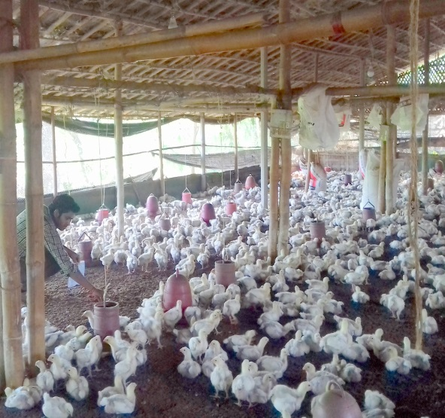
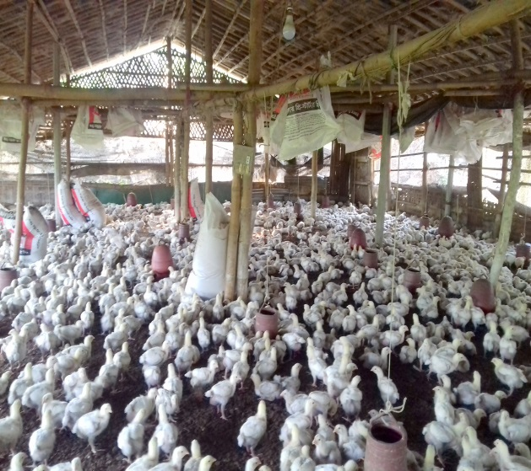

Collecting fecal sample
Broiler Farm
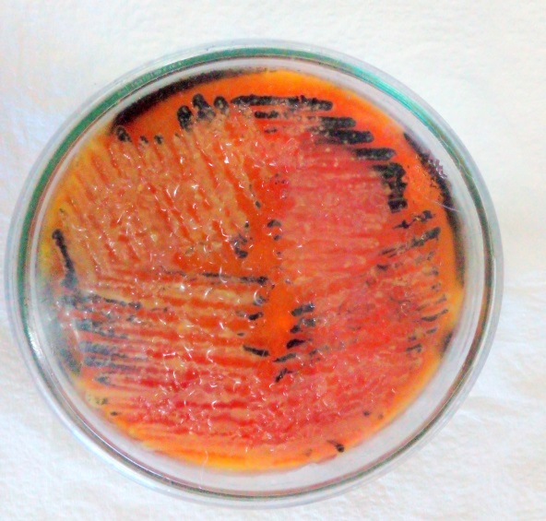
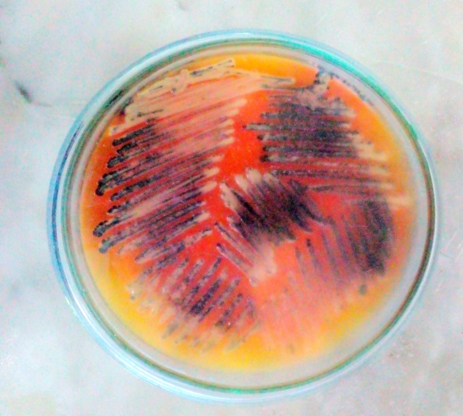

Salmonella on XLD agar
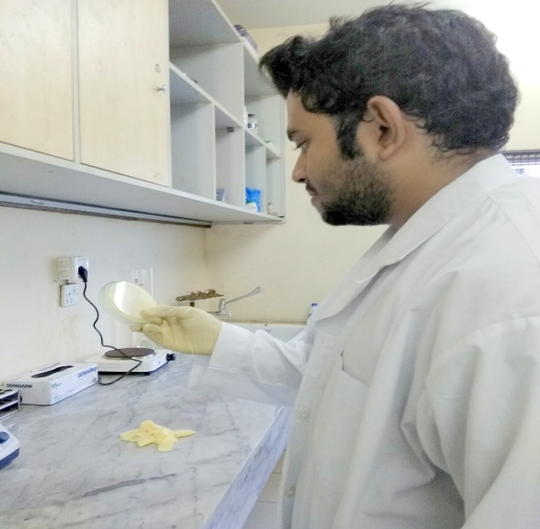
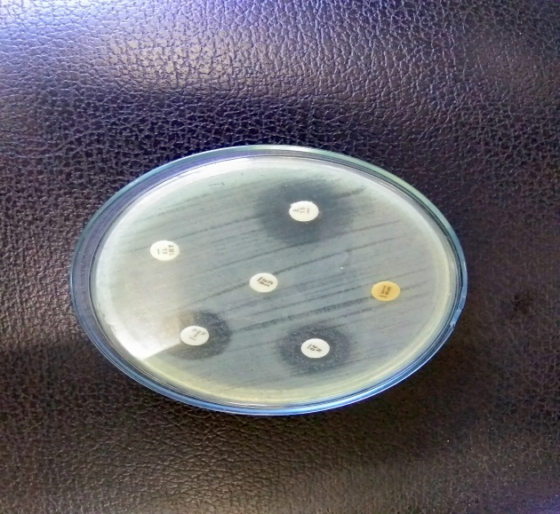

CS

Observing zone of inhibition
Culture Sensitivity test

CHAPTER 3
RESULTS

Among 30 samples of feces of broiler farms 9 (30%) pooled fecal samples were positive and individual colonies of Salmonella were isolated through different tests sequentially.

Graph 1: Graphical representation on prevalence of Salmonella

Results of culture examination
Salmonella was cultured on Brilliant-green agar(BGA) & Xylose lysine deoxicholate (XLD) medium for morphological characterization. After completing sequential processing, 30% samples were found positive and formed two types of colonies were isolated under microscopic examination. All the isolated colonies were Red to pink-white colonies surrounded by red zone on BGA, while Pink color colony with black center on XLD agar. In the microscopic examination of Gram’s staining, all the positive samples are found as Gram-negative, pale pink colored, short rod shaped transparent bacteria which are arranged in single or in pairs.

Table 3: The examination result at a glance done for isolation of Salmonella

SL | Name of the media / Test | Total no. of sample | No. of positive sample | Percentage  (%)
1. | Brilliant-green agar | 9 | 9 | 30%
2. | XLD agar | 9 | 9 | 30%
3. | Gram’s staining | 9 | 9 | 30%

Result of antimicrobial sensitivity test:
All the 9 positive isolates were subjected to do antibiotic sensitivity test to 5 different antimicrobial agents. From the isolates 77.78% samples were sensitive & 11.11% samples were intermediate to ColistinSulphate which was the highest in sensitivity. 55.56% samples showed sensitive to Ciprofloxacin. From the isolates 88.89%, 88.89% and 66.67% samples showed resistance to Amoxicillin, Ampicillin and Salfamethazole respectively.

Table 4: Antimicrobial resistance pattern against Salmonella isolates
Sample NO | Amoxicillin (AMX) | Ampicillin  (AMP) | Ciprofloxacin  (CIP) | ColistinSulphate (CT) | Salphamethazole  (SXT)
Sample 1 | R | R | S | S | R
Sample 2 | R | S | S | S | R
Sample 3 | R | R | R | S | I
Sample 4 | R | R | S | I | R
Sample 5 | R | R | R | S | I
Sample 6 | R | R | S | R | S
Sample 7 | R | R | I | S | R
Sample 8 | I | R | S | S | R
Sample 9 | R | R | R | S | R

Table 5: Prevalence of antimicrobial resistance pattern against Salmonella isolates

Antimicribial agents | No. of Positive isolates | Resistance  No (%) | Intermediately  Sensitive (%) | Sensitive  (%)
Amoxicillin | 09 | 8(88.89) | 11.11 | 0.00
Ampicillin | 09 | 8(88.89) | 0.00 | 11.11
Ciprofloxacin | 09 | 3(33.33) | 11.11 | 55.56
Colistinsulphate | 09 | 1(11.11) | 11.11 | 77.78
Salfamethazole | 09 | 6(66.67) | 22.22 | 0.00

Graph 2: Graphical representation of antimicrobial susceptibility profiling test:

CHAPTER 4
DISCUSSION
Overall prevalence of Salmonella infection
The study was conducted with the aim of isolation and identification of Salmonella present in pooled fecal sample of broiler farms in Patiya, Chittagong. Antibiogram was also done to know the sensitivity and resistance pattern against different antibiotics.The isolates were confirmed as Salmonella by cultural staining. Finally, antibiotic sensitivity and resistance patterns of the isolates of broiler chickens identified in this study. Among 30 pooled samples of 30 broiler farms, 9 isolates were positive for Salmonella. Here our study observed that 30% prevalence were found .The overall prevalence of Salmonellosis was recorded as 43.4% (Islam et al., 2006). Yang et al., (1996) reported as (39.02%) which are higher than that of the present study. It might be due to geographical location, age, managemental variation. Naurin et al, 2012 reported that the prevalence of Salmonella in Mymensingh region was 52% which is higher than our observation (30%) might be also the reason of geographical variation, seasonal variation, sample size etc. The highest prevalence of Salmonella in broiler chickens recorded in the current study might be due to overcrowding and improper sanitary measures of the farms. The results of this study indicated that broilers could be an important reservoir of Salmonella spp.
AntimicrobialSusceptibilityProfilingof Salmonella sp
Six drugs were used for antibiogram study. These were Amoxicillin, Ampicilin, Ciprofloxacin, ColistinSulphate, Salfamethazole. My observed result was Amoxicillin(88.89%), Ampicillin(88.89%), Ciprofloxacin(33.33%), ColistinSulphate(11.11%), Salfamethazole(66.67%) resistant to Salmonella.Aditya, 2015 reported that Colistinsulphate, 8(50%) isolates were resistant while the remaining 8 (50%) were intermediate but my result was 77.78% sensitive and 11.11% intermediate which is fully different from our observation.It might be the reason of variation in antimicrobial drug trial by veterinarians/farm owners.Nath et al., 2017 stated that 100% resistancy grow in case of Amoxicilin which is similar (88.89%) to our result.Similar type of finding was observed by Hemenet al., (2012). It is indicating that these antibiotics were used very frequently in treating large animal. The global situation concerning antibiotic resistance worldwide is at least alarming. In the present time, the recognition of the importance of antibiotic resistance is almost catholic. Therefore, certain measures have been implied by the states so as to mitigate this problem.

CHAPTER 5
LIMITATIONS
Although all the pooled samples were handled very scientifically from the beginning to the end of the study, there might have some error or mistake unwillingly. Moreover the sample size was too small to get precise result. The agar medium which was used for culture might have some manufacturing problem or contamination on Agar plate. The period of sampling time was also limited.

CHAPTER 6
CONCLUSION
The result of the study is directly indicated that isolates from broilers are being multi-drug resistant which may be due to indiscriminate and continuous use of sub-therapeutic doses of antibiotics during rearing in commercial production system. These findings would certainly help the veterinarians to select the specific antibiotics against Salmonella infections. This study will create public awareness about Salmonella in healthy poultry and would be helpful for controlling Salmonella associated food-borne infections originating from chickens. Moreover, the disease caused by Salmonella has a great public health importance. Therefore, broiler sector should be provided with immediate attention by the government to maintain strict hygienic measurement in farm all over the country.

ACKNOWLEDGEMENTS

All praises are due to the almighty Allah, the Creator and Supreme Authority of the universe, who enable the author to complete this assignment. I am grateful to my teacher and supervisor Dr. Md. AnowarParvez, Assistant Professor, Dept. of Medicine and Surgery, Chittagong Veterinary and Animal Sciences University for his valuable suggestions and guidance to complete this report.
I am also grateful to Dr. RajibChakrabarty, Veterinary Surgeon, Upazilla Veterinary Hospital, Patiya, Chittagong for giving me the opportunities to collect samples from broiler farm during two months internship working period by giving data about the location of broiler farms.
I would like to thanks Marina Ghosh, student of FVM 15th batch who has helped me in laboratory to isolate Salmonella and antibiogram profiling test. The clinical report was the partial part of her MS thesis.
I am so much grateful to the broiler farm owners to co-operate with me by giving their information.
I am also grateful to Professor Dr. Goutam Buddha Das, Vice Chancellor, Chittagong Veterinary and Animal Sciences University who has inspired me in various ways for successful ending of the Study.
I am also highly expresses my sincere gratitude and gratefulness to the internship Coordinator, ProfessorDr.A.K.M. Saifuddin, Director, External Affairs, Chittagong Veterinary and Animal Sciences University., for his constant inspiration, cordial co-operation, valuable suggestion for completion of the report work.
Finally, by no means least, I am really very much grateful to all of my teachers, friends, my parents, kiths and kins for their continuous inspiration to accomplish the study.

REFERENCES

Aditya, 2015.Drug resistant Salmonella in broiler chicken sold at local market in Bangladesh and its public health significance. Vol. 14(43), pp. 2995-3000
JM., IS. and N., 2015.Serotypes of Salmonella in Broiler Carcasses Marketed at Ibague, Colombia. v.17 / n.4 / 545-552
Nath, Akter, Dutta, Chakrabarty and Gupta, 2017.Prevalence and Antibiogram of Salmonella in Hisex Brown Strain at Commercial Poultry Farm in Chittagong.Volume 2, Issue 3 - 2017
Hamid, Rahman, Ahmed and Hossain, 2017.Status of poultry industry in Bangladesh and the role of private sector for itsdevelopment.Asian J. Poult. Sci., 11: 1-13.
Naurin, Islam and Khatun, 2012.Prevalence of Salmonella in Apparently Healthy Chickens in Mymensingh,Bangladesh.1(1): 30-33
Arsenault, Letellier, Quessy, Normand and Boulianne, 2007. Prevalence and risk factors for Salmonella spp. and Campylobacter spp. caecal colonization in broiler chicken and turkey flocks slaughteredin Quebec, Canada. Prev. Vet. Med. 81 (2007) 250–264
Abirami, Syuhada, Chuah, Nurul,Tan, Abidin and Rusul, 2017.Prevalence of Salmonella in poultry processing environments in wet markets in Penang and Perlis, Malaysia.Vet. World, 10(3): 286-292.
ATM., M., MAL., A., KM., 2015.Prevalence of Diseases in Commercial Chickens at Sylhet Division ofBangladesh.IntClinPathol J 1(5): 00023
Barua H., Biswas PK., Olsen KEP. And Clistensen JP, 2012. Prevalence and characterization of motile Salmonella in commercial layer poultry farms in Bangladesh.Volume 7 | Issue 4 | e35914
Alam, J., Koike, I., Giasuddin, M. and Rahman, M. 2003.Seroprevalence of poultry diseases in native chickens in Bangladesh.9th BSVER Anl.Scien. Conf., Publication No. 24, pp. 26.
Clinical Laboratory Standards Institute (CLSI). 2007. Performance standards for antimicrobial susceptibility testing; Seventeenth information Supplement. CLSI docu.M100-S17. 27: 3
Bouzoubaa, K., Lemainguer, K. and Bell, J. G., 1992.Village chickens as a reservoir of Salmonella pullorum and Salmonella gallinaruminMorocco.Prev. Vet. Med., 12, 95-100.
Bhattacharya, A. and Majumder, P., 2001. Fowl typhoid outbreak in broiler chick flocks in Tripura and its control. Indian Jour. of Ani. Sci., 71, 1034-1035.
Haider, M.G., Hossain, M.G., Hossain, M.S., Chowdhury, E.H., Das P.M. and Hossain, M.M., 2003. Isolation and characterization of enterobacteriaassociated with health and disease in Sonali chickens.Bangl. J. Vet. Med., 2: 15-21.
Jha, V.C., Thakur, R.P., Chand, T.K. and Yadav, J.N. 1995. Prevalence of Salmonellosis in chickens in the Eastern Nepal. Vet. Bull. 65: 7.
Hemen J. T., Johnson J. T., Ambo E. E., Ekam V. S., Odey, M. O. and Fila W. A. 2012. Multi Antibiotic Resistance of Some Gram Negative Bacterial Isolates from Poultry Litters of Selected Farms in Benue State. Int. J. Sci. Tech., 2(8):543-547.
Chiu LH, CH Chiu , YM Horn , CS Chiou, CY Lee, CM Yeh, CY Yu, CP Wu, CC Chang and C Chu, 2010. Characterization of 13 multi-drug resistant Salmonellaserovars from different broiler chickens associated with those of human isolates. BMC Microbiol, 10: 86.
Bryan FL and MP Doyle, 1995.Health risks and consequences of Salmonella and Campylobacter jejuni in raw poultry. J Food Prot, 58: 326-344.
FAO/WHO, 2002.Risk assessments of Salmonella in eggs and broiler chickens. Microbiological Risk Assessment Series 2, World Health Organization (WHO); Geneva, Food and Agriculture Organization of the United Nations (FAO); Rome, pp: 302.
Farrell, D., 2003. Status of poultry in global food production with special emphasis on the Asia Pacific Region.Proceedings of the 3rd International Poultry Show and Seminar, February 28-March 2, 2003, Dhaka, Bangladesh.Prev. Vet. Med. 81 (2007) 250–264

Angen, O., Skov, M.N., Chriel, M., Agger, J.F., Bisgaard, M., 1996.A retrospective study on Salmonella infection in Danish broiler flocks. Prev. Vet. Med. 26, 223–237.
Barrow, P.A., Simpson, J.M., Lovell, M.A., 1988. Intestinal colonisation in the chicken by food-poisoning Salmonella serotypes; microbial characteristics associated with faecal excretion. Avian Pathol. 17, 571–588
Cardinale, E., Tall, F., Gueye, E.F., Cisse, M., Salvat, G., 2004. Risk factors for Salmonella enterica subsp. enterica infection in senegalese broiler-chicken flocks. Prev. Vet. Med. 63, 151–161.
Rayamajhi N, Jung BY, Cha SB, Shin MK, Kim A, Kang MS, Lee KM, Yoo HS (2010). Antibiotic Resistance Patterns and Detection of blaDHA-1 in Salmonella Species Isolates from Chicken Farms inSouth Korea. Appl. Environ. Microbiol. 76(14):4760-4764.
Merchant IA and Packer RA, 1967.Veterinary bacteriology and virology, 7th edn. The Iowa University Press, Ames, Iowa, USA, pp. 286-306.

BIOGRAPHY

MyselfSushyamBiswas, son of Mr. ShyamalMitraBiswas and Mrs. SuchitraBiswas. I passed my Secondary School Certificate examination in 2009 from Chittagong Collegiate School, Chittagong and passed my Higher Secondary School Certificate examination in 2011 from Govt. City College, Chittagong. Now I am an intern doctor under the Faculty of Veterinary Medicine in Chittagong Veterinary and Animal Sciences University. In future, as a veterinarian I want to furnish and develop my veterinary profession. I have immense interest on medical research, public health and small animal medicine.

