Occurrence of diseases of turkey at Cox's Bazar, Bangladesh

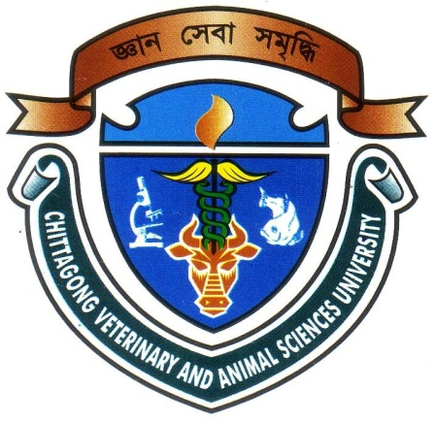
By
SADDAM HOSSAIN
Intern ID: B-11
Roll No: 12/11, Registration No: 00731
Session: 2011-2012
A clinical report submitted in partial fulfillment of the

Requirements for the Degree of

Doctor of Veterinary Medicine
Chittagong Veterinary and Animal Sciences University
Khulshi, Chittagong-4225, Bangladesh
November, 2017

Occurrence of diseases of turkey at Cox's Bazar, Bangladesh

By
SADDAM HOSSAIN
Intern ID: B-11
Roll No: 12/11, Registration No: 00731
Session: 2011-2012
Approved as to style and content by

…………………………......
Signature of Author
Saddam Hossain
Roll No: 12/11
Reg. No: 00731
Intern ID: B-11

……………………………….............
Signature of Supervisor
Dr. Md. Yousuf Elahi Chowdhury
Professor
Department of Medicine and surgery, CVASU

Chittagong Veterinary and Animal Sciences University
Khulshi, Chittagong-4225, Bangladesh
November, 2017
J

Table of contents

Contents Pages
Abstract ………………………………………………………………………..……V
Chapter 1: Introduction ……………………………………………………….…1-3
Chapter 2: Materials and methods ……………………………………………....4
Chapter 3: Results…………………………………………………………….….5-10
Chapter 4: Discussion ………………………………………………………….....11-13
Limitation. …………………………………………………………………………13
Conclusion ………………………………………………………………………….14
References ………………………………………………………………………15-16
Acknowledgement …………………………………………………………...…….17
Brief biography ……………………………………………………………………18

List of table

Table Title Page
Table 1: Show the number of diseases of turkey farm in Coxsbazar district……………………………………………………………………....7
Table 2: Show the occurrence of diseases of turkey in different age
group…………………………………………………………………….....8

List of figure
Figures Title Page
Figure 1: Show the relationship of occurrence of diseases of turkey farm on the basis of age group…………………………………………………….9
Figure 2: General physical examination of turkey….……………………………10
Figure 3: Observation of disease symptoms of turkey in farm……..…………...10

Occurrence of diseases of turkey at Cox's Bazar, Bangladesh
Abstract:
The study was performed to determine the occurrence of common turkey diseases in Cox’s Bazar district. A total of 540 live turkeys were investigated in 5 farms. Birds were categories into 3 age group that is, 1-3, 4-6and >7 months of age. Diseases were diagnosed clinically by clinical history and clinical signs which were observed physically in farm during the period of January, 2017 to October, 2017. Out of 540 birds, 14.8%, 4.25% and 1.30% were diagnosed for fowl pox, respiratory disorder and cannibalism respectively in the age group of 1-3 months. In 4-6 months of age group, 5.93% were digestive disorder, 6.40% swollen head syndrome were diagnosed. Turkey lameness and turkey blindness were recorded as 3.3% and 1.85% respectively in birds of >7 months of age. The occurrence of fowl pox is high in <3 months of ages. Turkey lameness and turkey blindness were more prone in the age of >7 months.Digestive disorder found more likely in before 4 to 6 months age of turkey. To the best of our knowledge, none of such study was conducted before on the occurrence of diseases of turkey at Cox’s Bazar, Bangladesh. This study may will help to take necessary steps of further study on turkey for the prevention and control of diseases in turkey farm in Bangladesh.

Key word:Occurrence, disease, turkey.

