INTRODUCTION
Neoplasia especially tumors of female reproductive system of dog is one of the most frequent problems. Tumors generally categorized into two groups on the basis of site of occurrence, such as, those arising from ovaries and those arising from tubular organs. Both benign and malignant tumor can be found but benign tumors are more common. So it is important to distinguish either the tumor is benign or malignant as well as to differentiate from other conditions (such as granulation tissue formation, cyst,abscess) as the treatment and prognosis vary substantially among these conditions.

Lower reproductive tract i.e. vagina and vulva are more prone to develop tumors compared to ovary and uterus in case of dog. Neoplasia of the female tubular genitalia account for 3% of all canine tumors; of these 85-90% occur in the vagina and vulva (Susaneck,1981). Benign tumors originating from mesenchymal tissue like leiomyomas(a type of smooth muscle tumor), fibroleiomyomas (a fibrobrous tissue and smooth muscle tumor) and fibromas(a fibrous tissue tumor) are more repeated than malignant tumors like leiomyosarcoma, squamous cell carcinomas etc.
Leiomyoma is a tumor of smooth muscle cells that may arise in any organ with a connective tissue or mesenchymal component (Susaneck,1981; Ashley, 1978). Leiomyomas are typical in the canine female reproductive tract and account for 2.4% of all canine neoplasms (Susaneck,1981; Barrett and Theilen,1977; Hulland,1978; Brodey and Roszel,1967; Jubb and Kennedy,1970). About 85% of leiomyomas occurring in the reproductive tract of the bitch arise from vagina, vestibule and vulva (Susaneck,1981; Barrett and Theilen,1977;Prashanth,2014;Brodey and Roszel,1967).The incidence of leiomyomas is highest between five and 16 years of age (Susaneck,1981; Brodey and Roszel,1967). The estrogen secreting tumors or ovarian follicular cyst are associated with leiomyomas of reproductive tract. Other reproductive problems like cystic endometrial hyperplasia, mammary hyperplasia and/or neoplasia can also be concurrently found (Susaneck,1981; Barrett and Theilen,1977; Brodey and Roszel,1967). The role of estrogen in production of leiomyoma is not clear. Estrogens are known to be carcinogenic, while the progestational phase of estrus inhibits tumor formation (Jubb and Kennedy, 1970).
Unsprayed female dogs are more likely to develop this tumor, however spayed female may also develop leiomyoma. Vaginal leiomyoma may be single or multiple, intraluminal or extraluminal. The tumor is usually round or oval, well defined and encapsulated.
The size and consistency may vary depending upon duration of growth, becoming firmer due to an increase in connective tissue. Large intraluminal tumors may protrude through the vulva, while extraluminal tumors tend to cause perianal swelling. It can show signs of dysuria, constipation, tenesmus.
Cyst is a circumscribed or sac like cavity containing clear or cloudy liquid or gaseous materials or other solid materials (Australia. Better health channel. “Cyst” Oct.2011.). Vaginal cyst can be occurred as a result of benign tumors of the vagina. Vaginal cysts may include Bartholin’s gland cyst, inclusion cyst, Mullerian cyst and Gartner duct cyst. Hence,the relationship of vaginal leiomyoma and perianal cyst has not been established yet. Only the extraluminal tumor are believed to be the cause of perianal swelling by some scientists.
Vaginal leiomyoma should be differentiated from malignant tumors by histological examinations. The prognosis of vaginal leiomyoma is good as they are benign but if the other organs are involved provided that metastasis has occurred,prognosis could be worsened.

In this case of vaginal leiomyoma with perianal cyst of an ovariohysterectomized dog, the clinical findings, diagnostic procedure, treatment by surgical excision and post-operative care will be discussed.

Objectives
The present case study is designed with the following specific objectives:
- To diagnose the vaginal leiomyoma and differentiate from malignant tumors as well as other conditions such as vaginal cyst,vaginal hyperplasia
- To correct and manage the vaginal leiomyoma by surgical procedure.
CASE PRESENTATION

A Labrador retriever bitch of ten years old appeared to Veterinary Teaching Hospital, Khon Kaen University, Thailand with a complaint of mass in vagina and the owner saw bloody urine once, after that found normal urine color for a week. The mental status of the dog was bright, alert and responsive. There was no sign of discomfort and hydration status was normal. The dog's appetite and thirst were normal and she had no difficulty in urinating or defecating. Owner reported that the dog had open cervix pyometra and ovariohysterectomy was done one year ago. The dog was checked for CBC, Blood parasite, Creatinine and ALT and abdominal ultrasonography.

Diagnosis

The blood parameters were within reference ranges and physical condition was good. A smooth surfaced multinodular mass was found on vaginal palpation located cranial to clitoris and caudal to cervix. The mass was firm, submucosal and extended towards the vulvar opening but the extent of the attachments of the mass could not be detected during this examination. The abdominal ultrasound showed normal colon (fig:1 ) and some mass around cervix (fig: 2). The skin outside the anus was swollen and intact showing no sign of necrosis presenting a round shaped mass. The swollen portion was punctured by a sterilized syringe and a clear fluid came out determining as perianal cyst. Surgical correction (by lumpectomy to remove the perianal cyst and by episiotomy to remove the vaginal mass) and biopsy of the mass were advised.

Restraining and Anesthesia

The dog was subjected to fasting for 12 hours for solid food and 6 hours for water. The perineal and perianal area were clipped, shaved, soaked with tincture iodine followed by 70% alcohol (fig:3). The patient was positioned in a ventral recumbency on a perineal stand with the tail flexed cranially over the spine. The anesthesia protocol was consisted of sedation with Diazepum (0.2mg/kg) intravenously, Morphine (0.3mg/kg) intramuscularly as analgesic and Propofol (6mg/kg) intravenously for induction. Isoflurane (1.5-2%) and oxygen combination was used to maintain the anesthesia by a cuffed ET tube. Fluid therapy was instituted with Lactated Ringers solution intravenously. The urethral orifice was closed by a sterilized Foley catheter in aid of defining the area as well as to avoid trauma (fig:11). The anal opening was closed temporarily by a simple interrupted suture.

Surgical procedure

An incision on the skin of perianal area(fig:4) was made carefully to avoid the puncture of the cystic membrane. The cyst was attached to the outer wall and no opening was found to the vaginal lumen. The surface was smooth and red in color(fig:5) with soft consistency. Then about 20ml of clear fluid was drained out and the cystic wall was resected (fig:6). The clear fluid was sent for histological examination soon after collection. Next the dead space was irrigated with saline water (fig:8) and occluded by subcutaneous suture using 3-0 Polyglactine 910 and the skin was reapposed with 3-0 Supramid through simple interrupted suture (fig:9).

Afterwards, an episiotomy was performed by midline skin incision through the dorsal commissure (fig:10) of the vulvar lips to distal to the external anal sphincter muscle, and, continued the muscle and vaginal wall with Mayo scissors. The mass was easily visualized after the incision. It had a smooth surface and multiple nodules were found of varying diameter (fig:13,15). All the nodules were round, red in color and firm in consistency (fig:16) having a well-defined stalk attached to the vaginal wall. The mass was excised and had been searched for other mass or nodules. More nodules were found in the vestibule of vagina. Those nodules were also excised and immediately sent to the Pathology laboratory of KKU for histopathological examination. The site was closed by reapposing the vaginal mucosa with simple interrupted suture with 3-0 Polyglactine 910(synthetic multifilament absorbable suture). Submucosal dead space was occluded by simple continuous suture with 3-0 Polyglactine(fig:17). Finally mattress suture were given to the skin to realign and reappose the dorsal commissure using 3-0 Supramid (fig: 18). The Foley catheter was kept for the drainage of the urine in order to prevent the infection of the vaginal floor. Povidone iodine solution was applied on the suture line and covered with a gauge. Then the animal was monitored for a period of one hour to regain its sense and to observe any post-operative complications immediately after the surgery.

Post-operative care:

After surgery medication is provided for ensuring a pain free recovery.
In this case, fluid therapy was instituted with Acetated Ringers solution for one hour to maintain electrolyte balance. An antibiotic (Cefalexin 500 @ one and half tablet per oral twice a day) course was given for fourteen days along with a non-steroid anti-inflammatory drug, Carprofen (Rimadyl 75 @ 1 tablet per oral twice a day) for five days. The dog was kept in a hot chamber to gain its normal body temperature and oxygen was provided for easy breathing until regaining the sense. It recovered uneventfully from anaesthesia and any post-operative complications such as urinary retension was not developed. The patient was advised to present to clinics ten days later.

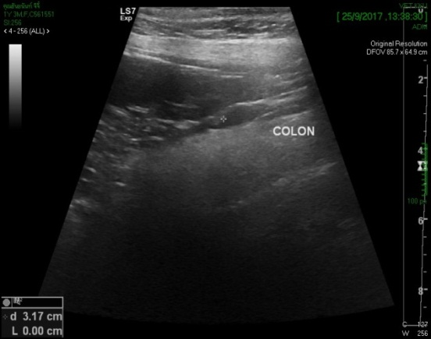 |  | 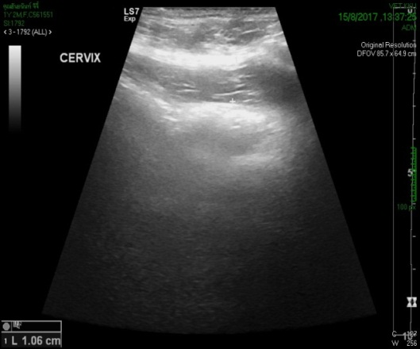
Figure 1: USG of colon (normal) |  | Figure 2: USG of cervix(indicating mass)
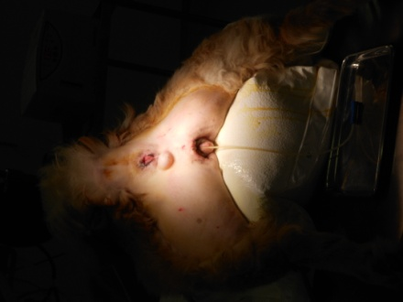 |  | 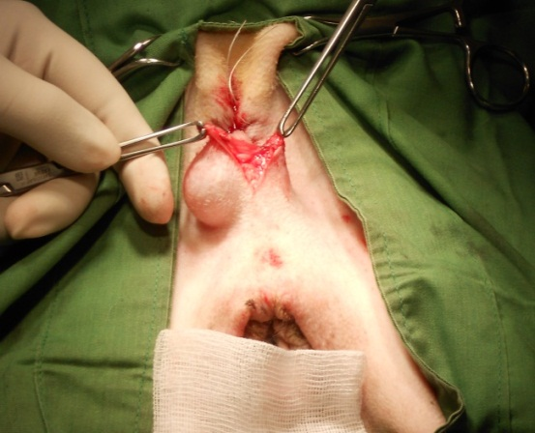
Figure 3: Preparation of surgical site(clipping, shaving,soaking with povidone iodine followed by alcohol) |  | Figure 4: Incision on skin of perianal area
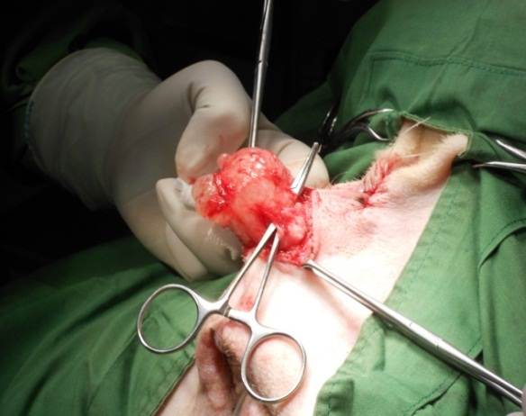  Figure 5: Exposure of red,smooth surfaced perianal cyst |  | 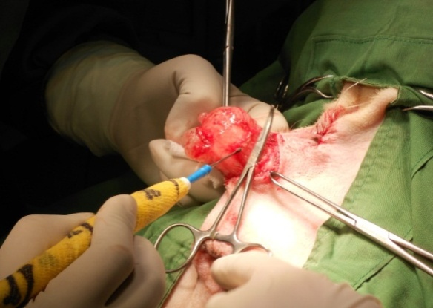  Figure 6: Resection of cyst
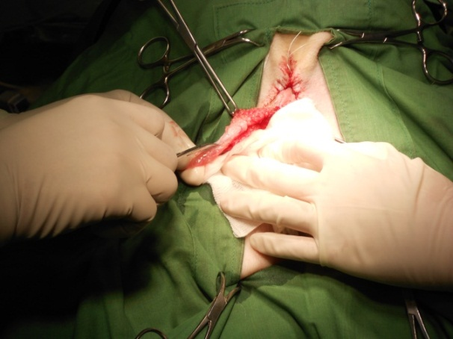 |  | 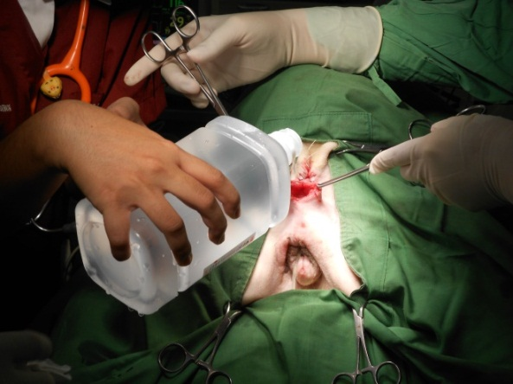
Figure 7: Complete removal of perianal cyst |  | Figure 8: 0.9% normal saline irrigation to the empty space
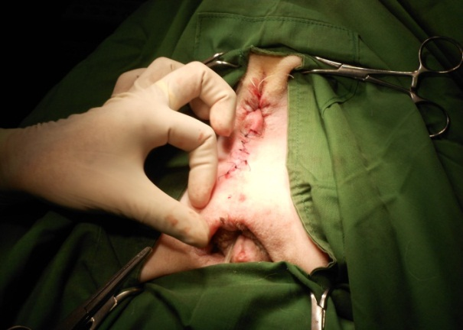 |  | 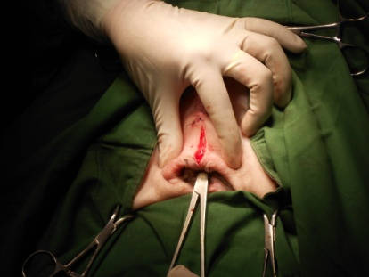
Figure 9: Simple interrupted suture on skin after lumpectomy |  | 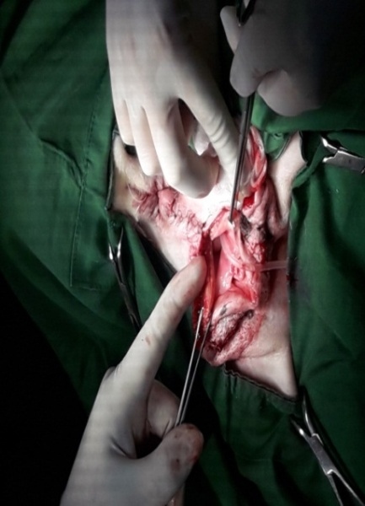  Figure 10: Incision on dorsal commissure of vagina for eoisiotomy
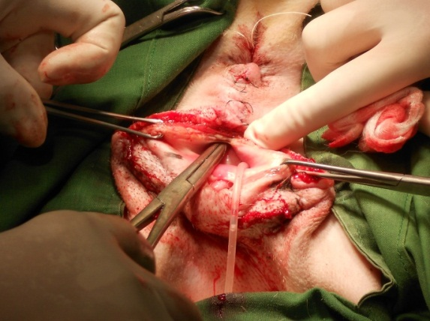
Figure 11: Foley catheter placed to urethral opening and simple inturrpted suture on anal opening |  | Figure 12: Exposure of vaginal floor
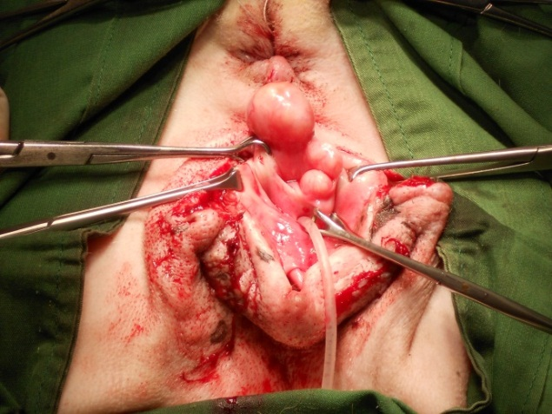 |  | 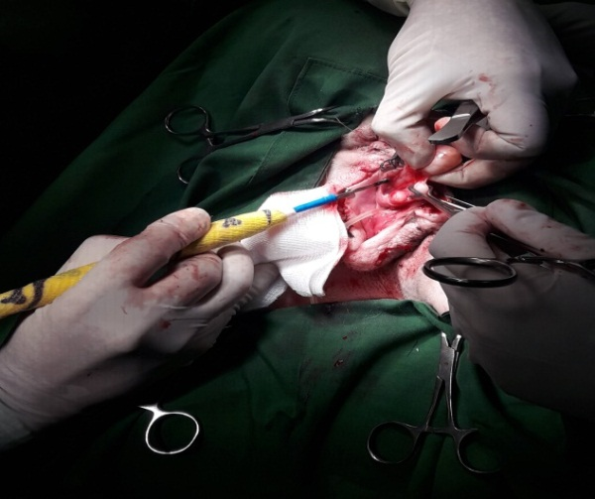
Figure 13 : Exposure to red color smooth surfaced multinodular mass |  | Figure 14: Excision of vaginal mass
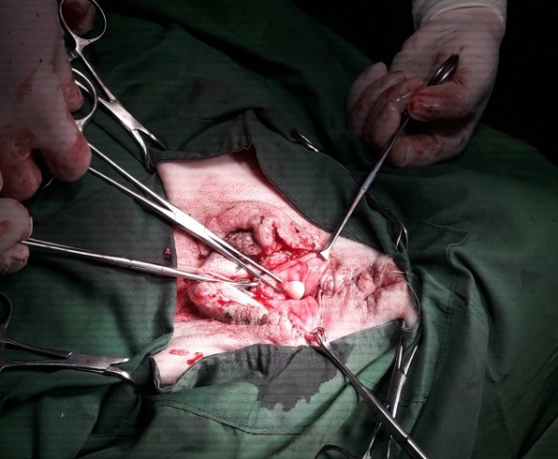 |  | 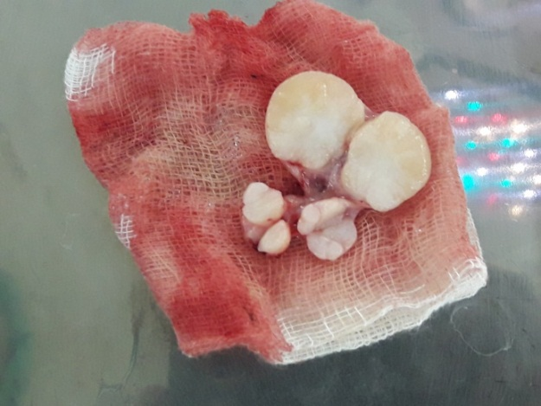
Figure 15: Searching for more mass |  | Figure 16: Vaginal tumors after complete excision
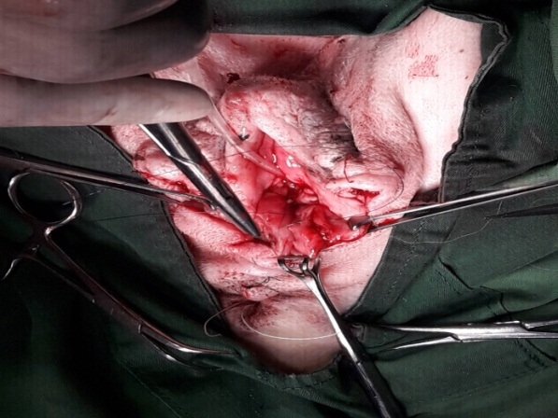
Figure 17: Occlusion of the space by subcuticular suture |  | Figure 18: Mattress suture given on skin and foley catheter placed on urethralopening
RESULT
The dog was presented to the clinics after ten days for control and blood sample was collected and evaluated. All the parameters were within the normal range. On this very day the suture was cut and noticed that the wound was healed. The mental status of the dog was alert and responsive.
Table 1: Blood parameters (CBC, Biochemistry)
Parameter | Result | Normal range
PCV (%) | 38 | 38-55
Hb (g%) | 12.8 | 12-18
RBC count (x10⁶/µL) | 6.64 | 6-9
RBC morphology | Hypochromasia (1+)  Anisocytosis (1+)
WBC count (x10³/µL | 10.5 | 6-15
Platelet count (x10³/µL) | 358 | 200-400
Platelet estimate | Adequate | Adequate
Band Neutrophil (%) | 1 | 0-4
Neutrophil (%) | 61 | 60-75
Lymphocyte (%) | 35 | 12-30
Monocyte (%) | 1 | 3-9
Eosinophil (%) | 2 | 2-10
Basophil (%) | - | 0-1
Creatinine (mg%) | 1.03 | 0.5-1.8
ALT (u/L) | 40 | 10-70
Total protein (g%) | 7.2 | 5.4-7.7
Albumin (g%) | 2.7 | 2.2-3.8

The appearance of cystic fluid reported clear, the specific gravity and total protein content were almost normal. There was no inflammatory cells indicating transudate.

Table 2: Criteria of transudates

Parameters | Result | Normal range
Appearance | Clear | clear
Specific gravity | 1.0 | < 1.012
Total protein (gm/dl) | 2.1 | <2.5
Inflammatory cells | Absent | Absent

In the macroscopic evaluation of the tissue sample of the vaginal mass, it was found a firm gray white tissue measuring 1.2*1.2*1cm (length*width*thickness). For histopathological evaluation, the tissue samples were fixed in 10% buffered formalin, embedded in paraffin wax and sectioned at 2-3μm, stained with hematoxylin and eosin (HE). The histological examination revealed benign spindle cell tumor consistent with leiomyomas. Finally the dog was given a good prognosis as the tumor was benign.

DISCUSSION:

Dogs are the only domestic species that commonly develop leiomyoma in female reproductive tracts. Up to 25% of mature female dogs with intact ovaries (“bitches”) have leiomyoma in their vaginas. Usually, there are usually multiple leiomyoma and the bitch has not been pregnant. Tumors can get large, over 10 cm in dimensions.

Genital tract tumors are usually seen in medium aged non-spayed dogs and the recommended treatment choice is the surgery (Klein, 2001) .There is a report
(Rollon et al,2008) about a vaginal fibroma treated with a progesterone receptor antagonist; aglepristone, due to canine genital tract leiomyomas are reported as having high progesterone receptors (Millan et al,2007)and after the mass reduced in size by using aglepristone it has been removed surgically in that report. In term of present case study the dog is middle aged but it is a spayed dog. Again the mass has not been evaluated in accordance with the distribution of the receptor. In case of dog, the cause of the neoplasia of reproductive tract is generally unknown (Umamageswari et al., 2016), only exception is canine transmissible venereal tumor (CTVT). Many scientists believe that steroid hormones play a role in the pathogenesis of the tumor and recurrence of the tumor also relate to the steroid hormone. In human genital neurofibromas, the expression of progesterone is also reported. Hormonal influence on the growth of vulvar/vaginal tumors in dog is believed by some scientists (MacLachlan and Kennedy,2002). A previous case (Sontaş et al.,2010) informs that the tumor was accounted in a hysterectomized poodle dog which had an ovarian remnant, In the present study the dog was ovariohysterctomized a year before of the occurrence of vaginal leiomyoma and no remnant of ovary was found. So the hormonal influence might not have been acted on this mentioned case because of the absence of ovary and uterus.

Vaginal leiomyoma are best treated surgically (Klein, 2001) but condition can recur due to hormonal influence (Miettinen and Fetsch,2006). Therefore, ovariohysterectomy is advised at early age to prevent leiomyoma in female dog.

If any metastatic foci is present that should be removed because most of the tumors occur from the vestibule or the smooth muscle wall of vagina are removed through vagina(Kang and Holmberg,1983). An episiotomy is required for larger mass (Susaneck,1981; and Hammer,1983). Radiation therapy is considered fruitful if surgical removal of the tumor and/or the metastatic foci is not possible (Susaneck ,1981;Barrett and Theilen,1977;Brodey, 1967).

Accidental injury to nearby organs and iatrogenic damage to urethra are the common post-operative complications (Kang and Holmberg,1983). Catheterization of urinary bladder will assist in avoiding these conditions. In the current study,catheter was used and successfully avoided complications.

Relationship in the pathogenesis of perianal cyst and vaginal leiomyoma is not well established. Further recommendations for research is helpful to determine the probable cause of perianal cyst will assist better recovery of patient.

The best way to prevent and control of vaginal leiomyoma is to perform ovariohysterectomy. But the cause of occurrence of leiomyoma in a spayed dog is not clear. However the recurrence rate of benign tumor is 0% in case of spayed bitch whereas the recurrence rate is 15% in those with intact bitches (Thatcher and Bradley,1983; Herron1983; Withrow and Susaneck,1986). Being a spayed dog, the patient of current study, has a good prognosis without facing the incidence of recurrence of tumor.

CONCLUSION

In dogs vaginal tumor may never bother the animal and thus never be diagnosed unless protrude from the vulva. The complications showed by the animal may not be direct result of tumor such as painful urination,difficulties in whelping, urinary problem and many more. Vaginal leiomyoma may be overlooked due to lackof vaginal examination. Therefore detailed vaginal examination should be taken into account for diagnosis of tumor as well as surgical management of vaginal leiomyoma should be done thereafter proper diagnosis.

REFERENCES

Ashley, D. J. B. (1978). Evans' histological appearances of tumours (Vol. 2). Churchill
Livingstone.
Barrett, R. E., &Theilen, G. H. (1977). Neoplasms of the canine and feline
reproductive tracts. Current veterinary therapy VI. Philadelphia, London, Toronto: WB Saunders Co, 1263-1267.
Brodey, R. S. (1967). Neoplasms of the canine uterus, vagina, vulva: A clinicopathologic
survey of 90 cases. J Am Vet Med Assoc, 151, 1294-1307.
Bojrab, M. J. (1975).Current Techniques in Small Animal Surgery [1.]. Lea &Febige
Herron, M. A. (1983). Tumors of the canine genital system. Journal of the American Animal Hospital Association, 19(6), 981-994.
Jubb, K. V. F. (1985).PATHOLOGY OF DOMESTIC ANIMALS3E(Vol. 2).
Academic press.
Kang, T. B., & Holmberg, D. L. (1983).Vaginal leiomyoma in a dog.The Canadian
Veterinary Journal, 24(8), 258.
Klein, M. K. (2001).Tumors of the female reproductive system.Small animal clinical
oncology, 610-618.
MacLachlan, N. J., & Kennedy, P. C. (2008).Tumors of the genital systems.Tumors in
Domestic Animals, Fourth Edition, 547-573
Miettinen, M., &Fetsch, J. F. (2006). Evaluation of biological potential of smooth
muscletumours. Histopathology, 48(1), 97-105.
Millan, Y., Gordon, A., de los Monteros, A. E., Reymundo, C., & De Las Mulas, J.
M. (2007).Steroid receptors in canine and human female genital tract tumours with smooth muscle differentiation.Journal of comparative pathology, 136(2), 197-201.
Prashanth, C. (2014).Clinical Study on Incidence and Risk factors for Vaginal Tumors
in Dogs with Particular Reference to Vaginal Leiomyoma (Doctoral dissertation, Karnataka Veterinary, Animal and Fisheries Sciences University, Bidar).
Rollón, E., Millán, Y., Las Mulas, D., & Martín, J. (2008). Effects of aglepristone, a
progesterone receptor antagonist, in a dog with a vaginal fibroma. Journal of Small Animal Practice, 49(1), 41-43.
Sontas, B. H., Altun, E. D., Güvenc, K., Arun, S. S., &Ekici, H. (2010). Vaginal
neurofibroma in a hysterectomized poodle dog. Reproduction in domestic animals, 45(6), 1130-1133
Susaneck, S. J. (1981).Tumors of the female reproductive tract.Oncology Notes.
Comparative Oncology Unit, Colorado State University.
Thacher, C., & Bradley, R. L. (1983). Vulvar and vaginal tumors in the dog: a
retrospective study. Journal of the American Veterinary Medical Association, 183(6), 690-692.
UMAMAGESWARI, J., SRIDEVI, P., RANGASAMY, S., & SRIDHAR, R. (2016).
VAGINAL LEIOMYOMA IN A PREGNANT BITCH.The Indian Journal of Animal Reproduction,37(2).
Withrow, S. J., &Susaneck, S. J. (1986). Tumors of the canine female reproductive
tract. Current therapy in theriogenology, 2.

ACKNOWLEDGEMENT

The author is ever grateful and obliged to God, the Almighty, on whom we depend for sustenance and guidance.
It is indeed a proud privilege to express gratitude and profound regards to her supervisor Asst. Professor DR. Md. Shohel Al Faruk, Department of Physiology, Biochemistry and Pharmacology, Chittagong Veterinary and Animal Sciences University, for his guidance, patience, valuable suggestions and encouragement throughout the work.
The author highly expresses her sincere gratefulness to DR. Tuli Dey, lecturer, Department of Medicine and Surgery, Chittagong Veterinary and Animal Sciences University for her valuable suggestions in the completion of the report.
The author would like to give special thanks to honorable Vice Chancellor Professor Dr. Gautam Buddha Das and Prof. M.A. Halim,Dean, Faculty of Veterinary medicine , Chittagong Veterinary and Animal Sciences University.Heartfelt thanks to Prof. Dr. AKM Saifuddin, Director, External affairs for the inspiration during the study period.
Finally the author expresses profound gratitude to her Parents for providing their unfailing support and continuous encouragement throughout the year of study.This accomplishment would not be possible without them.

The Author
November, 2017

BIOGRAPHY

I am Trisha Ray, daughter of Mr. Subhash Chandra Ray and Mrs. Shikha Rani Dey. I was born in Chittagong. We are two siblings. I passed my SSC examination in the year of 2008 from Rangunia MMP High School as well as HSC in the year of 2010 from Chittagong College. Now I am an intern student under the faculty of Veterinary Medicine inChittagong Veterinary and Animal Sciences University. I strongly believe that success of one’s life depends on determination and hard work. In future, I would like to work devotedly to uphold the dignity of veterinary profession in our country.

