Contents
Contents
TITLE |  | PAGE
CONTENTS |  | 1
LIST OF TABLES |  | 2
LIST OF FIGURES |  | 2
LIST OF ABBREVIATIONS |  | 3
ABSTRACT |  | 4
CHAPTER 1 | INTRODUCTION | 5-6
CHAPTER 2 | CASE PRESENTATION  1.Owner's complain  2.Clinical observation  3.Sample collection  4. Lab diagnosis  a)Urinalysis  b) Haemogram and Serum  Biochemistry  c) Radiography  5.Confirmatory diagnosis | 7-10  7  7  7-8  9-10  9  9  10  10  11
CHAPTER 3 | TREATMENT AND ADVICE | 12-13
CHAPTER 4 | LIMITATION | 14
CHAPTER 5 | DISCUSSION | 15-18
 | CONCLUSION | 19
 | REFERENCES | 20-22
 | ACKNOWLEDGEMENTS | 23

Contents
LIST OF TABLES
NO | TITLE | PAGE
Table 1 | Urinalysis | 9
Table 2 | Haemogram | 9
Table 3 | Serum Biochemistry | 10

LIST OF FIGURES
NO | TITLE | PAGE
Fig. 1 | Lateral recumbency with oral and neck lesion | 8
Fig. 2 | Tongue necrosis with ulceration | 8
Fig. 3 | Abscess on the ventral aspect of neck | 8
Fig. 4 | Ulcerated growth on foot pad and hind limb joint | 8
Fig. 5 | Blood collection from the dog | 8
Fig. 6 | X-ray was performed | 8
Fig. 7 | X-ray view showing the abscess on the ventral aspect of the neck | 10
Fig. 8 | Abdominal view indicating mild cardiomegaly | 10
Fig. 9 | Abscess cleaning with gauze | 12
Fig. 10 | Povidone Iodine was inserted into the abscess to remove pus | 12
Fig. 11 | Abscess was squeezed to remove pus | 12
Fig. 12 | Abscess after cleaning | 12
Fig. 13 | Prescription | 13

LIST OF ABBREVIATIONS
Contents

ABBREVIATION | ELABORATION
CKD | Chronic Kidney Disease
IRIS | International Renal Interest Society
dL | Deciliter
ml | Milli liter
mmol | Milli mole
% | Percentage
gm | Gram
mg | Milligram
BUN | Blood Urea Nitrogen

Abstract

Abstract

Chronic Kidney Disease with Diagnostic Staging and
Management In A Geriatric Dog

In this case study, the clinical and biochemical findings of chronic kidney disease(CKD) and proposed therapeutic recommendation in a geriatric dog is presented. The predominant signs in the affected dog were anorexia, vomition, dullness, weight loss, oral ulcers, polyuria, and polydipsia, pallor of mucosa and recumbency. Blood picture revealed mild increase in neutrophil. Serum urea nitrogen, creatinine and phosphorus levels were significantly elevated. The International Renal Interest Society (IRIS) staging system was used for the staging and treatment of the affected dog. The dog met the criteria for Stage 4 because its blood creatinine was >5 mg/dL. Though the prognosis is poor, proper medication and dietary supplement was given which can increase the lifespan of the affected dog.

Key words : Chronic Kidney Disease, Geriatric, IRIS, Staging, Diagnosis, creatinine, prognosis,
medication, dietary, lifespan

CHAPTER 1
Introduction
INTRODUCTION

Recently pet population is increasing rapidly through our country. Chronic kidney disease is a common disease in geriatric dogs all over the world. As the number of dogs is increasing, it is important to give emphasis on this disease.

Chronic Kidney Disease(CKD) occurs when compensatory mechanisms of the diseased kidneys are no longer able to maintain the excretory, regulatory, and endocrine functions of the kidneys which resultant retention of nitrogenous solutes, derangements of fluid, electrolyte and acid-base balance, and failure of hormone production (Stephen P, Di Bartola).

It is a common problem in aged dogs and is associated with significant morbidity and mortality. CKD may affect 0.5 to 1.0% of the geriatric canine population(Stephen P, Di Bartola). The prevalence for CKD in dogs varies widely depending on age and population studied with prevalence reported as low as 0.37% in U.K. practices,5.8% in four U.S. veterinary teaching hospitals and 10% in geriatric dogs( IDEXX,2015).

CKD results from a progressive and irreversible loss of functioning nephrons and the cause is often difficult to determine. Several risk factors are attributed for CKD in dog including old age, specific breeds, smaller body size, periodontal disease and obesity (O'Neill DE,2013). Some other causes are chronic tubulointerstitial nephritis of unknown cause, Chronic pyelonephritis ,Chronic glomerulonephritis,Amyloidosis, Chronic obstruction(hydronephrosis) and sequel to acute renal disease (e.g., leptospirosis).

Dogs with CKD exhibit polyuria, polydipsia, anorexia, vomiting, weight loss, pallor of mucous membrane, oral ulceration, halitosis and acute blindness( McGrooty Y.D,2008). Patient history, results of physical examination, urinalysis, hematology, serum biochemistry and nephrosonography provide a practical means of diagnosing CKD in dogs (Oburai et al. 2015).

In spite of the poor long term prognosis, patients with CKD often survive for many months to years with a good quality of life. Early diagnosis and a structured approach to CKD investigation and therapeutic management may slow down disease progression in dogs. Conservative medical management of CKD includes providing adequate and appropriate nutrition, correcting fluid deficit, electrolyte abnormalities and acid base imbalance, improve clinical signs of CKD and providing renoprotective therapy to slow down the disease progression (Polzin DJ 2007; Brown S et al. 2013).

History, physical examination, and diagnostic findings often indicate whether a patient has acute or chronic kidney disease. History may be in preceding weeks to months, polyuria/polydipsia, weight loss, and decreased appetite;small, irregular kidneys that are non-painful; ;normocytic, normochromic nonregenerative anemia in chronic kidney disease (O'Neill DE, 2013).

Introduction

CKD diagnostics procedures are complete blood count with reticulocyte count, serum biochemical profile, with electrolytes and acid–base measurement, Urinalysis + urine protein: creatinine ratio, Urine culture and susceptibility, blood pressure measurement and urine system imaging (ultrasound and/or radiography).

Treatment goals and recommendations are specific to IRIS CKD stage (International Renal Interest Society. 2013). Since prerenal contributions will often increase the degree of azotemia to the next stage, normal renal perfusion (adequate patient hydration and effective circulating volume) should be restored before determining the patient’s stage of CKD. Treatment of CKD should be individually tailored to each patient. IRIS CKD stage management guidelines are providing renal diet, phosphorus binder, ACE inhibitor and correcting dehydration given (McGrooty Y. 2008).

Antacids and antiemetic are useful for managing GI complications of uremia. Due to diminished ability to produce erythropoietin, dogs with CKD take longer to normalize anemia related to GI ulcers. Phosphate binders are used in combination with a prescription renal diet when diet alone is insufficient to control hyperphosphatemia and form nonabsorbable complexes with dietary phosphate within the GI tract.( Jacob F et al. 2002).Alkali therapy can be used for patients with persistent acidemia. To treat proteinurea the first step in therapy is a protein-restricted renal diet ( Bartges JW.2013). Additionally ACE inhibitor and Omega 3-polyunsaturated fatty acids can be given.( The Merck Veterinary Manual Online 2013).

Prognosis is associated with severity of disease. Studies have shown shorter median survival times in dogs with higher IRIS stages. Median survival time for IRIS Stage 1 dogs was over 400 days, Stage 2 ranged from 200 to 400 days, Stage 3 ranged from 110 to 200 days, and Stage 4 ranged from 14 to 80 days (O’Neill DG et al. 2013; Parker VJ et al. 2011).Successful treatment of CKD delays disease progression, likely provides greater survival times, and increases patient quality of life.

Considering the above importance, the case report was carried out with the following objectives:

1. To discuss about the diagnostic procedures of chronic kidney disease in

2. To be able to stage CKD based on level of serum creatinine method developed by
International Renal Interest Society ( IRIS ).

3. To know about the basic line of treatment of chronic kidney disease in dog.

Case Presentation
Chapter 2
CASE PRESENTATION

Case History:
A 9 years old male Labrador retriever dog weight of 30 kg was brought by owner to the Madras Veterinary College Teaching Hospital, Chennai. This case was confirmed as a Chronic Kidney Disease on the basis of clinical history, clinical signs and lab diagnosis.

1 .Owners complain:
Owner complained that the animal was dull and depressed, off feed and gradually emaciated. It was also suffered from polyurea and polydipsia. Moreover there was an abscess on the ventral aspect of the neck and tongue wound for past 1 month.

2. Clinical observations:
Position and posture: lateral recumbency.
Body condition: Emaciated
Body weight: 30 kilograms
Rectal temperature: 102° Fahrenheit
Heart rate: 80 per minute
Respiration rate: 24 breaths per minute.
Lymph node: Not palpable.
Skin/coat: Dull
Musculoskeletal: Decreased range of motion in hind limbs, not painful. There was ulcerated like growth on foot pad and hind limb joints
Oral cavity: Halitosis present. There was an ulcerated wound on the lateral aspect of tongue where bleeding noticed.
Neck: There was an abscess on the ventral aspect of neck. Pus discharged was noticed and there was pain on palpation.

3. Sample collection:
Based on clinical history and observations we collected urine from the dog. Meanwhile blood sample was drawn from the cephalic vein. These sample was sent to the Clinical pathology lab, Department of Clinics, Madras Veterinary College Teaching Hospital, Chennai following appropriate procedure.
Moreover the dog was sent to the radiology department for an X-ray to find any problem on the skull and thoracic region. During X-ray, lateral view of skull and thoracic region were considered.

Case Presentation

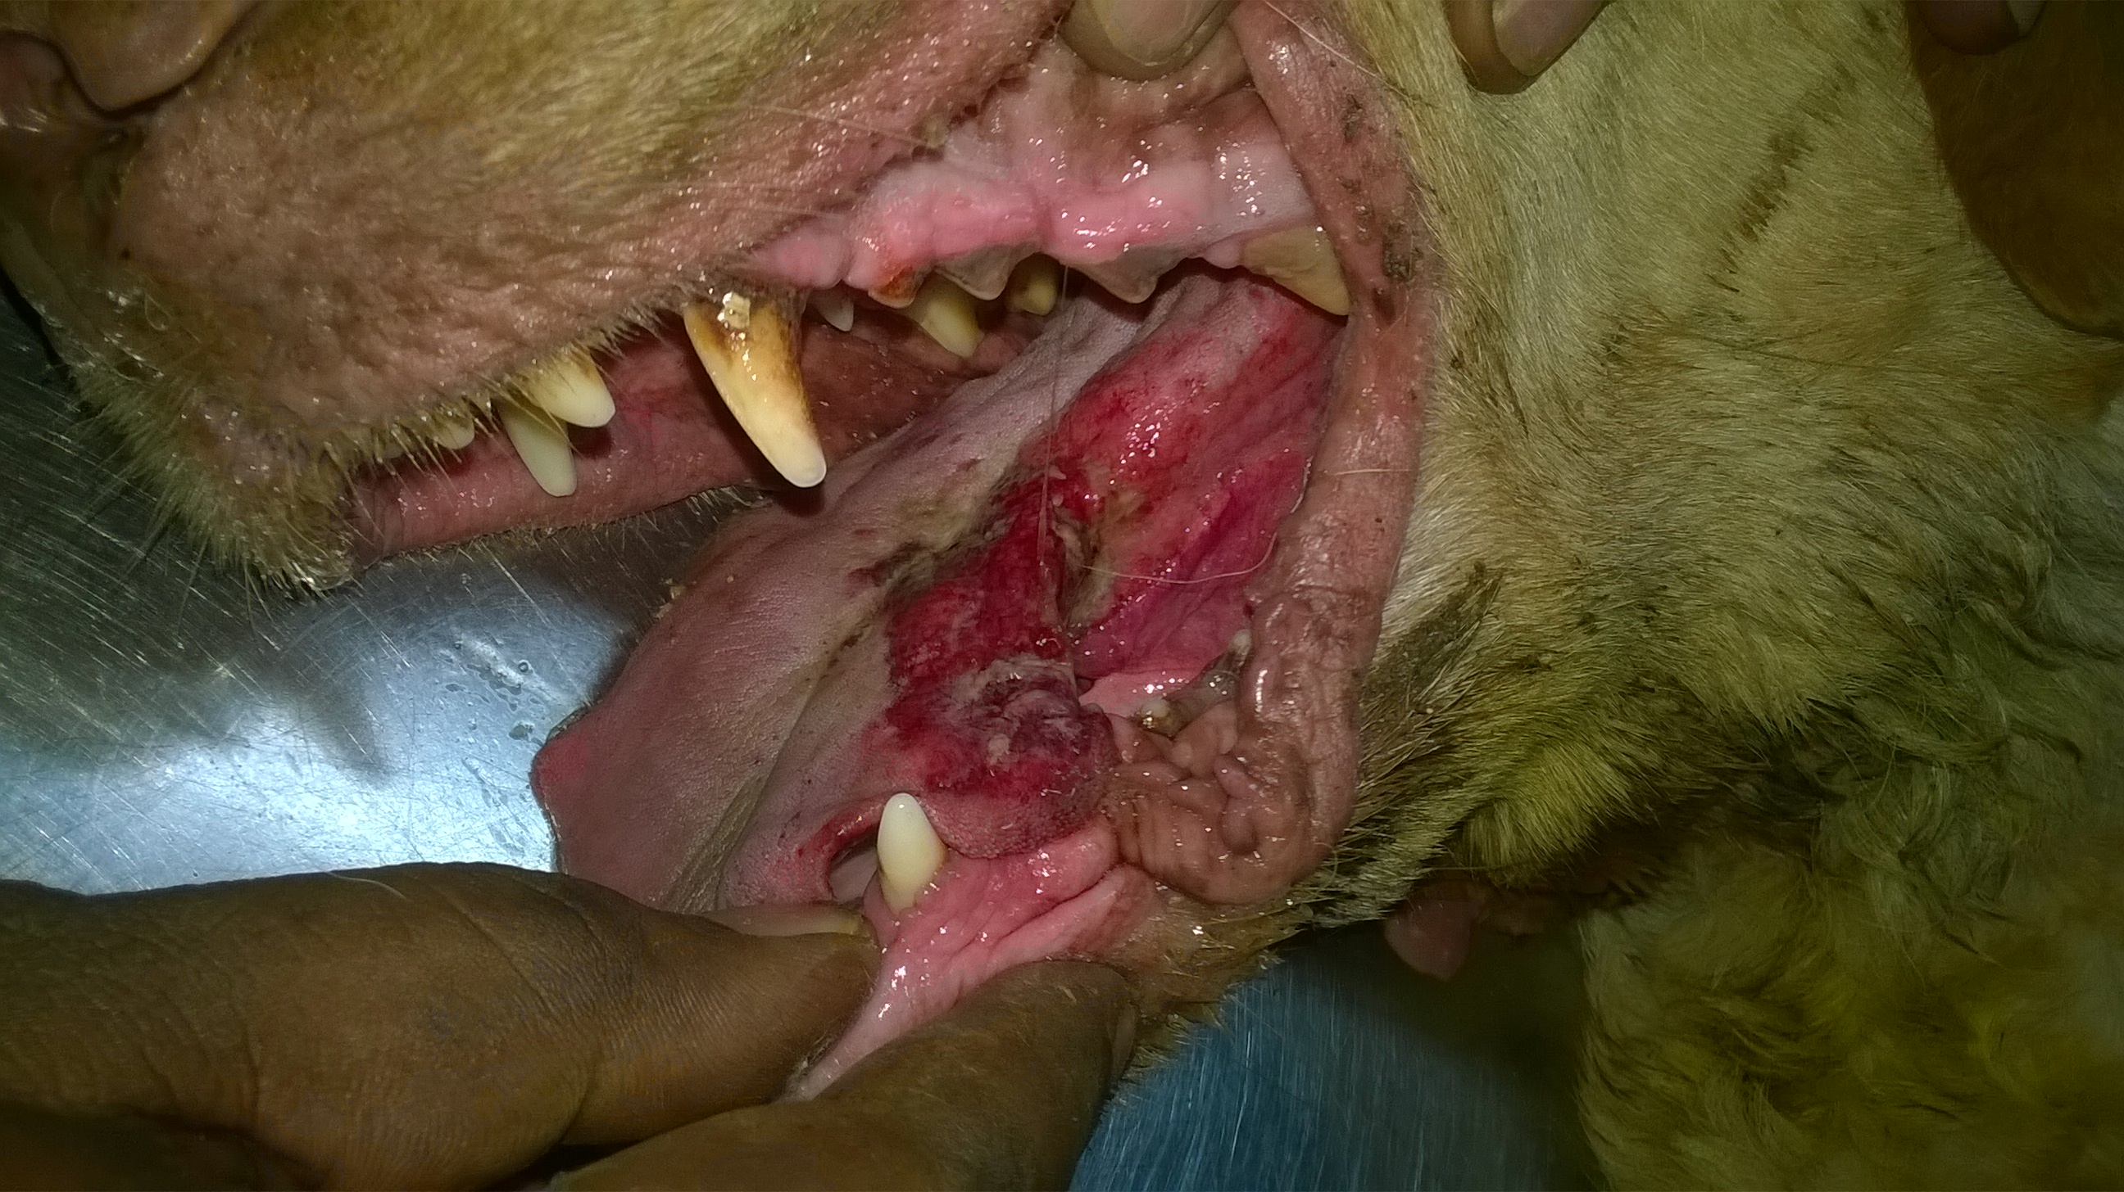
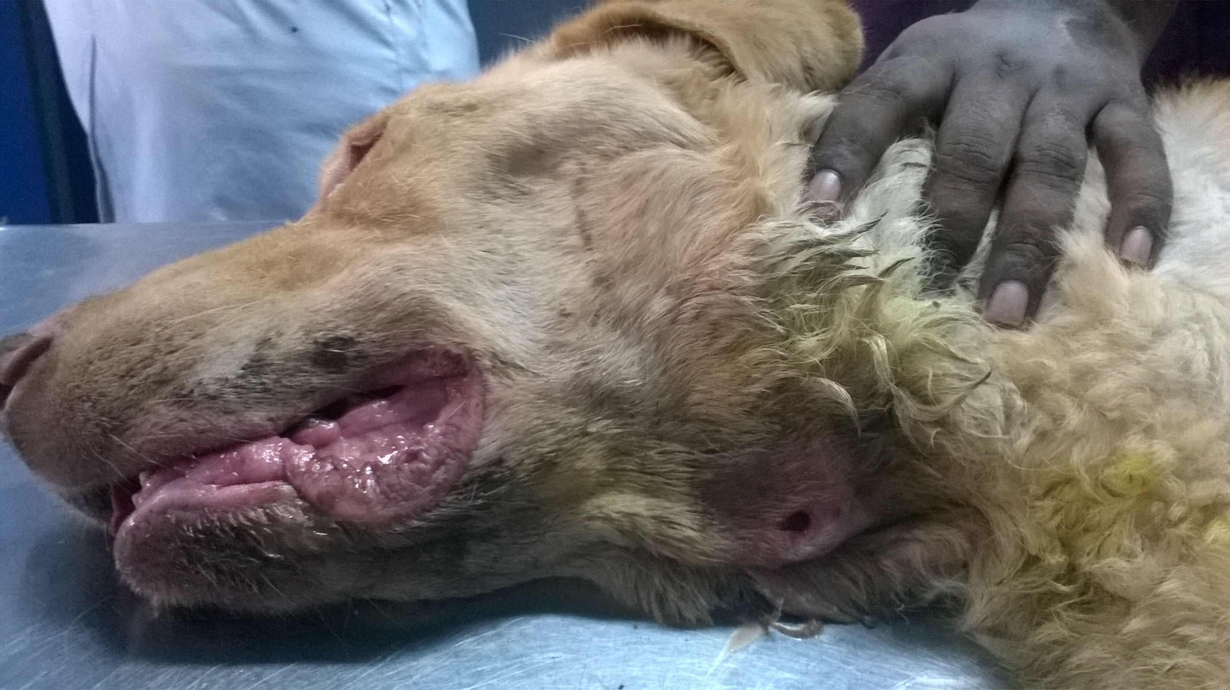

Fig 5: Blood collection from the dog
Fig 2: Tongue necrosis with ulceration
Fig 1: Lateral recumbency with oral & neck lesions

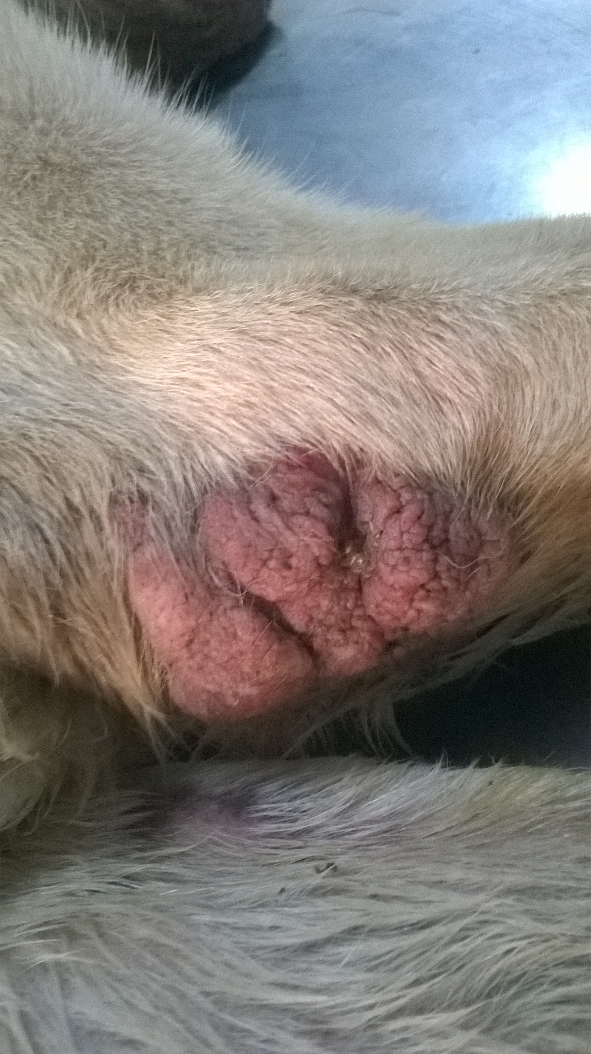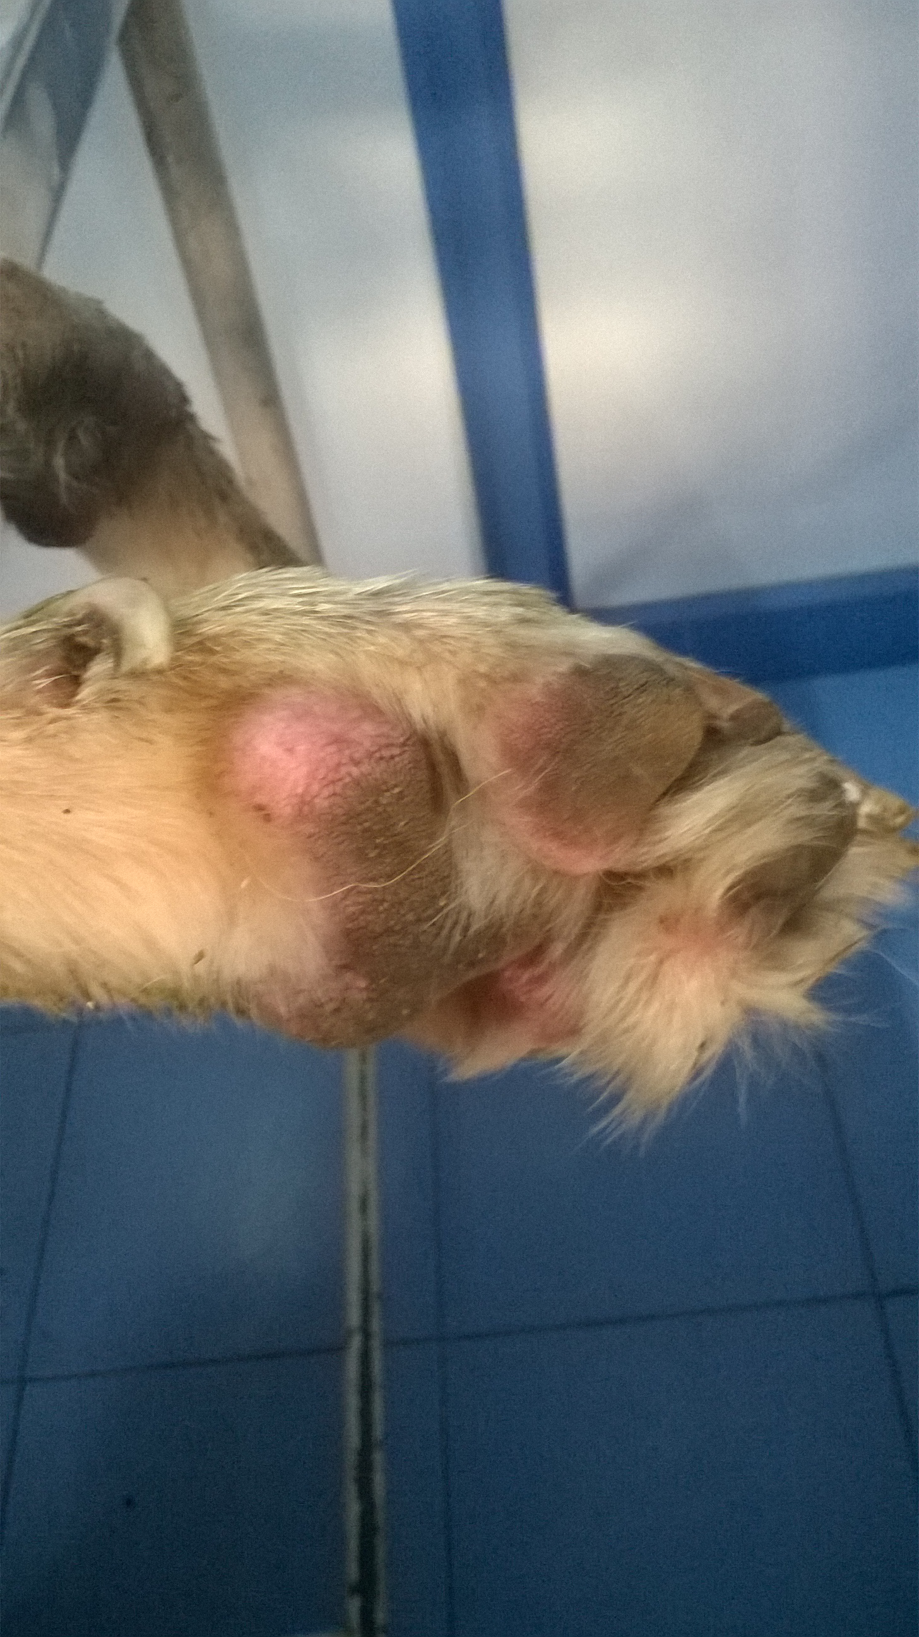

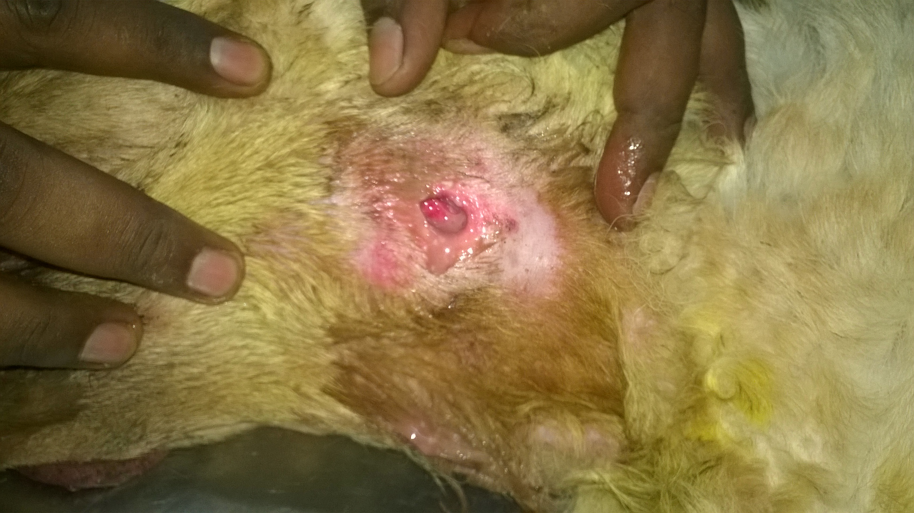
Fig 4: Ulcerated growth on foot pad and hind limb joint

Fig 3: Abscess on the ventral aspect of neck
Fig 6: X-ray was performed
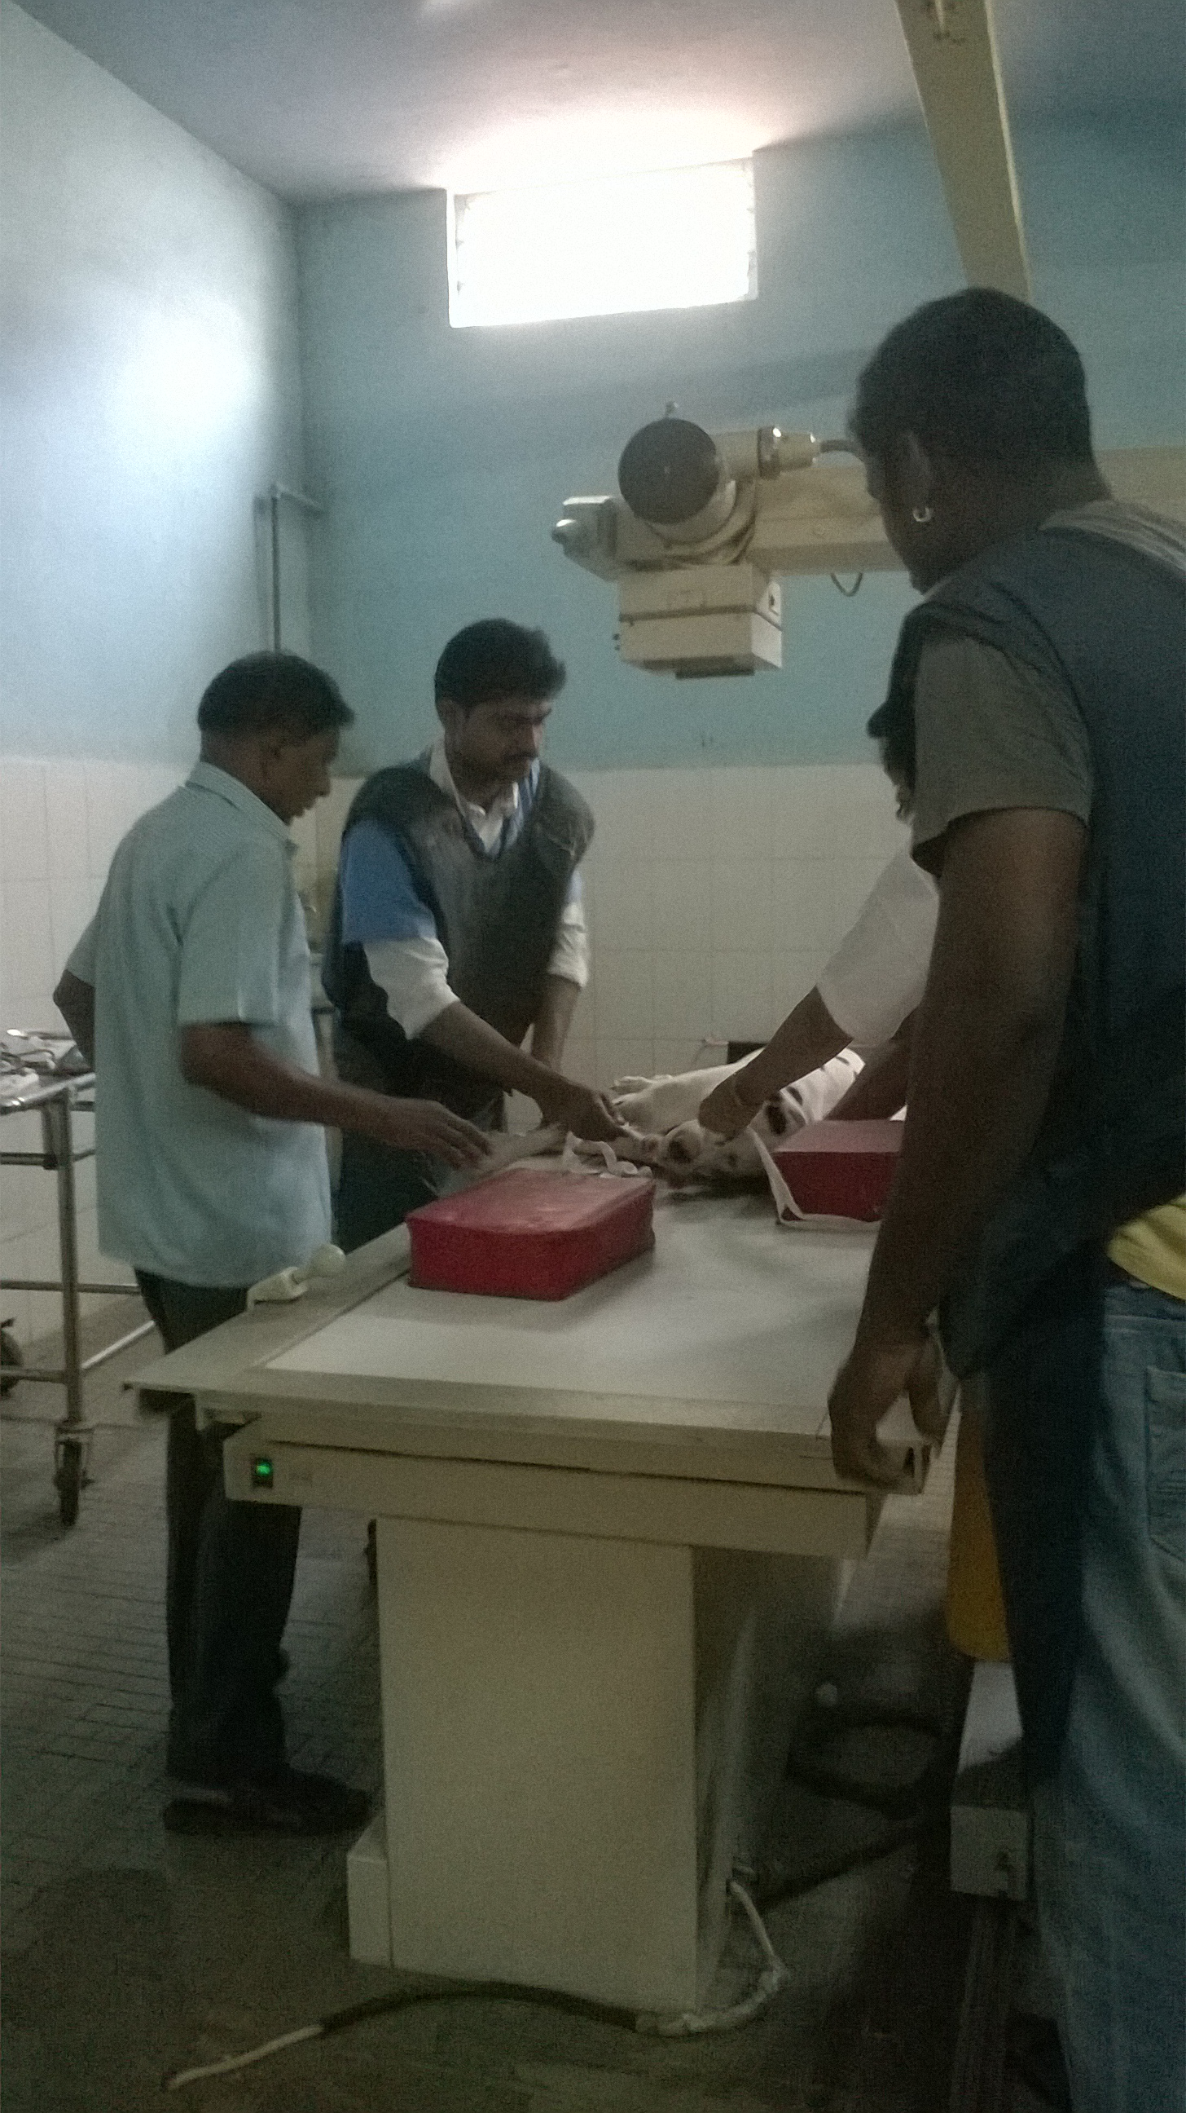
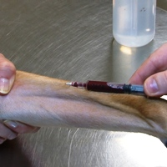
4.Lab Diagnosis:
Case Presentation
Collected whole and clotted blood and urine samples were tested in Clinical pathology lab, Department of Clinics, Madras Veterinary College Teaching Hospital, Chennai.

a. Urinalysis:

Source | Free catch
Color | Pale yellow
Turbidity | Clear
Specific gravity | 1.010
Blood | Negative
Glucose | Negative
Ketones | Negative
Bilirubin | Negative
pH | 6
Sediment analysis | No RBC , WBC or crystals seen.  Rare granular cast.

b.Blood parameter and serum biochemistry:

CBC Parameter | Result | Reference Range*
Haemoglobin | 9.5 g/dl | 12-18 g/dl
PCV | 25.9 % | 37-55%
RBC | 4.65 x 10⁶ cmm | 5-9 10⁶ cmm
WBC | 26,300 x 10³ cmm | 5-9 x 10³ cmm
Platelets | 6,00,000 /microliter | 1,75,000-5,00,000 /microliter
Neutrophils | 87% | 60-77%
Lymphocytes | 11% | 12-30%
Monocytes | 3 % | 3-10%
Eosinophils | 2 % | 2-10%

Case Presentation

Chemistry parameter | Result | Reference range*
BUN | 149.01 mg/dL | 10-28 mg/dL
Creatinine | 6.41 mg/dL | 0.5-1.4 mg/dL
Total protein | 7.50 g/dL | 5.4-7.1 g/dL
Albumin | 2.60 g/dL | 2.3-3.8 g/dL
ALT(SGPT) | 90 IU/dL | 21-102 IU/dL
AST(SGOT) | 65 IU/dL | 23-66 IU/dL
Total Bilirubin | 0.49 mg/dL | 0.15-0.5 mg/dL
Direct Bilirubin | 0.17 mg/dL | 0.06-0.12 mg/dL
Glucose | 66 mg/dL | 65-118mg/dL
Phosphorous | 13.12 mmol/dL | 2.6-6.2 mmol/dL

In haemogram we observed that there was lower number of platelets count which indicates thrombocytopenia. [ The Merck Veterinary Manual ].
In serum biochemistry result we observed that there was an increase on BUN(149.01 mg/dL) and serum creatinine level (6.41 mg/dL). [ The Merck Veterinary Manual ].

* Reference range from IDEXX

c. Radiography:

In X-ray we observed there was a mild cardiomegaly and abscess on ventral aspect of the neck.

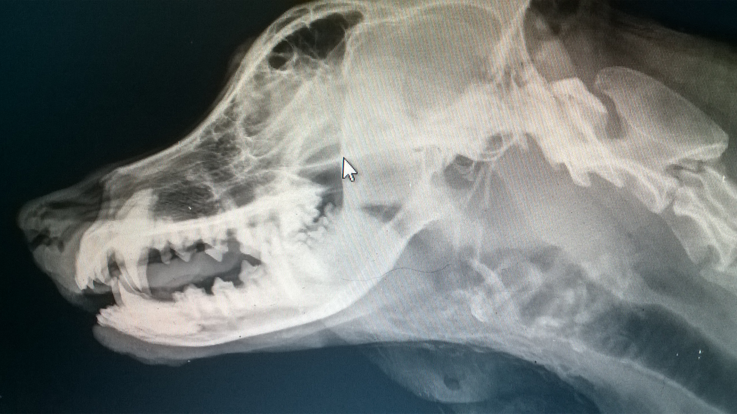

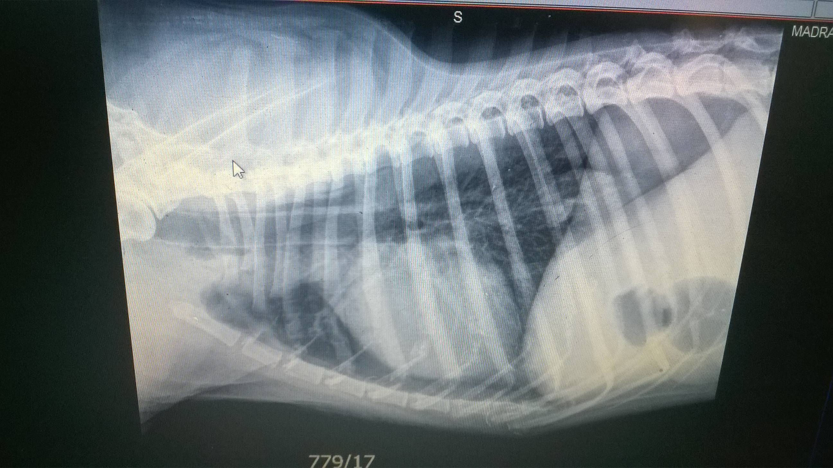

Fig 8: Abdominal view indicating mild cardiomegaly.

Fig 7: X-ray view showing the abscess on the ventral aspect of the neck
5. Confirmatory Diagnosis:
Case Presentation

The lab result showed an elevation of the BUN or blood urea nitrogen (149.01 mg/dL; Normal value 10-28 mg/dL).*
The lab results also showed an elevation of creatinine(6.41 mg/dL; Normal value 0.5-1.4 mg/dL)*.
The serum phosphorus level was also elevated(13.12 mmol/dL; Normal value 2.6-6.2 mmol/dL).*

The veterinarian uses the IRIS staging system to put Chuck into Stage 4 Chronic Renal Disease. On the basis of the International Renal Interest Society(IRIS) ,CKD has to be first diagnosed by clinical signs and then IRIS staging can be applied according to serum creatinine level.**

Stage | Renal Azotemia | Serum creatinine concentration
1 | Non azotemic | < 1.4 mg/dL
2 | Mild | 1.4-2.0 mg/dL
3 | Moderate | 2.1-5.0 mg/dL
4 | Severe | > 5 mg/dL

The dog meets the criteria for stage 4 because its blood creatinine level is more than 5 mg/dL.
After evaluating the information gained from the history, physical examination, and lab results, it was diagnosed as a case of chronic kidney disease(Stage 4).

* The Merck Veterinary Manual Online. (2013).
**(From Canine and Feline Nephrology and Urology, 2nd edition , Chew DJ et al., 2011]

CHAPTER 3
Treatment and Advice
TREATMENT AND ADVICE

At first the abscess on the ventral aspect of neck was cleaned with Povidone Iodine solution
with packed gauze.

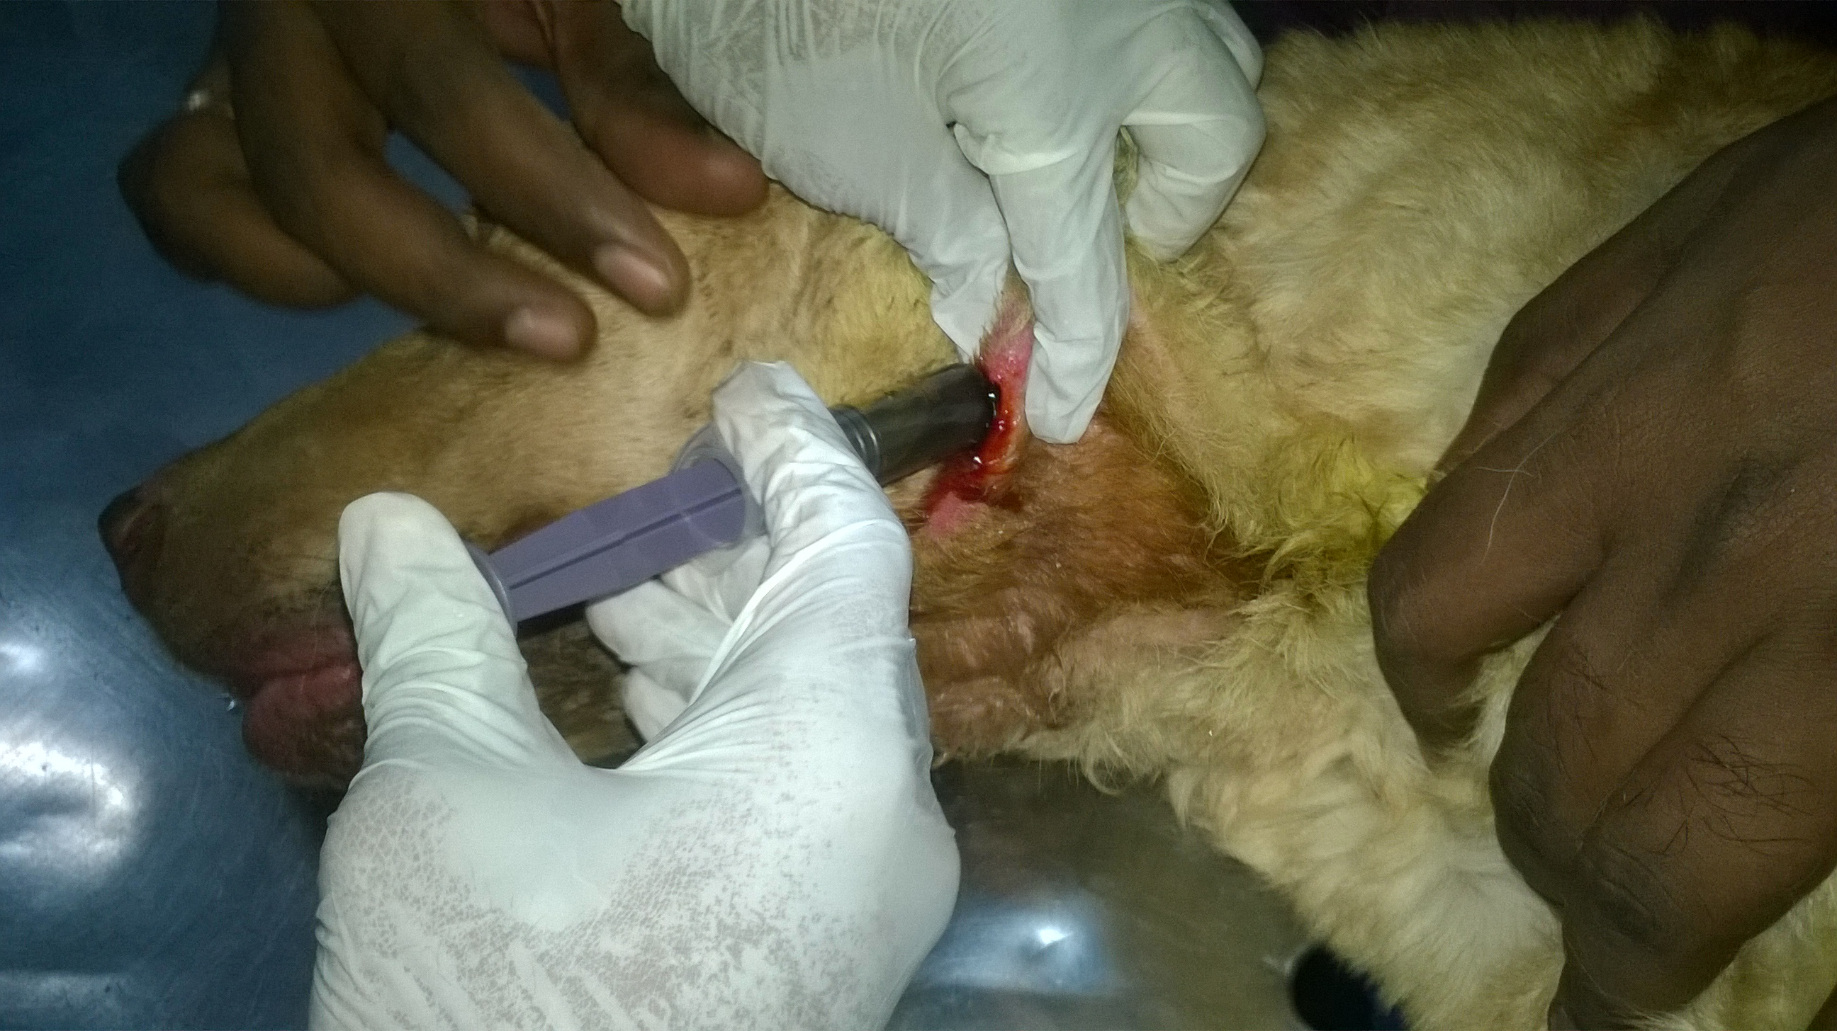
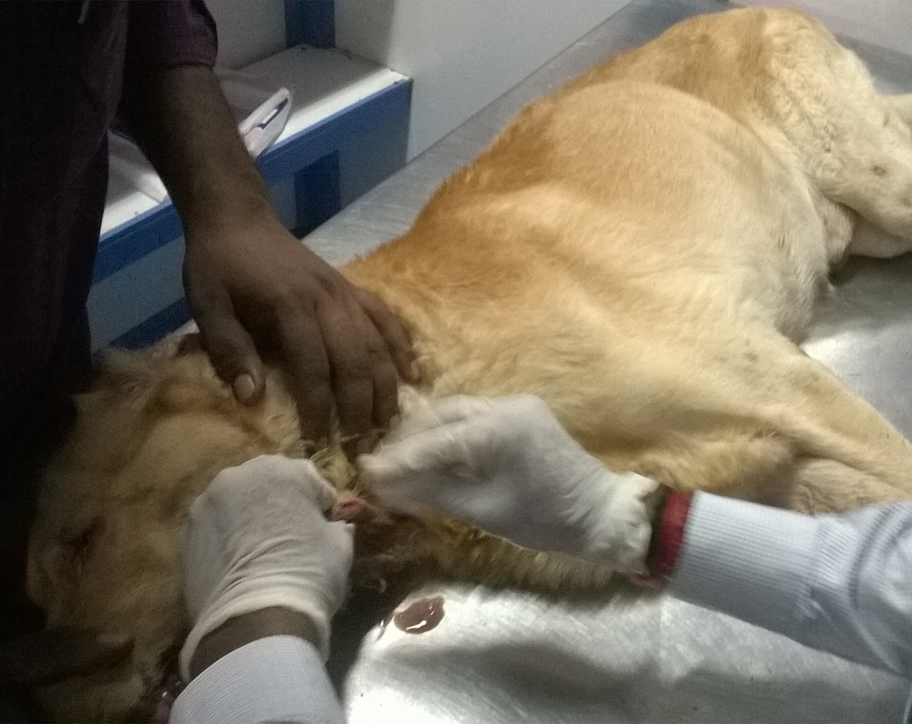

Fig 10: Povidone Iodine was inserted into abscess by using syringe to remove pus

Fig 9: Abscess cleaning with gauze

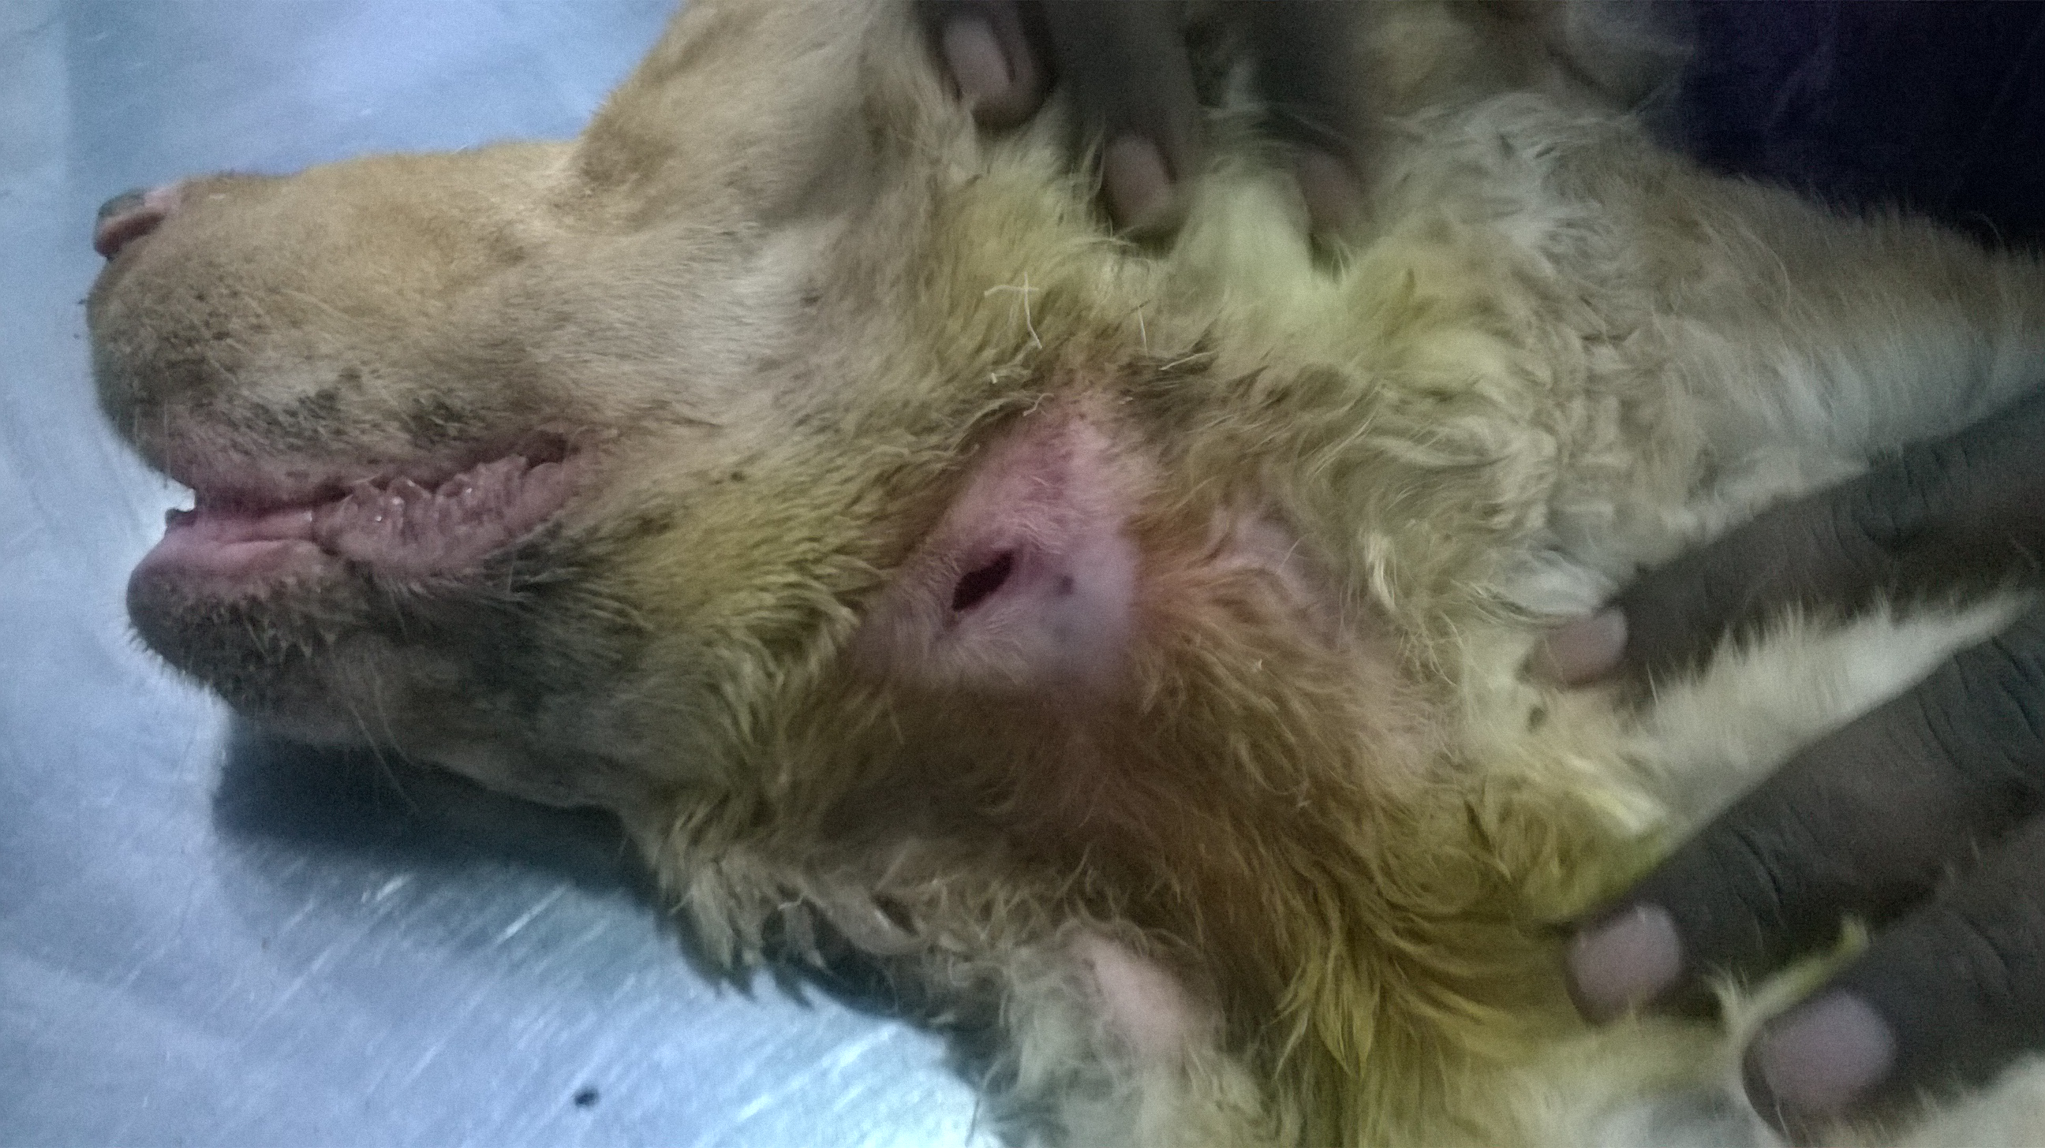
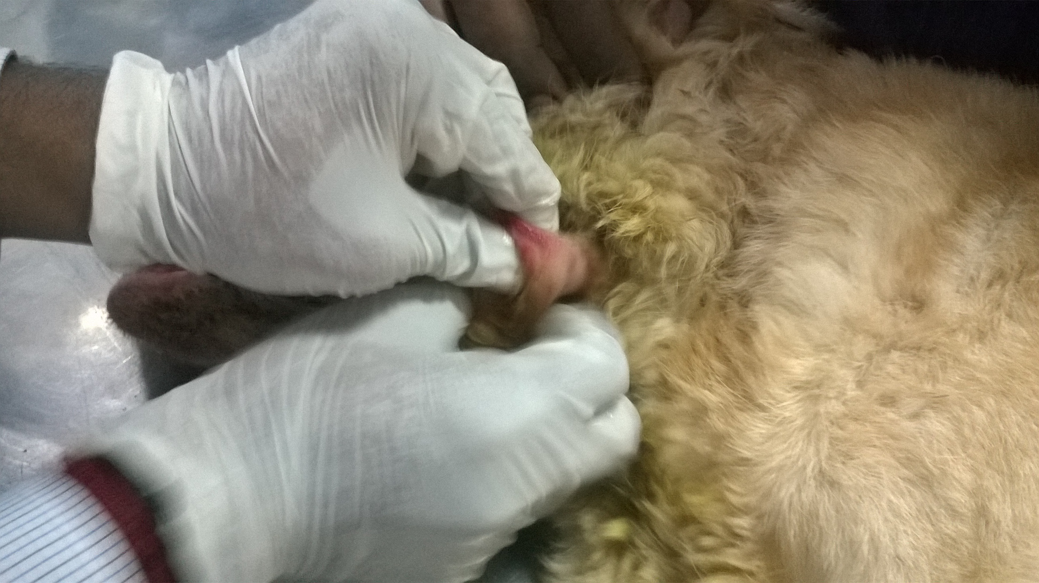

Fig 11: Abscess was squeezed to remove pus
Fig 12 : Abscess after cleaning

Treatment and Advice
Treatment:

1. Injection Ringer's Lactate was given intravenously to prevent dehydration.
2. Injection Meloxicam (0.2 mg/kg) was given subcutaneously to reduce pain.
3. Injection Ceftriaxone (15-50 mg/kg) was given intravenously to prevent bacterial infection.
4. Injection Ranitidine (2 mg/kg q12h) was given intramuscularly which works as a histamine blocker and to minimize acid secretion.
5. Injection Domperidone (2-5mg/kg) orally was given as antiemetic.

Advice:
Owner was told to continue the treatment for minimum 10 days. After 10 days he would bring the dog for further checkup.
Low-protein , low-protein diets were recommended. Diet should contain a reduced level of high-quality protein, restricted sodium and phosphorus rich foods and provide adequate B-complex vitamins.
Owner would monitor the dog for anorexia, dehydration, mouth ulcers, bad breath, increased lethargy, pale gums, vomiting, and diarrhea. Any of these can indicate a worsening of its symptoms.
He would keep track of food and water consumption of the dog. If it is not drinking enough water, it will need additional fluids to prevent dehydration. Monitoring its weight will ensure it is receiving enough calories to maintain its weight at a healthy level.

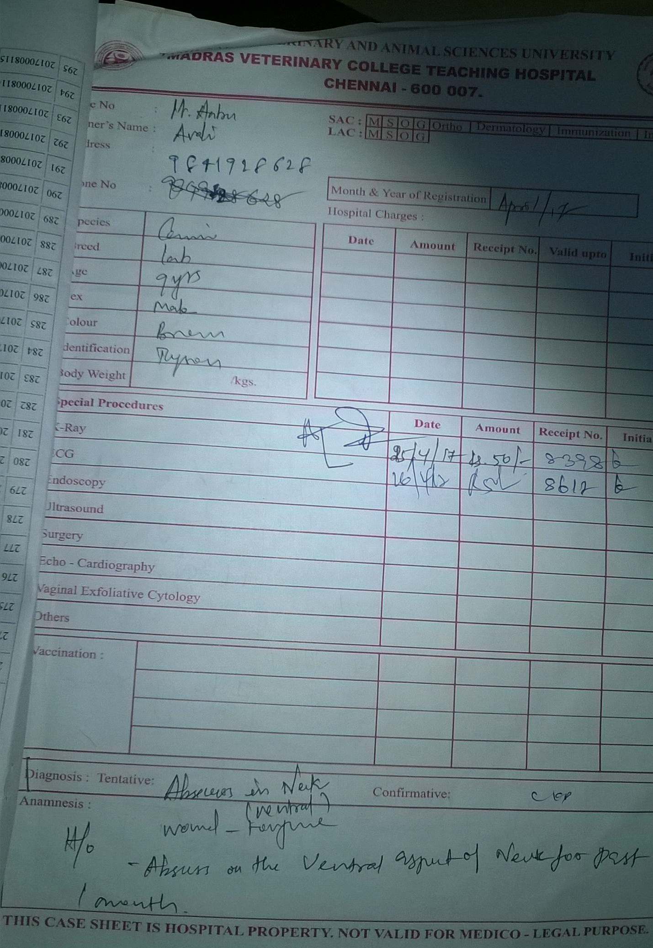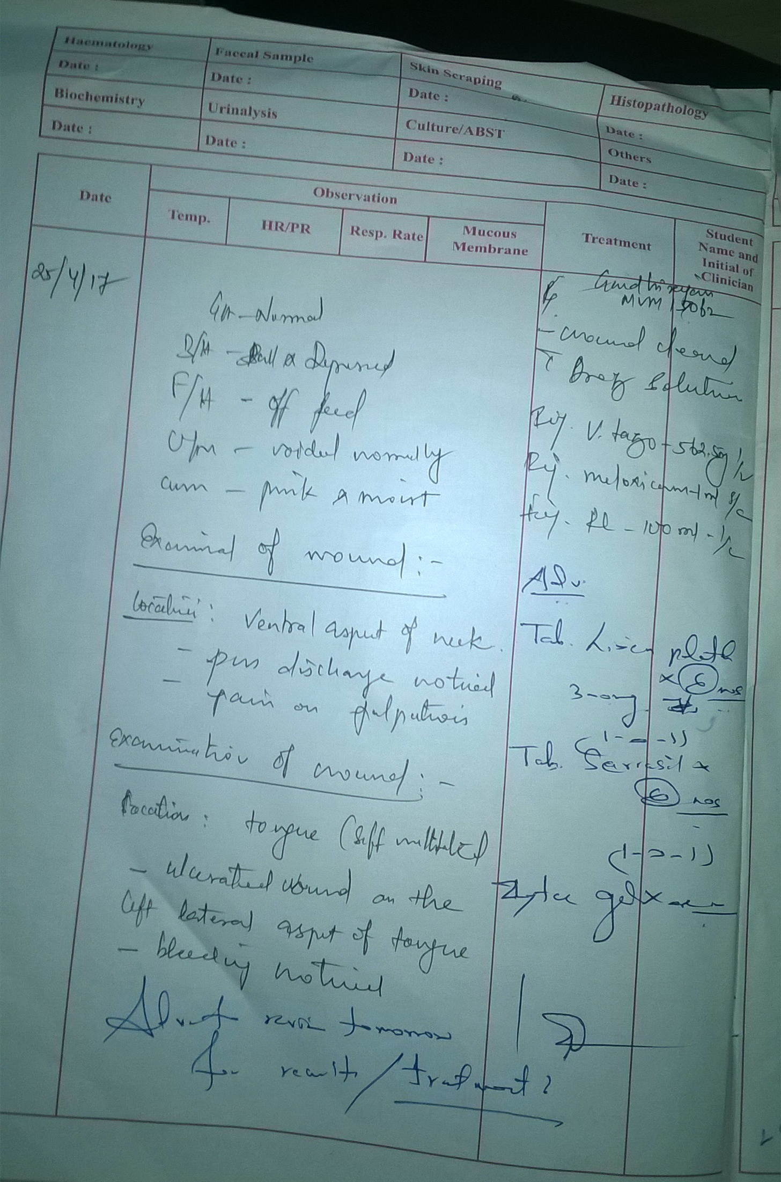
Fig 13 : Prescription
Limitation
Chapter 4
Limitation

The limitations of the case study were-
1.Urine protein to creatinine ratio would need to be evaluated for proper staging.
2. Blood pressure would need to be evaluated for proper staging.
3. Radiographical examination of kidney (Nephrosonography) would need to be evaluated.
4.As the time was short, follow up of the case was not possible.

Chapter 5
Discussion
Discussion

Chronic kidney disease is the most common kidney disese in dogs and cats. The incidence of the diagnosis of CKD in cats is made 2 to 3 times as frequently compared to dogs and is especially common in geriatric cats. It is clinically characterized by the development of variably progressive irreversible intrarenal lesions and loss of renal functions. A variety of interventions (diet and drugs) can slow the progression of the renal disease, improve the quality of life for the patient, and/or extend the quantity of life.

The prevalence for CKD in dogs varies widely depending on age and population studied with prevalence reported as low as 0.37% in U.K. practices (O’Neill DG et al. 2013), 5.8% in four U.S. veterinary teaching hospitals (Bartlett PC et al.2010) and 10% in geriatric dogs (Brown SA et al. 2015). Although CKD is a progressive disease, early diagnosis and management may modify the rate of progression and improve patient quality and quantity of life.

The cause of CKD is difficult to determine when diagnosed in later stages of disease. Damage can occur to any part of the nephron, including the glomerulus, tubule, interstitial tissue or vasculature, which can result in irreversible damage and loss of function of the nephron. The more common causes of CKD in dogs and cats include incomplete recovery from an acute renal injury ( toxic,infectious-bacterial,mycotic,Leptospirosis,Leishmaniasis).pyelonephritis,glomerulonephritis (more common in dogs), nephrolithiasis and ureterolithiasis (more common in cats), tubulointerstitial disease, feline infectious peritonitis in cats, Lyme disease in dogs, amyloidosis, neoplasia, hypercalcemia, various hereditary nephropathies.

There are some markers of kidney damage. These are blood markers( Elevated BUN, elevated serum- creatinine ratio, hyperphosphatemia), urine markers( impaired urine-concentrating ability, proteinuria, renal hematuria, abnormal pH) and imaging markers(abnormalities in Kidney-size,shape,location,density,number). Azotemia is an increased concentration of non-protein nitrogenous compounds in the blood as measured by elevated BUN and creatinine levels. Azotemia can be pre-renal, renal or post-renal. Pre-renal azotemia occurs when the glomerular filtration rate (GFR) is decreased due to a disturbance in the circulatory system such as cardiac disease. In pre-renal azotemia, the kidneys are still able to concentrate the urine as shown by a normal urine specific gravity with no evidence of protein in the urine. Post- renal azotemia results from urinary obstruction or rupture and clinical signs include frequent attempts to urinate with little to no production, or a distended abdomen due to the presence of urine in the abdomen (uroabdomen). Renal azotemia is diagnosed when the kidneys are no longer able to concentrate urine (USG 1.008 – 1.012), blood urea and creatinine levels are elevated above normal reference levels, and there are clinical signs of polyuria (increased urination) and polydipsia (increased thirst). It doesn't develop until 75% or more of the nephron population has become non-functional.

Discussion

The BUN measures the by-products of protein metabolism that are normally excreted by the kidneys. If the kidneys are not working correctly and filtering out these waste products, they will build up in the blood.

An elevation of creatinine that is a breakdown product of muscle and a measurement of the glomerular filtration rate of the kidneys. The kidneys are the only organs that excrete creatinine, and if there is an increased level of creatinine in the blood, it means that kidney function is impaired.

When the serum phosphorus level is elevated, the kidneys may be failed to excrete excess amounts in the urine. Normal kidneys can process phosphorus, but during chronic renal disease, the damaged kidneys cannot remove phosphorus from the bloodstream very efficiently. Excessive dietary phosphorus that isn’t excreted can start to pull calcium out of the bones making them weaker.

When urine specific gravity is below than normal value, it indicates that the urine is not being concentrated, and there is too much water being excreted. Large quantities of protein excreted in the urine indicates that there may be some types of kidney disease.

If there is a presence of granular casts in the urine, it indicates that the kidneys are sloughing some of the cells that line the renal tubules. “If a castis seen in the urine, kidney (renal) disease or involvement exists; the presence of casts indicates kidney (renal) disease rather than lower urinary tract disease (Ringsrud, 2001, p. 191).Gastric lesions are due to back diffusion of acid, bleeding due to platelet dysfunction, bacterial NH₄⁺ production from urea, ischemia due to vascular lesions and increased gastrin. Kidney disease can directly and indirectly cause vomiting due to the accumulation of uremic toxins within the blood.

Patients in IRIS Stage I and II may not have any clinical signs and are not yet azotemic, so their owners do not suspect that anything is amiss. IRIS Stage I and II may be detected in patients who receive regular senior pet evaluations if an upward trend is noticed in their blood urea nitrogen (BUN) and creatinine levels. By IRIS Stage III, approximately 75% of renal nephrons are non-functional, and clinical signs start to come to the fore. “With appropriate therapies, animals can survive for long periods of time with only a small fraction of functional renal tissue, perhaps 5 -8% in dogs and cats” (The Merck Veterinary Manual Online [Merck], 2013, p. 9).Common complications of chronic kidney disease are anemia,arterial hypertension, dehydration, hyperphosphatemia, hypokalemia, malnutrition, metabolic diseases etc.
Treatment goals and recommendations are specific to IRIS CKD stage (International Renal Interest Society. 2013). Since prerenal contributions will often increase the degree of azotemia to the next stage, normal renal perfusion (adequate patient hydration and effective circulating volume) should be restored before determining the patient’s stage of CKD. Treatment of CKD should be individually tailored to each patient. IRIS CKD stage management guidelines are providing renal diet, phosphorus binder, ACE inhibitor and correcting dehydration given (McGrooty Y. 2008). Common drugs of choice are Ranitidine ( 2 mg/kg PO,Im q12h)/Famotidine (0.5-1 mg/kg PO,IM q12-24h) to decrease acid secretion.Intestinal phosphate binders ( e.g. aluminium carbonate, 30- 100 mg/kg/day PO with meals) as needed to correct hyperphosphatemia.Sodium bicarbonate is used to correct metabolic acidosis( IV to raise blood pH > 7.1). ACE inhibitor is used (for proteinuria (benazepril or enalapril @0.5-1 mg/kg PO q 12h).
Discussion
Prescription renal diets typically have reduced protein, phosphorus, and sodium concentration, increased B-vitamins, fiber, and omega-3 fatty acids. It reduces the risk of uremic crisis. Other benefits includes prolonged median survival time, slower progression of CKD and improved quality of life. Providing a reduced level of high-quality protein will help to meet dog's nutritional requirement for protein while attempting to decrease the workload of his kidneys by avoiding excessive nitrogenous waste.

Patients with kidney disease can not eliminate excess sodium and fluid from the body efficiently. Excessive amounts of sodium can contribute to hypertension (high blood pressure), and the build-up of fluid (edema). Hypertension can result in greater damage to the kidneys, and edema can contribute to heart failure. Normal kidneys can process phosphorus, but during chronic renal disease, the damaged kidneys cannot remove phosphorus from the bloodstream very efficiently. Excessive dietary phosphorus that isn’t excreted can start to pull calcium out of the bones making them weaker. The increase in B-vitamins is to replace the larger amount of water soluble vitamins excreted because of its increased urinary frequency.

In addition to a prescription renal diet, the dog should always be allowed access to fresh water. Pets with renal disease are at risk for dehydration because their bodies cannot concentrate their urine output which means they are losing a large amount of water that would be retained in a pet with normal renal function. The new diet should be introduced slowly which will help to prevent gastrointestinal upset. Commercial diets for CRF should be protein(15-17%),phosphorus (0.2-0.3%) and sodium (0.2-0.3%).

Diseased animal will need rechecks every four months to monitor the progression of his disease. At each visit its physical condition and weight will be monitored, its blood values and blood pressure will be evaluated, and drug therapy will be instituted as needed. Renal disease is not curable;numerous steps can minimize the symptoms and slow the progression of the disease. Owner should monitor him for anorexia, dehydration, mouth ulcers, bad breath, increased lethargy, pale gums, vomiting, and diarrhea. Any of these can indicate a worsening of its symptoms. Owner should keep track of food and water consumption and watch for a decrease in either. If the dog does not drinking enough water, it will need additional fluids to prevent dehydration. Monitoring hits weight will ensure it is receiving enough calories to maintain his weight at a healthy level.

So we can say-
Discussion

1. CKD is relentlessly progressive. Renal lesions continue to develop and renal functions are lost
(GFR, urinary concentration, biosynthesis of EPO and calcitriol) during CKD. The rate of this
progression can be highly variable between individuals and even in the same individual over
time.

2. IRIS (International Renal Interest Society) staging of CKD is important in order to detect CKD
earlier and to identify risk factors for progression.

3. Staging is based on serum creatinine, proteinuria (urinary protein to creatinine ratio – normal,
borderline, overtly increased), and systemic blood pressure (low, moderate, severe risk).

4. Though not well established yet, matching CKD treatments with IRIS stage is a goal.

5. The goal of all treatment for CKD is to slow the rate for the acquisition of renal lesions and to
delay the rate of loss for renal functions.

6. Renal diets have been shown to increase survival in both dogs and cats with varying degrees
of azotemic CKD.

7. No diet has ever been shown to prevent the development of CKD.

8. The nutrient profile of the renal diet is altered for many nutrients. The overarching principle
for renoprotection and increased life span is likely to be that of phosphate restriction in the
diet.

10. Control of total body phosphate burden is an overarching goal in the management of CKD.
Increasing phosphate retention during CKD occurs even as serum phosphorus values remain
within the reference range. Diet as a single treatment is not often sufficient to achieve the
recommended target for serum phosphorus. Consequently most CKD patients will benefit
from treatment with intestinal phosphate binders.All intestinal phosphate binders provide
treatment of the food to prevent phosphorus in the diet from being absorbed into the
circulation.

Conclusion

Conclusion

Chronic kidney disease is a common disease in geriatric dogs all over the world. As the number of pet population specially dogs are increasing, it is important to give emphasis on this disease. It is a common progressive disease of kidneys and occurs mainly in old dogs with male predominance. It occurs when compensatory mechanisms of the diseased kidneys are no longer able to maintain the excretory, regulatory, and endocrine functions of the kidneys which resultant retention of nitrogenous solutes, derangements of fluid, electrolyte and acid-base balance and failure of hormone production. It results from a progressive and irreversible loss of functioning nephrons and the cause is often difficult to determine. Several risk factors are attributed for CKD in dog including old age, specific breeds, smaller body size, periodontal disease and obesity. Some other causes are chronic tubulointerstitial nephritis of unknown cause, Chronic pyelonephritis ,Chronic glomerulonephritis, Amyloidosis, Chronic obstruction(hydronephrosis) and sequel to acute renal disease (e.g., leptospirosis). Dogs with CKD exhibit polyuria, polydipsia, anorexia, vomiting, weight loss, pallor of mucous membrane, oral ulceration, halitosis and acute blindness.Patient history, results of physical examination, urinalysis, hematology, serum biochemistry and nephrosonography provide a practical means of diagnosing CKD in dogs. In spite of the poor long term prognosis, early diagnosis and therapeutic management may slow down disease progression in dogs. Conservative medical management of CKD includes providing adequate and appropriate nutrition, correcting fluid deficit, electrolyte abnormalities and acid base imbalance, improve clinical signs of CKD and providing renoprotective therapy to slow down the disease.

References
References

Adams LG. Chronic renal failure. In text book of the 5 minute veterinary consultant - canine and feline. Edited by Tilley LP and Smith JF. Publisher Williams and Wilkins, Philadelphia, 1997, 1156-57.

Brown S, Elliott J, Francey T, Polzin D, Vaden S. et al. Consensus recommendations for standard therapy of glomerular disease in dogs. Journal of Veterinary Internal Medicine, 27 Suppl 1, 2013, S27-43.

Brown SA. Management of chronic kidney disease. In: BSAVA manual of canine and feline nephrology and urology. editors, Jonathan Elliott and Gregory F. Grauer, 2nd ed. ed. Quedgeley: British Small Animal Veterinary Association; 2007:223-230

Canine and Feline Nephrology and Urology, 2nd edition –Chew DJ, DiBartola SP, Schenck PA, Elsevier Saunders, St. Louis Missouri, 2011.

Cowgill LD. Anemia of chronic kidney disease. In: Tilley LP, Smith FWK, eds. Blackwell’s 5-minute veterinary consult: canineand feline. 4th edn. Ames: Blackwell Publishing, 2004: 80–81

Diagnostic Staging and Management of Dogs and Cats with Chronic Kidney Disease, Dr Sheri J. Ross, BSc, DVM, PhD, Dipl. ACVIM (Internal Medicine)

Erlinger TP, Tarver-Carr ME, Powe N R et al. Leukocytosis, hypoalbuminemia, and the risk for chronic kidney disease in US adults. American Journal of Kidney Disease, 42, 2003, 256–63.

Eschbach JW, Adamson JW. Anemia of end-stage renal disease (ESRD). Kidney International, 79, 1985, 1-5.

Forrester DS, Lees GE. “Diseases of the kidney and ureter,” in Saunders Manual of Small Animal Practice, p. 803, WB Saunders, Philadelphia, Pa, USA, 1994.
References

Forrester DS, Lees GE. “Diseases of the kidney and ureter,” in Saunders Manual of Small Animal Practice, p. 803, WB Saunders, Philadelphia, Pa, USA, 1994.

Foster, J. D. (2013, September/October). Canine chronic kidney disease: Current diagnostic and goals for long-term management. Today’s Veterinary Practice, 21-26

Galler A, Tran JL, Krammer-Lukas S, Holler U, Thalhammer JG, Zentek J, Willmann M. Blood vitamin levels in dogs with chronic kidney disease. Vet J 2011.

International Renal Interest Society. (2013). IRIS staging of CKD.

Jacob F, Polzin DJ, Osborne CA, et al. Clinical evaluation of dietary modification for treatment of spontaneous chronic renal failure in dogs. J Am Vet Med Assoc 2002; 220(8):1163–1170

Jacob F, Polzin DJ, Osborne CA, Neaton JD, Lekcharoensuk C, Allen TA, Kirk CA, Swanson LL. Association between initial systolic blood pressure and risk of developing a uremic crisis or of dying in dogs with chronic renal failure.. Journal of American Veterinary Medical Association, 222(3), 2003, 322–9.

Jacob F, Polzin DJ, Osborne CA,et al. Clinical evaluation of dietary modification for treatment of spontaneous chronic renal failure indogs. J Am Vet Med Assoc 2002; 220(8):1163–1170.

Lucre VM, Kelly DF, Darker PGG, Gaskell CJ. Chronic renal failure in young dogs-possible renal dysplasia. Journal of Small Animal Practice, 21(3),1980, 169-81.

Lulich JP, Osborne CA, O’Brien TD, Polzin DJ. Feline renal failure: questions, answers, questions. Compend Contin Educ Pract Vet.1992;14(2):127–153.

McGrooty Y.Diagnosis and management of chronic kidney disease in dogs and cats. In Practice, 30, 2008, 502-07.
References

Nabity MB, Lees GE, Boggess MM, Yerramilli M, Obare E, Yerramilli M, Rakitin A, Aguiar J, Relford R. Symmetric dimethylarginine assay validation, stability, and evaluation as a marker for the early detection of chronic kidney disease in dogs. J Vet Intern Med. 2015;29. http://onlinelibrary.wiley.com/doi/10.1111/ jvim.12835/pdf. Accessed July 10, 2015.

O’Neill DG, Elliott J, Church DB, McGreevy PD, Thomson PC, Brodbelt DC. Chronic kidney disease in dogs in UK veterinary practices: prevalence, risk factors, and survival. J Vet Intern Med.2013;27(4):814–821.

Polzin DJ. 11 guidelines for conservatively treating chronic kidney disease. Veterinary Medicine 102, 2007, 788-99

The Merck Veterinary Manual Online. (2013). Renal dysfunction in small animals

Vaden SL. Glomerular disease. In: Ettinger SJ, Feldman EC, editors. Textbook of Veterinary Internal Medicine. 6th ed. St Louis, Missouri: Saunders (Elsevier); 2005. pp. 1786–1800.

Acknowledgement
Acknowledgement

The author is ever grateful and indebted to the Almighty Allah without whose grace it would never been possible to pursue this study in this field of science and to complete this clinical report for the Degree of Doctor of Veterinary Medicine(DVM).
The author would like to thank his beloved teacher and supervisior Dr. Md. Shohel Al Faruk, Assistant Professor, Department of Physiology, Biochemistry and Pharmacology, Chittagong Veterinary and Animal Sciences University, for his valuable advice, suggestions and kind co-operation during the study period.
The author expresses his sincere gratitude and gratefulness to Professor Mohammad Ali, Madras Veterinary College, Chennai for his valuable advice, inspiration, cordial co-operation, valuable suggestions during the study period.
The author would like to thank to the Director of External Affairs, Professor Dr. A.K.M Saifuddin, Dept. of Physiology, Biochemistry and Pharmacology, Chittagong Veterinary and Animal Sciences University for his suggestion.

