An epidemiological study on lumpy skin disease at Rangunia upazila of Chattogram district.
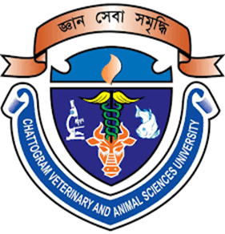

A Clinical Report Presented in Partial Fulfillment of the Requirement for the Degree of Doctor of Veterinary Medicine

A report submitted by-

Umme Aysha Habiba

Roll No: 15/36

Reg. No: 01451

Intern ID: F-34

Session: 2014-2015

Faculty of Veterinary Medicine

Chattogram Veterinary and Animal Sciences University

Khulshi, Chattogram

An epidemiological study on lumpy skin disease at Rangunia upazila of Chattogram district.

A clinical report submitted as per approved styles and contents

…………………………………..  Signature of Author  Umme Aysha Habiba  Intern ID : 34  Roll No : 15/36  Reg. No : 01451  Session : 2014-2015 | ………………………………….  Signature of Supervisor  Dr. Mohi Uddin  Associate Professor  Dept. of Anatomy & Histology  Faculty of Veterinary medicine

ChattogramVeterinary and Animal Sciences University

Khulshi, Chattogram

