CHAPTER ONE

INTRODUCTION

Pyometra is a common problem in feline practice particularly in aged cat during luteal phase. When it occurs, it often results in sterility in spite of proper medical treatment. Clinically, the cat may present with inappetence, depression, polydipsia, lethargy and abdominal distention. She may or may have not vaginal discharge and fever and with open have an elevated white blood cell count. The incidence of cat pyometra is approximately 34% before 10 years of age (Hagman, 2000).During this time, the progesterone level are elevated and help to create ideal conditions for infection. This progesterone primed condition stimulates uterine glandular secretion within the uterus, which suppresses uterine contraction (Cox, 1970) and inhibits the effect of infection fightings blood cells in the uterus. The effects are cumulative in that each estrous cycle results in more glandular activity and higher levels of inflammatory cells and fluid or mucous within the uterus. After the establishments of bacterial infection, which may originate from bacterial infection, urinary tract infection or fecal contamination the bacteria enter uterus and multiply.

E. coli is a main causal agent (Susi et al., 2006).This bacteria produces endotoxins. In approximately 90% of cases, Escherichia coli is a main causal agent. Escherichia coli is thought to be the local and systemic inflammatory reactions associated with pyometra. Cystic endometrial hyperplasia often precedes the disease, but can also be found in many older cats with no signs of pyometra. Scientific reports on feline pyometra are not frequent in Bangladesh but common reproductive problems in pets have been reported (Juyana et al., 2005).Different treatment methods have been applied during treatment of pyometra but the popular and effective treatment is ovariohysterctomy (Feldman and Nelson, 2004; Johnston et al., 2001).

CHAPTER TWO

CASE HISTORY AND DESCRIPTION
A six years old, local breed female cat was admitted to Teaching and Training Pet Hospital and Research centre, Chattogram Veterinary and Animal Sciences University, Bangladesh with a several day history of mucopurulent vaginal discharge with bad odor, reffered by Central Veterinary Hospital, Dhaka, Bangladesh. The case history revealed that after littering since two months ago, the animal suffering from restlessness, slight anorexia, progressive loss of body condition and mucopurulent vaginal discharge with bad odor.
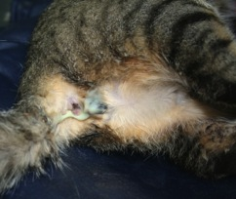
Firstly general physical examination was done. It shows that the cat was dull and depressed, licked her backside and was uncomfortable. The vital signs were unaffected except slight pyrexia with small amount of bad smelled vaginal discharge. Then blood sample was collected for routine examination of blood (TLC, TEC, DLC, Calcium etc.) limit (Table1 and Table 2).Almost all the parameter was within normal limit except PCV and Hb decreased and WBC, AST, ALT, Urea, Creatinin increased level that indicate infection. Then special examination was done such as USG and X-ray. Ultrasonographic examination revealed that hyperechoic tubuler pocket like structures that indicates pyometra. Then other special examinations were performed that was X-ray. In X-ray radiopaque extended uterus was found which indicates the uterus was filled with pus. Considering all examinations, it was suggested for ovariohysterectomy. The most common reason given for surgical removal of uterus and ovaries is prevention of diseases reoccurrence.

Figure 1: Mucopurulent pus coming out through vagina

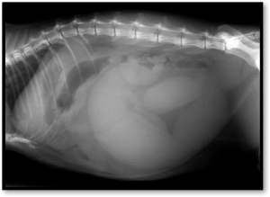

Figure 2: Radiopaque extended uterus by X-ray

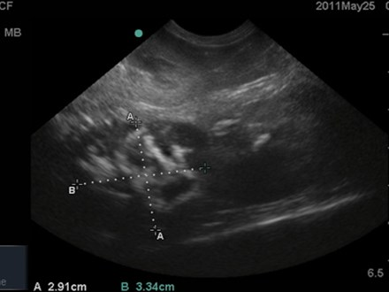
Figure 3: Hyperechoic pocket like tubular structure by ultrasonography

Table 1: Routine Examination of Blood
Name of the Test | Results | Normal Range
Hb(gm%) | 4.8 | 9.8-15.4
Total RBC | 4 | 5-10
Total WBC | 3.5 | 5.5-19.5
PCV% | 19 | 29-45
Neutriphil% | 80 | 35-75
Basophil% | 0 | 0-1
Eosinophil% | 1 | 0-4
Monocytes% | 4 | 0-5
Lymphocyte% | 20 | 27-36

Table 2: Biochemical Serum Examination of Blood
Name of the Test | Results | Normal Range
Urea(mg/dl) | 43 | 19-34
Creatinine(mg/dl) | 3.8 | 0.9-2.2
ALT( U/L) | 99 | 25-97
AST(U/L) | 36 | 7-38
Serum Total Protein(g/L) | 66.6 | 60-79
Serum Glucose(mmol/L) | 4.7 | 3.3-6.7

CHAPTER THREE

MATHODOLOGY

RESTRAINING AND ANESTHESIA
Both Physical and chemical methods were used to control the cat. The cat’s legs were tied with a leash for easy restraining. The surgical site was located in the caudal midline 2cm behind the umbilicus. After cleaning and shaving, the surgical site was soaked in tincture iodine. The cat was kept under fasting condition for 12 hours. As pre-anesthetic, Xylazine hydrochloride solution@1mg/kg body weight (inj. Xylazine Indian immunologicals LTD. India) intramuscularly followed by general anesthesia injection Ketamine hydrochloride@10mg/kg body weight (G-ketamine, Gonashasthaya Pharmaceuticals LTD.BD) intravenously was administrated. The maintenance anesthetic dose was given@ half of the initial dose during the surgery. The normal saline (Normosal, Libra pharmaceuticals LTD, Bangladesh) was infused intravenously@200ml during the surgery.

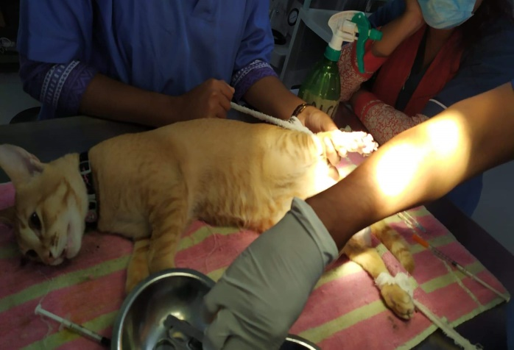
Figure 4: Pre-anesthetic was administrated

SURGICAL PROCEDURE
The patient was kept on the operation table and covered with sterilized draper keeping the operative site open. The surgery was aseptically controlled under general anesthesia. Laparotomic midline incision 2-3cm behind the umbilicus was performed. At first 3cm long incision was made on skin. The bleeding was checked by applying gauze pressure and artery forceps. The subcutaneous tissues and fats were removed. Then muscles and peritoneum were incised. Large vein were ligated to check hemorrhage. The uterine horns was identified by fingers and ovaries were found following the horn to their ends. The broad ligament attached to the ovaries were torn so the ovaries could be identified. The right ovarian arteries were ligated and transfixed with absorbable suture material (Catgut 1-0).The right ovarian arteries was cut. The same procedure was followed for left ovary. The uterine body and related arteries were ligated just in front of the cervix leaving the cervix as natural barrier. The uterus and ovaries were then removed. The abdomen was checked for any bleeding.

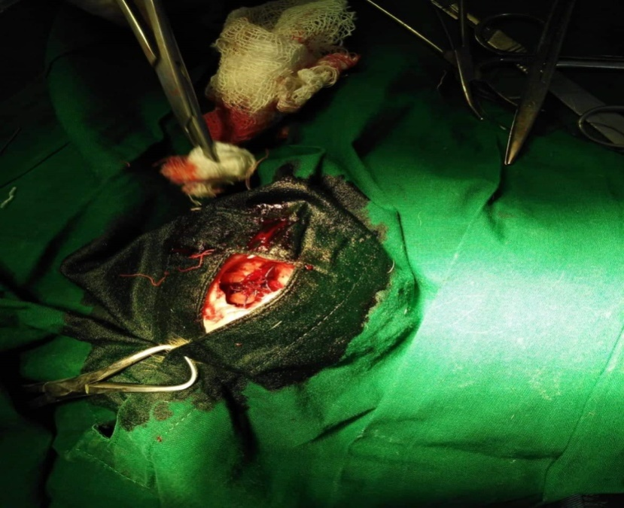
Figure 5: Incision behind umbilical area

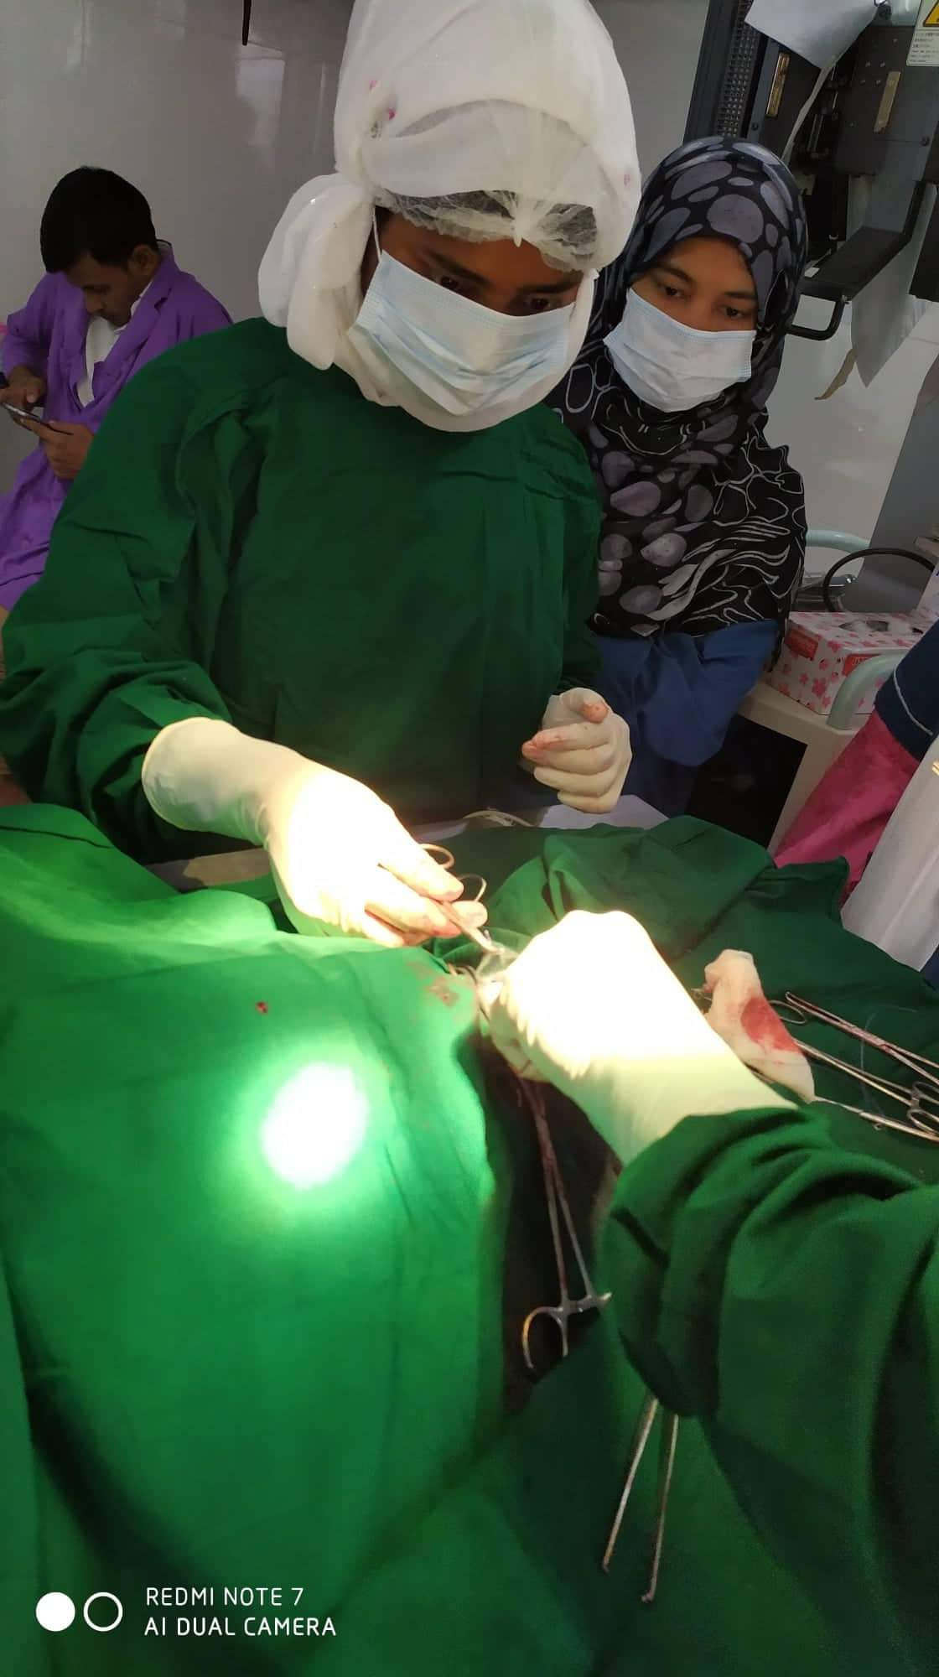
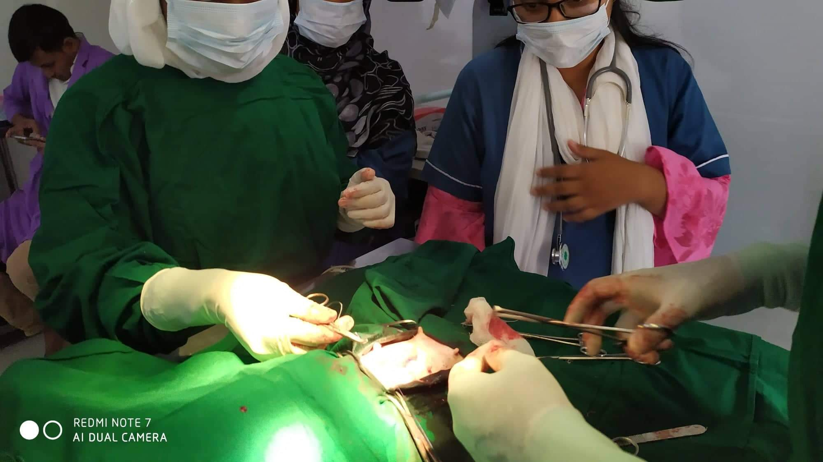

Figure 7:Exteriorization of uterine horn
Figure 6: Moping
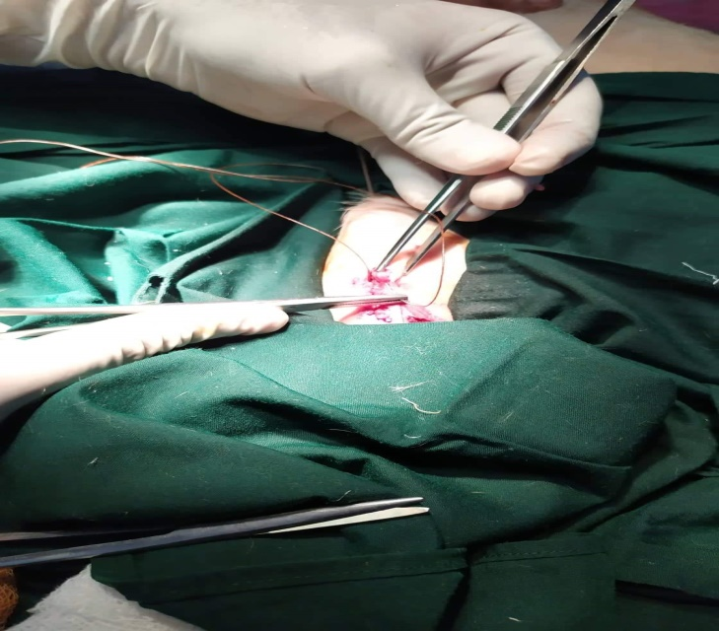
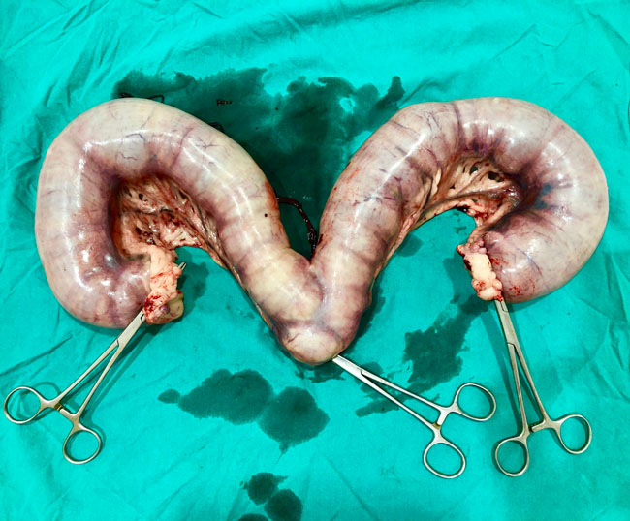

Figure 9: Uterus filled with pus
Figure 8 : Suturing

The peritoneum and muscle layers were sutured with simple continuous pattern with catgut (1-0).The subcutaneous layer was sutured with subcuticular pattern using catgut (1-0).The skin was then closed with cross-mattress suture pattern using silk. The sutured wound was covered by Viodin ointment.

POSTOPERATIVE TREATMENT AND CARE
After surgery, antibiotic ceftriaxone@50mg/body weight (Inj.Trigectvet 1gm;SK+F Pharmaceuticals, Bangladesh)was administrated intramuscularly daily for 7 days Antihistaminic Chlorpheneramine maleate@1mg/kg body weight (Inj. Astavet, Acme Laboratories LTD, Bangladesh) was administrated intramuscularly, daily for 7 days. Analgesic meloxicum (Inj.Melvet,Acme Laboratories limited Bangladesh) was administrated subcutaneously daily for 3 days for pain management. The patient was kept in clean squeeze cage and observed for 7 days. No complication was noted and the cat recovered uneventfully. On the 14thday, the suture was removed and it was noticed that the surgical site was healed completely.

CHAPTER FOUR

RESULTS AND DISCUSSION

A cat that was brought to hospital with several day history of slight anorexia, progressive loss of body condition, mucopurulent pus with bad odour coming out through vagina was tentatively diagnosed as pyometra. Then, pyometra was confirmed by special examination ultrasonography and x-ray. Later, it was corrected through ovariohysterectomy. Antibiotic ceftriaxone and antihistaminase Chlorpheneramine maleate was administrated intramuscularly daily for seven days and analgesic meloxicum was administrated subcutaneously daily for three days for pain management as postoperative care. Finally, it was observed that the surgical site was healed completely without any complication.

Pyometra is a uterine inflammatory disorder characterized by cystic endometrial hyperplasia (Johnston et al., 2001; Potter et al., 1991). They concluded that the prevalence of pyometra in cats increases with age in sexually intactfemale cats and mainly after parturition, while Agudelo (2005) suggested that the disease is common in queens older than three years and in other queens older than five years with no relationship to the number of parturitions, these close to findings were reported in this case. Hagman et al. (2014) found comparatively higher prevalence of pyometra in Bengal cat which is almost similar to this study. Pyometra is a disease of the middle-aged or older animal which was also stated by Brady et al, (2000). It could be speculated whether this increase is related to degenerative changes in the uterus or other conditions such as ovarian pathologies or uterine neoplasia that more often affect older animals and may predispose for developing pyometra. But it was also described in younger cats (Miller et al., 2003; Sontas et al., 2013; Payan-Carreira et al., 2013).

The present study shown that the hemoglobin level of cat was decreased (Table 1) indicating anemia which is in agreement with the previous reports (singh et al., 2006, Nath et al., 2009). This might be due to loss of red blood cells by diapedesis into uterine lumen apart from depressed feed intake and impaired erythropoiesis under toxemic condition in severely affected cases (Dabhi et al., 2009).

The PCV level decreased (Table 1) in the cat indicating a mild normocytic, normochromic philia might be due to regenerative type of anemia (Nelson and Feldman, 1986). According to Greene et al, (1998) total erythrocyte count before treatment was decreased in the bitches affected with pyometra indicating anemia which is similar to this study. It might be associated with the toxic depression of the bone marrow whereas severe non-regenerative, microcytic, hypochromic anemia accompanied by extremely high white blood cell levels might be indicative of a concurrent blood loss possibly by diapedesis into luminal pus and due to shortened life span of circulating erythrocytes associated with iron deficiency (Schepper et al., 1987). Different degree of leucocytosis was observed in bitches affected with pyometra which is consistent to this study. It might be due to severity of the inflammation varying between animals.

In the present study, absolute neutrophilia, lymphopenia, monocytosis with normal eosinophil count was the most consistent finding in cat affected with pyometra. Neutrophilia with regenerative shift to the left might be due to retention of purulent exudates in the uterus which exerts a chemotactic effect on neutrophils resulting into accelerated granulopoiesis and lymphopenia might be due to severe stress and elevated monocyte count might be due to chronic suppurative process (Singh et al., 2006). Neutrophilia is a typical feature in hematology of cat affected with pyometra (Pande et al., 2006) which might be due to influence of toxins in pyometra (Hagman et al., 2006).

The ovariohysterectomy was the choice of treatment of pyometra in this case. Potter et al. (1991) recorded that 61% of affected cats were spayed or died because of complications relating to reproductive tract disease. The case fatality for pyometra overall was 5.6% in cats. In dogs it was reported 3% to 4% (Egenvall et al., 2001). The reason for the higher fatality rate in cats is not known, but one theory could be that this species is less sensitive to endotoxin, or not as prone to show clinical signs unless they develop sepsis (Van Miert et al., 1968).

Pyometra can cause liver and kidney function changes (Nak et al., 2001). Occasionally, in this study ALT level moderately increased (Table 2) which supports the finding of Nak (1999). Because of septicemia hepatocellular damage were happened resulting diminished hepatic circulation and cellular hypoxia in the dehydrated cats. In this study, decreased ALT result can explain by a process of inhibition of liver enzyme synthesis or possible hepatic membrane damage. Renal dysfunction may develop secondary related to bacterial endotoxin to pyometra (Alacam, 1998). In this case blood urea nitrogen and creatinine concentration increased (Table 2). It might be due to dehydration (Nak, 1999). A high creatinine concentration (Table 2) was determined in 12% of a group of cats with pyometra (Kenney et al., 1987).

In this study ovariohysterectomy was performed under general anesthesia using xylazine hydrochloride and ketamine hydrochloride which is supported by the study of Deniz et al. (2005). In present study, the surgical site of cat was healed completely without any complication. Another study reported that postoperative wound after ovariohysterectomy dehiscence. It was might be due to applied rough handling and tearing of tissues during surgery, improper selection of the suture material, inefficient suturing, infection, hematoma or seroma formation, failure to obliterate dead space and training of the animal. In such cases, debridment and fresh coaptation of the wound is indicated (Singh and Singh, 1993).

CHAPTER FIVE

CONCLUSIONS
Pyometra is one of the most common reproductive disorders in cat. In closed cervix pyometra it is difficult to diagnose, so ultrasonography and radiology is the choice of methods for conform diagnosis of pyometra in cat. Ovariohysterectomy is the option for treating the pyometra in cat. No complication was noted and the cat was recovered uneventfully. It can be concluded that, ovariohysterectomy is the best method to treat a cat having problem of pyometra.

REFERENCES

Agudelo CF, 2005.Cystic Endometrial Hyperplasia-Pyometra Complex in cats, a review. Veterinary Quarterly, 27(4): 173-183.
Cox, J.E., 1970. Progestagens in bitches: A review. J. Small Anim. Prac., 11: 759-778.
Dabhi DM, Dhami AJ, Parikh PV and Patil DB, 2009. Comparative evaluation of haematological parameters in healthy and pyometra affected bitches, Indian Journal of Animal Reproduction, 30 :70-72.

Deniz N, Deniz M, Yavuz N and Abdülkadir K, 2005. Cytology and pathology in a controlled study of pyometra in cats. Australian Veterinary Practice, 35 (1):10-14.

Egenvall A, Hagman R, Bonnett BN, Hedhammar A, Olson P, Lagerstedt AS, 2001. Breed risk of pyometra in insured dogs in Sweden. Journal of Veterinary Internal Medicine, 15:530–8.
Feldman, E. C., & Nelson, R. W. (2004). Cystic endometrial hyperplasia/pyometra complex. Canine and feline endocrinology and reproduction. Canine and FelineEndocrinology and Reproduction. 3rd ed. WB Saunders Company, USA, 847-860.

Greene CE, Miller MA and Brown CA, 1998. Pyometra in bitches induces elevated plasma endotoxin and cystic endometrial hyperplasia complex. Infectious Diseases of Dog and Cat. Philadelphia, London, 623-626.

Hagman R, Kindahl H and Lagerstedt AS, 2006. Pyometra in bitches induces elevated plasma endotoxin and prostaglandin F á metabolite levels, Acta Veterinaria Scandinavica, 47:55-68.

Hagman R, Kindahl H, Fransson BA, Bergström A, Holst BS, Lagerstedt AS, 2006. Differentiation between pyometra and cystic endometrial hyperplasia/mucometra in bitches by prostaglandin F2alpha.

Jhonson CA. Female reproduction and disorders of the female reproductive tract. In: The Cat. Diseases and Clinical Management, vol. 2, 2nd edition, Edited by R. Sherding. Churchill Livingstone, New York, 1994, p. 1855-1876.

Johnston SD, Root MV and Olson PN. Canine and Feline Theriogenology, lst edition, 2001. W.B. Saunders Company. Philadelphia. p. 396-405 and p. 447-471.

Johnston SD, Root-Kustritz MVand Olson PN, 2001. Canine and Feline Theriogenology. Philadelphia: WB Saunders, 2001, p. 389-474.
Juyena, N.S., M.G.S. Alam, M.A. Hossain and M. Hossain, 2005. Occurrence of dog diseases in Dhaka Metropolitan City. The Bang. Vet., 22: 50-53.
Miller MA, Ramos-Vara JA, Dickerson MF, Johnson GC, Pace LW and Kreeger JM, 2003. Uterine neoplasia in 13 cats. Journal of Veterinary Diagnostic Invesigationt,;15:515–522.

Nak, D, 1999. Kedi vekopeklderde pyometranin fizyopatolojisi, tanisi ve prostaglandinlerle sagitimi, Y Y Ü Sagi Bil Enst Derg5:79.

Nelson RW and Feldman EC, 1986. Pyometra. Veterinary Clinics of North America: Small Animal Practice, 16 :561-576.

Nath K, Tiwari SK and Kalim O, 2009. Physiological and haematological changes in bitches with pyometra, Indian Veterinary Journal, 86: 734-736.

Pande N, Prabhakar S, Gandotra VK, Honparkhe M and Nanda AS, 2006. Efficacy of different techniques for diagnosis of pyometra in female dogs, Indian Journal of Animal Reproduction, 27 : 31-33.

Payan-Carreira R, Saraiva A, Santos T, Vilhena H, Sousa A, Santos C, Pires M, 2013. Feline endometrial adenocarcinoma in females < 1 year old: a description of four cases. Reproduction of Domestic Animal.

Potter K., Hancock D.H., Gallina A.M. (1991): Clinical and pathologic features of endometrial hyperplasia, pyometra, and endometritis in cats: 79 cases (1980– 1985). Journal of American Veterinary Medicine Association, 198, 1427–1431

Schepper JD, Stock JVD and Capiau E, 1987. Anaemia haematological changes in bitches with pyometra Journal of Small Animal Practice, 28 :137-145.

Singh H and Singh K. 1993. Wound healing and tissue repair. Ruminant Surgery. (Eds) Tyagi R P S and Singh J. 1 St edn. CBS Publishers and Distributors, Delhi, p:59–60.

Singh S, Dadhich H and Sharma GD, 2006. Haemato-biochemical studies in cystic endometrial hyperplasia pyometra complex in canine, Indian Journal of Veterinary Pathology, 30 :46-48.

Sontas H, Erdogan Ö, Apaydin Enginler SÖ, Yilmaz ÖT, Sennazli G, Ekici H, 2013. Endometrial adenocarcinoma in two young queens. Journal of Small Animal Practice, 54:156–9
Susi, A., R. Iris and H. Madeleine, 2006. Canine pyometra: New approaches to an old disease. Proceedings of the 31st World Small Animal Veterinary Conference, (WSAV'06), Czech Republic, pp: 691-692.

Van Miert AS, Frens J, 1968. The reaction of different animal species to bacterial pyrogens. Zentralbl Veterinarmed A, 15: 532–43.

ACKNOWLEDGEMENTS
Firstly, I would like to express my deepest sense of gratitude to “The Almighty Allah”, who enables me to complete the research work and dissertation. I would like to express the heartiest appreciation, gratitude and best regards to the supervisor Dr. Azizunnesa, Professor, Department of Medicine & Surgery, CVASU. I really deem it a proud to do a research work under her constructive, useful and effective supervision.I feel much pleasure to convey thanks to the Prof. Dr. Abdul Ahad, Dean, Faculty of Veterinary Medicine; Prof. Dr. A.K.M Saifuddin, Director, External Affairs, CVASU for the valuable cordial co-operation and suggestion during the whole intern period.
Last but not least I would like to express my gratitude, cordial respect to my beloved family members for their immense sacrifice, blessings and encouragement.

BIOGRAPHY
I am Ripta Moni, daughter of Akkas Ahamad and Ayesha Begum. I passed my Secondary School Certificate examination in 2011 (GPA 5.00) followed by Higher Secondary Certificate examination in 2013 (GPA 5.00). Now I am an intern Veterinarian under the Faculty of Veterinary Medicine in Chattogram Veterinary and Animal Sciences University, Bangladesh. In the future, I would like to work as a Veterinary practitioner & do work on dairy sector improvement in Bangladesh.

