CHAPTER I
INTRODUCTION
Dried milk or milk powder is the product obtained by the removal of water from milk by heat or other suitable means, to produce a solid containing 5% or less moisture. There are two types of milk powder on the basis of composition e.g. full cream milk powder & skim milk powder.
Dry milk provides a means of handling the excess milk supply in a dairy factory during the flush season, while in the lean season, that meant for the production of dry milk can be diverted to market milk. Thus dry milk may be called the balance wheel of the dairy industry today.
Every parent heed about their children’s health and feeding. The best source of babies feeding is their mother’s milk (breast feeding). But in few cases the mother naturally fails to fulfill the breast feeding requirement of baby due to disease factor or hormonal imbalance. But in some cases the mother itself is not interested in breast feeding, reasons manifested, the working females cannot provide proper feeding to their baby. In rare cases modern world females do not feed their babies just to maintain their apparently beauty. So they follow the infant formula (available in market) suggested by their nutritionist or doctor. No doubt, the Infant milk powders are generally considered as product of good microbiological quality with no risk of spoilage, but several factors may contribute to change its physical and chemical properties which reduce shelf-life and thus its commercial value (Cousins et al., 1987). Although the micro-organisms in infant milk cannot grow due to its low moisture content and do not play any direct role in their spoilage. But their occurrence in infant milk powder is of great significance and serves as an index of hygienic standards maintained during production, processing and handling. The infant milk provides a highly nutritious substrate that can support the wide variety of bacteria as well as yeast and molds for their growth and reproduction (Phillips and Griffiths, 1990). The contamination role of bacteria during the preparation of infant milk powder has been well documented. The thermophilic can have significant economic consequences when they exceed specification limits and may result in down grading of the products (Ronimus et al., 2005). Because these have ability to produce extremely heat resistant spores, and thus are significant source of pre- and post pasteurization (White et al., 1993).
Since, no work has been done before on any aspects of milk powders in internship programme of Chittagong Veterinary and Animal Sciences University. Thus, present study has been designed for evaluating the chemical and microbiological quality of milk powders.

USES OF FULL CREAM MILK POWDER
The various uses of milk powder are:
- In the preparation of reconstituted milk
- In tea and coffee
- In baby food preparation
- In candy and confectionary, bakery products etc.

HISTORY AND DEVELOPMENT
Marco Polo, the celebrated Venetian traveler of the thirteenth century, reported that the soldiers of Kublai Khan, a Mongol Emperor, carried dried milk when on an excursion. Before it was used, water was added to a portion of the dried material. Mixing was accomplished by the horses’ movements while travelling. Next we hear of dried milk in tablet form made in 1810 by the French scientist, Nicholas Appert, by the air-drying of milk solids concentrated to a ‘doughy’ consistency.
In 1855, Grimwade of Britain developed a modified dry product from highly concentrated milk to which was added sodium or potassium carbonate and sugar. This semi solid material was extruded into thin streams and dried in trays .
In 1902, Just of the USA was among the first inventors of a drum drier with two rolls. Numerous other types of drum driers were invented, but most of these were used to a limited extent. Vacuum drum driers were designed between 1889 and 1909. Among the early inventors of spray drying equipment were Percy of the USA (1872) and Stauf of Germany (1901). Peebles of the USA(1782) is known for his pioneering research to improve the reconstitution ability of non-fat dry milk in water.

Keeping quality
Keeping quality or shelf-life of dried milk or milk product refers to the time (in days or months) it retains its edible qualities after production. There are different factors influencing the keeping quality. Generally deterioration occurring during storage involves flavor, color and solubility index. The rate of spoilage is influenced by the following factors: a. composition; b. quality of milk used in production; c. care during production; d. care during handling and storage; e. manufacturing conditions, especially heat-treatment; f. moisture content; g. metallic contamination; h. packaging conditions (materials and methods), and j. storage conditions.
In commercial practice, the three most important factors influencing keeping quality are: fat content, moisture percentage and storage temperature. Milk fat deteriorates rapidly and moisture adversely affects storage life as the content increases above 4 per cent. To prevent absorption of moisture during storage, the package should be relatively impervious to moisture vapor. High storage temperatures are detrimental to the keeping quality. Hence temperature lowers than 24 degree centigrade is desirable. If possible, refrigerated storage should be used for long term storage in tropical countries.

Major changes during storage
Micro-organisms do not generally proliferate in dried milks storage defects are purely chemical in nature. There are two major types of storage deterioration, viz., one affecting fat and the other affecting lactose-protein.

- Fat decomposition. This may be divided into oxidation and rancidity.
- Oxidation. Whole milk powder undergo oxidative deterioration in storage.
Various factors influence the rate of milk fat oxidation. These are:
- Storage temperature
- Presence of copper and iron
- Acidity
- Sunlight
- Pre-heating
- Addition of anti-oxidants
- Gas-packing.
- Rancidity. True rancidity may be due to the hydrolysis of fat through lipase enzyme, leading to the production of free fatty acids, such as butyric.

Standards
- Prevention of Food Adulteration Rules (PFA)
- Whole milk powder. According to the PFA rules, 1976, whole milk powder is the product obtained from cow or buffalo milk, or a combination thereof, or from standardized milk, by the removal of water. It may contain calcium chloride, citric acid and sodium citrate, sodium salts of orthophosphoric acid and polyphosphoric acids, not exceeding 0.3 per cent by weight of the finished product, and 0.01 per cent of butylated hydroxyl anisole (by weight) of the finished product. Such addition need not be declared on the label. Milk powder should contain not more than 5.0 per cent moisture and not less than 26.0 per cent fat. The total acidity expressed as lactic should not be more than 1.2 per cent. The standard plate count may not exceed 50,000/g. and the Coli count may not exceed 90/g. The maximum solubility index should be 15.0 for a roller-dried and 2.0 per cent for a spray-dried product.

(b) According to the Indian Standards Institution (ISI, 1967), the specification for dried milks , vide IS: 1165, 1967 (First Revision) are as given in table 1

Characteristics | Requirement for whole milk powder
Flavor and odor | Good
Moisture(%wt) (Max) | 4.0
Total milk solids(%wt) | 96.0
Solubility:  - Solubility index (max.)  - Solubility (%wt. min.) | 15.0  85.0 ml
Total ash (On dry basis)  (%wt. max.) | 7.3
Fat (%) | Not less than 2.6
Titratable acidity (% lactic) | 1.2
Bacterial count per g. (max.) | 50,000
Coliform count per g. (max.) | 90

(c) The American Dry Milk Institute Standards (ADMI) of whole milk are given in table
Table:2
Particulars | Instant  US extra | Spray  US extra | Spray  US stand | Roller  US extra | Roller  US stand
Moisture (%) NMT | 2.25 | 2.25 | 3.0 | 3.0 | 4.0
Milk fat (%) NLT | 26.00 | 26.00 | 26.00 | 26.00 | 26.00
Solubility index(ml.) NMT | 0.5 | 0.5 | 1.0 | 15.0 | 15.0
Scorched particles (mg/g.)NMT | 15.0 | 15.0 | 22.5 | 22.5 | 32.5
Titratable acidity (%) NMT | 0.15 | 0.15 | 0.17 | 0.15 | 0.17
Standard plate count(per g.) NMT | 30,000 | 50,000 | 100,000 | 50,000 | 100,000
Coliform count (per g.) NMT | 90 | - | - | - | -
Copper(ppm) NMT | 1.5 | 1.5 | - | 1.5 | -
Iron (ppm) NMT | 10 | 10 | - | 10 | -
Oxygen (% vol) NMT | 2 | 3 | - | 3 | -

Food and Nutritive Value
Under modern drying methods, the nutritive value of milk is preserved to a great extend. While there appears to be only a slight destruction of lysine in spray drying, the severe heat-treatment of roller drying destroys more lysine. Dry whole milk is a good source of vitamin A, calcium and phosphorus. It is also a valuable source of riboflavin.

Objectives of the study
- To compare the actual nutritional composition with the standard label recommended by the company.
- To determine the adulteration of milk powder.
- To know the acidity percentage.
- To know the bacterial load.
- To know the sanitary condition of the products.
- To know the shelf-life of the products.

CHAPTER II
REVIEW OF LITERATURE
Milk contains all the essential nutrients for all physiological function of the body system. According to Byron et al (1974) the average composition of milk is water 87.20%, dry matter 12.80% (fat 3.70%, Protein 3.50%, Lactose 4.90% and Ash 0.70%). Milk is also good source of calcium, phosphorus and fat soluble vitamins (A, D, E and K). For this reason it is the nature’s most nearly perfect food. Milk is highly perishable agricultural product because its support to luxuriant growth of almost all kinds of microbes. Surplus milk which could be utilized by converting it into various milk products such as ghee, butter, yoghurt (Dahi), powdered milk, cheese, cream, condensed milk and various other fermented dairy products should be taken into consideration. Dry milk or powder milk is a product obtained by the removal of water and fat from whole milk, usually fat percent of whole milk powder is minimum 26% and maximum 40%, for partially skimmed milk powder minimum 1.5% and maximum 2.5%. For all types of powder milk water content ranges from 3-5% (Edgar Spreer, 1995). Under any circumstances water percent of dry milk should not exceed 5%. The removal of water from the milk takes place in two stages. The first stage is concentration by vacuum evaporation and the second stage is drying. Ninety percent of the water in the milk is removed in the evaporator and only ten percent in the spray dryer (Robinson, 1994a). The two principal processes for the manufacture of milk powder are the roller or the drum process and the spray process. Other systems are the form mat process and the freeze drying process. More recently, equipment in which combinations of these fundamental processes are found has been developed (FAO/WHO, 1973). Powder milk has a much longer keeping quality and can be held in un-refrigerated storage condition. Much less storage space is required per unit of solids. Distribution is possible to the countries particularly those with unfavorable conditions of the perishable dairy products to be impractical. Consequently, dry milk has superiority both in economy and convenience. Powder milk is advantages for its concentrated source of many essential nutrients (Hall and Hedrick, 1966).
Powder milk (whole and non fat) are used in manufacturing ice cream, infant foods, bakery goods, confections and sausages and they are utilized by flour millers, and cheese processors. In Bangladesh, whole milk and half-cream powder milk available in tin containers are mainly used as baby food. These are also used for convalescents and in the preparation of many other sweetmeats. Now a day, the production of dried milk has become an increasingly important segment of the dairy industry. The world’s recorded annual output of dried milks and some milk by-products in 1969 (FAO, 1970) was 4.2 million tons, the contribution of India being 31.1 thousand tons, 0.7% of the total. There are definite indications of greater future production of dried milks due to their better keeping quality, they are requiring less storage space and lower shipping costs - all of which are economically attractive. The ultimate aim of the industry is to obtain dry products which when recombined with water , give little or no evidence of detrimental change compared to the original liquid product .The other aims are to ensure good keeping quality and a low manufacturing

CHAPTER III
Materials and Methods
The present study was designed to evaluate some chemical and microbiological parameters of powder milk available at local market in Chittagong town.
Location:
The present experiment was conducted in Dairy Science laboratory at Chittagong Veterinary and Animal Sciences University.
Study Period: The study was conducted form July 2012 to February 2013.
Collection of the samples:
To perform the experiment, six commercial brands viz, Aarong, Dano, Marks, Fresh, Today & Goalini were chosen. A total of 18 samples, three of each brand of different batch of production were collected from the shops around the CVASU campus.

Chemical Tests: Acidity, Moisture and Fat percentage were estimated according to the guideline given on Manual on milk and milk products testing procedures, 1984.

Determination of Fat
The principle of determination is the same as at Gerber fat test. Milk proteins are destroyed by sulphuric acid and fat separated by centrifugation of butyromter. The percent of fat is read from fat column. Below are described two methods in use for determination fat in milk powder (FCMC= full cream milk powder).
Apparatus
- Analytical balance.
- Standard Gerber butyrometers for FCMC.
- Rubber stoppers.
- Standard pipettes for milk (11 ml or 10.94 ml)
- Standard pipette for sulphuric acid, 10 ml.
- Standard pipette for amyl alcohol, 1 ml.
- Shaking stand for butyrometers.
- Centrifuge, working at speed 1100 r.p.m.
- Water bath.
- Washing glass.

Reagents
- Sulphuric acid density 1.815g/ml at 20 ͦC.

- Amyl alcohol, density 0.816at 15.50 ͦC.
Procedure
- Firstly I prepared recombined milk by weighing 13 g of FCMP, dispersing in 100 ml of distilled water.
- Then I poured 10 ml of sulphuric acid into the butyrometer by means of a standard pipette.
- Pipette of 11 ml of recombined milk at temperature about 20 degree centigrade without allowing mixing of milk with sulphuric acid.
- After that I added 1 ml of amyl alcohol with the automatic filler.
- Centrifugation of the butyrometers were done immediately after mixing and centrifugation was done for 5 minutes at 1100 r.p.m with taking a water filled tube at opposite direction.
- After removing butyrometer from centrifuge machine I placed them in water bath at temperature 65 ͦC, for 3 minutes, stopper downwards.
- Taking the butyrometer from water bath, I adjusted the position of the fat on the main graduation mark. Then the reading of fat percentage of the lowest point of meniscus were taken, leveling it with the eye.

ACIDITY TEST BY TITRIMETRIC METHOD:
Apparatus
- Small beaker
- Graduated pipettes of 10 ml and 20 ml
- Pipette, 1 ml
- Burette.
Reagents
- 0.5 percent phenolphthalein solution in 50 percent alcohol.
- 0.10 N solution of sodium hydroxide (NaOH). Dissolve 4.005 g of pure sodium hydroxide in distilled water to get 1 litre of solution.
Procedure
Firstly I prepared reconstituted milk from milk powder by dissolving and dispersing 13 g of full cream milk powder in 100 ml of distilled water with the use of warm water at 45 ͦC.
Then I measured 9 ml of milk into a beaker and 9 ml of distilled water with the same pipette. Addition of 1 ml phenolphthalein solution to the samples and mixing were done properly. From burette I poured sodium hydroxide solution slowly into the beaker with the milk sample until a faint pink color appeared.
Records of the amount of sodium hydroxide were noted down . Then number of ml of 0.10 N sodium hydroxide used were divided by 10 gives the acidity of milk powder in percent of lactic acid.

Determination of Moisture Content
Materials
- Moisture analyzer
- Sample
Procedure
A direct moisture analyzer has been used for this purpose. The steps followed were as follows –
- After weighing of 3 or 4 g of sample I started the machine.
- Heating was continued until full evaporation completed.
- Then the result of total moisture percentage were given by the machine.
- Thus every result of the samples was noted down.

Bacteriological examination of dry milk: Standard Plate Count (SPC) and Presumptive Coliform Test were performed according to Manual of Methods of Analysis of Foods (Milk and milk products), 2005.

Most of the microorganisms present in milk are likely to be destroyed during the process of drying except for a few highly resistant types. The number of surviving organism may, however, be high due to the use of poor quality milk for drying and inadequate heat-treatment. There is also scope for several types of organisms to gain entry into the product from the plant equipment, containers and atmosphere due to poor sanitation. Although these organisms presence may be undesirable in reconstituted milk, infant foods and other products made with the use of such milk powder. Samples of dry milk are, therefore, examined for total number of viable organisms ( agar plate count), direct microscopic count, and presence of Coliform bacteria or other undesirable types like hemolytic Streptococci and staphylococci.

Collection of Samples
Procedure representative samples from bulk or retail packing’s of milk powder. In the case of standard containers take out at least three plugs or columns from the bulk using sterile tubes or triers and transfer portions (about one oz each) from various parts of the bulk to the sample jar. Since dried milk absorbs moisture quickly make the transfers rapidly after opening the container and when the transfer is completed seal the container immediately If some portions of the package appear to damp, caked or dirty such portions should be sampled separately and the observations are recorded.

Preparation of Dilutions
I shaked the sample jar thoroughly to mix the contents and transferred 1 g of the sample into 9 ml dilution blank (Previously warmed to 45 degree centigrade) and shaking was done gently to dissolve the powder completely. That gave a dilution of 1: 10. In the case of whole milk powder precautions were taken to avoid churning of fat. Mild agitation of dilution blanks followed by soaking from 1 to 3 minutes and then vigorous shaking helped in dissolving particles which otherwise may be mistaken on plates for pin point colonies. In the case of very insoluble samples (due to age or acid development) they can usually be dissolved in sodium citrate dilution blank.

Standard Plate Count
Materials
- Agar media.
- Dilution blank.
- 1.1 ml pipette.
- Petri dishes.
- Spirit lamp.
- Autoclave.
- Incubator.
- Colony counter.
- Sample

Procedure
- I cooled 1: 10 dilution of the sample prepared as described above and made higher dilutions ( 1 : 100 or 1 : 1000).
- I Plated the dilutions in duplicate, adding agar medium and incubating the plates at 35 ͦC for 2 or 3 days according to procedure described in milk.
- I counted the plates showing 30 to 300 colonies.
- Since samples may contain appreciable numbers of aerobic spore-formers, which may form spreading colonies in plates making it difficult to count the colonies, plates with next higher dilution should be counted for checking the estimate.
- (Addition of a layer of 3.5 ml of sterile agar over the medium after it has set helps in reducing spreading colonies).
- Results were taken from standard plate count per g of milk powder.

ISI STANDARDS
Milk powder (whole & skim)
Bacterial count (per g ) ( max ) – 50,000.

Presumptive Coliform Test

Materials and procedure
Same as in the case of coliform test for milk using Mc. conkeys broth medium. Positive coliform test in 1:10 dilution is an indication of insanitary methods of production and packaging.
According to ISI
Coliform count per g (max) 90.

Data analysis
The statistical analysis of data was done as per Steel and Torrie (1980), using Completely Randomized Design (CRD). Analysis of variance test was done to find out the statistical difference within the quality of the six types of packaged powdered milk.

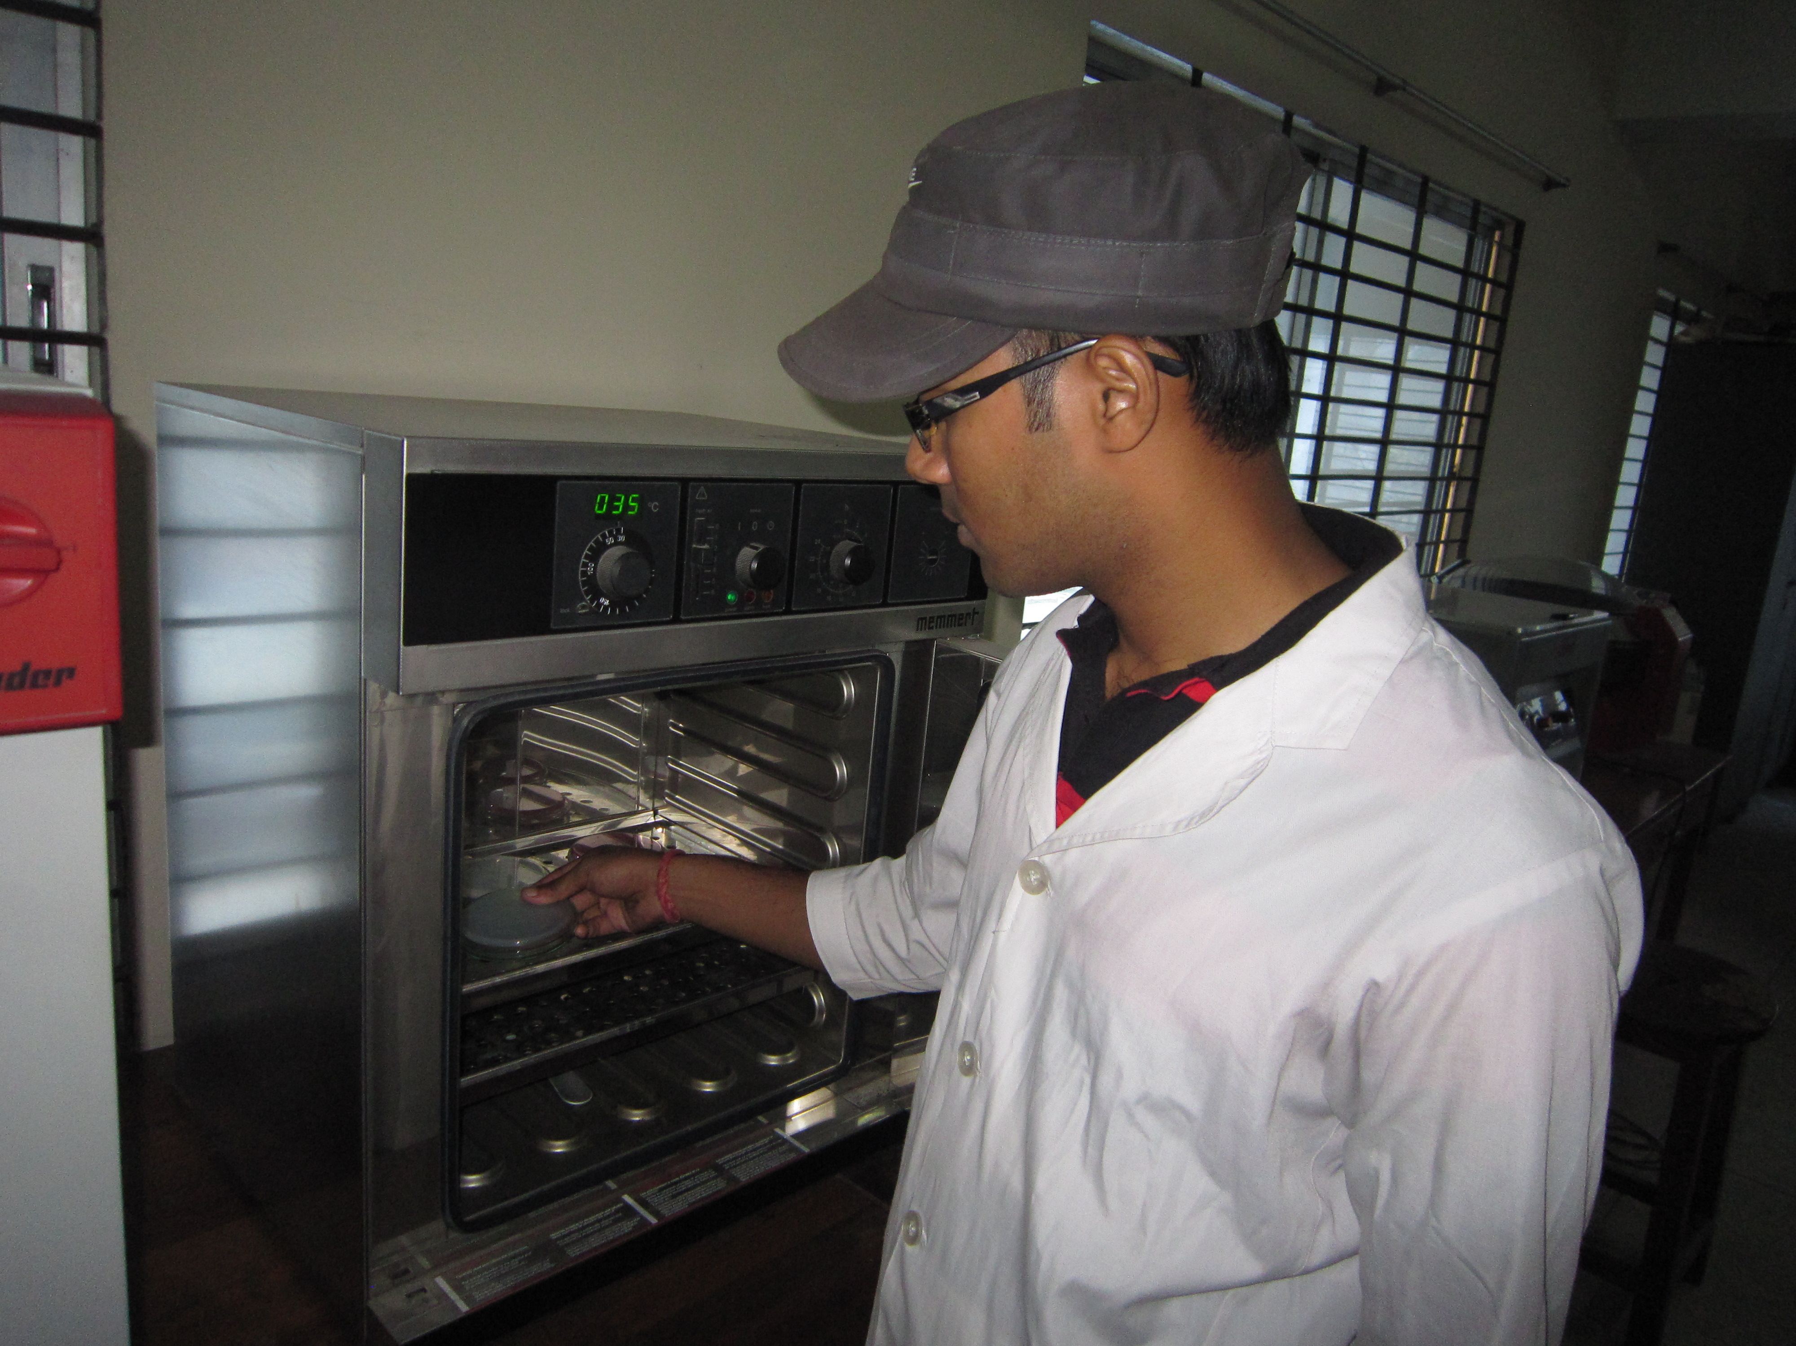
Fig: SPC (Standard Plate Count)
Fig: Acidity Test
Fig: Moisture Test
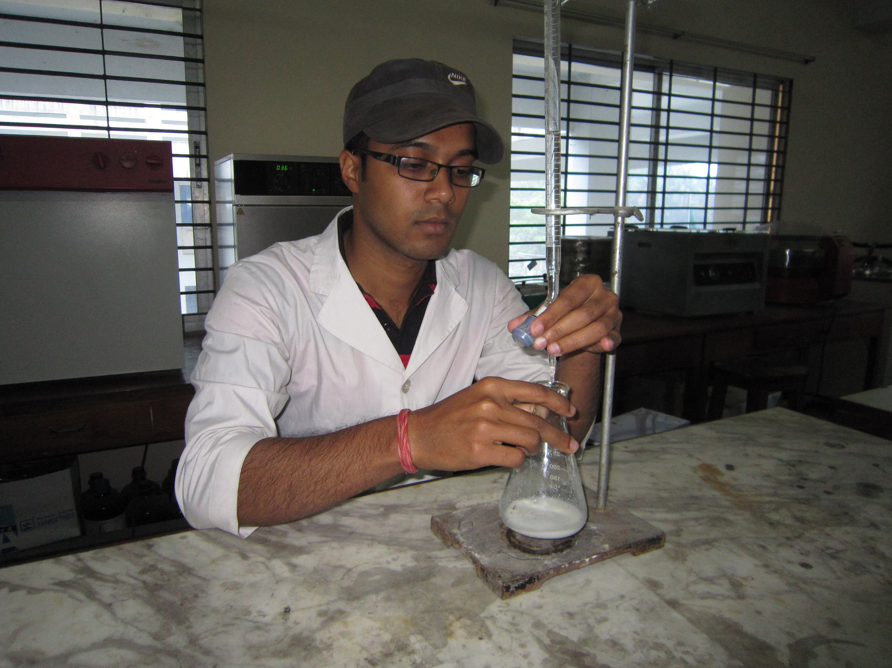
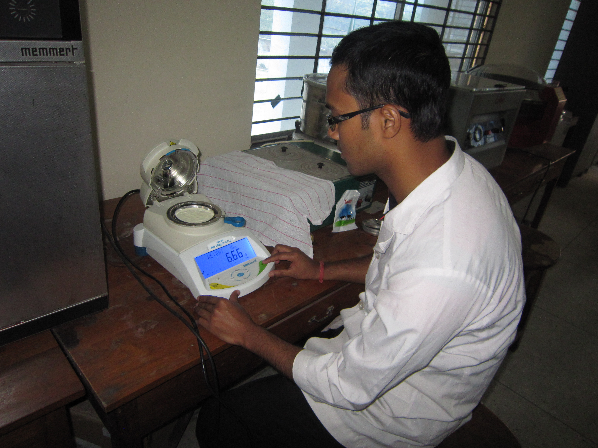
CHAPTER IV
Result and Discussion
Chemical comparison
Parameters found in different brands:
Table: 3
Parameters | Aarong | Fresh | Today | Marks | Dano | Goalini | Level of significance
Acidity | 0.12±0.00 | 0.12±0.01 | 0.11±0.01 | 0.11±0.01 | 0.14±0.01 | 0.11±0.01 | NS
Moisture | 3.9 ± 0.29 | 5.15±0.37 | 4.8 ± 1.04 | 4.75±0.21 | 5.2 ± 0.78 | 4.6 ± 0.81 | NS
Fat | 2.8± 0.22 | 4.0 ± 1.63 | 3.8 ± 0.95 | 2.4± 0.47 | 3.6 ± 0.00 | 2.7 ± 0.60 | NS

Acidity content
The acidity percentage of Aarong, Fresh, Today, Marks, Dano and Goalini were 0.12±0.00, 0.12±0.01, 0.11±0.01, 0.11±0.01, 0.14±0.01, 0.11±0.01respectively (Table1) and the differences (P<0.01) were highly significant. It was observed that the average value of acidity obtained from Dano (0.14±0.01) was significantly (P<0.01) higher and Today, Marks, Goalini (0.11±0.01) were significantly lower (P<0.01) than the acidity of other samples of powder milk (Table 1). According to BSTI,(Year??) and ADMI (1971) acidity content of the dry whole powders milk recommended as (0.15%). The present study was below according to the BSTI and ADMI standard. Judkins and Keener (1960) reported that the normal acidity of market milk may be ranged from 0.08 to 0.23%. Generally we know that the acidity of normal milk samples is within the range of 0.10 to 0.18 per cent with an average of 0.16 per cent (Eckles, 1951). Another experiment Kumar and Murty (1992) found that the acidity percentage of buffalo whole milk powder packed in HPPE bags was 0.98 %.

Moisture content
Moisture of milk powder obtained from Aarong, Fresh, Today, Marks, Dano and Goalini were 3.90±0.29, 5.15±0.37, 4.80±1.04, 4.75±0.21, 5.20±0.78, 4.60±0.81 g/100g, respectively (Table 1). It was found that there were non-significant differences within the moisture of different types of milk powder collected from local market (Table 1). It was observed that the average value of moisture obtained from Dano(5.20±0.78) was non-significantly higher and Aarong(3.90±0.29) was non-significantly lower than the moisture of milk powder of other five samples (Table 1). Kumar and Murthy (1992) found the average moisture of Buffalo whole milk powder 3.23%. On the other hand, Pijanowski (1975) was found the average moisture of whole milk powder 2.74%. According to the BSTI the moisture content of whole milk powder should be up to 4%. According to the ADMI (1971) the moisture of whole milk powder should be within the range of 2-5%. Result of present study agreed with the range of ADMI standard.

Fat content
Fat of milk powder obtained from Aarong, Fresh, Today, Marks, Dano and Goalini were
2.8±0.22, 4.0±1.63, 3.8±0.95, 2.4±0.47, 3.6±0.00, 2.7±0.60%, respectively (Table 1) and the different were statistically non significant. It was observed that the average value of fat obtained from Fresh(4.0±1.63) was statistically non-significantly higher and Marks (2.4±0.0.47) was lower than the fat of milk powder of other five samples (Table 1). Pijanowski et al. (1975) found that average fat % of whole milk powder was 2.54%. According to the BSTI and ADMI (1971) average fat content of dried whole milk are minimum 2.6%. The present study was within the same range of the BSTI and ADMI standards except Marks. (Eckles et al. (1951) stated that dry whole milk should contain minimum 2.6% fat. Kumar and Murthy (1992) found that the fat content of buffalo whole milk powder packed was 2.61%.

Standard Plate Count (SPC):
Number of colonies/gm milk powder found in different brands:
Table: 4

Brand | Aarong | Fresh | Marks | Dano | Today | Goalini
Plate No.
1 | 15 | 16 | 17 | 17 | 17 | 18
2 | 17 | 19 | 18 | 11 | 15 | 12
3 | 12 | 11 | 13 | 21 | 16 | 16
4 | 20 | 20 | 17 | 14 | 21 | 19
5 | 18 | 16 | 20 | 17 | 18 | 20

Presumptive Coliform Count:
Number of colonies/gm milk powder found in different brands:
Table: 5

Brand | Aarong | Fresh | Marks | Dano | Today | Goalini
Plate No.
1 | 17 | 20 | 17 | 18 | 12 | 18
2 | 8 | 15 | 12 | 11 | 8 | 12
3 | 5 | 7 | 9 | 8 | 6 | 9
4 | 2 | 3 | 6 | 5 | 2 | 4
5 | 3 | 2 | 2 | 3 | 2 | 2

According to the ISI standard procedure, number of colony should be 30 to 300 but the above findings shows that there is no such category to be counted for the SPC and Presumptive coliform Count.
However, according to the ISI standard, bacterial count for milk powder is Max. 50000 per gram and Max. 90 coliform bacteria per gram. So all the brands that I had studied was safe for consumption as their bacterial load is negligible.
Thus elastration of result and discussion in case of bacterial count is satisfactory.

CHAPTER V
CONCLUSION

From the results, Aarong powder milk was found somewhat better than that of other brands in terms of maintaining proper Fat, acidity and lower moisture content. All other samples were about same except Marks having lower fat percentage. This result indicated that all milk powder companies under studied were following the legal standard of composition of powder milk. Both the Standard Plate Count and Presumptive Coliform Test gave an indication of maintaining of sanitary methods of production and packaging.

CHAPTER VI
REFERANCES

American Dry Milk Institute (ADMI) 1942. Dry Milk Solids. Bul. 904 5th Ed. 32.N. Lasslle St. Chicago, III, U.S.A

American Dry Milk Institute (ADMI) Inc. 1962. Standards for grades for the dry milk industry including methods of analysis. Bull. 916.

American Dry Milk Institute (ADMI) Inc. 1971. Standards for Grade of Dry Milk Including Methods of Analysis, Bulletin 916.

Amrita Kadian; Srivastava D. N.; Dabur R S; Kadian A. 1998. Bacteriological and sensory qualities of milk powders manufactured in Haryana Agricultural University, Journal of research 28 (4): 129-134.

Association of Official Agricultural Chemists (AOAC). 1980. Official Methods of Analysis 13* Ed. Washington D.C. U.S.A.

Association of Official Agricultural Chemists (AOAC). 2003. Official methods of analysis, (17* edition) Washington D.C. U.S.A.

Barbano, D.M., Clark, J.L., Dunham, C.E. 1988. Comparison of Babcock and ether extraction methods for determination of fat content of milk: collaborative study, J Assoc off Anal Chem. 1988 Sep-Oct; 71(5):898-914.

BSTI (Bangladesh Standards & Testing institution) Maan Bhaban, Dhaka, Bangladesh-1208

Byron, H. W., Amold, H.J. and Jhon, A.A. 1974. Fundamentals of Dairy Chemistry. The Avi Publishing Company Inc. 2nd Ed. pp. 2-8.Chicago, U.S.A.

Cousins, C.M., A.J. Bramley and R.K. Robinson, 1987. Microbiologia de la leche cruda. Microbiol. Lactol., 1: 109-150.
De Sukumar(2010), Outlines of Dairy Technology, OXFORD University Press, ISBN-13:978-0-19-561194-6,Page 309-314.

Eckles, C.H., Cobms, W.B. and Macy, H. 1951. Milk and milk products. 4th edition, McGarh-Hill Book Company, New York. pp. 49-57. U. S.A.

Edgar Spreer, Milk and Dairy product Technology 637, S 768m C.1

FAO/WHO. 1973. Code of principles concerning milk and milk products (7`h Ed.) Standard for whole milk powder, partly skimmed milk powder and skimmed milk powder. No. AS. FAO/WHO.

Hall, C.W. and Hedrick, T.I. 1966. Drying of milk and milk products (2"d ed.). The Avi publishing comp., Westport (Conn.).

Judkins, H.F. and Keener, H.A. 1960. Milk production and processing. New York. Jhon Wiely and Sons. Inc. pp. 27-41.

Laboratory Manual: Methods of Analysis of Milk and its products. 1964b. The Milk Industry Foundation, Washington D.C. 20036.U.S.A. pp. 320-321.
Manual on milk and milk products testing procedures, 1984. Co-operative dairy organization and Extension programme (Phase II). Food and Agricultural Organization of the United Nations, Dhaka.
Manual of Methods of Analysis of Foods ( Milk and milk products), 2005. Ministry of Health and Family Welfare, Govt. of India, New Delhi.

Phillips, J.D. and M.W. Griffiths, 1990. Pasturized Dairy Products: Constraints Imposed by Environmental Contamination. Wiley, USA., pp: 387-456.
Pijanowski, E., Zamarlicki, S. and Nowak, D. 1975. A selective chemical analysis of whole fresh milk powder and its technological interpretation. Acta Alimentaria Polonica 1(1): 83-97.

Robinson, R.K. 1994a. Modern Dairy Technology, Advance in milk processing, 2nd edition Vol.1,
Chapman and Hall, 2-6 Boundary Raw, London SE1 9HN, UK. P.159.

Steel, R.G.D. and Torrie, J.H. 1980. Principles and Procedures of Statistics. 2nd Edition McGraw Hill Book Co., New York.

White, D., R.J. Sharp and F.G. Priest, 1993. A polyphasic taxonomic study of thermophilic bacilli from a wide geographical area. Antonie van Leeuwenhoek, 64: 357-386.

