MANAGEMENT AND PHENOTYPIC CHARACTERIZATION OF AVAILABLE TURKEY AT BURICHANG, CUMILLA
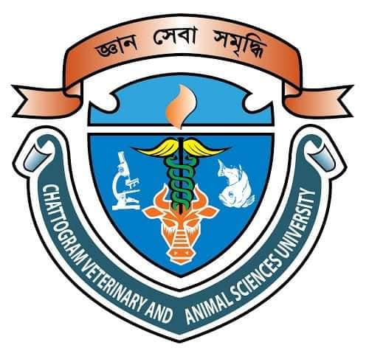
A Production Report Submitted
By

Md. Nazmul Hoque Peas
Intern ID: 69
Roll No: 14/15
Reg. No: 01166
Session: 2014-2015

The report submitted in the partial fulfillment of the requirements for the Degree of Doctor of Veterinary Medicine (DVM)

Faculty of Veterinary Medicine
Chattogram Veterinary and Animal Sciences University Khulshi, Chattogram-4225, Bangladesh

August, 2020
MANAGEMENT AND PHENOTYPIC CHARACTERIZATION OF AVAILABLE TURKEY AT BURICHANG, CUMILLA

A Production Report Submitted
By
Intern ID: 69
Roll No: 14/15
Registration No: 01166

Approved as to styles and contents by

…………………………………………
Signature of Author
Md. Nazmul Hoque Peas
Roll No: 14/15
Reg. No: 01166
Intern ID: 69
………………………………………
Signature of Author
Dr. Md. Moksedul Momin
Assistant Professor
Department of Genetics and Animal Breeding, CVASU
Chattogram Veterinary and Animal Sciences University
Khulshi, Chittagong-4225, Bangladesh

