Acknowledgement

These are few lines of acknowledgement can never substitute the deep appreciation that I have for all those without whose help, support and inspiration this dissertation would not have taken its present shape.
The author is ever grateful and indebted to the Almighty Allah, the creator and soul authority of universe, who enabled me to complete this work successfully. The author express his deepest sense of gratitude, sincere appreciation and profound regards to authors reverend teacher, Dr. A. K. M. Humayun Kober, Associate Professor of the Dept. of Dairy and Poultry Science, Chittagong Veterinary and Animal Sciences University for his scholastics guidance, uncompromising principles, sympathetic supervision, valuable advice, constant inspiration, radical investigation and constructive criticism in all phases of this study and preparing the manuscript. I also acknowledges of the farmer of Hathazari area for their co-operation collect the data.
I express my sincere gratitude to all teaching and non teaching staff members of my working departments for their support. My sincere thanks to all of my Friends and well Wishers for their help, encouragement and inspiration during the study period and preparing a report.

The Author:

Abstract

The study was conducted to ascertain the different types of injury, mortality and welfare during broiler transportation. Two flocks having 825 and 911 broiler were examined for different types of injuries during transportation. Injuries during transportation were identified by visual observation and palpation. These are like rough handling during loading & unloading, space allowance in crates, ambient temperature, feed withdrawal time, transport & time of distance influence the injury, mortality, loss of body weight & welfare. For identification of risk factor during transportation this farm chicken are transported to market for sale. The data of different type of injuries (e.g. dislocation of wing, dislocation of leg, laceration of wing & leg) were collected during transportation of market from farm by using visual observation and palpation method. Results with respect to the frequency of weight loss, dislocation of wing, dislocation of leg, laceration of wing & leg were approximately 6%, 14%, 12%, 5% & 2%, respectively. On the other hand mortality percentage of adult chicken was found 0.05% during transportation. From these findings it can be concluded that chicken are facing a great number of serious injuries during handling and transportation.

Introduction

In Bangladesh animal welfare is not a new concept. Now a day it’s a matter of concern to us. Bangladesh is a country with a very high population density. Agricultural development involving allocation of additional land is not possible at all. Therefore, emphasize should be given to other sectors in agriculture like broiler rearing. The potential for the development of small-scale poultry as well as broiler sector has been successfully proved and the contributions of this sector have a significant role in the economy of Bangladesh (Rahman, 2003). In Bangladesh, the demand for broiler meat is increased rapidly. To fulfill our animal protein requirement by our indigenous production lot’s of chicken are transported from farm to the market. When poultry is transported to the market there are several stages that each has the potential to cause injury. Specific criticism has been directed at the duration of journeys to the market. In Bangladesh, the road transport conditions involve high stocking densities, poor ventilation, overcrowding beside, high humidity, high temperatures and cruelty forms of animal handling during loading & unloading, this may increase the risk of injury, dislocation of joint, stress & mortality. Dehydration causes loss of water from both the intracellular and extracellular compartments and has been associated with reductions in carcass weight and changes in meat quality. One of the major challenges faced by the poultry industry worldwide is different risk factors during chicken transportation that influence injury, mortality and welfare. The poultry industry is subject to increased public scrutiny and criticism over the manner in which birds are transported for slaughter. In adverse weather conditions, the number of dead-on-arrival (DOA) in individual loads can reach high levels. When chickens are transported for slaughter there are several stages that each have the potential to cause injury and mortality: catching, loading into crates, transportation, waiting in a holding area and unloading. Although there is evidence that journey duration can affect chicken mortality, the fitness of the birds and the quality of the journey (pre- and post-transport handling and the environmental conditions) must also be taken into account (Cockram, 2007). The type of handling system e.g. loose crates or modules and the manner in which the birds are handled can affect the risk of injury (Bayliss and Hinton, 1990). The variability in DOA and injury rates suggests that there are multiple risk factors that can affect the risk of DOA and injury (Nijdam et al., 2004). To my knowledge, however, very few literatures are available regarding poultry welfare in Bangladesh. That’s why I have selected this topic for my report. Therefore, the present study was undertaken for assessment of poultry welfare in selected area of Bangladesh during chicken transportation.

Objectives:
- To assess different types of injury, mortality and welfare during broiler transportation.
- To know the different aspects of management of poultry during transportation.

Review of literature

In transit birds may be exposed to a variety of potential stressors including the thermal demands of the transport micro-environment, acceleration, vibration, motion, impacts fasting, withdrawal of water, social disruption and noise (Nicol and Scott, 1990; Mitchell and Kettlewell, 1993; Mitchell and Kettlewell, 1998; Carlisle et al., 1998; Abeyesinghe et al., 2001). Each of these factors and their various combinations may impose stress upon the birds, but it is well recognized that thermal challenges and in particular heat stress constitute the major threat to animal well-being and productivity (Mitchell and Kettlewell, 1998; Mitchell et al., 2000; Weeks and Nicol, 2000; Elrom 2000; Mitchell et al., 2001; Nilipour 2002; Mitchell 2006).
Physical injury:
Dislocated humerus bones are seen in broilers after transportation and the numbers were estimated to reach 1.1% of 53,000 birds by. Bayliss and Hinton cited work carried out in the 1980’s where it was reported that during catching, loading and unloading, wings and legs may be broken or dislocated due to rough handling. Bremner and Jonston (pointed out that fractures in broilers were located mainly on femur, radius, ulna, furculum and ischium. They also add that the damage of catching plays only a minor part in the overall problem of broken bones (3%) and the processing may increase the percentage of fractures to 96%.
Thermal stress:
The imposition of thermal loads upon the birds in transit will result in moderate to severe thermal stress and consequent reduced welfare (Mitchell et al., 1992; Mitchell and Kettlewell, 1998; Mitchell et al., 2001), increased mortality due to either heat or cold stress (Hunter et al. 1999., 2001) and induced pathology including muscle damage and associated changes in product quality (Gregory, 1998; Mitchell, 1999). It is apparent that climatic conditions, which will influence the internal vehicle thermal micro-environment, will determine the effects of transport upon the birds. In turn the duration of the journey will be another important factor affecting the effects of any hostile “on-board” thermal conditions. Mortality has long been a concern in relation to poultry transportation (Bayliss and Hinton, 1990) and continues to be an episodic issue in all countries where meat birds are produced. Warriss et al., (2005) have described a highly significant relationship between mortality of broilers in transit (Dead on Arrivals or DOAs) or in lairage and the maximum daily ambient temperature. It was proposed that at external temperatures greater than 17ºC measures might be required to ameliorate the damaging effects of transport on bird welfare.
In contrast Ritz et al., (2005) have reported that elevated temperature during hot weather pose a greater pre-slaughter risk of mortality to broilers during loading and lairage at the slaughterhouse than on the vehicle if it is constantly moving. The authors acknowledge, however, that it is difficult to precisely attribute DOAs to a specific part of the process of handing and transport. Under commercial conditions it is difficult to establish the causes of mortality in transit and there are few studies available that have provided such information (Hunter et al., 1997). It is examined the distribution of mortalities on commercial broiler transport vehicles and reported a significant link between the onboard thermal micro-environment and DOA values. They reported that 89.4% of dead birds (DOA) exhibited macroscopic pathological lesions. Infectious disease states were the main cause of lesions followed by heart and circulation disorders and trauma. It should be noted, however, that birds affected by any of these pathologies will be rendered susceptible to thermal stress and thus may succumb at when exposed to thermal conditions that would so adversely affect healthy birds.
Dead on arrival birds:
Broiler DOA figures (annual averages) may vary from around 0.15% (Mitchell, 2006) to values as high as 0.25% (Verecek, 2006), 0.35% (Bianchi et al., 2005; Petracci et al., 2006) and 0.46% (Nijdam, 2004). Thus it may be assumed that the actual levels of mortality or DOA vary widely depending upon many factors including season, geographical location, journey length, size of bird stocking density, health status, vehicle design and slaughterhouse design and practice. Average values of DOA tend to be elevated in the summer months in many and a model developed. (Nijdam et al., 2004). It was proposed that minimisation of the last two factors may be important strategies for the reduction of DOA in commercial practice. Journey length has long been recognised as an important factor in broiler DOA (Warriss et al., 1990).
Feed withdrawal and weight loss:
Another important consequence of transportation of broilers which is weight loss of broiler chickens in transport has been found to be related to journey duration (Karaman, 2009). This also leads to effect upon chicken transportation (Mitchell et al., 2003).
This reduces product delivery weight and significant dehydration will compromise bird welfare and affect product quality. If it assumed that thermal challenges represent a major risk to the welfare of birds in transit and to production efficiency then understanding the thermal micro-environment on commercial transport vehicles is essential to the development of appropriate strategies to control that environment and to reduce the risk of thermal stress in transit.
From this above literature it can be state that it is a matter of concern for poultry welfare is a major consideration in meat production and is based upon the belief that poultry can suffer.

Materials and Methods
Selection of the study area
The study was conducted at two commercial broiler farm at Hathazari thana of Chittagong district where transportation occur from farm during sells of birds to market during the period from August, 2013 to October, 2013 . The main reasons of selection of the farm were regular transportation to meet demand of customers which is suit for my study. The data was collected after transportation of 7-18 km distance from farm to the market.

Study population
The study population comprised 1,736 chickens originating from 2 broiler farms. A total of 1736 (825 & 911 two different flocks) were examined at Hathazari thana of Chittagong district.
.
Data collection
Data regarding Dead on Arrival (DOA) birds, laceration and dislocation of wings, legs, body weight before and after marketing and stocking density during transportation were recorded by using preset questionnaire. The risk factors during transportation were also identified by visual observation and palpation.

Transportation system
At approximately 5-7 weeks of age, chickens have reached the 'target' weight for marketing. Before marketing the chickens to be transportation for slaughter, food is withdrawn for 12-18 hours and water for 6 hour. Humane handling the birds by one leg and carrying them in bunches (Fig: 3) to lairage. They are then transferred into the lairage and stacked onto a van. The container modules were a metal frame type containing 2 to 3 compartments (Fig 2). During this of transportation the birds already have wound, fractures, dislocations & laceration of wing & toe and this process adds significantly to their pain. Once on the van, the chickens, who have spent their entire lives in sheds are then exposed to traffic noise and at times also temperature extreme.

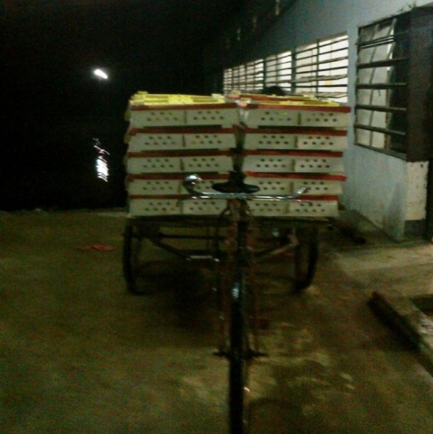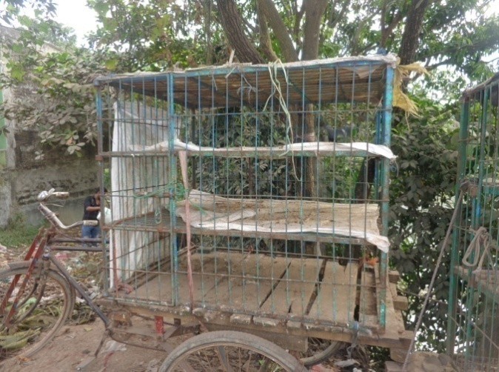
Fig1: Day old chick transportation at night; Fig 2: Vehicles used for transportation ofbroiler;
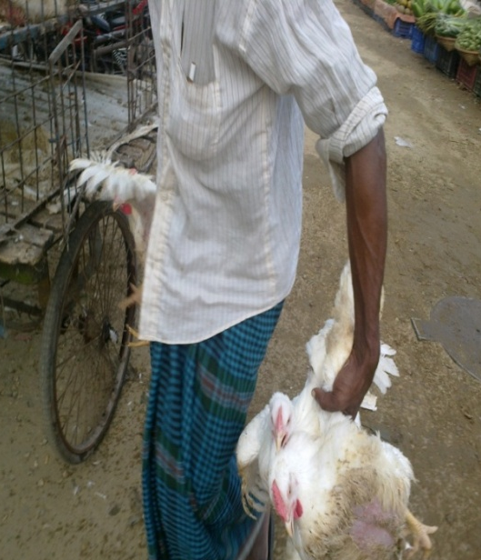
Fig 3: Carrying them in bunches on hand;

During transportation due to rough handling, overcrowding in sunlight leads to heat stroke and death. When the vehicle arrives at the market, chickens are manually removed from the crates. Then the dead bird, injuries like dislocation, fractures, laceration of wing & leg of each van were recorded. During transportation due to rough handling injury on wing & leg are markedly visible. On the other hand overcrowding leads to dead which is mainly depends upon the ambient temperature of the environment.
Different types of injuries
Among the chicken different sort of injuries in the body area were inspected or observed carefully; for example, dislocation & laceration of wing & leg observed. Besides this body weight loss also observed. The different types of injuries and their complications were examined closely and defined. Inspection and palpation methods of examination of animal were used to assess the physical condition of bodily injured chicken.
Dislocation
Dislocation means displacement from their normal position of bones meeting at a joint such that there is complete loss of contact of the joint surfaces. In chicken it is mostly found at the knee joint. Example of dislocation given on Fig: 4 & 5.
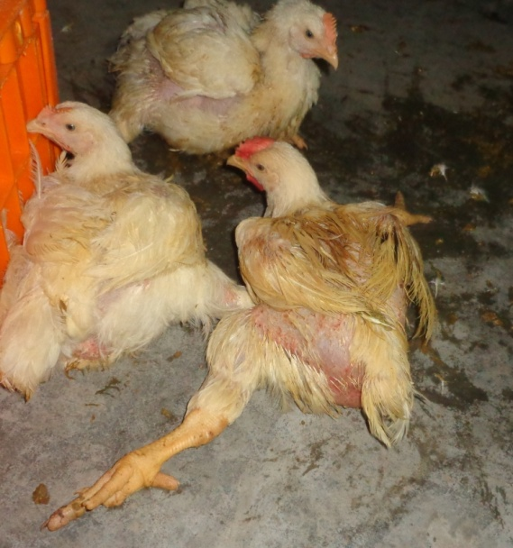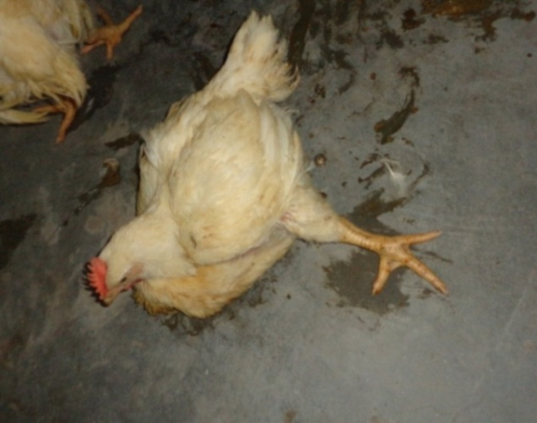
Fig 4: Dislocation of leg ;
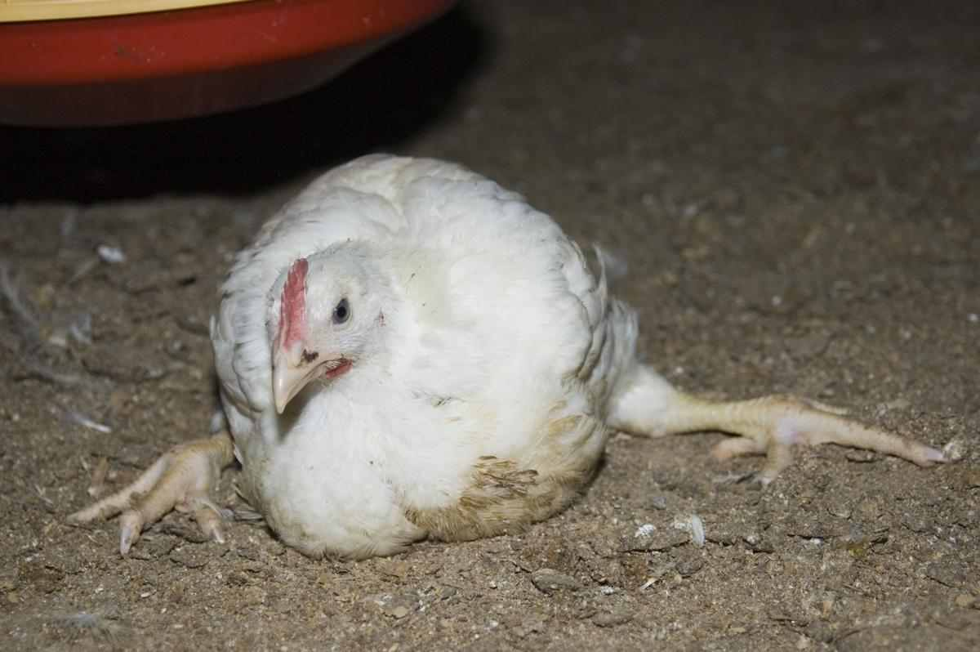
Fig 5: Dislocation of leg ;
Laceration
Laceration is a type of injury in which skin is torn, cut, or punctured (an open wound), or where blunt force trauma causes a contusion (a closed wound). In pathology, it specifically refers to a sharp injury which damages the dermis of the skin. This type of injury is occurred due to presents of sharp object present in the crates of van which leads to injury of leg & wing. This laceration also occurred by sharp nails due to overcrowding of chicken.
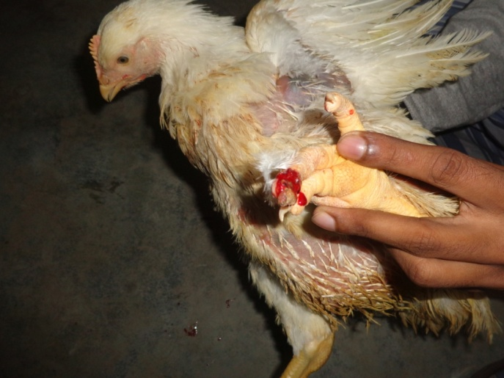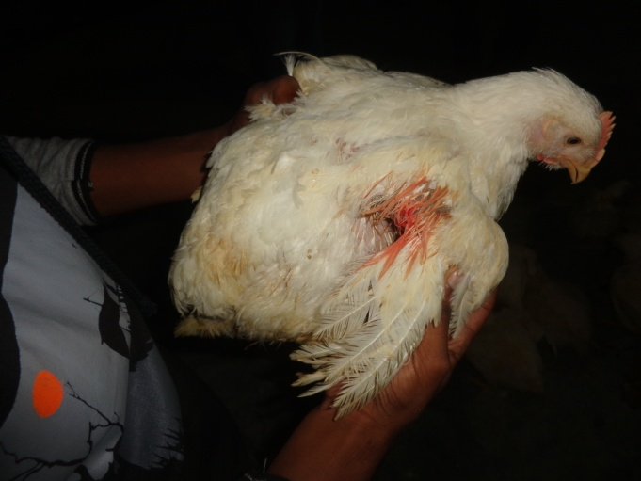
Fig 6: Laceration of leg & wing;
An example of observed laceration injury is shown in Figure 6.
Swelling
Swelling is a transient abnormal enlargement of a body part or area not caused by proliferation of cells. An example of observed swelling is shown in Figure 7.
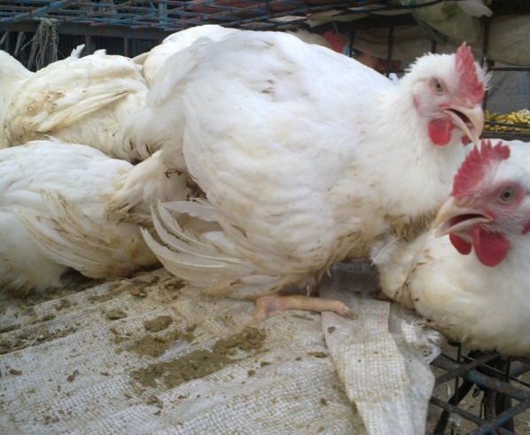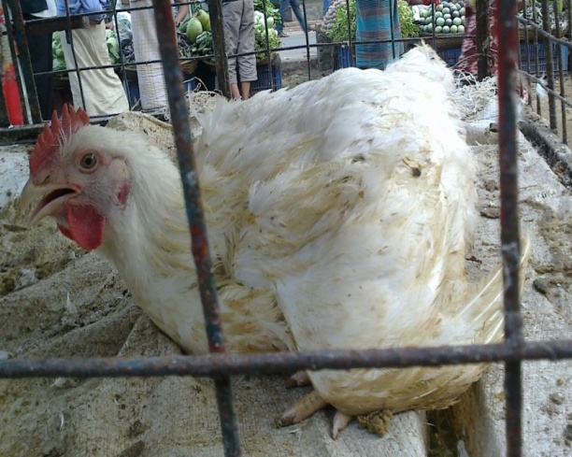
Fig 7: Swelling of wing;

Possible cause of injuries
The possible cause of the injuries was recorded either in the rough handling, cage metal friction, sharp objects friction and overcrowding during transportation. This list of possible causes was developed and evaluated by observing the animals, asking questions and discussing with the traders and the animal handlers, reviewing the literature and taking into account the experience of the researchers in observing the shape and depth of the injuries.
Dead on arrival birds
These birds are mainly found after transportation due to heat stress, overcrowding, less ventilation or previously occurrence of disease. This dead on arrival percentage was mainly highest at the summer season if transport at daylight. A figure: 6 of dead on arrival birds is given below which is transported at the middle of the day.

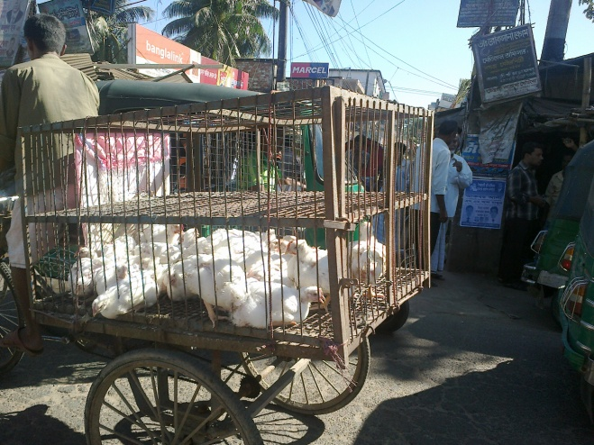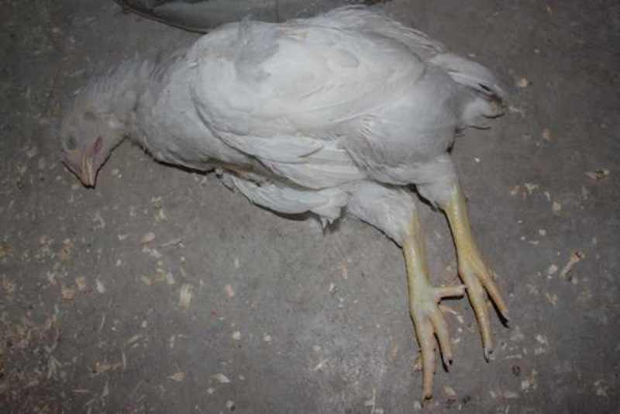
Fig 8: Transportation of broiler at mid day leads to mortality;
The DOA bird’s percentage was collected by interviewing who was involved during transportation previously.

Results & discussion

Factors associated with DOA and injured percentages (weight loss, dislocation of wing, dislocation of leg, laceration of wing & leg) of broilers per flock were identified. Ambient temperature, catching method, number of broilers in the flock, mean body weight before and after transportation, space allowance in crates, transport time, and lairage time were all associated with the DOA percentage of broilers also recorded. Season, moment of transport, and ambient temperature were associated with the bruises percentage of broilers also considered.
Table1: Total no. of injured and dead birds during transportation to the market (n=1736)
Flock | No. of chicken marketing | No. of injured | No.of DOA
A | 250 | 88 | 0
 | 350 | 105 | 1
 | 218 | 78 | 0
B | 206 | 83 | 0
 | 350 | 106 | 0
 | 350 | 112 | 0

A=1st broiler flock containing 825 chicken; B=2nd broiler flocks containing 911 chicken;
From this above table it can be said that when large no. of chicken when marketed the injure percentage also increase in same manner.
However, in these studies, risk factors were only identified and the sizes of their effects were not quantified. Knowledge of the magnitude of effects is necessary to establish the reduction of DOA birds or injured percentage of broilers that could be obtained by removing or reducing these risk factors.
Relation of injured percentage with journey distance
Besides this during transportation injury rate also closely related with the size of the flock that transported & the distance. In this transportation when large amount of bird transported for long distance no. of inured bird also increase. This is also happen during transportation of 350 birds at a distance of 18 km leads to injury of 16 birds. On the other hand when 218 birds is transported at a distance of 7 km leads injury of 2 birds. When transporting poultry for 4 hours or more, vehicles should be equipped with mechanical ventilation systems. But in our country it is never practiced.

Fig 9: Frequency of injury in relation of journey distance;
From this we compare and got a point that large no. of bird when transported for long distance leads to increase the injured percentage. For DOA and corrected injured percentages, catching and transporting during day time was found to be a risk factor. Moreover, the increased percentage of bruises such as laceration may have resulted from higher activity of broilers during daytime.
Table 2: Type of injuries and total no. of DOA with percentage (n=1736)
Types of injuries | Total injured | Percentage (%)
Dislocation of wing | 243 | 14
Dislocation of leg | 208 | 12
Laceration of wing | 87 | 5
Laceration of leg | 34 | 2
DOA | 1 | 0.06
From this able table we see that within the injured percentage dislocation of wing percentage are more than the other.

Relation of weight loss with journey distance:
Handling, crating, and transport are known stressors. Apart from stress caused by these factors, broilers suffer metabolic exhaustion due to feed and water withdrawal during a large part of the last day of their life. Broilers may lose live weight, glycogen stores may be depleted and hyperthermia can occur during lairage. The stress and metabolic exhaustion most likely contributes to weight loss during transport.
Birds of lower initial body weight (<2.0 kg) lost 47, 64 and 106 g of body weight on journeys of 1, 2 and 3 hours duration, respectively. For heavier birds (>2.5 kg), the corresponding figures were 93, 139 and 141 gm, respectively.

Table 3: During transportation loss of mean body weight;
Duration of transport(hr) | Before journey mean body weight(kg) | Loss of mean body weight(gm)
1 | 2 | 47
 | 2.5 | 93
2 | 2 | 64
 | 2.5 | 139
3 | 2 | 106
 | 2.5 | 141

From this above table we can compare and get point duration of journey and longer feed withdrawal time responsible for loss of body weight.

Relation of temperature with transportation
Both low and high temperatures increase the DOA percentage. In my data collection I also found that transportation during daylight results DOA. A good explanation for this increase might be thermal stress.
During a normal summer journey of 3 h, with an ambient temperature around 21°C and the value can be 17.3°C. A value of 27°C or more temperature, hyperthermia is profound and may become life threatening (Mitchell and Kettlewell, 1998). So a value of temperature may be a part of the explanation for mortality both at high and low temperatures. The interaction between ambient temperature and transport time resulted in a smaller increase of DOA percentage than would have been expected from the separate effects of ambient temperature between 15 and 25°C and transport time. Webster et al. (1992), who observed that broilers transported in an open transport vehicle would be thermally comfortable when the ambient temperature was between 18 and 26°C. In our transportation the temperature is maintained within 26-28°C which is nearly recommended within the range.
The European Food Safety Authority recommended the upper temperature limit in a transport container for broilers should be 24-25°C, assuming a relative humidity of 70% or higher. The lower temperature limit for broilers in containers should be 5°C.
Stocking density during transportation
An increase of the stocking density in this broiler during transportation likely results in an increase of the environmental humidity, due to water evaporation from the respiratory tract, skin, and excreta. Under these circumstances, heat loss will be more difficult, which can lead to hyperthermia. In our country during transportation stocking density is not considered. This leads to increase the injury, temperature & humidity ultimately leads to death. The space allowances recommended for poultry in transport by EU Regulation 1/2005 are as follows:
Table 3: Stocking density during transportation
Weight of broiler | Stocking density during trasportation  (cm² / kg) | EU recommended space (cm² / kg)
<1.6 kg | 180-200 | 220-240
1.6 to <2.5 kg | 160 | 200-226

Besides the human factor, this influences the injury in large flocks. Feed withdrawal is commonly used to reduce the amount of gut contents prior to slaughter, thereby reducing the probability of contamination. The longer feed withdrawal time might have an influence on mortality. The longer feed withdrawal time also affect upon the meat quality.
Conclusion

During transportation of poultry there are intimate association between management & injury. These management parameters were stocking density in lairage, feed and water withdrawal period, distance between farm and slaughter area turns to increase the injured percentage. Ambient temperature also responsible for mortality of chicken. Injury on leg & wing occur due to more chicken when transport within a small space. Duration of transport also affect upon the chicken body weight. Heat stress during summer leads to increase percentage of DOA. Chicken also experienced a dislocation, laceration, swelling of wing and leg of serious injuries and this calls for greater attention to be paid to handling methods of chicken in Bangladesh during transport and slaughter. These findings contribute to the understanding of the welfare scenario of chicken at selected markets of Bangladesh during transport and slaughter. Also, these scenarios clearly indicate the potential scope and need for undertaking intensive focus oriented research and development initiative on prevailing animal welfare issues in Bangladesh.

References

Abeyesinghe, S.M., Wathes, C.M., Nicol, C.J. and Randall, J.M. (2001). The aversion of broiler chickens to concurrent vibrational and thermal stressors. Applied Animal Behaviour Science 73: 199-215.
Baker, C.J., Dalley, S., Yang, X., Kettlewell, P.J. and Hoxey, R. (1996). An investigation of the aerodynamic and ventilation characteristics of poultry transport vehicles: Part 2, Wind tunnel experiments. Journal of Agricultural Engineering Research 65: 97-113.
Bayliss, P.A., Hinton, M.H. (1990) Transportation of broilers with special reference to mortality rates. Applied Animal Behaviour Science 28: 93-118.
Dalley, S., Baker, C.J., Yang, X., Kettlewell, P.J. and Hoxey, R. (1996). An investigation of the aerodynamic and ventilation characteristics of poultry transport vehicles: Part 3, Internal flow field calculations. Journal of Agricultural Engineering Research 65: 115-127.
Drain, M.E., Whiting, T.L., Rasali, D.P. and Angiolo, V.A. (2007). Warm weather transport of broiler chickens in Manitoba, Farm management factors associated with death loss in transit to slaughter. Canadian Veterinary Journal-Revue Veterinaire Canadienne, 48, 76-80.
Elrom, K. (2001). Handling and transportation of broilers; welfare, stress, fear and meat quality: Part V: Transport to the slaughterhouse. Part VI: The consequences of handling and transportation of chickens. Israeli Journal of Veterinary Medicine 56:1-3.
European Food Safety Authority (2004). The welfare of animals during transport. The European Food Safety Authority Journal 44, 1–36.
European Food Safety Authority Panel on Animal Health and Welfare (AHAW); Scientific Opinion concerning the welfare of animals during transport. European Food Safety Authority Journal 9(1).
European Food Safety Authority Panel on Animal Health and Welfare (AHAW), 2010a. Scientific Opinion on the influence of genetic parameters on the welfare and the resistance to stress of commercial broilers. European Food Safety Authority Journal, 8(7), 1666.
Gregory, N.G. (1994). Pre slaughter handling, stunning and slaughter. Meat Science 36:45-56.
Hoxey, R. P., Kettlewell, P. J., Meehan, A. M., Baker, C. J., and Yang, X. (1996). An investigation of the aerodynamic and ventilation characteristics of poultry transport vehicles: part-I, full scale measurements. Journal of Agricultural Engineering Research 65: 77-83.
Hunter, R. R., Mitchell, M.A., and Matheu, C. (1997). Distribution of 'dead on arrivals' within the bio-load on commercial broiler transporters: correlation with climate conditions and ventilation regimen. British Poultry Science 38: Supplement, S7-S9.
Hunter, R.R., Mitchell, M.A., Carlisle, A.J., Quinn, A.D., Kettlewell, P.J., Knowles, T.G. & Warriss, P.D. (1998). Physiological responses of broilers to pre-slaughter lairage: effects of the thermal micro-environment. British Poultry Science 39: S53-S54.
Mitchell, M. A., Carlisle, A.J., Hunter, R.R. & Kettlewell, P.J. (2003). Weight loss in transit: an issue in broiler transportation. Poultry Science 82: (supplement): 101 (52)

Mitchell, M.A., and Kettlewell, P.J. (1998). Physiological stress and welfare of broiler chickens in transit. Poultry science 77 (12) 1803-1814.
Mitchell, M.A., and Kettlewell, P.J. (1993). Catching and transport of broiler chickens. Proceedings of the Fourth European Symposium on Poultry Welfare . C.J. Savory & B.O. Hughes, pp 219-229, Universities Federation for Animal Welfare.
Rahman, M., 2003. Growth of poultry industry in Bangladesh: Poverty alleviation and employment opportunity. In: Proceedings of the 3rd International Poultry Show and Seminar, Organized by World’s Poultry Science Association, Bangladesh Branch, Dhaka, Bangladesh, pp:1-7.

Appendix

Questionnaire

Time of marketing:………………………………………………………………..

Transported by: ……………………………………………………………………

Cage size:……………………………………………………………………………

Stocking density:…………………………………………………………………..

No. of chicken transport :…………………………………………………………

Distance from farm to market:…………………………………………………..

No.of injured:……………………………………………………………………

Types of injuries: ……………………………………………………………….....

No.of dead on arrival:……………………………………………………………..

Before journey body weight:…………………………………………………….

After journey body weight:………………………………………………………

Feed and water withdrawal time…………………………………………………

Journey time:……………………………………………………………………….

