INTRODUCTION

Nutrition and husbandry management during the past half century have resulted in a phenomenal improvement in productivity. Today’s diet consists of highly concentrated feedstuffs providing the flow of nutrients for efficient digestion and utilization. However, cereals and legumes, the bulk of modern commercial poultry diets, contain a significant amount of fibre. In addition to the fibre from the feed, poultry housed in floor systems are able to ingest litter materials from the floor. Their effects on digestibility, gut functions and bird behavior are largely unknown (Hetland B. et al., 2004)

The current use of highly processed ingredients in poultry diets has negative effects on the development of the digestive tract of poultry. Broilers housed in a litter floor system consume saw dust, possibly to compensate for the low levels of coarse fibrous materials in their diet. The coarse fibrous nature of sawdust may improve the development of the gizzard allowing improved nutrient utilization (Amerah, A.M. et al., 2007).

It has been shown that the presence of crude fiber improves growth and feed efficiency and gives beneficial effects on feathering and on protection from cannibalism in chicks (Hetland H. et al., 2003, Davis F. et al., 1947, Hill F. W. et al., 1954, Saito M. et al., 1959). However, crude fiber is poorly digested in poultry (Dymsza H. et al., 1955, Tasaki I. et al., 1959). Indeed, insoluble fibre itself has shown beneficial effects on nutrient digestion and gizzard activities (Hetland et al., 2003; Rogel et al., 1987). Recently, it has been reported that dietary fiber may have protective effects against accumulation and lipid metabolism in the certain diseases in humans (Trowell H. 1972, Cummings J. H. 1973, Heaton K. W. 1976) and growing chicks, atherosclerosis induced by increased serum cholesterol concentration in chicks (Fisher H. et al., 1966, Grimminger P. et al., 1966, Menge H., 1974). Gizzard stimulation using wood shavings improved starch digestion and the performance of broiler chickens (Amerah A.M. et al., 2007).

Poultry meat is an excellent source of protein and other nutrients. Due to improve digestibility, broiler meat is now worldwide accepted food for all kind of people. Poultry farming provides not only economic benefits to the poor farmers but also help to improve the health of their family. Approximately 20% of the protein consumed in Bangladesh originates from poultry (Das. et. al, 2008).

According to FAO statistics, Bangladesh produced 104000 tones hen eggs and 111000 tones chicken meat giving world position of 46 and 52 respectively in 1998. The latest information available from Poultry International Anon, (2000) also showed that per capita poultry meat and egg consumption is around 1 kg and 20 eggs/respectively. This data clearly indicate that the availability of poultry meat and egg is still very much lower in Bangladesh in spite of the significant development in the commercial poultry sector during the last 10 years.

While predicting future needs is risky, it is very likely that the human population will increase substantially in the next twenty years. Agricultural production is declining or stabilizing in many areas, so competition for food resources will increase. Poultry and livestock will be competing with humans. Producers may be forced to use poorer quality feed ingredients for animals than are currently in use. Research on the practical use of ingredients such as cellulose, uric acid, and chitin should be undertaken (Gary E. Duke, 1996). Hunter et al. (1981) stated that the main value of sawdust appears to be as a source of dietary fibre.

Bangladesh is by mid 2008 classified as a low income country, i.e. with a GINA per capita of US $ 450 in 2006 below the cutting line of US $ 935 (World Bank, 2008). Its population is more than 144 million in 2006 places it as the seventh most populous country in the world (Xist, 2008). The economy of Bangladesh is agro based. About 21.77% of Gross Domestic products (GDP) come from agriculture sector of which livestock alone share 7.23%. (BBS, 2005-2006)Bangladesh have 24.7 million cattle, 0.86 million buffalo,1.34 million sheep and goat,195 million poultry(DLS2006). About 89% of rural households rear poultry and average number of bird per house is approximately 6.8 (The Bangladesh Census of Agriculture, 1996).

Broiler production in Bangladesh is increasing day by day. The higher price and non-availability of feed ingredients are two major limitations to the growth of commercial broiler enterprises. The feed cost alone accounts 60-70% of total production cost and the broiler farming requires quality feed at reasonable cost to make farming profitable (Bulbul and Hossain, 1989). Therefore, it is imperative to explore cheaper locally available feedstuff to reduce feed cost. About 80% feedstuffs used in poultry ration are being imported. As a result, the cost of feed prepared for poultry using those grains stand high. Computing feed with conventional feed ingredients available hardly permits profitable poultry production.

Now attention is, thefore being focused on cheap but suitable alternative feedstuff,especially crop recidues and industrial by product,to sustain livestock industry(Al Hassan,1985).The evaluation of unconventional feed resources along side other strategies would reduce pressure on the demand for conventional feed ingredient and accelerate the attainment of feed security for poultry.(Fajimi et al;1993).For this purpose saw dust can be used as unconventional feed resources for livestock. Million of lignocelluloses material(saw dust) which are wasted every year are found around industrial sites such as sugar mills and saw mills can be used as unconventional feed ingredient.(Piden and Bender,1975).This study was undertaken to investigate the use of untreated softwood in broiler diets. Studying this effect on growth and digestibilities where as to estimate the cost effectiveness of the diets.

OBJECTIVES OF EXPERIMENT

- To asses the microbial load in caecal fluid of sawdust diet.

- To find the effects of sawdust on digestive function (consistency of faeces and digesta, color of digesta ).

- To find the effects of sawdust on ph of caecum and colon fluid, weight of liver and gizzard.

REVIEW OF LITERATURE

The following literatures were reviewed related to experiment undertaken and parameters that were studied.

Oke, D.B. et al., (2007) have investigated the effects of Sawdust (SD) obtained from Daniellia ogea (Ogea) on the performance, carcass characteristics and gut dimensions of broiler chicks. Daily feed intake, weight gain and feed conversion ratio were significantly influenced by the experimental diets. Experimental birds fed diets B, C, D, E and F consumed more feed than the group on diet A, the control (96.57, 118.29, 149.14, 203.71, 194.00, 63.14 g day, respectively). This resulted in the values of the feed conversion ratio of these birds being inferior to the control. Birds on diets D and E had the highest daily weight gain of 27.51 and 28.09 g, respectively. Birds fed diet F recorded the least daily weight gain of 20.57 g. The dressing percentage, carcass parts (Neck, Wings, Drumstick, Breast, Back, Thigh) and gut weights were significantly different.

AM Amerah A.M. et al., (2007) reported that wood shavings increased the relative gizzard weight and, improved ileal starch digestibility and feed efficiency, compared to other dietary treatments. All gut components were shorter in birds given feeds containing cellulose and wood shavings compared to those fed the control and whole wheat diets.

Iyayi E.A. et al., (2004) have investigated the replacement value of a by-product of cassava harvesting–cassava fruit coat (CFC) meal for wheat bran (WB) for broiler production. Daily feed consumption was non-significantly reduced with increasing CFC meal levels. Daily weight, feed conversion ratio and efficiency of feed utilization were significantly (p<0.05) reduced with more than 50% level of CFC meal. Increasing levels of CFC meal had no significant effect on the carcass measures except the meat: bone ratio which was significantly (p<0.01) reduced.

The weight of liver was significantly (p<0.05) decreased, while those of intestines, kidneys and gizzards significantly (p<0.05) increased. The digestibility (% nutrient retention) of dry matter, crude protein, ash, crude fat and nitrogen free extractives was significantly (p<0.05) reduced by 25, 29, 23, 24, 14 and 25%, respectively with increasing levels of CFC. Results suggest that CFC meal does have a potential for replacing the expensive wheat bran as a fibre source in broiler feeding. High levels (>136.50 g/kg) in the diets of broilers elicit reduced nutrient digestibility, reduced weight and accretion of intestinal and visceral organs.

B. Tamir et al., (2009) reported that inclusion of dried leaves of sweet potato up to 100 g/kg DM in the finisher ration might be considered as the optimum level of supplementation when chickens are sold on live weight basis, but if birds are sold on eviscerated carcass weight basis, inclusion up to 150 g/kg DM might be economically feasible as it produced higher carcass yield components. Inclusion of dried leaves of sweet potato at the level of 200 g/kg DM resulted in lower daily DMI as compared to chicks in control diet (T1). The daily body weight gain declined when the level of dried leaves of sweet potato in the diet was 150 and 200 g/kg DM. Inclusion of dried leaves of sweet potato up to 100 g/kg DM did not affect eviscerated carcass weight, and weights of drumstick with thigh and breast meat were not affected by inclusion of dried leaves of sweet potato up to 150 g/kg DM.

Bhattacharya A.N. et al., (1966) digestion and metabolism trials were conducted with 10 yearling wethers to study the protein and energy value of autoclaved peanut hull and wood shaving broiler litters, when each was incorporated at levels of 25 and 50% in a corn-hay basal ration. Apparent digestibility of crude protein was not significantly different among rations. Crude fiber digestibility of the litter rations was higher than that of the control ration. Dry matter, NFE and energy digestibility were lower for the litter rations and decreased when the litter level in the ration was increased from 25 to 50%. Crude fiber digestibility of the litters was depressed when the level of litter was increased from 25 to 50%. There were no other significant differences in digestibility between kinds or levels of litter. The average apparent digestibility of the crude protein of the litters was 72.5%. There were no significant differences in digestible protein, digestible energy, metabolizable energy and TDN content (dry basis) between kinds or levels of litter. Average values were 22.7%, 2440 kcal. per kg., 2181 kcal. per kg. and 59.8%, respectively.

Gous R.M., et al., (2009) reported that broiler chickens given diets high in protein, or choice-fed on a high protein balancer, had much lower abdominal fat contents than those reported in many recent experiments. The values for males were 10.8 g/kg live weight at 56 d at 2.43 kg live weight in one experiment in Scotland and 16.0 g/kg live weight at 42 d at 1.93 kg live weight in another in South Africa. For females the values were 18.8 g/kg live weight at 56 day at 2.15 kg live weight in Scotland and 15.7 g/kg live weight at 42 d at 1.60 kg in South Africa. The content of abdominal fat was, in general, increased by reducing the protein content of the diet or by dilution of the food with oil or starch. It was, in general, reduced by diluting the food with dietary fibre which also reduced live weight gain. The results are consistent with the idea that chickens attempt to control their food intake so that they achieve a particular fatness. This level of fatness differs between the sexes and between degrees of maturity.

Summer J.O., et al., (1986) concluded that broilers gained more weight, but had a poorer feed: gain ratio than did turkeys, while the Leghorns were vastly inferior. Higher dietary fat levels markedly increased weight gain of the broilers, while the turkeys and Leghorns were little affected. Higher levels of dietary fibre reduced linearly the body weight gain of the broilers and turkeys, but only at the 30% level of inclusion was weight of the Leghorns reduced. Of the three species Leghorns had the largest gut size per unit body weight, while the broiler was significantly larger than the turkey. Dietary fat level had no effect on gizzard weight of Leghorns, while broiler gizzard weight was significantly increased and that of turkeys significantly reduced with increased fat levels. Higher dietary fibre levels increased gizzard weight for all three species. Increased dietary fat levels increased intestinal weight, while increased dietary fibre decreased intestinal weight for all three species. However, while intestinal length per unit body weight differed between species, it varied little with changes in dietary fat level.

Scheideler S. F. et al., (1998) observed that diets with flaxseed significantly reduced pullet weight gain and feed conversion (feed: gain) to 17 wk of age. Dietary fiber from oats alone improved weight gain and feed: gain compared to the flaxseed or flaxseed with oat diets. Dietary fiber from both sources increased gizzard size and viscosity of gut contents compared to the corn/soy control. Performance in the laying period (18-38 wk) indicated no significant change in performance due to dietary fiber inclusion in pullet rations.
Wyatt G.M. et al., (1988) concluded that caecal and colonic enlargement is due to tissue hypertrophy in response to increased bulk of contents, irrespective of the nature of that bulk which varies with diet; it is unlikely that short-chain fatty acids or other microbial metabolites are the stimulus for the trophic response seen when non-digestible dietary polysaccharides are fed to rats. All polysaccharide-containing diets led to enlargement of the caecum and colon, associated with increased weight of contents, and of tissue. Carboxymethylcellulose (CMC) had the most marked effect and animals given this also had watery faeces. The density of bacteria in the caecum and colon varied significantly with diet and the proportion of aerobic bacteria in the flora was increased by the CMC diet. In vitro, CMC and hydroxypropylmethylcellulose were poorly fermented. There was a high correlation (caecum r 0.93; colon r 0.94) between tissue weight and wet weight of organ contents but no correlation with bacterial density, number of bacteria per organ, moisture content or short-chain fatty acid content.

Quisenberry J. H. (1968) reported that dietary clay supplements are used as binding and lubricating agents in the production of pelleted feeds. They are effective as calorie extenders and effective ones are estimated to be worth approximately calories of metabolizable per gram. The high-swelling and water absorbing capacity of some bentonites make them attractive dietary additives for control of wet droppings in caged layers. Continued research on ways of maximally utilizing clay products as feed additives seems warranted.

Bilgili S. F. et al., (1999) broilers reared on sand had significantly greater male body weight and feed consumption than birds reared on pine shavings in Trials 1 and 2. No differences were found in mortality, female body weight, feed conversion, foot pad lesions, or carcass quality between the treatments in any of the trials. No significant differences were detected in chilled carcass yields on sand had significantly lower fat yields than buds reared on pine shavings pens in Trial 3. However, birds reared. Coliforms and aerobic plate counts were significantly lower for sand pens than for pine. No significant differences were found in litter temperature, moisture, and ammonia production rates between the treatments.

Yang, Y. et al., (2008) studied the working mechanisms for non-starch polysaccharides to improve the growth performance of broiler chickens. The xylanase supplement increased body weight gain (BWG) and improved feed conversion ratio (FCR) at the end of the experiment but protein and starch digestibilities were not affected by xylanase. Up to day 7, xylanase increased the counts of C. perfringens in the ileum and total anaerobic bacteria (TAB) in the caeca (p<0.05, p=0.07, respectively). By day 21, the counts of ileal lactobacilli (p<0.05) and TAB (p=0.07) were lower in birds given the xylanase-supplemented diet than in those on the control diet.

Richard, S. Adans, Pemstste Emeritus(1997), The estimated nutrient content of hardwood sawdust or thin savings is on a dry matter basis: crude protein1.65%,acid detergent fiber 81%,TDN 0.33%,NEL 300 Mcal/ib, calcium 11%,phosphorus 0.02%The feeding value may be higher than individual by its energy content due to the contribution to the physical needs of the ruminant.

Mokhtar S. Radwan (EL-Fayoum, Egypt), The chemical analysis of sawdust was: crude protein (2.53), Either extract (0.76%) ,NFE (24.53%), Crude fibre (60.25%), Ash (1.86%), those for dry matter digestibility coefficient were 72.6%, 62.0%, 71.8% and72.2% and those for organic matter were 73.8%, 63.8%, 72.4% and 72.0 % respectively.

Oluyemis J.A. and F.A. Robert,(2000)said ,Fiber levels as low as 1-2% and as high as 9%(Hauseretal,1945), have been recommended for growing broiler. Young bird can tolerate dietary fiber contain of 13% and 15%respectively for efficient functioning of their alimentary tract(Sainsbury,1980).

(Abdelsamie et al;1983),reported that increased fibre content of diets led to increase in weight and lengh of gastrointestinal tract. Zemak, B.F. B.J. Kosikova, J.Augustine and D.joniok,(1979). Sawdust have antibiotic properties like lignin component. Inhibiory effect of compond with guaiacyl and syringyl structure representing the structure of native lignin; were studied on model cellulose of bacteria,yeast,yeast like microorganism and mould.Lignin composed exhibted the most inhibitory effect on growth of the studied microorganism.

MATERIALS AND METHODS

The experiment was conducted under 3 broiler chickens ( same age, same weight app: 1200g and healthy chicken)
The chicken were purchased from local market and divided randomly by 3 numbers a,b,c respectively.

1.Housing:
Broiler collected from the local market & kept in a wooden poultry model house.

2.Feeder and waterer :
Adlibitum feed and water was supplied to the bird throughout the experimental period. Fresh clean and cool drinking water was supplied all times in drinker.
For each cage given one feeder and one waterer. Before giving these cleaning and washing were done. Morning and evening we changed the feed and water.

3.Ventilation and curtain management:
Ventilation was facilitated to maintain good air quality for poultry and appropriate litter moisture for a healthy environment. It was confirmed by cross ventilation system to remove carbon dioxide and ammonia from poultry houses and to bring in oxygen.

4.Sanitation:
proper hygienic measure and sanitation program was followed during the experimental period. Feeder and drinker was cleaned regularly to prevent infection.

5.Experimental feed:
Feed: Aga grower ration(pellet) was fed to the experimental birds. 6% Aga grower ration was replaced by saw dust . Sawdust was collected from nearest sawmill.

6.Procedure:
Feed was offered for 5 days for these experiment. In experimental cage the faeces color and consistency was examined. Broilers were slaughtered & weight of liver, gizzard of individual birds was measured by balance.

Ph of the collected fluid of caecum, colon was determined by Ph meter. Microbial load in the caecum was observed by preparation of slide, Giemsa staining and counted the bacterial colony under microscope. We counted different rod and cocci shaped colony in 30 focus.

Tabulated value of composition was considered in formulating diet composition.
Table of sawdust composition are given below:

Common name | Scientific Name | Nutritive Value
 |  | DM | A SH | CP | CF | EE | NFE | ME(Kcal/Kg)
1.DEWA | Common Name | 94.6 | 1.34 | 2.8 | 43.5 | 1 | 45.96 | 3085
2.SILKOROI | Aibizia procera | 94.6 | o.67 | 1.9 | 65 | 2 | 25.03 | 3148
3.AKASMONI | Acasia auriculiformis | 92.6 | 0.67 | 1.9 | 65 | 2 | 23.03 | 3082
4.ARJUN | Terminalia arluna | 96.8 | 0.67 | 2.2 | 49 | 1 | 43.93 | 3179
5.JAM | Syzygium cumini | 97.4 | 2.6 | 2.6 | 66 | 1 | 25.2 | 3135
6,JALPAI | Elaeocarpus floribundus | 97.4 | 2.6 | 1.8 | 49 | 2 | 41.93 | 3174
7.BAEL | Aegle marmelos | 96.4 | 1 | 2.2 | 60 | 0.60 | 32.6 | 3139
8.RAINTREE | Samania samun | 95.2 | 2.7 | 2.5 | 70 | 0.6 | 19.4 | 3043
9.MAHAGONY | Swietenia mahagony | 95 | 0.67 | 2.5 | 46 | 1.2 | 44.63 | 3128
10.DESHI GAB | Diospyros peregrine | 94 | 1.34 | 1.9 | 55 | 2 | 33.76 | 3106
11.DESHI TATUL | Tamarindus indica | 92.4 | 7.6 | 2.4 | 66 | 0.60 | 15.8 | 2789
12.AMM | Magnifera indica | 93 | 1 | 3.5 | 63 | 1 | 24.5 | 3043
13.JAMBURA | Citrus grandis | 91.6 | 1 | 2.4 | 72 | 1 | 15.2 | 2997
14KADAM | Anthocephalus chinensis | 91.6 | 2.2 | 2.4 | 73.5 | 1 | 12.5 | 2997
15.KATHAL | Artocarpus heterophyllus | 92 | 3.34 | 2.1 | 39.5 | 2 | 45.06 | 2974
16.SAGUN | Tecna grandis | 93.6 | 1.67 | 2.2 | 44 | 2 | 43.73 | 3082
17.EUCALYPTUS | Eucalytus teritocornis | 94 | 1.67 | 2.2 | 44 | 2 | 44.06 | 3093
18.SISSO | Swietenia sissoo | 94 | 1.34 | 2.2 | 44 | 1 | 45.46 | 3065
19.SHIMUL | Boxbax ceiba | 93.4 | 1.34 | 2.6 | 74 | 1 | 14.46 | 3045
20.CHALTA | Dillenia indica | 93 | 0.34 | 2.6 | 41 | 2 | 47.06 | 3106
Table no-1: Chemical composition of different sawdust (Ref. Production report, Jahidur rahman, 06/12).

ME was estimated by ME(Kcal/Kg)=32.95(% cp+ % EE×2.25+% available carbohydrate)-29.20 as per Lodhi et al.(1976)

Table 2: Chemical composition of saw dust(g/100g)(in laboratory)
(Ref. Production report, jahidur rahman,06/12).

Parameters | Minimum | Maximum | Mean | STDEV | S.E | Sig.
Moisture (g/100g) | 2.6 | 8.4 | 5.85 | 0.4053 | 1.81 | NS
DM (g/100g) | 91.40 | 97.40 | 94.13 | 0.4042 | 1.80 | **
CP (g/100g) | 1.8 | 3.5 | 2.94 | 0.8086 | 0.386 | *
CF (g/100g) | 41 | 74 | 56.475 | 2.709 | 12.11 | Ns
NFE (g/100g) | 12.8 | 60.24 | 32.165 | 2.709 | 12.737 | *
EE (g/100g) | 1 | 3 | 1.35 | 0.1263 | 0.565 | **
Ash (g/100g) | 0.67 | 2.6 | 1.791 | 0.356 | 1.596 | **

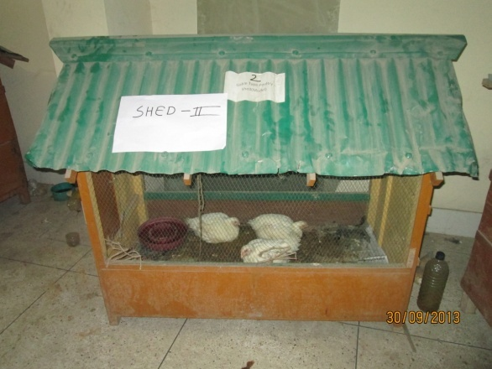

Figure 1: Shed of experimental broiler

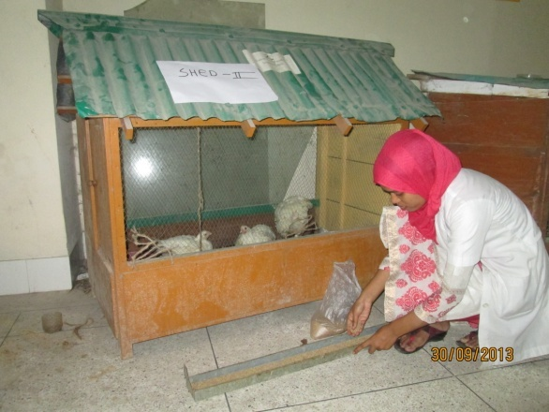

Figure 2: Feed was given in feeder
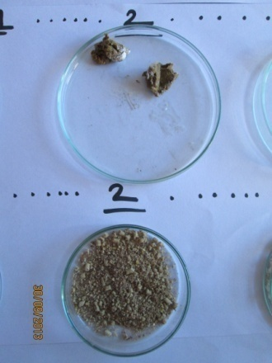

Figure 3: Feed & fecal sample

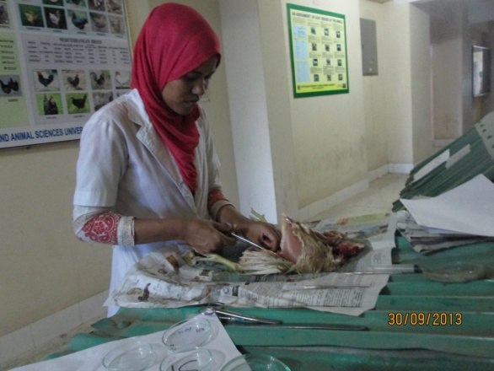

Figure 4: Postmortem of broiler
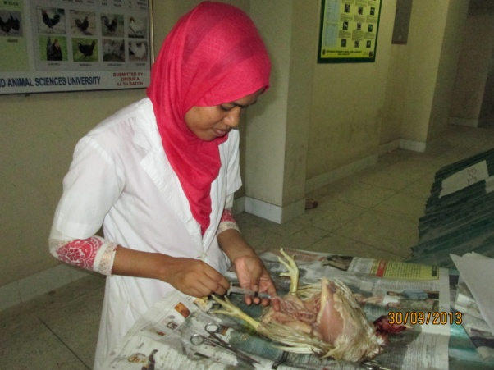

Figure 5: Collection of intestinal fluid
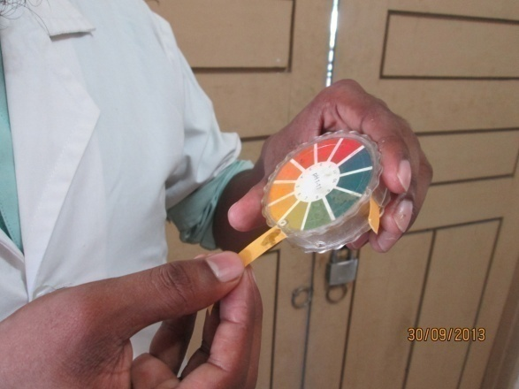

Figure 6: Measurement of caecal fluid ph

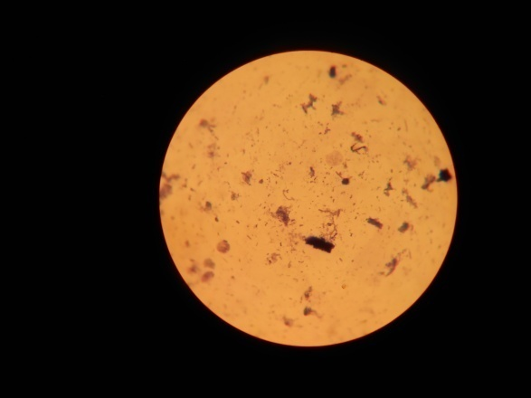

Figure 7: Caecal microbial colony under microscope

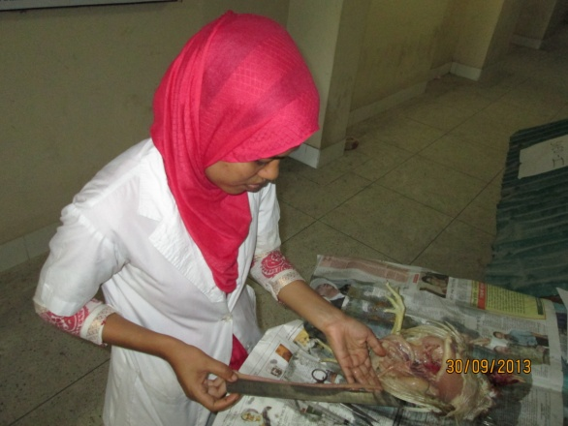

Figure 8: Intestinal lenth measurement

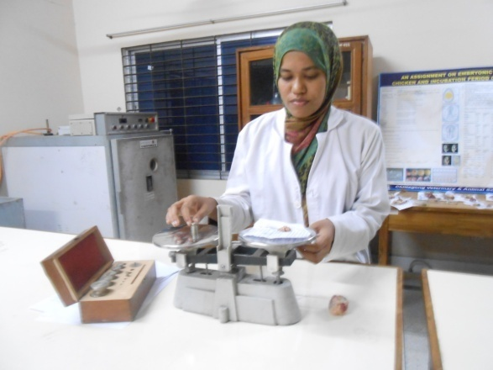

Figure 9: Organ weight by balance
RESULTS

- Table 3: Microbial load (caecum),consistency (faeces & digesta), ph (colon & caecal fluid)
Parameter | Observation
Microbial colony (caecum) | 359 colonies (30 focus)
Consistency of digesta | sticky
Color of digesta | Blackish
Consistency of faeces | Good
Average Ph of caecal fluid | 6.67
Average Ph of colon fluid | 7.3

In sample, fed with sawdust diet caecal microfloral colony under the microscope was 359 colony under 30 focus .Consistency of digesta was sticky, color was blackish, consistency of faeces was good. Average ph of caecal fluid was 6.67,colon fluid was 7.3.

- Table 4: weight of Gizzard & Liver
Organs Weight | Gizzard | Liver
Sample (a) | 39.3 gm | 32.4 gm
Sample (b) | 38.6 gm | 33.1 gm
Sample © | 39.1 gm | 32.5 gm
Average | 39.0 gm | 33.0 gm
In sample, fed with sawdust diet, average gizzard weight was 39.0 gm. Average Liver weight was 33.0 gm.

DISCUSSION

In the present experiment, average ph of caecum fluid was 6.67,which is 0.09 less than the normal ph of caecum (6.76,encyclopedia),which is near to normal. After staining of caecal fluid microfloral colony was 359 colonies under 30 focus. We observed different colony of gram(+)&gram(-) bacteria.

Wyatt G.M. et al., (1988) concluded that caecal and colonic enlargement is due to tissue hypertrophy in response to increased bulk of contents. . All polysaccharide-containing diets led to enlargement of the caecum and colon, associated with increased weight of contents, and of tissue. The density of bacteria in the caecum and colon varied significantly with diet. Zemak, B.F. B.J. Kosikova, J.Augustine and D.joniok,(1979). Sawdust have antibiotic properties like lignin component. Inhibiory effect of compond were studied on model cellulose of bacteria, yeast,yeast like microorganism and mould.

Average weight of gizzard& liver was 39.0 & 33.0 gm respectively, Dietary fibre level had no effect on gizzard weight of Leghorns, while broiler gizzard weight was significantly increased.(Summer,J.O.et.al.,1986).Normally average gizzard & liver weight are 36.0,30.0 gm respectively(encyclopedia).
CONCLUSION

The result of the experiment shows that sawdust can be used in broiler ration as unconventional feed ingredients. Although the above parameters are varied in different breeds, saw dust, the unconventional feed ingredients can be utilized by treatment to stimulate the gut function. During scarcity of conventional feed ingredients it can be used to fill up gap and to minimize the feed cost.

It is concluded that consumption of saw dust may have commercial application in poultry diet to improve nutrient digestibility and production performance.

REFERENCES

A. Adebayo, T. A. M. Awoniyi and A. H. Akenroye (2009). Growth performance and meat wholesomeness of broiler chickens reared on different types of litter materials. Journal of Food, Agriculture & Environment, Vol.7 (3&4).

AM Amerah, V Ravindran, RG Lentle, DG Thomas (2007) Effects of fibre source and whole wheat inclusion on the performance, starch digestibility and gut parameters of broiler chickens, Asia Pac J Clin Nutr, 16 (Suppl 3): S59.

A. N. Bhattacharya and J. P. Fontenot (1966). Protein and Energy Value of Peanut Hull and Wood Shaving Poultry Litters. J. Anim Sci. 1966. 25:367-371.Anon (2000). Poultry International. August 2000, P-10.

B. L. Damron, S. K. Williams and A. R. Eldred (2001). Unhydrolyzed Vegetable Sucrose Polyester in Broiler Diets. Poultry Science 80:1506–1508

B. Tamir and W. Tsega (2009).Effects of different levels of dried sweet potato (Ipomoea batatas) leaves inclusion in finisher ration on feed intake, growth, and carcass yield performance of Ross broiler chicks. Trop. Anim. Health and Prod. Vol. 42, Num. 4, 687-695, DOI: 10.1007/s11250-009-9476-7.

C. D. Bennett, H. L. Classen and C. Riddell (2002). Feeding Broiler Chickens Wheat and Barley Diets Containing Whole, Ground and Pelleted Grain. Poultry Science 81:995–1003.

Cummings, J. H. (1973) Dietary fiber. Gut 14, 69-81.

Das, S. C., Chowdhury, S.D., Khatun, M.A., Nishibori, M.; Isobe, N. And Yoshimura, Y. (2008). Poultry production profile and expected future projection in Bangladesh. World's Poultry Science Journal, 64:99-118.

Davis, F. & Briggs, G. M. (1947) The growth-promoting action of cellulose in purified diets for chicks. J. Nutr. 34, 295-300.

Dymsza, H., Boucher, R. V. & McCartney, M. G. (1955) Investigation of crude fiber digestion in 12-week old turkeys. Poultry Sci. 34, 240-242.

E. A. Iyayi and F. K. Fayoyin (2004). Expanding rural poultry production through the use of low cost Cassava fruit coat as alternative fibre source for broilers. Conference on International Agricultural Research for Development. Berlin, October 5-7, 2004.

Ewing, W. R. (1963) Fiber in the poultry ration. In: Poultry Nutrition (5th addition), pp.548-557. The Ray Ewing Company, California.

Fisher, H., Siller, W. G. & Grimminger, P. (1966) The retardation by pectin of cholesterol-induced atherosclerosis in the fowl. J. Atheroscler. Res. 6, 292-298.
FAO (1998). The output of meat & egg of Bangladesh. Food out look, No. 4, Rome, Italy Felton, K.E.(1976).

Gary E. Duke, Practical advancements in Digestive physiology and futuristic Research needs in poultry, J. Appl. Poultry Res. 5:81-85.

Gous, R. M. G.C. Emmans, L.A. Broadbent and C. Fisher 81990). Nutritional effects on the growth and fatness of broilers. Br. Poult. Sci. 31: 495-505.

Grimminger, P. & Fisher, H. (1966) Antihyper cholesterolemic action of scleroglucan and pectin in chickens. Proc. Soc. Exp. Biol. Med. 122, 551-553.

H. Hetland, B. Svihus & M. Choct (2004) Inclusion of dust bathing materials in housing systems for layers can affect performance and functionality.

H. Hetland, M. Choct and B. Svihus (2004). Role of insoluble non-starch polysaccharides in poultry nutrition. World's Poultry Science Journal (2004), 60:415-422.
Heaton, K. W. (1976) Fiber, blood lipids, and heart disease. Am. J. Clin. Nutr. 29, 125-126

Hetland, H., B. Svihus and Å. Krogdahl. (2003) Effects of oat hulls and wood shavings on digestion in broilers and layers fed diets based on whole or ground wheat. British Poultry Science, 44: 275-282.

Hill, F. W. & Dansky, L. M. (1954) Studies of the energy requirement of chickens. 1. The effect of dietary energy level on growth and feed consumption. Poultry Sci. 33, 112-119.

Menge, H., Littlefield, L. H., Frobish, L. T. & Weinland, B. T. (1974) Effect of cellulose and cholesterol on blood and yolk lipids and reproductive efficiency of the hen. J. Nutr. 104, 1554-1566.

N. Kocabagili, M. Alp, N. Acar and R. Kahraman (2002). The Effects of Dietary Humate Supplementation on Broiler Growth and Carcass Yield. Poultry Science. 81:227–230.

National Research Council, 1994. Nutrient Requirements of Poultry, 9th Ed. National Academy Press, Washington, DC.

Oke, D.B. and M.O. Oke, (2007). Effects of feeding graded levels of sawdust obtained from Daniellia ogea tree on the performance and carcass characteristics of broiler chickens. Res. J. Poult. Sci., 1: 12-15.

Quisenberry J. H. (1968). The use of clay in poultry feed. Clays and Clay Minerals, Vol. 16, pp. 267-270.

Rasha M.S. and Khadiga A. A. A. (2007). Effect of Dietary Hyacinth Bean (Lablab purpureus) on Broiler Chicks Performance. Res. J. of Agri. and Bio. Sci., 3(5): 494-497.

S. F. Bilgili, G. I. Montenegro, J. B. Hess, and M. K. Eckman (1999). Sand as litter for rearing broiler chickens. Appl. Poultry Science. Res. 8: 345-351.

Saito, M., Tasaki, L, Kibe, K., Yamada, H. & Igarashi, T. (1959) Effect of various cellulose levels in the diet on the chick growth. Poultry Sci. 38, 373-376.

Schiedeler, S. F., D. Jaroni and U. Puthponsiripon (1998). Strain, fibre source and enzyme supplementation effects on pullet growth, nutrient utilization, gut morphology and subsequent layer percormance. J. Appl. Poult. Res. 7 (4): 359-378.

Setia A. and Mikkelsen L.L. (2008). Book of Abstarcts. Supliment of the World’s Poultry Sci. J. XXIII World’s Poultry Congress 2008.

Snedecor, G. W. & Cochran, W. G. (1968) Statistical methods, ed. 6. Iowa State University Press, Ames, Iowa.

Summer, J.O. and S. Leeson (1986). Influence of nutrient on feed composition, weight gain and gut capacity of broilers, leghorns and turkeys reared to 26 days of age. Anim. Feed Sci. Technol. 16: 129-141.

Tasaki, I. & Kibe, K. (1959) A study on the digestion of cellulose in poultry. PoultrySci. 38, 376-379.

Trowell, H. (1972) Ischemie heart disease and dietary fiber. Am. J. Clin. Nutr. 25, 926-932.

Wyatt, G.M., N. Horn, J.M. Gee and L.T. Johnson (1988). Intestinal microfloral and gastrointestinal adaptation to dietary polysaccharides. Br. J. Nutr. 60: 197-207.

Yang, Y., Iji P. A., Kocher A., Mikkelsen L. L. Choct M. (2008). Effects of xylanase on growth and gut development of broiler chickens given a wheat-based diet. Asian - Australasian Journal of Animal Sciences. November 1, 2008.

