Introduction
Cereals and legumes, the bulk of modern commercial poultry diets, contain a significant amount of fibre. In addition to the fibre from the feed, poultry housed in floor systems are able to ingest litter materials from the floor. Their effects on digestibility, gut functions and bird behavior are largely unknown (Hetland B. et al., 2004)
The current use of highly processed ingredients in poultry diets has negative effects on the development of the digestive tract of poultry. Broilers housed in a litter floor system consume wood shavings, possibly to compensate for the low levels of coarse fibrous materials in their diet. The coarse fibrous nature of wood shaving may improve the development of the gizzard allowing improved nutrient utilization (Amerah, A.M. et al., 2007).
It has been shown that the presence of crude fiber improves growth and feed efficiency and gives beneficial effects on feathering and on protection from cannibalism in chicks (Hetland H. et al., 2003, Davis F. et al., 1947, Hill F. W. et al., 1954, Saito M. et al., 1959). However, crude fiber is poorly digested in poultry (Dymsza H. et al., 1955, Tasaki I. et al., 1959). Indeed, insoluble fibre itself has shown beneficial effects on nutrient digestion and gizzard activities (Hetland et al., 2003; Rogel et al., 1987). Recently, it has been reported that dietary fiber may have protective effects against accumulation and lipid metabolism in the certain diseases in humans (Trowell H. 1972, Cummings J. H. 1973, Heaton K. W. 1976) and growing chicks, atherosclerosis induced by increased serum cholesterol concentration in chicks (Fisher H. et al., 1966, Grimminger P. et al., 1966, Menge H., 1974). Gizzard stimulation using wood shavings improved starch digestion and the performance of broiler chickens (Amerah A.M. et al., 2007).
Poultry meat is an excellent source of protein and other nutrients. Due to improve digestibility, broiler meat is now worldwide accepted food for all kind of people. Poultry farming provides not only economic benefits to the poor farmers but also help to improve the health of their family. Approximately 20% of the protein consumed in Bangladesh originates from poultry (Das. et. al, 2008).
According to FAO statistics, Bangladesh produced 104000 tons hen eggs and 111000 tones chicken meat giving world position of 46 and 52 respectively in 1998. The latest information available from Poultry International Anon, (2000) also showed that per capita poultry meat and egg consumption is around 1 kg and 20 eggs/respectively. This data clearly indicate that the availability of poultry meat and egg is still very much lower in Bangladesh in spite of the significant development in the commercial poultry sector during the last 10 years.
By increasing the productivity of poultry meat and eggs, the existing gap between supply and demand of animal protein can be ridged. Though presently only 15% of the total poultry products are coming from commercial farms, poultry industry has established its position as the fastest growing segment in the agricultural sector. Profitable poultry farming is a highly specialized job in which a lot of factors may be responsible to offset the profit amount (Khan et al., 2008).
The most possible ways of improving the profits are increasing the output or reduce the inputs. Feed is the single; largest input in poultry farming, constituting about 60-70% of the production costs. The ideal approach will be to derive maximum benefit out of this single input.
While predicting future needs is risky, it is very likely that the human population will increase substantially in the next twenty years. Agricultural production is declining or stabilizing in many areas, so competition for food resources will increase. Poultry and livestock will be competing with humans. Producers may be forced to use poorer quality feed ingredients for animals than are currently in use. Research on the practical use of ingredients such as cellulose, uric acid, and chitin should be undertaken (Gary E. Duke, 1996). Hunter et al. (1981) stated that the main value of wood shavings appears to be as a source of dietary fibre.
Bangladesh is by mid 2008 classified as a low income country, i.e. with a GINA per capita of US $ 450 in 2006 below the cutting line of US $ 935 (World Bank, 2008). Its population is more than 144 million in 2006 places it as the seventh most populous country in the world (Xist, 2008). The economy of Bangladesh is agro based. About 21.77% of Gross Domestic products (GDP) come from agriculture sector of which livestock alone share 7.23%. (BBS, 2005-2006)’Bangladesh have 24.7 million cattle, 0.86 million buffalo, 1.34 million sheep and goat, 195 million poultry (DLS2006). About 89% of rural households rear poultry and average number of bird per house is approximately 6.8 (The Bangladesh Census of Agriculture, 1996).

Broiler production in Bangladesh is increasing day by day. The higher price and non-availability of feed ingredients are two major limitations to the growth of commercial broiler enterprises. The feed cost alone accounts 60-70% of total production cost and the broiler farming requires quality feed at reasonable cost to make farming profitable (Bulbul and Hossain, 1989). Therefore, it is imperative to explore cheaper locally available feedstuff to reduce feed cost. About 80% feedstuffs used in poultry ration are being imported. As a result, the cost of feed prepared for poultry using those grains stand high. Computing feed with conventional feed ingredients available hardly permits profitable poultry production.
Now attention is, thefore being focused on cheap but suitable alternative feedstuff, especially crop residues and industrial by product, to sustain livestock industry (Al Hassan, 1985).The evaluation of unconventional feed resources alongside other strategies would reduce pressure on the demand for conventional feed ingredient and accelerate the attainment of feed security for poultry. (Fajimi et al; 1993).For this purpose wood shaving can be used as unconventional feed resources for livestock. This study was undertaken to investigate the use of untreated softwood in broiler diets. Studying this effect on growth and digestibilities where as to estimate the cost effectiveness of the diets.

Objectives of experiment
-To assess the effects of wood shavings on digestive function (consistency of faeces and digesta, color of digesta of broiler).
- To find the effects of wood shavings on p^{h} of caecum and colon fluid, weight of liver and gizzard.
-To detect the microbial load in caecal fluid in wood shavings diet.

Review of literature
The following literatures were reviewed related to experiment undertaken and parameters that were studied.
Iyayi E.A. et al., (2004) have investigated the replacement value of a by-product of cassava harvesting–cassava fruit coat (CFC) meal for wheat bran (WB) for broiler production.
Daily feed consumption was non-significantly reduced with increasing CFC meal levels. Daily weight, feed conversion ratio and efficiency of feed utilization were significantly (p<0.05) reduced with more than 50% level of CFC meal. Increasing levels of CFC meal had no significant effect on the carcass measures except the meat: bone ratio which was significantly (p<0.01) reduced.
The weight of liver was significantly (p<0.05) decreased, while those of intestines, kidneys and gizzards significantly (p<0.05) increased. The digestibility (% nutrient retention) of dry matter, crude protein, ash, crude fat and nitrogen free extractives was significantly (p<0.05) reduced by 25, 29, 23, 24, 14 and 25%, respectively with increasing levels of CFC. Results suggest that CFC meal does have a potential for replacing the expensive wheat bran as a fibre source in broiler feeding. High levels (>136.50 g/kg) in the diets of broilers elicit reduced nutrient digestibility, reduced weight and accretion of intestinal and visceral organs.
AM Amerah A.M. et al., (2007) reported that wood shavings increased the relative gizzard weight and, improved ilea starch digestibility and feed efficiency, compared to other dietary treatments. All gut components were shorter in birds given feeds containing cellulose and wood shavings compared to those fed the control and whole wheat diets
B. Tamir et al., (2009) reported that inclusion of dried leaves of sweet potato up to 100 g/kg DM in the finisher ration might be considered as the optimum level of supplementation when chickens are sold on live weight basis, but if birds are sold on eviscerated carcass weight basis, inclusion up to 150 g/kg DM might be economically feasible as it produced higher carcass yield components. Inclusion of dried leaves of sweet potato at the level of 200 g/kg DM resulted in lower daily DMI as compared to chicks in control diet (T1). The daily body weight gain declined when the level of dried leaves of sweet potato in the diet was 150 and 200 g/kg DM.
Inclusion of dried leaves of sweet potato up to 100 g/kg DM did not affect eviscerated carcass weight, and weights of drumstick with thigh and breast meat were not affected by inclusion of dried leaves of sweet potato up to 150 g/kg DM.
Oke, D.B. et al., (2007) have investigated the effects of Wood Shavings (WS) obtained from Daniellia ogea (Ogea) on the performance, carcass characteristics and gut dimensions of broiler chicks. Daily feed intake, weight gain and feed conversion ratio were significantly influenced by the experimental diets. Experimental birds fed diets B, C, D, E and F consumed more feed than the group on diet A, the control (96.57, 118.29, 149.14, 203.71, 194.00, 63.14 g day, respectively). This resulted in the values of the feed conversion ratio of these birds being inferior to the control. Birds on diets D and E had the highest daily weight gain of 27.51 and 28.09 g, respectively. Birds fed diet recorded the least daily weight gain of 20.57 g. The dressing percentage, carcass parts (Neck, Wings, Drumstick, Breast, Back, and Thigh) and gut weights were significantly different.
B. Tamir et al., (2009) reported that inclusion of dried leaves of sweet potato up to 100 g/kg DM in the finisher ration might be considered as the optimum level of supplementation when chickens are sold on live weight basis, but if birds are sold on eviscerated carcass weight basis, inclusion up to 150 g/kg DM might be economically feasible as it produced higher carcass yield components. Inclusion of dried leaves of sweet potato at the level of 200 g/kg DM resulted in lower daily DMI as compared to chicks in control diet (T1). The daily body weight gain declined when the level of dried leaves of sweet potato in the diet was 150 and 200 g/kg DM.
Inclusion of dried leaves of sweet potato up to 100 g/kg DM did not affect eviscerated carcass weight, and weights of drumstick with thigh and breast meat were not affected by inclusion of dried leaves of sweet potato up to 150 g/kg DM.
Bhattacharya A.N. et al., (1966) digestion and metabolism trials were conducted with 10 yearling withers to study the protein and energy value of autoclaved peanut hull and wood shavings broiler litters, when each was incorporated at levels of 25 and 50% in a corn-hay basal ration. Apparent digestibility of crude protein was not significantly different among rations. Crude fiber digestibility of the litter rations was higher than that of the control ration. Dry matter, NFE and energy digestibility were lower for the litter rations and decreased when the litter level in the ration was increased from 25 to 50%. Crude fiber digestibility of the litters was depressed when the level of litter was increased from 25 to 50%. There were no other significant differences in digestibility between kinds or levels of litter. The average apparent digestibility of the crude protein of the litters was 72.5%. There were no significant differences in digestible protein, digestible energy, metabolizable energy and TDN content (dry basis) between kinds or levels of litter. Average values were 22.7%, 2440 kcal. Per kg., 2181 kcal. Per kg. And 59.8%, respectively.
Gous R.M., et al., (2009) reported that broiler chickens given diets high in protein, or choice-fed on a high protein balancer, had much lower abdominal fat contents than those reported in many recent experiments. The values for males were 10.8 g/kg live weight at 56 d at 2.43 kg live weight in one experiment in Scotland and 16.0 g/kg live weight at 42 d at 1.93 kg live weight in another in South Africa. For females the values were 18.8 g/kg live weight at 56 day at 2.15 kg live weight in Scotland and 15.7 g/kg live weight at 42 d at 1.60 kg in South Africa. The content of abdominal fat was, in general, increased by reducing the protein content of the diet or by dilution of the food with oil or starch. It was, in general, reduced by diluting the food with dietary fibre which also reduced live weight gain. The results are consistent with the idea that chickens attempt to control their food intake so that they achieve a particular fatness. This level of fatness differs between the sexes and between degrees of maturity.
Summer J.O., et al., (1986) concluded that broilers gained more weight, but had a poorer feed: gain ratio than did turkeys, while the Leghorns were vastly inferior. Higher dietary fat levels markedly increased weight gain of the broilers, while the turkeys and Leghorns were little affected. Higher levels of dietary fibre reduced linearly the body weight gain of the broilers and turkeys, but only at the 30% level of inclusion was weight of the Leghorns reduced. Of the three species Leghorns had the largest gut size per unit body weight, while the broiler was significantly larger than the turkey. Dietary fat level had no effect on gizzard weight of Leghorns, while broiler gizzard weight was significantly increased and that of turkeys significantly reduced with increased fat levels. Higher dietary fibre levels increased gizzard weight for all three species. Increased dietary fat levels increased intestinal weight, while increased dietary fibre decreased intestinal weight for all three species. However, while intestinal length per unit body weight differed between species, it varied little with changes in dietary fat level.
Wyatt G.M. et al., (1988) concluded that caecal and colonic enlargement is due to tissue hypertrophy in response to increased bulk of contents, irrespective of the nature of that bulk which varies with diet; it is unlikely that short-chain fatty acids or other microbial metabolites are the stimulus for the tropic response seen when non-digestible dietary polysaccharides are fed to rats. All polysaccharide-containing diets led to enlargement of the caecum and colon, associated with increased weight of contents, and of tissue. Carboxymethylcellulose (CMC) had the most marked effect and animals given this also had watery faeces. The density of bacteria in the caecum and colon varied significantly with diet and the proportion of aerobic bacteria in the flora was increased by the CMC diet. In vitro, CMC and hydroxypropylmethylcellulose were poorly fermented. There was a high correlation (caecum r 0.93; colon r 0.94) between tissue weight and wet weight of organ contents but no correlation with bacterial density, number of bacteria per organ, moisture content or short-chain fatty acid content.
Quisenberry J. H. (1968) reported that dietary clay supplements are used as binding and lubricating agents in the production of pelleted feeds. They are effective as calorie extenders and effective ones are estimated to be worth approximately calories of metabolizable per gram. The high-swelling and water absorbing capacity of some betonies make them attractive dietary additives for control of wet droppings in caged layers. Continued research on ways of maximally utilizing clay products as feed additives seems warranted.
Bilgili S. F. et al., (1999) broilers reared on sand had significantly greater male body weight and feed consumption than birds reared on wood shavings in Trials 1 and 2. No differences were found in mortality, female body weight, feed conversion, foot pad lesions, or carcass quality between the treatments in any of the trials. No significant differences were detected in chilled carcass yields on sand had significantly lower fat yields than buds reared on wood shavings pens in Trial 3. However, birds reared. Coli forms and aerobic plate counts were significantly lower for sand pens than for pine. No significant differences were found in litter temperature, moisture, and ammonia production rates between the treatments.
Rasha M. S. et al., (2007) conducted experiment to determine the effect of decorticated Hyacinth bean on the performance of broiler chicks and some blood parameters. The results of the experiment indicated that dietary treatments had significant effect on feed intake, weight gain and feed conversion ratio (FCR). Inclusion of Hyacinth bean in broiler diets resulted in reduction in feed intake and weight gain. Moreover, the treatments had no effect on dressing percentage. Rickets occurred in 12.5%of birds fed 10 and 15% Hyacinth bean Supplementation of Hyacinth bean in broiler diets had no significant effect on serum calcium and total serum protein. However, the treatment had significantly decreased serum phosphorus and bone ash.
Mokhtar S. Radwan (EL-Fayoum, Egypt), The chemical analysis of wood shaving was: crude protein (2.53), Either extract (0.76%) ,NFE (24.53%), Crude fibre (60.25%), Ash (1.86%), those for dry matter digestibility coefficient were 72.6%, 62.0%, 71.8% and72.2% and those for organic matter were 73.8%, 63.8%, 72.4% and 72.0 % respectively. Oluyemis J.A. and F.A. Robert, (2000) said, Fiber levels as low as 1-2% and as high as 9 %( Hauseretal, 1945), have been recommended for growing broiler. Young bird can tolerate dietary fiber contain of 13% and 15%respectively for efficient functioning of their alimentary tract (Sainsbury, 1980). (Abdelsamie et al; 1983) reported that increased fibre content of diets led to increase in weight and length of gastrointestinal tract. Zemak, B.F. B.J. Kosikova, J. Augustine and D. joniok,(1979). Wood shaving has antibiotic properties like lignin component. Inhibitory effect of compound with guaiacyl and syringyl structure representing the structure of native lignin; were studied on model cellulose of bacteria, yeast, yeast like microorganism and mould. Lignin composed exhibited the inhibitoriest effect on growth of the studied microorganism.

Materials and Methods
The experiment was conducted under 3 broiler chickens (same age, same weight app: 1200g and healthy chicken)
The chicken were purchased from local market and divided randomly by 3 numbers a,b,c respectively.
- Cleaning the housing:
Necessary cages were made by tin, wood and wire net. Brush was used to remove the dust and dirt and any kinds of unexpected material. We changed 3 times the litter material to prevent the coccidiosis.
- Feeder and waterer :
Adlibitum feed and water was supplied to the bird throughout the experimental period. Fresh clean and cool drinking water was supplied all times in drinker. For each cage given one feeder and one waterer. Before giving these cleaning and washing were done. Morning and evening we changed the feed and water.
- Sanitation: Proper hygienic measure and sanitation program was followed during the experimental period. Clean feeder and drinker was used.

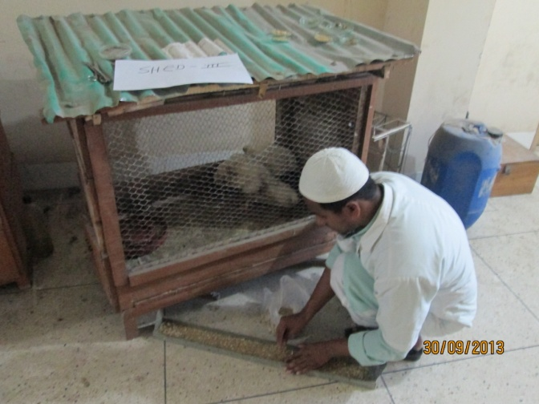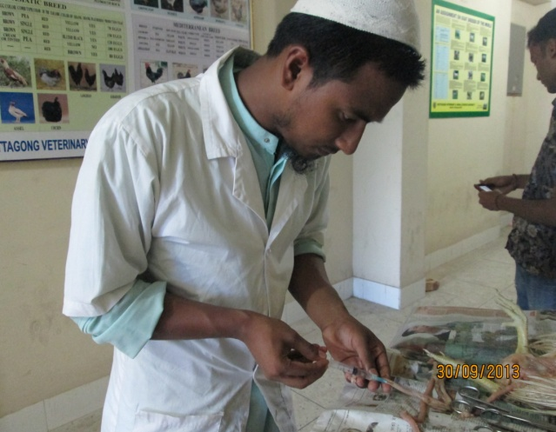
Wood Shavings given as Broiler feed Collection of caecal fluid

Experimental feed:
Basal feed: Aga grower ration (pellet) was given as a basal feed. Added 6% of wood shavings with Aga grower ration. After three days, whole rice was mixed. Wood shavings were collected from a carpenter.
Chemical composition of wood shaving
Chemical composition was used from literature in formulating ration e.g.-
Wood shavings are the main component of particle board. Nutritionally it contain 88.90% dry matter,2.43% crude protein,62.25% crude fiber,0.76% either extract, 10.80%ash,24.53%NFE (Bhattacharya and Fontenot).In addition to wood shavings contain vitamin and phosphorus and mineral. It contain Calcium oil (0.11%) and phosphorus(0.02%)(Richard.S.Adans et al 1997),Research journal of poultry science(2007,).determined the proximate value of Ogea wood shaving , Dry matter( 997.200,Ash(6.40),Crude protein(8.80),Crude fiber(676.10)Either extract(14.70).All values are determined as g/kg dry matter basis.
Richard.S.Adams.Pennstate(1997),reported chemical composition of wood shavings contain crude protein(1.60%), acid detergent fiber(81%), TDN(33%), Fresh wood shavings contain 40-50% dry matter, or kiln dried wood shavings contain 85-88% dry matter. Wood shavings contain fat and lignin component which protect the plant against predators during alive condition.
(Zemak .B.F.B.J kosikova, J.Augustine and Djoniok.1979). Wood shavings have antibiotic like activity which similar to lignin component. Inhibitory effect of compound with guaiacyl and syringyl structure representing the structure of native lignin.
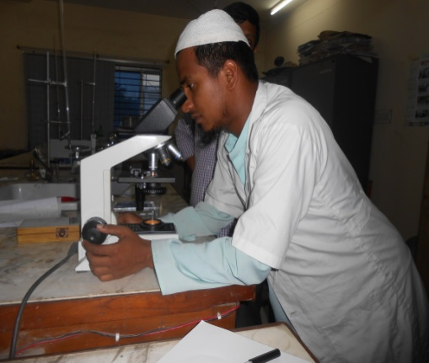 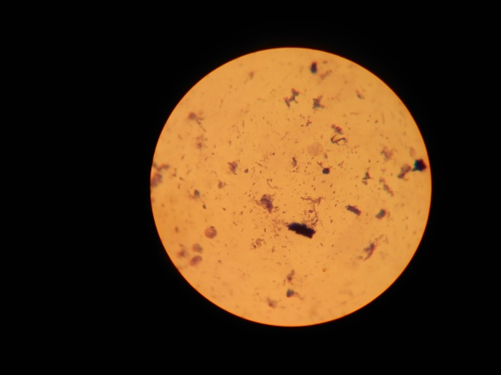Observed the bacterial colonies
Under microscope Bacterial colonies

Results
We observed total 5 days for this experiment. During these days, the chicken was fed all types of feed. In experimental cage the feces color was normal and consistency was watery. After that we slaughtered the Broiler. We separated liver, gizzard, and pancreas from each chicken and given title Sample – (a,b,c).Taken weight for each of the sample separately by using the balance and compared them. We also taken the P^{h} of the content of caecum,colon and were collected the fluid of caecum for knowing the microbial load in the gut by preparation of slide,Giemsa staining and counted the bacterial colony under microscope. We counted different rod and cocci shaped colonies in 30 focuses.
Table 1: Microbial load (caecum), consistency (faeces&digesta), ph (colon&caecal fluid)
Parameter | Observation
Microbial colony(caecum) | 219 colonies (30 focuses)
Consistency of digesta | sticky
Color of digesta | Blackish
Consistency of faeces | Watery
Average P^{h} of caecal fluid | 6.70
Average P^{h} of colon fluid | 7.4
In sample, fed with wood shaving diet caecal micro floral colony under the microscope was 219 colonies under 30 focuses. Consistency of digesta was sticky, color was blackish, and consistency of faeces was watery.
Table 2: Weight of Digestive organs
Organs Weight | Gizzard | Liver
Sample (a) | 35.04 gm | 31.6 gm
Sample (b) | 34.5 gm | 30.85 gm
Sample (c) | 33.9 gm | 31.8 gm
In sample, fed with wood shaving diet, gizzard weight of sample (a,b,c) was 35.04 ,34.5, 33.9 gm respectively. Liver weight of sample (a,b,c) was 31.6, 30.85, 31.8 gm respectively.
Discussion
In the present experiment, average ph of caecum was 6.70, which is 0.06 less than the normal ph of caecum (6.76, Encyclopedia), which is near to normal. After staining of caecal fluid micro floral colony was 219 colonies under 30 focuses. We observed different colony of gram (+) &gram (-) bacteria.
Wyatt G.M. et al., (1988) concluded that caecal and colonic enlargement is due to tissue hypertrophy in response to increased bulk of contents. . All polysaccharide-containing diets led to enlargement of the caecum and colon, associated with increased weight of contents, and of tissue. The density of bacteria in the caecum and colon varied significantly with diet. Zemak, B.F. B.J. Kosikova, J.Augustine and D. joniok, (1979).Wood shaving has antibiotic properties like lignin component. Inhibitory effect of compound was studied on model cellulose of bacteria, yeast, yeast like microorganism and mould.
Average weight of gizzard& liver was 34.48 & 31.41 gm respectively, Dietary fibre level had no effect on gizzard weight of Leghorns, while broiler gizzard weight was significantly decreased.(Summer,J.O.et.al.,1986).Normally average gizzard & liver weight are 36.0,30.0 gm respectively(Encyclopedia).

CONCLUSION
The result of the experiment showed that wood shavings can be used in broiler ration as unconventional feed ingredients to make the ration bulky. Although the above parameters are varied in different breeds, wood shavings, the unconventional feed ingredients may be used by treatment to stimulate the gut function. During scarcity of conventional feed ingredients it can be used to fill up gap and to minimize the feed cost.
It is concluded that consumption of hard or soft wood shavings may have commercial application in poultry diet to improve nutrient digestibility and production performance.

REFERENCES
Al. hassan W.S.1985; The potential of agro-industrial by products and crop resude for sheep and goat production in Nigeria; processing of ruminant product in Nigeria, 1:165-175.
A.O.A.C. (1994), Method of analysis 11th ed; Association of officials Analytical chemistry, Washington. D.C.
Akbar hossain, M.A.S. Chuudhury, M.S.T.T. Islam, D.K. Malakar, and S.M. Iqbal, June 2009, plant diversity of the horticulture farm of BAU with their respective common names, families. Genera, spicies and habit; Bangladesh, agril. Ref (32):189-204.
Athony, W.B. and T.P. Cunningham (1968), hard wood shaving in all concentrate; J. Bhattacharya, and J. P. Fontenot. 1965.
Anim Sci, 27:1159 (Abstrr)
Bulbul.S.M and Hossain.M.D.1989, Probable problems of poultry feed formulation in Bangladesh, Poultry.Advisor, 12(3):27-29
D.A. Dinius and E.E. Williams (1975), wood shaving as a diluent for adapting cattle to concentrate diets, J. ANIM; Vol.4 (NO4).
Fajmi,A.O,g.m.Babafunde,F.F.Ogunlananda.Oyegida.1993.Comparative utilization of rubber seed oil and palm oil by broiler in a humid topical environment; ANIM. Feed Sci.Tecnol,43;177-188.
Ferguson (1942), Saurinen et al ;( 1985) the digestibility of wheat strew and straw pulp, Biological Journal (36), 786-789.
Hunter. R.A. Purser, D.B. and Barron, R.J.W (1981) Digestibility of wood shaving estimated by the nylon, Australian journal, Animal Husbandry,21;52-54.
King, J.D.L. (1984) Ceude fiber in rabbit diet, commercial rabbit 12, 11-19.
Millet, ET. M.A.A.J Baker, W.C. Feist; R. W. Mellen Berger and. D. Satter, 1970; Modifying wood to increase its in vitro degradability, J. Anim. sci 31:781-788.
Mokhtar, S. Radwan, Use of sawdust as a source of fiber in rabbit, Dept. Animal production ,Faculty of Agriculture, Cairouni, Al-Fayoum. Eguypt.
0luyene, J.A. and F. A. Robert 2000, poultrt production in warm wet climate (2nd edi), published by spectrum Books Limited, Ibadan, Nigeria.
Pidgen, W.J. and Bender, 1975, Utilization of lignocelluloses by ruminants. Ruminant nutrition; Selection articles from World Animal Review, FAO, Rome, pp, 30-32
Richard. S. Adams July 1997, Sawdust for Emergency feeding of dairy cattle, College of Agricultural sciences, Pennotate, pp-28902213.
Robertson .J. B. and P.J. Van Soest 1977, Dietary fiber estimation in concentration feedstuffs, J. Anim. Sci.Supp:254 (Abstr).
Savory, C.J. and M.J Gentle ,1976,Changs in food intake and gut size in Japanese quail in response to manuputation and idetaru fiber content,Br.poul.sci;271-280.
Saarine 1958, Investigations on cellulose fodeer, Birch wood, Paperi JA PUV, 40, 495.
Tarkow, H.andW.C.Feist, 1969, a mechanism for improving the digestibility of lingocellulose materials with dilute alkali and liquit ammonia, Adv.Chem, Ser.95-197.
Zemek, B.F.B.J. Kosikova, J. Augustine and.D.Joniok, 1979, antibiotic properties of lignin components, Folia Micro, 24:438-486.
Bulbul, S.M. and Hossain, M.D. 1989, Probable problems of poultry feed formulation in Bangladesh, Poultry Advisor, 12(30:27-29)

