A Report on
Production of organic selenium for livestock’s and poultry
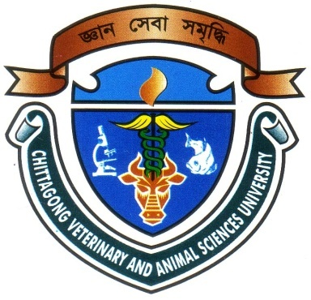

A Production Report Submitted in Partial Fulfillment of the Requirement for the
Degree of Doctor of Veterinary medicine

A Report submitted by

Roll.No:08/31

Reg.No:373
Intern ID NO: C – 21
Session: 2007-2008

Faculty of Veterinary Medicine

Chittagong Veterinary and Animal Sciences University

Khulshi, Chittagong-4202

A Report on
Production of organic selenium for livestock’s and poultry
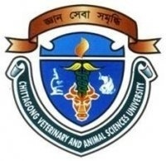
A Production Report Submitted as per approved style and content

------------------------------------------- ---------------------------------
(Signature of Author) (Signature of Supervisor
Chowdhury sultana Sabrina Dr. Gauranga Ch. Chanda
Roll No: 08/31 Professor and Head,
Reg. No: 373 Department of Dairy & Poultry Science
Intern ID No: C-21
Session: 2007-2008
Chittagong Veterinary and Animal Sciences University
Khulshi, Chittagong – 4202

CONTENTS
SL. NO | TOPICS | PAGENO.
01 | ACKNOWLEDGEMENT | 1
02 | ABSTRACT | 2
03 | INTRODUCTION | 3-4
04 | REVIEW OF LITERATURE | 5-7
05 | METHODS AND MATERIALS | 8-9
06 | FIGURE | 10
07 | RESULTS AND DISCUSSION | 11
08 | CONCLUSION | 12
09 | DESCRIPTION ABOUT SELENIUM | 13-17
10 | REFERENCES | 18-20

ACKNOWLEDGEMENT
At the begining, I wish to acknowledge the immeasurable grace and profound kindness of the Allah, the supreme ruler of universe without whose blessings I could not accomplish this report.
It is my great privilege to express my deep sense of gratitude and profound regards to my honorable supervisorDr. Gouranga Ch. ChandaMSc,PhD,MBA,Professor and Head, Department of Dairy & Poultry Science,Chittagong Veterinary And Animal Sciences University, CVASUChittagong for his guidancein planning, conducting and completing the study.The cooperation of ProfessorAshraf Ali Biswas, Head of the Department, Department of Animal Science and Animal Nutrition,CVASU, Chittagong who was also involved in performing this report from its inception to completion.
I acknowledge all the respondents of the study areas and the institutions without whose willingness in providing with the information the study would not be possible to perform.

The Author

ABSTRACT
Selenium yeast ,produced by growing select strains of Saccharomyces cerevisiaein selenium-rich media, is a recognized source of organic food-form Se, but the determination of its exact composition with respect to the Se species present produced confilicting results.Improved methods of analysis have since reveled it to contain 90+ % of its Se in the form of selenomethionine, the principal organic nutritional form of Se for higher animals and humans. Yeast (Saccharomyces cervisiae) also excellent sources of methionine. So yeast media also widely used as a protein source.This study is conducted to know the amount of organic selenium and methionine produced by the yeast (Saccharomyces cerevisiae).Amount of those organic selenium and methionine from yeast media estimated by chemical test. It was found that yeast media contain 3.5% methionine and 2 mg per gm of inorganic selenium. The safety record of Se yeasty is excellent. During the three decades of its world-wide use as a source of supplement Se ,no cases of Se poisoning have occurred due to dosage or formulation errors.

Keywords: Selenium; Selenium yeast; Saccharomyces cervisiae; Selenomethionine; Supplement selenium; Selenium poisoning

INTRODUCTION
Bangladesh is an agricultural based country and its population is too large. Land and life closely entwined in Bangladesh over 80% of th country is 120 million people lives in rural sector and highly depend on agricultural system. Agricultural generated 39% of the GDP and share of the livestock subsector 2.8%(Brammer et al 1996) livestock population and poultry population in our country are 47.51 million and 245.89 million(BLRI, report 2006-2007).There are so many dairy and poultry fare are established. They need various mineral preparation and amino acid for the growth,bone development,feathering,enzyme and structure and function and appetite.They predominantly act as catalyst, in many enzyme and hormone systems(under et al1999).Among the trace minerals selenium is most important mineral for the production and reproductive function of livestock ration which is more safely than in organic selenium. Studies shows that selenium is key supporting normal reproductive function, reproductive status of bull, calf health, stress due to weaning and feed lot receiving,meat quality shelf life and nutritional value of meat.Selenium plays an important role in beef cattle diets organic selenium is produced from the yeast Saccharomyces cerevisiae.Organic selenium is more digestible than inorganic forms and better retained. Which leads the animal build nutrient,reserves against periods of increased demand without risking toxicity.Selenium yeast has received allowance for use in chicken diets,followed by turkey,swine,goat,sheep,equine, beet and dairy feeds and dog diets.
Selenium (se) is both an essential nutrient for humans and animals and a toxicant at excess levels in foods. Its content in animal products reflects that of the feeds consumed. In order to meet Se nutritional requirements, it is a common animal production technology to supplement livestock and poultry diets with selenium,As a consequence, supplemented animals yield animal products (e.g. milk, meat, eggs) with higher Se concentrations. Because of concern about safety of human consumers, the quantities of selenium that can be supplemented to food-producing animals are strictly regulated. Nutritional and safety implications of selenium supplementation in animal production are discussed. Many studies indicate that selenium from organic sources, e.g. from selenium- riched yeasts, is more bioavailable compared to inorganic sources

and results in more selenium deposited in animal tissues. Problems can arise from accidental overdosing or errors in formulation of Se supplements in food-producing animals, which could lead to animal toxicosis and excessive enrichment of se in the human food chain. A study is reported in which the effects of a tenfold over-dose of Se, administered through Se-riched yeast, have been examined on selenium status and on Se deposition in eggs and edible tissues in laying hens.(Donate et al, 2009)
Organic selenium is most important for our live stocks and poultry but the farmers expense huge amount of money to buy these mineral preparation.
Low cost selenium preparation is not available in our country.So it is very important issue to preparing the organic selenium preparation with is low cost.
Methionine is the first limiting amino acid for poultry and livestock. It is also help the poultry and livestock for their body growth, feather formation, eggs production, milk production and reproduction of cattle.But their product those available in market is high price and quality not ensured. So we want to make low cost preparation of organic selenium and methionine.
Objectives of this study:
To established the production method of organic selenium from yeast.

REVIEW OF LITERATURE
Ouerdane, L. et al(2008) reported that, for the first time, a quantitative replacement of methionine (Met) by selenomethionine% substitution, with up to 4940 microgram of SeMet/g of yeast obtained for the entire protein pool of a wild-type yeast grown on a SeMet-containing medium. The incorporation of selenium in yeast proteins, in the form of selenomethionine, and the influence of various organic and inorganic Se and S sources present in the media were monitored during the growth of a wild- type Saccharomyces cerevisiae, which allowed the optimization of the composition of a fully defined synthetic growth medium that ensured maximum SeMet incorporation. Quantitation of SeMet and Met was performed by species-specifie isotope dilution GC-MS. In a medium containing Se(VI),the maximum replacement of Met with SeMet was 50%,which is considerably higher than that obtained with the current commercial Se Yeast formulations. For yeast grown in a Met-free defined medium, which was supplemented with SeMet, nearly total replacement of Met with SeMet could be achieved.
Svoboda, M. et al (2005) reported that the aim of the trial was to determine the efficacy of organic Se from Se-enriched yeast in placental tranfers to piglets in the conditions of a Czech pig farm. In group I (n=8) the sows were fed during gestation and lactation a diet supplemented with inorganic Se (sodium selenite, 0.3 mg/kg of Se for the gestation and 0.38 mg/kg of Se for the lactation diet).In group II (n=8) the diet of the sows was supplemented with organic Se from Se-enriched yeast (0.3 mg/kg of Se for the gestation and 0.38 mg/kg of Se for the lactation diet).Se concentrations in the whole blood, colostrum and milk were higher (p<0.01) in the group of sows fed with the organic Se form.No differences in GSH-Px activities in the whole blood were found between the two groups of sows.The concentrations of Se in piglet tissues (heart p 0.01, muscle p>0.01) were also higher when the organic form was provided. It is concluded that the use of the organic Se from Se-enriched yeast in sows resulted in greater transfer of Se to their progeny, however it did not have a positive effect on the antioxidant system of the organism.
Suhajda, A .et al (2005) reported that under appropriate conditions yeasts are capable of accumulating large amounts of trace elements, such as selenium, and incorporating them into organic compounds. It has been found that introduction of water-soluble selenium salt as a component of the culture medium for yeasts produced by conventional batch processing results in a substantial amount of selenium being absorbed by the yeast. Using a culture medium supplemented with 30μg/ml sodium-selenite added during the exponential growth phase results in selenium-accumulation in the range of 1200-1400 μg/g dried baker’s yeast(Saccharomyces cerevisiae) measured by ICP-AES method. The most important parameters influencing incorporated forms of selenium are pᵸ value and dissolved oxygen level in the culture medium, and depending on these the selenium consumption rate of yeast is 0.40-0.50 mg/g h-1 specific selenium consumption rate was found to be appropriate to obtain selenium-enriched baker’s yeast of a high quality.
Payne ,R .L. et al (2008)reported that A 28-d experiment using 288 Hy-Line W-36 laying hens was Conducted to compare sodium selenite(SS) with Se-enriced yeast(SY).The Se from SS or SY was supplemented into a corn-soybean meal basal diet 0, 0.15,0.30, 0.60 or 3.00 ppm, and the basal diet was formulated to provide 0.82% lysine and 2950 Kcal/kg ME.Each treatment was replicated 4 times with of 4 hens per cage in each replicate. Hen production was assessed daily, and 2 eggs per replicate were collected every 4 d for whole-egg Se analysis. Albumen quality was assessed at 2 egg storage temperatures (7.2 vs. 22.2⁰c) with the eggs collected on d 24 and 28, respectively.
Momose ,H.et al (2007) reported that yeastSaccharomycescerevisiae produced cellular protein with methionine contents as high as 3.6 and 4.3% respectively, when incubated in the presence of methionine. The former strain contained 2.5% methionine even when incubated at 37⁰c in the absence of methionine. Wild strain Y5α, on the other hand, had 1.75% methionine under all conditions tested. Most temperature-sensitive mutants isolated had the same methionine content as the wild streain. It is concluded that the proportion of a specific amino acid, such as methionine, in Saccharomyces cerevisiae protein can be altered by culturing temperature-sensitive mutants at an elevated temperature.
Demirci ,A . et al(1999) reported that incorporation of sodium selenite or sodium selenate into Saccharomyces cerevisiae biomass by continuous fermentation in a medium with minimal sulfur and methionine concentrations. Selenium incorporation was followed by atomic absorption analysis and methylene blue reduction time (MBRT).Continuous fermentation at 0.2 h⁻1 dilution rate and sodium selenite addition gradient up to 0.69 g/l of sodium selenite yielded 1.89 g/l of biomass with 1904 μg of selenium/g of dry biomass. However, MBRT was 0.1 min, which indicated that the majority of selenium was in the inorganic form. On the other hand, continuous fermentation at 0.2 h⁻1 dilution rate and sodium selenate gradient up to 0.28 g/l of sodium selenite yielded 0.76 g/l of dry biomass with 687 μg of selenium of dry biomass, and MBRT was 26 min which indicated a high concentration of organically bound Selenium. Overall, the results indication a se/s ratio of 3:9:1 and a dry biomass/se ratio of 5:5:1 as optimal type Saccharomyces cerevisiae, which allowed the optimization of the composition of a fully defined synthetic growth medium that ensured maximum SeMet incorporation. Quantitation of SeMet and Met was performed by species-specifie for continuous production of organically bound selenium.

METHODS AND MATERIALS
SELENIUM YEAST MANUFACTURE
Yeast (Saccharomyces cerevisiae) was reported as early as 1961 to take up inorganic Se from the culture medium and to convert it into selenomethionine. The biosynthesis of selenomethionine is know to occur in analogy to that of methionine and to utilize.The maximum amount of selenium Selenium yeast of commerce is usually cultured from 500 to 2000 ppm of Se and is indistinguishable in appearance, flavor, odour, microbiological purity and vitamin content from normal dried food yeast. Selenium yeast is produced industrially by methods which may differ in important and which in part are proprietory and /or patented. For a description of some selenium yeast production processes and suppliers. To be marketable as a food, Selenium yeast must meet or exceed the standards laid down by IUPAC for dried food yeast. It is defined as “the whole organism of one individual yeast, or a mixture of several yeasts belonging to the family Saccharomycetaceae, obtained either as a by – product of fermentation processes or by special culture” Dried Selenium yeast must not exceed the upper limits if moisture, ash, lead, arsenic, live bacteria counts and mold counts. Minimum levels are set for nitrogen. Thiamine, riboflavin, and niacin. It is furthermore required to be free of starch and bacteria of the genus salmonella. (@2006 IUPAC, Pure and Applied Chemistry 78, 105-109)

Preparation of yeast culture media:
Required materials:
1.Sugar
2.Wheat bran powder
3.Bread powder
4.Mustard Oil Cake
5.Distilled water
6.Selenium powder

Yeast Culture
According to Demirci,A.,A.L.Pometto and D.J.Cox.(1999),the procedure followed was as follows-
i) At first sugar is dissolved in distilled water and gradually wheat bran powder, Bread powder, Mustard Oil Cake are mixed with sugar solution.
ii) Yeast (Saccharomyces cerevisiae) Culture are inoculated into the prepared media.
iii) Few amounts of Selenium powder (obtained from the sample of the experimental laboratory) mixed with yeast media.
iv) The growth of Saccharomyces cerevisiae are observed by direct microscope; it was find that full growth of yeast required 21 days.

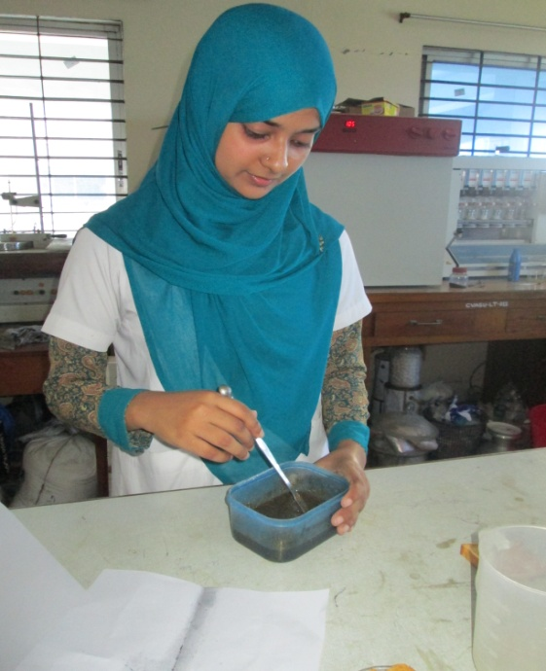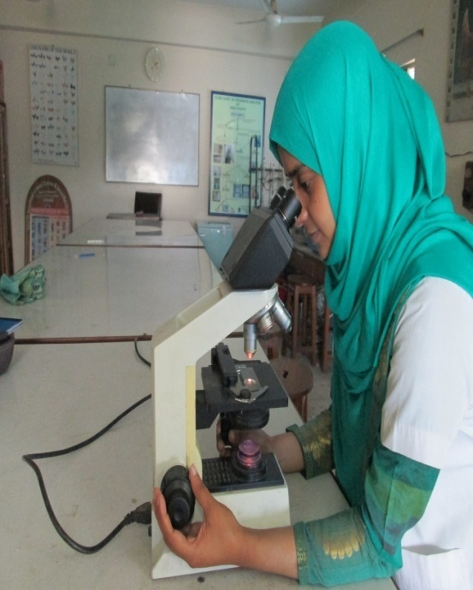
Figure: Preparation of yeast culture media Figure: Microscopic observation of yeast.

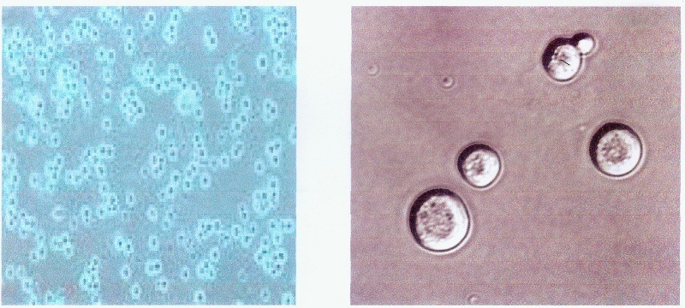

Figure: Saccharomyces cerevisiae under the microscope

RESULTS AND DISCUSSION
The yeast Saccharomyces cerevisiae was grown in the inorganic Selenium richedmedia.After testing the media we stimated that this media contain 16.169 mg/gm of organic Selenium.
According to Suhajda ,A., et al (2005) the Selenium yeast produced 1.2 mg- 1.4 mg per gm yeast media. My finding result is higher than this. It may be due to variation of culture media and strain of Saccharomyces cerevisiae, and other production procedure.

SELENIUM YEAST SAFETY:
Whereas pure selenomethionine is a toxic substance, I g of which taken orally could be fatal to an adult, selenium yeast poses no comparatively serious threat since, to obtain the same amount of selenomithionine, approximately I lb of a 1000 ppm. Selenium yeast would have to be ingested. The chronic toxicity of selenium yeast has been reported to be lower compared to sodium selenite in experiment with weanling rats and growing.
However, this is true only for growing young animals, young, growing animals are less sensitive to chronically toxic levels of selenomethionine in the feed only because some of it is continuously removed from circulation and incorporated into newly synthe-sized proteins. Nevertheless, the use of se yeast as a feed additive or se for supplements is always safer than that of sodium selenite, if only because its low concentration safeguards against formulation or dosage errors. Accordingly, the sfety record of Selenium yeast is excellent: In the three decades of its use as a feed additive and in nutritional supplements, no case of accidental se poisoning have been reported. (Larsen at al,2

CONCLUSION
Organic selenium and methionine are the most important nutrient for livestock and poultry but organic selenium is not available in natureal feed items. Some of yeast has capacity to convert the inorganic selenium into organic selenium. The first process of manufracture Se yeast was developed more than three decades ago, Its chemical analysis and especially the quantitative determination of selenomethionine, initially caused difficulties, resulting in claims the Se yeast was poorly characterized and of variable composition. In the meantime, the analytical problems have been largely overcome, and it is now generally agreed that se yeast contains most of its total se in the form of selenomethionine. The application of improved methods of analysis also revealed the composition of Se yeast to be more uniform than peviously assumed. Since selenomethionine is the chief form of selenim in which it enters the food chain, selenium yeast thus is to be regarded as an excellent source of naturally biosynthesized, food-form selenium. The organic selenium and methionine production is not familiar in our country.
Finally, cocerns that the ingestion of selenomethionine may result in the accumulation of selenium to potentially toxic levels in the organism must be judged as unfounded, since ingested selenomethionine is not only incorporated into proteins, but is also continuously released from them by normal catabolic process. But the organic selenium and methionine production from the Saccharomyces cerevisiae is easy and cheapest than other commercial method. Wecan easily able to produce organic selenium and methionine by using the locally available ingredient in our country.Its may be bring good prosphet in our livestock and poultry industries.(Dunlap et al,2000)

DESCRIPTION ABOUT SELENIUM
SELENIUM:
selenium is one of the most interesting trace minerals from a historical point of view. After its discovery in 1817 it was determined to by toxic and carcinogenic to animals. In1957 it however selenium was determined to be dietary essential to animals o protect them from disorders such as liver necrosis exudative diathesis and pancreatic fibrosis. In1973 selenium was determined to add to diets for swine and poultry. Because of this potential toxicity the FAD regulates the inclusion of selenium in animals feeds.
Selenium requirement:
Selenium is often available in multivitamin and mineral supplements. The amount of selenium is listed in micrograms/day, or μg/day. The Food and Nutrition Board of the Institute of Medicine recommends following dietary reference intake (DRIs) of selenium:
- 0-6 months:15 μg/day
- 7-12 months:20 μg/day
- 1-8 years:30 μg/day
- 9-13years:40 μg/day
- 14 and older:55 μg/day
Function of organic selenium:
Selenium has a variety of functions.
- selenium is a trace element nutrient which functions as cofactor for reduction of antioxidant enzymes such as glutathione peroxidase and certain forms of thioredoxinreductase found in animals and some plants (this enzyme occurs in all living organisms, but not all forms of it plants require selenium).
Glutathione peroxidase (GSH-Px) catalyzes certain reactions which remove reactive oxygen species such as peroxide:
2 GSH+ H₂O₂--------GSH-Px----GSSG+ 2H₂O

- Humans and animals require selenium for the function of a number of selenium-dependent enzymes, also known as selenoproteins. During selenoprotein synthesis, selenocysteine is incorporated into a very specific location in the amino acid sequence in order to form a functional protein.
- It helps make special proteins, called antioxidant enzymes, which play a role in preventing cell damage.
- They serve to protect the integrity of cell walls from the harmful and destructive effects of free radicals, which are produced during energy metabolism. This is crucial for the proper functioning of healthy epithelial tissue, such as the reproductive tract and mammary system.
- Selenium and vitamin E are also very important in the functioning of the immune system.

Deficiency symptom:
- White muscle disease (muscular dystrophy) in calves, lambs, and piglets; retained placenta and slower uterine involution after calving in cattle; poor semen quality; oxidized flavor in milk; and poor growth rates.
There is one disease that is consistent in all livestock species, and that is
- Nutritional muscular dystrophy is caused by the deficiency of Se and/or vitamin E and S-containing amino acids. The disease is characterized by degeneration of the skeletal muscles, causing stiff gaits, and other problems.
- Exudative diathesis, which is the accumulation of fluid throughout the body, particularly in the abdomen and feet. This is caused by increased permeability of the capillaries and leakage of fluid from the the capillaries.
- Pancreatic fibrosis, muscular dystrophy may occur.
- With a severe selenium deficiency growth rate is reduced and mortality is i
Too much selenium in the blood can cause a condition called Selenosis. Selenosis can cause loss of hair, nail problems, nausea, irritability, fatigue, and mild nerve damage. Symptoms of selenosis include a garlic odour on the breath, gastrointestinal disorders, and hair loss, sloughing off nails, fatigue, irritability and neurological damage. Extreme cases of selenosis can result in cirrhosis of the liver, pulmonary edema and death.
Benefits for Broiler Breeders:
Selenium is found in every cell in the body functioning in at least 35 different proteins. These proteins include key antioxidants including Glutathione Peroxidase(GHS-Px). Good selenium status and GSH-Px activity is vital for optimal antioxidant function, immunity, fertility and health.

Hatchability:
Fertility and hatchability are of great importance in broiler breeders. Flock managers continually seek to improve these parameters. In commercials trials, increases of between 0.2% and 2% in hatchability have been observed when organic selenium was fed.
Improved Chick Viability:
Organic selenium has been improved the antioxidant statue of the developing chick embryo and chick through 10 days, thereby sparing vitamin E. This manifests itself in improved chick viability.

Effect of organic selenium in both Males and Females:
Commercial layer and broiler breeding operations are constantly striving to maximize the fertility of their flocks. With increasing demand for productivity improvements, consideration needs to be given to the selenium status of the bird to optimize fertility by supplementing with organic selenium that selenium improves fertility, particularly in the stages of lay. Past studies have shown a higher bioavilability associated with organic selenium sources than inorganic sources(Agate et al 2000)
In the female bird, sperm are stored in the sperm-storage tubules (SST). Only between 1-2% of inseminated sperm enter the SST where they are held virtually dormant before release.

The standard decline in fertility as birds age is believed to be, in part due to reduced ability of the female bird to hold sperm in the SST. The conditions within the SST are critical if sperm viability is to be maximized one critical factor is the antioxidant status within the tubules. Until recently, methods for assessing these storage parameters were limited, however , a novel technique, the perivitelline sperm hole assay has been developed allowing a quantification of fertility. Sperm enter the avian ova through the inner perivitelline layer of the germinal disc. By assessing the number of perivitelline sperm holes, a strong indication of flock fertility is obtained. A recent study at the University of Albrta, demonstrated a significant impact on this parameter when organic selenium was added to the diet of hens for a bthree weeks period.

Effects of organic selenium on Fertility in Male birds:
Sperm antioxidant status is dependant on selenoprotein P. This intriguing protein has a dual function in the developing sperm.
1.It functions as an antioxidant.
2. As the sperm matures, selenoprotein P takes on a structural role within the midpiece of the sperm.

The mid-piece is the vulnerable section of the sperm. It contains high concentrations of free radical suscesptible long chain polyunsaturated fats. These fats are present to provide flexibility as the mid-piece drives the sperm tail. Energy generated from this activity results in “Free radicals” production, hence increasing the requirement for antioxidant protection. Sel-Plex meets this required demand for antioxidant protection, ensuring the integrity of the mid-piece.
Impact of organic selenium on feathering:
Feather scores have been consistently improved with the use of Sel-Plex. Seleno
-cysteine, on of the active ingredients of Sel-Plex.Selenocysteine, one of the active ingredients of Sel-Plex, is involved in the development of feathers.
Impact of organic selenium on Early Mortality:
Organic selenium has consistently been shown to reduce chick mortality and this effect is more pronounced when birds are disease challenged.
Heat stress and Vitamin E:
Some flock managers use high levels of vitamin E to improved the bird’s resistance to heart stress. Studies have shown there is a synergistic effect between and organic selenium vitamin E levels improving the bird’s ability to avercome the effects of heart stress.

REFERENCES:
Dunlap,K.,(2000).Effect of feeding organic selenium in diets of laying hens on selenium content .Page-47 .
Sehwarz,K., Foltz,C.M., J. Am. Chem. Soc. 79. 3292(1957).
Schrauzer,G.N., Adv. Food (Nutr. Res. 47.73(2003)
EC scientific committee on food (2003) Opinion of the scientific committee on Food on the Revision of reference Values for Nutrition Labeling. Commission to the European Communities.Brussels (2003).
Blau,M., Biochun. Biophys.Acta49.389 (1961).
Schrauzer,G.N. Med,J., Foods 1.201 (1998).
Korhola,M., Vainio,A., Edelmann,K., Ann. Clin. Res. 18.65 (1986).
Power,R.F., In proc. SDTA 5th Internal. Symp.Pp 89-94. 8-10 May. Brussels STDA.
Demirci,A., Pometto,A.I., Cox, J., (1999) Agric Food Chem. 47.2496.
Suhajda, A., Hegoczki, J.,Janzso,B., Pais,I., Vereczkey, j. (2003) Trace Elem. Med. Biol. 14.43.
Sehrauzer,G.N. McGinness,J.E., (1979) Trace Subst in Environ. Health XIII. 64.
Agric,J.,( 2002 )Food Chem. 48..
Larsen,E.H., Hansen.,M., Paulin,H., Moesgaard,S., MReid, M. Rayman. J. (2004) AOAC Int. 87. 225.
Kaminski,R. Skowronska,A., Boakye,B.T., Tyson,J.F., Uden,P.C., J. Agric. (2004)Food Chem. 52.3761.
Yang,X., Tian,Y., P. Ha. L. Gu. J. Hyg. (1997) Res. 26.113.
Terry,N., Zayed,A.M., Souza,M.P., Tarun,A.S., (2000) Ann. Rev. Plant Physiol. Plant Mol. Biol. 51. 401-432.
Schrauzer,G.N., White,D.A., (1978) Bioinorg Chem. 8.303.
Park.,H.K., Sanders,B.B., Smith,Jr.J.C., Taylor,J.R., Med,J., (1996) Assoc. 276..
Yang,G., Zhou.R., S. Yin. Liu.X. J. Trace Elem. Electrolytes Health Dis. 3.77 (1989).
Spallholz,J.E., and Rafferty,A., In Selenium in Bilolgy and Medicine, Part
A. G. F. Combs. J. E. Spallholz. O. A. Levander. J. E. Oldfield (Eds). pp. 516 -Van Nostrand Reinhold.New York (1987).
Kim,Y.Y., and Mahan,D.C., Anim,J., (2001) Set. 79.942.
Miller, J. K. E. Brezezinska-Selbodzinska, and F. C. MaDsen. 1993.Oxidative stress, antioxidants, and animal function. J. Dairy Sci. 76:2812.
Spurlin, K. M. and J. Spain. 1999. Nutrition and immune function. Proc. AFIANutrition Council: Interrelationship between nutrition and disease. St. Louis,Mo. P. 1
Combs,G.F.Jr.and S.B. Combs.1986. The role of selenium in Nutrition.AcademicPress,Orlando,FL.
FDA.2000.FDA approves food additive petition for selenium yeast.Page10 in FDA Veterinarian Newsletter(July/August)
Forstrom,J.W.J.J.Zakowshi,and and A.L. Tappel.1978.identification of the catalytic site of rat liver glutathion peroxidase as selenocysteine. Biohemistry 17:2639-2644 .
Henry,P.R. and C.B. Ammerman .1995.Selenium bioavailability.Page301 in Bioavailability of Nutrients for Animals.Aminoacids,minerals, and vitamime D
H.Baker, and A.J.Lewis, ed. Academic Press,SanDiego,CA.Hy-Line International.2003.Variety W-36 commercial Management Guide 2003-2005 .Hy-Line international ,West Des Moines,IA.
Kelly.M.P. and R.F.Power.1995.Fractionation and identification of the major selenium containing compounds in selenizedyeast.J.DairySci .78(Suppi 1):237.
Latshaw,J.D. and M.D. Biggert. 1981. Incorporation of selenium Into egg proteins after feeding selenomethionine or sodium selenite. Poult .Sci.60:1309-1313.
National Research Council.1994.Nutrient Requirements of Poultry.9threv.ed.National Academy Press, Washington,DC.
Patton,N.D.2000.organic selenium in the nutrition of laying hens:Effects on egg selenium content, egg quality and transfer to developing chick embryos.Ph.D.Diss. Univ. Kentucky,Lexington,KY.
Roland,D.A.1988.Egg shell problems: Estimates of incidence and economic impact. Poult. Sci.67:1801-1803.
Rotruck, J. T. , A. L. Pope, H. E. Ganther, A. B. Swanson, D. G. Hafeman, and W. G. Hoekstra. 1973. Selenium: Biochemical Role as a Component of glutathione peroxidase. Science 17:588-590.
SAS Institute. 19990. SAS/STAT User’s Guide: Statistics. Release 6.08.SAS Institue.Inc. Cary, NC.
Siske, V. L. Zeman, and D. Klecker. 2000. The egg shell: A case Study in improving quality by altering mineral metabolism- Naturally. Page 327 in Biotechnology in the Feed Industy.Proceedings of Alltech’s 16th Annual Symposium.T. P. Lyons and K. A. Jacques, ed. Nottingham University Press, Nottingham, UK.
Steel, R. G. D. and J. H. Torrie. 1980. Principles and Procedures of Statistics. A Biochemical Approach.2nd ed. McGraw-Hill, New York, NY.
Sunde, R. A. and W. G. Hoekstra. 1980. Incorporation of selenium from selenite and selenocysteine into glutathione peroxidase in the isolated perfused rat liver. Biochem.Biophys. Res. Commun. 93:1181-1188.
Swanson, C. A. 1987. Comparative utilization of selenite, Selenomethionineand selenized yeast by the laying hen. Nutr. Res. 7:529-537.
Wakebe, M. 1998. Feed for chicken and for hen. Japanese patent office, Patent number JP 10023864A2. Jan 27, 1998.
Wilson, J. X. E. M. K. Lui, and R. F. DelMaestro 1992.Developmental Profiles of antioxidant enzymes and trace metals in the chick embryo. Mech. Ageing Dev. 35:51-6

