ABSTRACT

Poultry farming is an emerging industry in Bangladesh. Hygienic poultry production can pave way to better income and sustainable development. Poultry health management is important due to emergence of highly pathogenic diseases like Highly Pathogenic Avian Influenza (HPAI) in different parts of the world. Bio-security measures become vital for better performance and quality of poultry production in competitive world. The latest technological innovations may help adoption of bio-security measures and environment friendly practices in poultry production system. Bio-security policy can be formulated with the participation of farmers. It would give new dimensions towards poultry farming in different clusters in Bangladesh. Moreover, participatory response of poultry entrepreneurs to the programs prioritizing poultry disease investigation, eradication and safe guarding poultry industry would be valuable. There must be research tie up with different Institute regarding production, processing and marketing of poultry products. The study was examined analysis of bio-security practices in Breeder farm. The farm was selected during internship program in Aftab Bahumhuki Farm Ltd, nearest breeder farms of Ctg. District. For achieving the objective set information was collected through a questionnaire by interviewing the farm duty officer & other stuffs. The controlled information was analyzed and conclusion was made for making a sustainable breeder farm.

CHAPTER- I

INTRODUCTION

1.1: Background
Bangladesh is a land of agriculture. Livestock & poultry sector are the most important part of our economy. In our country lots of dairy & poultry farms have been established for last one decade.

Poultry are considered as important source of protein all over the world. The concept of human nutrition has taken as a new dimension and today emphasis has been given on the consumption of high protein and low caloric diet but in reality, shortage of protein especially of animal origin has been severely affected the health of the people of our country. It is obvious that poultry meat and eggs contain high quality proteins and can also be produced more economically than any other source of equivalent quality. Moreover, high multiplication rate of chicken also makes it more important than any other animal protein source.

In Bangladesh, poultry contributes a major share of animal protein. Here, although natural condition is favorable but poultry is mainly produced on back yard subsistence and scavenging method. More than 80% poultry products of our country contributed by rural or back yard farms Livestock census in 1989 shows that 0.3 millions households representing 74.30% of total poultry population covering 73.3 million poultry birds This means that per capita and per family availability of poultry birds are only 0.91 and 5.3 respectively. The estimated availability of animal protein is as low as 9 gms per head per day as against the requirement of 20 gms (Islam and Ahmed, 2003). Again our people get only 1.45 egg per week against 3. Low intake of protein not only affects the physical health but also retards the development of mental faculty of our children (Islam et al, 2002). Poultry farming in Bangladesh have considerable potentiality for providing employment opportunities for our unemployed and young people. Poultry farming requires small spaces and less investment and can be operated in the backyards even in small towns and small farms. Poultry rearing is an old aged practice in Bangladesh. But unfortunately, farmers do not have sufficient scientific knowledge about poultry rearing. Every year about 30% of poultry birds die due to attack of various diseases lack of proper treatment. In addition lack of proper housing, management and care the often die due to attack of epidemic diseases. It is possible to increase poultry production significantly, if technologies like improved breeding, feeding, housing, disease control, sanitary measures and other improved practices could be used properly.

Poultry birds are one of the most susceptible objects of various kinds of diseases. Being reared well housing, feeding, breeding, management, a total flock may die due to by attack open epidemic poultry disease causing heavy economic loss of the farmers. Diseases are transmitted to the poultry farms by various ways. So, it is highly important to prevent and control the poultry diseases by ensuring fruitful measures in order to prevent transmission of pathogens. Thus bio-security has become and integral part of any successful poultry production system that reduces the risk and consequences of introducing an infectious disease. Bio-security means the procedure that reduces the probability of disease out breaks by controlling potential introduction of pathogens. The components of bio-security include management and placement programs, farm lay out, decontamination, pest control and immunization, directly affect productivity and profitability. So preventive measures must be practical, enforceable and cost effective

1.2: Bio-security of Farm

The term frequently used when discussing disease control practices is “Bio-security”. The
Word itself is a compilation of “bio” and “security”. The term “Bio” is from the Greek word “bios” means life. The definition of “security’ means freedom from risk or danger; safety. When combined together as the term “Bio-security” it roughly translates as life free of risk or in other words safety for the living. In regard to poultry; the term can be defined as any procedure or practice which will prevent or limit the exposure of a flock to disease or disease causing organisms or the overall practices and protocols designed to keep disease off the farm.

1.3: Justification of the study
It is a hard fact of the poultry livestock industry that disease within the flocks is a costly and risky business. In fact, it is well accepted that disease accounts for at least 10% of total production costs and the overall costs of outbreaks of specific disease in poultry make devastating reading. The most effective form of protection against disease, especially for livestock farmed under modern production techniques is Bio-security i.e. excluding disease from the farming environment, and this holds the key to successful and profitable farming. The present study will identify some basic problem that are faced by owner of the farm & will also suggest measures for probable solutions. The concerned agency person, policy makers will be benefited from the recommendation of the study. The study will be helpful to chicken meat & egg producers because it will give them insight on the relative profitability of the chicken.

1.4: Objectives of the study
Considering these facts, the present study was carried out to know the present preventive measures undertaken by the farmers in order to keep their birds healthy and disease free, so that they can obtain the maximum profit. The specific objectives of the study were:

- To know the present status of bio-security maintained in breeder farm.
- To find out the problem faced by the farmers in relation to standard biosecurity practices & suggest probable solutions.
- To reduce the cost of production.
- To know how Bio-security affects the production of broiler & Layer chicks.

CHAPTER-II

REVIEW OF LITERATURE

Bio-security is an important criteria to control disease of the farm level in poultry. Major infectious & vulnerable diseases will spread to the farm due to deficiency of bio-security plan. Some of articles on bio-security of breeder poultry farms were studied and few reviewed findings were mentioned below:

2.1: Bio-security

E.Gilinsky, (2006) stated that bio-security as it pertains to poultry farm farms is the protection of poultry flocks from any type of infectious agent, whether viral, bacterial, fungal, or parasitic in nature. Due to the number of birds confined in one place, and the speed at which many infectious agents travel through flocks, outbreaks may have catastrophic results for poultry growers and processors. Bio-security has three major components: 1) Isolation, 2) Traffic Control, and 3) Sanitation.

Isolation refers to the confinement of animals within a controlled environment. Buildings or fences keep birds in, as well as keep other animals (including humans) out.

Traffic Control includes inter-farm as well as intra-farm vehicle patterns.

Sanitation is the disinfection of materials, people, and equipment entering the farm as well as on the farm.

Normally bio-security means protecting of birds from the transmissible infectious micro-organisms like viruses, mycoplasma, bacteria and parasites but some people extent its’ definition to include non-living threats such as mycotoxins.

Hugh Millar, (2004) reported that Disease agents and pests can be introduced to a poultry farm by movement of eggs, birds, people, vehicles and equipment between farms, and by clothing, footwear, aerosols, water, feed, litter, wild birds, biting insects and vermin.

N. L. Tablante et al., (2000) surveyed that a 10 page questionnaire on bio-security practices was mailed to 187 growers on the Delmarva peninsula in October 2000. The growers were selected by three broiler integrators on the basis of flock performance & were classified as cases (bottom 10% performers) & controls (top 10% performers). After two mailing, 71 grower (38%) responded to the survey of which 47 (66.2%) represented good performers & 24(33.8 %) represented poor performers.

T. Tiensin et al., (2004) reported that several measures were taken after the first isolation of HPAI virus in January 2004.Initially all poultry, their products, feed, bedding, waste & manure from infected flocks were destroyed immediately by the veterinary authorities. Culling infected birds in each flock was generally completed 1-2 days after the virus was confirmed by virus isolation. Furthermore, movement of poultry & their products were restricted within an area a 1 to 5 km radius around the infected area.

2.2: Basic bio-securities

Buffer distances
H. Millar, (2006) designed a table for detecting the bio-security buffer distance.

Farm type | Species | Buffer(m)
New farm | Fowl/turkey or other avian species | 1000
Units in large farm complexes | Fowl/turkey or other avian species | 200-500
Farm complexes | Fowl/turkey or other avian species | >2000
Breeder farms | Fowl/turkey or other avian species | 2000-5000
Duck or waterfowl farm | Duck, waterfowl | 5000

2.3: Economic Benefits of Bio-security in Breeder farm

It is a hard fact of the poultry livestock industry that diseases with the flocks is a costly business. Infact, it will accepted that disease accounts for at least 10% of total production costs and the overall costs of outbreak of specific diseases in poultry make devastating reading. For example, an outbreak of Avian Influenza (AI) in Italy in May 2000 cost at least 200 million Euros and caused with death of over 14 million birds. Another example is if exotic Newcastle disease become established in USA. It could cost the poultry industry over $ 230 million a year and result in increased cost of Eggs & poultry to customers.

The vast majority of the cost of disease is actually due to the hidden cost of sub-clinical disease which has infected the stock but for which there are apparent disease IBD infection have shown that the income per 100 birds with evidence of chronic Gumboro infection is 14% less as compared to the income generated by unaffected flocks.

The great challenge therefore for the poultry industry is how to overcome the direct & indirect threat of disease. Basically poultry firmer have the choice of producing more birds at the same cost or producing the same amount of birds but at less cost.

2.4: Bio-security the key to successful disease control
They key to producing the same number of birds at reduced cost is increased efficiency and one of the most significant limiting factors to efficiency and good performance is disease. Hence id disease is prevented or limited, efficiency will automatically rise. The most effective form of protection against disease, especially for livestock farm under modern production techniques is bio-security i.e. excluding disease for the farming environment, and this holds the key to successful and profitable farming. Target & individually relevant bio-security action taken at a practical farm level have the potential to provides real benefit in disease control, which will bring direct returns to individual producer.

2.4.1: Site of the farm

M. Blackwall, (1997) reported that the farm location should be away from other poultry & breeders should be sited at least 5 miles from any commercial farms.
Reuters, (2006) reported that a 3 km or 2 miles quarantine zone has been set up around the village try to prevent the spread of diseases.

M. G. Uddin, et al., (2007) reported that state farm distance should be minimum 300 meters to prevent cross transmission of diseases.

Feed & water supply

D.J. Helm, (2005) reported that the feed clean up spills so as to not attract wild birds or rodents & avoid using pond water, this can spread Avian influenza if the pond is used by infected waterfowl.

2.4.2: Litter

G. Arzey, (2007) .reported that new litter for deep litter during the growth phase of day old & pullet rearing should be accessed from known, reputable sources & stored in a bird-proof location. Wet & dump litter should removed soon or use Ca(OH)_{2.}

S.D. Chowdhurey, (2006) stated that litter should be made infection free & for this the litter should spray without wetting. The waste litter should be destroyed.

2.4.3: Disinfection & hygiene

M. Blackwell, (1997) reported that effective cleaning & disinfection reduces pathogen numbers & the weight of the disease challenge & enhance any bio-security program. It can only achieve with sufficient turn round down time to allow removal of all litter & to satisfy required contact times for disinfection product used prior to restocking.

T.M. Nelson, (2004) suggested that broken or unused equipment & furnishing, dust or fan inlets & ceiling beams, tiny pieces of debris, cracks & joints in boards & dried films of body fluids all provide places for microbes to hide from the effect of a disinfectant.

2.4.4: Vaccination

George Arzey, (2007) said that professional vaccination crews should have their own bio-security code, which should be examined by farmer prior to visit. It is essential that vaccination crews do not visit more than one farm on the same day & that all their equipment is sanitized before the next job.

2.4.5: Sources of diseases in poultry facilities:

J.B. Carey et al.,(2006) reported that

- Diseases may be introduced by people —employees, service representatives, truck drivers, vaccination crews, veterinarians, etc.
- They may be transferred via new poultry —chicks, pullets, breeding males, semen, etc.
- They may arise from previously contaminated and improperly cleaned premises or equipment, wild birds, insects, wind, water, etc.

Following are guidelines for developing standard operating procedures for each potential disease source. These guidelines should be thoroughly understood and practiced by all poultry producers and affiliated personnel.

2.4.5: Spread of Diseases among birds to birds

Human are the most important factors in the transmission of infectious agents of poultry in the context of modern commercial poultry operations. Pathogens may be carried on shoes, cloths, caps, hair and hands. Managers and workers are indirectly responsible for the transmission of pathogens into the farm by mixing sources of chicken or introducing inadequately cleaned equipment. Transmission of avian pathogens mainly occurred by two ways:
- Biological transmission- occurs when the pathogens multiply in the infected most.
- Mechanical transmission- occurs when carries avian pathogens that survive without multiplication objects.
.
2.4.5: Biological transmission

Transovarian transmission: some avian pathogens are disseminated exclusively by transovarial transmission also occurs among pathogens readily transmitted by contact. Examples include Mycoplasma gallisepticum, M. synoviae, reoviruses, Salmonella gallinarum, Salmonella pullorum, EDS viruses. These agents are tranmitted from parents to offspring through the egg over prolonged periods.

Mixing sources of birds: when birds of different sources or ages are mixed, there is an opportunity for the spread disease. Infected carries may appear and still be capable of transmitting avian pathogens to susceptible contacts. Birds can transmit infectious agents for long periods after recovery.

Wild birds: contact between domestic and wild birds may serve as a common source of infection. Influenza virus and Pasteurella multocida (Fowl Cholera) can be transmitted by direct indirect contact.

Vermin: rodents are common carries of S. typhimurium and S. enteritidis. Raccons and oppossums have been incriminated in transmitting P.multocida.

Insects: some avian pathogens replicate in insects for part of their life cycle, e.g. Leucocytozzon sp. Complete one part of life cycle in insect and another part in chicken host. Many files serve as biological vectors for protozoan parasites.
Helminthes and other vertebrates: earthworms serve as transport host for the eggs of the caecal round worm. Tape worms that affect poultry have a specific in vertebrate host such as earth worms, house files, beetles, snails, dung beetles and ants.

Humans: Zoonotic avian infection transmitted from avian species includes Newcastle disesease, influenza, Salmonellosis, tuberculosis etc.

2.4.5: Mechanical transmission

- Insect (biting insect, mosquitoes, and ticks) transmits fowl pox, pasteurella etc.
- Feed- is a major source of paratyphoid.
- Hatchery contamination can be source of bacteria and other organisms.
- Humans’ dead birds, etc. also are major source of avian pathogen.

In addition air born transmission also possible. It is likely that transmission occurs between adjacent houses.
In short spreads of poultry diseases mainly occur by-
- Movement of poultry, people, vehicles and equipment between and within farms.
- Introduction of birds of low or unknown health status.
- Contact with neighbor’s flock.
- Using shared farm equipment and vehicles, which have not been effectively cleansed and disinfected.
- Contact with vermin and wild birds.
- Contamination feed and water.
- Unsatisfactory cleaning and disinfection of vehicles, shades, feeding troughs and other equipment (Defra, 1886).

1
2
3
4
5
Cycle of spread

- Presence of patient/carrier.
- Casual agent able to leave the body of infected host.
- Must survive outside body of host.
- Be taken to vicinity of farm/house.
- Presence of susceptible host to allow entry and multiplication of the organism (pathogens). ( M. M. Amin, 1999).

2.4.6: Elements of disease control

Medication and vaccination have traditionally played a major role in treating diseases but it is now widely accepted that they cannot, in isolation, prevent losses due to disease. Modern farming methods demand an all-encompassing holistic approach. Unless the background challenge from disease organisms can be controlled, and good management practices strictly followed, medication and vaccination alone are not capable of adequately protecting stock. Livestock must be given an environment in which disease and infection is controlled to the point where vaccination and medication can achieve beneficial effects. Bio-security is a key element in this triangle of disease control methods.

Each side of the triangle is essential in protecting the health of the livestock, but each is inter-dependent with the other two sides. It is easy to see how poor disinfection standards – unfortunately the normal condition on too many farms – can undermine vaccination programs or how excessive disease challenge resulting from poor bio-security inevitably overwhelms good management. Whatever the “missing piece” failure of one element will overwhelm the others and losses of production and profits are the result.

Measures for reducing diseases:
- Making a flock health plan by consulting with a vet that includes the basic bio-security measures in the guidance to reduce the risk of disease spreading. Plan should include isolation for new stock and sampling procedures for certain diseases.
- After the above mentioned three points are confirmed, the following to be considered.
- Don’t bring infection to farm or spread it around farm, on cloths, footwear or hands. Clean overalls and footwear must be ware when entering farms. Protective clothing and footwear should be removed and either cleaned and disinfected, laundered or disposed.
- Have pressure washers, brushes hoses, water at an approved disinfectant available. Make sure that they are used by visitors to clean vehicles equipment and boots.
- Ensuring that all records are accurate and up to date.
- Training of stuffs to ensure that they understand Bio-security and strict hygiene is important.
- Strictly limit and control the access to poultry flocks. If possible the site should be fanced with a controlled entry point. Visitors and their vehicles should be limited and as per as possible kept away from the poultry building pastures.
- Wild birds can carry poultry diseases. Minimize contact between poultry and wild birds.
- Keep farm access routes, parking area, yards, building areas and storage areasclean and tidy and well maintained. This helps avoid wild birds and animals being attracted on to the site and entering buildings and stones.
- Keep wild birds, dogs, cats, rodents or other livestocks out of poultry buildings and feed stores.
- Have an active rodents and pest control system in place. Be vigilant for evidence for vermin.
- Supply only clean and fresh drinking water to birds. Wash lines and drinkers must be flushed through and cleaned regularly in the case of birds restricts access to possible sources of standing water used by wild birds.
- Feed bins, hoppers and feedings equipment must be cleaned and maintained regularly. Feed should only be obtained from a mill or supplier who will make available result of salmonella tests on request (Beaumont et al 1994).
- Damaged eggs, dead birds, litter and manure may carry diseases. Disposed of them promptly and properly (Hossain 1999).
- Regularly clean and disinfectant all crates, container and others equipments into different poultry building without having proper disinfection ( Juberi 2003).
- Clean and disinfect all vehicles after each journey. If possible, do not use the same vehicles for transporting birds, feeds, manure and other wastes(Nuotio 1994)

CHAPTER-III

Materials and Methods

3.1: Selection of farm and location:
The Aftab Bahumhuki farm Ltd. was selected during internship program. It is located Bajitpur in Kisorganj district.
.
3.2: Duration of the study:
The duration of the study was 28 October 2013 to 19 November 2013. Regular observation was made during the period to collect necessary data from the selected farms.

3.3: Methods followed in collecting information
At first questionnaire was formed containing some basic questions with a view to extract information regarding management and preventive measures undertaken in relation to the objectives set. Emphasis was given to the key considerations of bio-security like location of the farm, placement of houses, drainage system, garbage disposal, dipping/ food bath, shower system, personal hygienic management, sanitary condition (cleaning, disinfection, fumigation etc), vaccination schedule, entry system (humans and vehicles etc) , water and feed supply, rodents control system followed in rearing etc. The farm was surveyed directly and information were collected by visiting own self and also by interviewing the manager and other employee(s), if any.

3.4: Analytical techniques:
After collection of observational information from the Aftab breeder farm the data were compared to standard breeder farm.

CHAPTER-IV

Strategy of a Standard Poultry Breeder Farm

4.1: Entry of the farm:
Entry of the farm is one of the most elements of maintaining farm bio-security as this is the pathway of transferring diseases by people to the farm. Some important bio-security measures were undertaken were found as follows:

4.1.1: Foot bath:
All personnel should use foot bath on entering the farm. Foot bath is used for disinfection.

4.1.2: Spray room:
All personnel must use spray room on entering the farm to prevent infection into farm that carry from outside of the farm.

4.1.3: Vehicles:
Vehicles, other than service trucks with heavy equipment, should be parked in a designated area away from the poultry houses (30 meters). Ideally, the vehicles will be equipped with a disinfectant sprayer to treat wheels and the vehicles’ cabin mats.

4.1.4: For visitors:
- Visits should be avoided as much as possible. When a visit is necessary, it is important to follow a protocol that will serve a dual purpose: protect the birds on the farm and on other farms, and educate visitors regarding the risks of disease transmission.

- Visitors should be made aware of the risk of disease transmission via traffic of vehicles, equipment and people. A sign reminding people of this risk should be clearly displayed on the farm. A sign-in log including date, time, name (s), purpose of visit, and premise visitor is coming from should be readily accessible.

- Visitors must use the foot bath, spray room on entering the farm.

4.2 Entry of the farm shed:
Entry of the farm shed was also found another important key element to maintain bio-security of the farm. Some important bio-security measures were undertaken were found as follows:

4.2.1: Shower Procedure:

Entering the farm shed
- A shower divides the dirty side (outside of farm) from the clean side (inside of farm). Never move any material from the dirty side to the clean side.
- Remove clothing on the dirty side; use lockers if available; if not, keep all your belongings together on a bench.
- Shower using soap. Wash entire body, including hair.
- Use clean towels to dry off once on the clean side of the facilities and put on farm clothing.
- Never cross back to the dirty side unless you are leaving the farm, and you are willing to take a shower on your way out.
- Employees or visitors’ vehicles should be considered as part of the “dirty side”. Therefore, no one should return to their personal vehicle after showering or if wearing company or farm clothing.
- If bringing lunch on the clean side: a lunch box with hard cover must be washed before going through the shower to the clean side.
4.2.2. Use of separate sandals and dress:
Infection can be transfer by sandals and dress. So all personnel must use different sandals and dress before entering the shed.

4.2.3 Foot bath
Foot bath is used to prevent infectious disease in the farm shed. All personnel must use foot bath on entering the shed.

4.2.4 Use of mask
Mask is used to protect the bird gaining any infection from personnel and also to protect the personnel from birds infection or disease like Avian influenza.

4.2.5 Leaving the farm shed
• Remove farm clothing and place in the laundry container.
• Shower must be taken like entering the farm.
• Use a clean towel to dry off. If you go on the “dirty” side with a towel, do not return the towel to the clean side.
• Put on your personal clothes.
• Exit the building via the “dirty side”.
• In case of power failure; change disposal clothing, boots, hairnet, and wash hands before going on a farm without power (by-passing the showers).

4.2.6: Location of the farm
The farm should be located few kilometers away from dwellings. It should not be located near the main road.

4.2.7: Source of breeding stock:
Having achieved a high standard from the terminal disinfection, it is important that the new stock introduced comes from a reliable source which is trusted to be disease free. If not, all the work carried out with the cleaning procedures will be in vain.

4.2.8: Source of water:
The supply of water must be from safe source. Water should be kept clean, cool and free from pathogens. Chlorination may be used to sanitize a water supply. It helps to control bacteria and also helps to prevent slime and algae build-up in water lines. A chlorine level of 3-5 ppm is recommended at the drinker level. Water analysis, at three month intervals, is good practice to determine the need for treatment.

4.2.9: Hand washing:
Dirty or unwashed hands transfer infection. All visitors to the site should be required to wash their hands before entering. All staff should wash their hands before starting work, after breaks and when changing work activities.

4.2.10: Water Sanitizing
Drinking water can be a potent source and spread of infection. Header tanks and pipelines need to be regularly cleaned and disinfected with a non-tainting disinfectant.
4.2.11: Aerial Disinfection:
Spraying a fine disinfectant mist or fog over birds can help reduce cross infection and secondary infection during outbreaks of respiratory and other diseases. It is particularly of value in preventing secondary bacterial infection (e.g. E. coli septicemia) following a virus challenge such as Infectious Bronchitis Virus.

4.3: Litter Treatment
Problems of Aspergillosis and Coccidiosis other litter-borne contamination can develop rapidly when climatic conditions change. Disinfection of litter by spraying with a safe disinfectant at the rate of 1 litre per 10 m² has been found beneficial in reducing the incidence and severity of these problems.

4.4: Cleaning and disinfecting procedures
Disinfect flock environments on a regular basis. Disinfection reduces the pathogens in the flock environment, which thereby reduces the risk of disease. Disinfecting involves two steps: cleaning and applying a disinfectant. Always clean first. If the area is not cleaned thoroughly, the disinfectant will not work.
- All removable equipment and fittings should be taken out of the building and soaked in clean water in a tank or pit. After a thorough soaking they should be cleaned with a pressure washer. Once all dirt has been removed, they should be soaked in a disinfectant solution at the correct dilution as recommended by the manufacturer. Use an officially approved disinfectant.
- After equipments removal, brush or blow off dust.
- Remove the litter from the site in covered transport after end of the each flock.
- Pressure wash the surfaces of the house with detergent, paying particular attention to air inlets, fan shafts and concrete floors.
- Use the pressure washer on the outside of the fan shafts and air inlets. It is advisable to wash off the dust that accumulates on the roof and in the gutters.
- When the interior is clean, add disinfectant to the water and pressure wash the entire house.
- When the floor is dry, spray the floor and the sidewalls with an approved disinfectant. It is advisable to spray an area of 6 m (20 ft) around the house with the disinfectant solution.
In some cases it may be necessary to treat the house with an insecticide.
Follow the directions on the disinfectant container, and use only the appropriate disinfectant. Disinfectants will not be as effective if they are excessively diluted to cut costs or if they are used improperly. Improper mixing decreases the effectiveness of the disinfectant and increases the probability of a disease outbreak.Sweep out loose dirt, cobwebs, and other loose materials.
Rinse away all organic matter. Allow the disinfectant to dry completely.

4.5: Rodent and wild bird control

Rats and mice can be responsible for the spread of a number of serious diseases on breeder farms including Salmonella infections. Ensure that feed spillages are removed as quickly as possible and that houses are secure from vermin. Use an effective Rodenticide and baiting program for control of rats and mice. Birds can carry infection to farm from other places. So step should be taken to prevent the entry of foreign bird into farm.

4.6: Dead bird disposal

The immediate burning or burying of dead birds is an important part of a good disease prevention program. You should never leave dead birds in the pens, feed rooms or around the poultry house.

Dead birds act as a source of disease that can be spread by rats, mice, dogs, cats, flies, beetles, mosquitoes, free flying birds and insects that may act as carriers of the disease. No single method is perfect for disposal of dead birds, but a method once decided, use it correctly. Methods of disposal may vary from farm to farm and area to area. The two most acceptable methods are described below.

4.7.Incinerators:
A good incinerator is probably the best means of disposal, especially in an area where there is poor soil drainage or a danger of contaminating the water supply. While building or purchasing an incinerator, the following points should be taken into consideration:
- Capacity: Choose a unit large enough, which will take care of expansion needs for the future.
- Cost of Operations: Design an incinerator, which will be cost effective.
- Sturdiness: Make use of special long lasting fire bricks.
- Automatic Controls: Saves fuel cost.
- Location: Locate the incinerator at a place where it will be handy to use but downwind from residences.
- After Burner: An incinerator with an after burner attached should be used to reduce possible air pollution.
4.8. Disposal Pit:
A less desirable but acceptable method of dead bird disposal is through the use of an adequately designed and tightly covered disposal pit.
- This saves labor and at times, it is unnecessary to dig a hole or start a fire each time a bird dies
- Dogs or rodents cannot dig up birds
- It has no noticeable odor if tightly covered
- No fire hazards
- Pit can be used year round
- Birds decompose fairly rapidly without the use of chemicals. A pit 6 ft (1.83 m) in diameter and 6 ft deep (1.83m) is large enough to take care of one 10,000-capacity broiler unit. Contact a local government or agricultural agency to verify that disposal pits are permissible in your area.
4.9. Egg Collection, Handling and Storage at the Farm:

The vital product of the breeder farm, the hatching egg, must be treated with care from egg collection up to dispatch to the hatchery.

Where eggs are collect manually, the staff concerned should only commence the job after thoroughly washing their hands.

The egg storage room should have been thoroughly cleaned and disinfected before lying commences and again at any stage that the room is emptied. The fogging or misting of a suitable disinfectant periodically is an advantage particularly if eggs are stored on the farm for a number of days.

4.10. Hatching Egg Transport:

Before departing from the hatchery for egg collection the vehicle should have been thoroughly cleaned and disinfected, inside and out. On arrival at a farm, the driver should observe any hygiene regulations in place concerning entry of the vehicle to the farm. This is of particular importance when the vehicle is calling on more than one farm on a trip. An ideal situation is to have an access to the egg store from the outside of the farm perimeter, removing the need for the vehicle to enter the farm.

After collection of observational information from the Aftab breeder farm the data were compared to standard breeder farm.

4.11. Hatchery Bio-security:
Careful staff training and supervision is essential to maintain the necessary standards of bio-security within the hatchery.

Ideally, a hatchery should have well defined working areas and where possible the staff should be specific to those areas. Basically the operational areas of the hatchery can be divided into a “clean” and a “dirty” area. “Clean being from egg reception to setting, and “dirty” from hatching to dispatch. Where it is possible to separate staff working in these areas they should wear different colored uniforms.

The cleaning and disinfection requirements in each area will differ, not only in procedures but also in frequency. In many areas there may be the need for a daily, weekly and even monthly set of procedures.

These should be clearly tabulated and documented for the staff, making clear the frequency of the required task and the methods to be observed. The correct use and dilution of chemicals used also needs to be laid down clearly. The staff should always wear full protective clothing, including face visor and gloves when mixing and spraying chemicals. The Health and Safety Data sheets for all products in use should be readily available.

Apart from the detailed attention requirements of specific areas of the hatchery, general attention has to be given to personal hygiene and site security.

All personnel working within the hatchery should change into suitable protective clothing provided by the hatchery on arrival for work. Adequate changing and washing facilities should be provided. Before starting work, after breaks and when changing work activities, staff should wash their hands thoroughly.

As far as site security is concerned, it should be ensured that no visitor is admitted to the hatchery without first registering in the visitor’s book, putting on full protective clothing provided and washing his or her hands. Ensure that the wheels of all vehicles entering the site are sprayed with disinfectant with the equipment provided.

Foot dips or pads should be provided at the entrances to the hatchery and at strategic points inside the hatchery. Clean foot dip containers and fill with fresh disinfection solution and place at each point. Change the disinfectant solution at least twice weekly. Ensure that a Foot dip instruction sign is clearly visible near to each foot dip.

4.12. Chick Delivery:

The chick delivery vehicle is an extension of the hatchery and should be treated as such in respect of cleaning and disinfection. On returning from farm deliveries, the vehicle should be thoroughly cleaned and disinfected, inside and out at a suitable point, preferably away from the main hatchery building. This done, it should be closed and secured in readiness for the next delivery.

4.13. Fumigation:
After end of the each flock fumigation is done. Formaldehyde has been used for many years as an effective fumigant. The environment during fumigation is critical to its efficiency, and these are the points to follow:
- Increase relative humidity to 70-80%.

- Heat house to 21°C (70°F) as formaldehyde gas has a high temperature coefficient.

- Wash down all surfaces or place pans of water in the house, so increasing the relative humidity and gaining maximum benefit from both the gaseous actions of formaldehyde and its condensation into a polymerized form.

- The house should be sealed and left to cool for 24 hours after fumigation, thus promoting uniform condensation.

4.14. Formalin and potassium permanganate:

This method produces a violent chemical reaction that generates considerable heat and releases formaldehyde gas. Use 1 liter formalin per 25m³ (40 fl oz / 1000 ft³) in the ratio of three parts formalin to two parts of potassium permanganate. Because of the violent chemical reaction, never use more than 1.2 liters (2 pints) of formalin in any one container. The container should have deep sides (at least 3 times the depth of the chemicals, with a diameter equal to the height) to prevent the mixture bubbling over. The formalin must be placed on concrete or metal, and not on shavings or any other inflammable material.

4.15. Continuous Bio-security:

Having achieved a high standard of terminal disinfection and placed healthy stock on the farm, this status has to be maintained throughout the growing and production stages of the flock.

There are many opportunities to prevent introduction of infection or cross infection to stock on the farm. Continuous bio-security routines take into account the different disease problems which occur at different stages of production. The following will help to prevent the introduction, incidence and spread of disease.

4.16. Terminal Disinfection Program for Breeder Farms:

Before a new breeder flock is introduced to the farm it is vital to ensure that the premises undergoes a thorough terminal disinfection to prevent the carryover of pathogenic organisms. This can be divided into stages:

• Stage 1 Removal of Equipment and Dry Cleaning
• Stage 2 Water System
• Stage 3 Cleaning and Sanitizing Buildings and Equipment
• Stage 4 Disinfection
• Stage 5 Set-up

CHAPTER-V

Discussion

In the main gate of Aftab breeder farm there are present foot bath and spray room which primarily prevent carrying organism of farm staffs, visitors that is standard one maintained in good breeder farm. Manual spray and disinfection bath is used for disinfect the vehicle that is not well enough. Absence of automatic spray for vehicle is one of the problem of the farm.

Office room of the Aftab breeder farm located inside of the main gate of the farm. It should be located outside of the main gate because many people come to farm for official purpose. It may reduce the microbial load and disease prevalence of the farm.

The wash room on entering the main shed is the standard one that maintained in a good breeder farm. There are present separate wash room for staffs of rearing, laying shed and that is good one because disease causing organism can spread from shed to shed by farm staffs and workers.

The farm staffs and all workers use separate dress, sandals and mask on entering the farm shed that is good for maintaining bio-security in a breeder farm. Present of foot bath on entering the shed is strictly maintained in Aftab breeder farm which is a sign of good bio security practices in a breeder farm.

Water supply of this farm is from safe sources and chlorination is done to sanitize the water that is standard maintained in good breeding farm.

Cleaning and disinfection is important to maintain a good bio-security practices in breeding farm. Cleaning and disinfection of different utensil is done on a regular basis in this farm and after that drying is done properly.

Drainage system is important factor to prevent the spread of organism. The drainage system of the farm is not improved enough to maintain a good bio-security. Rodent and wild bird act as a carrier of many organism. In this farm, there is no such technique to protect the rodent and wild bird. Wild bird can enter the farm easily.

The distance between the two shed is not well enough to prevent the spread of disease from shed to disease. The farm is located nearer to the road. Organism can spread to farm by vehicle, human etc.
The distance of farm and dwelling is much less than standard distance. It has a public health significance.
Proper disposal of dead bird is important to protect the other healthy bird from infection. Disposal of dead birds is done by burial method in this farm. It is standard for maintaining good bio-security practices.

Vaccination is important for immunity against disease. Vaccination schedule maintained properly in this farm.

Distance between sheds in the farm(ft) | Distance of dwelling from the farms(ft) | Distance of road from the farms(ft)
20 m | 100 m | 5 m
Table-1: Distances of farm from shed, dwellings, road etc.

Table-2: Vaccination schedule:

SL. NO. | Age (day) | Age (week) | Name of vaccine | Route
1 | 4 | - | Coccidia vaccine | Water
2 | 6 | - | MA5 | Eye
3 | 8 | 2 | IBD live, ND + IBD killed | Eye & S/C ½ dose
4 | 10 | 2 | ND Live | Eye
5 | 12 | 2 | Reo Live | S/C
6 | 14 | 2 | IB 4/91 | I/O
7 | 16 | 3 | IBD live | Eye
8 | 26 | 4 | IBD live | Eye
9 | 35 | 5 | Reo Live | S/C
10 | 40 | 6 | ILT Live | Nasal
11 | 42 | 7 | (ND+IB) Killed + ND Live | S/C or Eye
12 | 45 | 7 | Fowl pox | Wing web
13 | 50 | 8 | Chicken anemia vaccine | I/M or S/C
14 | 56 | 8 | Fowl cholera (Killed) | I/M or S/C
15 | 63 | 9 | Salmonella (Killed) | S/C
16 | 70 | 10 | IB 4/91 | I/O
17 | 80 | 12 | Coryza (Optional) | I/M or S/C
18 | 84 | 12 | Fowl cholera (Killed) | I/M or S/C
19 | 91 | 13 | Salmonella (Killed) | S/C
20 | 98 | 14 | AE + Pox | Wing web
21 | 100 | 15 | ILT Live | Nasal
22 | 105 | 15 | Coryza (Optional) | I/M or S/C
23 | 112 | 16 | ND+IB killed+MA5(IB Live) | Eye & S/C
24 | 126 | 18 | EDS Killed | S/C
25 | 147 | 21 | ND + IB + IBD + Reo Killed | S/C
Note: 1. IB, ND Lasota Live vaccine to be given every 4 weeks depending on flocks and field condition.

2. It is not practical to recommend a specific vaccination program for poultry in all areas. This is a suggested vaccination schedule, it can be changed depending on prevalence of disease and flock condition.

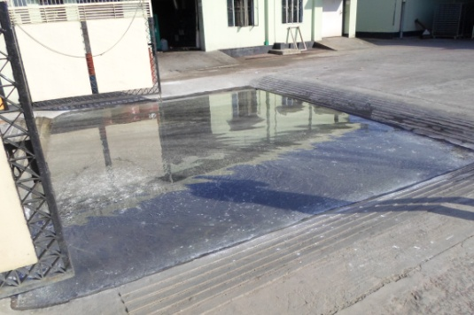

Fig: Water bath in Main gate.

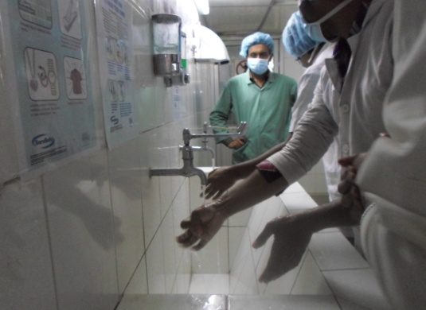
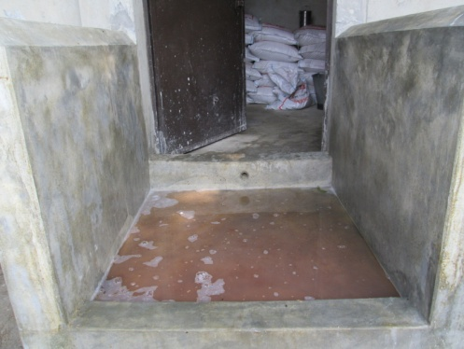

Fig: Water bath before entrance of shed.

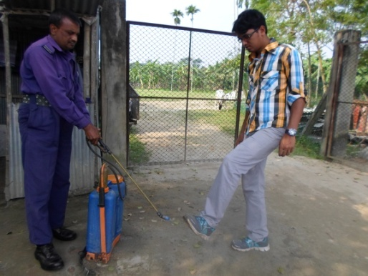

Fig: Hand Fig: Manual spraying under shoe of visitors.
Washing.

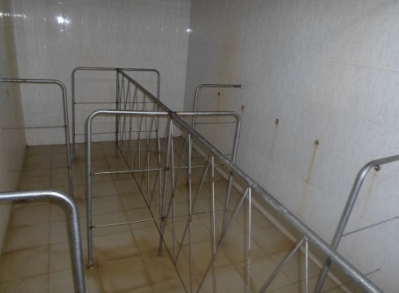
Fig: shower room.

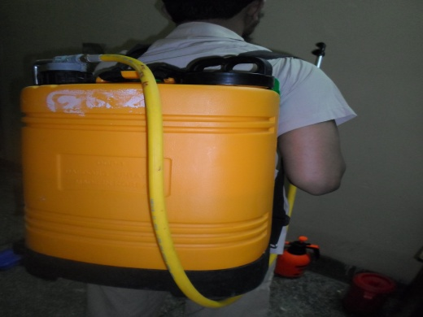
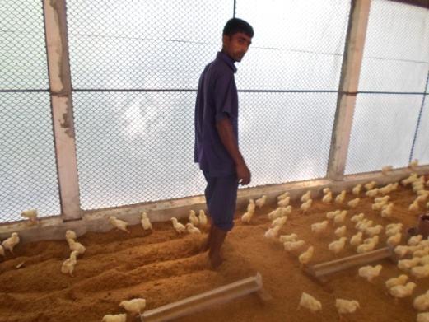
Fig: Disinfectant sprayer. Fig: Litter management.

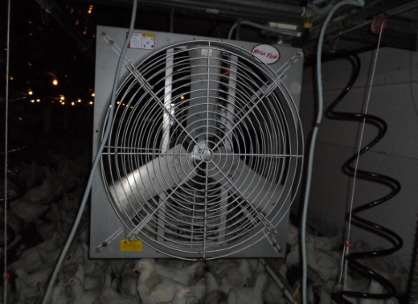
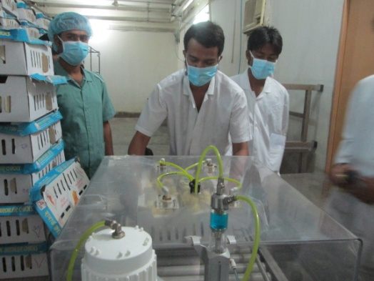
Fig: Exhusting fan for removal of Fig: Spray vaccination in DOC.
NH3gas.

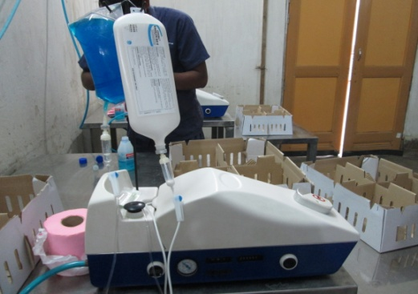
Fig: Manual vaccinator of individual chick.

CHAPTER-VI

PROBLEMS, SOLUTION & LIMITATIONS

6.1. Identified Problems:

- Lack of knowledge: Most of the staffs having lack of knowledge. For this reason they are facing problems in poultry rearing.
- Lack of extension service: Extension services of Govt. & NGO are not well enough.
- Lack of willingness: Staffs also are not motivating themselves for good bio-security practices.
- Lack of communication: Communication were not well enough to maintain good boi-security practices.
- Lack of skills: Due to lack of knowledge skills were not also developing.
- Lack of experienced manpower: Due to lack of knowledge & skills there are sort of experienced manpower.

6.2. Measures suggested for Solution:
The problems that are occurring due to lack of bio-security can be solved by the following possible ways.

6.2.1. Measures for stop diseases:
- Making a flock health plan by consulting with a vet that includes the basic bio-security measures in this guidance to reduce the risk of disease spreading. Plans should include isolation for new stock and sampling procedures for certain disease.
- Ensuring that all records are accurate and up to date.
- Training of staffs to ensure that they understood bio-security and strict hygiene is important.

After the above mentioned 3 points are confirmed, the following points to be considered.
- Don’t bring infection to farm or spread it around farm, on cloths, footwear or hands. Clean overall and footwear must be worn when entering farms. Protective clothing and footwear should be removed and either cleaned and disinfected, laundered or disposed.
- Strictly limit and control the access to poultry flocks. If possible the site should be fenced with a controlled entry point. Visitors and their vehicles should be limited and as far as possible kept away from poultry building and pastures.
- Have pressure washers, brushes, hoses, water and an approved disinfection available. Make sure that they are used by visitors to clean vehicle equipments and boots.
- Keep farms access routes, parking areas, yards, building areas and storage areas clean and tidy and well maintained. This helps avoid wild birds and animals being attracted on to the site and entering buildings and stores.
- Wild birds can carry poultry diseases. Minimize contact between poultry and wild birds. Prevent accumulation of standing water and remove spilled feed that could attract wild birds maintain buildings to ensure that wild birds do not nest or roost in them.
- Keep the wild birds, dogs, cats, rodents or other livestocks out of poultry buildings and feed stores.
- Have an active rodents and pest control system in place. Be vigilant for evidence of vermin.
- Supply only clean and fresh drinking water to birds. Water lines and drinkers must be flushed through and cleaned regularly in the case of free range of birds restrict access to possible sources of standing water used by wild birds.
- Feed bins, hoppers and feeding equipment must be cleaned and maintained regularly. Feed silos and containers must be sealed to prevent animals and wild birds contaminating feed.
- Feed should only be obtained from a mill or supplier who will make available results of Salmonella tests on request (Beaumont et al., 1994)
- Damaged egg, dead birds, litter and manure may carry diseases. Dispose of them promptly and properly (Hossain, 1999)
- Clean and disinfect all vehicles after each journey. If possible, do not use the same vehicles for transporting birds, feed, manure or other wastes (Nuotio, 1994)
- Regularly clean and disinfect all crates, containers and other equipments before and after use. Do not move any equipments into different poultry buildings without having proper disinfection(Jubery, 2003)

6.2.2 Decontamination and disinfection of poultry houses:

Decontamination is the process of physically removing biological or inorganic material from surfaces of a building or equipment. Disinfection is the destruction of pathogenic organisms that may be adherent to surfaces of buildings or equipments or that may be present in biological material. This two processes are complementary and should be carried out sequentially to destroy pathogens. Decontamination and disinfection are required between production cycles to destroy residual bacteria virus and fungi that may infect the subsequent flocks. It is also necessary to remove pathogens from equipments or clothing to prevent transfer between sites (Simon, 2004)

Complete decontamination of houses and their surroundings between successive flocks contributes to optimum livability and growth. With complete replacement of litter the following procedure should be followed.
The surface of litter should be sprayed with a carbonated insecticide to reduce the level of litter beetles the insecticide should make contact with the lower sidewalls of the house to destroy beetles migrating from the litter into in solution.
- Litter should be moved to the center of the house.
- Litter should be covered and transported from the farm to a remote area for processing.
- Loose equipments should be disassembled and components removed from the house for cleaning and disinfection.
- All electrical units and motors should be sealed after removal of dust.
- The house should be swept to remove residual litter and debris.
- The house should be decontaminated with and approved non ionic detergent solution applied at a pressure of 200-500 lb/sq, in using a concentration consistent with the supplier’s recommendation (Kelly et al., 1995)
- The sequence of spraying the exterior should be roof, exterior walls, drains and service area.
- Remaining feed should be removed from the bulk bin. Feed bins should be decontaminated and allowed to drain and dry.
- The anterior structure and equipments should be rinsed with water and the remaining detergent solutions and slurry should be flushed from the house into the drainage system.
- Time should be allowed for the house to dry.
- The interior of the house should be sprayed with a quaternary ammonium or phenolic disinfectant as per manufacture’s recommendation (Jamaluddin, 1991).
- A 2-5% of carbonated insecticide solution should be sprayed on the ceiling, over the walls and on the floor as a final control for litter beetles.
- Clean shavings should be spread to a depth of 3-4 cm over the floor area.
- Rodent baits should be placed in selected areas of the house.
- Water lines and drinkers should be drained and cleaned. A concentrated chrome solution (1 lt of 6% chlorine per 50lt of water) can be pumped through the drained water lines and allowed to stand for 24 hours. After the lines are cleaned they must be drained and dried (Kelly et al., 1995).

6.2.3. Limitations of the study:
- The study was conducted for 1 month. This period was very short to conduct a study fruitfully.
- Many times staffs were non cooperative.
- Sometimes misleading information was drawn by farmers.
- Staffs tried to hide their fault so sometimes errors might happened during fulfilling the questionnaire.
- Unable to observe the brooding system of chicks.

CHAPTER-VII

CONCLUSION & RECOMMENDATIONS

7.1 Conclusion:

Poultry is a major sub-sector of livestock. Poultry rearing has emerged as an integral part of agribusiness of the farming community in Bangladesh. It is now one of the most prospective sectors for development in our country. It is a quick returnable enterprise that needs relatively small initial investment. Poultry diseases are one of the most important causes for loss in poultry farming. The farmers do not get expected return due to attack of poultry diseases. The diseases often attack in endemic form & a great economic loss to the poultry owners. We all know that prevention is better than cure. Here bio-security is the best protection to act against most of the diseases of poultry & hence check economic loss. For this reason we can easily tell that good bio-security has major role in the best possible control of diseases. A strong bio-security easily reduces the treatment costs & thereby increases profitability of a farm.
In addition to that-

- Bio-security helps to keep out many sorts of exotic diseases.
- The risks of zoonotic diseases can be reduced.
- The overall flock health of a farm can be improved & make better.
- It lessens many extra costs of a farm specially the cost of disease treatment.
- It improves the farm productivity as well as profitability.
- It has a great role in public health.
- Farmers can be beneficial to take protection prior to disease occurrence.

Bio-security measures are the pre-requisite of poultry farming. If the importance of bio-security can be realized & followed properly, producers & neighbours both can be risk free as well as beneficial. So it is of great importance to know the present status of bio-security practiced in commercial farms of rural areas (Jubery, 2003). The present study gives a very short overview of the present status of bio-security maintained in breeder farm.

7.2. Recommendations:
There exists the shortage of capital & management knowledge of poultry owner. The poultry producers should be trained about improved farming & beneficial effects of bio-security. This will help to improve the productivity of poultry & thus help to meet the increasing demand of protein in our country.
- The poultry producers should be trained about improved poultry farming & beneficial effects of bio-security.
- Bio-security campaign should be conducted.
- Drainage system, control of rodent and wild bird should be improved.
- The study should be further conducted to get as good result as possible.

REFERENCES

- Amin, M.M. 1999. Poultry Diseases in Bangladesh. Present Status and Control Strategies, seminar and international Poultry show, April , 24-26.

- Arzey, G. 2007. NSW Bio-security guidelines for free range poultry farms, Published by, NSW Department of Primary Industries. March, pp-27-32

- Beaumont, C., Drotrais, J., Mulline, C., Lantief, F., and Perdon, P. 1994. Comparison of Resistance of Poultry Lines by Salmonella Enteritis. July, pp-46

- Begum, K. 2007. Bio-security of the poultry farm. Its value & practices.

- Blackwell, M. 1997. Production Bio-security, poultry international, published by, Antec International Ltd. Page no. 52

- Buiyan, J.F. 2004. A report on comparative study of biosecurity practices in broiler & layer farm of the rural areas of Madaripur district

- Carey, J.B., Prochaska, J.F. and Jeffrey J.S., 2006. Disease outbreaks cost poultry producers and related industries millions of dollars a year in lost revenue.

- Texas Agricultural Extension Service page no-37-42

- Chowdhury, S.D. 2006. Several Dimension of Litter Management, published by Khamar as Farm Management, February-March, page no-17

- Defra, 1886. Bio-security Guidelines for Poultry Keepers. Antec International bulletin, pp-15-18

- Gilinsky, E. 2006. Bio-security Procedures for Poultry Farm Visits, Guidance Memo No. 06-2005

- Helm, D.J. 2005. Practical Disease Prevention, Bio-security on Poultry Farms, POB 102406, Columbia, SC 29224

- Islam and Ahmed, 1989. Livestock Resources of Bangladesh. Present status and future possibility. Published by DLS, March-April pp-18

- Islam, 1988. Backyard Poultry Farming and the Role of Women, Published by DLS, July, pp-37.

- Jamaluddin, 1985. Proceeding of workshop on commercial poultry farming in Bangladesh. Nov. 10.11.1985. BARC. Winrock International Institute for Agricultural Development.
.

