**A Report on**

**PREPARETION OF LIVER EXTRACT AND study the BEEF**

**PRODUCTION at Dinazpur district**

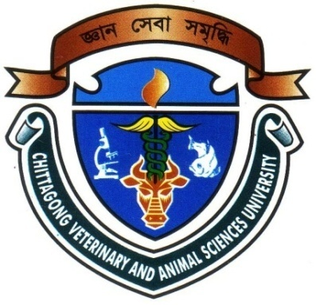

**A Report Submitted By:**

**Roll: 2008/30**

**Rag: 372**

**Internship ID-B-20**

**Session: 2007-2008**

**AS THE PARTIAL FULFILLMENT FOR THE DEGREE OF DOCTOR OF VETERINARY MEDICINE (DVM)**

**Faculty of Veterinary Medicine,**

**Chittagong Veterinary and Animal Sciences University**

**Khulshi, Chittagong – 4202**

**A REPORT ON**

**PREPARETION OF LIVER EXTRACT AND study the BEEF PRODUCTION at Dinazpur district**

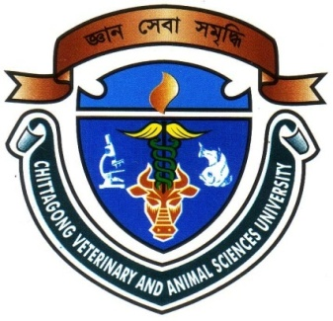

**A Report Submitted as Per Approved Style and Content**

**……………………………………**

**Signature of Supervisor**

**Name : Professor Dr. Md Kabirul Islam Khan**

**Disignation : Dean of Faculty of Veterinary Medicine**

**Chittagong Veterinary and Animal Sciences University**

**Khulshi, Chittagong - 4202.**

**A REPORT ON**

**PREPARETION OF LIVER EXTRACT AND study the BEEF PRODUCTION at Dinazpur district**

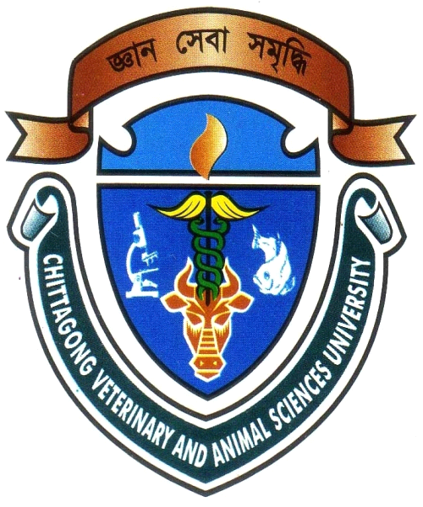

**A Report Submitted as Per Approved Style and Content**

**……………………………………**

**Signature of Author**

**Name : Saptomee Roy**

**Roll: 2008/30**

**Reg: 372**

**Internship ID-B-20**

**Session: 2007-2008**

**Chittagong Veterinary and Animal Sciences University**

**Khulshi, Chittagong - 4202.**

**CONTENTS**

|  |  |  |
| --- | --- | --- |
| **SL.NO** | **Topics** | **Page** |
|  | Acknowledgement | i |
|  | Abstract | ii |
|  | Introduction | 1-2 |
|  | Review of literature | 3-6 |
|  | Methodology | 7-8 |
|  | Preparation of liver extract | 9-12 |
|  | Result and Discussion | 13 |
|  | Conclusion | 14 |
|  | Implication of liver extract | 15 |
|  | Composition of some liver tonic | 16-17 |
|  | References | 18-19 |

**ACKNOWLEDGEMENT**

All praises are due to Almighty Creator, the creator and supreme authority of the universe; who enabled me to complete this work successfully. It is deemed as a proud privilege and extra terrestrial pleasure to express author ever indebtedness, deepest sense of gratitude, sincere appreciations, profound regards to reverend and beloved teacher Professor Dr. Md Kabirul Islam Khan, Dean, Faculty of Veterinary Medicine, Chittagong Veterinary and Animal Sciences University for his scholastic guidance, sympathetic supervision, valuable advice, constant inspiration, affectionate feeling, radical investigation and constructive criticism in all phases of this study.

I take the opportunities to express my deepest sense of respect and appreciations to honorable Vice Chancellor Prof Dr.A.S.Mahfuzul Bari, DVM ,Ph, Chittagong Veterinary and Animal Sciences University.

I would like to pay my solemn gratitude to respectable teacher Associate professor Dr.Bibek Sandra Sutrodher, Director of External Affairs, Chittagong Veterinary and Animal Sciences University.

I wish to acknowledge the lab assistants, Department of Animal Science and Animal Nutrition Lab.

I express my sincere gratitude to all teaching and non teaching staff members of my working departments for their support

The Author

**i**

**ABSTRACT**

The study was conducted at Sador Thana of Dinazpur district and at Animal Nutrition laboratory to know the situation of beef production and prepare the liver extract. Nowadays cattle fattening is well recognized system of beef production in Bangladesh. Beef production contributes about 2.95% GDP in the economy of Bangladesh. For beef fattening farmers use traditional feeding such as green grasses vegetable byproducts and sometimes supply nutritional supplements such as urea treated straw. Pasture grazing or feedlot farming is used in some areas. In some commercial farms weaning is maintained properly. Some farmers maintained special dietary supplement in their farm for beef fattening in a short time. Liver extract is the processed beef liver which is the vital component of liver tonic. For that reason farmers use liver tonic which is prepared by liver extract.

**Keywords:** Beef production, liver extract, traditional feeding and farm.

ii