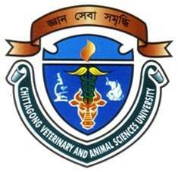
Milk Production and Its Influential Factors in Different Dairy Cattle genetic Resources of Comilla District

A production report submitted by
Md. Mizanur Rahman
Roll no: 08/64
Intern ID: E- 43
Reg. No: 406
Session: 2007-2008

Report presented in partial fulfillment for the Degree of
Doctor of Veterinary Medicine (DVM)

Faculty of Veterinary Medicine
Chittagong Veterinary and Animal Sciences University Khulshi, Chittagong-4225

January 2014
Milk Production and Its Influential Factors in Different Dairy Cattle Genetic Resources of Comilla District

A production report submitted as per approved style and content

Signature of the Author  Roll no- 08/64  Intern ID: E -43  Reg. No-406  Session: 2007-2008 | Signature of Supervisor  Musammet Rasheda Begum  Assistant Professor (Biostatistics)  Dept. of Agricultural Economics and Social Sciences  Faculty of Veterinary Medicine  Chittagong Veterinary and Animal  Sciences University Khulshi, Chittagong-4225

January 2014

