Effects of Commercial Feed on the Feed Conversion Ratio and Growth Performance of Cobb 500 in Small Scale Poultry Farm

ABSTRACT

The study was conducted in different small scale intensive commercial poultry farm in Chittagong. The aim of the study was to assess the effect of different commercially available feed on growth and feed conversation ratio of Cobb 500 broiler. Effect of two commercial feed (CP and Aga) was evaluated on four broiler farms. The management system of four farms was more or less same and considered as constant traits. Feed conversion ratio and live weight gain was observed on a period of 35 days at 7 days interval. Study shows there is no statistically significant variation due to feeding different trade feed. Average feed intake /bird at 5th week was 2655.8 gm and live weight gain is 1617.5 gm in the studied farm. The feed conversion ratio is highest of 1.56 at Mejbah poultry farm where lowest at 1.73 in Anower poultry farm. The total live weight gain significantly (p<0.05) increases at 4 to 5 weeks within the farm. However, within the farm Mejbah poultry fed with Agha branded feed performed highest feed conversion ratio and live weight gain.

Keywords: FCR, Management, Commercial feed, Cobb 500, live weight gain

CHAPTER I
INTRODUCTION
Bangladesh is overpopulated agro based country. Agriculture is the main source of income in Bangladesh (Devendra and Thomas, 2002). Most of the people depend on livestock and agro farming in Bangladesh (Kruska et al., 2003). Poultry production is the effective way to bridge between high population and protein demands for proper nutrition. The increase demand of animal protein can be fulfilled by effective production of poultry egg and meat in Bangladesh. Broiler is an important commercial enterprise (Sarker et al., 2001). The broiler has fast growing character and high feed conversion ratio with pliable meat. So it can play important role in supplying the extra demand of animal protein in Bangladesh. There are about 288.566 million of chickens are available in Bangladesh (DLS, 2007). The average demand of meat is 6.482 Million Metric ton (120gm/ day/head) in Bangladesh but the production is 2.33 million metric ton. So, 4.15 million metric ton meats is yet shortage in Bangladesh. The poultry meat contributes 33% of the total animal protein (Hossain et al., 2006). Bangladesh has an ancient record of chicken rearing in traditional backyard farming (Sultana et al., 2012). Now a day, Commercial broiler farming is very popular trade in Bangladesh. It is also a potential way to overcome the poverty and unemployment problem in Bangladesh (Dolberg, 2008). There are small number of commercial farm started the broiler farming in early nineties. But the broiler farming is getting more and more popularity in different people with diverse background. On average a 5 million of Bangladeshi are directly involve in poultry farming (Das et al., 2008).
Broiler is fast growing poultry attains ∼1.5-2 kg live weight within 35 days. The feed conversion ratio is also higher than other poultry species. The meat quality is also preferable for its tenderness and pliable character. They can convert the feed intake to meat production efficiently (Khetaniet et al., 2009). The average feed conversion ratio of broiler under intensive farming is usually 2-2.30 (Jahan et al., 2006). But the factor depends on different managemental and environmental factors. Currently, 85% private hatchery produce broiler DOC (Day old Chicks) in Bangladesh. The small scale commercial farmers purchase the DOC mainly from agent of the hatchery. The quality of the chick may vary hatchery to hatchery and breed to breed. Then the DOC is reared under intensive farming system in small scale broiler farm.
The small scale broiler farmers are depends on commercially available feed for their farm (Dolberg, 2004). There are many structured and local feed mills available in Bangladesh though the exact number is not recorded (Khan et al., 2002). In Chittagong region, CP feed, Nourish feed, Agha feed, Paragon feed are frequently used by the small scale farmers. Although there is a good number of feed mill available in Bangladesh but only limited numbers of feed mills are concern about the quality of feed. The main cost of 60-70 % involve in feeding program of farm. So the feed conversion ratio and effect of different commercial feed on growth performance of broiler is needed to evaluate (Hossain et al., 2011).
In broiler the feed conversion ratio (FCR) or feed conversion efficiency (FCE) referred as converting the feed mass into meat production or body mass. The low feed conversion ratio indicates high commercial value. It means the low FCR value indicate the animal is efficient user of feed. However the FCR value is frequently affected by the growth rate, rations ingredients and contents, housing and management system, environmental factor and overall health status of the bird.
There are sufficient literatures available on evaluation of FCR in broiler parents stock in large scale farming. But limited study was conducted on evaluation of commercially available feed and the performance of broiler in small scale farming system. Therefore the present study was conducted with an aims to evaluate the effects of commercial feed on growth performance of broiler chicken in small scale poultry farm of Chittagong region. The overall objectives of the study were:
- To know the management practices in small scale broiler farms in Chittagong.
- To evaluate the effect of commercial feed on performance of broiler chicken.
- To know the feed intake and live weight gain of Cobb 500.
- To estimate the feed conversion ratio (FCR) under different management system and feed.

CHAPTER II
LITERATURE REVIEW
The following literatures were reviewed during the experimental period to understand the related work on the current study.
Global livestock industries have a contribution of more than 40% GDP and currently employing 1.3 billion of people (Thornton et al., 2010). The livestock industries are supplying one third of human protein demands across the world (Steinfield et al., 2006).

It is estimated that the global meat production will projected double within 2050 for increased demands and intensive trade in this sector (FAO, 2006). Poultry industry as micro sector of livestock contributing with meat, eggs and other food products and recognized as most promising livestock industry in the world (Hossain et al., 2011).

Poultry meat is the fastest growing component of global meat production, consumption, and trade, with developing and transition economies playing a leading role in the expansion. In addition to providing opportunities to increase poultry exports, rising poultry production spurs growth in global import demand for feeds and other inputs and generates up- and downstream investment opportunities (Regmi et al., 2001).

Broiler industry has gone tremendous changes from past two decades around the world. The body weight gain of the broiler strains has been markedly increased, and the feed utilization has been strongly improved with the advancement of new technology applied in poultry nutrition as well as in genetics (Mack et al., 2005).

In Bangladesh the broiler production is major subsector of livestock industries. The rapid growing and short period of interval to gain the desirable parameter is on the major reason behind it (Sarker et al., 2001). The poultry meat and egg contribute more than 33% animal protein source in Bangladesh. The industry is also getting popularity day by day. According to FAO statistics, Bangladesh produced 593932.00 tons meat in 2009 where 43% are from broiler farm (FAO, 2011).
Shamsuddoha and Sohel, (2004) reported that poultry industry as a fundamental part of animal production is committed to supply the nation a cheap source of good quality nutritious animal protein in terms of meat and egg.

Despite the tremendous growth and development of modern broiler strains all over the world, the inadequate supply of quality animal protein is still the main problem for the people of Bangladesh. This problem is being aggravated by the increasing trend of human population, and thus creating a heavy pressure on every form of food supply in Bangladesh. The expansion of commercial broiler production in Bangladesh has a great potential for the partial fulfillment of huge protein gap of the country. Broiler production is being raised by both large scale and small scale commercial entrepreneurs under farming conditions for fulfilling the protein need of the country. Many people are now being encouraged in this enterprise, as maximum return can be achieved shortly by investing minimum capital in broiler production (Sarker et al., 2001).

The poultry production system is Bangladesh can divide as large scale, medium scale and small scale farmers. The main contribution from farm is small scale intensive farming. Intensive farming system with low scientific evaluation is most prevailed broiler farming system in Bangladesh. The backyard farming system of mainly dominated with non descriptive local chicken like naked neck, Assel and red jungle fowl. But the commercial broiler farms are using different breeds and breed combination. According to Saleque, (2007) the broiler commercial system are using the broiler breeder strains commonly used by the broiler industry in Bangladesh are Arbor Acres, Hub chicks, Ross, Starbro, Hubbard classic, Cobb- 500, MPK, Lohman, Hybro G and Hybro N. Cobb 500 is famous for lowest cost of live weight produced, superior performance on lower cost feed ration, and most feed efficient, best broiler uniformity for processing (Cobb venture, 2012).

Bangladesh is a tropical country. The environmental condition is differing from those countries where the high performing breeds are originated. Hossain et al., (2011) stated Cob 500 as the most efficient breed is small scale poultry farming.

Estevez, (2007) reported that scientific breeding, feeding management and disease control is the key requirement for profitable broiler farming. Sultana et al., (2013) stated that 30% farmer took necessary suggestions from the experienced farmers rather than going the veterinary doctor. 90% farmers regularly vaccinated their broilers with one or two vaccine but only 35% complete full recommended vaccination schedule. Among the respondents 70% farmers had taken short training on broiler farming from Youth development board.
Kawsar et al., (2013) stated that scientific management intervention increases the profitability and feed conversion ration of small scale poultry farm. The author concluded training to the small-scale broiler farmers, introduction of improved management practices, regular monitoring with adequate poultry extension services are the key elements to get satisfactory result from broiler farming. According to Sarker, (2011) farmers having less than 1000 birds are not conscious about the bio-security measurement in farm while the large farmers follow strict bio-security system.
Live weight gain is the major commercial traits for broiler farming. Highly efficient breeds gain desirable live weight within the time limit. Samarakoon and Samarasinghe, (2012) cited the live weight gain and feed conversion ratio is most important traits for effective profitable broiler farming. Feeding is the major cost involve in poultry farming. About 80% of the farming cost spends in the purpose. Therefore effective feed formulation and feed conversion ratio is the major points for profitable farming.
The small scale broiler farmers are frequently using the commercially available feed in Bangladesh. The exact number of feed mills now in operation is not definitely known but a report stated that there are 40 feed mills with 900 dealers at the private sector who are producing and distributing poultry feeds all over the country (Roy et al., 2004). Although a good number of feed mills are in operation in the country only a few of these are serious in maintaining quality of their product. A report stated that, the feed requirement is about 1610 thousand metric tons per year, of which 472 thousand metric tons (29.34%) is covered by industrial feed and the remaining 1138 thousand metric tons are replenished by the feeds from other sources (self-mixed feed) of the poultry farm (Khan and Husain, 2002).

The commercial feed available in Bangladesh may not in same quality. It may differ from manufacturer to manufacturer. However, the feeding practices of broiler are a vital issue for getting optimum production and growth performance.

Chapter: III
MATERIALS AND METHODS
3.1 Study site:
The study was conducted in Potiya and Hathazari thana of Chittagong districts during undergraduate internship placement. Four intensive small scale poultry farm were considered for the study and the duration of the study from 20 September to 20 October, 2013. The four farms were Mejbah poultry, Joynal poultry from Hathazari and Solaiman and Hanif Poultry from Shikolbaha, Potiya.
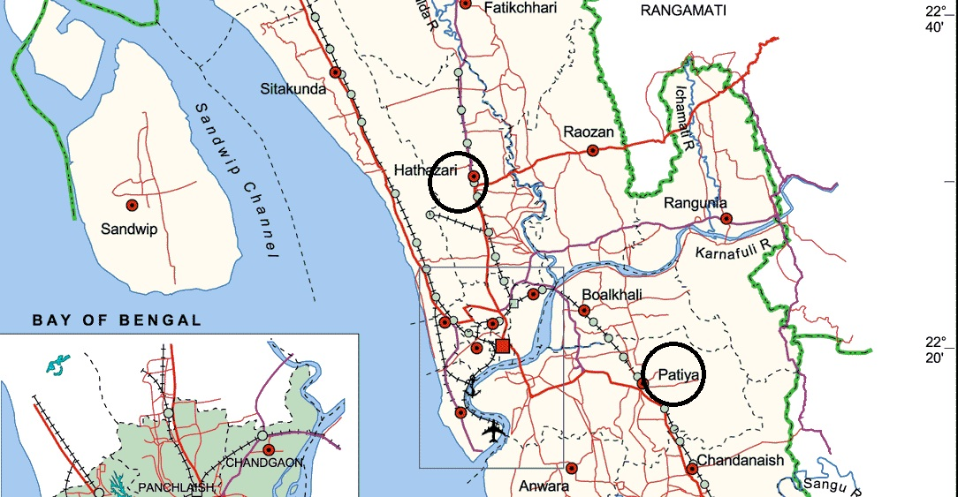
Fig-1: The black marked area is the study site of poultry farms
3.2 Study design and Experimental population:
The Mejbah poultry, Joynal poultry, Solaiman poultry and Hanif poultry farms were cited as Farm 1, Farm 2, Farm 3 and Farm 4 respectively in the study. The farm 1, 2, 3 and 4 having the population of 2500, 2000, 1500 and 1000 respectively, cob 500 commercial poultry strain where farm 1 and 2 are fed with commercially available AGHA Feed and Farm 3 and 4 fed with CP Feed. The day old chicks are procured from Agha Hatchery in the entire experimental farm.

3.3 Data collection and management:
The data were collected by a structured data sheet from the studied poultry farm. The live weights of day old chicks were recorded and it continues up to 35 days at 7 days interval. The feed intake by the birds also recorded from the record book of the farm. The manegmental data were collected as descriptive format through questionnaires and personal observation. The data were inputted in Microsoft excel-2007.
3.4 Data analysis:
The feed conversion ratio was calculated from average feed intake and the total live weight gain in the poultry farm. The formula is:
Feed conversion ratio (FCR) = | Total feed intake
 | Total body weight gain

The mean, standard deviation was calculated by using Microsoft Excel-2007. The line graph was prepared by using Microsoft Excel-2007.
3.5 Managements System of the farm:
3.5.1 Housing:
The studied poultry farms shed were oriented in north south direction except the Jaynal poultry (South east). The roofs were made with tin-shed followed by underlying coccid for maintaining the temperature. The floors were made with concrete and rice husk was used as litter materials.
3.5.2 Shed preparation:
Individuals sheds were prepared for birds rearing of a single age and the birds were managed in All in All out principles. Fumigation by using formaldehyde and potassium permanganate (2X) was done prior starting a new batch of day old chicks. All equipment was thoroughly cleaned and disinfected prior arrival of bedding materials and chicks. All vehicles, equipments and personnel were disinfected prior entry in the shed.

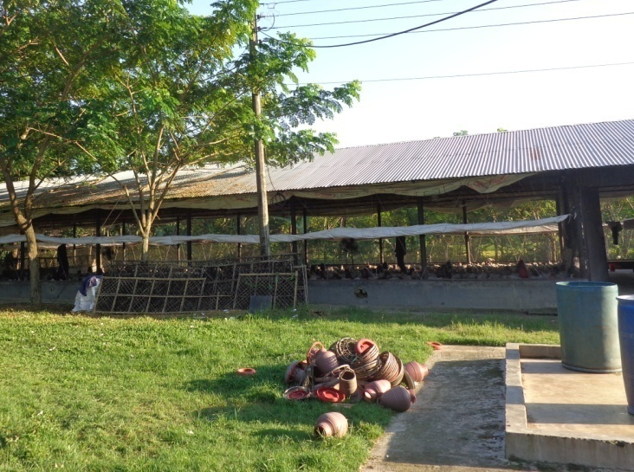  Fig-2: Housing of broiler | 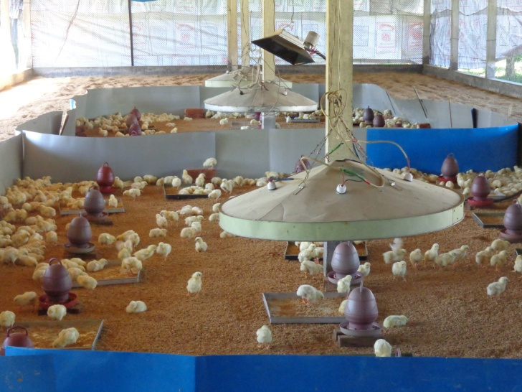  Fig-3: Brooding
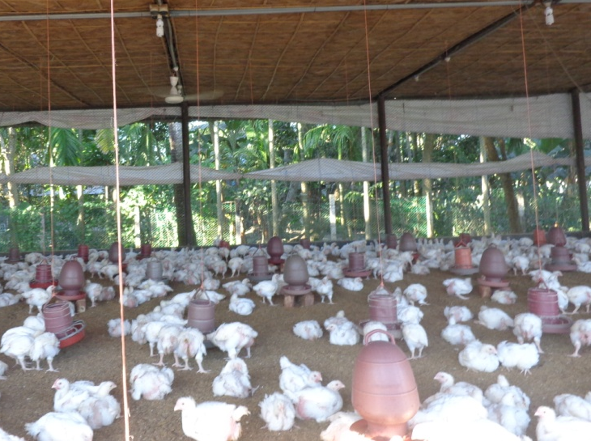  Fig-4: Feeding and watering of broiler | 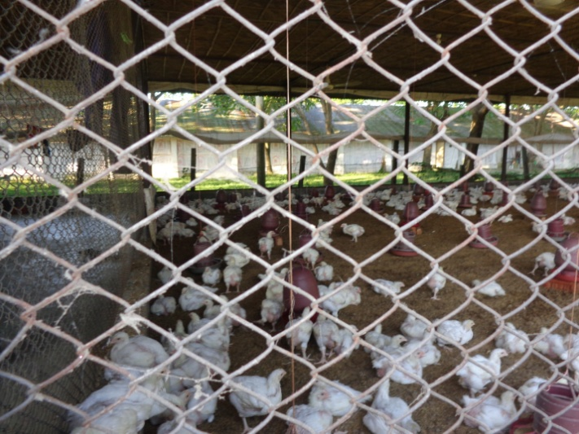  Fig-5: Ventilation during day time

3.5.3 Feeing of broiler:
The chicks were fed with commercially available feed in the market. The Farm 1 and Farm 2 were fed with Agha feed where the Farm 2 and Farm 3 fed with CP feed. There are three types of feed for the broiler e.g. Broiler starter, broiler grower and broiler finisher. The standard value for different stage of broiler is shown below.
Table-1: Recommended nutritional value for broiler at different ages
Stage | ME | CP | Ca | P
Starter | 3000 | 22 | 1 | 0.5
Grower | 3100 | 21 | 0.95 | 0.45
Finisher | 3200 | 20 | 0.90 | 0.45

3.5.4 Bio-security:
Bird health is out most important for profitable broiler farming. The bio-security of the broiler farm was maintained strictly. Foot bath were used at the entrance of the farm. The vehicles and equipments were disinfected prior entrance in the farm. The dead birds were incinerated where the ill birds were isolated. The exotic bird and other pest were controlled by fencing around the farm.
3.5.4 Vaccination:
Vaccination for prevention of diseases in the farm is practiced. The vaccination schedule is as follows:
Table-2: Vaccination schedule in the studied farm
Days | Farm 1 | Days | Farm 2 |  | Days | Farm 3 | Days | Farm 4
3 | IB+ND | 1 |  | BCRDV | 4 | BCRDV
14 | IBD | 11 |  | IBD | 10 | IBD
18 | IB+ND | 17 |  |  |  |  | 10 | IBD
24 |  | 22 |  | RDV

CHAPTER IV
RESULT AND DISCUSSION
4.1: Feed conversion ratio:
The feed conversion of four farms is shown in table-3. There is no significant variation in feed conversion ratio among the four farms at (p>0.05).

Table- 3: Weekly feed conversion ratio of broilers at different farms

Days | Mejbah | Joynul | Anower | Belal | Mean | SD | SE | Sig.
1-7 | 0.90 | 0.98 | 0.97 | 0.94 | 0.95 | 0.04 | 0.02 | NS
8-14 | 1.06 | 1.25 | 1.21 | 1.17 | 1.17 | 0.08 | 0.04 | NS
15-21 | 1.22 | 1.36 | 1.45 | 1.26 | 1.32 | 0.10 | 0.05 | NS
22-28 | 1.40 | 1.56 | 1.60 | 1.49 | 1.51 | 0.09 | 0.04 | NS
29-35 | 1.56 | 1.68 | 1.73 | 1.60 | 1.64 | 0.08 | 0.04 | NS
NS=Non-significant (p>0.05)
However, the Anower poultry farm (farm-3) showed poor rate of feed conversation ratio of 1.73 and Mejbah poultry showed the good rate of feed conversion ratio of 1.56. But there is no statistically significant difference between FCR of those farms. The mean feed conversion ratio of four farms is 1.64. The result is supported by Hossain et al., (2006) but somewhat varies from Samarakoon and Samarasinghe, (2012). This variation might be due to management and environmental status of the poultry farm.

4.2 Live weight gain:
Table-4: Weekly live weight gain of broilers at different farms
Days | Mejbah | Joynul | Anower | Belal | Mean | SD | SE | Sig.
1-7 | 172.0 | 168.0 | 165.0 | 170.0 | 168.8 | 3.0 | 1.5 | NS
8-14 | 450.0 | 400.0 | 410.0 | 420.0 | 420.0 | 21.6 | 10.8 | NS
15-21 | 820.0 | 772.0 | 700.0 | 800.0 | 773.0 | 52.5 | 26.2 | *
22-28 | 1310.0 | 1147.0 | 1090.0 | 1200.0 | 1186.8 | 93.6 | 46.8 | ***
29-35 | 1720.0 | 1600.0 | 1500.0 | 1650.0 | 1617.5 | 92.5 | 46.3 | **
NS=Non-significant (p>0.05); *=Significant at 5% level (p<0.05); **=Significant at 1% level (p<0.01); *=Significant at 0.1% level (p<0.05)

Graph-1: Relationship between times and live weight gain (gm) in four farms

From the table it is shown that highest body weight gain is recorded from Mejbah poultry farm (1720 gm) and the lowest body weight in the Anower poultry farm (1500 gm). The table also shows that the body weight increases with age in the entire studied farm. There is statistically significant difference observed at 0.1% level (p<0.05). The result is supported by Hossain et al., (2006) but somewhat varies from (Roy et al., 2004). From the graph 1 it can be seen that live weight gain is a steadily progressed. The live weight gain is increasing simultaneously with the increase of ages. The R² value is very high and it is good fitted to the linear.
4.3 Feed intake:
Table 5: Weekly feed intake of broilers at different farms
Days | Mejbah | Joynul | Anower | Belal | Mean | SD | SE | Sig.
1-7 | 155.0 | 165.0 | 160.0 | 160.0 | 160.0 | 4.1 | 2.0 | NS
8-14 | 480.0 | 500.0 | 495.0 | 490.0 | 491.3 | 8.5 | 4.3 | NS
15-21 | 1000.0 | 1050.0 | 1020.0 | 1010.0 | 1020.0 | 21.6 | 10.8 | NS
22-28 | 1834.0 | 1790.0 | 1740.0 | 1788.0 | 1788.0 | 38.4 | 19.2 | NS
29-35 | 2700.0 | 2688.0 | 2595.0 | 2640.0 | 2655.8 | 48.1 | 24.0 | NS

Graph-2: Relationship between times and feed intake (gm) in four farms
The data showed the mean of feed intake among the four farms 2655.8 gm where highest feed intake was recorded at Mejbah poultry of 2700 gm and the lowest at Anower poultry of 2595.0 gm. There is no statistically significant variation in feed intake among the studied farm. So the two commercial trade feed are performing same in the small scale broiler farming. The study is more or less similar to (Hossain et al., 2006), but slightly lower than the report described by Roy et al., (2004). From the graph 2 it can be stated that live weight gain is a gradually increased. The live weight gain is increasing simultaneously with the increase of ages. The R² value is very high and it is good fitted to the linear.

Graph 3: Relationship between live eight gains and feed intake (gm) in four farms
From the graph-3 it can be described that live weight gain is a progressively increased. The live weight gain is increasing concurrently with the increase of feed intake. The R² value is very high and it is good fitted to the linear.

CHAPTER V
CONCLUSION
The study shows that the body weight gain of Cob-500 is at satisfactory level under proper care and management system. There is no statistically significant difference in feed conversion ratio and weight gain when fed two different trade feed. But within farm the CP trade feeding farm gain higher weight than Agha. However, the actual feed conversion ratio is poor than the estimated value. It is recommended that proper management, sanitation, lighting, vaccination and disease control can efficiently increase the FCR value in broiler chicken. Intensive studies prioritizing the different trade feed and breed with larger sample is recommended.
CHAPTER V
REFERENCES

Das, S. C., Chowdhury, S. D., Khatun, M. A., Nishibori, M., Isobe, N., & Yoshimura, Y. (2008). Poultry production profile and expected future projection in Bangladesh. World's Poultry Science Journal, 64(01), 99-118.

Devendra, C., & Thomas, D. (2002). Crop–animal systems in Asia: importance of livestock and characterisation of agro-ecological zones. Agricultural Systems, 71(1), 5-15.

Dolberg, F. (2004). Review of household poultry production as a tool in poverty reduction with focus on Bangladesh and India. Livestock and livelihoods: challenges and opportunities for Asia in the emerging market environment. India, National Dairy Development Board, and Rome, FAO, Pro-Poor Livestock Policy Facility (South Asia Hub).

Dolberg, F. (2008). Poultry sector country review. Bangladesh: Food and Agriculture Organization of the United Nations.

Estevez, I. (2007). Density allowances for broilers: where to set the limits? Poultry Science, 86(6), 1265-1272.

Food and Agricultural Organization of the United Nation (FAO) statistics cite at http://faostat.fao.org/site/610/DesktopDefault.aspx?PageID=610#ancor accessed on 10 January, 2014

Hamra, C. F. (2010). An Assessment of the Potential Profitability of Poultry Farms: A Broiler Farm Feasibility Case Study (Doctoral dissertation, The University of Tennessee)

Hassan, A. A., Nwanta, J. A., Njoga, E. O., Maiangwa, M. G., & Mohammed, A. (2011). Economic Analysis of Broiler Production on On-farm Formulated and Commercial Feeds: A Case Study of Igabi Local Government Area of Kaduna State, Nigeria. Nigerian Veterinary Journal, 32(2).
Hossain, M. A., Roy, B. C., Islam, M. M., & Miah, M. Y. (2006). Performance of broiler fed with different commercial compound feeds of Bangladesh. Bangladesh Journal of Veterinary Medicine, 4(2), 97-101.

Hossain, M. A., Suvo, K. B., & Islam, M. M. (2011). Performance and Economic Suitability of Three Fast Growing Broiler Strains Raised Under Farming Condition in Bangladesh. International Journal of Agricultural Research, Innovation and Technology, 1(1-2), 37-43.

Jahan, M. S., Asaduzzaman, M., & Sarkar, A. K. (2006). Performance of broiler fed on mash, pellet and crumble. International Journal of Poultry Science, 5(3), 265-270.

Kawsar, M. H., Chowdhury, S. D., Raha, S. K., & Hossain, M. M. (2013). Impact of management intervention on productive performance and profitability of small-scale broiler farming in Bangladesh. Livestock Research for Rural Development.5 (81)

Khan, M. M., & Husain, B. H. (2002). Macroeconomic (supply and demand situation) analysis of poultry sub-sector. Khamar 15, 9-12.

Khetani, T. L., Nkukwana, T. T., Chimonyo, M., & Muchenje, V. (2009). Effect of quantitative feed restriction on broiler performance. Tropical animal health and production, 41(3), 379-384.

Kruska, R. L., Reid, R. S., Thornton, P. K., Henninger, N., & Kristjanson, P. M. (2003). Mapping livestock-oriented agricultural production systems for the developing world. Agricultural systems, 77(1), 39-63.

Mack, S., Hoffmann, D., & Otte, J. (2005). The contribution of poultry to rural development. World's Poultry Science Journal, 61(1), 7-14.

Parker, D., Shirley, R., Vazquez-Añón, M., Knight, C., Azevedo, L., & Marangos, A. (2006). Improved performance of Cobb 500 birds fed increased amino acid density in Wheat or Maize-based diets. In EPC 2006-12th European Poultry Conference, Verona, Italy, 10-14 September, 2006. World's Poultry Science Association (WPSA).
Regmi, A., Deepak, M. S., Seale Jr, J. L., & Bernstein, J. (2001). Cross-country analysis of food consumption patterns. Changing structure of global food consumption and trade, 14-22.

Roy, B. C., Ranvig, H., Chowdhury, S. D., Rashid, M. M., & Chwalibog, A. (2004). Evaluation of compound broiler feeds manufactured in Bangladesh. Livestock Res. Rural Dev, 16(11), 1-8.

Saleque, M. A. (2007). Poultry Industry in Bangladesh: Current Status and Its Challenges and Opportunity in the Emerging Market Environment. Poultry Business Directory.

Samarakoon, S. M. R., & Samarasinghe, K. (2012). Strategies to Improve the Cost Effectiveness of Broiler Production. Tropical Agricultural Research, 23(4), 338-346.

Sarker, M. S. K., Ahmed, S. U., Chowdhury, S. D., Hamid, M. A., & Rahman, M. M. (2001). Performance of different fast growing broiler strains in winter.Pakistan J. Biol. Sci, 4(3), 251-2001.

Sarker, S., Talukder, S., Chowdhury, E. H., & Das, P. M. (2011). Knowledge, attitudes and practices on biosecurity of workers in live bird markets at Mymensingh, Bangladesh. Journal of Agricultural & Biological Science, 6(6).

Shamsuddoha, M., & Sohel, M. H. (2004). Problems and Prospects of Poultry Industry in Bangladesh: A Study on Some Selected Areas. The Chittagong University Journal of Business Administration, 19.

Steinfield, H., Gerber, P., Wassenaar, T. D., Castel, V., & De Haan, C. (2006).Livestock's long shadow: environmental issues and options. Food & Agriculture Org.

Sultana, F., Khatun, H., & Islam, A. (2013). Small scale broiler farming at Santhia upazilla of Pabna District of Bangladesh. Bangladesh Journal of Animal Science, 41(2), 116-119.

Sultana, R., Nahar, N., Rimi, N. A., Azad, S., Islam, M., Gurley, E. S., & Luby, G. S. (2012). Backyard poultry rising in Bangladesh: a valued resource for the villagers and a setting for zoonotic transmission of avian influenza. A qualitative study. Rural and Remote Health, 12(1927).

Thornton, P. K. (2010). Livestock production: recent trends, future prospects. Philosophical Transactions of the Royal Society B: Biological Sciences, 365(1554), 2853-2867.

