CHAPTER- 1

INTRODUCTION

The poultry industry in Bangladesh is very diverse. It comprises Grand parent stock, parent stock, broiler chicken, layer chicken, native chicken, and ducks. Among these, parent stock sector is most significant. because it is connected to the production of broiler & layer chicken & as well as these broiler parent stock are used as a significant source of protein & nutrition when culled. The hatching eggs received from the broiler parent stock when put into the incubator hatch out into the commercial broiler chicks which when reared upto the requisite weight are sold into the market. There are 227 hatcheries in the country & total number of breeder parent stock was 38,67,000 .( Farm poultry & livestock survey 2007-2008,Nov 2010, BD Bureau of statistics). Major hatchery zones are Faridpur, Mymensingh, Gazipur etc.

Various number of broiler breeder parent stocks having excellent genetic potential & best performance have been developed by various breeder companies. 80% of the broilers breeders are produced by four foreign breeder companies: Aviagen, Cobb-Vantress, Hubbard Farms, Hybro. Among these Cobb 500 is an English straimn which shows an excellent production reproduction performance in standard condition. It has a worldwide reputation for the lowest cost of producing chicken meat. Cobb geneticists have developed this breed by the research of more than 30 years progress using a combination of both traditional & pedigree selection & new technology. They have developed a very high breeder performance of cob 500.( Cobb breeder management guide)

CHAPTER-2
RIVIEW OF LITERATURE
Grobas, Elibol, Bell reported that Egg production & Hatchability of broiler eggs can be influenced considerably by age flock, breed & strain of chicken used & breeding programme , light stimulation, nutrition or by a combination of the three.
Colin C. whitehead, 2010. Recent research has demonstrated the importance of the early nutritional status of the hatched chick in enhancing performance. It is therefore vital that , in formulating diets for the parent birds, attention is paid not only to maximizing egg output & hatchability but also to ensuring that the eggs produced contain adequate amounts of the nutrients vital for supporting the early development of hatching chick.
Heier & jarp reported a significance effect of prolonged egg storage time on Hatchability.
Robinson & Wilson (1999) showed that the restricted lighting management programme for broiler breeder can helps to achieve the sexual maturity during 18 to 22 wks of age.
Krishnappa et. al (1992) concluded that restricted feeding during growing period( 7-22 wks old) can significantly reduced body weight , increased age at sexual maturity& also increase production.
R. keith Bramwell et. al ( 2008) reported that obtaining accurate body weights is a critical part of the process of rearing replacement broiler breeder pullets & managing breeder hens & males.From the first new weeks of age in the pullet house, all feed allocations are determined by the birds weekly weight gains. Obtaining accurate body weights is very important to maintaining uniformity ,body conformation & the overall developments of pullets & youngh cockerels. Research has shown that accurately & uniformly controlling body weight of both replacement breeders & breeders in the hen house will result in improved performance parameters.
The studies of bruggman concluded that the birds restricted for feed from 7-15 wks of age had higher proportional weights of ovary ( more than or equal to 1.7%) & oviduct ( more than or equal to 1.58%) at age of sexual maturity.
Krawczyk reported that a well equipped machinized house reduced the the labour inputs as compared to unmachinized house.
Dr Tom Smith (2009) suggested that breeder bird must not have a deformed beak, slipped wing,blindness in one or both eyes or any defect that may interfere with normal eating , drinking, & maintaining social stature in the flock.Male birds must be aggressive & have straight, sound legs & toes. Female should reflect good egg laying traits & good health & vigor.
Dr Tom Smith (2009) also suggested that commercial hatching eggs may be collected as often as four or five times daily to ensure egg quality.Keep nest eggs separate from eggs found on the floor so disease organisms are not spread. Do not incubate dirty floor eggs; they may spread disease to clean.
Chowdury et. al (2003) reported that the exotic broiler parents chicks can successfully reared in open sided house.

CHAPTER- 3
MATERIALS & METHODS
  - Origin of the study
The report has been done as a part of the internship program.The report is based on KEARI hatchery & poultry process Ltd. Here it is tried to retrieve the biosecurity,housing,brooding,feeding,vaccination,hatchery management & all sorts of activities practiced here.
3. 2 Study population
KEARI hatchery & poultry process Ltd has approximately 50,000 bird of different age group in five shed. But for convenience of my study I had selected one flock containing 11,000 bird of which 10100 were female birds & 900 were male birds.
  - Objectives of the report
The reports broad objective is to provide sufficient information about poultry industry to develop the recent portrait about this emerging sector . For this reason it is attempted to find out some specific objectives which are mentioned:
- To provide information about the companies
- To develop production status of the hatchery.
- To develop a better marketing strategy for the company.
- To minimize the cost of the company.
  - Study timeline
Working period & work place | Activities
1st & 2nd week  *Hatchery unit  *Feed processing unit | Planning  Data collection  - Primary data  - Secondary data
3rd & 4th week  *Parent stock shed | Data analysis  Preparing & finalizing

3.5 Management
Management is the art & science of combining ideas,facilities,processes,materials & labour to produce & market a worthwhile product or service successfully.
  - Introduction of cob500
The cob500 is a competitive breeder, providing excellent egg & chick . Cobb is the world oldest poultry breeding company. Beginning in 1916 in Massachuetts, USA, Cobb has developed into the global leader in broiler breeding.
1916: Robert C Cobb senior buys the old pickard farm in Littleton, Massachuetts, on November 20. Cobb pedigreed chicks is formed.
1920: Incubator capacity increases to 1400 eggs.
1925: One million breeders were produced.
1947: Cobb begins a breeder line of all white birds,called white Rocks. These birds along with the vantress male provide the foundation of todays pedigree cob lines.
1955: The white Rocks are introduced into the US broiler breeder market.
1966: Introduction of the cob 100.
1970: UK breeding program initiates the cob 500.
1983: The cobb500 enters the U.S.A new pure line operation, Venco,begins in india.
(Source-www.cobb-vantress.com)

CHAPTER-4
RESULTS & DISCUSSION

I have done a comparative study on management of cobb 500 broiler parent stock in keari poultry hatchery & process ltd. with standard management system.The findings of the study & their logical interpretations are presented in this chapter.
4.1. Biosecurity
The term biosecurity is derived from the Greek words ‘bios’ means life & security means to save/guard.It is a process through which all the channels of entrance & spread out of pathogens are efficiently & conveniently prevented in poultry farm. Biosecurity, in other words reducing the number of infectious organisms in the environment, is the most effective form of protection. Biosecurity,an integral part of any successful poultry production system.
There are 3 types of biosecurity-
1.Structural biosecurity
2.Conceptual biosecurity
3.Operational biosecurity

Conceptual & structural biosecurity
- First of all decision should be made where will be site suitable to establish the farm & which type of farm is to be set up.
- The poultry farm should be constructed away from locality.
- The poultry shed should be constructed in East – west direction to avoid direct sunlight & provide good concrete floor.
- Proper distance amoung farm,hatchery,feed mill should be maintained.
- A boundary wall with a security gate should be constructed & a strong barrier over the boundary wall should be provided.
- There must be well drainagesystem,electricity & other resource facility at farm.
- Separate rooms for each operation should be constructed & there should be an office,a staff room , vehicle room,storage room,bathroom,dress changing room before entering the shed.
- Proper drainage system should be provided & carcass disposal facility must be there.
- The proper measures of ventilation should be adopted & wire net should be provided in the ventilator so that no wild bird may enter.
- The proper curtains shold be provided to protect the flock fromextreme climatic condition & rain water entry.
- The proper feeding & watering system should be provided to prevent fungal growth.
- Residential building should be constructed at long distance outside the boundary wall.
- A signboard sited ‘No entrance’ without permission of the authority should be hanged over the main gate.
- Farms should contain flock of single age .As a general rule the distance between flock of different ages should be no less than 200O ft.

Operational biosecurity
- Foot water bath should be used before entering each age group shed & regular changes of foot water bath should be done.
- No other poultry livestock or domestic pets of anykind should be allowed on parent farm.
- Isolation of sick bird should be done in different shed.
- A vermin control program should be practiced at all times.It is important to maintain a clean,rubbish free environment. Rotate brands of bait regularly to prevent vermin developing resistance. Any spilled feed should be cleaned up immediately.
- Feed delivery vehicles should not enter the farm,butshould fill feed bins from outside the perimeter fence. Any vehicle that must enter the farm must be washed & disinfected at the gate.
- Feeder & drinker must be regularly washed with disinfectant.
- All in all out system should be followed.
Routine biosecurity proceures in hatcheries should include the following:
- Avoid utilizing manure contaminated eggs as hatching eggs Remember chicken manure provides an ideal environment for the AI virus to survive and spread.When field outbreaks of AI have been traced it has been found that intermittent usage of manure laden eggs for hatching purposes is one of the main suspects for the root cause of the problem.

- Hatchery managers should refrain from visiting other hatcheries.
- keep outside visitors to an absolute minimum
- Located away from waterways used by migratory fowls; duck , geese.
- Located or built as far as possible from roadways handling high volumes of poultry vehicles such as feeds.
- Personnel must follow always follow a route that will take them from clean areas to contaminated ones & not vice versa.
- Sexing & vaccination of chicks should be performed in a special room.
- Culled DOC & other wastes leaving the hatchery should be transported in clean, disinfected vehicle, which are to be used exclusively for this purpose.

Rodent and Wild Bird Control
It is necessary to prevent rodents and wild birds from entering the building because they transmit disease and eat feed. The following procedure should be adopted:
- Check all walls, panels and ceilings for holes, and repair these if necessary.
- Ensure that the fan/inlet boxes are bird proof.
- Check that all doors close firmly and tightly, with no gaps.
- Check for any leaks in the feed system. Easily accessible feed attracts vermin.
- In open-sided housing, the building must be made bird-proof, and repaired where necessary.An area of concrete or gravel extending to a width of 1-3m (3-10ft) around the house can discourage rodents from entering.
The following figures describe the routes of biosecurity which may break down.
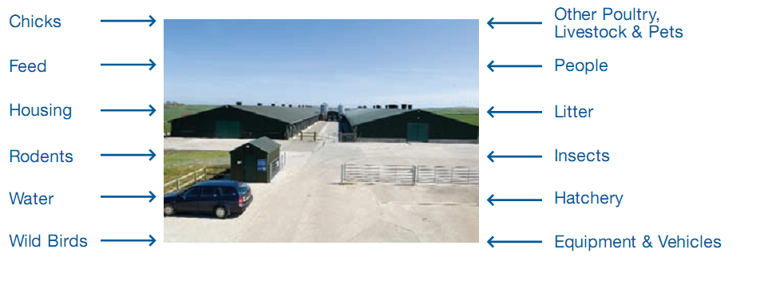
Picture-1: Routes of biosecurity
In a nutshell operational biosecurity includes -
- Sanitation b) Disinfection c) Vaccination d) Medication e) Parasitic control f) Good nutrition g) Good environment

Biosecurity maintenance in KEARI POULTRY HATCHERY & PROCESS LTD.
In comparison with the standard biosecurity management the farm authority do not maintain minimum amount of biosecurity. Although some facts of biosecurity is maintained, but it is neglegable. The followings are the positive aspect of biosecurity:
1. This farm is established in an isolated area for developing new parent farm.
2. Good fencing system & foot bath is maintained in only one shed.
3. Quarantine system of personnel is maintained when they worker or others come from outside. (1 days quarantine)
4.Before collection of egg spraying of hand of personnel by antiseptic.
5. Spraying of vehice by disinfectant.

The negative practices of biosecurity are-
- Some personnel stay inside the farm with their family which is a threath to biosecurity.
- No auto spray system & shower room in main gate.
- Feeding system is not automatic ,is manual for that reason there is chance of contamination.
- No fenching system is available in back & alongside of shed.
- No separate vehicle for egg transport & chick transport.
- No shower room in hatchery.
- The customer for chick are permitted to entry in the hatchery.
- Workers moves outside of the farm without permission.No strict management for this.
- To eliminate the infestation of rat there is no programme.
10.No proper drainage system is available.
11. Most workers don’t maintain personal hygiene.

4.2. Preparing the poultry house for chicken
After ending of production period of a flock , culling of all birds which actually starts on the basis of production performance. During cleaning strict procedures , protocols & all in- all out system must be maintained.
Remove all equipments such as – feeder,nipple line,cooling pad, nest box, slat, angle, inside partition etc. After removal of slat, the litter materials are removed from each pen. Then pen are cleaned by broom & filled with disinfectant mixed water for 1 day. All equipment are washed by disinfectant. The water line is cleaned by bleaching powder. Inside the shed is washed by disinfectant. Outside & inside partition net are cleaned & painted by red oxide.The floor are soaked by lime. When the floor is prepared then all cleaned equipments are installed inside the shed. Then fumigation is done & the door remain closed for 7 days. For fumigation formalin & potassium permanganate are used. Formalin is used @ 1.2 ml for 1 sq.ft. & potassium permanganate is used @ .6 gmfor 1 sq.ft.
4.3 Installation of chick
The DOC is imported from America or Thailand, sometimes from kazi GP. After landing on airport the chicks are transported to shed by a controlled AC vehicle. All personnel involved in chick shipment must maintain farms biosecurity precautions & wear clean uniform & boots. The drivers are not allowed to enter the farm.Spread the chick box evenly through-out the house beside drinker line. The chick must be active, chirping, healed navels.Otherwise discard the chick.
Before receiving bird the feed & water are loaded in newspaper & waterer. Checking that everything is in good working order. Warming up the house is also a essential factor.
After arrival of chicks , unloading of all chick boxes & distribution of them in house. Feeding the chicks 5 % Glucose solution & vit C for stress relief.After placing the chicks again checking of the equipment & temperature of the house.Take random weighting of 10% chick.
4.4. Brooding
Brooding is necessary to provide proper heat, ventilation & access to feed & water for the chicks so as to optimize desired growth & development.Ideal brooding condition include:
- At day – old, chicks require a brooder temperature 32 to 35°C & a house temperature of 26 to 27°C
- The brooder temperature can be reduced approximately 2°C every four hrs.
During brooding , the litter act as a insulation & comfort for tha baby chicks.Here
recycled papers are used due to its good absorption properties.
Brooding is performed by bulb.During summer 2 bulb of 100W & 1 bulb of 60 W. During winter 2 bulb of 200 w & 2 bulb of 100w.
Gas brooder is available but don’t use.

Space reqired for brooding
Age ( day) | Space during winter Sq.ft/bird | Space during summer Sq.ft/bird
1-3 | .2 | .3
4-7 | .35 | .4
8-11 | .45 | .6
12-14 | .50 | .85
15-20 | .60 | 1
After 20 days | 1.5-2.0 | 1.5-2.0

The chick position relative to heat is an important indication.
Uniform spread , active chick Optimum situation.
In groups near the sides of the house Temperature too high
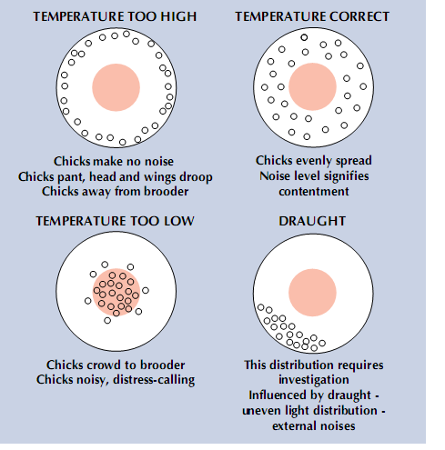
Huddling under the brooder Temperature too low

Picture-2: Brooding system of chicks
Advantage of brooding
1. Immunity will be increased.
2. The efficacy of the vaccine will be proper.
3.Due to sametemparature in all side the uniformity of flock will achieve.
4. Chick mortality will reduce.
5. The unhealed navel will be healed.
4.5. Management of water & drinker
Water is the largest component of chicks body representing about 70% of total body weight. A loss of about 10% of this water may result in death. Birds on a restricted feeding programme appear to drink much more water than birds that are on full feed.Water intake is influenced by several factors such as age,atmospheric temperature,relative humidity,air movement,feed intake,feed composition,health status etc.So it is difficult to estimate the water amount correctly.Before supplying of water to chick , the water is sanitized with Safex. No test for measurement of water quality is done.Sometimes PH level is measured from icddrb.
Nipple drinker:Nipple drinking system is maintained. Nipple drinkers should be installed at 12 birds per nipple. Drinker line height should be started low at the beginning of the flock and increased as the birds get older. Drinker lines that are too high can restrict bird water consumption while water lines that are too low can result in wet litter. In the initial stages of brooding, the nipple lines should be placed at a height at which the bird is able to drink. The back of the chick should form an angle of 35-45° with the floor whilst drinking is in progress. As the bird grows the nipples should be raised so that the back of the bird forms an angle of approximately 75-85° with the floor and so that the birds are stretching slightly for the water. Just prior to placing the chicks on the nipple drinking system, triggering all of the nipples to check perfect flowing of water. The height of the water lines should adjust in such a way that the lines are at the chicks eye level for the first two days.
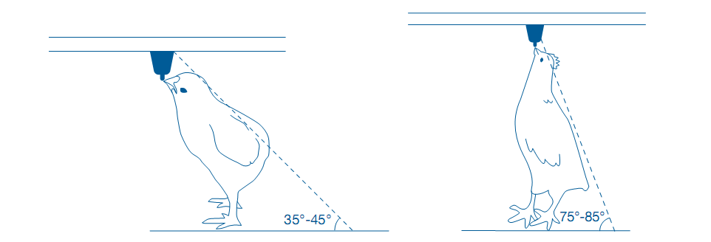
Picture-3: Nipple drinker height adjustment
4.6. Debeaking
Advantage of debeaking:
- Reduction of cannibalism.
- Feed waste will be reduced.
- Uniformity of the flock.
Debeaking is done at 7- 10 days of age of both sexes & should provide 24 hrs of supplemental vitamin K & electrolytes for 3 days.Malechicks should be debeaked by removing only 1/3 of the beak as the beak of the male is vital in the mating process. Second beak trimming is done only in female at 14-15 wks. It must bedone by experienced personnel.The machine must be checked before.New bade is used which temperature will be 650-815 °C . Debeaking is performed within 2 seconds.
The injured bird is in special nusing by vit k & again debeaking is performed. Good debeaking is very important to ensure good uniformity & optimum reproductive efficiency.

4.7. Vaccination
Objective : To provide the bird with exposure to a form of the infectious organism (antigen) which will promote a good immunological response.

There are various routes for vaccination which are-
- Water vaccination
- Spray vaccination
- Intra ocular vaccination
- Intra nasal vaccination
- Subcutaneous injection
- Intramascular injection
- Wing web punching
- Vaccination through feed.
Vaccination schedule
Age | Disease | Route
Day old | Mareks  Newcastle Disease | Subcutaneous injection(Hatchery)  Eyedrop / course spray
Day 10 | Reo virus | Subcutaneous injection
Day 18  Day 21 | Newcastle Disease  Infectious Bursal Disease | Fine spray  Drinking water
6 Weeks | Newcastle Disease | Fine spray
8 Weeks | Infectious Bronchitis | Course spray
11 Weeks | Newcastle Disease | Fine spray
13 Weeks | Avian Encephalomyelitis  Fowl Pox  InfectiousLaryngotracheitis  Infectious Coryza | Drinking water  Wing web stab  Eyedrop  Intramuscularor S/C injection
16 Weeks | Newcastle Disease | Fine spray
18 Weeks | Newcastle Disease  Infectious Bronchitis  Infectious Bursal Disease  Reo Virus  Infectious Coryza (if required)  Salmonella enteritis | Intramuscularor S/C injection
21 Weeks | Newcastle Disease - fine spray every 4-6 weeks during laying period

4.8. FLOCK UNIFORMITY
Keeping flocks near target body weight with good uniformity is very important in breeder management. Uniform flocks that are close close to body weights come on production on time, peak higher & produces higher hatching eggs. The flocks can be considered as relatively uniform if approximately 85% of the birds weigh
- +/- 15% of the average weight between 5-12 wks of age.
- +/- 12% of the average weight between 13-18 wks of age.
- +/- 10% of the average weight between 19-24 wks of age.
- +/- 8% of the average weight during production period.

4.9. Ventillation
The primary goals of effective ventilation are to remove excess heat and moisture, provide oxygen while removing harmful gasses maintaining air quality in the house. When house ventilation is set up incorrectly the systems can struggle to achieve the primary goals and performance and health status of the breeder flock will all suffer.
To provide best air quality to the chicken while maintaining comfortable temperature & humidity in the poultry house which include : 1) Natuaral ventilation 2) Tunnel ventilation.
A common ventilation error is that managers are often nervous of ventilating younger flocks particularly during cold and humid weather. It's important to realise that during cold weather moisture coming into the house with outside air and the amount of house heat lost during minimum ventilation is insignificant compared with the benefits gained in bird performance. Cold air can't hold much moisture, and as it is warmed by good mixing with the house air its relative humidity will drop. This enables the ventilation air flow through the house to absorb and exhaust excess moisture and harmful gases. Thus we can and must operate minimum ventilation rates even during the harshest of external climates.
During hot weather, the cooling pad are soaked with cold water which help to decrease temperature inside the shed for comportable environment of bird.Here air is drawn through a water soaked filter by tunnel ventilation.
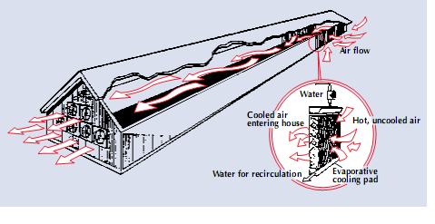
Picture-4: Tunnel ventilation & cooling pad system

4.10. Growing period management of Female bird
Management of female during production
To obtain the maximum numbers & size of hatching eggs through the entire production period female management is important.
1.Pullet & males should weighed weekly until 40 wks & thereafter weigh the bird at 2 wks interval through the end of the production period.
2. Feed increase according to production percentage. For 2% production , increase 1 gm feed/ bird.

Lighting:
It is well know that lighting patterns strongly influence the maturity of broiler breeders. However, applying the lighting programme properly demands an understanding of the physical development and response of these birds to lighting.
The lighting program during growing, production allows for a better control of age at sexual maturity in both males & females.This control is necessary to obtain the optimum number of fertile hatching age, of the correct size.The consequence of too early onset of production are often more detrimental than a slight delay.Too early light stimulation will cause egg bound of hen & death.
During production period , provide 1 bulb of 22wt for 100 sq.ft at 7 ft above.
Lighting schedule maintained in KEARI POULTRY:
Age | Lighting hours
1-2 wk | 24 hrs
3wk | 23 hrs
4 wk | 22 hrs
5 wk | 21 hrs
6 wk | 20 hrs
7 wk | 19 hrs
8 wk | 18 hrs
9 wk | 17 hrs
10 wk | 16 hrs
11 wk | 15 hrs
12 wk | 14 hrs
13 wk | 13 hrs
14-18 wk | 12 hrs
19 wk | 13 hrs
20 wk | 13.5 hrs
21 wk | 14 hrs
22 wk | 14.5 hrs
23 wk | 15 hrs
24 wk | 15.5 hrs
25 wks up to end | 16 hrs
Use 24-23 hrs light during first 3 wk to increase feed & water consumption
4.11. Male: significant contribution in breeding programme
Males should be rared separately from female. This separate rearing helps to design separate feeding programmes for males & females as per their needs & will help improve body weight uniformity. It is essential to check the males individually remove those having defects in leg, keel , back & the ones with poor health. At 23 wks only 3 % males are given to females.Gradually 8-9% males are given at 27-28 wks on the basis of production. The selected males should have straight & strong legs with good toes, joints & keels should be free from any defects.
Housing of males: When males are reared separately , it is advisable to place the males into laying house one week before the females. This helps the male to learn to eat from male feeders. Check male & female body weight ratios.Male should be at least 600-700 gm heavier than female at 24 wks of age.
Feeding of male: controlling of breeder male body weight is significant. Due to their genetic potential,growth rate, feed efficiency they are more heavy than females which makes them unable to mate. Adlibitum feeding are practiced for first 2 wks. At 21 days 60 gms feed are given which gradually increased to 127- 130 gms at 25 wks.It actually depends on production.Adult male require less protein & calcium than female.
Pre-breeder ration: The use of a pre-breeder feed from 105 days (15 weeks) of age is strongly recommended. This will provide sufficient amino acids and other nutrients for satisfactory development of reproductive tissues. Additional calcium may also be provided to ensure maximum development of medullary bone. Provision of extra vitamins will maximise levels in body tissues before egg production commences. Energy level in the pre-breeder feed should
4.12. Housing system
The birds were kept in the environmentally controlled house.The environmental temperature was controlled by cooling pad.There was also exhaust fan to remove the odor keeps the room cool always.
The house is facing east-west.
Length of house: 380 ft
Width of house: 45 ft
Cooling pad : 85 ft
Exhaust fan : 9
Roof of the house made by tin.
Floor system: Now-a-days the commercial broiler breeder hens are usually reared on different types of floor system. One of them is the slut cum litter system.In the study farm upon which my study was conducted the broiler breeders were reared on slat cum litter system of flooring.
Slat cum litter system: In this system, about two-third areas was covered with slats & one third areas was covered with litter materials.The litter used was rice husk with a depth of 6 inches. The slats were used in the house through the “ down the edge of house fashion”.In this system the middle area contain litter materials & the surrounding area covered with slats.The top of the slat was 16 cm above the top of the litter.
Ammonia control
Ammonia produced in the chicken house must be eliminated.The tolerable levelis 15 ppm. Above this level ammonia irritate the mucus membrane which may cause conjunctivitis, air sack leision.The cilliary activity of the trachea will be reduced. There will be increased succeptibility to coccidiosis & reduced growth rate due to less feed intake . To eliminate ammonia practice basic management practices- stocking density, increase water consumption ,adequate use of ventilation & correct use of fans.
4.13. Preparation of feed:
Parent stock can be fed successfully on mash, crumbled or pelleted feeds. The starter feed should be a crumble and thereafter a coarse meal is probably the first choice.
The feed that are supplied to the male & female breeders are produced according to nutritional specifications. The micronutrients are important for their effect on development & mineralization of bones. Fluctuation of a little amount effect on performance on cobb500.

Feed ingredients & amount used for feed formulation:
Name of ingredients | Amount in kg Female breeder (for 100 kg) | Amount in kg  Male breeder ( 100 kg)
Maize | 60.55 | 61.31
Soyameal | 24.35 | 14.44
Soya oil | 3.15 | 2.5
Rice polish | - | 4
Wheat bran | 1.28 | 12
Salt | .4 | .4
Limestone | 7.3 | 2.1
DCP | 1.8 | 1.8
Breeder premix | .4 | .4
Toxin binder | .3 | .3
Methionine | .16 | .15
Choline | .15 | .15
Lysine | .03 | .04
Enzyme | .05 | .05
Mineral | .05 | .05
AD sel | .03 | .3

Feeds are given manually in feeder through of the nest. Feed are given at 4.00 am once daily.There are separate feeder for male & female. Before distribution of feed , the feeder are down from the hanging condition.

4.14. Hatchery Management:
The production of good quality day old chicks from hatching eggs demands effective and frequent egg collections, appropriate and timely disinfection, cooling, storage and incubation of the eggs. Each of these processes has to be carried out so that the development of the embryo is not damaged. The best hatchability of fertile eggs is achieved when the eggs are kept in clean conditions and at the correct temperature and humidity from the time they are laid until when they are hatched.
4.14.1. Egg collection & hygiene :
Nest management: Naturally clean eggs maintain a greater potential hatchability and chick quality than soiled or contaminated eggs, regardless of the disinfection procedures used on the shell surface. Hens are more likely to use nests that satisfy the requirements of their natural laying behaviour (i.e. clean, dry, dimly lit and, secluded), and nest boxes should be of appropriate design. Nest boxes should be located where the birds will use them and should be at a height where they will not become contaminated with floor litter, or provide a refuge for females avoiding the males. Birds should be trained to use the nests prior to lay.
Nest Box Design: Nest boxes are usually assembled in 2- or 3-tier units allowing 1 nest/4 birds. The nest dimensions should be approximately 30cm (12in) wide x 35cm (14in) deep x 25cm (10in) high. The design should allow for good ventilation.

The eggs were collected 4 times daily at 8.00 am, 10.00 am,12.30 am , 4.00 pm. Remove & discard eggs unsuitable for hatching. These are-
- Dirty
- Cracked
- Small
- Very large or double yolk
- Poor shells
- Grossly mis-shapen
- Wrinkled egg
Pictured below are some eggs that may cause problems and should be considered for rejection:
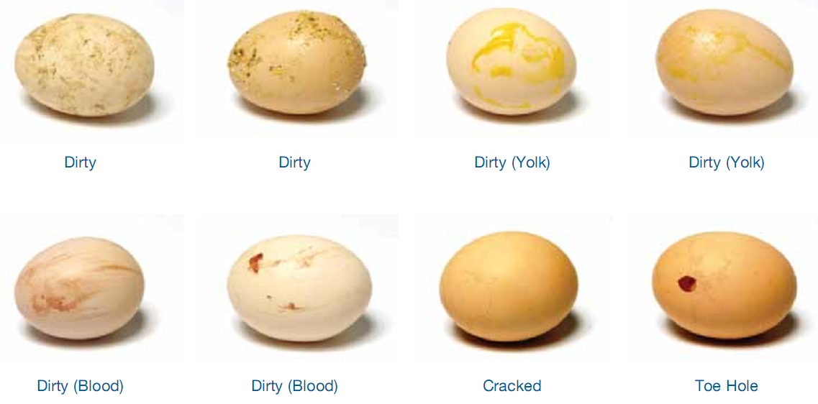
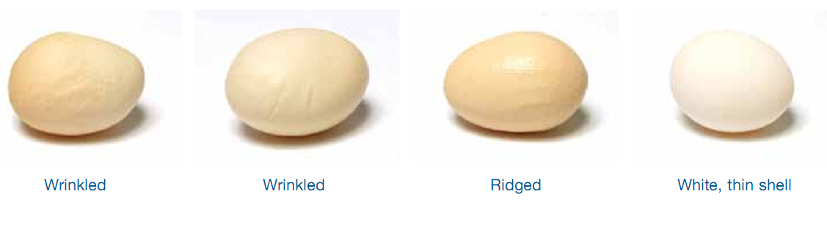
Picture-5: The rejected egg
4.14.2. Transporting of hatching eggs from shed to hatchery & storage
Egg were transported from farm to hatchery by their own disinfected vehicle, After loading of egg fumigation is not done.
Storage of eggs: Eggs were stored on the basis of market demand & capacity of the incubator.The humidity was 85%.The temperature depends on the storage period.Temparature are lowered to prevent the embryo development. The air should move freely around & between all eggs. If storage period longer it is essential to lower temperature to maintain internal egg quality.

Period of storage | 0-4 days | 5-7 days | 8-14 days
Temparature | 17-18°C | 16-17°C | 14-16°C
Relative humidity | 80% | 85% | 85%
Egg positon | Broad end up | Broad end up | Broad end down

There are three storage areas: farm egg room,transport & hatchery egg room.It is necessary to maintain same temperature & humidity in all storage areas. A relationship exists between the length of time eggs are stored & the optimum temperature & humidity for best hatchability. Generally , the longer eggs are to be stored ,the lower the storage temperature & vice versa.
When the eggs are stored for over 7 days ,then turning is required.

4.14.3. INCUBATOR & HATCHER
There are 3 types of incubator used in KEARI hatchery
1.Linco,Denmark: Capacity of the setter is 1,20,960 . Capacity of the hatcher is 20160.
2. Diamond,India: There are total 7 setter machine in the hatchery. Capacity of each setter & hatcher machine is 50,880 & 72000 respectively.
3. Nature farm, USA : The capacity of setter machine is 1,15,200. The capacity of hatcher is 38,400.
Temparature & humidity maintained in all types of incubator .
 | Temparature | Humidity
Setter | 99.5°F | 87
Hatcher | 98.5°F | 88-90

4.14.4. Preparation of setter & loading of eggs in setter
All the setting trays were washed with water & bleaching powder.Then the trays were sprayed with antiseptic solution @ 3ml/L water. Then the trays were dried in the sunlight. Before setting of eggs setter has to be fumigated by mixing 40 cc formaldehyde & 20 gm potassium permanganate for each 9.3 sq.meter space.The pot where the chemicalswere mixed should be large enough.After keeping the pot in setter the door has to be immediately closed for 1 hr. After fumigation eggs were trayed vertically with the broad end uppermost & pointed end downwards. Second fumigation was made in the setter after placing of egg trays by 17.5 gm potassium permanganate & 25 cc formalin for each 9.3 sq.m for 30 min. Then machine was started.A thermometer was fitted in inside the incubator for maintaining proper tempareture. The incubator has a glass window fitted infront of the hatching egg tray.For best hatch results 21% Oxygen & .5 % carbon-di-oxide are reqired . Eggs remain in setter for 18 days.
4.14.5. Turning of eggs
Eggs must be turned during incubation.This prevents the embryo from sticking to shell membranes, particularly duringnthe first week of incubation & aids development of the embryonic membranes. As emryo develop & their heat production increases regular turning will aid airflow & assist cooling.
In the setter machine eggs were set by large end up. Eggs were turned in every 1 hour interval, if manually then at 2 hrs interval till 18th day of incubation.Eggs were checked after 15 days of the setter machine by using bulb box. Checking was done to determine bursting of eggs. No checking is done in Denmark incubator of india due to difficulty & structure of the machine.

4.14.6. Preparation of hatcher & transfer of eggs from setter to hatcher
Eggs are removed from setter after 18 days & transferred to hatcher trays. Some points must be considered:
1)The transfer operation should proceed smoothly & quickly to avoid cooling the eggs as this will delay hatching.
2)Shells are more brittle at this stage because the embryos have withdrawn some of the shell calcium for skeletal development. Therefore care must be taken when transferring eggs to avoid breakages.
3) Ensure the hatcher trays are properly washed & allowed to dry before eggs are transferred.Eggs in wet trays will cool down while the water is evaporating in the hatcher.
When piping occurs within 5-10% eggs. Then eggs were transferred from setter to hatcher. Before transferring eggs, hatcher trays were removed,cleaned,washed & in the same way as the setter trolley.Then fumigation was done in the hatchery by using ventilators & the door remain closed.The hatcher door remain closed for at least 1 hr . Then all ventilators & the door were opened.Formalin was taken in a plate & kept at the corner of the machine . A correct functioning thermometer & hygrometer was kept visible in each hatcher. The water from the egg during incubation influence the quality of chicks.If more water loss from the egg the following result are found such as Dry chicks, small chicks,early hatch, reduced hatch etc.If less water loss from the egg the following result are found such as unhealed navels, weak chicks,red hock, delay hatch etc. ( Mahmud jamil 2003)
4.14.7. Grading of chicks
After hatching chicks were graded in two categories-
Grade-A:
- Round bright eyes,sturdy legs,ability to stand firmly
- Healed navels
- Trueness of type
- Freedom of any deformity
Grade-B:
- Chicks with unhealed navels stand up well.
Rejected chick: The chick with crooked legs or toes,odd shaped beaks,eyes missing,pasty vents are discarded.
But the problem is that many grade B chicks they include under grade A whether unhealed navels and minor deformities.

4.14.8. Packaging & delivery of the chick
After grading , the chicks are packaged.There is four chamber in packet each contain 10 chick, in total 40 chick. After packaging The chicks are placed in chick holding room.
4.14.9. Disposal of hatchery waste
With an average of 85% hatchability, 15% of the eggs will be either infertile or contain embryos.These eggs together with the eggshells that remain after pulling chicks, constitute hatchery waste. Legislation in some countries now prohibits the incorporation of hatchery waste into by product meal due to the risk of spreading pathogenic organisms. The all waste are placed in a container & disposed away from hatchery.

Keari Poultry Hatchery &Process Ltd
Magurjura,Trishal,Mymensingh
Comparative study between std. value with actual value(Weekly Basis) of Flock no 32
Table 1: 1st wk – 10th wk
 |  | Age in Wk
Index | Parent | 1st |  | 2nd |  | 3rd |  | 4th |  | 5th |  | 6th |  | 7th |  | 8th |  | 9th |  | 10th
 |  | Act. | Std. | Act. | Std. | Act. | Std. | Act. | Std. | Act. | Std. | Act. | Std. | Act. | Std. | Act. | Std. | Act. | Std. | Act. | Std.
Mortality | Female | 0.24 | 0.2 | 0.5 | 0.2 | 0.36 | 0.2 | 0.2 | 0.2 | 0.1 | 0.2 | 0.1 | 0.2 | 0.1 | 0.2 | 0.1 | 0.2 | 0.1 | 0.2 | 0.12 | 0.2
 | Male | 0.3 | 0.2 | 0.98 | 0.2 | 0.22 | 0.2 | 0.4 | 0.2 | 0.2 | 0.2 | 0.2 | 0.2 | 0.5 | 0.2 | 0.22 | 0.2 | 0.13 | 0.2 | 0.45 | 0.2
Body Wt(g) | Female | 145 | 115 | 241 | 214 | 320 | 338 | 443 | 454 | 576 | 566 | 692 | 666 | 828 | 766 | 940 | 866 | 960 | 966 | 1012 | 1066
 | Male | 155 | 145 | 315 | 300 | 395 | 495 | 615 | 710 | 823 | 890 | 970 | ### | 1167 | 1205 | 1268 | 1335 | 1366 | 1455 | 1615 | 1692
Feed(g) | Female | Adlib | 25 | 30 | 29 | 33 | 33 | 42 | 39 | 47 | 44 | 50 | 46 | 52 | 48 | 53 | 50 | 54 | 52 | 56 | 54
 | Male | Adlib | 26 | 34 | 34 | 40 | 42 | 50 | 52 | 62 | 59 | 67 | 64 | 68 | 65 | 70 | 66 | 75 | 68 | 77 | 71
Egg Pron(%)
Egg Wt(g)
Chick pron(%)

Table 2: 11th wk – 20th wk
 |  | Age in Wk
Index | Parent | 11th |  | 12th |  | 13th |  | 14th |  | 15th |  | 16th |  | 17th |  | 18th |  | 19th |  | 20th
 |  | Act. | Std. | Act. | Std. | Act. | Std. | Act. | Std. | Act. | Std. | Act. | Std. | Act. | Std. | Act. | Std. | Act. | Std. | Act. | Std.
Mortality% | Female | 0.12 | 0.2 | 0.07 | 0.2 | 0.09 | 0.2 | 0.05 | 0.2 | 0.05 | 0.2 | 0.07 | 0.2 | 0.09 | 0.2 | 0.02 | 0.2 | 0.0 | 0.2 | 0.03 | 0.2
 | Male | 0.37 | 0.2 | 0.07 | 0.2 | 0.07 | 0.2 | 0.22 | 0.2 | 0.15 | 0.2 | 0.0 | 0.2 | 0.15 | 0.2 | 0.07 | 0.2 | 0.22 | 0.2 | 0.3 | 0.2
Body Wt(g) | Female | 1145 | 1166 | 1290 | 1266 | 1420 | 1366 | 1471 | 1467 | 1614 | 1567 | 1694 | 1668 | 1840 | 1778 | 1940 | 1906 | 2105 | 2053 | 2260 | 2204
 | Male | 1615 | 1692 | 1834 | 1805 | 1971 | 1918 | 2110 | 2030 | 2237 | 2153 | 2324 | 2275 | 2440 | 2406 | 2600 | 2574 | 2670 | 2693 | 2814 | 2845
Feed(g) | Female | 58 | 56 | 60 | 56 | 63 | 60 | 65 | 62 | 68 | 65 | 72 | 70 | 77 | 75 | 82 | 81 | 89 | 88 | 97 | 96
 | Male | 80 | 73 | 82 | 75 | 82 | 77 | 84 | 80 | 84 | 82 | 87 | 86 | 88 | 91 | 90 | 95 | 93 | 99 | 97 | 103
Egg Pron(%)
Egg Wt(g)
Chick pron(%)
Table 3: 21th wk – 28th wk
 |  | Age in Wk
Index | Parent | 21th |  | 22th |  | 23th |  | 24th |  | 25th |  | 26th |  | 27th |  | 28th
 |  | Act. | Std. | Act. | Std. | Act. | Std. | Act. | Std. | Act. | Std. | Act. | Std. | Act. | Std. | Act. | Std.
Mortality% | Female | 0.02 | 0.2 | 0 | 0.2 | 0.05 | 0.2 | 0.01 | 0.2 | 0.02 | 0.2 | 0.06 | 0.2 | 0.12 | 0.2 | 0.12 | 0.2
 | Male | 0.15 | 0.2 | 0 | 0.2 | 0 | 0.2 | 0.22 | 0.2 | 0.6 | 0.2 | 0.8 | 0.2 | 0.68 | 0.2 | 0.6 | 0.2
Body Wt(g) | Female | 2372 | 2357 | 2566 | 2516 | 2716 | 2675 | 2896 | 2830 | 3002 | 2970 | 3109 | 3105 | 3240 | 3230 | 3326 | 3320
 | Male | 3042 | 3001 | 3200 | 3116 | 3399 | 3333 | 3510 | 3501 | 3640 | 3624 | 3615 | 3708 | 3830 | 3774 | 3845 | 3830
Feed(g) | Female | 105 | 104 | 115 | 113 | 123 | 121 | 130 | 130 | 135 | 139 | 141 | 148 | 155 | 158 | 167 | 167
 | Male | 105 | 109 | 114 | 114 | 117 | 118 | 121 | 122 | 128 | 125 | 130 | 128 | 133 | 131 | 135 | 131
Egg Pron(%) |  |  |  |  |  |  |  |  |  | 4.56 | 5.5 | 21.46 | 21.9 | 45.82 | 52.3 | 65.69 | 73.7
Egg Wt(g) |  |  |  |  |  |  |  |  |  | 50.9 | 50.4 | 51.75 | 52.3 | 54.1 | 53.9 | 56.39 | 55.5
Chick pron(%) |  |  |  |  |  |  |  |  |  | 55.7 | 65.5 | 70.15 | 73.5 | 80.9 | 78.3 | 81.53 | 81.3

Table 4: 29th wk – 34th wk
Index | Parent | 29th |  | 30th |  | 31th |  | 32th |  | 33th |  | 34th
 |  | Act. | Std. | Act. | Std. | Act. | Std. | Act. | Std. | Act. | Std. | Act. | Std.
Mortality% | Female | 0.1 | 0.20 | 0.15 | 0.20 | 0.15 | 0.20 | 0.19 | 0.20 | 0.16 | 0.20 | 0.19 | 0.20
 | Male | 0.6 | 0.20 | 0.68 | 0.20 | 0.60 | 0.20 | 0.45 | 0.20 | 0.60 | 0.20 | 0.75 | 0.20
Body Wt(g) | Female | 3338 | 3395 | 3552 | 3437 | 3560 | 3469 | 3580 | 3496 | 3582 | 3518 | 3585 | 3533
 | Male | 3865 | 3858 | 3950 | 3885 | 4000 | 3912 | 4005 | 3939 | 4000 | 3966 | 4120 | 3993
Feed(g) | Female | 170 | 167 | 174 | 170 | 175 | 170 | 175 | 170 | 175 | 170 | 175 | 170
 | Male | 135 | 131 | 135 | 132 | 135 | 132 | 135 | 133 | 135 | 133 | 135 | 134
Egg Pron(%) |  | 78.94 | 82.7 | 84.96 | 86.3 | 86.79 | 88.2 | 85.58 | 87.6 | 85.46 | 86.5 | 83.92 | 85.3
Egg Wt(g) |  | 56.87 | 56.8 | 58.28 | 58.0 | 60.43 | 59.0 | 61.43 | 59.8 | 61.67 | 60.4 | 61.54 | 61.0
Chick pron(%) |  | 84.46 | 83.7 | 82.5 | 85.7 | 85.81 | 87.2 | 83.12 | 88.4

Table 5: 35th wk – 42 th wk
Index | Parent | 35th |  | 36th |  | 37th |  | 38th |  | 39th |  | 40th |  | 41th |  | 42th
 |  | Act. | Std. | Act. | Std. | Act. | Std. | Act. | Std. | Act. | Std. | Act. | Std. | Act. | Std. | Act. | Std.
Mortality% | Female | 0.2 | 0.20 | 0.14 | 0.20 | 0.24 | 0.20 | 0.24 | 0.20 | 0.24 | 0.20 | 0.25 | 0.20 | 0.24 | 0.20 | 0.28 | 0.20
 | Male | 0.60 | 0.20 | 0.75 | 0.20 | 0.75 | 0.20 | 0.45 | 0.20 | 0.53 | 0.20 | 0.68 | 0.20 | 0.53 | 0.20 | 0.53 | 0.20
Body Wt(g) | Female | 3560 | 3548 | 3565 | 3563 | 3570 | 3578 | 3610 | 3593 | 3625 | 3608 | 3680 | 3623 | 3650 | 3638 | 3660 | 3653
 | Male | 4110 | 4020 | 4120 | 4047 | 4135 | 4074 | 4151 | 4101 | 4165 | 4128 | 4162 | 4155 | 4192 | 4182 | 4250 | 4209
Feed(g) | Female | 174.18 | 170 | 174.4 | 170 | 173.8 | 170 | 173.8 | 169 | 173.8 | 169 | 173 | 169 | 172 | 168 | 172 | 168
 | Male | 131.35 | 134 | 130 | 135 | 129.2 | 135 | 128 | 136 | 128 | 136 | 129 | 137 | 129 | 137 | 130 | 138
Egg Pron(%) |  | 82.72 | 84.3 | 81.74 | 83.2 | 80.48 | 82.2 | 79.62 | 81 | 78.02 | 79.9 | 76.62 | 78.9 | 74.92 | 77.8 | 72.72 | 76.8
Egg Wt(g) |  | 61.8 | 61.6 | 62.02 | 62.1 | 62.47 | 62.5 | 62.9 | 62.9 | 62.53 | 63.3 | 63.21 | 63.7 | 63.5 | 64.0 | 63.71 | 64.4
Chick pron(%) |  | 88.6 | 89.3 | 85.18 | 89.4 | 86.94 | 89.5 | 88.11 | 89.6 | 86.8 | 89.7 | 86.46 | 89.7

Table 6: 43th wk – 50th wk
Index | Parent | 43th |  | 44th |  | 45th |  | 46th |  | 47th |  | 48th |  | 49th |  | 50th
 |  | Act. | Std. | Act. | Std. | Act. | Std. | Act. | Std. | Act. | Std. | Act. | Std. | Act. | Std. | Act. | Std.
Mortality% | Female | 0.31 | 0.20 | 0.28 | 0.20 | 0.25 | 0.20 | 0.27 | 0.20 | 0.31 | 0.20 | 0.16 | 0.20 | 0.32 | 0.20 | 0.29 | 0.20
 | Male | 0.53 | 0.20 | 0.45 | 0.20 | 0.68 | 0.20 | 0.53 | 0.20 | 0.45 | 0.20 | 0.45 | 0.20 | 0.45 | 0.20 | 0.53 | 0.20
Body Wt(g) | Female | 3685 | 3668 | 3692 | 3683 | 3712 | 3698 | 3725 | 3714 | 3682 | 3728 | 3685 | 3744 | 3687 | 3758 | 3695 | 3773
 | Male | 4300 | 4236 | 4315 | 4263 | 4317 | 4280 | 4332 | 4317 | 4300 | 4344 | 4300 | 4371 | 4320 | 4398 | 4325 | 4425
Feed(g) | Female | 172 | 167 | 172 | 166 | 170 | 166 | 170 | 166 | 169 | 165 | 169 | 164 | 169 | 163 | 168 | 162
 | Male | 134 | 139 | 135 | 139 | 136 | 140 | 136 | 140 | 137 | 140 | 137 | 141 | 138 | 141 | 140 | 142
Egg Pron(%) |  | 73.05 | 75.6 | 73.28 | 74.6 | 75.49 | 73.5 | 73.2 | 72.4 | 71.95 | 71.30 | 71.21 | 70.2 | 69.54 | 69.2 | 67.37 | 68.1
Egg Wt(g) |  | 64.16 | 64.7 | 66.16 | 65.1 | 66.16 | 65.4 | 66.16 | 65.8 | 65.16 | 66.1 | 65.16 | 66.5 | 65.16 | 66.8 | 65.16 | 67.2
Chick pron(%) |  | 84.4 | 89.5 | 82.5 | 89.3 | 83.28 | 88.9 | 79.19 | 88.6 | 80.03 | 88.2 | 77.34 | 87.8 | 73.76 | 87.3 | 65.81 | 86.9

The egg production achieved at 25th weeks of age was 4.56% which was lower than recommended production i.e. 5.5%. The peak production was 86.79% achieved at 31th week of age. There were 2% less egg production than standard.
The maximum hatchability% was observed 88.6% at 35th week of age. Hatchability were always lower than standard.

Figure-1 : Graphical representation of egg production

Above Bar chart shows the Actual & Standard value of egg production percentage at 5 different weeks.
Laying starts at 25th wk with a lower percentage which is about 4.56%. Peak production is achieved at 31th wk with 86.79%. At 31th,37 th & 43 th wks there are 2% variation between actual & standard value but at 49th wk, there is a little deviation.

Figure-2: Graphical representation of hatchability.

Above Bar chart illustrate the actual & standard value of Hatchability at 4 random wks.
Hatchability starts from 55.7% with 5 % deviation from the actual value. Peak production arrives at 35 th wk which is about 88.6%. At 50th wk there is a great deviation of actual value from standard value.

CHAPTER- 5
PROBLEMS & RECOMMENDATION

KEARI Poultry hatchery contribute 9-10% of total chick supply in Bangladesh. Although it is a well recognized farm , it has some limitation which are hindrance to be a Model poultry farm.

Major important point for from technical view
- Residence must be avoid from inside the farm and establishing residence near but out side the farm
- Out side of the shed area would be filled with sand or soil
- Need feed and rice husk storage room in side the farm area
- Office room with other facilities for technical person in shed area
- Set up auto spray and shower room in main gate
- Any vehicle should not be allow in the shed area or allow by special condition
- Provide special individual vehicle for feed and egg carrying
- Established modern egg store room
- Feeding system must be replace by auto feeding system
- Scientific pit for disposal of dead birds
- Automatically temperature and humidity control
- Develop/set up modern or digital temperature recording system of the shed
- Established diagnostic lab. with veterinary doctor
- Increasing manpower in different view
- Established cantin and mosque in side the farm
- Develop security system
- Supply available spare instrument
- Set up CC camera in the farm area
- Emergency alarm system would be established
- Repair boundary wall
- Any vehicle should not be allow in the shed area or allow by special condition
- Provide special individual vehicle for feed and egg carrying
- Feeding system must be replace by auto feeding system
- Scientific pit for disposal of dead birds
- Develop/set up modern or digital temperature recording system of the shed
- Moisture detecting meter

CHAPTER- 6
CONCLUSION

The target of raring a broiler parent stock is to achieve a healthy day-old-chick.But it depends upon
- An environment that is managed to provide birds with all their requirements for ventilation, air quality, temperature and space.
- The prevention, detection and treatment of ill health.
- The provision of nutrient requirements through the compounding of appropriate feed ingredients, and the proper management of the provision of feed and water.
- Attention to bird welfare throughout, especially prior to processing.
All of these are interdependent. If any one element is sub-optimal, then broiler performance overall will suffer.
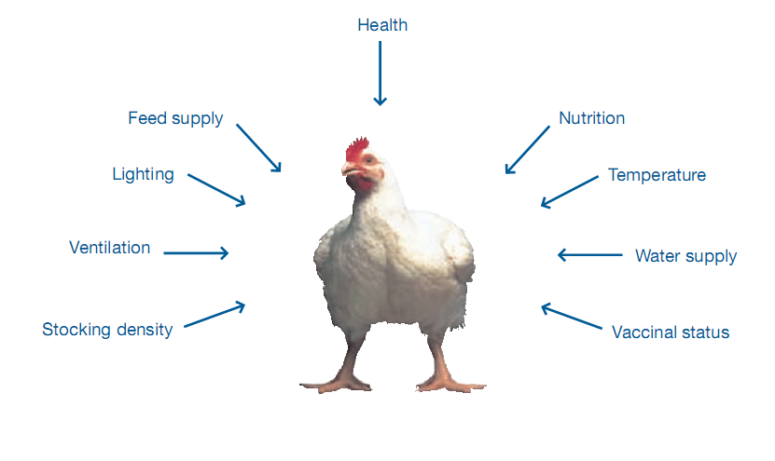
Picture-6: Limits to broiler growth & quality

From the overall study it is concluded that, it is possible to all sorts of production from Cobb 500 broiler breeder parent stock.
The egg production achieved at 25th weeks of age was 4.56% which was lower than recommended production i.e. 5.5%. The peak production was 86.79% achieved at 31th week of age. There were 2% less egg production than standard.
The maximum hatchability% was observed 88.6% at 35th week of age. Hatchability were always lower than standard.Hatchability was lower due to not maintaining of all practices after egg collection to hatching of eggs.

REFERENCES

Bell, D.D.and W.D.Jr. Weaver, 2002. Commercial chicken Meat & Egg production . 5 th.Ed.,Cambridge, Massachusetts., Kluwer Academic Publisher.

Bhuyian, M.F.A 2007 Environment friendly poultry management: Prospect of organic fertilizer ( Poribesh sohayik poultry borjo babosthapona, Joybo sarer sombhabona). Farm house- A monthly agribusiness magazine, Dhaka-1212. 1: 35-36.

Chowdhury , S.D, Das C, Pramanik, H.A.M Roy, C.R, and Shaha. K.S (2003). Broiler parent stock production in Bangladesh: It is possible to achieve target body weight & acceptable uniformity in open sided house. Proc 3rd WPSA International Poultry Show and Seminar PP: 15-23.

Cobb 500 Breeder management guide 2009.

Elibol, O.,S.D, Peak and J Brake,2002.Effect of flock age, length of egg storage and Frequency of turning during storage on hatchability of broiler eggs. Poultry. Sci., 81: 945-950

Farm poultry & livestock survey 2007-2008,Nov 2010, BD Bureau of statistics

Grobas, S., Mendez, C.De Blas & GG Mateos 1999. Laying hen productivity as affected by energy, Supplemental fat & linoleic acid concentration of the diet. Poultry science 78., 1542-1551.

Heier, B.T., & J. Jarp. 2001 An epidemiological study of the Hatchability in broiler breeder flocks.Poultry science . 80 (8) : 1132-1138.

Kraczyk. J.E., Herbut, and S. Wezyk. 2001. Labour requirements of broiler chicken production depending on technological solutions in the broiler house. Annals of animal science. 1 (1): 213-219

Krishnappa, P. Devagowda, GR and Ramappa, B.S (1992) Effect of restricted feeding on subsequent performance of broiler breeders dams. Indian journal of poultry science 27:1, 29-31.

Robinson, FE, R.A. Renama, J.J.R Feddes, M.J Zuidhof and Wilson J.L ( 1999) Egg production and fertility traits of broiler breeder hens as influenced by strain and early feed allocation: poultry science (Supp 11) 17.

