CHAPTER I
INTRODUCTION

Livestock is one of the most potential sub-sectors of agriculture in Bangladesh which plays an indispensible role to promote human health and national economy of the country In recent years, there has been increasing recognition of the importance of livestock to the poor, with estimates indicating that at least 70% of the rural poor depend on livestock for part of their livelihoods (Livestock in Development, 2006). As such, there is an increasing demand for a better understanding of the role of livestock in poverty reduction. However, most interventions did not have an explicit focus on the poor (Livestock In Development, 1998) and little information has been generated on the impact of livestock-oriented projects on the rural poor.
Bangladesh is a moderately hot and humid country with short winter and prolonged rainy season. Among the parasites, tick (ectoparasites) and endoparasites are very common. They are voracious blood suckers regardless sex and developmental stage. They continuously suck blood for long time, usually for 3-5 (Kettle, 1995) days resulting anaemia, malnutrition, and eventually reduce productivity of the host (Soulsby, 1982).
Ticks and tick borne diseases (TTBDs) are widely distributed throughout the world particularly in tropical and subtropical countries. Endemic diseases such as tick-borne diseases particularly anaplasmosis, babesiosis and theileriosis which have considerable economic importance locally and regionally (Mc Cosker, 1979).
Anaplasmosis is common in tropical and subtropical countries and lead to meat and milk production losses in ruminants (Uilenberg, 1995). Identification of Anaplasma species is based on morphology, host specificity, transmission mode, tick vector competency and epidemiological data. As different species share a similar morphology and tick vector data are not always available, differential diagnosis for a particular species is difficult. Information regarding to the epidemiology of tick-borne hemoprotozoan diseases, such as dynamics of transmission by the tick vector, is important for the development of effective control strategies (Morzaria et al., 1992).
The hot and humid weather of Bangladesh favors the growth and multiplication of arthropods vector like tick, flies, mosquitoes that are responsible for transmission of different causative agents from diseased animal to healthy animal resulting different disease including babesiosis, anaplasmosis, theileriosis etc.
Anaplasmosis is an infectious disease of goat caused by several species of the blood parasite Anaplasma. A. marginale is the most common pathogen of cattle. Sheep and goats are much less commonly affected. Anaplasmosis is also called “yellow bag” or “yellow fever” as affected animals can develop a jaundiced appearance. Anaplasmosis is seen worldwide (Smith, 2002). Anaplasmosis is a tick transmitted hemorickettsial infection and babesiosis is tick transmitted hemoprotozoan infection of cattle. Both diseases have got a serious economic impact due to obvious reason of death, decreased production and lowered working efficiency. Both diseases have been reported in Bangladesh. The agro-ecological and geo-climatic conditions of Bangladesh are highly favourable for growth and multiplication of ticks which act as natural vectors of babesiosis and anaplasmosis (Ahmed, 1976; Samad and Gautam, 1984). There are many research works are done on Hemo-parasitic diseases at different regions in Bangladesh but veterinary clinical based works are not available which is very important. The study was undertaken in Dinajpur Sadar region, Bangladesh with the following objectives.
1) To know the prevalence of Anaplasmosis in goat in Dinajpur Sadar region.
2) To know the relationship between ectoparasites and Anaplasmosis in goat.
3) To know the prevalence of Anaplasmosis in goat based on age, sex, breed and tick infestation of the goat.

CHAPTER II
REVIEW OF LITERATURE
Climatic condition of Bangladesh favours the tick population, which are vectors of various tick borne diseases. Prevalence of tick borne protozoan parasites such as Babesia bigemina, Theileria mutans, Anaplasma centrale, Anaplasma marginale, Babesia bovis, Babesia gibsoni, Babesia canis and Theileria ovis has been reported in animals of Bangladesh. Therefore, few important literatures related to these diseases are reviewed here.
2.1: Anaplasmosis
Bram (1983) found that anaplasmosis is characterized by fever, severe anemia, jaundice, brownish urine, loss of appetite, dullness or depression, rapid deterioration of physical condition, muscular tremors, constipation, yellowing of mucous membrane and labored breathing. Merck Veterinary Manual (1997) published that anaplasmosis, formerly known as Gall sickness, traditionally refers to a disease of ruminants caused by obligate intra-erythrocytic bacteria of the order Rckettsiales, family Anaplasmataceae, genus Anaplasma.
2.2: Etiology of anaplasmosis
Bram (1983) found that there are many Anaplasma species parasites but Anaplasma marginale and Anaplasma centrale are the most important species. Goat anaplasmosis is usually caused by Anaplasma marginale .
Ristic and Weinman (1968) mentioned that clinical anaplasmosis is usually caused by Anaplasma marginale. Goat is also infected with Anaplasma centrale, which generally results in mild disease.
2.3: Epidemiology of Anaplasmosis
2.3.1: Geographical occurrence
Smith (2002) showed that anaplasmosis is seen worldwide and has been reported in at least 40 states in the USA. Gautam et al. (1982) that the animals show clinical diseases under stress of certain intercurrent diseases, inclement weather, pregnancy and lactation. The exotic and to lesser extent crossbred animals are fully susceptible. The disease causes direct losses due to prolonged period of convalescence, low productivity and mortality.
Blood et al. (1968) found that anaplasmosis is transmitted by a diverse group of biological and mechanical vectors. Infection in goat is endemic in tropical and subtropical areas that support large population of these vectors. Infection occurs sporadically in temperate climate areas. Lew and Jorgensen (2005) mentioned that anaplasmosis occurs in tropical and subtropical regions worldwide (~40° N to 32° S), including Asia.
2.3.2: Mode of infection
Ristic and Weinman (1968) mentioned that Anaplasma is one of the most important parasites transmitted by at least 20 ticks species, including Argas persicus, Ornithodoros lahorensis, Boophilus annulatus, B. decoloratus, B. microplus, Dermocentor albipictus, D. andersoni, D. accidentalis, D. variabilis, Hyalomma excavatum, Ixodes ricinus, Rhipicephalus bursa, R. sanguineus and R. simus (Marchette and Stiller, 1982) but mostly Boophilus microplaus causing Anaplasmosis (TFRC, 1996). Various other biting arthropods have been implicated as mechanical vectors. Experimental transmission has been demonstrated with a number of species of Tabanus (Horse fly) and with mosquitoes of the genus Psorophora.
Ristic (1996) found that the experimental and epizootiological evidence incriminates horse flies (Tabanus spp.) as the most significant insect vector of anaplasmosis. Transmission by flies is affected by direct transfer of blood from infected to susceptible cattle and must take place within a few minutes after feeding on an infected animal.
Blood et al. (1968) reported that anaplasmosis is spreaded from animal occurs chiefly by insect vectors. A variety of arthropods may act as vectors but significant natural vectors are ticks in the family Ixodidae and flies in the family Tabanidae. Of ticks, the one –host Boophilus spp. are major importance in tropical and subtropical regions and three- host Dermocentor spp. major importance in the Western USA.
Merck Veterinary Manual (1996) published that numerous species of tick vectors (Boophilus, Dermocentor, Rhipicephalus, Ixodes, Hyaloma and Ornithodoros) can transmit Anaplasma spp. after feeding on an infected animal. Transplacental transmission has been reported and is usually associated with acute infection of the dam in the second or third trimester of generation. Anaplasmosis may also be spread through the use of contaminated needles or dehorning or other surgical instruments.
Soulsby (1986) found that transmission by blood sucking flies is well recognized and Tabanids deer flies, stable flies and mosquitoes are the insects chiefly concerned. Direct transfer of infected blood must take place for insect transmission and this must occur within a few minutes after feeding on an infected animal. Mechanical transmission of anaplasmosis is well known and major and minor operations in cattle husbandry such as dehorning, castration, vaccination, blood sampling etc. may be responsible for the transmission of Anaplasmosis both in and out of season.
2.4: Risk factors
2.4.1: Susceptible host
Blood et al. (1968) mentioned that breeds with black or red coat color have a higher risk of infection than those with white coats in regions where biting flies are the insect vectors. Shompole et al. (1989) found that Anaplasma ovis and A.marginale infect the goats. Anaplasma species are obligate intraerythrocytic parasites in the order Rickettsiales which infect domestic and wild ruminants transmitted biologically by certain tick species and mechanically by other blood sucking arthropods.
Maas and Buening (1981) found that Anaplasma marginale also causes latent anaplasmosis in sheep and goats. Bazargani et al. (1985) showed that goat can also be a susceptible host for Anaplasma ovis.
2.4.2: Nutritional status
Blood et al. (1968) mentioned that clinical disease is less severe in animal on a low plane of nutrition. Exposure of infected, clinically normal animals to devitalizing environmental influences, particularly shortage of feed and the presence of other diseases may result in the development of acute introduced into outbreaks among them are not uncommon after 2-3 weeks of entry.
2.4.3: Season
Blood et al. (1968) mentioned that in temperate climates, a seasonal occurrence of disease occurs in association with seasonal occurrence of the insect vectors. Winter outbreaks are likely associated with iatrogenic transmission or possibly the winter tick.
Fourie et al. (1989) reported that in southwestern Orange Free State, most cases occurred in the first week in May, but the timing of outbreaks varied with latitude; it is possible that rainfall and low temperature have an influence on when outbreaks occur.
2.5: Clinical signs of Anaplasmosis
Barry and van Niekerk (1990) reported that anaplasmosis is suspected of causing abortions in goats that are subjected to physical stress, such as walking long distances during the dry seasons. Therefore this parasite may be of economic importance under certain conditions. Tick paralysis caused by a toxin produced by some species of ticks, such as the Karoo paralysis tick Ixodes rubicundus, is the most economically important tick problem in South Africa. It affects sheep, goats and cattle.
Bram (1983) mentioned that anaplasmosis is characterized by fever, severe anemia, jaundice, brownish urine, loss of appetite, dullness or depression, rapid deterioration of physical condition, muscular tremors, constipation, yellowing of mucous membrane and labored breathing.
Urquhart et al. (1996) reported that the clinical features include pyrexia, anorexia, labored breathing and severe drop in milk yield or abortion. Occasionally per acute cases occur, which usually die within a day of the onset of clinical signs.
Splitter et al. (1956) found that experimental inoculation of goats with A. ovis induces an acute disease characterized by depression, anorexia, fever, and progressive anemia.
2.6: Post-mortem findings of Anaplasmosis:
Blood et al. (1968) reported that the most obvious findings are emaciation, pallor of the tissues and thin watery blood. There is mild jaundice and the liver is enlarged and deep orange in color. The kidneys are congested and there may be myocardial hemorrhages. The spleen is enlarged with soft pulp. The bone marrow cavity may be redden by increased hematopoietic tissue in acute case but there may be serious atrophy of bone marrow fat in chronic case.
Ristic (1996) reported that the gross pathological changes are typical of anemia in which erythrocytes are removed by the reticuloendothelial system. The prominent changes are icterus, pale mucous membrane, enlarged spleen and obstructed gall bladder. Petechial hemorrhage may be observed on the epicardiam and pericardiam and the heart is usually pale and flabby. The liver may be mottled yellow or brown, hepatic and mediastinal lymphnodes are brown and moist on section.
2.7: Diagnosis of Anaplasmosis
Splitter et al. (1956) and Shompole et al. (1989) reported that based on the intraerythrocytic location of inclusion bodies, as a conventional diagnostic method, A. ovis is differentiated from A. marginale.
Lew and Jorgensen (2005) and Lew et al. (2002) reported that the PCR, as a more sensitive and specific technique than other conventional methods, has been increasingly applied to diagnose anaplasmosis in blood and tick vectors.
Ristic (1996) reported that during the acute stage of anaplasmosis, the diagnosis is made on the basis of clinical symptoms, hematological changes and microscopic examination of stained peripheral blood films for intraertthrocytic inclusion bodies. Giemsa staining is the oldest and most frequently used method. Other staining methods include toluidine blue and acridine orange. The latter method, an ultraviolet microscope is used for visualization of the intraertthrocytic inclusion bodies.
Blood et al. (1968) reported that anaplasma organism can be diagnosed by the blood smear prepared from the peripheral blood. Diff-Quick staining of blood smears is as accurate as Giemsa in the detection of Anaplasma spp. It can be completed in 15 seconds where as Giemsa staining took an hour.
Ristic (1996) reported that various soluble and corpuscular antigens extracted from the blood of infected animals have been used for serologic diagnosis of anaplasmosis. Currently used tests are Complement Fixation (CF), Capillary Tube Agglutination (CTA) and Card Agglutination (CD). Blood et al. (1968) reported that the complement fixation test is the standard test for the detection of carrier animals. It is satisfactory for use in cattle, goat and sheep but antibody titer is highest during the active phase of the disease. A rapid card agglutination test, which tests serum or plasma for antibodies against Anaplasma marginale, is cheap and quick and sufficiently accurate to be used as a hard test. Other serological tests like a capillary tube agglutination test, indirect fluorescent antibody test, a dot ELISA are also used for the detection of Anaplasma spp. Nucleic probe analysis can be used to detect low level of parasitemia.
2.8: Treatment of Anaplasmosis
Blood et al. (2000) reported that treatment is with tetracyclines. Treatment of clinical disease can be with oxytetracycline, 6-10 mg/kg BW daily for three days, or a single injection of long-acting oxytetracycline at a dose of 20 mg/kg intramuscularly. The convalescent period is long. Concurrent administration of estradiol cyionate (14.3 mg/kg intramuscularly) appears to improve the rate of recovery by promoting parasitemia during treatment. Tetracycline will not eliminate infection and immunity will persist. Blood transfusions are indicated in animals with a PCV less than 50%. Imidocarb (3mg/kg BW) is also an effective treatment for clinical cases and does not interfere with the development of acquired immunity to A. marginale.
Kamaruddin et al. (2007) mentioned that anaplasmosis is treated with the tetracycline or oxytetracycline injection (6-10 mg/kg BW daily for 3 days) and imidocarb (3 mg/kg Bw) is also used. Oral administration of chlortetracycline (11 mg/kg BW) for 30-60 days is also effective in eliminating the carrier-state.
2.9: Prevention and Control of Anaplasmosis
Blood et al. (2000) reported that the eradication of anaplasmosis is not a practicable procedure in most countries at the present time because of the wide range of insects which are capable of carrying the disease, the long infectivity of carrier animals, and in some areas, the presence of carriers in the wild animal population. In enzootic areas some benefits is derived from the control of ticks and others vectors weekly dipping in an acaricide is used in tropical areas to control this and other tick-borne diseases. The introduction of the disease into herds by carrier animals should be prevented by prior serological testing. Attention should be also given to prevent iatrogenic transmission with instrument used for injection or surgical operations by disinfection after use on each animal. Exposure negative animals that are to be introduced into an enzootic area should be vaccinated. Serological tests should be done and culling of reactors or treating them as outlined above to eliminate carrier state. If an outbreak does occur, affected animals should be treated vigorously and in-contact animals vaccinated and placed on a regimen of prolonged tetracycline protection. Most control programs in enzootic areas are based on increasing the resistance of the population by immunization. In any vaccination programs particularly attention should be paid to the animals at high risk, particularly animals brought in from non-enzootic areas, those in surrounding similar areas to which infection may be spread by expansion of the vector population under the influence of suitable climatic conditions, and animals within the area which are likely to be exposed to climatic or nutritional stress.
Urquhart et al. (1996) mentioned that vaccination of susceptible stock with small quantities of blood containing the mildly pathogenic A. centrale or a relatively avirulent strain of A. marginale is practiced in several countries; any clinical sings in adult being controlled by drugs.
Pegram et al. (1993) mentioned that control of Tick-borne diseases has traditionally been based on dipping of animals using acaricides. Initiated during colonial times, government-sponsored programmes were introduced to protect exotic and crossbred animals. In many countries, dipping services were provided by the State and were backed up by laws making dipping compulsory. In areas of high infestation, treatment could be provided as often as twice a week.
Taylor et al. (2007) reported that the control of the disease depends on effective quarantine to prevent the introduction of the vector tick. The control of ticks by dipping or spraying animals at risk with recommended acaricides. In routine surgery, Care should be taken to prevent accidental transfer of blood from one animal to another. Widespread use of tick vaccines may also have a significant influence on the incidence of infection in cattle. Radostits et al. (2008) and Zaugg (2009) also reported it.

CHAPTER III
MATERIALS AND METHOD
3.1: Study area
The study was carried to measure the proportional prevalence of blood parasitic diseases in goat at District Veterinary Hospital, Dinajpur. Blood samples were collected from the goat which had come for treatment in Veterinary Hospital. 60 blood samples were collected from these susceptible goats.
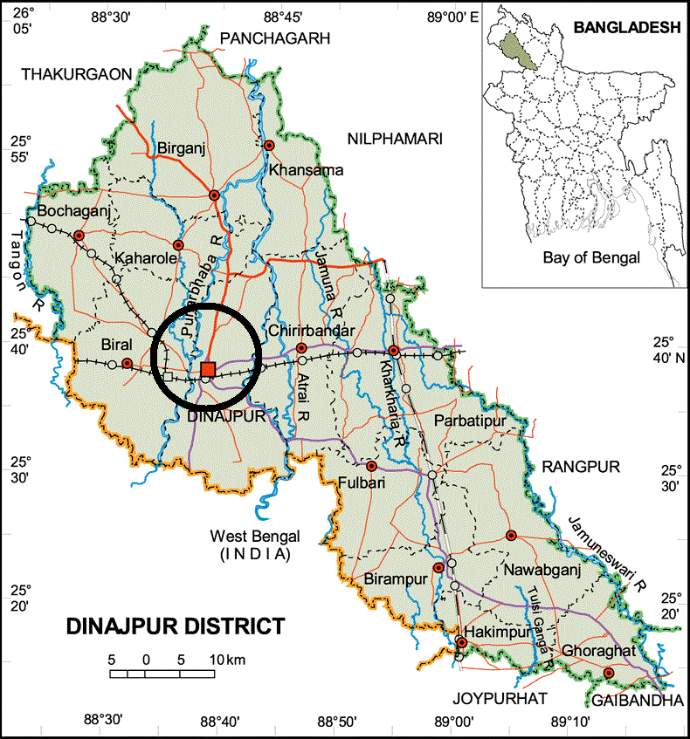
Figure 1: Map indicates the area of Dinajpur Sadar region

3.2: Study period
The study was undertaken for a period of 50 days from 15th May to 4th July, 2013.

3.3: Source of animal and data
The data used for the study were collected from the following sources
- Data of animals were collected from the blood examination record sheet of District Veterinary Hospital, Dinajpur.
- Blood samples with other necessary information were collected from animals (N= 60).

3.4: Survey design
A preset sheet was used to record information like age, sex, size of the farms, presence of tick or other arthropods. The goats were grouped primarily into three categories as age, sex and breed. Then age group were subdivided into 3 categories (< 6 months, 6-12 months, > 12 months), the sex group were subdivided as male and female and breed group were divided into Black Bengal Goat and Jamunapari.

3.5: Examination of animals and sample collection
The animal was examined especially on the basis some parameters like rectal temperature, visible mucous membrane, body condition score, lymphnodes palpation, presence of ticks, urine color. Single blood smear from each animal were collected from ear vein by puncturing with sterile needle. The slides were touched to the coming out blood and then spread by another slide. The slides were air dried and fixed by 100% methyl alcohol for 5 min.
3.6: Staining and examination of blood samples
The prepared blood smears were stained with the Giemsa stain (working solution) for 25 to 30 minutes. After rinsing with water they were air dried and examined under microscope (10×100x) with immersion oil for the identification of blood parasites as described by Soulsby (1982).
3.7: Measuring the prevalence
The proportional prevalence of hemoparasitic infections in goat was estimated by the following formula:

The proportional prevalence of hemoparasitic infections
= $\frac{No. of individual having a disease in a particular point of time}{No. of individual in the population at risk at the point of time}$ × 100 (Thrusfield, 1995)

3.8: Analysis of the data
The procured data through and record of blood smears examination were stored, sorted and coded by using Office 2007 service pack and data were analyzed by STATA version 11.0 (STATA Corporation, Collage Station, Texas, USA). Chi-square test was performed to get the p-value (significance was considered p < 0.05).

CHAPTER IV
RESULTS AND DISCUSSION
4.1: Result
4.1.1: Prevalence study
The study revealed that the proportional prevalence of anaplasmosis (Anaplasma marginale) in goats at Sadar, Dinajpur was 8.33% (Table 1). Other hemoparasitic diseases were not found.
Table 1: Summary estimates of blood parasites and tick among age group (N= 60)
Category | Variable | Positive (Percentage) | P
Anaplasma marginale | < 6 month age (n= 15) | 4 (26.67%) | 0.011
 | 6-12 months age (n = 23) | 0 (0%)
 | > 12 months age (n= 22) | 1 (4.55%)
Anaplasma centrale | < 6 month age (n= 15) | 0 (0%) | -
 | 6-12 months age (n = 23) | 0 (0%)
 | > 12 months age (n= 22) | 0 (0%)
Babesia spp. | < 6 month age (n= 15) | 0 (0%) | -
 | 6-12 months age (n = 23) | 0 (0%)
 | > 12 months age (n= 22) | 0 (0%)
Tick | < 6 month age (n= 15) | 6 (40.00%) | 0.038
 | 6-12 months age (n = 23) | 6 (26.09%)
 | > 12 months age (n= 22) | 14 (63.64%)

Table 2: Summary estimates of blood parasites and tick between sex group (N= 60)
Category | Variable | Positive (Percentage) | P
Anaplasma marginale | Male (n= 20) | 1 (5.00%) | 0.509
 | Female (n= 40) | 4 (10.00%)
Anaplasma centrale | Male (n= 20) | 0 (0%) | -
 | Female (n= 40) | 0 (0%)
Babesia spp. | Male (n= 20) | 0 (0%) | -
 | Female (n= 40) | 0 (0%)
Tick | Male (n= 20) | 4 (20%) | 0.010
 | Female (n= 40) | 22 (55%)

Table 3: Summary estimates of blood parasites and tick between breed group (N= 60)
Category | Variable | Positive (Percentage) | P
Anaplasma marginale | Black Bengal (n= 36) | 4 (11.11%) | 0.340
 | Jamunapari (n= 24) | 1 (4.17%)
Anaplasma centrale | Black Bengal (n= 36) | 0 (0%) | -
 | Jamunapari (n= 24) | 0 (0%)
Babesia spp. | Black Bengal (n= 36) | 0 (0%) | -
 | Jamunapari (n= 24) | 0 (0%)
Tick | Black Bengal (n= 36) | 13 (36.11%) | 0.167
 | Jamunapari (n= 24) | 13 (54.17%)

4.1.2: Factors affecting the occurrence of diseases
4.1.2.1: Types of animals
The measures of association between test positive animals with other explanatory variables have been represented in Table 2 and Table 3. The percentage of occurrence of positive animals was recorded higher (10%) in female compared to male (5%) with the p value is 0.509 although the animal variation was not statistically significant.
4.1.2.2: Age
Animals of age between below six months were highly (26.67%) susceptible to blood parasitic disease (anaplasmosis) than others (p = 0.011).
4.1.2.3: Breed
The study revealed that the occurrence of blood-parasite (anaplasmosis) infection in Black Bengal goats were higher (11.11%) than the Jamunapari goats (4.17%) with the p value was 0.340 although the breed variation was not statistically significant.
4.1.2.4: Tick
Total 43.33% animals have ticks in their body. The blood parasitic infection is always related with tick infestation.
4.2: Discussion
Mohanta et al. (2011) reported that the proportional prevalence of Anaplasma marginale infection in goats was 14.94% in hilly area of Bangladesh which is more than the present study result.
Ahmadi-Hamedani et al. (2009) reported that 63.73% goats were infected with anaplasma spp in Iran which more than the study result in Bangladesh. This variation might be due to season, area, management, duration of study and resistance of the animal and tick activity.
In case of age Mohanta et al. (2011) reported that older animals were more susceptible than young animal but the study revealed that young animal (4-6 months) were more susceptible than older animal.
4.3: Limitations of the study
The study period was too short to perform properly. The data and samples were collected at only one season. Farmers were not cooperative and friendly. In many cases, they were not cooperative to allow for collecting of the blood samples of their goats. In some cases, proper interview was not taken from the animal owner.

CHAPTER V
CONCLUSION
Anaplasmosis is an infectious disease of livestock caused by several species of the blood parasite A. marginale is the most common pathogen of cattle. Sheep and goats are much less commonly affected. The proportional prevalence of anaplasmosis (Anaplasma marginale) in goats at Sadar, Dinajpur was 8.33%. Among the host risk factors, the female goats were more susceptible to blood parasitic diseases. Animals of four to six months of age were prone to blood parasitic diseases than others groups. Animals having ectoparasites especially ticks in their body tested positive with blood parasitic diseases more than the animals having no ticks in their body.

CHAPTER VI
REFERENCES

Agricultural Revolution, news paper (2013): Small scale Black Bengal Goat rearing on Bangladesh Saturday, March 9, 2013.
Ahmadi-Hamedani, M. K., Z. Rahbari, S. Kazemi, B. and Bandehpour, M., 2009. Molecular identification of anaplasmosis in goats using a new PCR-RFLP method, Iranian Journal of Veterinary Research, Shiraz University, vol-10, pp: 367.
Alam, J., 1993. Livestock: the sector for more investment in Bangladesh. Asian Livestock, vol-18, pp: 77-81.
Banerjee, G. C., 1980. A Text book of Animal Husbandry, 4th edition, published by Mohan Primlami, Oxford and IBM Publishing Company. 66 janpath, New Delhi 1001, pp: 591.
Barry, D. M. and van Niekerk C. H., 1990. Anaplasmosis in improved Boer goats in South Africa artificially infected with Anaplasma ovis. Small Ruminant Research, vol-3, pp: 191–197.
Bazargani, T. T., Rahbari, S., Nadalian, M. and Ghodsian, I., 1985. A report of some cases of anaplasmosis in cattle and goats. J. Fac. Of Vet. Med., University of Tehran., Vol-40, pp: 95-105.
Blood, D. C., and Henderson, J. A., 1968. A Textbook of Diseases of cattle, sheep, pigs, goats and horses, 4th edition. Baillere Tindall Publication, London. pp. 1261-1264, 1289-1294, 1324-1329.
Bram, R. A., 1983. Tick-borne livestock diseases and their vectors: the global problem. Ticks and tick-borne diseases, FAO Animal Production and Health Paper., Rome, vol- 36, pp: 7-11.
Burtis, C. A. and Ashwood, E. R., 1999. Textbook of clinical chemistry. 3rd. Edn., London, W. B. Saunders Co, PP: 523-526.
Department of Livestock Services (DLS), 2007. Livestock & Poultry population in Bangladesh, Website Address: http://www.dls.gov.bd, Category: DLS.
Sulaiman, E. G., Arslan, S. H., Al-Obaidi, Q. T., Daham, E., 2010. Clinical, haematological and biochemical studies of babesiosis in native goats in Mosul, Iraqi Journal of Veterinary Sciences, Vol-24, pp: 31-35.
Fourie, L. J., Petney T. N., Horak I. G and de Jager, C., 1989. Seasonal incidence of Karoo paralysis in relation to the infestation density of female Ixodes rubicundus. Veterinary Parasitology vol-33, pp: 319–328.
Gautam, O. P. and Banerjee, D. P., 1982. Anaplasmosis in cattle with reference of the diseases in India, Journal of Parasitology, vol-6(2), pp: 169-181.
Haenlein, G. F. W., 1998. Value of goats and sheep to sustain mountain farmers, International Journal of Animal Science, vol-13, pp: 187,194.
Heffernan, C. and Misturelli, F., 2000. The delivery of veterinary services to the poor: Preliminary findings from Kenya. Report of the DFID-funded study R7357. Veterinary Epidemiology and Economics Research Unit (VEERU), Department of Agriculture, University of Reading, Reading, UK. pp: 81
Hungerford, T.G., 1962. Diseases of Livestock, Angus and Robertson Ltd, 5th edition, pp: 201- 207.
Inci, A., Ica, A., Yildirim, A., and Duzlu, O., 2010. Identification of Babesia and Theileria species in small ruminants in Central Anatolia (Turkey) via reverse line blotting. Turkish Journal of Veterinary Science, Vol-34(2), pp: 205-210.
Kettle, D.S., 1995. Medical and Veterinary Entomology, 2nd edn. Colset Pte Ltd, Singapore. Lew, A. and Jorgensen, W., 2005. Molecular approaches to detect and study the organisms causing bovine tick borne diseases: babesiosis and anaplasmosis. Afr. J. Biotechnol., vol- 4, pp: 292-302.
LID (Livestock In Development), 1998. Strategies for improving DFID‟ s impact on poverty reduction: A review of best practice in the livestock sector. LID (Livestock in Development), Crewkerne, UK. pp: 71
Maas, J. and Buening, G. M., 1981. Characterization of Anaplasma marginale infection in splenectomized domestic goats. Am. J. Vet. Res., vol-42, pp: 142-145.
Meyer, D. J. and Harvey, J. W., 2004. Veterinary laboratory medicine, 3rd. Edn., London, W. B. Saunders Co, PP: 17-24, 63-65, 163.
Morzaria, S., Katende, J., Kairo, A., Nene, V., Musoke, A., 1992. New methods for the diagnosis of Babesia bigemina infection. Mem. Inst. Oswaldo Cruz vol- 87, pp: 201–205.
Nagore, D., Garcia-Sanmartin, J., Garcia-Perez, A. L., Juste, R. A., and Hurtado, A., 2004. Identification, genetic diversity and prevalence of Theileria and Babesia species in a sheep population from Northern Spain. International Journal of Parasitology, vol- 34,pp: 1059-1067.
Pegram, R. G., Tatchell R. J., de Castro J. J., Chizyuka H. G. B., Creek M. J., McCosker P. J., Moran, M. C. and Nigarua, G., 1993. Tick control: new concepts. World Animal Review vol-2, pp: 74-75.
Radostits, O. M., Gay, C. C. and Hinchcliff, K. W., 2000. A Textbook of Diseases of cattle, sheep, pigs, goats and horses, W.B. Saunders, 9th edition, pp: 1261-1265, 1289-1295.
Radostits, O. M., Gay, C. C., Hinchcliff, K. W., and Constable, P. D., 2008. Diseases associated with protozoa. 10th Edn. In: Veterinary Medicine: A Textbook of Diseases of cattle, horses, sheep, pigs, and goats. Saunders Elsevier, pp: 1483-1540.
Rahbari, S., Nabian, S., Khaki, Z., Alidadi, N., and Ashrafihelan, J., 2008. Clinical, haematologic and pathologic aspects of experimental ovine babesiosis in Iran. Iranian Journal of Veterinary Research, Vol-9(1),pp: 59-64.
Ristic, M. and Weinman, D., 1968. Infectious blood diseases of man and animals, Academic press, New York, USA, vo-11, pp: 473-542.
Ristic, M., 1996. Diseases of cattle in the tropics, Martinus Nijhoff publishers, vol-6, pp: 327- 344, 443-468.
Schnittger, L., Yin, H., Jianxun, L., Lugwing, W., Shayan, P., Rahbari, S., Voss-Holtmann, A., and Ahmed, J. S., 2000. Ribosomal small-subunit RNA gene-sequence analysis of Theileria lestoquardi and other Theileria species highly pathogenic for small ruminants in China. Parasitol. Res.vol-86, pp: 352–358.
Shompole, S., Waghela, S. D., Rurangirwa, F. R and McGuire, T. C., 1989. Cloned DNA probes identify Anaplasma ovis in goats and reveal a high prevalence of infection. J. Clin. Microbiol., vol-27, pp: 2730-2735.
Smith, B. P., 2002. Diseases of the hematopoietic and hemo-lymphatic systems: Large Animal Internal Medicine, 3rd ed. St. Louis, Mosby, pp: 1049-1051
Soulsby, E. J. L., 1986. Helminths, Arthropods and Protozoa of Domesticated Animals, 7th edn. Baillere Tindall Publication, London. Pp.707-717, 729-735.
Splitter, E. J., Anthony, H. D. and Twiehaus, M. J., 1956. Anaplasma ovis in the United States: experimental studies with sheep and goats. Am. J. Vet. Res., vol-17, pp: 487-491.
Taylor, M. A., Coop, R.L., and Wall, R. L., 2007. Veterinary Parasitology. Third Edn.
The Merck Veterinary Manual, 1997. Professional Hand Book Merck and Co, INC, 9th edition, pp: 18-22, 30-33.
Thrusfield, M., 1995. Veterinary Epidemiology. Blackwell Science Ltd., a Blackwell Publishing Company., pp: 39-41.
Uilenberg, G., 1995. International collaborative research: significance of tick-borne hemoparasitic diseases to world animal health. Vet. Parasitol, vol-57, pp: 19–41.
Urquhart, G. M., Armour, j., Duncan, dunn, A. M. and Jennings, F. W., 1996. Veterinary parasitology, Blackwell science Ltd, 2nd edition, pp: 242-249.
Zaugg, J. L., 2009. Babesiosis. In: Smith, B. P. (Eds): Large Animal Internal Medicine. Mosby, Elsevier, St. Louis, pp: 1157.

ANNEX
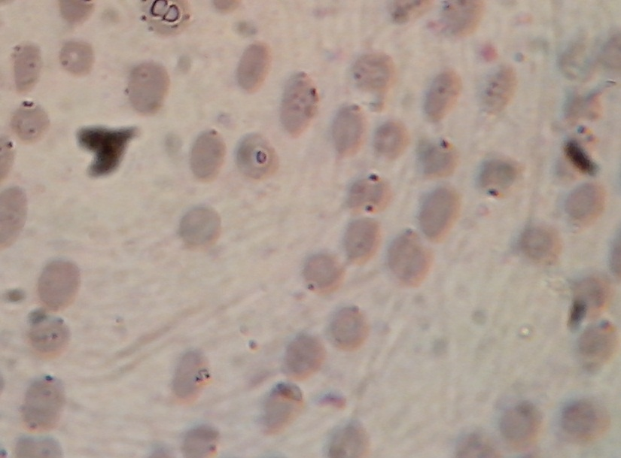
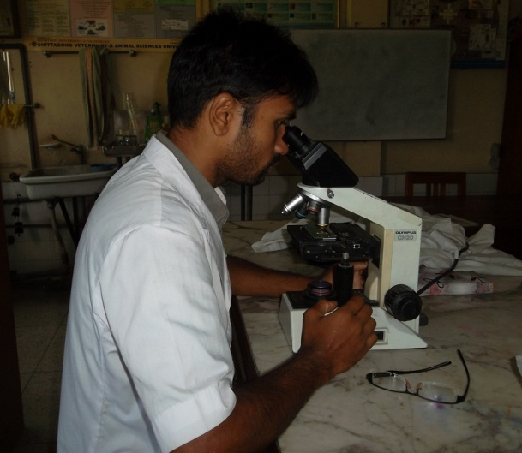
Figure3: Microscopic examination

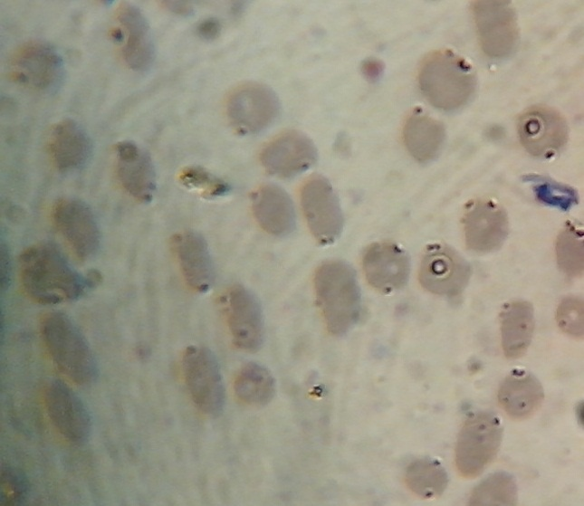

Figure2: Detection of Anaplasma marginale in microscopic examination

