A Case report on Chronic Skin Disease and Antimicrobial Resistance in a Dog at SAQTVH, Khulshi, Chattogram

A clinical report submitted in partial satisfaction of the requirement for the Degree of Doctor of Veterinary Medicine (DVM)

Submitted By:
Md. Foisal Shikder
Roll No: 18/33
Reg. No: 02093
Intern ID: 31
Session: 2017-18

Faculty of Veterinary Medicine
Chattogram Veterinary and Animal Sciences University
Khulshi, Chattogram – 4225, Bangladesh
A Case report on Chronic Skin Disease and Antimicrobial Resistance in a Dog at SAQTVH, Khulshi, Chattogram

Approved by:
(Dr. Mukta Das Gupta)
Associate Professor
Department of Microbiology and Veterinary Public Health, CVASU

Faculty of Veterinary Medicine
Chattogram Veterinary and Animal Sciences University
Khulshi, Chattogram – 4225, Bangladesh
Statements of Author

I, Md. Foisal Shikder, hereby declare that I have completed all tasks and provided the information in this report. The data was gathered through publications, websites, and other sources both domestically and abroad. All citations have been properly acknowledged. As a result, I am entirely responsible for gathering, combining, preserving and publishing all of the data that has accumulated in this report.

The Author
November 2, 2023

List of Contents
Serial No. | TITLE |  | PAGE NO.
 | Statement of Author | iii
 | List of Contents | iv
 | List of Tables | v
 | List of Figures | v
 | List of Abbreviations | vi
 | Abstract | 1
Chapter 1 | Introduction | 2-3
Chapter 2 | Materials and Methods | 4-5
 | Study area and study period | 4
 | Sample Collection | 4-5
 | Data Collection | 5
 | Diagnosis | 5
 | Clinical Examination | 5
 | Physical Examination | 5
 | Diagnostic Test | 5
Chapter 3 | Results | 6-10
Chapter 4 | Discussion | 11-13
Chapter 5 | Limitations | 14
Chapter 6 | Conclusions | 15
 | References | 16-17
 | Appendix | 18
 | Acknowledgement | 19
 | Biography | 20

List of Tables
Serial No. | Table Name | PAGE NO.
Table 1 | Blood Examination Report (Estimation are carried out by Celltac Alpha) | 6
Table 2 | Blood Examination (Biochemistry) Report (Examination are carried out by Humalyzer 3000) | 7
Table 3 | Antimicrobial Sensitivity Test (Disc Diffusion Method) | 7

List of Figures
Serial No. | Figure Name | PAGE NO.
Figure 1 | Geographical location of SAQTVH, CVASU, Khulshi, Chattogram | 4
Figure 2 | Lhasa Apso Dog Breed | 8
Figure 3 | Alopecia in neck | 8
Figure 4 | Dermatitis in vaginal region | 8
Figure 5 | Reddish Vaginal Area | 8
Figure 6 | Pustular eruption | 8
Figure 7 | Woods Lamp Technique to detect Fungus | 8
Figure 8 | Black Pointed Candida sp. | 9
Figure 9 | Ear Mites Demodex canis | 9

LIST OF ABBREVIATIONS
ABBREVIATIONS | FULL WORD
SAQTVH | Shahedul Alam Quadary Teaching Veterinary Hospital
CVASU | Chattogram Veterinary and Animal Sciences University
CS | Culture Sensitivity
ESR | Erythrocyte Sedimentation Rate
cumm | cubic millimeter
mg/dl | milligrams per deciliter
g/dl | grams per deciliter
% | percentage
mm | millimeter
TEC | Total Erythrocyte Count
RBC | Red Blood Cell
TLC | Total Leucocyte Count
WBC | White Blood Cell
PCV | Packed Cell Volume
ALT | Alanine Transaminase
AST | Aspartate Aminotransferase
SGOT | Serum Glutamic Oxaloacetic Transaminase
SGPT | Serum Glutamic Pyruvic Transaminase
BUN | Blood Urea Nitrogen
SID | Semel In Die
BID | Bis In Die
TID | Ter In Die
bw | Body Weight
spp | species
mg/kg | milligram/kilogram
IU | International Unit

Abstract

The most vital organ in the body is the skin, which is occasionally referred to as the integumentary system. It performs a variety of vital roles in preserving homeostasis throughout the body. The management of frame temperature is perhaps the most crucial of these duties. Additionally, the skin guards the frame from bacterial infiltration and physical damage. The skin and pores include a variety of sensory organs that perceive the outside environment and extra cells that may produce vitamin D when exposed to sunshine. The study aimed to know the specific causal pathogen behind the reason for chronic skin diseases and antimicrobial resistance in a dog. A study was undertaken to know the specific pathogen, diagnosis, and treatment of chronic skin disease of the dog named Likey at Shahedul Alam Quadary Teaching Veterinary Hospital (SAQTVH) in Chattogram Veterinary and Animal Sciences University (CVASU) from February 22nd to April 7th, 2023. In this study, the dog was observed with clinical signs of maculo-papular-pustular eruption, pruritus, alopecia, reddening of vulva, pus discharge from hind leg digits, continuous licking of vagina, leg and body coat, foul odor from digit and visible ectoparasites respectively. A diagnosis or recommendation for treatment was made based on the presenting clinical signs, physical examination, and various diagnostic tests. In this study, the dog was diagnosed by Culture Sensitivity Test, Blood Biochemistry, Skin Impression Smear Test and Skin Scrapping Test. The dog was diagnosed with antimicrobial resistance, eosinophilia (17%), hyperglycemia (124.1 mg/dl), vaginal candidiasis and demodicosis. Mite infestation accounted for most of the skin damage. Vaginal candidiasis also accounted for vigorous licking on the genital area and the rest of the body. Antimicrobial resistance shows that the dog was immediately sensitive to ceftriaxone, ciprofloxacin, and clindamycin. A systemic immunosuppressive drug (Cyclosporine) was prescribed along with a systemic antifungal drug (Itraconazole) to combat dermatitis and candidiasis. Parental ivermectin was given to treat demodicosis.

Keywords: Antimicrobial resistance, candidiasis, cyclosporine, demodicosis, dermatitis.

Chapter 1: Introduction

Skin is the layer of often soft, flexible exterior tissue covering the body of a vertebrate animal. Skin serves three primary purposes, including protection, regulation, and feeling. It is the largest organ in the body. It is a barrier between the animal and its surroundings, performing numerous other tasks like immune defense, sensory perception, thermoregulation, and vitamin D production. Along with all these crucial roles and diseases directly impacting the skin, other tissue’s pathologic processes may also be shared by or reflected in the skin. Due to these characteristics, dermatologic problems are among the most commonly seen disorders in veterinary hospitals (Buckner et al. 2016).
A condition known as chronic skin disease can cause an animal to scratch constantly, chew on their paws, lose hair, experience recurring ear infections, lick their vagina, and experience several other uncomfortable symptoms. Countless illnesses can harm the skin and ears, such as allergies, serious infections, hormone disorders, skin cancer, and many more. In addition, since many of these issues can coexist and share similar symptoms, diagnosing and treating them may be difficult. When dealing with complicated skin and ear conditions, it is crucial to remember that many chronic conditions have a lengthy, frequently lifelong treatment regimen.
The most prevalent ones include food allergies, bacterial infections, yeast infections and allergies to environmental allergens. Immune-mediated illnesses, hormone disorders, and various types of neoplasia (cancer) are less frequent issues. Infections and parasites are the most common skin disorders that quickly spread between animals. Even if not all infections spread between animals, ringworm (Dermatophytosis), a fungal infection, parasites such ear mites and Cheyletiella, Scabies (Sarcoptes, Sarcoptic Mange) and occasionally drug-resistant Staphylococcus infections may be of concern.
Fungi are relatively uncommon causes of disease in healthy and immunocompetent humans and nonhuman vertebrates, even though hosts are constantly exposed to infectious propagules. However, an increasing number of recalcitrant fungal diseases in animals have occurred over the last two decades, originating from opportunistic and pathogenic fungi (Seyedmousavi et al. 2018).
Candidiasis can be superficial, affecting the skin and mucosal membranes of the gastrointestinal and urogenital tract. Dissemination of the fungus can lead to candidemia or localized infection of internal organs. In contrast to humans, epidemiological data and systematic analysis of risk factors are lacking for veterinary candidiasis. Animal candidiasis is mentioned in veterinary textbooks as occasionally affecting domestic animals. (Cutsem & Rochette, (1991); Quinn et al. (2002); Pohlman & Chengappa, (2022))
Fungal cultures can be used to identify fungi like dermatophytes, although rapid in-house procedures like cytology are often used to identify Malassezia species. Giemsa staining is another method for detecting candidiasis under a microscope. Histoplasmosis and Blastomycosis, two less frequent fungal infections, can arise in certain areas and conditions and are considerably more serious systemic issues.(Schaller et al. (2006))
Candida spp are ubiquitous and saprophytic yeast which widely distributed in a variety of animals. Candidiasis is localized fungal disease affecting skin and mucous membranes and genital and gastrointestinal tracts of dogs. There are predisposing factors such as injury to any of the mucous membranes, the use of catheters, administration of antibiotics, and immunosuppressive states help in developing candidiasis.
Fungal cultures can be used to identify fungi like dermatophytes, although rapid in-house procedures like cytology are often used to identify Malassezia species. Giemsa staining is another method for detecting candidiasis under a microscope. Histoplasmosis and Blastomycosis, two less frequent fungal infections, can arise in certain areas and conditions and are considerably more serious systemic issues. Candidiasis
Candida spp are ubiquitous and saprophytic yeast which
Widely distributed in a variety of animals. Candidiasis is localized
Fungal disease affecting skin and mucous membranes and genital
And gastrointestinal tracts of dogs. There are predisposing
Factors such as injury to any of the mucous membranes, the use of
Catheters, administration of antibiotics, and immunosuppressive
States help in developing candidiasis
Candidiasis
Candida spp are ubiquitous and saprophytic yeast which
Widely distributed in a variety of animals. Candidiasis is localized
Fungal disease affecting skin and mucous membranes and genital
And gastrointestinal tracts of dogs. There are predisposing
Factors such as injury to any of the mucous membranes, the use of
Catheters, administration of antibiotics, and immunosuppressive
States help in developing candidiasis
Candida spp are ubiquitous and saprophytic yeast which
Widely distributed in a variety of animals. Candidiasis is localized
Fungal disease affecting skin and mucous membranes and genital
And gastrointestinal tracts of dogs. There are predisposing
Factors such as injury to any of the mucous membranes, the use of
Catheters, administration of antibiotics, and immunosuppressive
States help in developing candidiasis.
Despite improvement in management, prevention and treatment strategies, bacterial and fungal diseases are still the most expensive treatment due to multidrug resistance. Indiscriminate use and misuse of antibiotics in pet animals against bacterial and fungal infections has led to emergence of multidrug-resistant strains.
Keeping in view the importance of pet as a companion animal and a potential zoonotic threat, the case study was designed to conduct the following objectives:
- To identify the specific cause of chronic skin disease in dog
- To determine the blood parameter, biochemical value, and antibiotics resistance in a dog with chronic skin disease for specific treatment.

Chapter 2: Materials and Methods

Study area and study period:
The case study was carried out for the periods of 1.5 months from February 22nd to April 7th, 2023. The sample were collected from the dog that were admitted to Shahedul Alam Quadary Teaching Veterinary Hospital (SAQTVH) in Chattogram Veterinary and Animal Sciences University (CVASU).
Geographical Coordinates:
Latitude: 22.365127643229684, Longitude: 91.80766735977909
Figure 1: Geographical location of SAQTVH, CVASU, Khulshi, Chattogram

Sample Collection:
This case study was conducted with a dog named Likey, a pet dog accused of skin diseases. Skin impression samples from the genital area were collected from this affected dog using slides. Sample (blood) were collected using a butterfly needle (23 G), and 10 ml of blood was taken for hematology and Blood biochemistry. Swab sample (pus) from hind leg digits were taken by inserting a sterile swab and was placed in a falcon tube (5ml) containing Phosphate Buffer Saline (PBS) and sent to the Microbiology Laboratory, CVASU, for culture sensitivity test (CS). Some procedures and methodology were followed according to Akter et al. (2018).
Data Collection:
The required information such as age, sex, body weight, breed, color, duration of illness, history of deworming, body condition, management system (type of feed supplied, housing pattern, type of floor, vaccination, hygienic measurement), previous diseases history, previous treatment and owner complaint were collected directly from the owner of the animal for the diagnosis with providing a questionnaire.
Diagnosis:
Dermatological problems were diagnosed by physical examination, clinical findings and different lab tests.
Clinical Examination:
The affected dog showed clinical signs of maculo-papular-pustular eruption, pruritus, scaling, alopecia and reddening of vulva, pus discharge from hind leg digits, continuous licking of vagina, leg and body coat, foul odor from digit and visible ectoparasites respectively.
Physical Examination:
Physical examination included a close inspection of the entire hair coat and skin under solid lighting. Flashlights were used to examine the skin of animals. Primary lesions were macules or patches, papules or plaque, pus from digits and fluid discharge from the genital area. Secondary lesions include epidermal collarettes, scars, excoriation and erosions.
Diagnostic Test:
Laboratory examination of skin impression smear samples was done to identify causal agents based on morphology by Giemsa Staining under a microscope. Laboratory tests covered multiple profound skin scrapping tests, woods lamp technique, haematology, Blood Biochemistry, CS test and response to drug trials.

Chapter 3: Results

The present case study was conducted at the Small Animal Unit under the Department of Medicine and Surgery in SAQTVH with a hospitalized dog with chronic skin disease. The dog was found to be infected with Candidiasis, Demodicosis and Allergic Contact Dermatitis. The dog was also diagnosed with Pododermatitis, which also had been diagnosed previously in a pet clinic. It has also developed antimicrobial resistance.
Table 1: Blood Examination Report (Estimation are carried out by Celltac Alpha)
Name of the Test | Result | Normal Range
Haemoglobin | 12.1 | 12-18 gm%
ESR (Wintrobe tube Method) | 5 | 0-6 (mm in 1st hour)
Total Count
Total Count of TEC/RBC | 7.1 | 5.5-8.5 (million/cumm)
Total Count of TLC/WBC | 8.3 | 6-17 (thousand/cumm)
Platelet | - | -
Circulating Eosinophils | - | -
PCV | 37 | 37-55%
Differential count of WBC
Lymphocytes | 18 | 12-30%
Neutrophils | 60 | 60-77%
Eosinophils | 17 | 2-10%
Monocytes | 5 | 3-10%
Basophils | - | 0-1%
Others | - | -

Table 2: Blood Examination (Biochemistry) Report (Examination are carried out by Humalyzer 3000)
Name of the Test | Result | Normal Range
Calcium | 10.1 | 9.1-11.7 mg/dl
Phosphorus | 3.4 | 2.9-5.3 mg/dl
Serum Glucose | 124.1 | 76-119 mg/dl
Total Protein | 6.2 | 5.4-7.5 g/dl
Serum Creatinine | 0.8 | 0.5-1.5 mg/dl
ALT (SGPT) | 38.2 | 21-102 mg/dl
AST (SGOT) | 60.2 | 23-66 g/dl
Serum BUN | 10.1 | 10-28 mg/dl

Table 3: Antimicrobial Sensitivity Test (Disc Diffusion Method)
Antimicrobials | Interpretation
Amoxicillin | Resistant
Penicillin | Resistant
Clotrimazole | Resistant
Ceftriaxone | Intermediate
Erythromycin | Resistant
Ciprofloxacin | Intermediate
Gentamycin | Resistant
Ampicillin | Resistant
Cephalexin | Resistant
Metronidazole | Resistant
Clindamycin | Intermediate
Doxycycline | Resistant

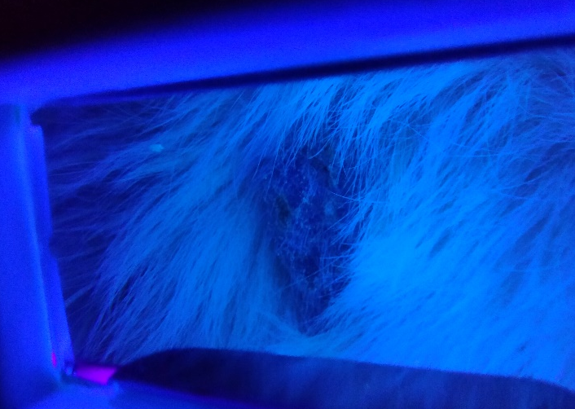
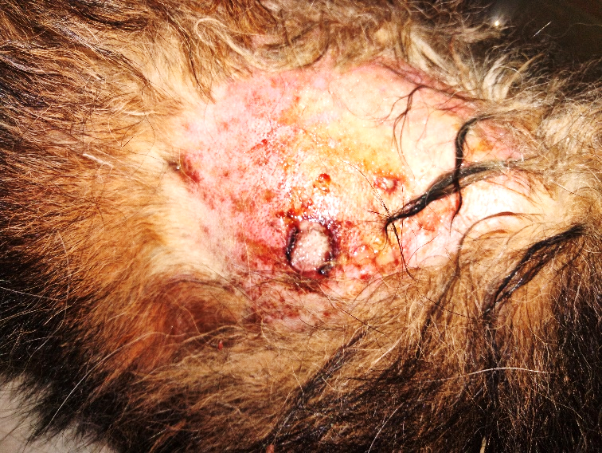
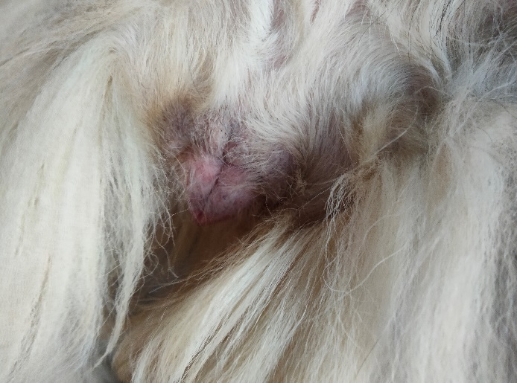
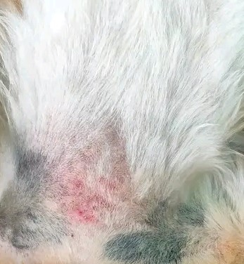
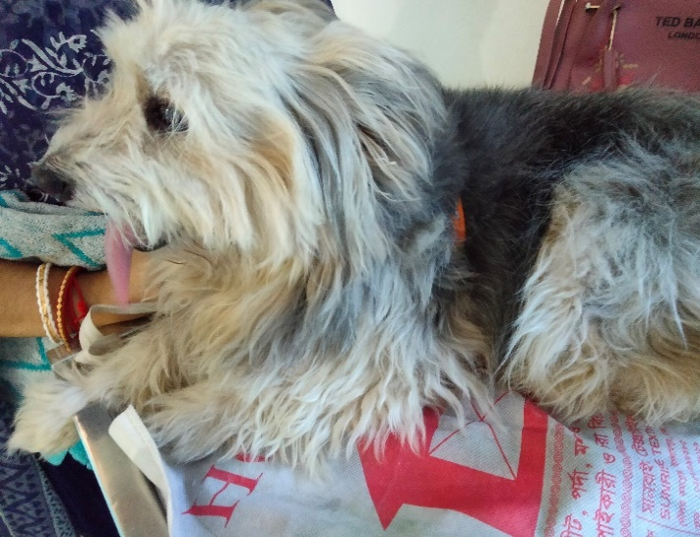
The haematological report showed that the blood parameter was standard for this dog, but there was an uprising of Eosinophils (17%), higher than its normal range (2-10%). Blood biochemistry report shows that Serum Glucose (124.1 mg/dl) level is slightly higher than its normal range (76-119 mg/dl). Besides these, the antimicrobial sensitivity/CS test showed that the dog was not susceptible to any of the 12 antibiotics tested. This dog was immediately sensitive to ceftriaxone, ciprofloxacin and clindamycin.
Figure 7: Woods Lamp Technique to detect Fungus
Figure 6: Pustular eruption
Figure 5: Reddish Vaginal Area

Figure 4: Dermatitis in vaginal region
Figure 2: Lhasa Apso Dog Breed
Figure 3: Alopecia in neck region

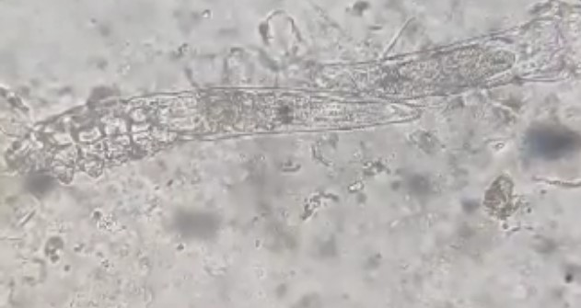
Figure 9: Ear Mites Demodex canis
Figure 8: Black Pointed Candida sp.

Treatment protocol for this patient:
Date: 22nd February 2023
Diagnosis: Pododermatitis and Demodicosis
Rx. (According to Generic Name)
- Ivermectin @ 0.2-0.5 mg/kg bw, SID, subcutaneously for single time, repeated 14 days later again
- Cyclosporine @ 5 mg/kg bw, SID, PO, for 7 days
- Pheniramine Maleate @0.5-1 mg/kg bw, BID, PO, for 7 days
- Permethrin (5%) @ applied locally on the affected area, BID, for 7 days
- Neomycin Sulphate @ applied locally on the affected area, BID, for 10 days
- Iodine (10%) @ applied on the digits and skin wound to clean, TID, until recovery
Advice: Use Elizabethan Collar on the neck region to prevent licking and scratching.

Date: 15th March 2023
Diagnosis: Alopecia and Vaginal Candidiasis
Rx. (According to Generic Name)
- Ketoconazole/Miconazole Shampoo (1%) @ applied 10 days interval to give bath
- Cypermethrin Shampoo @ applied 7 days interval to give bath
- Acetic Acid (8%) @ applied locally after bath
- Itraconazole @ 5-10 mg/kg bw, BID, PO, for 1st 7 days, then stop for 7 days, again continue for 7 days
- Clobetasol Propionate +Neomycin Sulphate +Nystatin @ applied on the vaginal area, TID, for 21 days
- Vitamin E @ 400 IU, PO, SID, for 14 days
After 23 days later, patients was recovered and prognosis was very good.

Chapter 4: Discussion

This case study was based on a dog who came to treat chronic skin disease several times at SAQTVH, CVASU. Due to the prevalence of demodicosis, I administered a subcutaneous injection of Ivermectin at the dose of 0.2-0.5 mg/kg body weight at the beginning. Then, I repeated the treatment after 14 days to prevent ear mites infestation. This infection may happen due to poor management, poor body condition, lack of health treatment and improper nutrition. According to Akter et al. (2018), the prevalence of canine demodicosis was 20.45% at Madras Veterinary College, Chennai, India. Ivermectin was used to treat the affected dogs with subcutaneous injection of Ivermectin at a dose of 0.2-0.4mg/kg body weight and repeated after 15 days. Another report stated that Ivermectin treatment was recommended at 0.2 mg/kg for dogs to prevent demodicosis (Esenkaya Taşbent & Di̇k, (2018)).
Similarly, Cyclosporine @ 5 mg/kg bw, SID, PO, for seven days and Pheniramine Maleate @0.5-1 mg/kg bw, BID, PO, for seven days was indicated for this infected dog to combat severe allergic reaction and secondary bacterial infection for Pododermatitis and dermatitis. According to Eichenseer et al. (2013), approximately two-thirds of the dogs improved in pruritus by more than 25 per cent with either of the antihistaminic medications. However, the efficacy of antihistamines cannot be compared to glucocorticoids and cyclosporine; thus, they are not suitable to treat an acute flare of a severely atopic dog where a fast and reliable decrease in pruritus is desired to improve the dog’s (and owner’s) quality of life and minimize the chance of secondary infection. According to Forsythe & Paterson (2014), the recommended induction dosage rate of cyclosporine for the treatment of Canine Pododermatitis is 5 mg/kg every 24 hours. In many cases, once maximal response has been achieved generally after four weeks of treatment, it is possible to reduce the amount of drug administered without reducing efficacy. Pododermatitis is a common presentation in many breeds.
A specific underlying cause, such as demodicosis, deep pyoderma, poor confirmation or Atopic Dermatitis, can be identified in most cases. However, despite a thorough workup, a specific cause remains elusive in some cases. Breathnach et al. (2005) successfully used cyclosporine to treat idiopathic pododermatitis in seven dogs. Topical Permethrin cream (5%) was applied locally on the affected area, BID, for seven days to treat Demodicosis. According to Li et al. (2023), during 1–2 months, the effect size varied from 0.88 (topical permethrin) to 4.40 (topical ivermectin). During 2–3 months, the effect size varied from 0.79 (topical permethrin) to 8.37 (topical ivermectin). The effect size varied over three months from 0.59 (topical permethrin) to 2.25 Intense Pulsed Light (IPL). Bezabh et al. (2022) reported that Permethrin cream (5%) can be used to treat demodicosis. Another study showed that treating Demodex blepharitis with permethrin (5%) cream decreased parasite burden and improved blepharitis signs and symptoms, with no reported adverse events. Permethrin might be a safe and effective alternative for treating blepharitis associated with Demodex infection (Hecht et al., 2019).
Neomycin Sulphate was applied locally on the affected area, BID, for 10 days to heal the surface wound due to licking. According to Lipsky & Hoey (2009), Neomycin is active against most aerobic gram-negative rods (excluding most Pseudomonas species) and Staphylococci (but not most other gram-positive cocci); resistance develops relatively frequently, as does contact dermatitis.
Ketoconazole or Miconazole Shampoo (1%) @ applied at ten days interval to give bath the dog. According to Moriello (2016), antifungal shampoos or rinses containing chlorhexidine combined with either miconazole, ketoconazole or climbazole, miconazole alone or 7% AHP diluted 1:20 had antifungal efficacy against Trichophyton species or Microsporum canis and may be suitable choices as hair coat disinfectants.
According to (Merck Veterinary Manual), miconazole has a broad antifungal spectrum against most fungi and yeasts of veterinary interest. Sensitive organisms include Candida immitis, Candida neoformans, and some Aspergillus and Madurella species are only marginally sensitive. Ketoconazole has an antifungal spectrum like miconazole, but it is more effective against Candida immitis and some other yeasts and fungi.
The patient was treated with Itraconazole @ 5-10 mg/kg bw, BID, PO, for 1st seven days, then stopped for seven days, again continued for seven days.
According to (MSD Veterinary Manual), Itraconazole is a synthetic, broad-spectrum antifungal drug belonging to the imidazole family. It is a potent inhibitor of ergosterol (a primary membrane lipid of fungi) synthesis. Itraconazole is effective against dermatophytes, Malassezia, Candida, Cryptococcus, Histoplasma, Blastomyces, and Sporothrix spp, as well as the protozoans Leishmania and Trypanosoma. For dermatophytosis in dogs, the dosage is 5 mg/kg, PO, every 24 hours until mycological cure. For systemic mycoses, the dosage is 5–10 mg/kg, PO, every 24 hours for 60 days.
Vitamin E @ 400 IU, PO, SID, for 14 days was given to this dog for rapid healing of the infected wound and skin. Hobson (2016) stated that vitamin E supplementation benefits wound repair and immune functions, particularly in elderly animals.
The patient was diagnosed with antimicrobial resistance (AMR) due to misuse of multidrugs without minimal doses and doctor prescriptions. Nowadays, cases of multi-drug-resistant infections are increasing in companion animals, most commonly in the urinary tract, skin, ears, respiratory tract, wounds, and surgical sites. Guardabassi et al. (2004) and So et al. (2012) mentioned that dogs are considered to be one of the potential reservoirs of antimicrobial resistance (AMR) determinants that can be transmitted to humans through direct or indirect contact. Besides, Song & Lim, (2015) reported that the number of people living with pets, especially dogs, has increased worldwide over the last few decades. Bourély et al. (2019) stated that in France, the estimated dog population has been stable since 2012 at around 7.3 million, and about 20% of households in the country accommodate pets. As the selection and spread of antimicrobial resistance, it has serious consequences for human beings, knowledge of the prevalence of resistance and temporal variations, with regular updates, in both humans and animals, is required to assess the potential threats to public health, to design efficient control strategies, and to measure their effectiveness.

Chapter 5: Limitations

There were some flaws in this research. The study period was limited and the study area was limited. Besides, due to time shortage, I could not use the organism on agar media or perform PCR for confirmatory diagnosis. As a result, the findings may not represent the actual scenario of this study.

Chapter 6: Conclusions

Nowadays, canine chronic skin diseases are increasing day by day. Poor supplementation, improper diagnosis and misuse of antimicrobials can make an animal resistant to antibiotics. Antibiotic resistance is a growing phenomenon in Asian countries and companion animals, particularly in dogs, which are relatively closer companions to humans. Many antibiotics used in veterinary medicine are similar to those used in human medicine. The conducted study will give a glimpse into chronic skin diseases, scenarios of antibiotic resistance and the purpose of diagnostic tests to detect specific pathogens in dogs.

References

Akter, S., Kabir, H., Biswas, S., Paul, P., & Hasan, T. (2018). Study on prevalence, diagnosis and treatment of dermatological disorders in hospitalized dogs at Madras Veterinary College (MVC), Chennai, India. Asian-Australasian Journal of Bioscience and Biotechnology, 3(1), 1–6. https://doi.org/10.3329/aajbb.v3i1.64744
Antifungals for Integumentary Disease in Animals - Pharmacology - MSD MANUAL (2022), 1(1-5). https://www.msdvetmanual.com/pharmacology/systemic-pharmacotherapeutics-of-the-integumentary-system/antifungals-for-integumentary-disease-in-animals
Azoles for Use in Animals - Pharmacology - Merck Veterinary Manual. (2022). https://www.merckvetmanual.com/pharmacology/antifungal-agents/azoles-for-use-in-animals
Bezabh, S. A., Tesfaye, W., Christenson, J. K., Carson, C. F., & Thomas, J. (2022). Antiparasitic Activity of Tea Tree Oil (TTO) and Its Components against Medically Important Ectoparasites: A Systematic Review. Pharmaceutics, 14(8), 1–40. https://doi.org/10.3390/pharmaceutics14081587
Bourély, C., Cazeau, G., Jarrige, N., Leblond, A., Madec, J. Y., Haenni, M., & Gay, E. (2019). Antimicrobial resistance patterns of bacteria isolated from dogs with otitis. Epidemiology & Infection, 147, e121. https://doi.org/10.1017/S0950268818003278
Breathnach, R. M., Baker, K. P., Quinn, P. J., Mcgeady, T. A., Aherne, C. M., & Jones, B. R. (2005). Clinical, immunological and histopathological findings in a subpopulation of dogs with pododermatitis. Veterinary Dermatology, 16(6), 364–372. https://doi.org/10.1111/J.1365-3164.2005.00471.X
Buckner, C. A., Lafrenie, R. M., Dénommée, J. A., Caswell, J. M., Want, D. A., Gan, G. G., Leong, Y. C., Bee, P. C., Chin, E., Teh, A. K. H., Picco, S., Villegas, L., Tonelli, F., Merlo, M., Rigau, J., Diaz, D., Masuelli, M., Korrapati, S., Kurra, P., Mathijssen, R. H. J. (2016). https://www.intechopen.com/books/advanced-biometric-technologies/liveness-detection-in-biometrics
Cutsem, J. van, & Rochette, F. (1991). Mycoses in domestic animals. https://www.researchgate.net/publication/7971266
Eichenseer, M., Johansen, C., & Mueller, R. S. (2013). Efficacy of dimetinden and hydroxyzine/chlorpheniramine in atopic dogs: A randomised, controlled, double-blinded trial. Veterinary Record, 173(17), 423. https://doi.org/10.1136/vr.101907
Esenkaya Taşbent, F., & Di̇k, B. (2018). [A dog related Demodex spp. infestation in a student: a rare Demodex case]. Mikrobiyoloji Bulteni, 52(2), 214–220. https://doi.org/10.5578/MB.66410
Forsythe, P., & Paterson, S. (2014). Ciclosporin 10 years on: Indications and efficacy. Veterinary Record, 174(SUPPL.2), 13–21. https://doi.org/10.1136/VR.102484

Guardabassi, L., Loeber, M. E., & Jacobson, A. (2004). Transmission of multiple antimicrobial-resistant Staphylococcus intermedius between dogs affected by deep pyoderma and their owners. Veterinary Microbiology, 98(1), 23–27. https://doi.org/10.1016/J.VETMIC.2003.09.021
Hecht, I., Melzer-Golik, A., Sadi Szyper, N., & Kaiserman, I. (2019). Permethrin Cream for the Treatment of Demodex Blepharitis. Cornea, 38(12), 1513–1518. https://doi.org/10.1097/ICO.0000000000002013
Hobson, R. (2016). Vitamin E and wound healing: An evidence-based review. In International Wound Journal (Vol. 13, Issue 3, pp. 331–335). International Wound Journal ISSN. https://doi.org/10.1111/iwj.12295
Li, J., Wei, E., Reisinger, A., French, L. E., Clanner-Engelshofen, B. M., & Reinholz, M. (2023). Comparison of Different Anti-Demodex Strategies: A Systematic Review and Meta-Analysis. Dermatology, 239(1), 12–31. https://doi.org/10.1159/000526296
Lipsky, B. A., & Hoey, C. (2009). Topical antimicrobial therapy for treating chronic wounds. Clinical Infectious Diseases, 49(10), 1541–1549. https://doi.org/10.1086/644732/2/49-10-1541-TBL006.GIF
Moriello, K. A. (2016). In vitro efficacy of shampoos containing miconazole, ketoconazole, climbazole or accelerated hydrogen peroxide against Microsporum canis and Trichophyton species, 19(4), 370–374. https://doi.org/10.1177/1098612X15626197
Pohlman, L. M., & Chengappa, M. M. (2022). Yeasts. Veterinary Microbiology: Fourth Edition, 405–417. https://doi.org/10.1002/9781119650836.ch43
Quinn, P. J., Markey, B. K., Carter, M. E., Donnelly, W. J. C., & Leonard, F. C. (2002). Veterinary microbiology and microbial disease. Veterinary Microbiology and Microbial Disease. Blackwell science.
Schaller, M., Zakikhany, K., Naglik, J. R., Weindl, G., & Hube, B. (2006). Models of oral and vaginal candidiasis based on in vitro reconstituted human epithelia. https://doi.org/10.1038/nprot.2006.474
Seyedmousavi, S., Bosco, S., De Hoog, S., Ebel, F., Elad, D., Gomes, R. R., Jacobsen, I. D., Martel, A., Mignon, B., Pasmans, F., Piecková, E., Rodrigues, A. M., Singh, K., Vicente, V. A., Wibbelt, G., Wiederhold, N. P., & Guillot, J. (2018). Fungal infections in animals: A patchwork of different situations. Medical Mycology, 56, S165–S187. https://doi.org/10.1093/mmy/myx104
So, J. H., Kim, J., Bae, I. K., Jeong, S. H., Kim, S. H., Lim, S. kyung, Park, Y. H., & Lee, K. (2012). Dissemination of multidrug-resistant Escherichia coli in Korean veterinary hospitals. Diagnostic Microbiology and Infectious Disease, 73(2), 195–199. https://doi.org/10.1016/J.DIAGMICROBIO.2012.03.010
Song, H. G., & Lim, S. U. (2015). Assessing pet industry in Korea using service quality improvement gap model. International Journal of Technology, Policy and Management, 15(1), 2–20. https://doi.org/10.1504/IJTPM.2015.067791

Appendix

Questionnaire
Patient Owner Name and Address :
Phone :
Occupation :
Pet’s Name :
General information of Pet
- Species and Breed:
- Body Weight:
- Age:
- BCS:
- Sex:
Owners Complaint (s):

Clinical History:
- Duration of illness:
- Feed Habit:
- Defecation:
- Urination:
- Vaccination:
- Feces:
- Any major outbreak in last 6 months:
- Roughage:
- Concentrate:
- Vitamin/Mineral Supplement:

Clinical Examination:
- Rectal Temperature:
- Respiration Rate:
- Heart Rate:
- Skin Condition:
- Posture:
- Hair Coat:
- Mucous Membrane:
- Dehydration:
- Foot Lesion:
- General Attitude:
- Genital Discharge:

Diagnosis:

Acknowledgement

In the name of Almighty Allah, the most Gracious and the most Merciful. All praises to Allah and His blessing for the completion of this report. I thank my Allah for all the opportunities, trials and strength that have been showered on me to finish writing the report. I experienced so much during this process, not only from the academic aspect but also from the aspect of personality. My humblest gratitude to the holy Prophet Muhammad (Peace be upon him) whose way of life has been a continuous guidance for me. The author expresses his sincere appreciation, respect, and immense gratitude to heist esteemed teacher and supervisor Dr. Mukta Das Gupta, Associate Professor, Department of Microbiology and Veterinary Public Health, CVASU, for his academic direction, kind supervision, precious advice and sound judgment throughout all stages of the study. In order to continue this internship program, the author wishes to express his sincere gratitude and respect to the Professor Dr. Mohammad Lutfur Rahman, Dean, Faculty of Veterinary Medicine, and Professor Dr. A. K. M. Saifuddin, Director of External Affairs, Chattogram Veterinary and Animal Sciences University.
Finally, a special thanks to Mehnaj Belal, a student of the Faculty of Food Science, CVASU, for helping with his authorization, referencing, report writing and helpfulness.

Biography

This is Md. Foisal Shikder, the child of Md. Babul Shikder and Ayesha Alam, doing his graduation in Doctor of Veterinary Medicine (DVM) at Chattogram Veterinary and Animal Sciences University under the Faculty of Veterinary Medicine. He passed the Secondary School Certificate Examination (SSC) in 2015 from Govt. Muslim High School, Chattogram, and the Higher Secondary Certificate Examination (HSC) in 2017 from Govt. Hazi Muhammad Mohsin College, Chattogram. Currently, he is doing his yearlong internship. He has a great interest in research about pet animal viral diseases, bat virus, wildlife and also worked as a research assistant for the detection of Canine Morbillivirus and Nipha Virus along with Mosquito Born Dengue Virus.

