A Clinical Report on Molecular Identification of
Cryptosporidium sp. by nested PCR


Report Presented in Partial Fulfillment of the Requirement for the Degree of
Doctor of Veterinary Medicine
A Report Submitted by
Roll no. -08/29
Intern ID No- B-19
Reg. No- 371
Session:2007-2008

Faculty of Veterinary Medicine
Chittagong Veterinary and Animal Sciences University
Khulshi, Chittagong-4202.

A Clinical Report on Molecular Identification of
Cryptosporidium sp. by nested PCR

A Clinical Report Submitted as per approved style and content

--------------------------------  Signature of Author  (Samar Chandra Roy)  Roll No: 08/29  Reg. No: 371  Intern ID: B-29  Session: 2007-2008 | --------------------------------  Signature of supervisor  (Prof.Dr.AMAM Zonaed Siddiki)  Dept. of Pathology and Parasitology  Chittagong Veterinary and Animal  Sciences University.

INDEX

Contents | Page No.
ACKNOWLEDGEMENTS | 01
ABSTRACT | 02
INTRODUCTION | O3-04
REVIEW OF LITERATURE | 05-07
MATERIALS AND METHODS | 08-15
RESULTS | 16
DISCUSSION | 17
CONCLUTION | 18
REFERENCES | 19-24

AcknowledgementS

The author would like to express the deepest sense of gratitude and all sorts of praises to the Creator, whose blessing have enabled the author to complete this report.
He also like to express his gratefulness to his supervisor Dr. AMAM Zonaed Siddiki, Professor, Department of Pathology and Parasitology, CVASU , for his sympathetic supervision, inspiration, constructive criticism, valuable suggestion and providing important information throughout the work and towards preparation of the manuscript in time.
He also would like to express his sincere thanks to respected Professor Dr. Md. Masuduzzaman and Professor Dr. Mohammad Alamgir Hossain, Department of Pathology and Parasitology, CVASU, for their valuable advice and inspiration.

He also grateful to Dr. Shubhagata Das and Dr. Md. Abdul Alim, Assistant Professor, Department of Pathology and Parasitology, CVASU for their kind help.

He would like to thanks to Dr. Md. Shafiqul Islam, Lecturer, Department of Pathology and Parasitology, CVASU for his valuable suggestion during the study.

Thanks are also to all lab technicians and support staffs of PRTC and Department of Pathology and Parasitology, CVASU for their help in lab work.
He would like to thanks to all his well-wishers especially senior students coming from CU and USTC for their constant guide and help those will be source of inspiration throughout the entire period of his life.

The Author
ABSTRACT
The intra cellular protozoan parasite Cryptosporidium sp. is one of the major causes of diarrhea in calf and other animals. During our study period we collected 50 diarrheic faeces samples of calves from 3 different districts (Chittagong, Pabna and Syrajgong) in the country. For diagnosis of Cryptosporidium sp. we have used molecular DNA based tools including highly sensitive nested polymerase chain reaction (nested PCR) and gel electrophoresis to identify the Cryptosporidium sp. from diarrheic faeces of calf below 6 months of age. For nested PCR analysis, specific primers for amplification of 581 base pair fragments of 18s rRNA gene were used. We could not find any positive band in first time reaction, based on this result it can’t sure that all the Templates were negative for DNA, because another investigator found 10% positive result from same sample by Z-N staining and due to time limitation we could not run pcr for several times up to standardization.
Key words: Cryptosporidium, nested PCR, calves.

INTRODUCTION
Bangladesh is an agriculture based country. Livestock is one of the major resources in this sector. There is about 20.75 million animals (Anonymous, 2007).Among the reared animals most of them are cattle. These animals are reared primarily for milk, meat and skin.
Diseases are one of the major problems for cattle rearing. Among these diseases diarrhea is one of the major cause for Cattle calf’s mortality. Calf can be suffered from diarrhea due to different causal agents like bacteria, virus, protozoa and parasites. Cryptosporidium sp are one of the chief causes for protozoan diarrhea. Cryptosporidium is reported to be present in more than 90% of all US dairy farms and or 50% or more of all dairy calves will shed detectable number of oocysts (Sischo et al., 2000). Yong animals are more susceptible to infection and disease while in adults it is asymptomatic in most cases. Calves are more susceptible shortly after birth and infection has been reported in both dairy and beef calves (Xiao and Herd, 1994; Garber et al., Atwill at el., 1999). The duration of infection is usually short, lasting about two weeks with peak oocysts shedding during the second week of infection (Ongerth and Stibbs, 1989; Xiao and Herd, 1994; Kemp and Wright, 1995; O’Handley et al., 1999; Uga et al., 2000). Clinical signs are usually manifested in calves 7-30 days of age with mild to moderate, pale or yellowish diarrhoea, which is accompanied by mucus. The condition can last for two weeks and alongside dehydration, calves become lethargic and anorexic, contributing to weight loss. They do not respond to antibiotic therapy and in more severe cases, dehydration and cardiovascular collapse leads to mortality (Olson et al., 2003). However, the healthy calves can be subclinically infected which contributes continuous oocyst excretion in faeces (Tzipori, 1988).
Cryptosporidium is an important cause of enteric infection in calf with severe outbreaks and high case fatality has been reported by several authors (Tzipori et al., 1981; Angus et al., 1982; Johnson et al., 1999). Previous reports indicate the prevalence of Cryptosporidium from 5% up to 77% worldwide (Bomfim et al., 2005; Ryan et al, 2005a; Santin et al, 2007 ).

Several molecular tests to detect parasites have been developed over the last decade. Their specificity and sensitivity have gradually increased, and parasites that were previously difficult to diagnose using conventional techniques began to be identified by molecular DNA based techniques such as PCR, Real-time PCR, sequence analysis and bioinformatics. Until now, molecular epidemiological data concerning calf’s cryptosporidiosis are limited. Considering the limited data on prevalence and molecular characterization of Cryptosporidium in calf, the present study was undertaken with a number of objectives as below:-

- To use nested PCR for identification of Cryptosporidium spp. in the laboratory from diarrheic feces samples.
- To investigate the prevalence of Cryptosporidium spp. from calves in selected areas of Bangladesh.

REVIEW OF LITERATURE
Cryptosporidium and Cryptosporidiosis
Cryptosporidium spp. are member of the phylum Apicomplexa and are found in human and animal populations worldwide. People and animals are vulnerable to these important opportunistic protozoa which causes Cryptosporidiosis. The protozoa have a wide host range as it can infect more than 152 species of human and animals. It has a predilection for epithelial cells in the digestive tracts of a wide variety of hosts which includes humans, livestock, companion animals, wildlife, birds, reptiles and fishes (O’Donoghue, 1995).

Taxonomy
All species of Cryptosporidium are taxonomically classified as below (Levine 1985)-

Phylum: Apicomplexa
Class: Sporozoasida
Subclass: Coccidiasina
Order: Eucoccidiorida
Suborder: Eimeriorina
Family: Cryptosporidiidae
Genus: Cryptosporidium

Diagnosis
A number of tests have been developed for the diagnosis of Cryptosporidium sp. These involve direct detection by microscopy of faecal materials after using specialized staining techniques (Garcia et al., 1983). The modified acid-fast stain (Ziehl-Neelsen stain) and auramine stain is widely used but has the limitation of relatively low sensitivity (Weber et al., 1991). However, examining under UV light with a rhodamine filter can increase the sensitivity up to 100 times (Nielsen and Ward, 1999). Use of polyclonal or monoclonal antibodies for detection by immunolabelling has also been developed, but proved less sensitive than conventional staining (Garcia and Shimizu, 1997). The recently developed PCR amplification technique has been found to be very specific and highly sensitive, targeting different genes including the oocyst wall protein (COWP), the small subunit of rRNA, β-tubulin, TRAP-C1, TRAP-C2, ITS1, polythreonine repeat (poly-T), dihydrofolate reductase (DHFR), and sequences and mRNA of heat shock proteins (Sulaiman et al., 1999). The efficacy of this technique for detection of Cryptosporidium in environmental and clinical samples has also been reported in several studies (da Silva et al., 1999). Certainly, the use of the PCR technique with sequence analysis provides help for genetic characterization of Cryptosporidium at the species level which can contribute significantly to epidemiological investigations.
Molecular identification of Cryptosporidium sp. based on Nested PCR
Different types of molecular diagnostic tools have been used in the identification of Cryptosporidium species. Several genes including 18S rRNA based tools are now generally used in identification of Cryptosporidium in humans, animals and water samples. Table 1 shows example of such reports where different genes and primer sets were used.
Table 1: Selected reports where PCR based diagnosis was used for Cryptosporidium identification by different investigators
Gene | Primer | Primer sequence | References
18s rRNA gene | 18SiCF2  18SiCR2  18SiCF1  18SiCR1 | 5-GAC ATA TCA TTC AAG TTT CTG ACC-3  5-CTG AAG GAG TAA GGA ACA ACC-3  5-CCTATC AGC TTT AGA CGG TAG G-3  5-TCT AAG AAT TTCACC TCT GAC TG-3 | Ryan et al., 2003
GP60 gene | AL3531  AL3535  AL3532  AL3534 | 5-ATA GTC TCC GCT GTA TTC-3  5-GGA AGG AAC GAT GTA TCT-3  5- TCC GCT GTA TTC TCA GCC-3  5-GCA GAG GAA CCA GCA TC-3 | Chalmers et al., 2007
SSU rRNA gene | CPB-DIAGF  CPB-DIAGR | 5-AAG CTG GTA GTT GGA TTT CTG-3  5-TAA GGT GCT GAA GGA GTA AGG-3 | Ondˇrej et al., 2004.
COWP gene, | CRY-9  CRY-15 | 5-GGA CTG AAA TAC AGG CAT TAT CTT G-3  5-GTA GAT AAT GGA AGA GAT TGT G-3 | Ondˇrej et al., 2004
HSP70 gene | _ | 5–GGTGGTGGTACTTTTGATGTATC-3  5 –GCCTGAACCTTTGGAATACG-3 | Budu-Amoako et al., 2011

MATERIALS AND METHOD
Source of samples
During the study, a total of 50 fresh fecal samples of calves were collected from SA Quadery Teaching Veterinary Hospital (SAQTVH) of the Chittagong Veterinary and Animal Sciences University (CVASU), Syrajgonj and Pabna district. The age of the animals were below 6 months and permission from all the owners were sought during fecal sample collection for this study. All relevant data such as breed, sex, age, housing, feeding, treatment history were recorded for further analysis.
Study area and period
The animals were located in Chittagong, Pabna and Sirajgong district. The experiment was carried out at Poultry Research & Training Center (PRTC) and the Parasitology Laboratory of the Department of Pathology & Parasitology, Chittagong Veterinary & Animal Sciences University (CVASU). The study period was during September, 2013 until March, 2014.
Collection of fecal samples
Feces were collected directly from the rectum of calf into a clean plastic specimen container that was immediately labeled and carried to the Laboratory. The fecal samples were preserved in – 20°C freezer for DNA extraction.
DNA extraction from fecal samples
Total genomic deoxyribonucleic acid (DNA) was directly extracted from fecal samples, using the QIAamps DNA stool mini kit (Qiagen®) according to manufacturer’s instructions (Qiagen, Hilden, Germany). Briefly the protocol was as follows:
Materials and Reagents:
• Buffer ASL
• Buffer AL
• Buffer AW1
• Buffer AW2
• Buffer AE
• Proneinase K
• QIAGEN InhibitEx ® tablet.
• 96-100% ethanol.
Protocol: Isolation of DNA from faeces for Pathogen Detection
- 180-220 mg faces were weighed in a 2 ml eppendorf tube and the tube placed on ice.
- 1.4 ml Buffer ASL was added to each fecal sample. Continuously vortex was performed for 1 min or until the faeces sample is thoroughly homogenized.
- Samples were placed on liquid N₂ for 5 min & then transferred to hot water bath for 5 min (This step was repeated for 4 times).
- Vortexed for 15s and centrifuged sample at full speed for 1 min to pellet faces particles.
- Pipetted 1.2 ml of the supernatant into a 2ml eppendrof tube and discarded the pellet.
- 1 InhibitEX Tablet was added to each sample and vortexed immediately and continuously for 1 min or until the tablet is completely suspended. Incubated suspension for 1min at room temperature to allow inhibitors to adsorb the InhibitEX matrix.
- Sample was centrifuged at full speed for 6 min to pellet inhibitors bound to InhibitEX matrix.
- All the supernatant were pipetted into a new 1.5 ml eppendorf tube and discarded the the pellet.The sample was centrifuged at full speed for 3 min.
- 15 µl Proteinase K was pipetteded into a new 1.5 ml eppendrof tube.
- 200 µl supernatant was pipetted from step 8 into the eppendrof tube containing proteinase K.
- 200 µl Buffer AL was added and vortexed for 15s.
- Samples were incubated at 70º C for 10 min.
- 200 µl ethanol (96-100%) was added to the lysate & mixed by vortexing.
- A new QlAamp spin column placed in a 2 ml collection tube was labeled and lided. The complete lysate was carefully applied from step 13 to the QIAamp spin column without moistening the rim. The cap was closed and Centrifuged at full speed for 1 min. The QIAamp spin column was placed in a new 2 ml collection tube, and discarded the tube containing the filtrate.
- The QIAamp spin column was carefully opened and 500 µl Buffer AW1 was added. The cap was closed and Centrifuged at full speed for 1 min. The QIAamp spin column was placed in a new 2 ml collection tube, and discarded the collection tube containing the filtrate.
- The QIAamp spin column was carefully open and 500 µl Buffer AW2 was added. The cap was closed and Centrifuged at full speed for 4 min. The collection tube containing the filtrate was discarded.
- Recommended: The QIAamp spin column was placed in a new 2 ml collection tube and discarded the old collection tube with the filtrate and centrifuge at full speed for 1 min.
- The QIAamp spin column was transferred into a new and labeled 1.5 ml eppendrof tube. The QIAamp spin column was carefully opened and pipeted 100 µl Buffer AE directly onto the QIAamp membrane. The cap
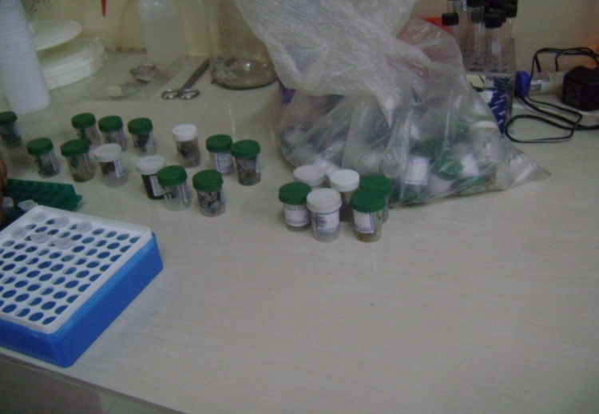
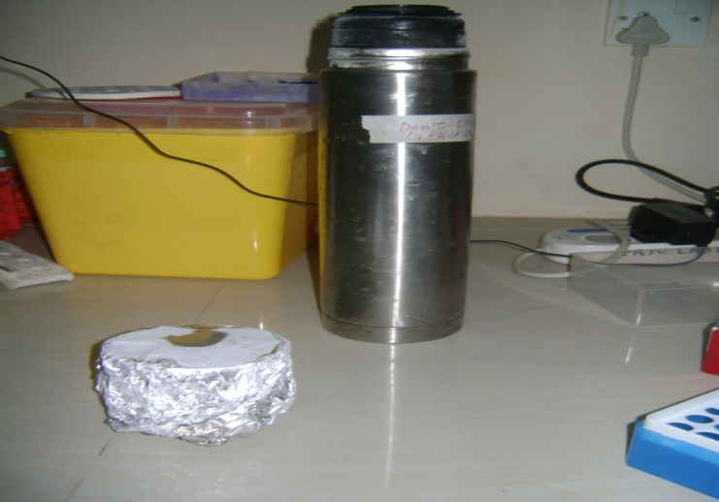
was closed and incubated for 1 min at room temperature, then Centrifuged at speed for 1 min to elute DNA.

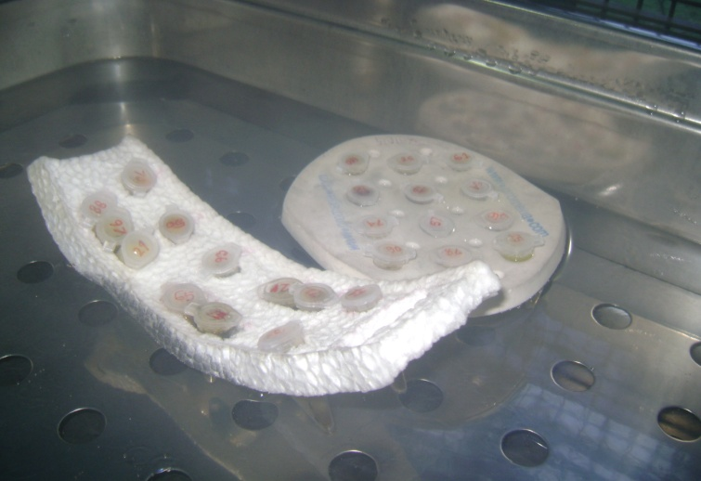
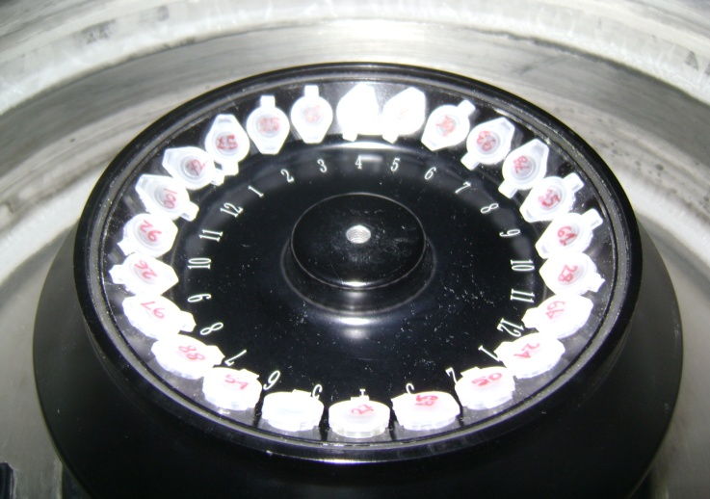
Fig 1:Samples before DNA extraction Fig 2: Samples kept in liquid Nitrogen

Fig 3 : Samples in hot water bath. Fig 4: Samples in centrifuge

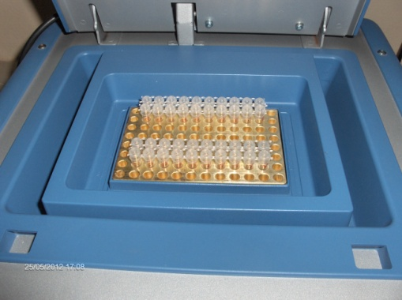
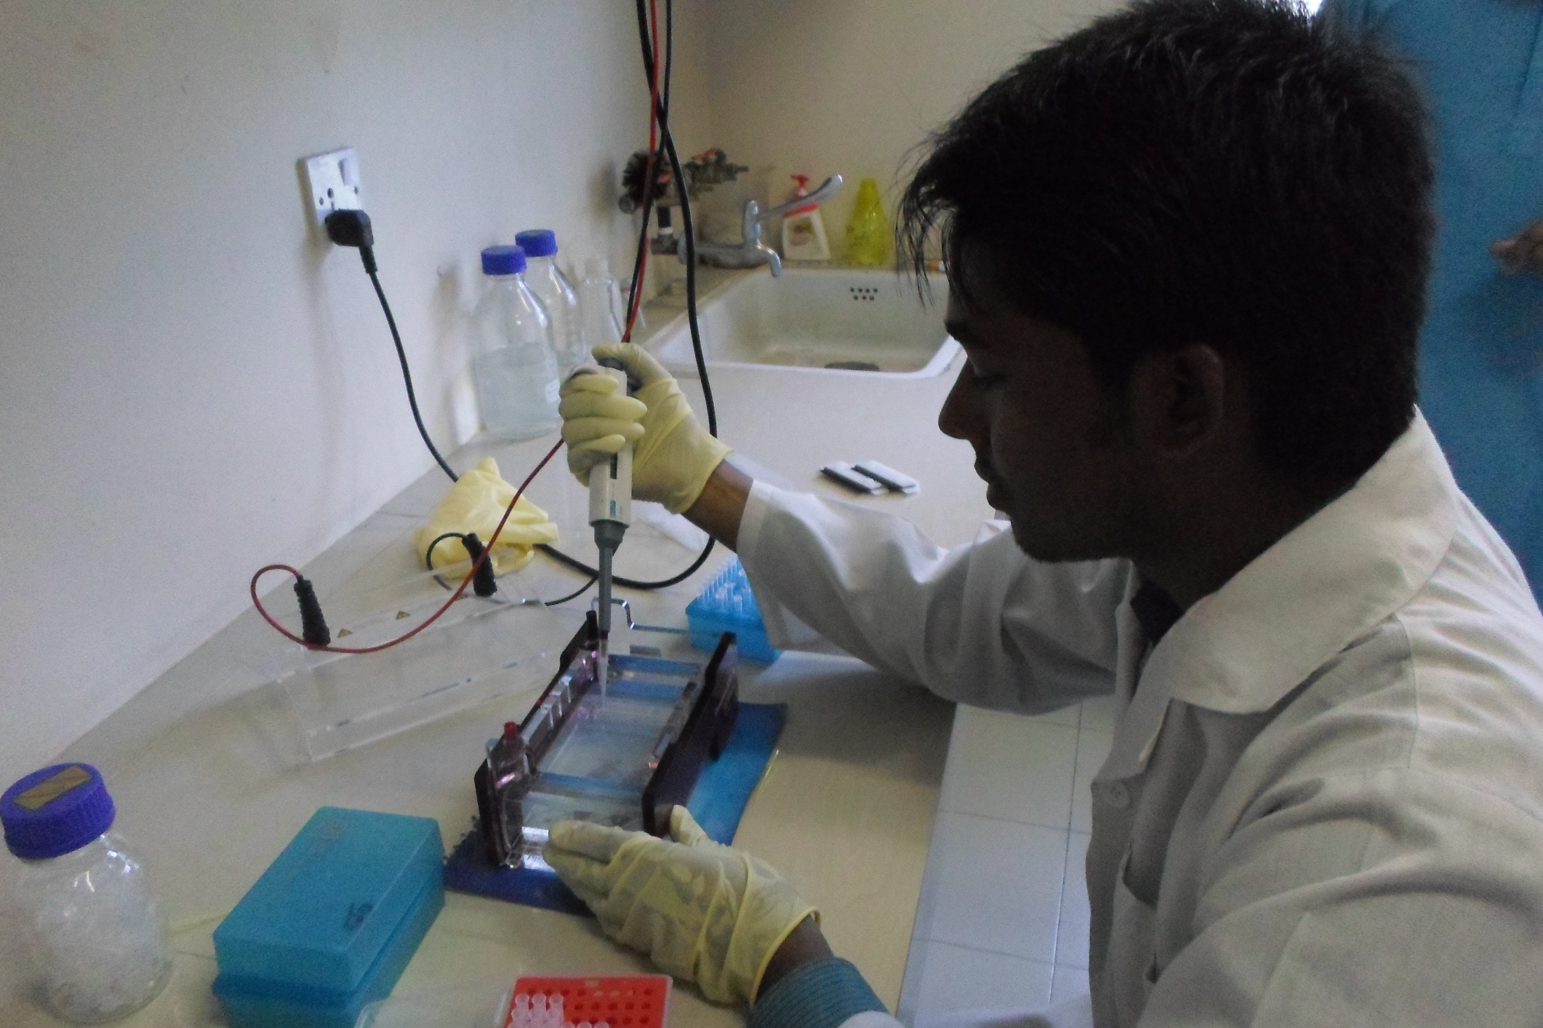

Fig 5: PCR tubes placed in Thermocycler Fig 6: Agarose gel electrophoresis
Nested PCR analysis of 18s rRNA gene
For the primary PCR, a PCR product of 758 bp was amplified using the primers mentioned below (Table 2). For the secondary PCR, a fragment of 581 bp was amplified using 1 µl of primary PCR product and the primers mention below (Original Gene Bank accession number: AF112573.1 ; Ryan et al., 2003). Section 3.6.2 (Page 22)
Table 2: Primer for 18s rRNA gene amplification
Name of primer | Sequence of primer | Lengh of sequence | Start | Stop
18 SiCF2 (Forward primer) | GAC ATA TCA TTC AAG TTT CTG ACC | 24bp | 271 | 294
18 SiCR2 (Reverse primer) | CTG AAG GAG TAA GGA ACA ACC | 21bp | 1028 | 1008
18 SiCF1 (Forward primer) | CCT ATC AGC TTT AGA CGG TAG G | 22bp | 293 | 314
18 SiCR2 (Reverse primer) | CTA AGA ATT TCA CCT CTG ACT G | 22bp | 873 | 852

Preparation to perform PCR:
PCR reactions were performed using each DNA sample in a 20 µl reaction mix containing the reagents in a PCR tube. DNA was extracted from faecal samples from all 50 isolates using the QIAamp Stool Mini Kit (Qiagen) according to the manufacturer’s instructions, incorporating an initial step of four freeze-thaw cycles (freezing in liquid nitrogen for 5 min and heating at 70ºC for 5 min) in the protocol to maximise oocyst lesion. The eluted DNA was dissolved in 15 ml ultra-pure water. For the amplification of the 18S ribosomal DNA (18S rDNA) gene, previously described PCR protocols were used (Ryan et al., 2005b). Amplification products were visualized on 1.0% agarose gels with ethidium bromide (described later). A positive (known DNA) and negative (PCR water) control samples were included in each PCR reaction.
Table 3: Reagent used in first round of nested PCR
Components | Initial concentration | Final concentration | Total reaction volume  (20 µl)
GoTaq Green Master mix (Promega Cat. No. #M7122 (Contain Taq polymerase, dNTP, MgCl₂, buffer) | 2x | 1x | 10 µl
Primer (Forward and Reverse) | 1x | 1x | 2 µl
Template (from eluted DNA recovered after DNA extraction) | 1x | 1x | 2 µl
Double distilled deionised water |  |  | 6 μl

Agarose gel electrophoresis
Electrophoresis was performed using agarose (Promega®) and tris buffer (TAE) solution. The PCR product was visualized in the 1.0% agarose gel by addition of ethidium bromide or SYBR Green dye (Sigma). These bind strongly to DNA by intercalating between the bases and is fluorescent meaning that it absorbs invisible UV light and transmits the energy as visible orange light. (Geurden et al., 2008).

Materials and Reagents:
Materials:
- Conical flask
- 50ml test tube
- Aluminium foil
- Electronic balance
- Microwave oven.
- Gel electrophoresis tank.
- Agarose
- Micropipette
- UV transilluminator

Reagents:
- 1.0% agarose
- 50x TAE buffer.
- Distilled water
- Ethidium bromide
- SYBR Green® dye

Procedure of agar gel electrophoresis:
1. For 1.0% agarose gel, we had weighted out 500 mg of agarose into a flask and mixed with up to 50ml X50 TAE buffer in the conical flask.
2. The mixture was then heated in a microwave oven until agarose was completely dissolved.
3. The agarose-TAE buffer solution was then allowed to cool in room temperature.
4. Gel casting tray was prepared by sealing ends of gel chamber with tape or appropriate casting system and placed appropriate number of combs in gel tray.
5. 20 microlitre of ethidium bromide or 1 micriltre of SYBR Green dye (X10,000) was added to agarose-TAE buffer mixture, shaked well & poured into gel tray
6. The gel was then allowed to be cool (left for 15-30 minutes at room temperature).
7. Now the Comb(s) were removed and the electrophoresis chamber will be filled with buffer (TAE buffer) until the casted gel is drowned completely.
8. 5 µl of DNA & 3 µl of Molecular weight marker (ladder) were loaded onto gel.
9. The electrophoresis was run at 110 volt and 140 mA for 30-50 minutes.
10. The gel then were taken to the UV transilluminator for image acquisition and analysis.

RESULTS

For molecular identification by PCR based approach, total DNA was extracted from all diarrheic fecal samples. Known positive standard were used during each PCR run. Optimization of PCR was achieved with different temperature and thermal profiles were followed as described previously by other investigators who have used similar primer sets to identify Cryptosporidium from fecal samples. Using nested PCR approach, 18s rRNA gene was amplified and no bands was observed. (Fig: 7 & 8)
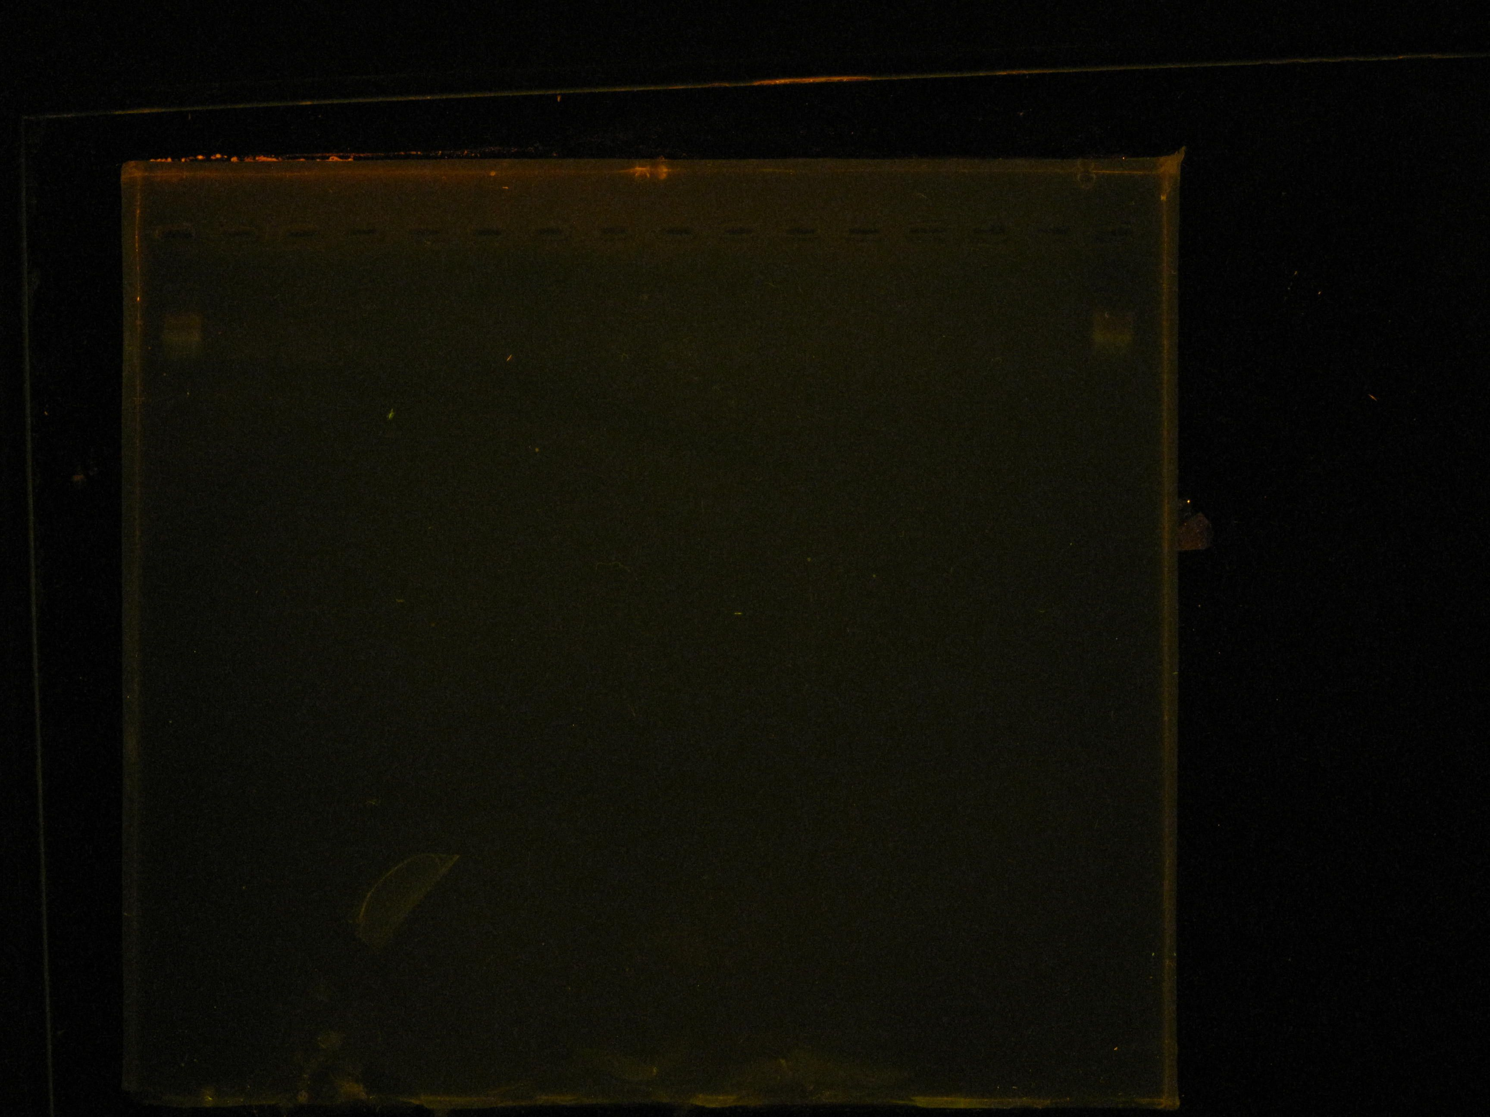
M M M M
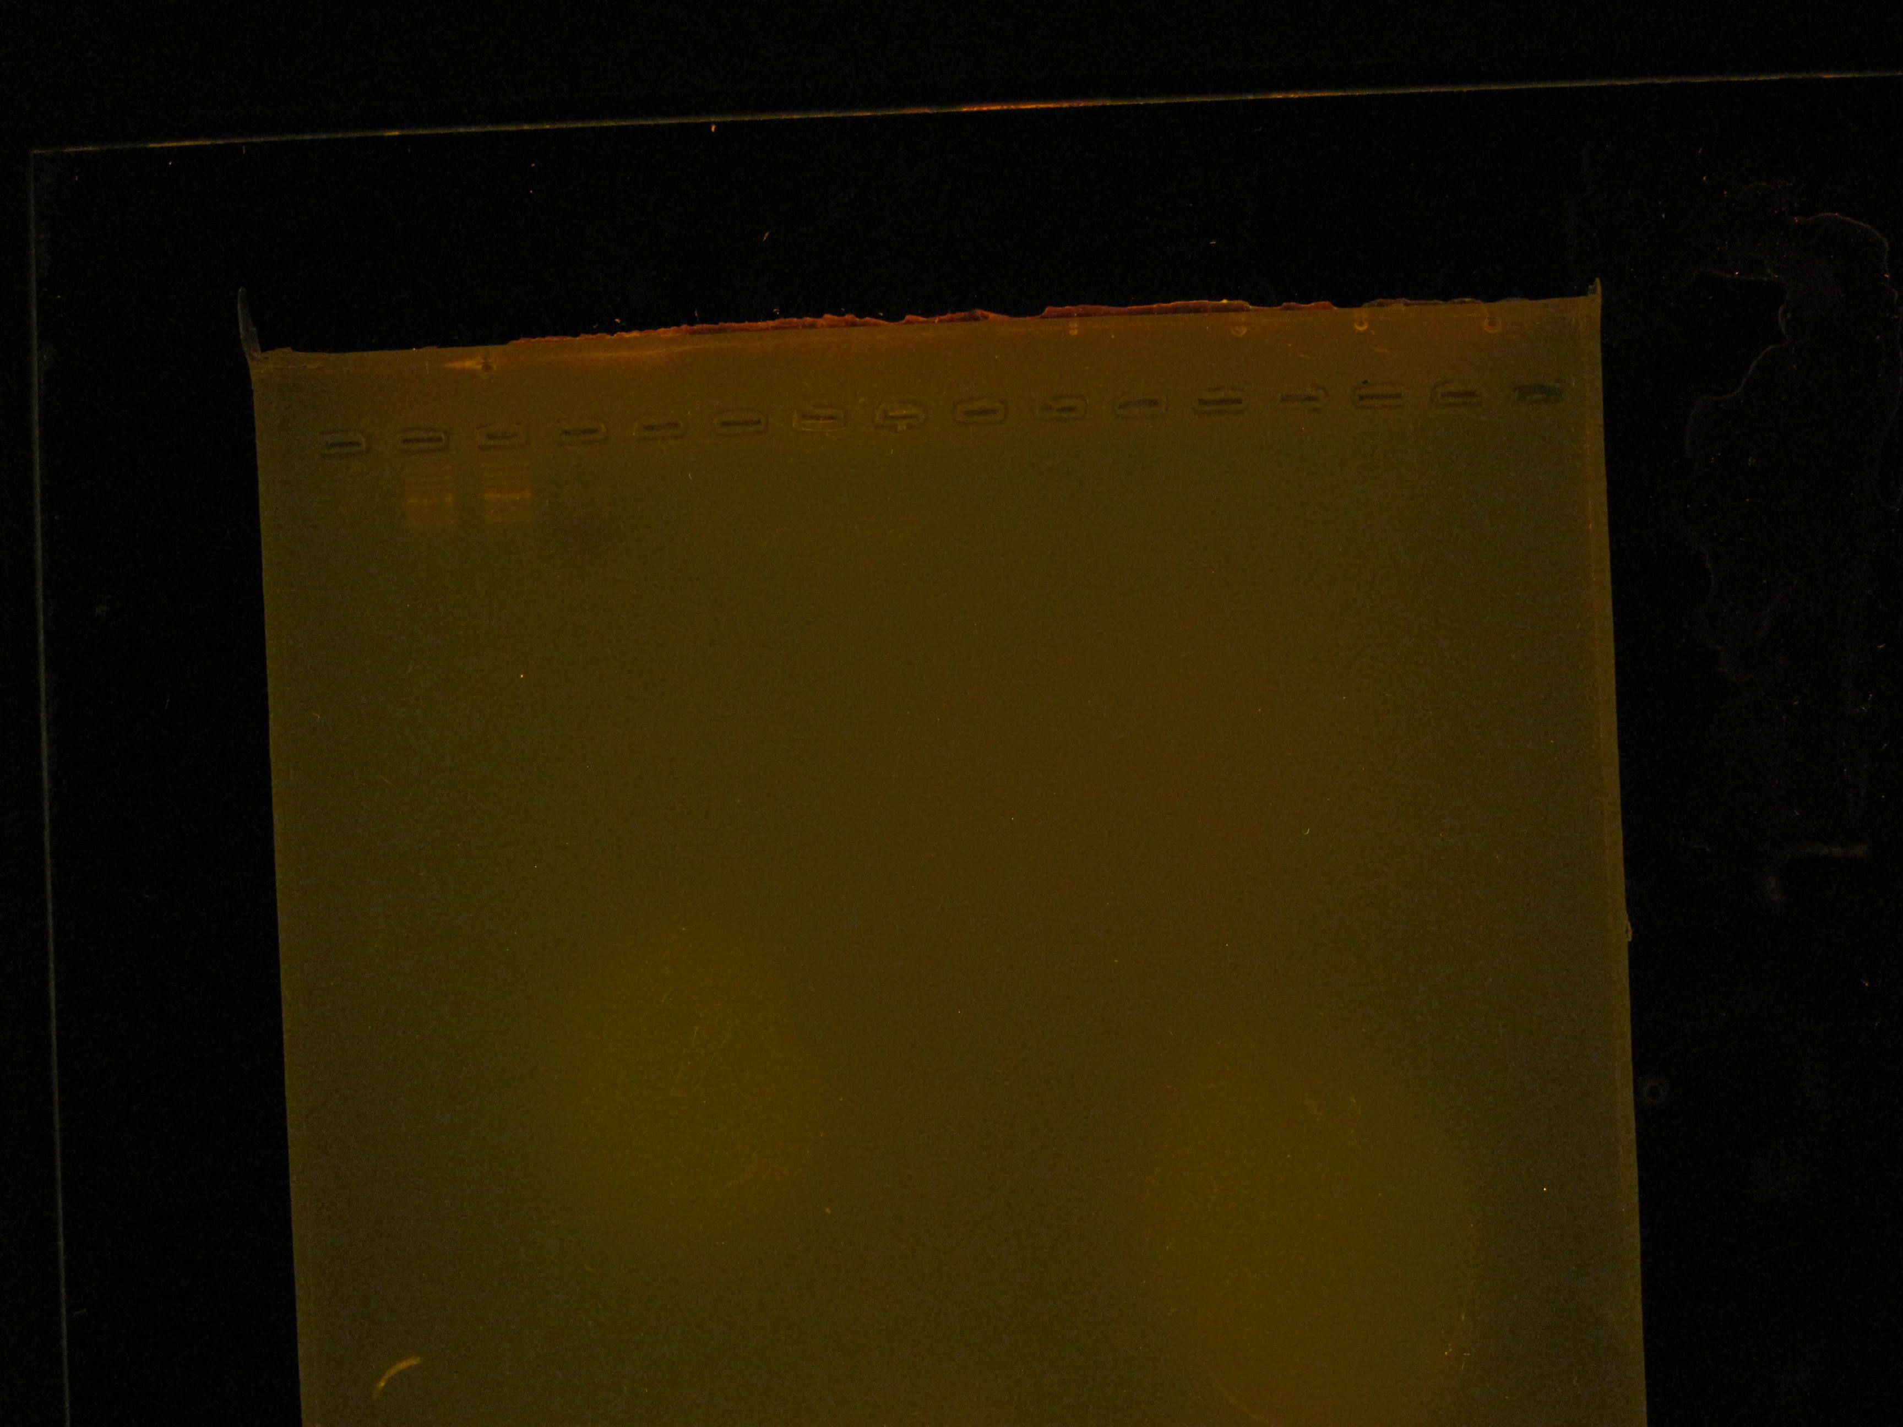
Fig 7: fig: 8

Fig : Electrophoretic (1% Agarose) separation of 18s rRNA gene fragment, Lane M, 100 bp ladder (Marker);no bands found in another lane using sample.

DISCUSSION

Calves under 6 months of age are frequently infected with Cryptosporidiosis. Cryptosporidiosis has been reported in several countries by a number of investigators. The prevalence rates have been reported that varies widely according to the sample size and geographic distribution. The prevalence recorded by a study performed by another investigator in CVASU found that 10% in calves was positive for Cryptosporidium using Ziehl-Neelsen technique. Previous reports indicate the prevalence of Cryptosporidium can be from 5% up to 77% worldwide (Bomfim et al., 2005; Ryan et al, 2005a; Santin et al, 2007).We have used nested PCR technique which is highly sensitive for diagnosis of Cryptosporidium spp .But unfortunately due to some unknown reason we could not find any bands after electrophoresis. The reasons why the DNA bands did not come may be followings:
- The electrophoresis machine used in the study is too old to perform correctly.
- Gel electrophoresis tank was damaged due to many time uses.
- Molecular weight marker (ladder) might be spoiled due to long time use.
- Different reagents used in study those are sensitive to temperature might not be stored in proper way.
- Agarose pulv. and SYBR Green® dye might be out of date.
- The samples might be spoiled due to improper cool chain maintain or long time storage.
- Due to time limitation the whole work could not be done again after study failure in another lab with different reagents and time limitations.

CONCLUSION
Cryptosporidiosis is a common cause of diarrhea in human and animals worldwide. It can be acquired by ingestion of Oocysts that were excreted in the faeces of infected individuals. Transmission can occur from person to person, from animal to person, animal to animal by ingestion of contaminated feed and water or contact of contaminated surfaces. The protozoan is highly resistant to environmental and chemical hazards and its propagation in vitro is difficult. No effective chemotherapy has been identified for the treatment of the disease in adult human and animals making cryptosporidiosis a persistent disease in the immunocompromised with high potential of transmission. As it is a zoonotic disease with persistent occurrence, its prevalence and epidemiological study is a matter of concern worldwide now a day for effective prevention and control. We have used highly sensitive nested PCR technique for identification and prevalence study of Cryptosporidium spp. During this study we have used 18S rRNA gene which was also found to be effective in identifying Cryptosporidium sp. at this level. But unfortunately after jel run due to some limitation we did not successfully completed the study. But from another study using Z-N staining it appears that cryptosporidiosis is one of the major causes for calves’ diarrhea. We did not find positive results that mean we had some problems in the whole procedure that should be recovered in further study.

Finally, we have found that the molecular technique of nested PCR approach is highly sensitive but time consuming for routine diagnosis of cryptosporidiosis in laboratory that can be used for diagnostic and research purposes.

REFERENCES

Albert MJ, Faruque AS, Faruque SM, Sack RB, Mahalanabis D. 1999. Case-control study of enteropathogens associated with childhood diarrhea in Dhaka, Bangladesh. J Clin Microbiol 37: 3458–3464.

Angus K.W., Sherwood G. Hutchison and I. Campbell. 1982. Evaluation of the effect of 2 aldehyde-based disinfectants on the infectivity of faecal cryptosporidia for mice. Res. Vet. Sci. 33:379-381.

Anonymous, 2007. Bangladesh Economic Review, Economic Adviser’s Wing, Finance Division, Ministry of Finance, Government of the People’s Republic of Bangladesh.

Atwill E.R., E.M. Johnson,M.G. Pereira. 1999. Association of herd composition, stocking rate, and duration of calving season with fecal shedding of Cryptosporidium parvum oocysts in beef herds. J. Am. Vet. Med. Assoc. 215 :1833–1838.

Barker I. K., and P. L. Carbonell. 1974. Cryptosporidium agni sp. from lambs and Cryptosporidium bovis sp. from a calf with observations on the oocyst. Z. Parasitenkd. 44:289-298.

Bejan A.,Viorica Mircean, Claudia Radu, Smaro S., Cozma V. 2009. Epidemiology of Cryptosporidium spp. infection in goat kids in the central and the northwest part of Romania. Sc. Parasit.1:32-36.

Berg, I. E., A. C. Peterson, and T. P. Freeman. 1978. Ovine cryptosporidiosis. J. Am. Vet. Med. Assoc. 173:1586-1587.
Bomfim T.C., Huber F., Gomes R.S., Alves L.L. 2005. Natural infection by Giardia sp. and Cryptosporidium sp. in dairy goats, associated with possible risk factors of the studied properties.Vet Parasitol. 134: 9-13.

Budu-Amoako, S. J. Greenwood, B. R. Dixon, L. Sweet, L. Ang, H.W. Barkema and J. T.McClur. 2011. Molecular Epidemiology of Cryptosporidium and Giardia in Humans on Prince Edward Island, Canada: Evidence of Zoonotic Transmission From Cattle. Zoonoses and Public Health. 01-10.

Causapé A.C., Quílez, J., Sánchez-Acedo, C., del Cacho, E.and López-Bernad, F. 2002. Prevalence and analysis of potential risk factors for Cryptosporidium parvum infection in lambs in Zaragoza(northeastern Spain). Veterinary Parasitology 104: 287-298.

Chalmers R.M., Ferguson, C., Caccio, S., Gasser, R.B., Abs, E.L.O.Y.G., Heijnen, L., Xiao, L., Elwin, K., Hadfield, S., Sinclair, M., Stevens, M. 2005. Direct comparison of selected methods for genetic categorisation of Cryptosporidium parvum and Cryptosporidium hominis species. Int J Parasitol. 35: 397-410.

Coombs G. H. and Muller, S. 2002. Recent advances in the search for new ant-coccidial drugs. Int. J. Parasitol. 32: 497-508.

De Graaf D.C., Vanopdenbosch E., Ortega-Mora L.M., Abbassi H., Peeters J.E. 1999. A review of the importance of cryptosporidiosis in farm animals, Int J Parasitol. 29:1269-87.

Díaz P, Quílez J, Robinson G, Chalmers RM, Díez-Baños P, Morrondo P. 2010. Identification of Cryptosporidium xiaoi in diarrhoeic goat kids (Capra hircus) in Spain. Vet Parasitol. 172(1-2):132-4.

Ducatelle, R., D. Maenhout, G. Charlier, C. Miry, W. Coussement, and J. Hoorens. 1983. Cryptosporidiosis in goats and in Mouflon sheep. Vlaams Diergeneeskd. Tijdschr. 52:7-17.

Elwin, K., Chalmers, R.M. 2008. Contemporary identification of previously reported novel Cryptosporidium isolates reveals Cryptosporidium bovis and the corvine genotype in sheep (Ovis aries). Parasitology Research 102: 1103–1105.

Fall, A., Thompson, R.C., Hobbs, R.P., Morgan-Ryan, U. 2003. Morphology is not a reliable tool for delineating species within Cryptosporidium. J. Parasitol. 89: 399-402.

Fayer R, Santín M. 2009. Cryptosporidium xiaoi n. sp. (Apicomplexa: Cryptosporidiidae) in sheep (Ovis aries). Vet Parasitol. 164(2-4):192-200.
Geurden T, Thomas P, Casaert S, Vercruysse J, Claerebout E. 2008. Prevalence and molecular characterisation of Cryptosporidium and Giardia in lambs and goat kids in Belgium. Vet Parasitol. 155: 142-5.

Haque R, et al., 2007. Multiplex real-time PCR assay for detection of Entamoeba histolytica, Giardia lamblia and Cryptosporidium spp. Am. J. Trop. Med. Hyg. 76:713–717.

Haque R, Mondal D, Karim A, et al., 2009. Prospective case-control study of the association between common enteric protozoal parasites and diarrhea in Bangladesh. Clin Infect Dis. 48:1191–7.

Haque R, Mondal D, Kirkpatrick BD, Akther S, Farr BM, Sack RB, Petri WA Jr. 2003. Epidemiologic and clinical characteristics of acute diarrhea with emphasis on Entamoeba histolytica infections in preschool children in an urban slum of Dhaka, Bangladesh. Am J Trop Med Hyg 69: 398−405.

Harandi M. and Ardakani R. 2008. Epidemiology of Cryptosporidium Infection of Cattle in Kerman/Iran and Molecular Genotyping of some Isolates. Journal of Kerman University of Medical Sciences, 15(4): 313-320.

Huttly SR, Barros FC, Victora CG, et al., 1990. Do mothers overestimate breastfeeding duration? An example of recall bias from as study in southern Brazil. Am J Epidemiol, 132: 572-5.

Iseki, M. 1979. Cryptosporidium felis sp. n. (Protozoa: Eimeriorina) from the domestic cat. Japn. J. Parasitol. 28:285-307.

Joachim A., Krull, T., Schwarzkopf, J. and Daugschies, A. 2003. Prevalence and control of bovine cryptosporidiosis in German dairy herds. Veterinary Parasitology 112: 277-288.

Khan WA, Rogers KA, Karim MM, Ahmed S, Hibberd PL, Calderwood SB, Ryan ET, Ward HD (2004). Cryptosporidiosis among Bangladeshi children with diarrhea: a prospective, matched, casecontrol study of clinical features, epidemiology and systemic antibody responses. Am. J. Trop. Med. Hyg. 71(4): 412-419.
Mondal, Leo, M., R. Haque, M. Kabir, S. Roy, R. M. Lahlou, D.. 2006. Evaluation of Entamoeba histolytica antigen and antibody point-of-care tests for the rapid diagnosis of amebiasis. J. Clin. Microbiol. 44:4569–4571.

Morgan-Ryan, U.M., Fall, A., Ward, I.A., Hijjawi, N., Sulaiman, I., Fayer, R., Thompson, R.C., Olson, M., Lal, A., Xiao, L. 2002. Cryptosporidium hominis n.sp. (Apicomplexa: Cryptosporididae) from Homo sapiens. J. Eukaryot. Microbiol. 49: 433-440.

Mueller-Doblies, D., Giles, M., Elwin, K., Smith, R.P., Clifton-Hadley, F.A., Chalmers, R.M. 2008. Distribution of Cryptosporidium species in sheep in the UK. Veterinary Parasitology 154: 214–219.

Munoz, M., Alvarez, M., Lanza, I. and Carmenes, P. 1996. Role of enteric pathogens in the aetiology of neonatal diarrhoea in lambs and goat kids in Spain. Epidemiology and Infection 117: 203-211.

Nielsen, C. K. and Ward, L. A. 1999. Enhance detection of Cryptosporidium parvum in the acid fast stain. J. Vet. Diagn. Invest, 11: 567-569.

Noordeena F. R.P.V.J Rajapaksea, , , A.C.M Faizalb, N.U Horadagodaa, A Arulkanthana. 2000. Prevalence of Cryptosporidium infection in goats in selected locations in three agroclimatic zones of Sri Lanka. Veterinary Parasitology. 93: 95–101.

O’Handley R. M., Cockwill, C., McAllister, T. A. Jelinski, M., Morck, D. W., and Olson, M. E. 1999. Duration of naturally acquired giardiosis and cryptosporidiosis in dairy calves and their association with diarrhea. J. Am. Vet. Med. Assoc. 214: 391-396.

O'Donoghue P. J. 1995. Cryptosporidium and cryptosporidiosis in man and animals. International Journal for Parasitology. 25: 139- 195.

Olson, M. E., Ralston. B. J., O’Handly, R., Guselle, N.J., and Appelbee, A. J. 2003. What is the clinical and zoonotic significance of cryptosporidiosis in domestic animals and wildlife, Cryptosporidium: From molecules to disease, edited by R. C. A. Thompson, A. Armson, and Una M. Ryan. : 51-68.

Ondˇrej Hajdušek, Oleg Ditrich, Jan Šlapeta. 2004. Molecular identification of Cryptosporidium spp. in animal and human hosts from the Czech Republic. Veterinary Parasitology. 122: 183–192.

Ongerth J. E. and Stibbs, H. H. 1989. Prevalence of Cryptosporidium in dairy calves in western Washington. Anal. J. Vet. Res. 50: 1069-1070.

Pritchard G.C., Marshall, J.A., Giles, M., Chalmers, R.M., Marshall, R.N. 2007. Cryptosporidium parvum infection in orphan lambs on a farm open to the public. Veterinary Record. 161: 11–14.

Pritchard, G.C., Marshall, J.A., Giles, M., Mueller-Doblies, D., Sayers, A.R., Marshall, R.N., Elwin, K., Chalmers, R.M. 2008. Cryptosporidium species in lambs submitted for diagnostic postmortem examination in England and Wales. Veterinary Record. 163: 688–689.

Qiagen, Hilden, Germany. Total DNA was extracted using a QIAmp DNA Stool Kit.

Quilez J., Torres, E., Chalmers, R.M., Hadfield, S.J., Del Cacho, E., Sanchez-Acedo, C., 2008. Genotype and subtype characterization of Cryptosporidium in lambs and goat kids in Spain. Applied and Environmental Microbiology 74: 6026–6031.

Rahman M, Shahid NS, Rahman H, Sack DA, Rahman N, Hossain S. 1990. Cryptosporidiosis: a cause of diarrhea in Bangladesh. Am J Trop Med Hyg. 42: 127–130.

Ramirez N. E., Ward, L.A. and Sreevatsan, S. 2004. A review of the biology and epidemiology of cryptosporidiosis in human and animals. Microbes. Infect. 6: 773 785

Reese N. C., W. L. Current, J. V. Ernst, and W. S. Bailey. 1982. Cryptosporidiosis of man and calf: a case report and results of experimental infections in mice and rats. Am. J. Trop. Med. Hyg. 31:226-229.

Reid A, Lymbery A, Ng J, Tweedle S, Ryan U. 2010. Identification of novel and zoonotic Cryptosporidium species in marine fish. Vet Parasitol. 168(3-4):190-5.

Robertson LJ, Gjerde BK, Furuseth Hansen E. 2010. The zoonotic potential of Giardia and Cryptosporidium in Norwegian sheep: a longitudinal investigation of 6 flocks of lambs. Vet Parasitol. 171(1-2):140-5.

Robertson LJ. 2009. Giardia and Cryptosporidium infections in sheep andgoats: a review of the potential for transmission to humans via environmental contamination. Epidemiology and Infections. 137, 913-921.
Ryan U., Lihua Xiao, Carolyn Read, Ling Zhou, Altaf A. Lal, and Ivan Pavlasek. 2003. Identification of Novel Cryptosporidium Genotypes from the Czech Republic. Applied and environmental microbiology. 69: 4302–4307.

Ryan U., Read, C., Hawkins, P., Warnecke, M., Swanson, P., Griffith, M., Deere, D., Cunningham, M., Cox, P.. 2005a. Genotypes of Cryptosporidium from Sydney water catchment areas. Journal of Applied Microbiology. 98: 1221–1229.

Ryan, U.M., Bath, C., Robertson, I., Read, C., Elliot, A., McInnes, L., Traub, R., Besier, B. 2005b. Sheep may not be an important zoonotic reservoir for Cryptosporidium and Giardia parasites. Applied and Environmental Microbiology. 71: 4992–4997.

Santin, M., Trout, J.M., Fayer, R. 2007. Prevalence and molecular characterization of Cryptosporidium and Giardia species and genotypes in sheep in Maryland.Veterinary Parasitology. 146: 17–24.

Sanz C. L, Illescas Gómez P, Sanz Sampelayo MR, Gil Extremera F, Rodríguez Osorio M. 2009. Prevalence of Cryptosporidium infection in goats maintained under semi-extensive feeding conditions in the southeast of Spain. Parasite. 16: 315-8.

Sischo W.M., E.R. Atwill, L.E. Lanyon, J. George. 2000. Cryptosporidia on dairy farms and the role these farms may have in contaminatingsurface water supplies in the northeastern United States. Prev. Vet. Med. 43 : 253–267.

