study on determination of anthelmintic efficacy and antimicrobial sensitivity in asiatic elephant
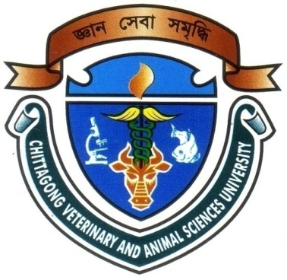

Intern ID: C-29
Roll No: 2008/44
Registration No: 386
Session: 2007-2008

Report Presented In Partial Fulfillment for the Degree of Veterinary Medicine.

Chittagong Veterinary and Animal Sciences University
Khulshi, Chittagong.

study on determination of anthelmintic efficacy and antimicrobial sensitivity in asiatic elephant
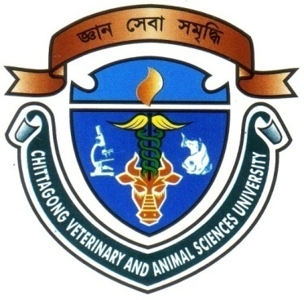

A CLINICAL REPORT IS SUBMITTED

BY
Intern ID: C-29
Roll No: 2008/44
Registration No: 386
Session: 2007-2008

Approved as to style and content by
………………………………….
Signature of Supervisor
Name: DR. S. K. M. AZIZUL ISLAM
Designation: Associate Professor
Dept. of Physiology, Biochemistry & Pharmacology.
Chittagong Veterinary and Animal Sciences University.

……………………………..
Signature of Author
Name: BIJAY MALLICK
Intern ID: C-29
Roll No: 2008/44
Reg. No: 386
Session: 2007-2008
Date of submission: 27-03-2014

CONTENTS
Chapters | Subject | Page no.
 | Acknowledgement
 | Abstract | 1
Chapter-I | Introduction | (2-3)
 | 1.1: Ojective of the study | 3
Chapter-II | Review of Literatures | (4-7)
 | 2.1: History of Asiatic Elephant  2.2: Taxonomy  2.3: Population and Distribution  2.4: Management practices of Asian Elephants  2.4.1: Feeding  2.4.2: Watering  2.4.3: Habitat and Ecology  2.5: Common Endoparasites are found in Elephants  2.6: Common infectious diseases of Elephants  2.6.1: Viral Infections  2.6.2: Bacterial Infections  2.7: Anthelmintics, Antibiotics and Vaccines are used | 4  4  4  5  5  6  6  7  7  7  7  7
Chapter-III | Materials and methods | (8-11)
 | 3.1: Data collection | 8
 | 3.2: Collection of faecal samples | 8
 | 3.3: Preservation of fecal samples: | 8
 | 3.4: Parasitological tests | 8
 | 3.5: Microbiological tests  3.5.1: Culture of bacteria  3.5.1.1: Culture in Selenite broth  3.5.1.2: Culture on Agar  3.5.2: Isolation and Identification of bacteria  3.5.3: Cultural Sensitivity (CS) Test  3.5.3.1: Materials Required  3.5.3.2: Methods  3.6: Drug selection and trial  3.7: Evaluation of clinical success  3.8: Statistical analysis  3.9 Flow chart showing Materials and methods | 9  9  9  9  9  10  10  10  11  11  11  12
Chapter-IV | Result and discussion | (13-16)
 | 4.1: Management practices of Elephants of safari park  4.2: Parasitological tests results | 13  13
 | 4.3: Microbiological tests Results | 15
Chapter-V | Conclusion | 17
 | References | (18-19)

List of Tables
Table No. | Title | Page No.
1 | Population of Asian Elephants | 5
2 | Used Antibiotic discs | 10
3 | Zones of inhibition for various antibiotics | 10
4 | Number of eggs and larvae of Strongyles in feces of elephants before anthelmintic treatment | 13
5 | Number of eggs and larvae of Strongyles in feces of elephants after anthelmintic treatment | 14
6 | Sensitivity of gastrointestinal Bacteria to different antibiotics | 15
7 | Percentages of antibiotic sensitivity in different samples | 15

ACKNOWLEDGEMENT
All praises are due to the Almighty God, the creator and supreme authority of the universe, who empowers the author to complete the research work successfully.

The author wishes to express his deepest sense of gratitude, sincere appreciation, indebtedness and profound regards to his respected teacher and reverend supervisor, DR. S. K. M AZIZUL ISLAM, Associate Professor, Department of Physiology, Biochemistry & Pharmacology, Faculty of Veterinary Medicine, Chittagong Veterinary and Animal Sciences University, for his constructive and constant guidance in planning and execution of this research work, continuous encouragement, scholastic guidance, and affectionate feelings throughout the course of research work.
The author is deeply owe, Professor Dr. A. K. M. SAIFUDDIN, Head of The Department, Department of Physiology, Biochemistry & Pharmacology, Chittagong Veterinary and Animal Sciences University, for his constant help and valuable advice during research work.
The author whishes to express his gratitude to the Dr. BIBEK CHANDRA SUTRADHAR, Associate professor and Director External Affairs, Chittagong Veterinary and Animal Sciences University, for his supervision and kind co-operation during the period of internship.
The author also would like to express his thanks to Rafiqul Islam, Monjurul Islam and Salauddin Bhai for continuous help in laboratory work.
Finally, the author wishes to express his sincere gratefulness to his parents for their blessing throughout his academic life.

The Author
March, 2014

