A STUDY ON HAEMATOLOGICAL CHANGES IN SUB CLINICAL MASTITIS AND PARAMPHISTOMIASIS AFFECTED HIGH YIELDING DAIRY COWS UNDER CHITTAGONG DISTRICT.

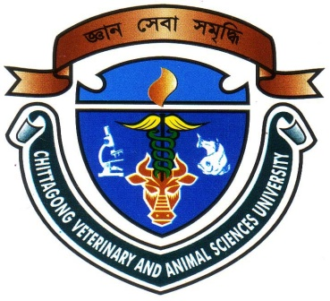

A clinical report submitted by

Examination Roll No: 2008/42
Reg. no: 384

Internship ID: C-27
Session: 2007-2008

This clinical report is submitted for Partial fulfillment of the Degree of Doctor of Veterinary Medicine (DVM)

Chittagong Veterinary and Animal Sciences University.

Khulshi, Chittagong-4225

March, 2014
A STUDY ON HAEMATOLOGICAL CHANGES IN SUB CLINICAL MASTITIS AND PARAMPHISTOMIASIS AFFECTED HIGH YIELDING DAIRY COWS UNDER CHITTAGONG DISTRICT.

A clinical report submitted as per approved style and contents

……………………………………….
Signature of Author
Name: Md. Zannatul ferdous siddiqe
Roll No: 2008/42
Reg. No: 384
Intern ID: C-27
Session: 2007-2008
………………………………
Signature of Supervisor
Dr. Bhajan Chandra Das
Associate Professor
Department of Medicine and surgery
Chittagong Veterinary and Animal Sciences University

March, 2014

