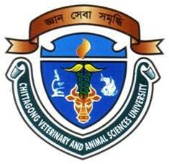
STUDY ON CASTRTION AND ITS EFFECTS ON BODY WEIGHT IN GOAT

A clinical report submitted by
Md. Jahirul Islam
Roll no: 08/18
Intern ID: B-11
Reg. No: 361
Session: 2007-2008

Report presented in partial fulfillment for the Degree of
Doctor of Veterinary Medicine (DVM)

Faculty of Veterinary Medicine
Chittagong Veterinary and Animal Sciences University,
Khulshi, Chittagong-4225

March 2014

STUDY ON CASTRTION AND ITS EFFECTS ON BODY WEIGHT IN GOAT

A clinical report submitted as per approved style and content

Signature of the Author  Roll no- 08/18  Intern ID: B-11  Reg. No-361  Session: 2007-2008 | Signature of Supervisor  Prof. Dr. Md. Masuduzzaman  Dept. of Parasitology & Pathology  Faculty of Veterinary Medicine  Chittagong Veterinary and Animal  Sciences University, Khulshi, Chittagong-4225

