CHAPTER 1

INTRODUCTION

Cattle have been reared in Bangladesh since early time of human settlement in the country. While they stand first in number among the ruminant species, the population of cattle in Bangladesh currently includes about 25.075 million animals, which are dispersed throughout the country (Anonymous, 2007). The average number of cattle per household is 2.459 and they are mostly reared by landless, small and medium farmers. Cattle are used primarily for meat production, milk production and their skin, horn, bone, blood are are valuable by-product.

Diseases are the major constraints of cattle production in Bangladesh. The mortality of cattle and calves is also another major problem confronting cattle rearing in Bangladesh. Like other livestock, Cattle is also susceptible to various diseases or disease conditions causing debility and mortality, which lead to huge economic loss. In Bangladesh, the common diseases which affect the young or adult cattle causing death are parasitism, infectious diseases like FMD, BQ, HS, Anthrax etc.

In parasitic infection main symptoms is diarroea, there are many parasite causing diarrohea, protozoa is one of them. There is different type of protozoa like Cryptosporidium Spp, Giardia spp, Trypanosoma spp, Tritrichomonas spp etc causing diarrohea. Cryptosporidium is the intracellular protozoa that causing diarroeiatic disease cryptosporidiosis.

Cryptosporidiosis, caused by Cryptosporidium sp, is primarily a disease of calves less than 6 month of age and is usually a milder disease compared to other protozoan diseases like coccidiosis. Infective oocysts are passed in feces and are transmitted by oral ingestion. Oocysts readily infect a variety of animals, including humans. Effective treatments are not available, but because the disease is usually mild and self-limited, supportive care, primarily hydration, is important. Control is strict sanitation and quarantine of sick animals. Cryptosporidium has been identified as the cause of numerous outbreaks of diarrhoeal illness in human and animals including cattle. While human infections are thought to be derived from animal sources such as cattle, sheep, goat and other animals, it is not yet established if there is any relationship between human and animal genotypes of Cryptosporidium. Cryptosporidiosis may lead to high morbidity and mortality rate (Foreyt, 1990; Robertson, 2009). Symptoms of acute cryptosporidiosis include lack of appetite, and weight loss (Geurden et al., 2008). Clinical signs are yellow diarrhoea with or without blood. Animals will show signs of abdominal pain, anemia, anorexia, dehydration, tenesmus, weakness and loss of weight.

Diagnosis of cryptosporidiosis is an important issue for their effective treatment and control. In field level Cryptosporidium spp are identified by modified Ziehl-Neelsen staining techniqe.The Ziehl-Neelsen stain also known as the acid fast stain, was first described by tow German doctors; bacteriologist Franz Ziehl (1859-1926) and the pathologist Friedrich Neelsen (1854-1898).It is a special type of staining that are used to identify the Cryptosoridium spp Mycobacterium spp, Nocardia spp, Isospora spp, Cyclospora spp, fungal hyphe etc.

Cryptosporidiosis in animals has been reviewed by different authors (Angus, 1983; Tzipori, 1983, 1988; Currant and Garcia, 1991; O`Donoghue, 1995; Olson et al., 2003; Ramirez et al., 2004). Infections of domestic and wild animals provide the biggest source of oocysts which are responsible for environmental contamination. In the USA, Cryptosporidium is reported to be present in more than 90% of all US dairy farms and 50% or more of all dairy calves will shed detectable number of oocysts (Sischo et al., 2000). Young animals are more susceptible to infection and disease while in adults it is asymptomatic in most cases. Calves are more susceptible shortly after birth and infection has been reported in both dairy and beef calves (Xiao and Herd, 1994; Garber et al., 1994; Atwill et al., 1999). The duration of infection is usually short, lasting about two weeks with peak oocysts shedding during the second week of infection (Ongerth and Stibbs, 1989; Xiao and Herd, 1994; Kemp and Wright, 1995; O’Handley et al., 1999; Uga et al., 2000). Clinical signs are usually manifested in calves early age with mild to moderate, pale or yellowish diarrhoea, which is accompanied by mucus. The condition can last for two weeks and alongside dehydration, calves become lethargic and anorexic, contributing to weight loss. They do not respond to antibiotic therapy and in more severe cases, dehydration and cardiovascular collapse leads to mortality (Olson et al., 2003). However, the healthy calves can be subclinically infected which contributes continuous oocyst excretion in faeces (Tzipori, 1988).

Cryptosporidium is also an important cause of enteric infection in young calves and severe outbreaks with high case fatality have been reported by several authors (Tzipori et al., 1981; Angus et al., 1982; Johnson et al., 1999). Previous reports indicate the prevalence of Cryptosporidium from 5% up to 77% worldwide (Bomfim et al., 2005; Ryan et al, 2005a; Santin et al, 2007). In one report by Geurden et al. (2008). Although a number of human cases of cryptosporidiosis have been well documented in childrens and adult diarrheal patients in Bangladesh, there is no report available about the prevalence and speciation of the Cryptosporidium sp. responsible for diarrhoea in calves in the country.
Considering the limited data on prevalence of Cryptosporidium especially in cattle calves, the present study was undertaken with a number of objectives as below :-
- To identify the oocysts of cryptosporidium spp. in cattle calves by Ziehl-Neelsen technique under microscope.
- To investigate the different risk factors of cryptosporidiosis in selected areas of Bangladesh.

CHAPTER 2

REVIEW OF LITERATURE

2.1. Cryptosporidium and Cryptosporidiosis
Cryptosporidium spp. is member of the phylum Apicomplexa and is found in human and animal populations worldwide. People from both developed and developing countries are vulnerable to these important opportunistic protozoa. The protozoa have a wide host range as it can infect more that 152 species of human and animals. It has a predilection for epithelial cells in the digestive tracts of a wide variety of hosts which includes humans, livestock, companion animals, wildlife, birds, reptiles and fishes (O’ Donoghue, 1995).

2.1.1. Taxonomy
Although the first report of Cryptosporidium infection in mice was published by Tyzzer in 1907, it was not until 1980s when it was reported as a cause of death in AIDS patients. The earliest cases of human cryptosporidiosis were diagnosed in animal handlers. All species of Cryptosporidium are taxonomically classified as below (Levine 1985)-

Phylum: Apicomplexa
Class: Sporozoasida
Subclass: Coccidiasina
Order: Eucoccidiorida
Suborder: Eimeriorina
Family: Cryptosporidiidae
Genus: Cryptosporidium
Members of this protozoan genus in the phylum Apicomplexa were long thought to be closely related to the coccidia, important parasites in human and veterinary medicine. Despite strong morphological similarities to the coccidia throughout the life cycle and the presence of mitochondrion-specific genes (Riordan et al., 1999), it has not been shown that C. parvum possesses a mitochondria-like organelle (Tetley et al., 1998) as found in classical coccidia. Between 1968 and 1981, different species of Cryptosporidium in fish, reptiles, birds, and mammals were named on the assumption that each host species harbored a separate species of Cryptosporidium (Fayer et al., 1986; Xiao and Fayer, 2008). While it is not yet confirmed the actual number of species of Cryptosporidium, Table 1 shows a list of named species as reported by Xiao and Fayer (2008).

Table 1. Named Species of Cryptosporidium (according to Xiao and Fayer 2008)
Species | Host | Author
C. andersoni | Bos Taurus (domesticated cattle) | Lindsay et al., 2000
C. bovis | Bos Taurus(domesticated cattle) | Fayer et al,2005
C. anserinum | Anser anser (domestic goose) | Proctor and Kemp, 1974
C. baileyi | Gallus gallus (domestic chicken) | Current et al., 1986
C. agni | Ovies aries(sheep) | Barker and Carbonell, 1974
C. crotali | Crotalus confluens (snake) | Triffit, 1925
C. ctenosauris | Costa rican lizard | Duszynski, 1969
C. cuniculus | Oryctolagus cuniculus (rabbit) | Inman and Takeuchi, 1979
C. felis | Felis catis (domestic cat) | Iseki, 1979
C. garnhami | Homo sapiens (man) | Bird, 1981
C. lampropeltis | Lampropeltis calligaster (lizard) | Anderson et al., 1968
C. meleagridis | Meleagris gallopavo (turkey) | Slavin, 1955
C. muris | Mus musculus (domestic mouse) | Tyzzer, 1907
C. nasorum | Naso literatus (fish) | Hoover et al., 1981
C. parvum | Mus musculus (domestic mouse) | Tyzzer, 1912
C. rhesi | Macaca mulatta (rhesus monkey) | Levine, 1981
C. serpentis | Colubrid, crotalid, and boid snakes | Levine, 1981
C. tyzzeri | Gallus gallus (domestic chicken) | Levine, 1961
C. vulpis | Vulpes vulpes (European fox) | Wetzel, 1938
C. wrairi | Cavia porcellus (guinea pig) | Vetterling et al., 1971
C. andersoni | Bos Taurus (domestic cattle) | Lindsay et al., 2000
C. bovis | Bos Taurus (domestic cattle) | Fayer et al., 2005
C. canis | Canis familiaris(domestic dog) | Fayer et al., 2001
C. fayeri | Macropus rufus (red kangaroo) | Ryan et al., 2008
C. galli | Gallus gallus (chicken) | Pavlasek 1999
C. hominis | Homo sapiens (human) | Morgan-Ryan et al., 2002
C. suis | Sus scrofa (domestic pig) | Ryan et al., 2004
C. xiaoi | Ovis aries (domestic sheep) | Fayer and Santin, 2009

2.1.2. Morphology
Among the coccidia, the genus Cryptosporidium has the smallest oocysts. They are spherical to ovoid and 50 fully sporulated oocysts averaged 7.4 by 5.6 µm for C. muris and 5.0 by 4.5 µm for C. parvum, the species infectious for most mammals (Upton et al., 1985). Sporulated oocysts each contain four sporozoites and a residuum composed of numerous small granules and a spherical or ovoid membrane-bound globule. Most, but not all, authors report no sporocyst wall within the oocyst (Levine, 1984). Other morphological features often observed in coccidian oocysts, such as a micropyle and polar granules, have not been found in oocysts of Cryptosporidium spp. The oocyst wall is smooth and colorless and averages about 50 µm in thickness. It is composed of two electron-dense layers separated by a thin electron-lucent space (Reese et al., 1982). The small size of the Cryptosporidium oocysts makes them indistinguishable at the species level based on morphology by light microscope (Fall et al., 2003). The oocysts are spherical or ovoid in appearance and contain 4 naked parallel sporozoites surrounded by a smooth oocyst wall. At the wall, a faint suture can be seen through which the sporozoites exit during excystation (Morgan-Ryan et al., 2002). There is some variation from species to species. The length of the oocyst ranges from 4.5 to 7.5 μm and the width from 4.2 to 5.7 μm.

2.1.3. Life cycle
The life cycle of C. parvum has been outlined in a number of reviews (Fayer and Ungar, 1986; Current and Garcia, 1991; O’Donoghue, 1995). Cryptosporidium is monoxenous, that is, its life cycle is completed within one host. The parasite moves from host to host via the faecal-oral route (Fayer and Ungar, 1986). The lifecycle (Fig. 1) begins with the ingestion of oocysts which excysts in the intestine releasing sporozoites. Thereafter, two cycle of schizogony is followed by gametogony with the production of male and female gametocytes (Tzipori and Griffiths, 1998). The trophozoites within parasitophorous vacuole undergo asexual multiplication by schizogony with production of merozoites. Several investigators reported endopolygeny for multiple division and sequential development involving two types of meronts (Vetterling et al., 1971a; Iseki, 1979; Current & Reese, 1986). Type I meronts form 8 merozoites, which are released when mature and are termed as type I merozoites. The type- I merozoites then invade other noninfected epithelial cells where they undergo another cycle of merogony and develop into type II meronts. The type II meronts form 4 type II merozoites, which do not undergo further merogony but produce macro and microgamonts.

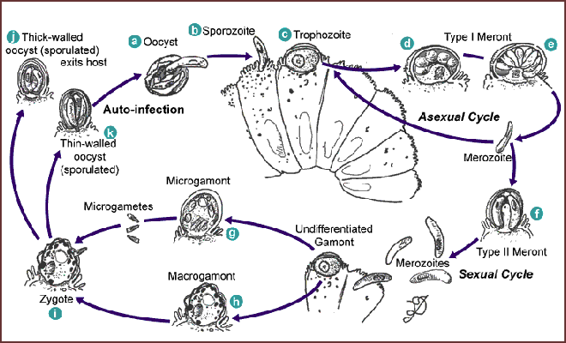
Fig-1. Different life cycle stages of Cryptosporidium spp (Reproduced from www.sciencedirect.com).

Sexual reproduction occurs by gametogony and both microgamonts and macrogamonts are formed from type II merozoites (Gobel & Brandler, 1982). Microgamonts develop into microgametocytes, which produce up to 16 non-flagellated microgametes. Macrogamonts develop into macrogametocytes and are fertilized by mature microgametes. The product of fertilization is zygote, around which a resistant wall is formed and subsequently termed as “oocyst”. Most oocysts are thick-walled and are excreted from the host in faecal material. Approximately 20% of the oocysts produced in the gut fail to form an oocyst wall and the developing sporozoites are only surrounded by a series of membranes. These "oocysts," devoid of a wall, are called "thin-walled oocysts."

The resultant zygotes undergo further asexual development (sporogony) and through meiosis lead to the production of sporulated oocyst containing 4 sporozoites. The thin walled oocyst is responsible for autoinfection within the host, which have been reported to excyst within the same host animal leading to a new cycle of development (Current, 1985; Current & Reese, 1986). Thus the thin walled oocysts and recycling type-I meronts are responsible for persistent chronic infection in the same host. The thick walled oocyst containing four sporozoites is ingested by the host from the environment, which are released into the epithelial cells of intestine where asexual development starts (Tzipori and Griffiths, 1998).

2.1.4. Diagnosis, treatment and control of cryptosporidiosis
2.1.4.1 Diagnosis
A number of tests have been developed for the diagnosis of Cryptosporidium. These involve direct detection by microscopy of faecal materials after using specialized staining techniques (Garcia et al., 1983). The modified acid-fast stain (Ziehl-Neelsen stain) and auramine stain is widely used but has the limitation of relatively low sensitivity (Weber et al., 1991). However, examining under UV light with a rhodamine filter can increase the sensitivity up to 100 times (Nielsen and Ward, 1999). Use of polyclonal or monoclonal antibodies for detection by immunolabelling has also been developed, but proved less sensitive than conventional staining (Garcia and Shimizu, 1997). The recently developed PCR amplification technique has been found to be very specific and highly sensitive, targeting different genes including the oocyst wall protein (COWP), the small subunit of rRNA, -tubulin, TRAP-C1, TRAP-C2, ITS1, polythreonine repeat (poly-T), dihydrofolate reductase (DHFR), and sequences and mRNA of heat shock proteins (Sulaiman et al., 1999). The efficacy of this technique for detection of Cryptosporidium in environmental and clinical samples has also been reported in several studies (da Silva et al., 1999). Certainly, the use of the PCR technique with sequence analysis provides help for genetic characterization of Cryptosporidium at the species level which can contribute significantly to epidemiological investigations.

2.1.4.2. Treatment
Despite intensive efforts, treatment of cryptosporidiosis with available anticoccidials is still not satisfactory (Haberkorn, 1996; Coombs and Muller, 2002). The macrolides, spiramycin and azithromycin have been found ineffective and less tolerable in both immunocompetent and immunodeficient individuals (Saez-Llorens et al., 1989; Galvagno et al., 1993; Vargas et al., 1993; O’Donoghue 1995). Diclazuril was tested in humans with unsatisfactory results (Connolly et al., 1990; Soave, 1990). In AIDS patients, letrazuril induces clinical improvements in up to 50% of patients and some inhibition of oocyst excretion (Guillem et al., 1992; Harris et al., 1994). Unfortunately, none of the widely used anticoccidials are suitable to treat clinically infected patients. Thus the search for new anticoccidials to treat cryptosporidiosis continues.

2.1.4.3. Control
Prevention is the most effective approach to control cryptosporidiosis. Contamination of water sources is the major source of human infection and thus prevention of environmental spread of oocysts is crucial. Cattle farms should be constructed away from streams and rivers to avoid possible water contamination. Prophylactic measures should be taken to reduce the transmission between animals, as they are the main source of zoonotic infection. This involves effective herd management without overcrowding or reducing stocking density, treatment of infected cattle separately, keeping young animals from the adults and minimizing human contact with calves (Ramirez et al., 2004). The destruction of oocysts with 5% ammonia solutions with heat is recommended for cleaning houses (Campbell et al., 1982).

2.1.5. Cryptosporidiosis in large ruminants
The parasite is common in ruminants throughout the world but reported prevalence rates vary widely. Among calves up to 100% of a herd may be affected, especially if the animals are housed communally (Casemore et al., 1997; de Graaf et al., 1999; Joachim et al., 2003; Sturdee et al., 2003).In India 461 calves fecal and 264 buffalo calves are taken and found the prevalence is 16.3% in Cattle calves and 24.5% in buffalo calves.In middle Egypt 458 fecal samples are collected and 14.9% positive case are found in Cryptosporidiosis positive (Anderson 1982; Angus et al., 1982; Barker 1974; Berg et al., 1978; Ducatelle et al., 1983; Hiepe et al 1985; Tzipori et al., 1981) Calves at 1-15 days were at the highest risk (P < 0.001), and a significant relationship between season and infection (P < 0.05) was recorded. A significant association between infection and hygiene (P < 0.001), type of floor (P < 0.01) and source of water (P < 0.01) was also recorded. Statistical analysis concerning the clinical signs and fecal characteristics revealed a significant association with fecal consistency (P < 0.001), presence of blood (P < 0.01) and mucous (P < 0.01). Moreover, a significant association was found between infection and the desire for suckling (P < 0.05) and tenesmus (P< 0.05). The results of the present study demonstrated the strong relation between infections by Cryptosporidium spp. and diarrhea in buffalo calves(Osama et al.,2008; Neonates are most susceptible to natural infections (Anderson 1982; Angus et al., 1982; Barker 1974; Berg et al., 1978; Ducatelle et al., 1983; Hiepe et al 1985). Experimental studies have shown that older calves also were susceptible to infection, 30-dayold calves were infected but had only a mild clinical response, and calves as old as 7 months were infected but no clinical information was provided (Tzipori et al., 1981). Diarrhoea, the most prominent clinical sign of bovine cryptosporidiosis, lasted 2 to 12 days and was sometimes accompanied by anorexia, poor growth, stiffness, hyperpnea, slow gait, limb muscle fasciculations, and depression. Most cases were diagnosed by identification of oocysts in feces. At necropsy, blood or mucoid fluid and bright yellow watery feces have been found in the colon, and both the small and large intestine have appeared mildly hyperemic (Berg et al., 1978, Tzipori et al., 1981).

2.1.6. Cryptosporidiosis in Bangladesh
Cryptosporidiosis has long been considered as an important pathogen causing diarrhoea in Bangladesh (Shahid et al., 1987). The very first report of cryptosporidiosis in Bangladesh indicates possible zoonotic transmission as reported from calves, animal handlers and associated family members at a dairy farm in Savar (near the capital city, Dhaka) (Rahman et al., 1990).

A prospective study on the urban slum in capital city, Dhaka reported that malnutrition significantly increases the risk of cryptosporidiosis along with some enteropathogen (Mondal et al., 2006). In another study, association of enteric protozoan-associated diarrheal illness with that of the nutritional status and growth of preschool children in Bangladesh was investigated. While comparatively more childrens were suffering from infection with Giardia and Cryptosporidium spp, no relationship was found between malnutrition and stunting growth of calves with cryptosporidiosis (Mondal et al., 2006).

Since long time, diarrheal diseases were considered as a leading public health problem, particularly in children in Bangladesh. Early studies in rural Bangladesh also indicated persistent diarrhoea in childrens as a concern for public health (Huttly et al., 1990). A separate recent study also indicated that E. histolytica, C. hominis, C. parvum, and G. lamblia assemblage A infections are important causes of diarrhoeal illness in Bangladesh population. The prospective case-control study was performed which involved a total of 3,646 case patients and 2,575 control subjects with asymptomatic infection (Haque et al., 2009).

Recently modern molecular biological approaches like multiplex real-time PCR assay has been used experimentally to identify different etiologic agents of diarrhoea including Cryptosporidium spp. in Bangladesh. However it is expensive to be used as routine diagnostic tool throughout the country (Haque et a., 2007). Using scorpion probes and real-time qPCR based on 18s rRNA gene, several Cryptosporidium species were reported from stool samples originated from Bangladesh. These include C. parvum, C. hominis, C. felis and C. meleagridis (Stroup et al., 2006).

Few studies have been directed to investigate the epidemiology, clinical features, and systemic antibody responses of cryptosporidiosis in Bangladeshi children. In one such study by Khan et al. (2004), Cryptosporidium spp. infection was found to occur most commonly in those childrens who are less than two years of age and was accompanied by watery diarrhoea and vomiting. In addition, Cryptosporidium-specific serum IgM levels were reported as significantly higher in cases compared with controls in the study groups.

The epidemiology, clinical features, nutritional status, and causative agents of diarrhea in Bangladeshi children were studied by Haque et al., (2003). Among other bacterial and viral pathogens Cryptosporidium was reported from 8.4% (n=893) samples as was identified as important cause of diarrhoea among childrens. A year long surveillance in a hospital at Dhaka, Bangladesh identified 1.4% (n=814) cases of diarrhoea caused by Cryptosporidium spp. in children under 5 yrs of age (Albert et al., 1999). Another year-long study from the same hospital identified 3% (n=1382) incidence of Cryptosporidium oocysts in the diarrhoeal stool samples (Rahman et al., 1990).Also a study had occurred in CVASU by Maqsudul Alam reported that 15 positive cases are found out 100 no. of sample in goat kids sample.(Maqsud et al.,2012)

CHAPTER 3

MATERIALS AND METHOD

3.1. Source of samples
During the study, a total of 50 fresh fecal samples were collected from dirrhoeic cattle calves of different region of pabna, sirajgong and Chittagong district and calves arriving at SA Quadery Teaching Veterinary Hospital (SAQTVH) of the Chittagong Veterinary and Animal Sciences University (CVASU). The ages of the animals were between 1 to 6 months and samples were collected by visiting different type of farm. All relevant data such as breed, sex, age, housing, feeding, treatment history were recorded for further analysis.

3.2. Study area and period
All the animals were located in different area of Bangladesh like Sirajgong, Pabna and around Chittagong Metropolitan area (CMA). The experiment was carried out at the Animal Disease Diagnostic Lab (ADDL) of Poultry Research & Training Center (PRTC) and the Parasitology Laboratory of the Department of Pathology & Parasitology, Chittagong Veterinary & Animal Sciences University (CVASU). The study period was during September, 2013 until March, 2014.

3.3. Collection of fecal samples
Feces were collected directly from the rectum of each cattle calf into a clean plastic specimen container that was immediately come to preservation in freezer, then I labbled the container and transport to Chittagong through icebox. The fecal samples were immediately used for staining or preserved in – 20°C freezer.

3.4. Ziehl-Neelsen staining technique
This is technique is used for the detection of oocysts of Cryptosporidium species in faeces. (Henricksen and Pohlenz,1981).

3.4.1. Materials and reagents
3.4.1.1. Materials required
- Fecal samples
- Slides
- Coplin jar
- Electric drier
- Compound microscope
- Immersion oil
- Tooth pick
- Cover slip

3.4.1.2. Reagents
- Methanol
- 3% carbol fuchsin
- 1% acid methanol
- 0.4% brilliant green

3.4.1.3. Reagents composition
- Recipe for 3% carbon fuchsin:
3 gm basic fuchsin
30 ml ethanol
15 ml carbolic acid
Up to 100 ml distill water

- Recipe for 1% acid alchol
70% Methanol 99 ml
Concentrated HCL 1 ml
- Recipe for Brilliant green
Brilliant green powder 0.4 gm
Up to 100 ml distill water

3.4.2. Procedure
- Using the tooth pick, a medium to thick smear of fecal materials were prepared and air- dried.
- The dried smear was then flooded with methanol for 3 min for fixation and then air-dried
- Later 3% carbol fuchsin was poured over the smear and left for approximately 15 min
- The slide was rinsed with running tap water
- Now 1% acid methanol was added in the smear to decolorise and left for 15 to 20 seconds
- The slide was again rinsed with running tap water
- Now 0.4% brilliant green was poured to counterstain and left for 30 seconds
- The slide was again rinsed with running tap water and then air-dried
- The stained slide was then examined using a compound microscope

3.4.3. Microscopic examination
Air dried slides were examined under light microscopy at X10, X40 and X100 magnifications. Ocyst of Cryptosporidium were found as pink colored round and spherical body as it takes carbol fuchin stain. The back ground of the slide takes blue color of brilliant green (Fig.7 and 17).

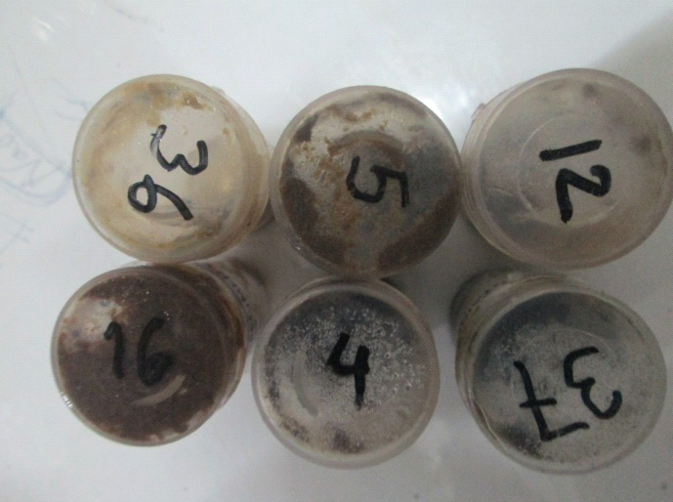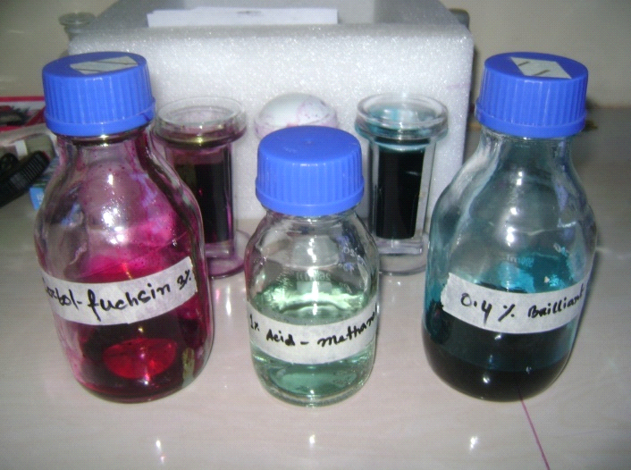
Fig2. Feces samples of Calves Fig 3. Reagents used in Z-N technique

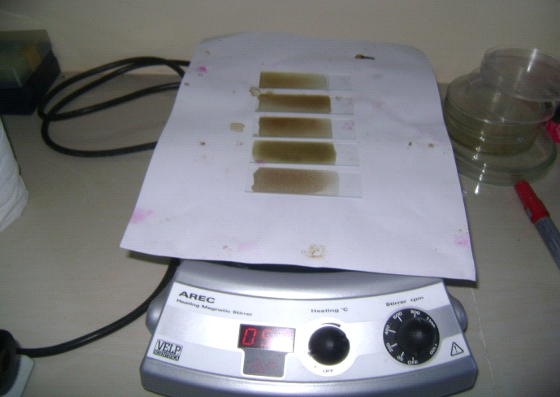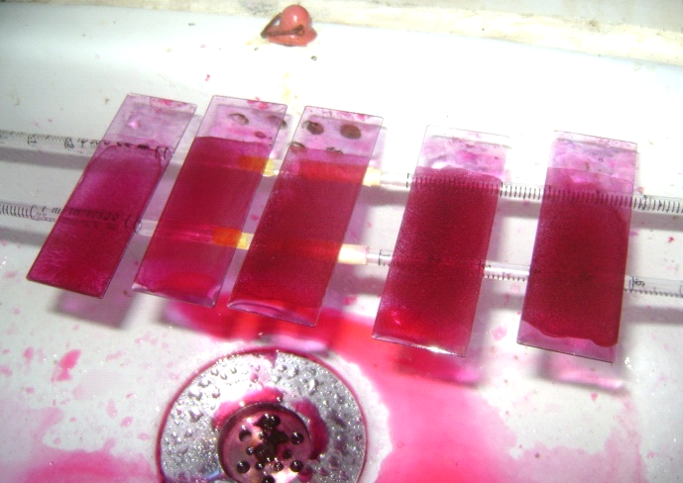
Fig 4. Fecal smear dried in drier. Fig 5. Smear staining with carbol
fuchsin.

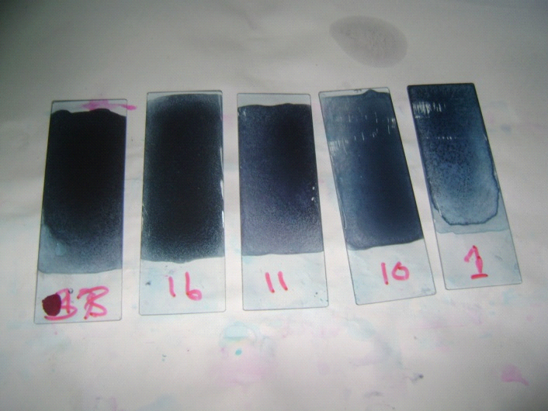 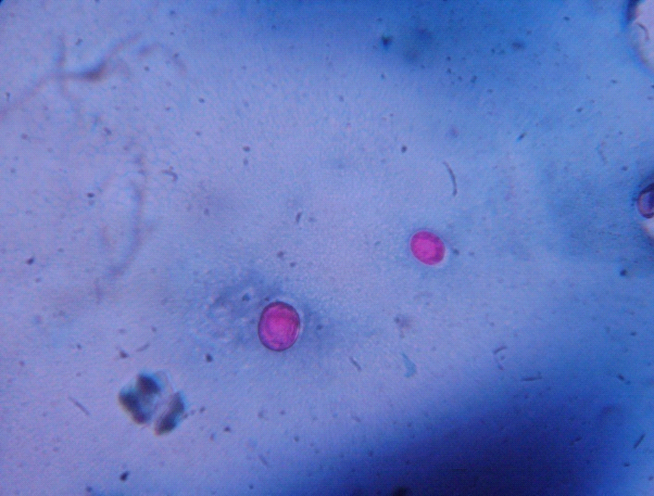Fig 6. Smear staining with brilliant Fig 7. Oocysts under microscope
green

CHAPTER 4

RESULTS

4.1. Microscopic identification
Initially after sampling the feces from diarrhoeic cattle calves, classical tools like Ziehl-Neelsen stain was used to identify Cryptosporidium positive cases. Through microscopy, only 5 samples were found as positive and oocyst was found (fig:8a,8b) out of 50 samples tested.

During this study four different types of breeds of cattle are taken namely Jersy cross, Holstein-Friesian cross,RCC and undescribed breed were sampled. While all of the calves were having diarrhoea, it was notable that Cattle calves out of the 5 cases were those of Holstein-Friesian and undescribed breed was found positive based on Ziehl-Neelsen staining and microscopy.

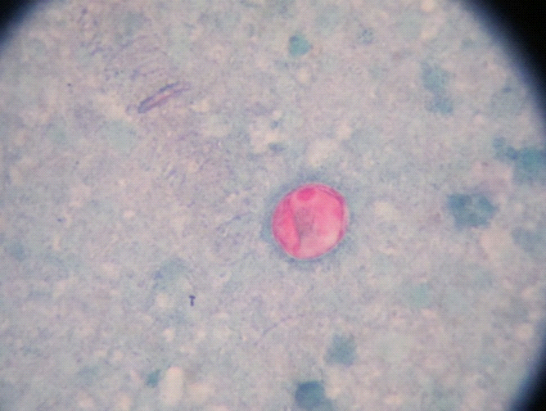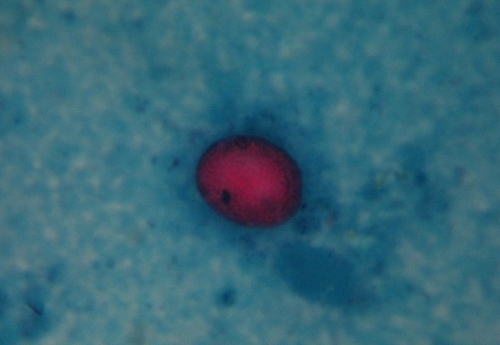
Fig 8 (a) and (b). Oocysts of Cryptosporidium sp. in modified Ziehl-Neelsen stain under microscope in ×100 objectives.

Fig 9. Breed specific prevalence of cryptosporidiosis

Fig 10. Sex specified prevalence of Cryptosporidiosis

CHAPTER 5

DISCUSSION

Cryptosporidiosis in calf have been reported in several countries by a number of investigators. The incidence and prevalence rates have been reported that varies widely according to the sample size and geographic distribution. The prevalence recorded during this study shows that 10% in Cattle calves (5 out of 50) was positive for Cryptosporidium. This finding was based on microscopic examination by Ziehl-Neelsen stain which is not 100% confirmatory. This is because not only cysts of Cryptosporidium but other organisms might interfere with the the test results. These includes several acid fast bacteria including Mycobacterium sp. This rate of prevalence was somewhat comparatively low with other investigators such as 23% in UK (Sturdee et al., 2003), 24% in Romania, 40-70% in Spain (Munoz et al., 1996; Casemore et al., 1997; Castro-Hermida et al., 2002; Causapé et al., 2002). Again this was comparatively higher as in Belgium where cryptosporidiosis was reported only in 9.5%. However, the rate was 20% in Trinidad and Tobago and 17.6% in Iran which indicates that further study can ensure actual prevalence of cryptosporidiosis in calves in Bangladesh. Considering this study as the first of its type, further sampling is warranted from different divisions, districts, farms and household level. It can be postulated that the comparative high rate of infection in these countries is due to high level of environmental contamination in Belgium and Spain which is usually very different in Bangladesh. Most large ruminants like Cattle and Buffalo in Bangladesh have little access to pasture and usually they are reared in semi-intensive method where there is little opportunity for the young animals to be infected by the contaminated oocysts. Due to lack of information in the subcontinent, we were unable to compare the occurrence of cryptosporidiosis in other large ruminants in the Indian subcontinent or Southeast Asia.

Considering the relative susceptibility, our data indicated that undescribed breed of cattle calves are more vulnerable to cryptosporidiosis compared to the exotic breed. This can highlight new thoughts on breed-associated immunologic factors and further research can answer if this can increase our understanding in developing new methods of immunoprophylaxis. A large number of articles have been published on the development of DNA vaccine but still now none was completely successful. Future research should be directed to elucidate breed-specific factors that may lead to consideration of a vaccine against cryptosporidiosis.

Concerning the sex-specific vulnerability, our data showed that female calves were more vulnerable compared to their male counterpart. This could be associated with different hormones that may contribute to variable susceptibility of different calves to this infection. This observation is also important as most of the marginal farmers in Bangladesh prefer rearing female goats and reduction of morbidity and mortality due to cryptosporidiosis would be crucal to help them reducing poverty. Further research can identify the biological factor that is responsible for this sex-specific susceptibility.

CHAPTER 6

CONCLUSION

Cryptosporidiosis is a moderate type of protozoal disease of animal. Prevalence of Cryptosporidiosis in Bangladesh is vary with different area. In this study we found that 10% fecal samples were positive for cryptosporidium spp which might be the cause of diarrhea on that claves. In field level diagnostic procedure and its treatment is not satisfactory .But Cryptosporidium spp have zoonotic significance. For that reason we have to concern about this disease and need more research. Although it is not sufficient for further research from but It is true that this report will help to know primary knowledge about the percentage of cryptosporidiosis in diarrhoiec calves, becuse to our best knowledge this is the first work about cryptosporidiosis of diarrhoeic cattle calves in Bangladesh.

REFERENCES

Albert MJ, Faruque AS, Faruque SM, Sack RB, Mahalanabis D. 1999. Case-control study of enteropathogens associated with childhood diarrhea in Dhaka, Bangladesh. J Clin Microbiol 37: 3458–3464.

Angus K. W. 1983. Cryptosporidiosis in man, domestic animals and birds: a review pp. 62-70.

Angus K.W., Sherwood G. Hutchison and I. Campbell. 1982. Evaluation of the effect of 2 aldehyde-based disinfectants on the infectivity of faecal cryptosporidia for mice. Res. Vet. Sci. 33:379-381.

Anonymous, 2007. Bangladesh Economic Review, Economic Adviser’s Wing, Finance Division, Ministry of Finance, Government of the People’s Republic of Bangladesh.

Atwill E.R., E.M. Johnson,M.G. Pereira. 1999. Association of herd composition, stocking rate, and duration of calving season with fecal shedding of Cryptosporidium parvum oocysts in beef herds. J. Am. Vet. Med. Assoc. 215 :1833–1838.

Barker I. K., and P. L. Carbonell. 1974. Cryptosporidium agni sp. from lambs and Cryptosporidium bovis sp. from a calf with observations on the oocyst. Z. Parasitenkd. 44:289-298.

Berg, I. E., A. C. Peterson, and T. P. Freeman. 1978. Ovine cryptosporidiosis. J. Am. Vet. Med. Assoc. 173:1586-1587.

Budu-Amoako, S. J. Greenwood, B. R. Dixon, L. Sweet, L. Ang, H.W. Barkema and J. T.McClur. 2011. Molecular Epidemiology of Cryptosporidium and Giardia in Humans on Prince Edward Island, Canada: Evidence of Zoonotic Transmission From Cattle. Zoonoses and Public Health. 01-10.

Casemore, D.P., Wright, S.E. and Coop, R.L. 1997. Cryptosporidiosis-human and animal epidemiology. In: Cryptosporidium and Cryptosporidiosis. Edited by R. Fayer. Boca Raton, Florida: CRC Press. 65-92.

Castro-Hermida, J.A., Gonzalez-Losada, Y., Freire-Santos, F., Gonzalez-Warleta, M., Mezo-Menendez, M. and Ares-Mazas, M.E. 2002. Efficacy of beta-cyclodextrin against experimental cryptosporidiosis in neonatal lambs. Journal of Parasitology. 88: 185-187

Chalmers R.M., Ferguson, C., Caccio, S., Gasser, R.B., Abs, E.L.O.Y.G., Heijnen, L., Xiao, L., Elwin, K., Hadfield, S., Sinclair, M., Stevens, M. 2005. Direct comparison of selected methods for genetic categorisation of Cryptosporidium parvum and Cryptosporidium hominis species. Int J Parasitol. 35: 397-410.

Connolly G. M., Youle M. and Gazzard B. G. 1990. Diclazuril in the treatment of severe cryptosporidial diarrheal in AIDS patients. 4: 700-701.

Coombs G. H. and Muller, S. 2002. Recent advances in the search for new ant-coccidial drugs. Int. J. Parasitol. 32: 497-508.

Current and Garcia. 1991. Cryptosporidiosis. Clin. Lab Med. 11: 873-897.

Current and Reeese, N. C. 1986. A comparison of endogenous development of three isolates of Cryptosporidium in suckling mice. J. Protozol. 33: 98-108.

Current, W. L. 1985. Cryptosporidiosis. J. Am. Vet. Med. Assoc. 187:1334-1338.

De Graaf D.C., Vanopdenbosch E., Ortega-Mora L.M., Abbassi H., Peeters J.E. 1999. A review of the importance of cryptosporidiosis in farm animals, Int J Parasitol. 29:1269-87.

Elwin, K., Chalmers, R.M. 2008. Contemporary identification of previously reported novel Cryptosporidium isolates reveals Cryptosporidium bovis and the corvine genotype in sheep (Ovis aries). Parasitology Research 102: 1103–1105.

Fall, A., Thompson, R.C., Hobbs, R.P., Morgan-Ryan, U. 2003. Morphology is not a reliable tool for delineating species within Cryptosporidium. J. Parasitol. 89: 399-402.
Fayer R. and Ungar B. L.P. 1986. Cryptosporidium and Cryptosporidiosis. Microbiological reviews. 50: 458-483.

Galvagno G.,Cattaneo G. and Reverso-Giovantin E. 1993. Chronic diarrhea due to Cryptosporidium: the efficacy of spiramycin treatment. Pediatr. Med. Chir. 15: 297-298.

Garber L.P., M.D. Salman, H.S. Hurd, T. Keefe, J.L. Schlater. 1994. Potential risk factors for Cryptosporidium infection in dairy calves. J. Am. Vet. Med. Assoc. 205 : 86–91

Garcia LS, and Shimizu RY 1997. Evaluation of nine immunoassay kits (enzyme immunoassay and direct fluorescence) for detection of Giardia lamblia and Cryptosporidium parvum in human fecal specimens. J Clin Microbiol 35: 1526-1529.

Garcia L. S., Bruckner, D. A., Brewer, T. C. and Shimizu, R. Y. 1983. Techniques for the recovery and identification of Cryptosporidium ocyst from stool samples. J. Clin. Microbil. 18: 185-190.

Guillem S., Gomez M, Romeu J. Raventos A, Fernandez A, Condom M. J. Clotet B. 1992. Letrazuril for the treatment of severe cryptosporidial diarrheal in AIDS. Jul. 19-24;8:B129(abstract no PoB 3257).

Haberkorn A. 1996. Chemotherapy of human and animal coccidiosis: state and perspectives. Parasitol. Res. 82: 193-199.
Haque R, Mondal D, Karim A, et al., 2009. Prospective case-control study of the association between common enteric protozoal parasites and diarrhea in Bangladesh. Clin Infect Dis. 48:1191–7.

Harandi M. and Ardakani R. 2008. Epidemiology of Cryptosporidium Infection of Cattle in Kerman/Iran and Molecular Genotyping of some Isolates. Journal of Kerman University of Medical Sciences, 15(4): 313-320.

Harris, Deutsch G. MacLean J. D. and Tsoukas C. M. 1994. A phase I study of letrazuril in AIDS-related cryptosporidiosis. AIDS 8:1109-1113.

Henricksen, S.A., Pohlenz, J.F.L. 1981. Staining of Cryptosporidium by a modified Ziehl-Neelsen technique. Acta. Vet. Scand. 22: 594-596.

Iseki, M. 1979. Cryptosporidium felis sp. n. (Protozoa: Eimeriorina) from the domestic cat. Japn. J. Parasitol. 28:285-307.

Joachim A., Krull, T., Schwarzkopf, J. and Daugschies, A. 2003. Prevalence and control of bovine cryptosporidiosis in German dairy herds. Veterinary Parasitology 112: 277-288.

Johnson E. H., Muirhead, D. E., Windsor, J. J., King, G.J., Al Busaidy, R., and Cornelius R. 1999. Atypical outbreak of caprine cryptosporidiosis in the sultanate of Oman. Vet. Rec. 145: 521-524.

Kaminjolo J.S., A.A. Adesiyun, R. Loregnard, W. Kitson-Piggott. 1993. Prevalence of Cryptosporidium oocysts in livestock in Trinidad and Tobago. Vet. Parasitol. 45 : 209–213.

Kemp J. S. and Wright, S. E. 1995. On farm detection of Cryptosporidium parvum in cattle. Calves and environmental samples. Protozoan Parasites and water, edited by W. B. Betts, D. Casemore, C. Fricker, H. Smith and J. Watkins. : 154=157. The Royal Society of Chemistry, London.

Khan WA, Rogers KA, Karim MM, Ahmed S, Hibberd PL, Calderwood SB, Ryan ET, Ward HD (2004). Cryptosporidiosis among Bangladeshi children with diarrhea: a prospective, matched, casecontrol study of clinical features, epidemiology and systemic antibody responses. Am. J. Trop. Med. Hyg. 71(4): 412-419.

Levine N. D. 1984. Taxonomy and review of the coccidian genus Cryptosporidium (Protozoa, Apicomplexa). J. Protozool. 31:94-98.

Levine N. D. 1985. Phylum II. Apicomplexa, Illustrated guide to the protozoa. Society for Protozoology, Lawrence, Kans. 56: 322-374.

Morgan-Ryan, U.M., Fall, A., Ward, I.A., Hijjawi, N., Sulaiman, I., Fayer, R., Thompson, R.C., Olson, M., Lal, A., Xiao, L. 2002. Cryptosporidium hominis n.sp. (Apicomplexa: Cryptosporididae) from Homo sapiens. J. Eukaryot. Microbiol. 49: 433-440.

Nielsen, C. K. and Ward, L. A. 1999. Enhance detection of Cryptosporidium parvum in the acid fast stain. J. Vet. Diagn. Invest, 11: 567-569.

O’Handley R. M., Cockwill, C., McAllister, T. A. Jelinski, M., Morck, D. W., and Olson, M. E. 1999. Duration of naturally acquired giardiosis and cryptosporidiosis in dairy calves and their association with diarrhea. J. Am. Vet. Med. Assoc. 214: 391-396.

O'Donoghue P. J. 1995. Cryptosporidium and cryptosporidiosis in man and animals. International Journal for Parasitology. 25: 139- 195.

Ondˇrej Hajdušek, Oleg Ditrich, Jan Šlapeta. 2004. Molecular identification of Cryptosporidium spp. in animal and human hosts from the Czech Republic. Veterinary Parasitology. 122: 183–192

Ongerth J. E. and Stibbs, H. H. 1989. Prevalence of Cryptosporidium in dairy calves in western Washington. Anal. J. Vet. Res. 50: 1069-1070.

Qiagen, Hilden, Germany. Total DNA was extracted using a QIAmp DNA Stool Kit.

Rahman M, Shahid NS, Rahman H, Sack DA, Rahman N, Hossain S.1990.Cryptosporidiosis:a cause of diarrhea in Bangladesh. Am J Trop Med Hyg. 42: 127–130.

Ramirez N. E., Ward, L.A. and Sreevatsan, S. 2004. A review of the biology and epidemiology of cryptosporidiosis in human and animals. Microbes. Infect. 6: 773 785

Reid A, Lymbery A, Ng J, Tweedle S, Ryan U. 2010. Identification of novel and zoonotic Cryptosporidium species in marine fish. Vet Parasitol. 168(3-4):190-5.

Robertson LJ. 2009. Giardia and Cryptosporidium infections in sheep andgoats: a review of the potential for transmission to humans via environmental contamination. Epidemiology and Infections. 137, 913-921.

Saez-Llorens, X., Odio, C.M., Umana, M. A. and Morales, M.V. 1989. Spiramycin vs. placebo for treatment of acute diarrhea caused by Cryptosporidium. Pediatr. Infect. Dis. J. 8: 136-140.

Shahid NS, Rahman AS, Sanyal SC. 1987. Cryptosporidium as a pathogen for diarrhoea in Bangladesh. Trop Geogr Med. 39: 265–270.

Sischo W.M., E.R. Atwill, L.E. Lanyon, J. George. 2000. Cryptosporidia on dairy farms and the role these farms may have in contaminatingsurface water supplies in the northeastern United States. Prev. Vet. Med. 43 : 253–267.

Soave R. 1990. Treatment strategies for cryptosporidiosis. Ann. N. Y. Acad. Sci. 616:442-451.

Soltane R., Guyot, K., Dei-Cas, E., Ayadi, A. 2007. Prevalence of Cryptosporidium spp. (Eucoccidiorida: Cryptosporiidae) in seven species of farm animals in Tunisia. Parasite (Paris, France). 14: 335–338.

Stroup S, Houpt E Samie A, Bessong PO, Obi CL, Sevilleja JE. Cryptosporidium species: preliminary descriptions of the prevalence and genotype distribution among school children and hospital patients in the Venda region, Limpopo Province, South Africa. Exp Parasitol. 2006. 114:314–22.

Sturdee A.P., A.T. Bodley-Tickell, A. Archer, R.M. Chalmer. 2003. Longterm study of Cryptosporidium prevalence on a lowland farm in the United Kingdom. Vet. Parasitol. 116 : 97–113.

Sulaiman I.M., Hira, P.R., Zhou, L., Al-Ali, F.M., Al-Shelahi, F.A., Shweiki, H.M., Iqbal, J., Khalid, N., Xiao, L. 2005. Unique endemicity of cryptosporidiosis in children in Kuwait. Journal of Clinical Microbiology. 43: 2805–2809.

Sweeny JP, Ryan UM, Robertson ID, Yang R, Bell K, Jacobson C. 2011. Longitudinal investigation of protozoan parasites in meat lamb farms in southern Western Australia. Prev Vet Med. 101(3-4):192-203.

Tetley, L., Brown, S.M.A., McDonald, V.M., Coombs, G.H. 1998. Ultrastructural analysis of the sporozoite of Cryptosporidium parvum. Microbiology. 144: 3249–3255.

Tzipori, S. 1983. Cryptosporidiosis in animals and humans. Microbiol. Rev. 47:84-96.

Tzipori, S. 1988. Cryptosporidiosis in perspective. Adv. Parasitol. 27: 63-129

Tzipori, S. and Griffiths, J.K.. 1998. Natural history and biology of Cryptosporidium parvum. Adv Parasitol. 40: 5-36.

Uga S., Matsuo, J., Kono, E. Kimura, K., Inoue. M. Rai, S.K. and Ono, K. 2000. Prevalence of Cryptosporidium parvum infection and pattern of oocyst shedding in calves in Japan. Vet. Parasitol. 94: 27-32.

Upton, S. J. and W. L. Current. 1985. The species of Cryptosporidium (Apicomplexa: Cryptosporidiidae) infecting mammals. J. Parasitol. 71:625-629.

Vargas S. L., Shenep J. L., Flynn P. M., Pui C. H., Santana V. M. and Hughes W. T. 1993.azithromycin for treatment of severe Cryptosporidium diarrhea in two children with cancer. J. Pediatr. 123: 154-156.

Wang Y, Feng Y, Cui B, Jian F, Ning C, Wang R, Zhang L, Xiao L. 2010. Cervine genotype is the major Cryptosporidium genotype in sheep in China. Parasitol Res. 106(2):341-7.

